Course: CSE 204 – Computer Networks
LAB 6 – ACL & IPv6 & NAT & FileZilla & Wireshark
Due date: November 29th, 2025

Student name | Phan Ngọc Hạnh Nhi
Student ID | 2131209002

Goal
- Implementing Access Control List
- Implementing Static NAT, Dynamic NAT and PAT
- Implementing IPv6 Routing
- Implementing File Transfer Protocol using FileZilla
- Using Wireshark software to monitor the network traffic

Assignment list
II.1. Access Control List (ACL)
Given a network as shown in the figure below.
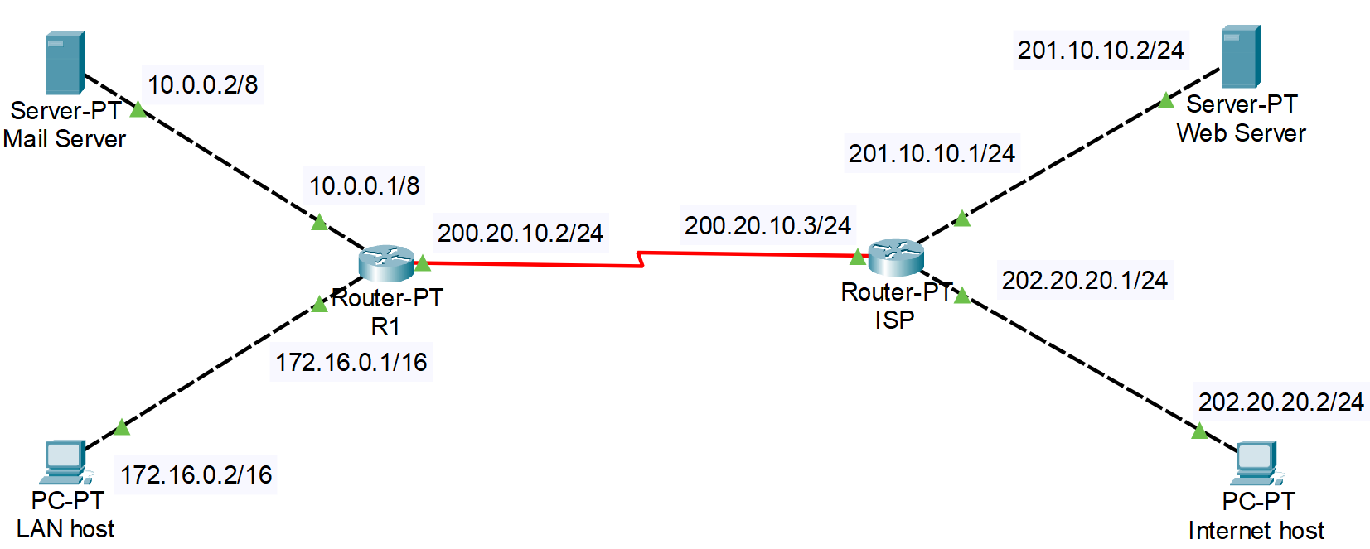
- Config IP address to all Routers’ interfaces and PCs. Show the results of each step:
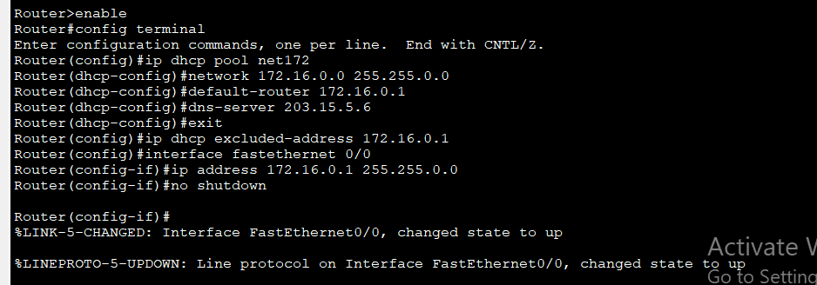
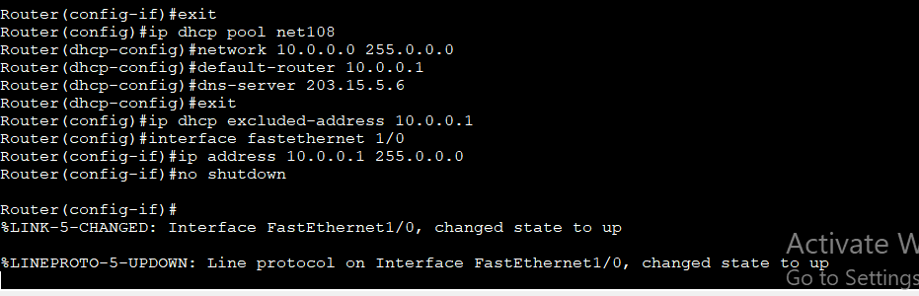
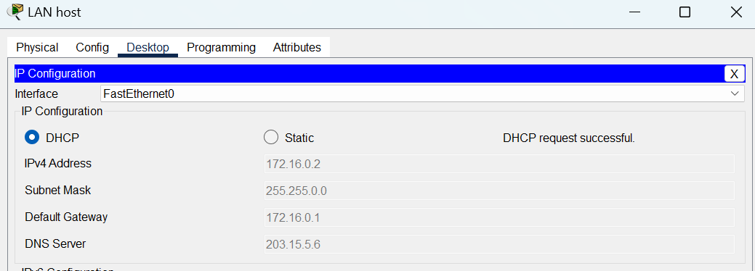
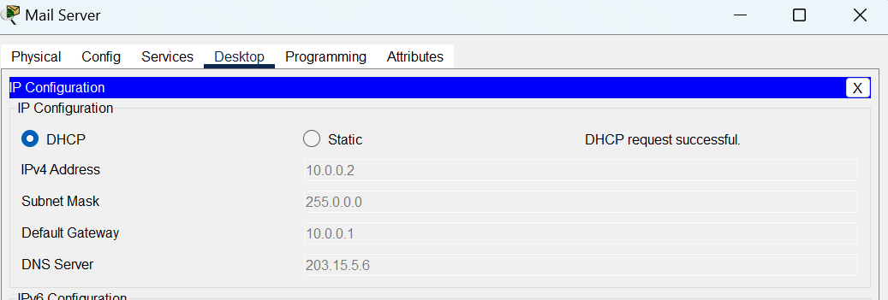
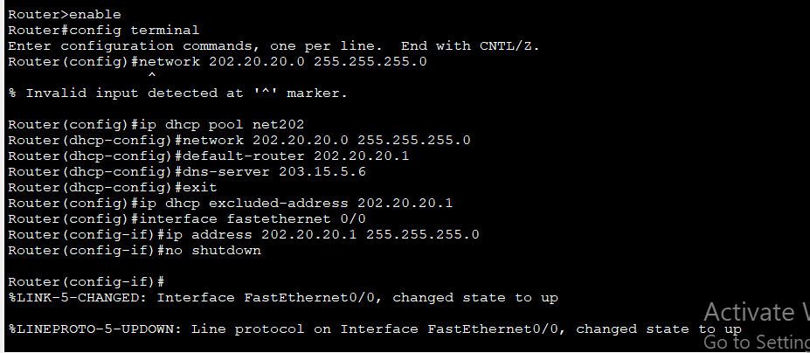
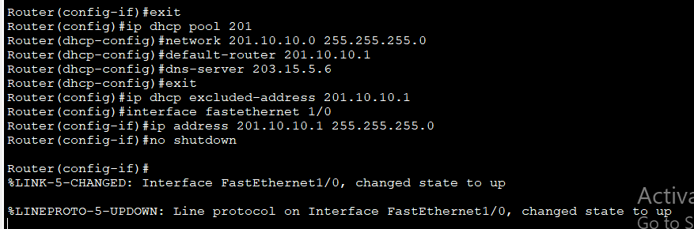
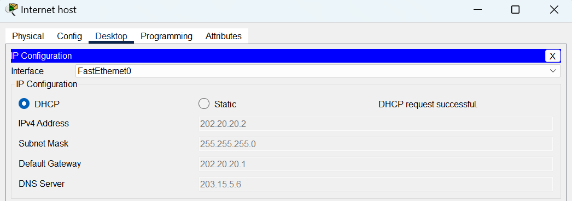
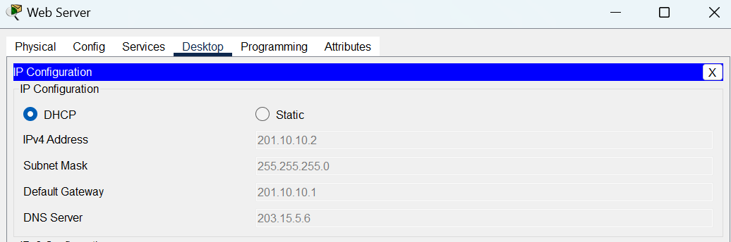
- Configure Routing protocols on 2 routers, so that all hosts and servers can ping to each other. Result:
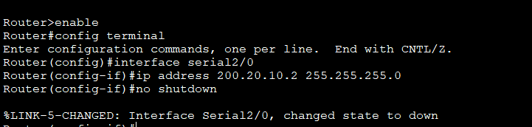
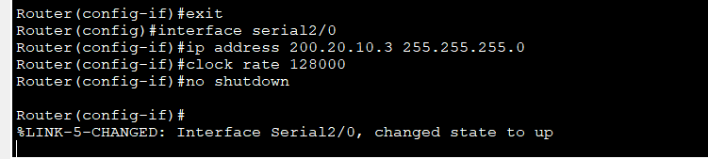
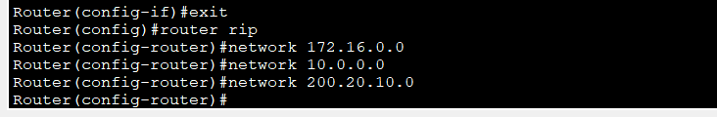
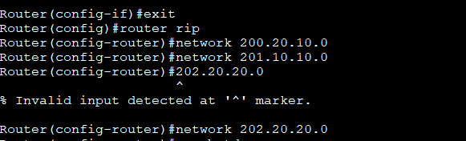
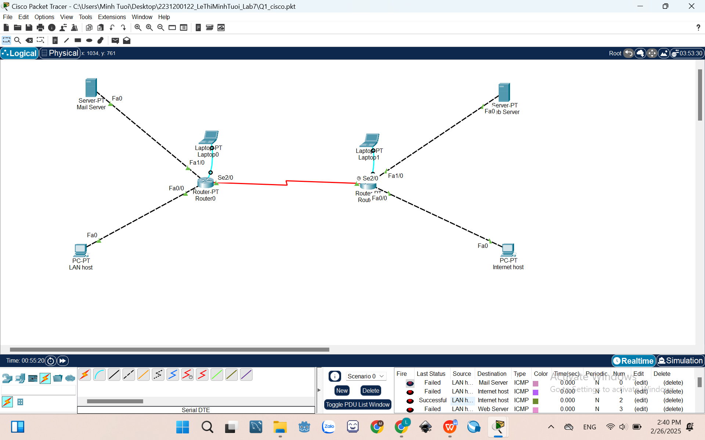
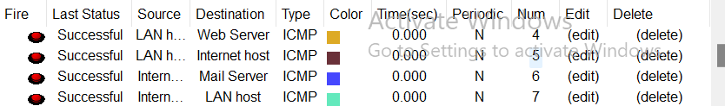
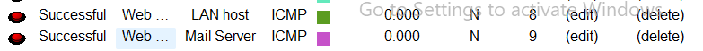
- Configure Access Control List on the Router R1 to ensure: LAN host CANNOT connect to other devices in the network.
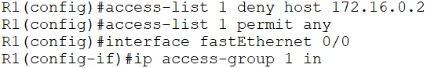
- Result:
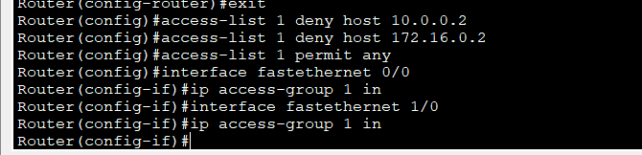
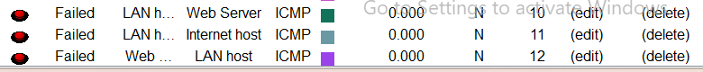
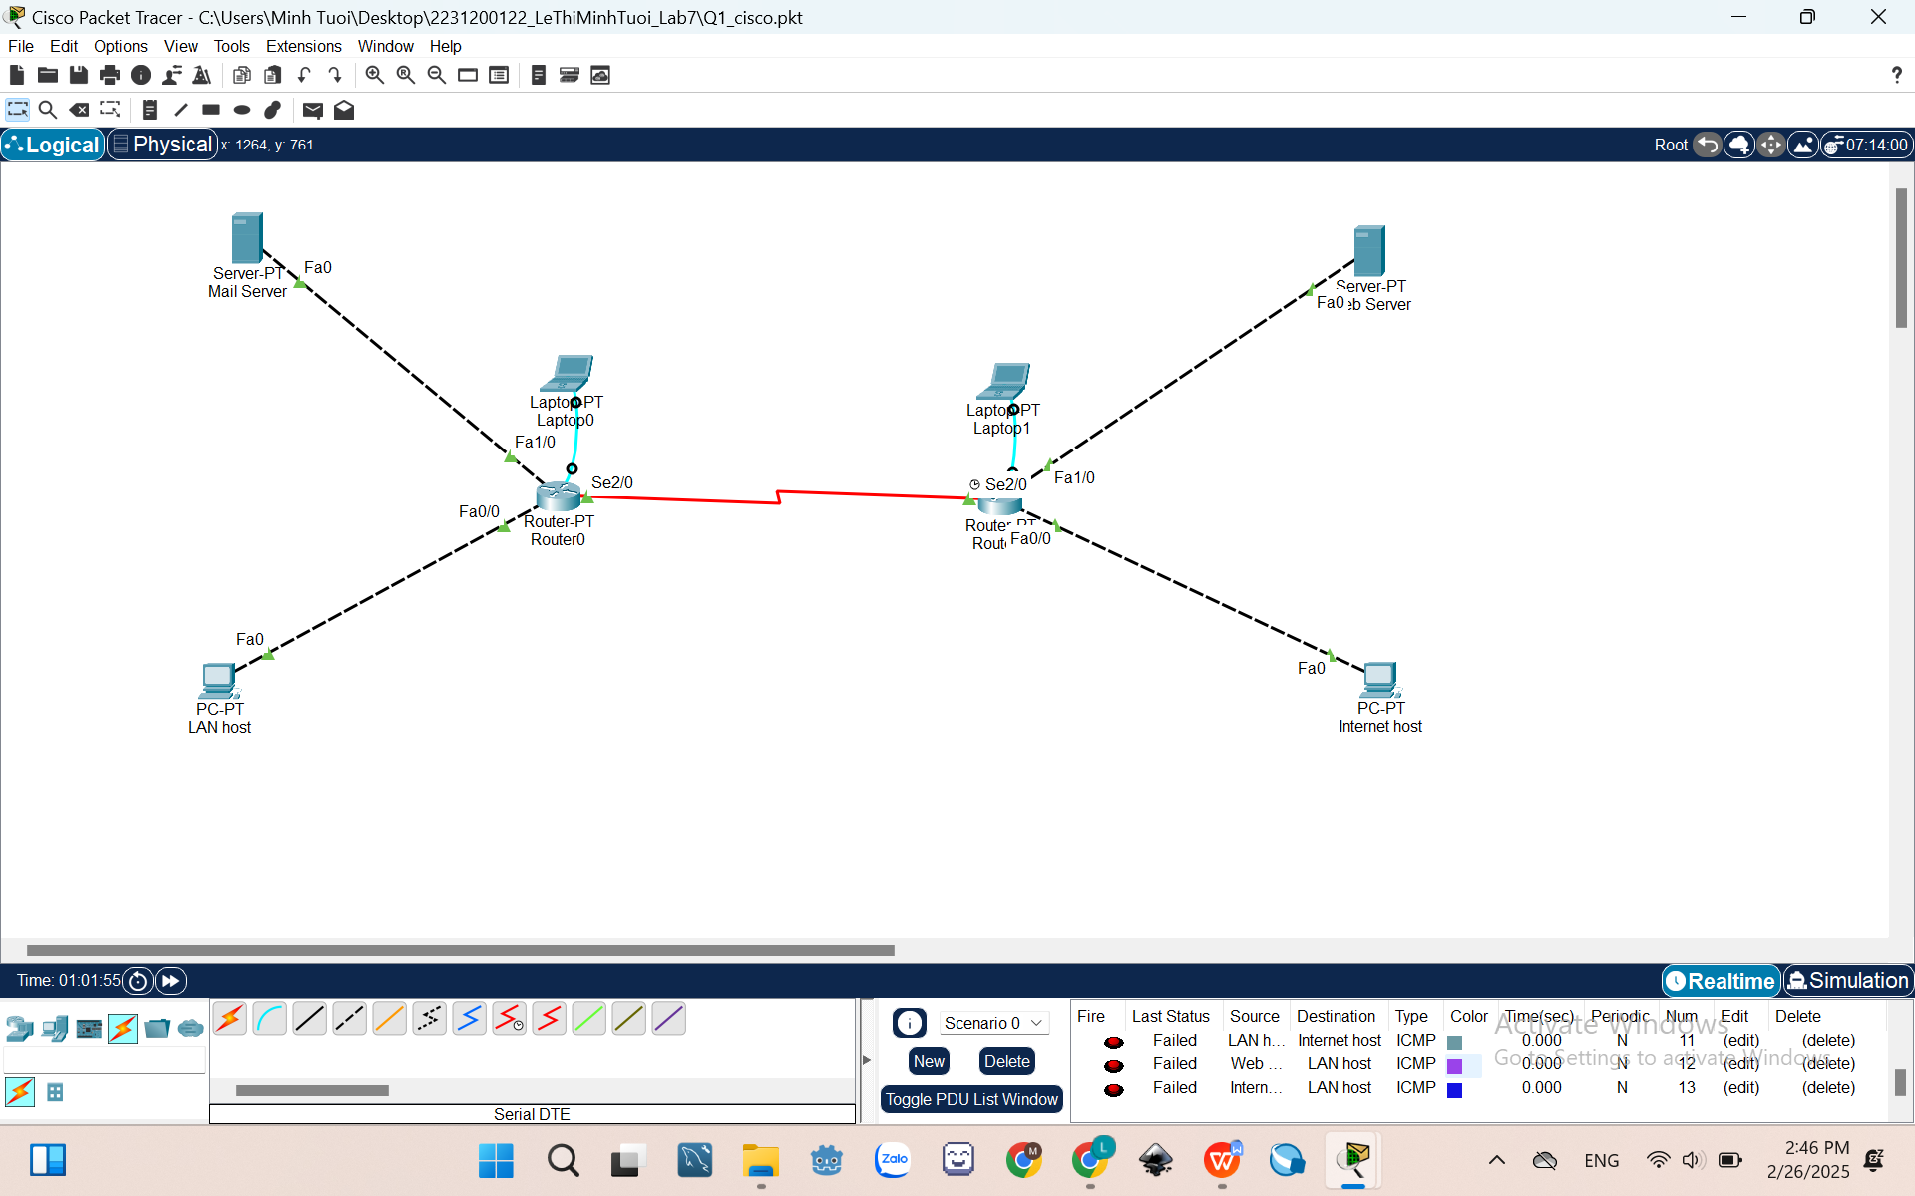
II.2. IPv6 Routing
Given a network as shown in the figure below.
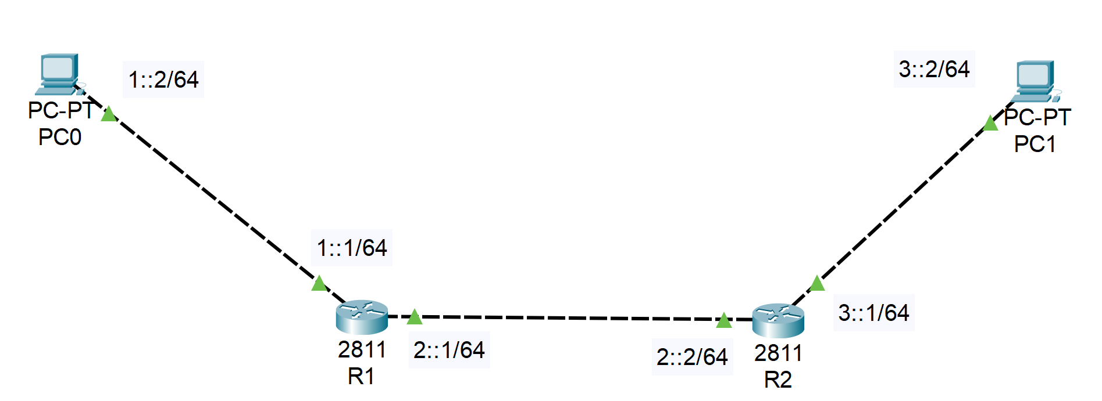
- On Router R1:
Router>enable
Router#config terminal
Router(config)#ipv6 unicast-routing
Router(config)#interface fastEthernet0/0
Router(config-if)#ipv6 address 1::1/64
Router(config-if)#no shut
Router(config-if)#exit
Router(config)#interface fastEthernet0/1
Router(config-if)#ipv6 address 2::1/64
Router(config-if)#no shut
Router(config-if)#exit
Router(config)#ipv6 route 3::/64 2::2

- On Router R2:
Router>enable
Router#config terminal
Router(config)#ipv6 unicast-routing
Router(config)#interface fastEthernet0/0
Router(config-if)#ipv6 address 3::1/64
Router(config-if)#no shut
Router(config-if)#exit
Router(config)#interface fastEthernet0/1
Router(config-if)#ipv6 address 2::2/64
Router(config-if)#no shut
Router(config-if)#exit
Router(config)#ipv6 route 1::/64 2::1

- Ping 2 PCs and show the result:
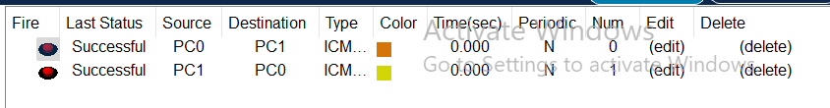
II.3. NAT
- Static NAT
Given a network as shown in the figure below.
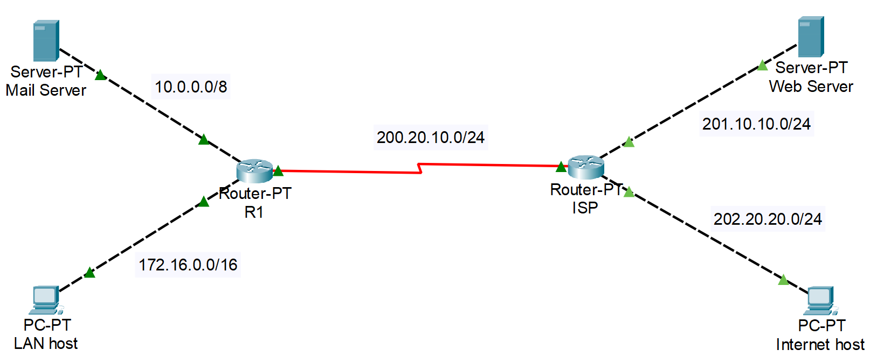
- Config IP address to Routers’ interfaces and PCs. Show the results of each step:
- Assume that Router R1 can use the public IP address range 199.99.9.0/24. Configure Static NAT on Router R1 to translate IP address of Mail Server to public IP address.
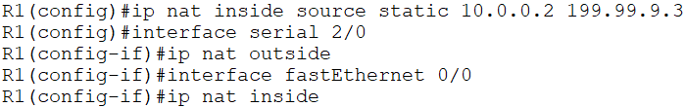
- Configure static routing on router ISP to the NAT address:
ISP(config)#ip route 199.99.9.0 255.255.255.0 200.20.10.2
- Configure default route on router R1:
R1(config)#ip route 0.0.0.0 0.0.0.0 200.20.10.3
- Can Mail Server ping to Web Server? Result:

- Check the IP NAT translation.
R1#show ip nat translations
- Result:
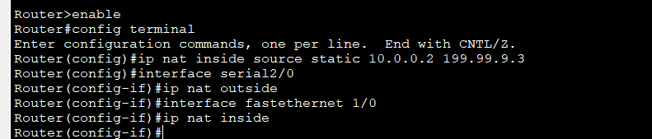
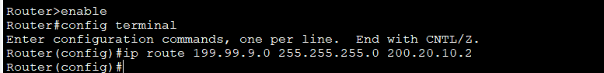
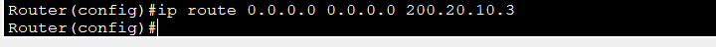
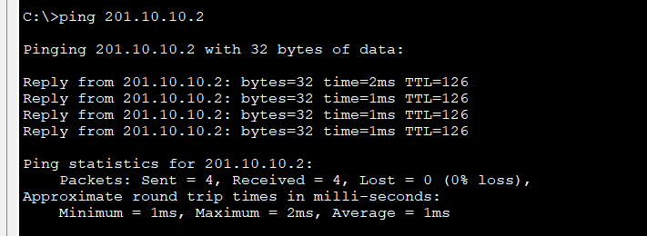
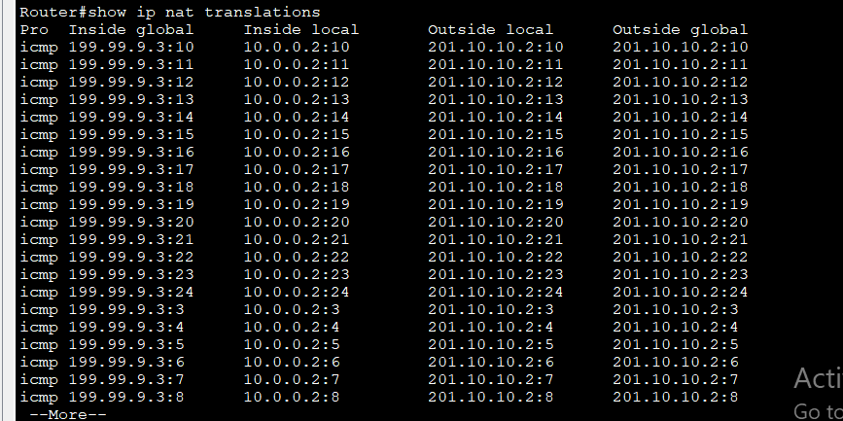
- Dynamic NAT
Given a network as shown in the figure below.
- Config IP address to Routers’ interfaces and PCs. Show the results of each step:
- Assume that Router R1 can use the IP address range my-pool (199.99.9.40 to 199.99.9.62/27). Configure Dynamic NAT on Router R1 to translate local IP address of Mail Server to my-pool.
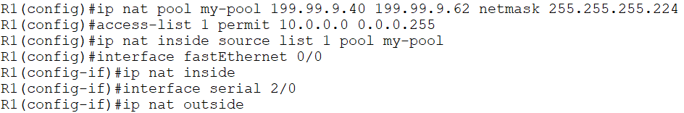
- Configure static routing on router ISP to the NAT address:
ISP(config)#ip route 199.99.9.32 255.255.255.224 200.20.10.2
- Configure default route on router R1:
R1(config)#ip route 0.0.0.0 0.0.0.0 200.20.10.3
- Can Mail Server ping to Web Server? Result:
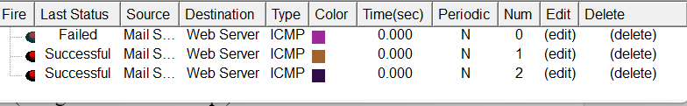
- Check the IP NAT translation.
R1#show ip nat translations
- Result:
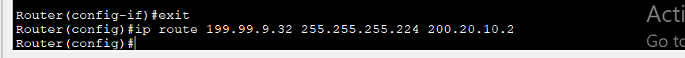
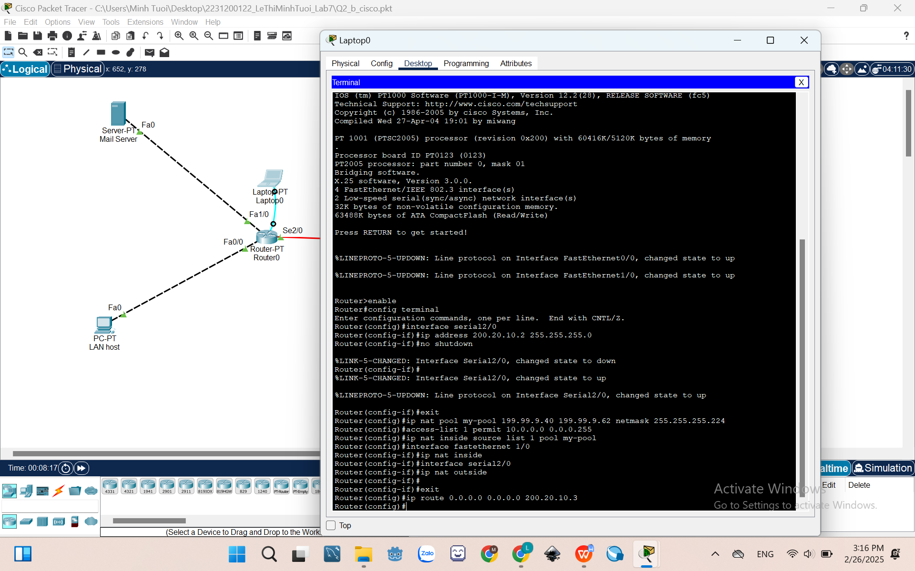
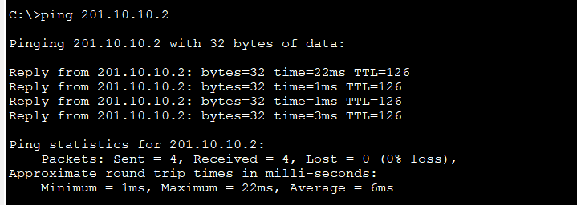
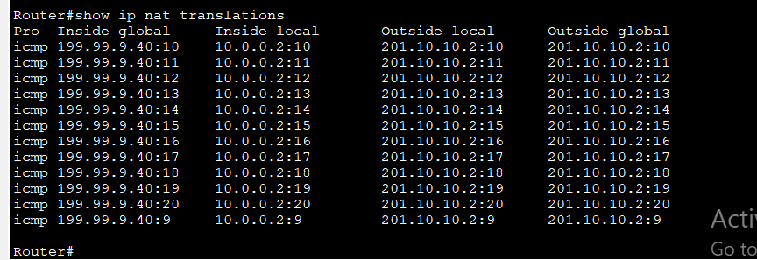
- PAT (NAT Overloading)
Given a network as shown in the figure below.
- Config IP address to Routers’ interfaces and PCs. Show the results of each step:
- Configure PAT on Router R1 to translate local IP address of Mail Server.
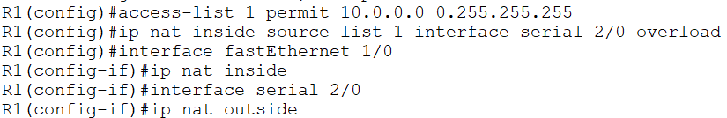
- Configure default route on router R1:
R1(config)#ip route 0.0.0.0 0.0.0.0 200.20.10.3
- Can Mail Server ping to Web Server (using Command Prompt)? Result:
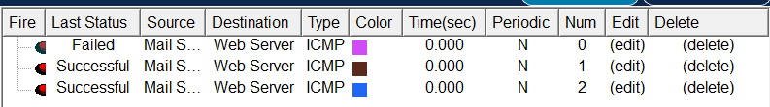
- Check the IP NAT translation.
R1#show ip nat translations
- Result:
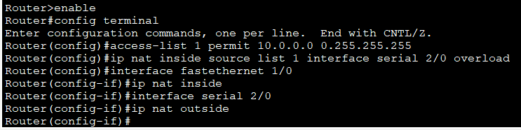
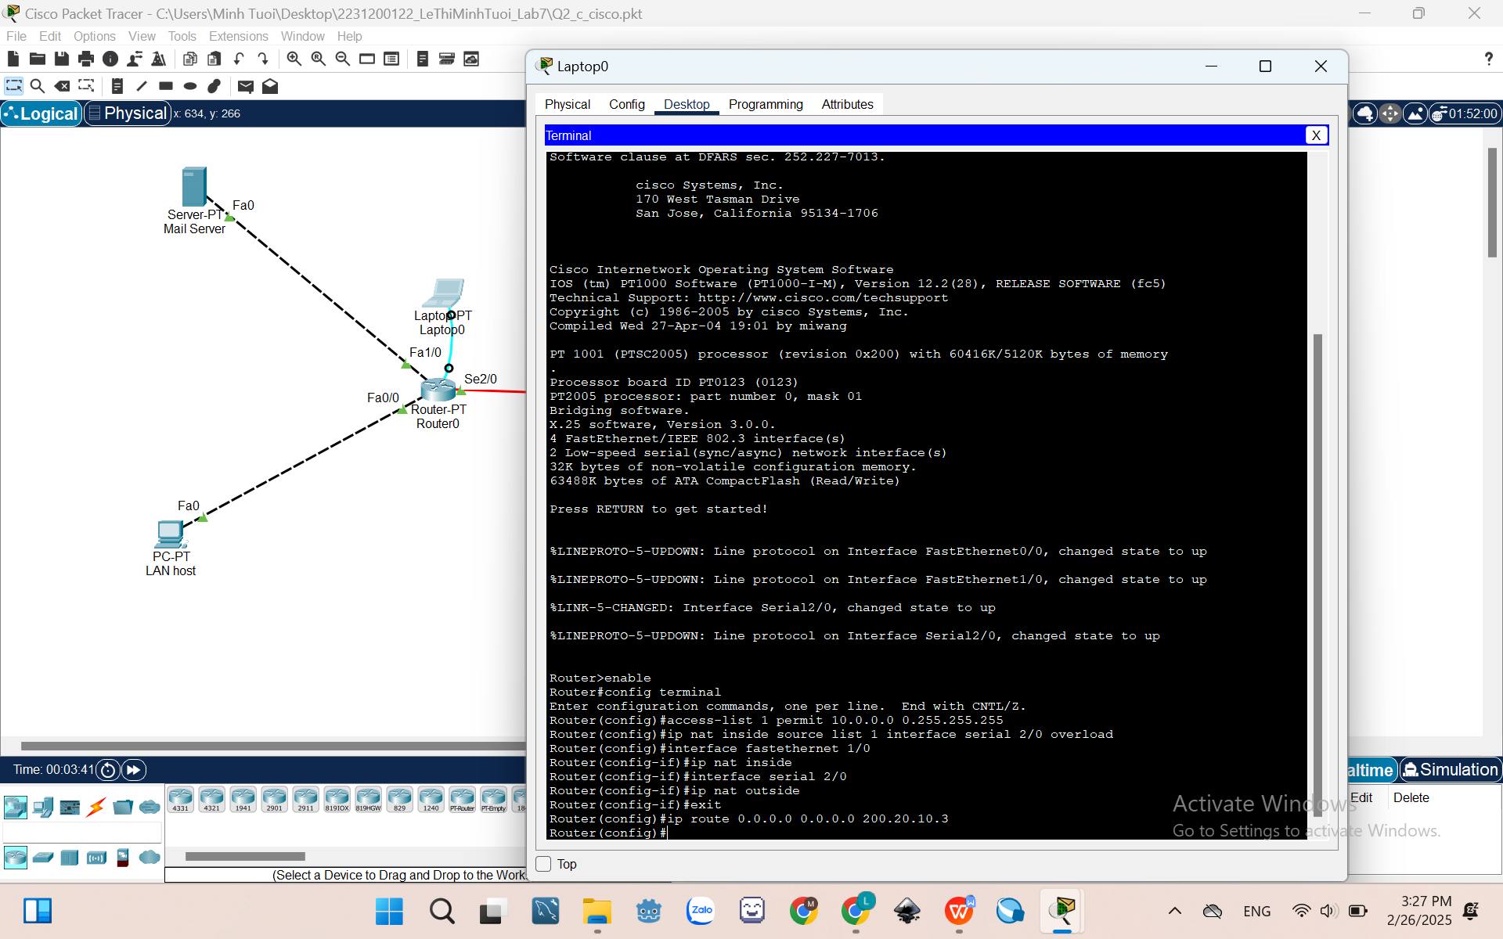
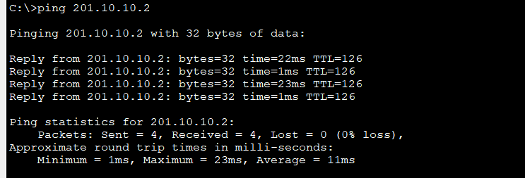
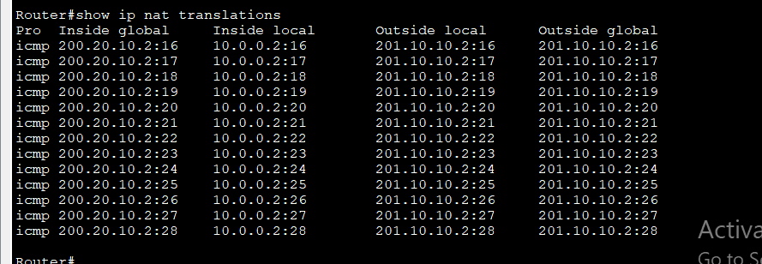
II.4. FileZilla Configuration
- Download and install FileZilla Server and FileZilla Client:
- Download FileZilla Server:
https://filezilla-project.org/download.php?platform=win64&type=server
- Download FileZilla Client:
https://filezilla-project.org/download.php?platform=win64
- Install and Configure FileZilla Server:
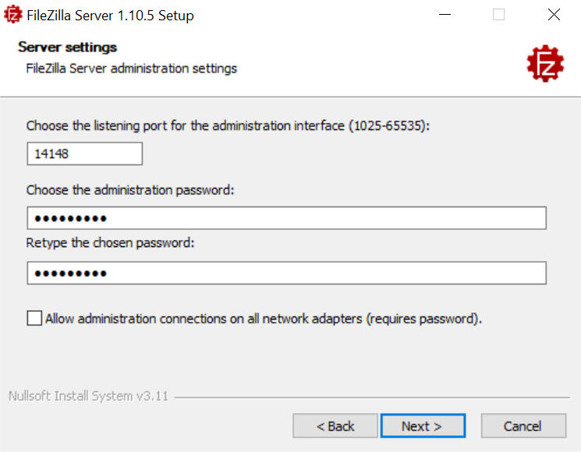
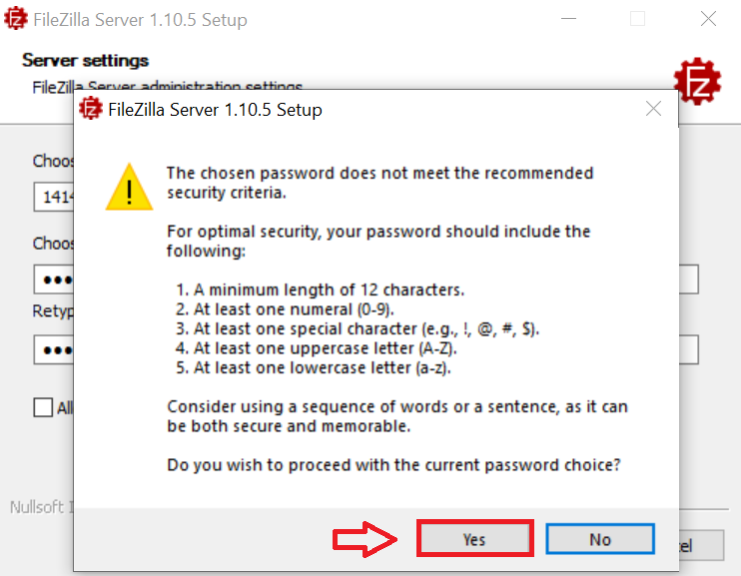
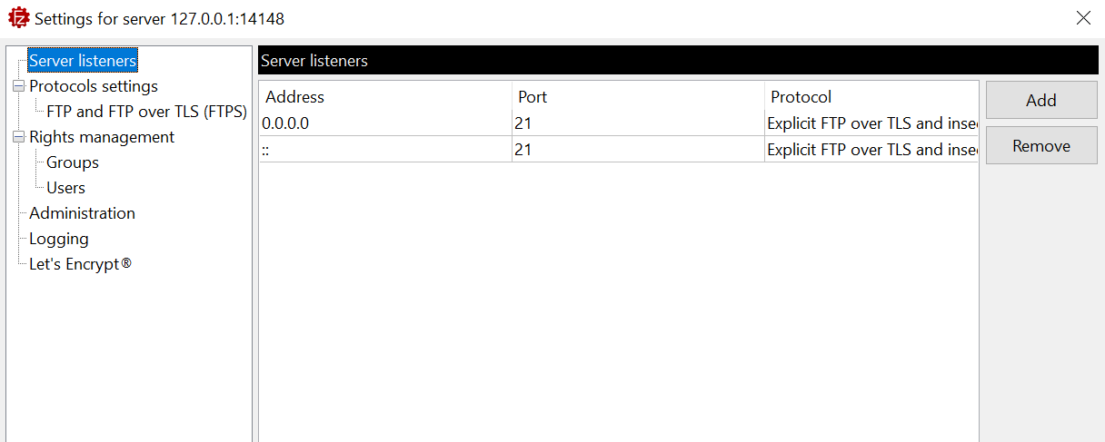
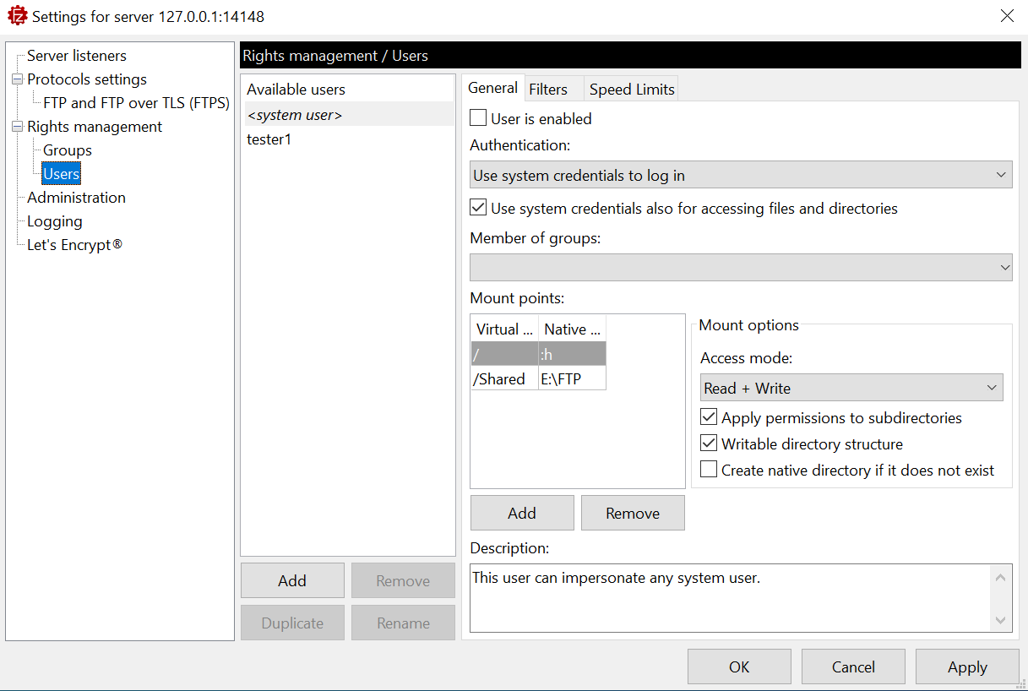
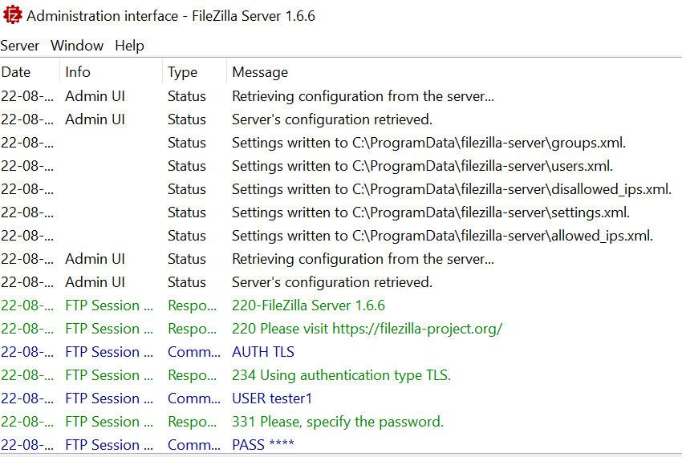
- Accessing to FileZilla Server using FileZilla Client:
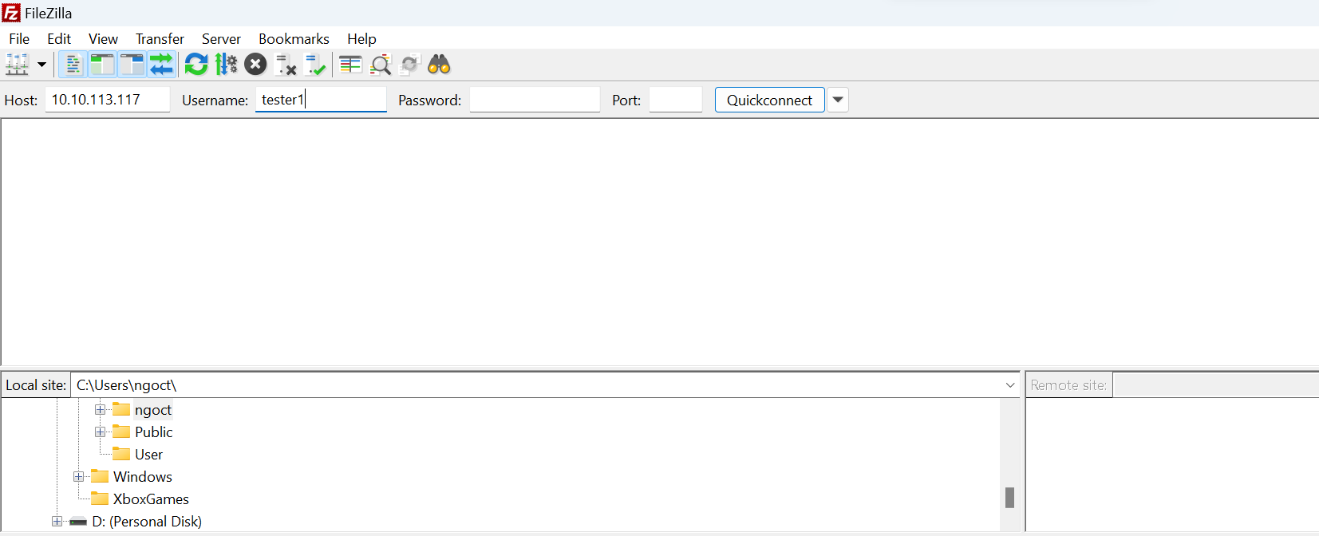
- Your result:
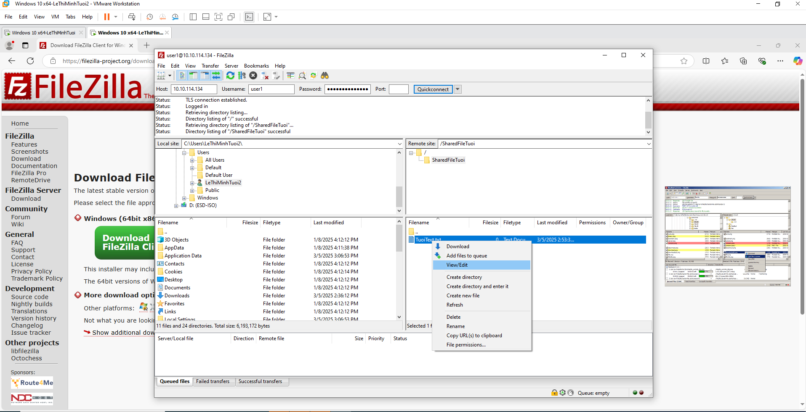
II.5. Wireshark
a) Wireshark Installation
- Follow the instructions to install Wireshark at: https://www.wireshark.org/
b) Using Wireshark
- To start to capture packets: At the main window, double-click on the Interface you want to capture the network traffic.
c) Wireshark Practice
- Start up the Wireshark packet sniffer
- Enter the following URL into your browser: http://gaia.cs.umass.edu/wireshark-labs/protected_pages/HTTP-wireshark-file5.html
OR: http://testphp.vulnweb.com/login.php
- Input the username and password. Then, click Sign in.
- Stop Wireshark packet capture and enter “http” in the display-filter-specification window, so that only captured HTTP messages will be displayed in the packet-listing window.
- Question 1: Find the credential (username, password) in the HTTP message.
Answer:
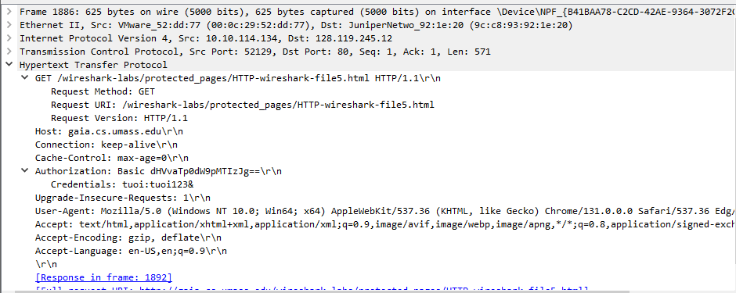
- Question 2: What is the server’s response (status code and phrase) in response to the initial HTTP GET message from your browser?
Answer:
d) Address Resolution Protocol
- Display the contents of the ARP cache on your computer using the command “arp –a”. What is the result of this command?
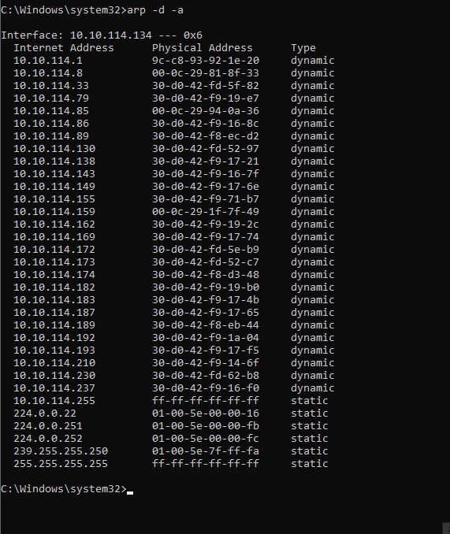
- Clear your ARP cache using the command “arp –d *” (make sure to open Command prompt using Administration privillege) and make sure your browser’s cache is cleared of previously downloaded documents. What is the result?
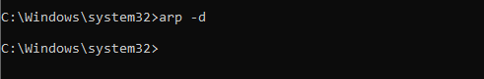
- Start the Wireshark packet sniffer.
- Enter the following URL into your browser: http://gaia.cs.umass.edu/wireshark-labs/HTTP-wireshark-lab-file3.html
- Your browser should again display the rather lengthy US Bill of Rights.
- Stop Wireshark packet capture
- Question 1: What is the hexadecimal value of the source address in the Ethernet frame containing the ARP request message sent out by your computer?
Answer:
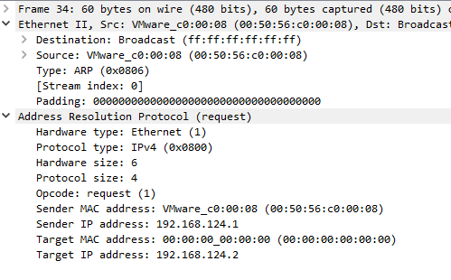
- Question 2: What is the hexadecimal value of the destination addresses in the Ethernet frame containing the ARP request message sent out by your computer?
Answer:

