Course: CSE 204 – Computer Networks
LAB 3 – File Sharing & Cisco Packet Tracer
Due date: November 8th, 2025

Student name | Phan Ngọc Hạnh Nhi
Student ID | 2131209002

Goal
- Understanding Windows File Sharing
- Understanding Cisco Packet Tracer

Assignment list
II.1 Basic File Sharing on Windows
Firstly, set the IP addresses of 2 PCs as follows: 192.168.1.x/24, 192.168.1.y/24
- Setup File Sharing
- First, open File Explorer on Windows and right-click on the folder you want to share. Then, choose Properties
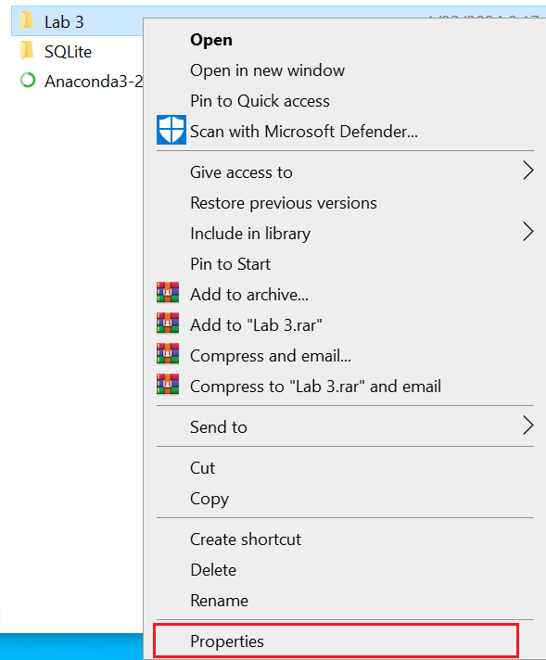
- Choose tab Sharing, and click button “Share…”

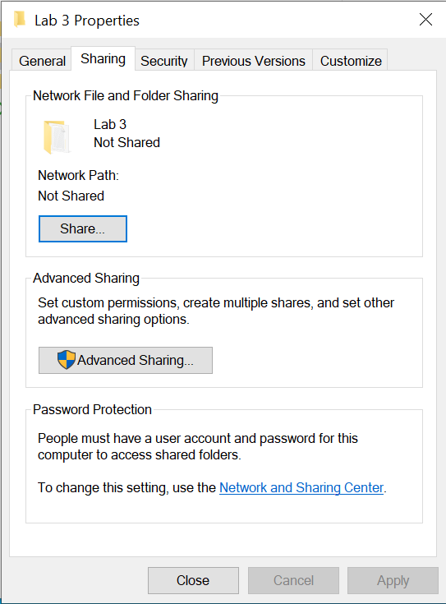
- In this step, we need to choose who we want to share the folder. Click on the dropdown button to choose the user, then click Add.
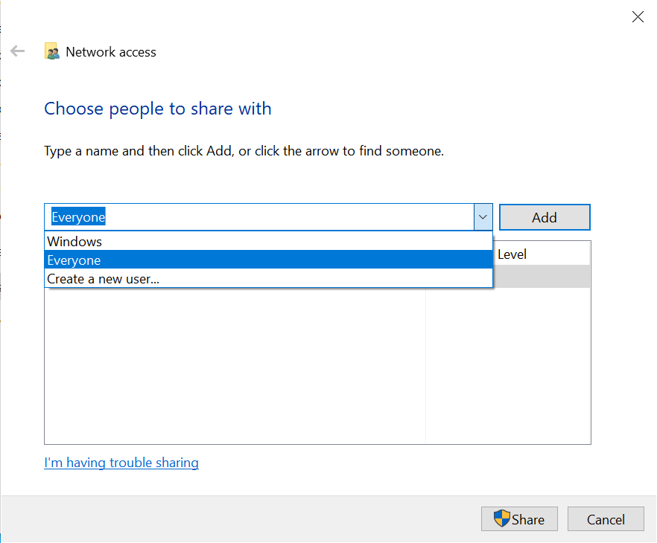
- After that, we need to set the permissions for the user we want to share. There are 2 options: Read OR Read/Write.
  - Read means user can only open the folder and the files inside it.
  - Read/Write means user can open or modify the content or delete the folder and the files inside.
- Finally, click Share.
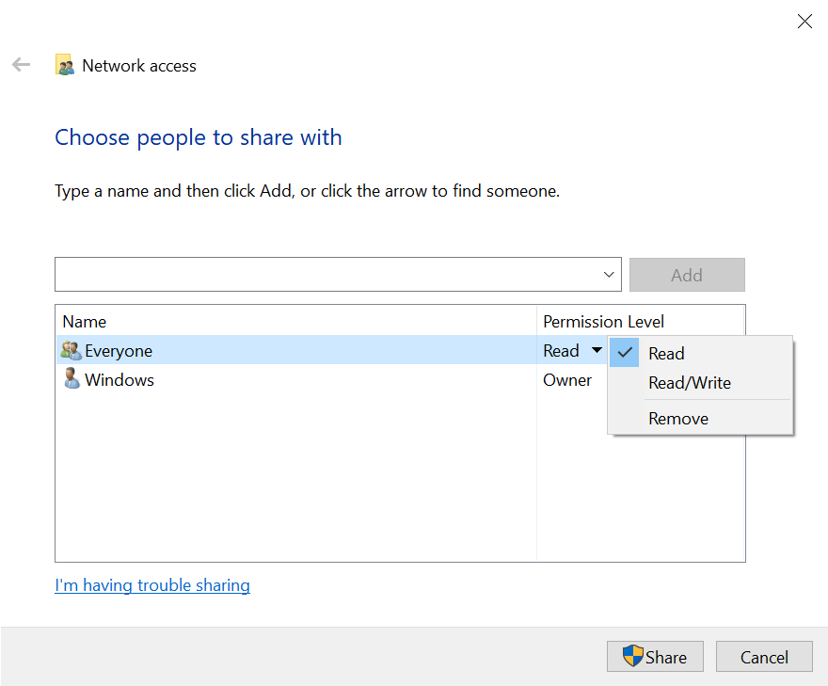
- Access to Shared files
- On the client computer, open File Explorer. O n the Address bar, type the address of the host computer, use the following syntax “\\IP-address”.
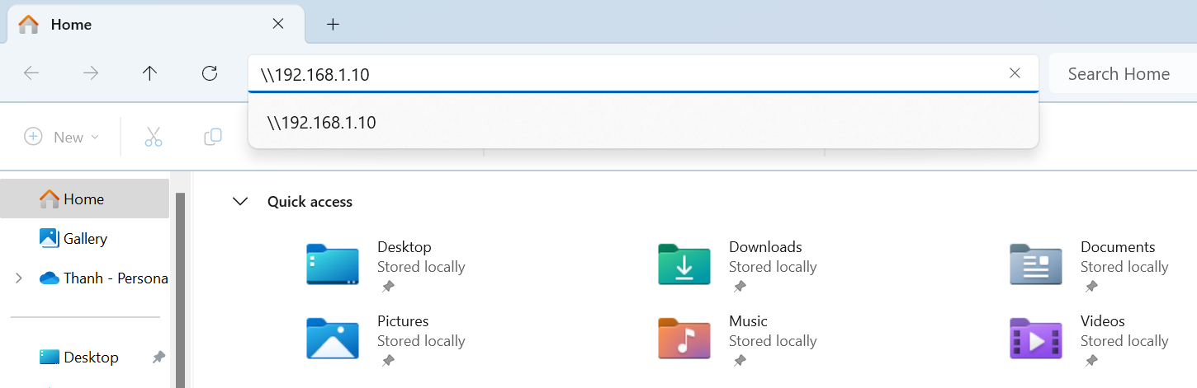
- Then, input the credentials (User name, Password).
Note: Do not check “Remember my credentials”
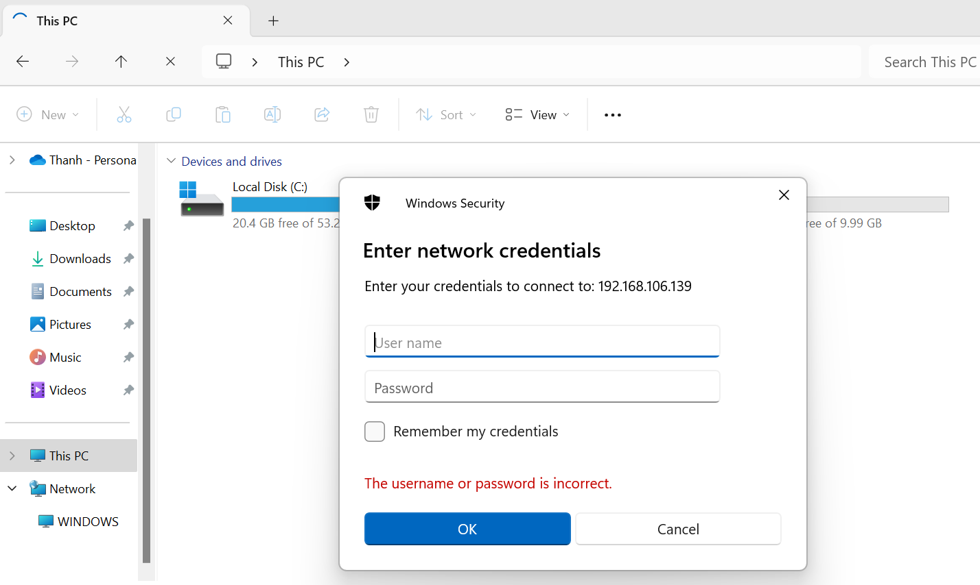
- Show your result here:
- PC 1:
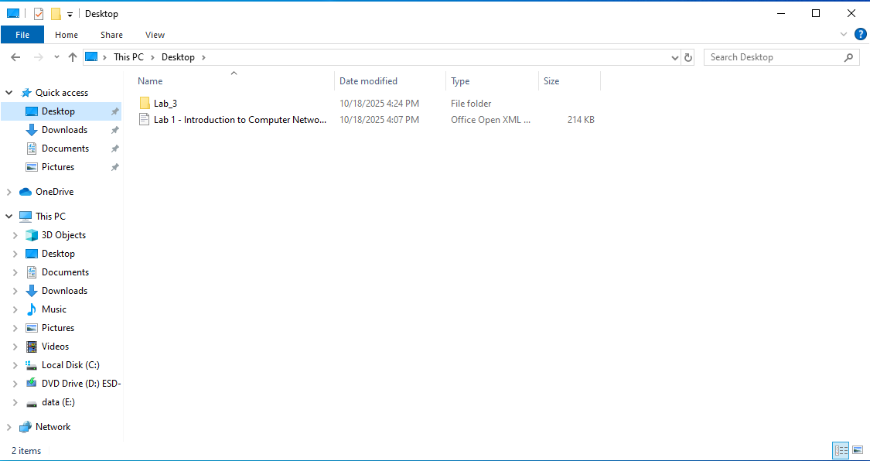
- PC 2:
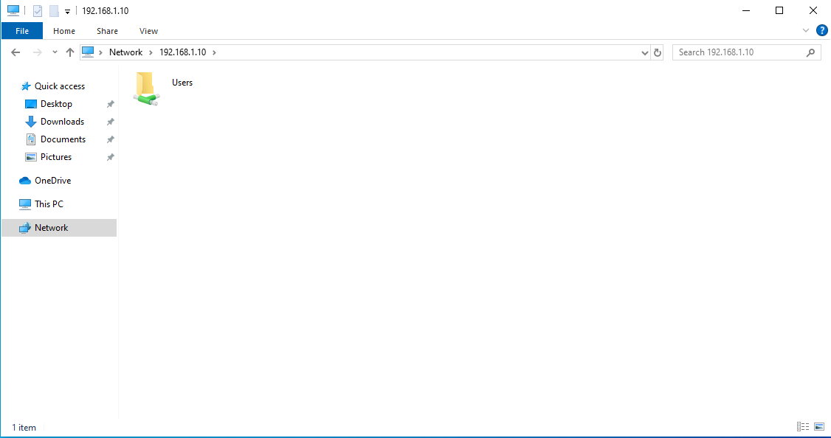
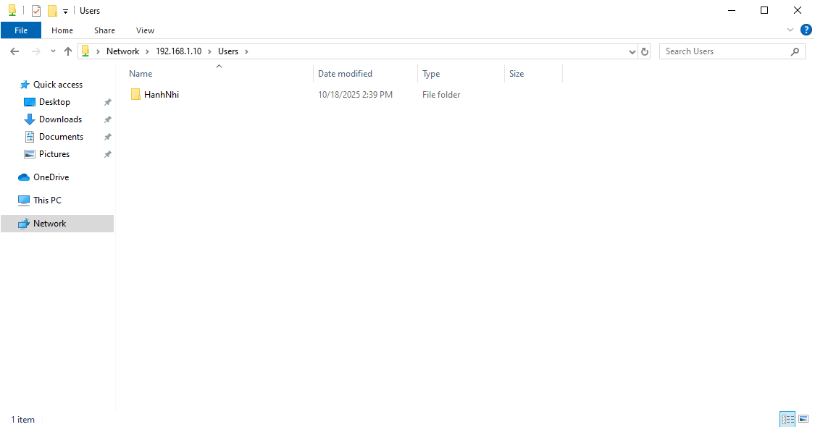
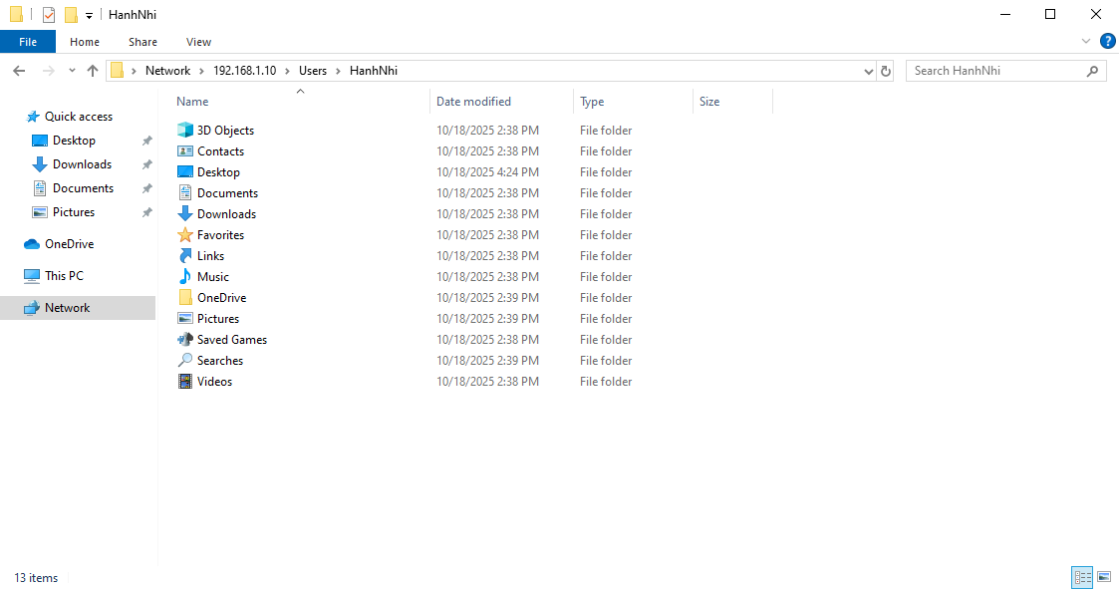
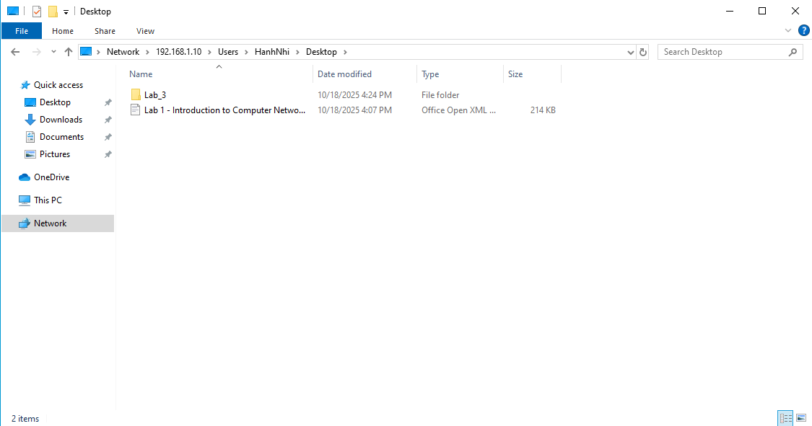
II.2 Advanced File Sharing on Windows
Keep the IP addresses of 2 PCs the same as in previous assignment: 192.168.1.x/24, 192.168.1.y/24
- Create 2 new user accounts
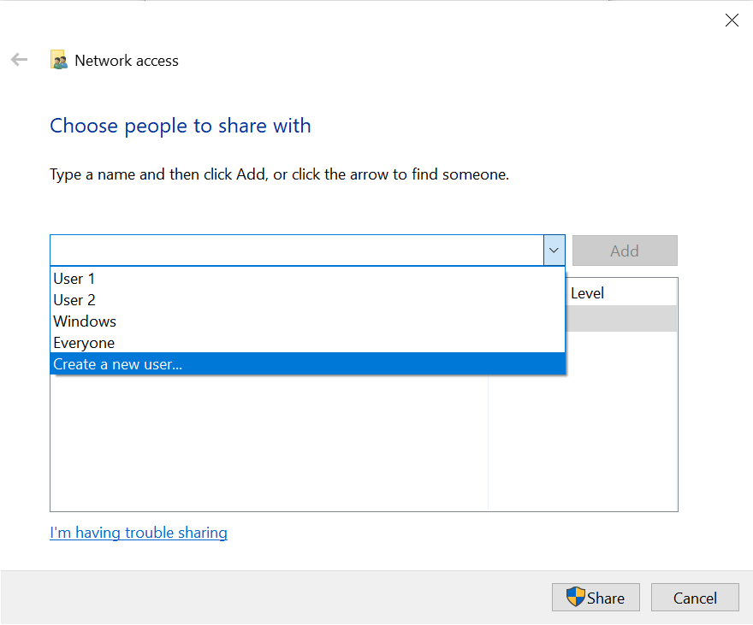
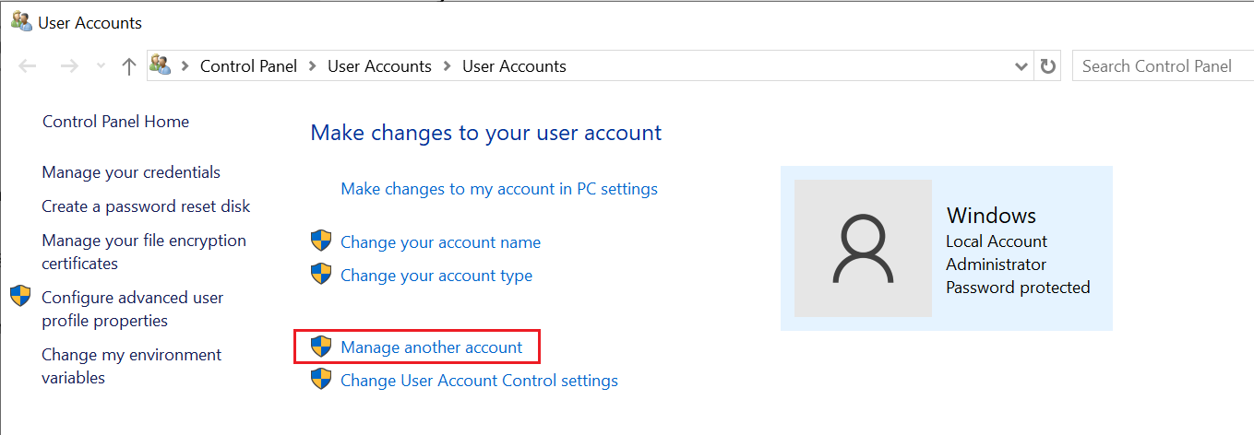
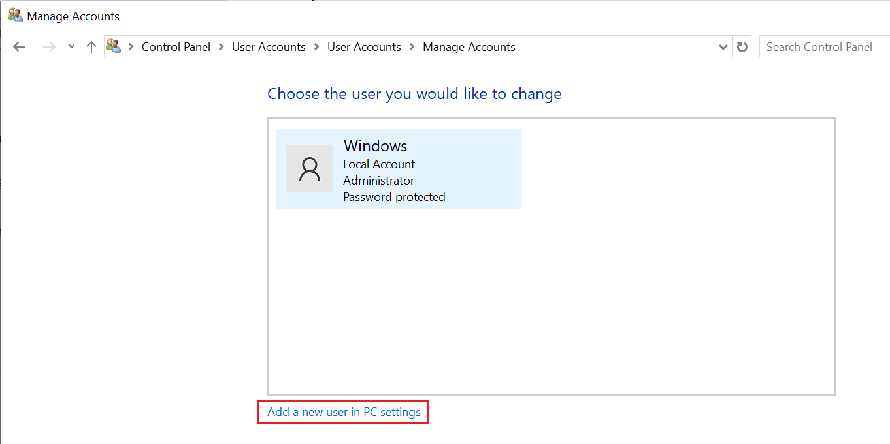
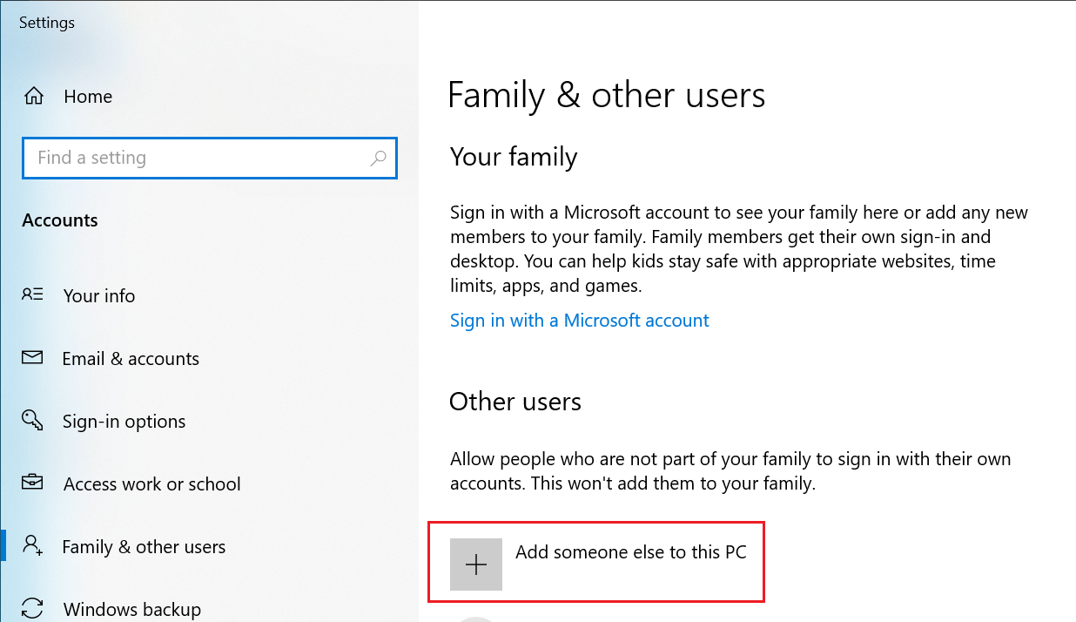

Note: All account names MUST be unique.
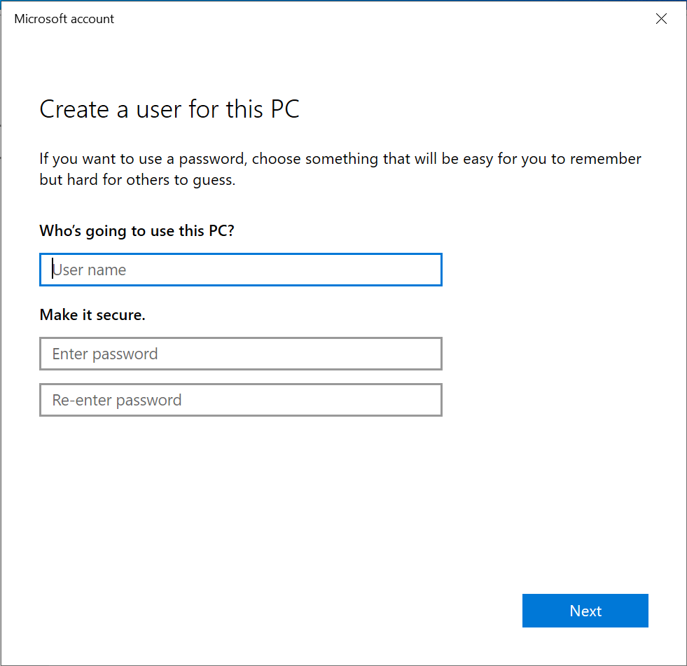
- Setup File Sharing
- Repeat the first step as in previous assignment. Set default permission for 2 users, then click Share
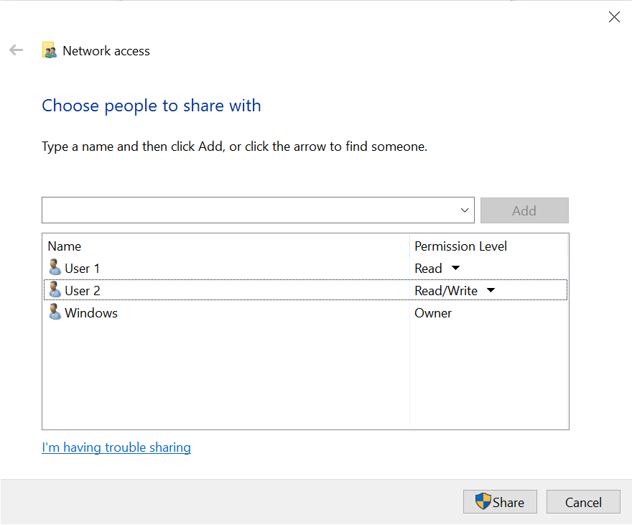
- Go back to the shared folder, right click on it and choose Properties. Switch to Sharing tab and click on Advanced Sharing…

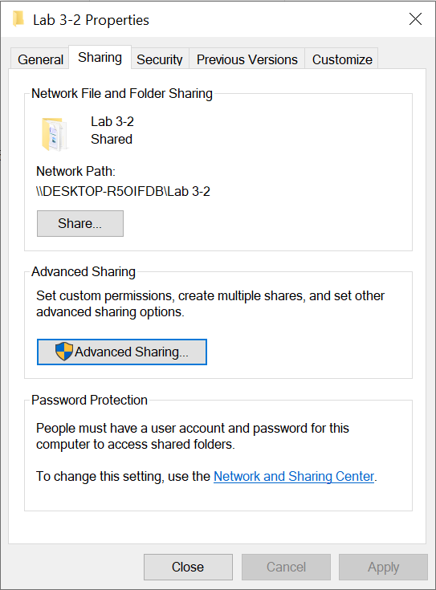
- After that, click Permissions
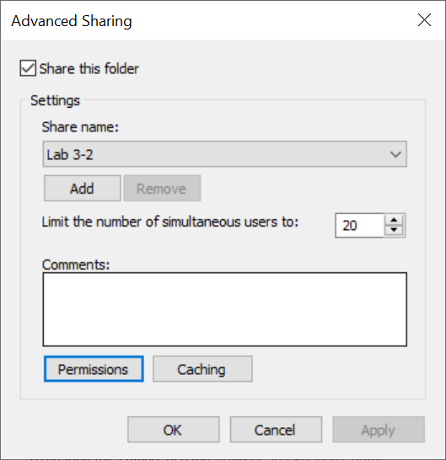
- Enter the username (e.g: User 1, User 2) and click Check Names to make sure the username is correct. Then, click OK
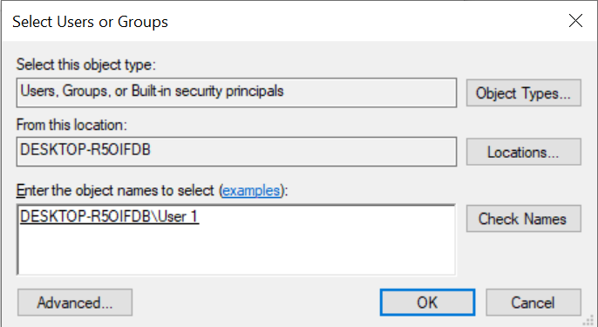
- Then, in the Permissions for User 1 section, set Deny to all permissions.
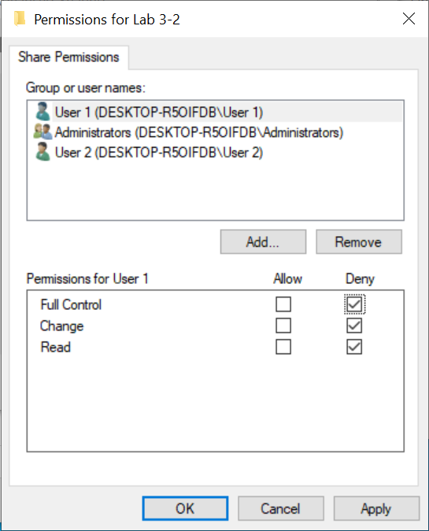
- Repeat the same steps for User 2 but in the section Permissions for User 2, set Allow to all permissions.

- Access to Shared files
Note: If you want to log in using another account, click on Windows button, sign out from current account and sign in again
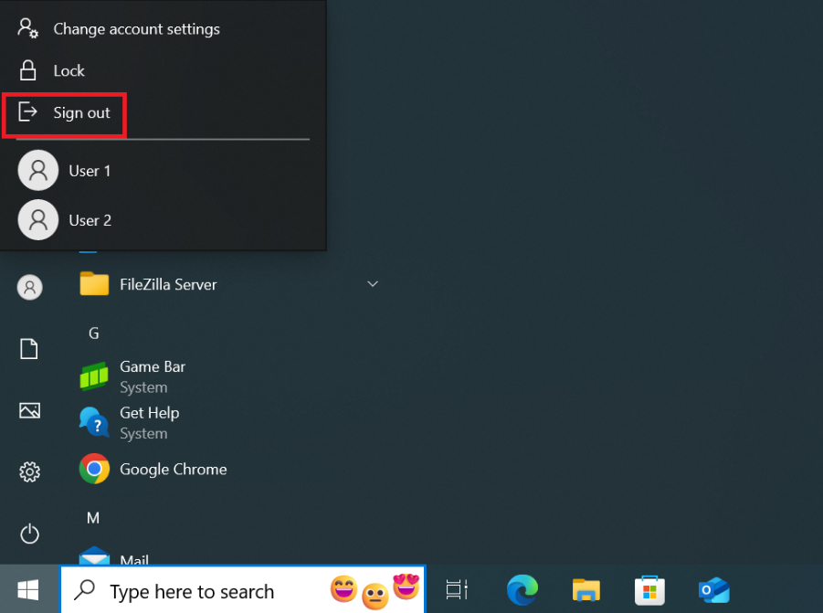
- On the client computer, open File Explorer. On the Address bar, type the address of the host computer, use the following syntax “\\IP-address”. Then enter the credentials for the user you want to log in.
- Result when access to the shared folder using User 1:
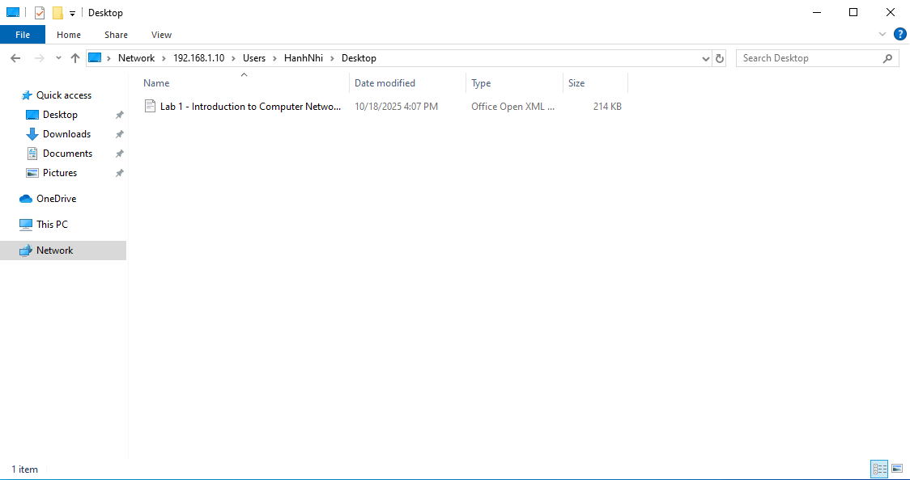
- Result when access to the shared folder using User 2:
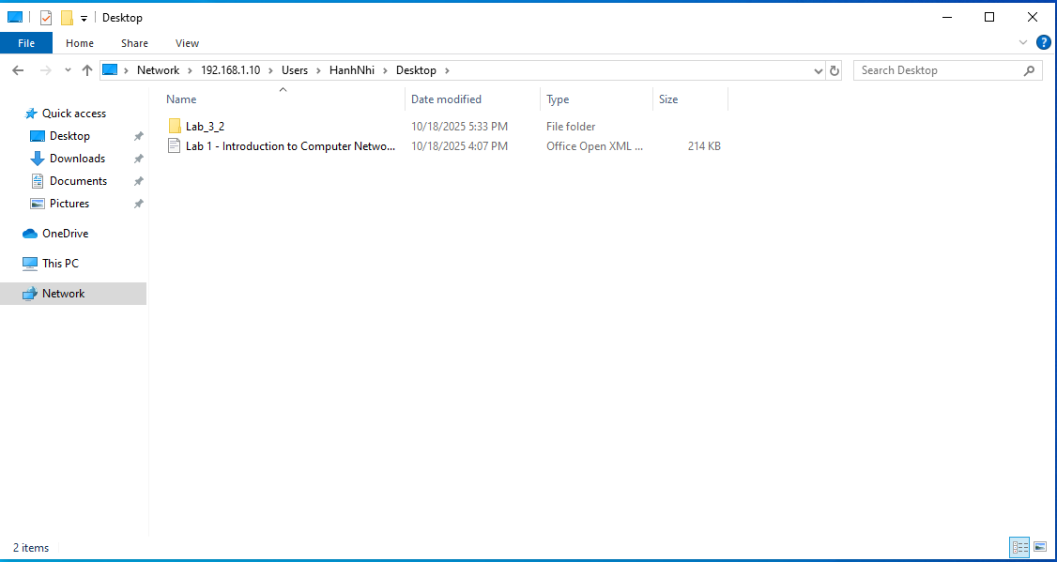
II.3 Advanced File Sharing on Windows (Part 2)
- Setup File Sharing
  - Firstly, go back to the shared folder permissions setting and set Allow to all permission for User 1.
- On host computer, go to the shared folder and create 2 text files “LAB 3.2.1 - Advanced” and “LAB 3.2.2 – Advanced 2”.
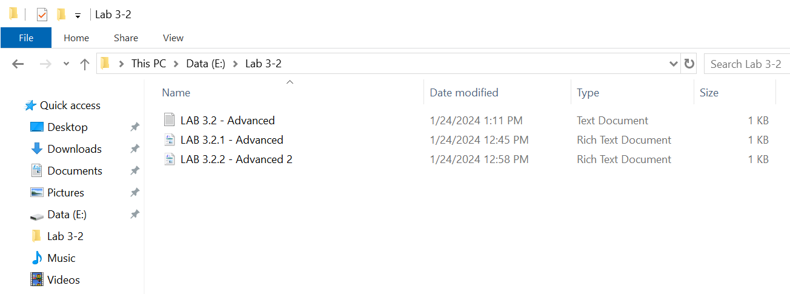
  - First, right-click on file “LAB 3.2.1 - Advanced”. Go to Security tab and click Edit button.
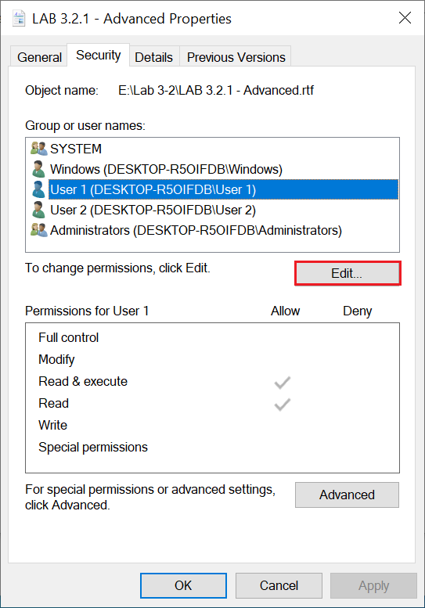
  - Set Allow to Full control for User 1. Then click OK.
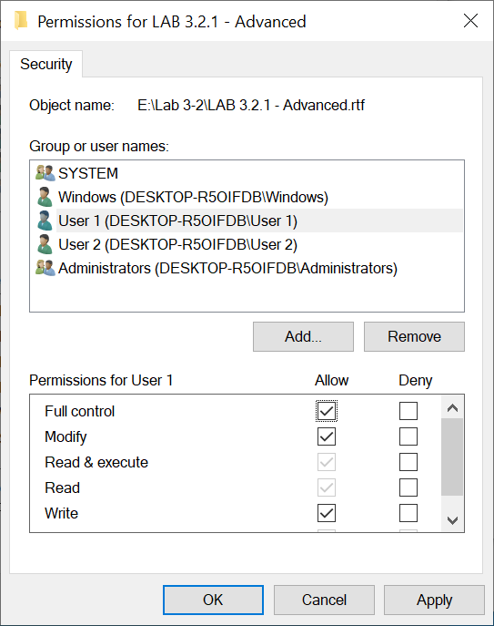
  - Switch to User 2 and set Deny to Full control. Then, click OK.
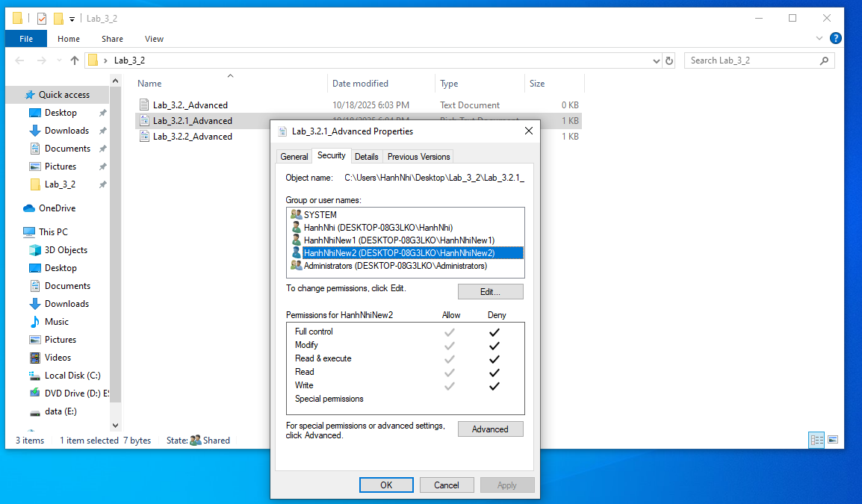
  - Now, repeat the same steps for file “LAB 3.2.2 – Advanced 2” so that User 1 can ONLY READ this file while User 2 has FULL ACCESS to it. Show the results (screenshots) below.
  - User 1
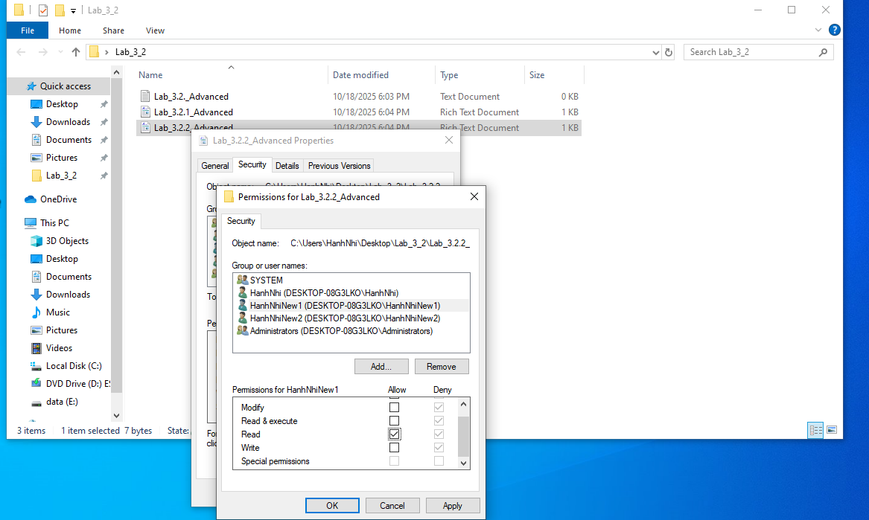
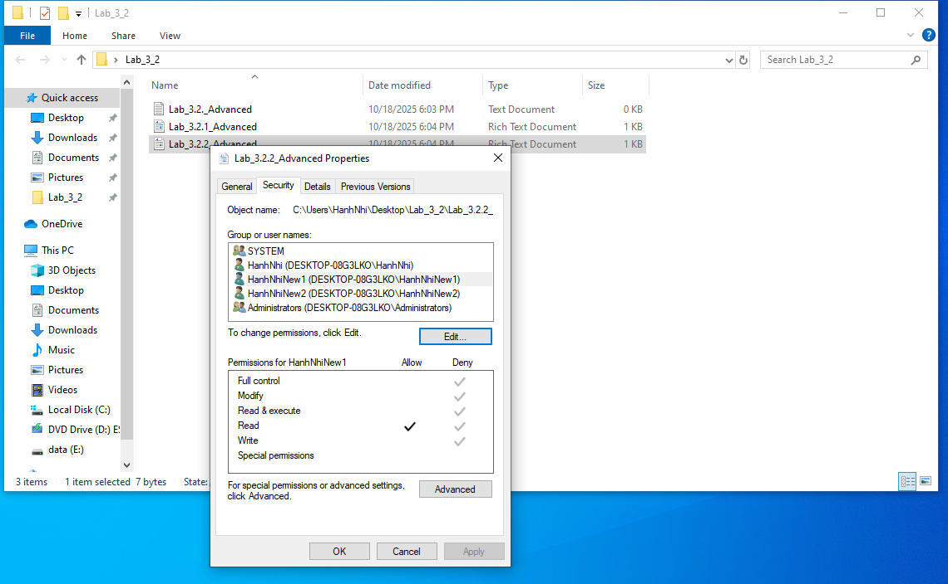
User 2
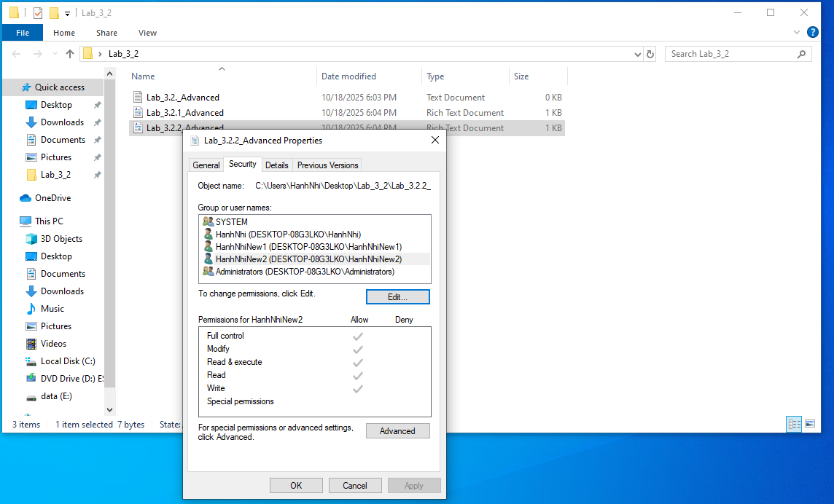
- Access to Shared files
- On the client computer, open File Explorer. On the Address bar, type the address of the host computer, use the following syntax “\\IP-address”. Then enter the credentials for the user you want log in.
Note: If you want to log in using another account, click on Windows button, sign out from current account and sign in again
- Result when access to the shared folder using User 1 (note that User 1 has full access to file “LAB 3.2.1 - Advanced” but has Read-only access to file “LAB 3.2.2 – Advanced 2”):
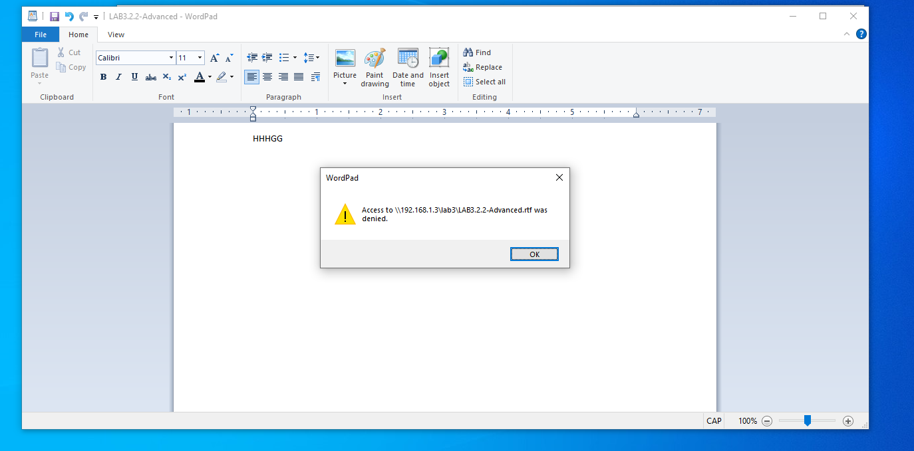
- Result when access to the shared folder using User 2 (note that User 2 has full access to file “LAB 3.2.2 – Advanced 2” but doesn’t have access to file “LAB 3.2.1 – Advanced”):

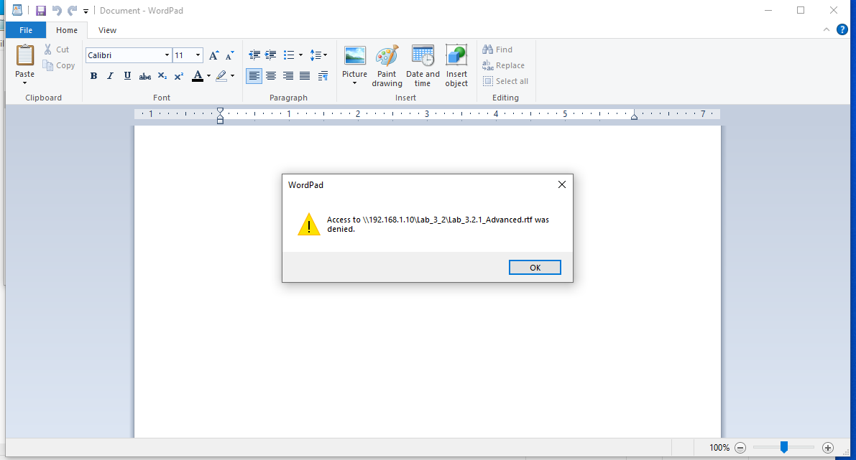

II.4 Advanced File Sharing on Windows (cont.)
Set the IP addresses of 2 PCs the same as follow:
- Host: 192.168.1.x/24
- Guest: 192.168.10.y/24
Repeat the same steps as in Assignment II.1. Show the results of each step and explain the results.
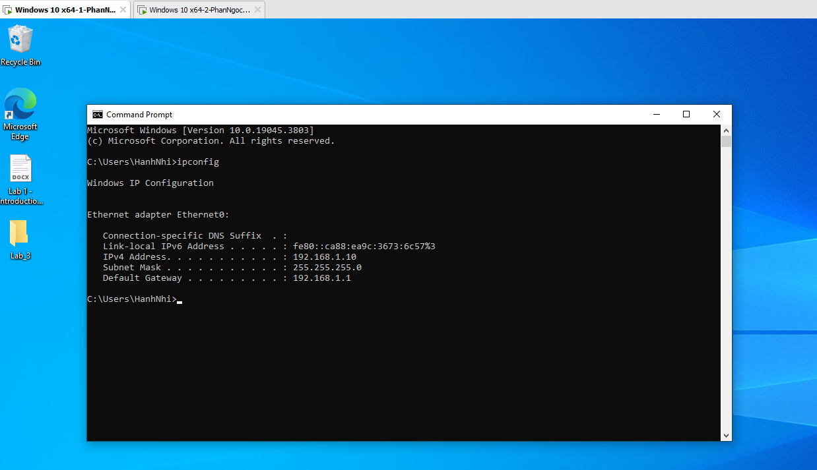
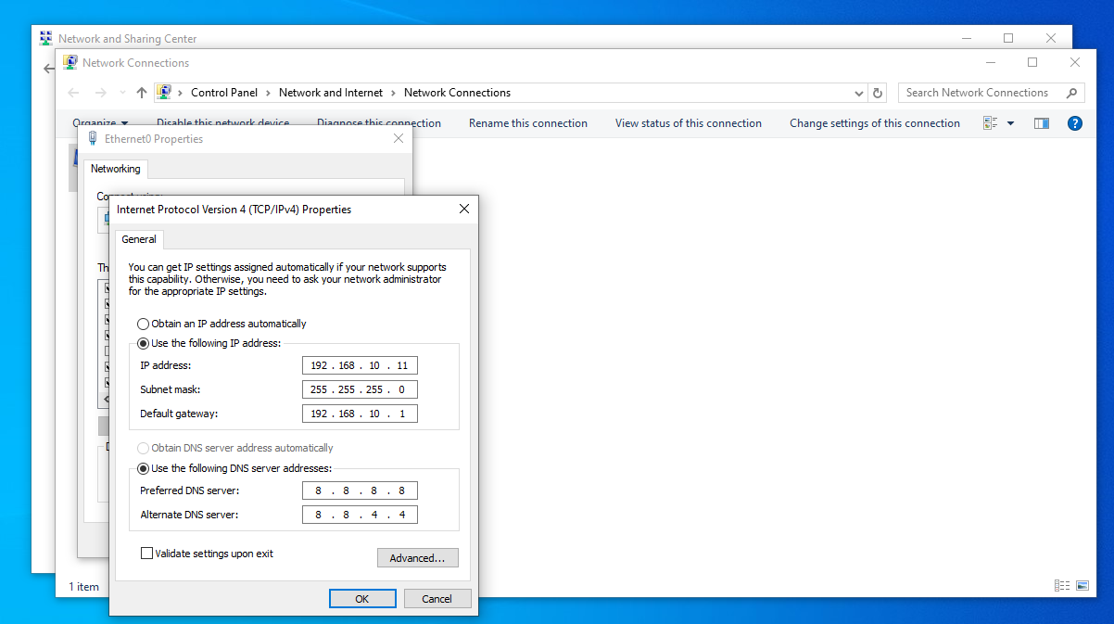
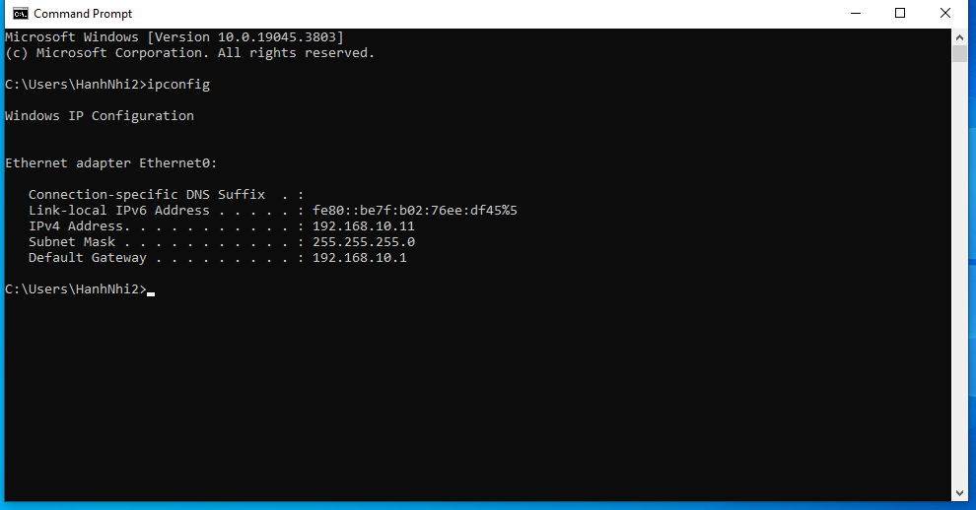
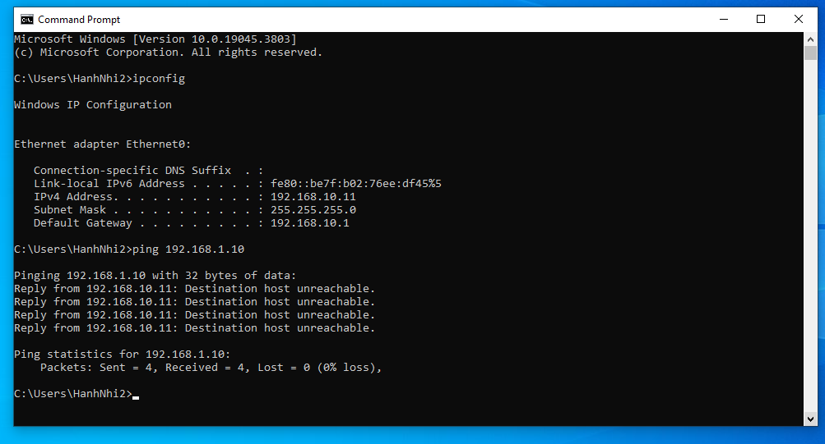
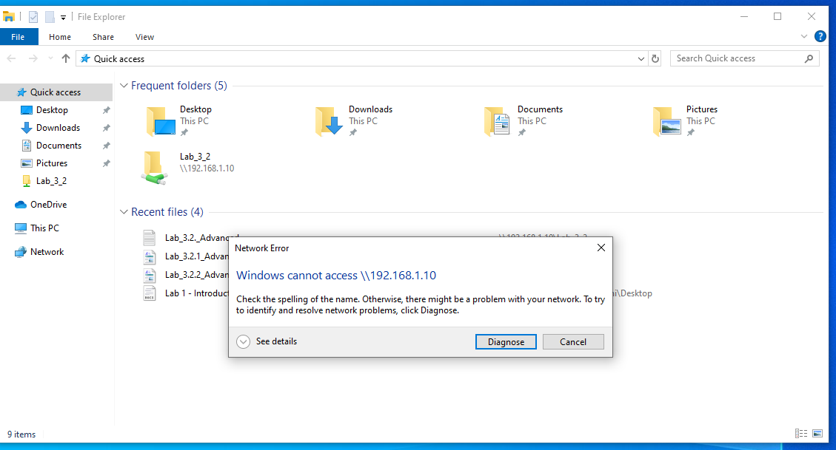
II.5 Cisco Packet Tracer
- Getting started with Cisco Packet Tracer
After installing Cisco Packet Tracer, we need an account to use the app freely. To create an account, do as follows:
- First, we go to the website: https://www.netacad.com/. Then, click on Login

- At Login page, go to the bottom and click on Sign up

- After that, fill in the necessary information and click Continue. OR we can sign up using Google account

- Follow the instructions on the website to create your Cisco account.
- Open Cisco Packet Tracer, choose Keep me logged in and log in using Networking Academy account.
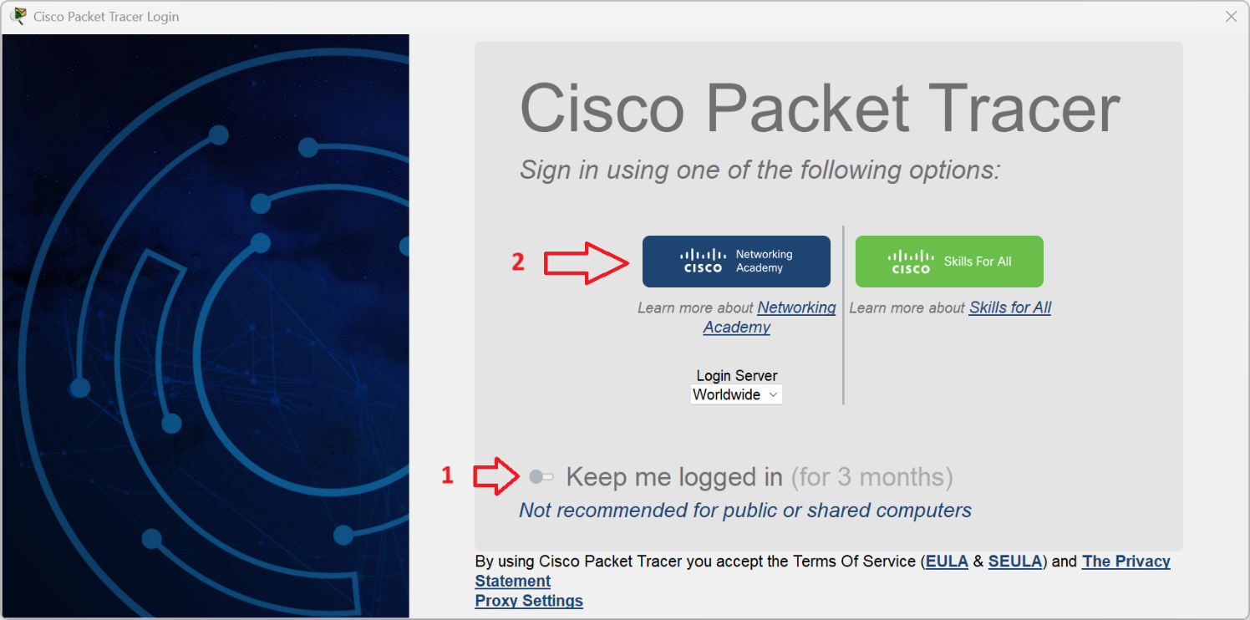

- Basic network configuration
- Case 1: Connect two PCs as in the below. Then, assign IP address for them as follow:
  - PC1: 192.168.1.2/24
  - PC2: 192.168.1.3/24
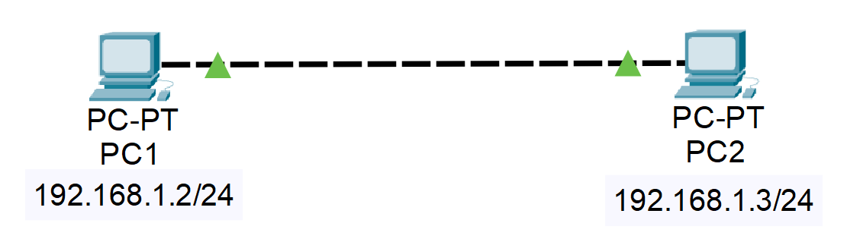
  - Finally, test the connection between 2 PCs using “ping” command.
  - Show the screenshots of each step
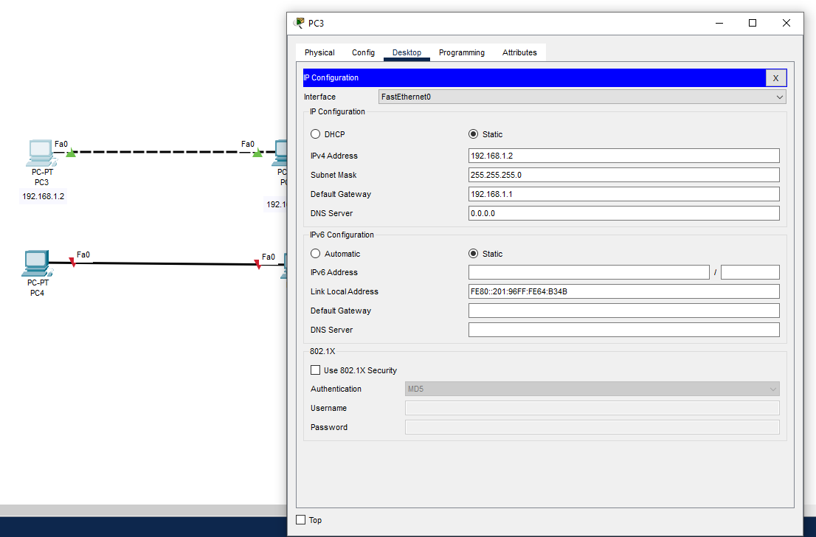
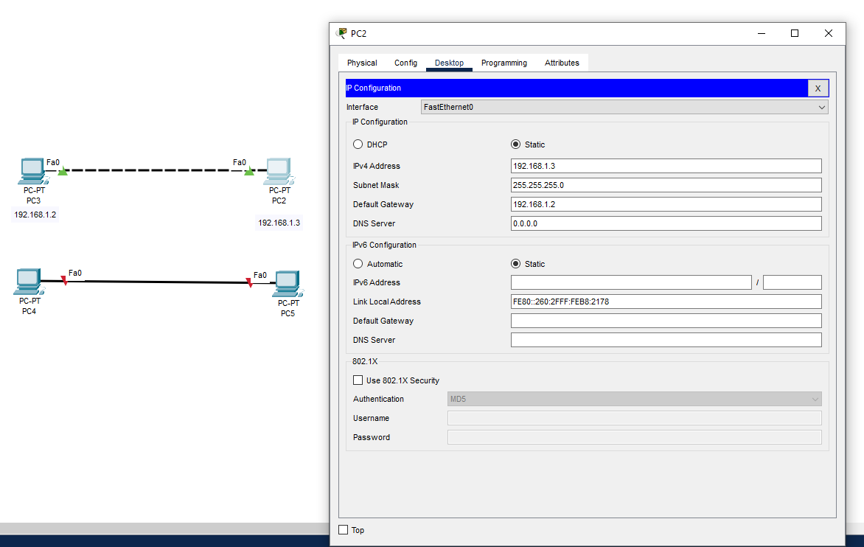
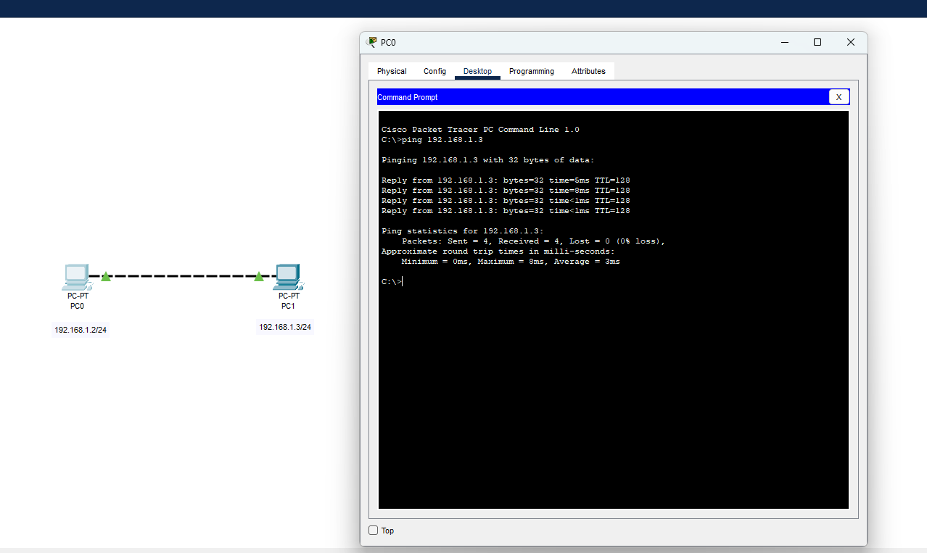
- Case 2: In this case, two PC from the previous case will connect via a Switch
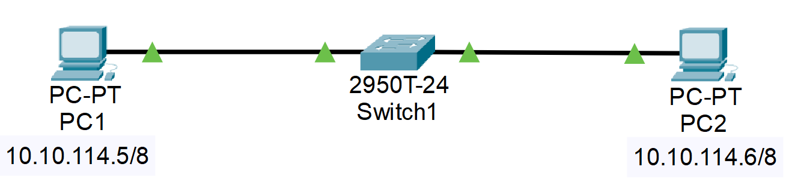
  - Show the screenshots of each step
