Course: CSE 204 – Computer Networks
LAB 4 – Switch Configuration
Due date: November 15th, 2025

Student name | Phan Ngọc Hạnh Nhi
Student ID | 2131209002

Goal
- Understanding Switch
- Use basic commands of Cisco switch
- Understanding how to configure VLAN and VLAN Trunking

Assignment list
II.1 Basic Switch Configuration
  - Switch connection
- Connect PC to Switch using Ethernet Cable
- Connect a Laptop to configure Switch using Console cable
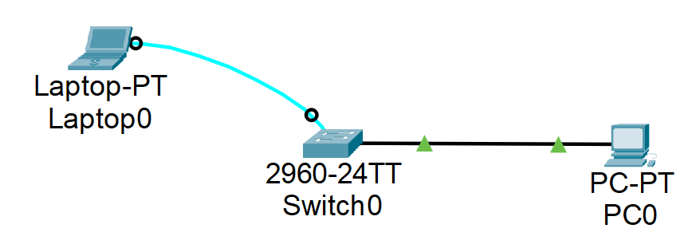
- On Laptop, go to tab Desktop and open Terminal app.

- Execute the following commands:
- Switch> enable
- Switch# erase startup-config
- Switch# reload
- Result:
- Switch> enable
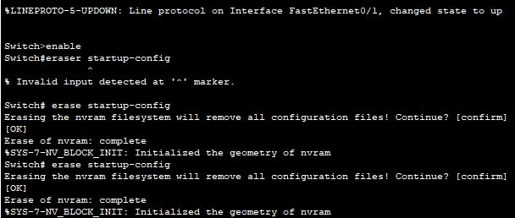
- Switch# erase startup-config
- Switch# reload
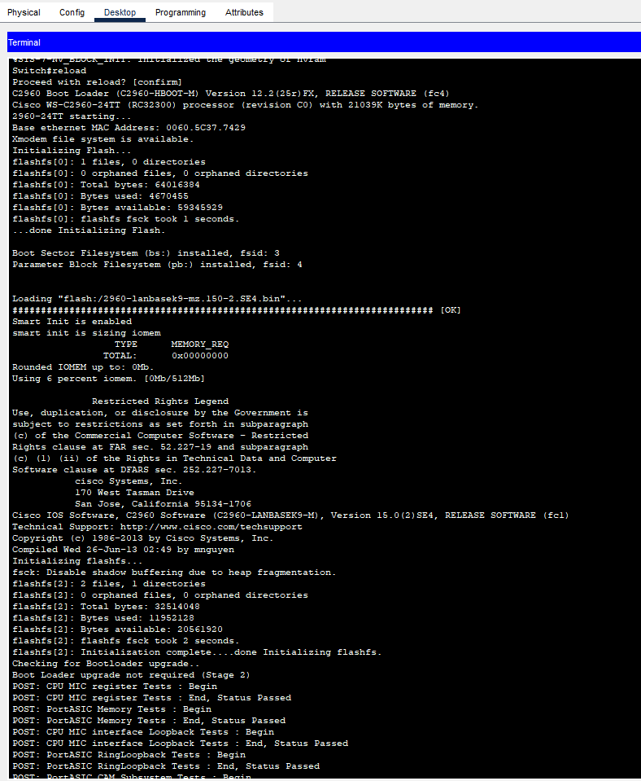
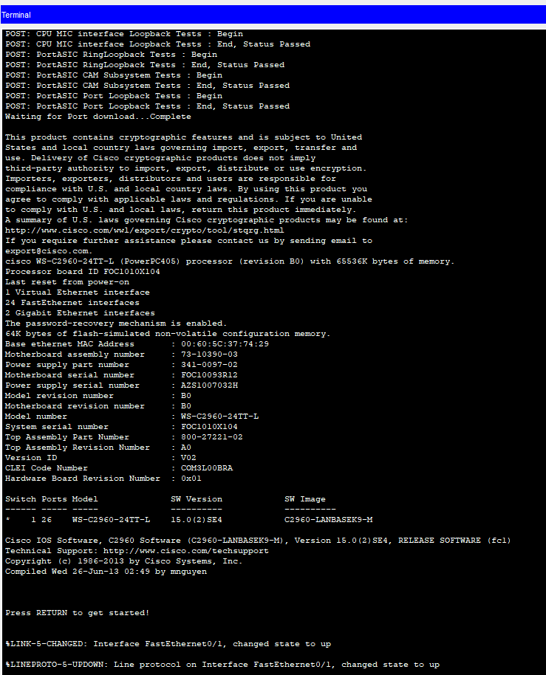
  - Switch basic configuration commands
Note: please run the following commands in this section and explain the function of those commands
- Execute the following command:
  - Switch# show running-config
  - Result:
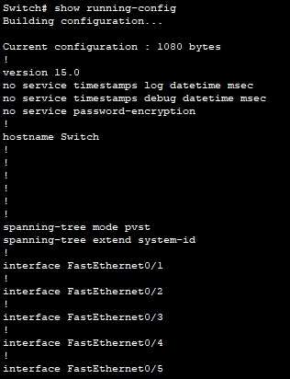
- Displays the current active configuration of the switch stored in RAM.
- Includes settings such as hostname, VLANs, interface configurations, passwords, and line (console/VTY) settings.
- Used to verify what is currently configured on the device before making changes or saving it to the startup configuration.
- Cisco Switch has default interface vlan1 as follows:
  - Switch# show interface vlan1
  - Result:
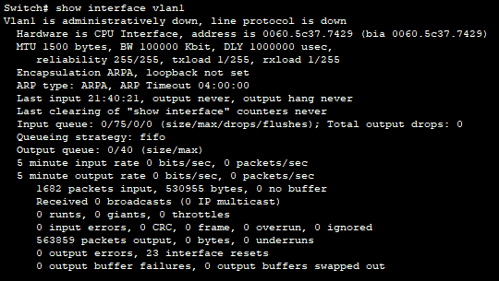
- Displays the status and details of the VLAN 1 interface (the default SVI – Switched Virtual Interface) on the switch.
- Shows whether VLAN 1 is up/down, its IP address and subnet mask (if configured), MAC address, MTU, and traffic statistics.
- Used mainly to check the management interface of the switch, since VLAN 1 is often used for remote management (Telnet/SSH) in basic setups.
- Check information of IP address, MAC address of interface
  - Switch# show interface fa0/1
  - Result:
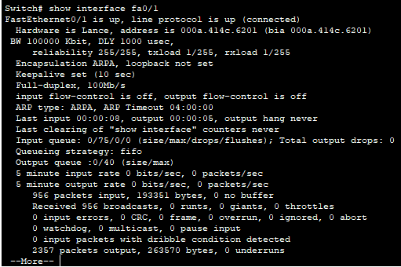
- Displays detailed information about the FastEthernet0/1 interface.
- Includes IP address (if configured), MAC address, line status (up/down), speed, duplex, bandwidth, and error counters.
- Used to check the physical/interface status and troubleshooting (collisions, input errors, drops, etc.).
- Check information of OS, RAM, Flash, Memory:
- Switch# show version
- Result:
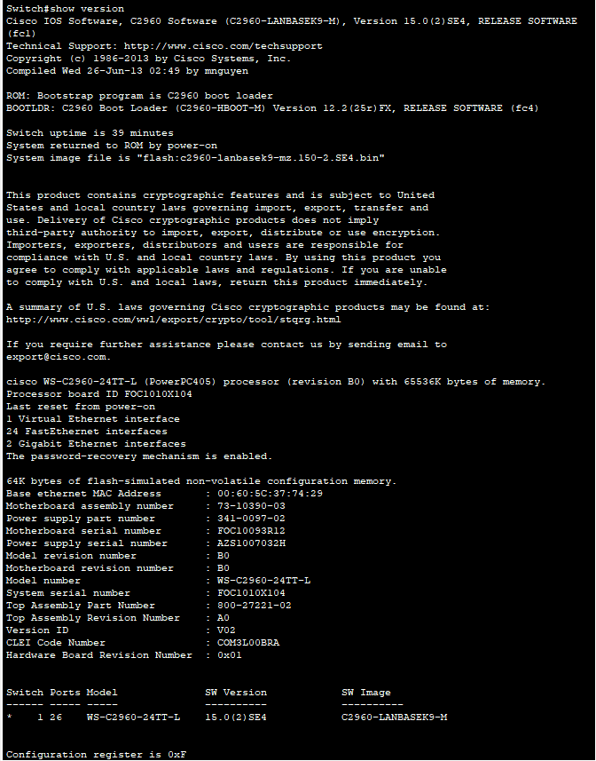
- Shows information about the switch’s operating system and hardware.
- Includes IOS version, device model, amount of RAM, Flash memory, CPU, system uptime, and configuration register value.
- Used to verify software/hardware specs, check if the correct IOS image is running, and collect device info for documentation or troubleshooting.
- Switch# show flash
- Result:
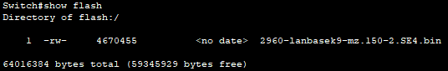
  - Shows the contents of Flash memory, including IOS image files and free/used space. Used to check which IOS is stored and whether there is enough space for upgrades.
- Check startup configuration
- Switch# show startup-config
- Result:
Displays the configuration stored in NVRAM that will be loaded when the switch boots. Used to verify what settings will apply after a restart.
- Switch# copy running-config startup-config
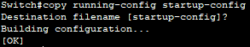
Saves the current active configuration in RAM to NVRAM as the startup config. Ensures your changes are kept after reboot.
- Switch# show startup-config
- Result:
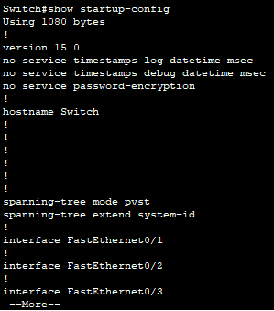
  - Configure Switch device name
- Configure hostname for Switch:
- Switch# configure terminal
- Enters global configuration mode so you can change the device configuration.
- Switch(config)# hostname S1
- Sets the switch name to S1, making it easier to identify the device (also changes the CLI prompt).
- Result:
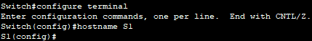
  - Configure passwords for Switch
- Configure password “cisco” for Switch:
- S1(config)# enable password cisco
- Sets the password required to enter privileged EXEC mode using the enable command.
- S1(config)# exit
- Result:
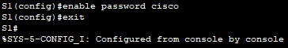
- Configure password “cisco” for Console interface
- S1(config)# line console 0
- S1(config-line)# password cisco
- S1(config-line)# login
- S1(config-line)# exit
- Result:
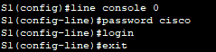
Configures the console line to require the password cisco and enables password checking for console access.
  - Configure IP for Switch
Switch is a layer 2 device which cannot be assigned an IP address. However, in order to remote access, an IP address can be assigned by using VLAN1 interface.
- Execute the following commands:
- S1#config terminal
- S1(config)# interface vlan 1
- Enters configuration mode for the VLAN 1 SVI (management interface).
- S1(config-if)# ip address 172.10.1.10 255.255.0.0
- Assigns an IP address and subnet mask to VLAN 1 so the switch can be managed over the network.
- S1(config-if)# no shutdown
- Enables (brings up) the VLAN 1 interface.
- S1(config-if)# exit
- S1(config)# ip default-gateway 172.10.1.1
- Sets the default gateway for the switch so it can reach devices in other networks.
- Result:
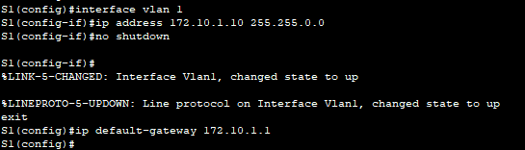
- Check configuration. Result:
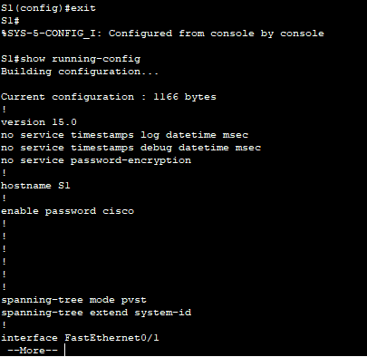
- At the PC, assign IP address to PC. Result:
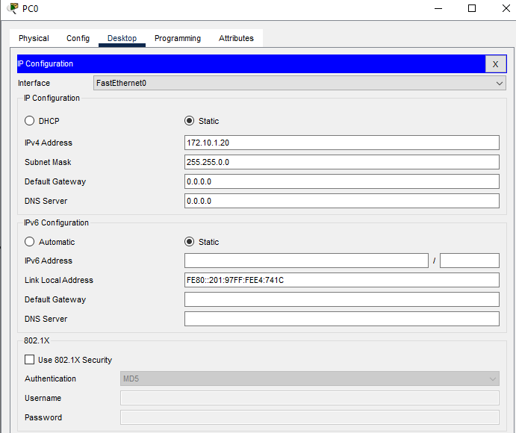
- Ping from PC to the switch. Result:
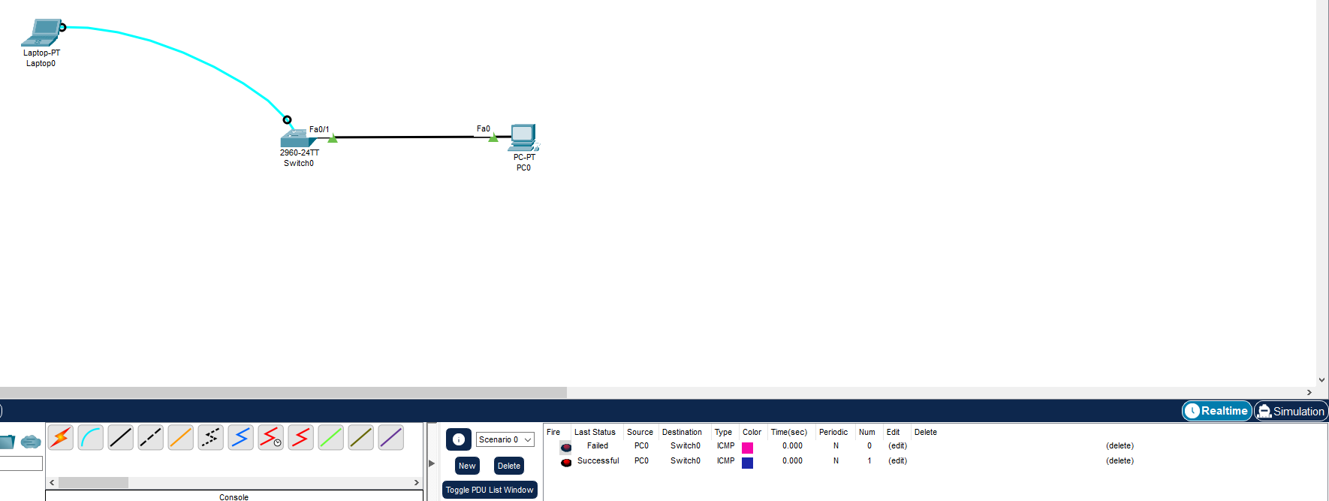
  - Remote control
- Telnet is a service to monitor/remote using line vty. Configure password “cisco” for vty
- S1(config)# line vty 0 4
- S1(config-line)# password cisco
- S1(config-line)# login
- S1(config-line)# exit
- Result:
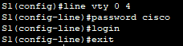
Configures the virtual terminal (VTY) lines for Telnet, sets the password to cisco, and enables password checking for remote access.
- Now, go to PC0 and open Telnet/SSH app. Choose Telnet as Connection type, then fill in the IP of Switch and click Connect:
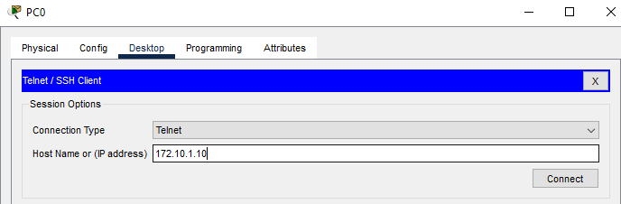
- Finally, fill in the password setup before. Result:
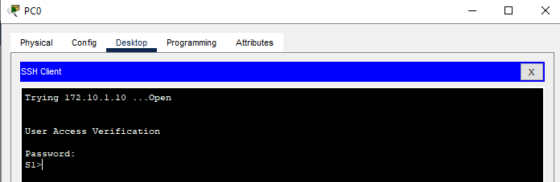

  - Change configuration at switch
- Execute the following commands:
  - S1#configure terminal
  - S1(config)#interface fastethernet 0/18
  - Enters configuration mode for interface FastEthernet 0/18.
  - S1(config-if)#speed 100
  - Forces the interface speed to 100 Mbps.
  - S1(config-if)#duplex full
  - Forces the interface to operate in full-duplex mode.
  - S1(config-if)#end
  - Result:
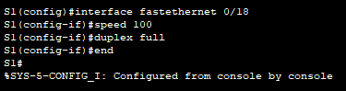
- Save configuation using the command below:
- S1#copy running-config startup-config
- Result:
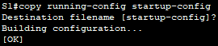
  - Show MAC table
- Execute the following commands:
  - S1#show mac-address-table
  - Result:
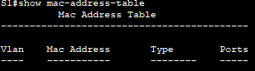
Displays the switch’s MAC address table, showing which MAC addresses are learned on which ports and VLANs, useful for checking connectivity and troubleshooting.
II.2 VLAN Configuration
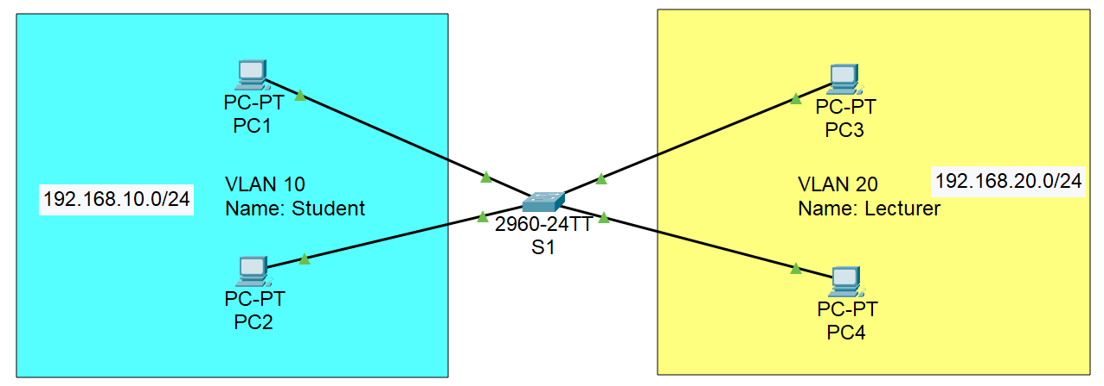
- Step 1: Assign IP for 4 PCs

- Step 2: Create 2 VLANs on Switch
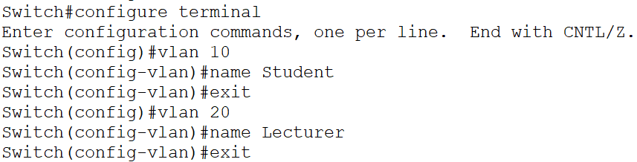
- Then, run the command “show vlan” to check the configuration. Result:
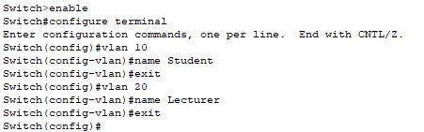
- Step 3: Assign ports to VLAN 10 and VLAN 20
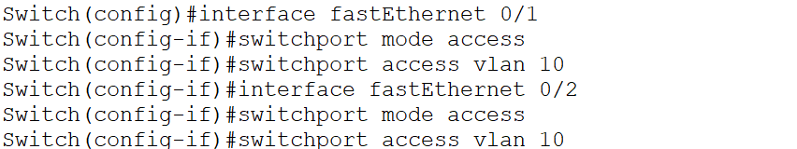
  - Repeat these steps for VLAN 20. Result:
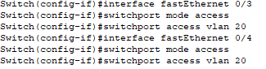
- Step 4: Check the VLAN configuration using command “show vlan”. Result:
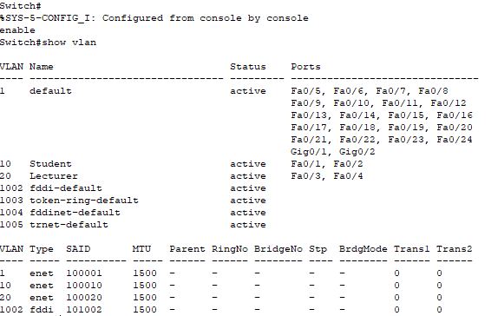
- Step 5: Check connection between PCs.
  - Ping PC1 and PC2, then explain the result. Result:
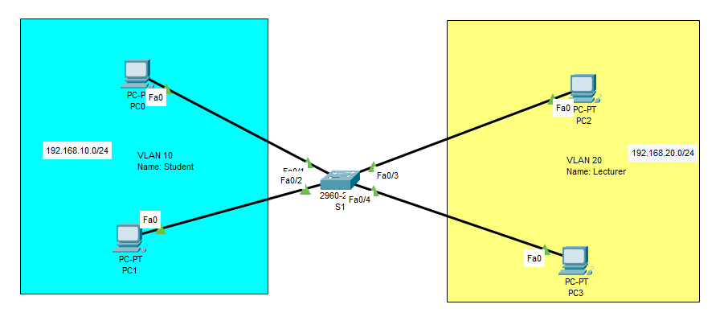
  - Ping PC2 and PC3, then explain the result. Result:
II.3 VLAN and Trunking Configuration
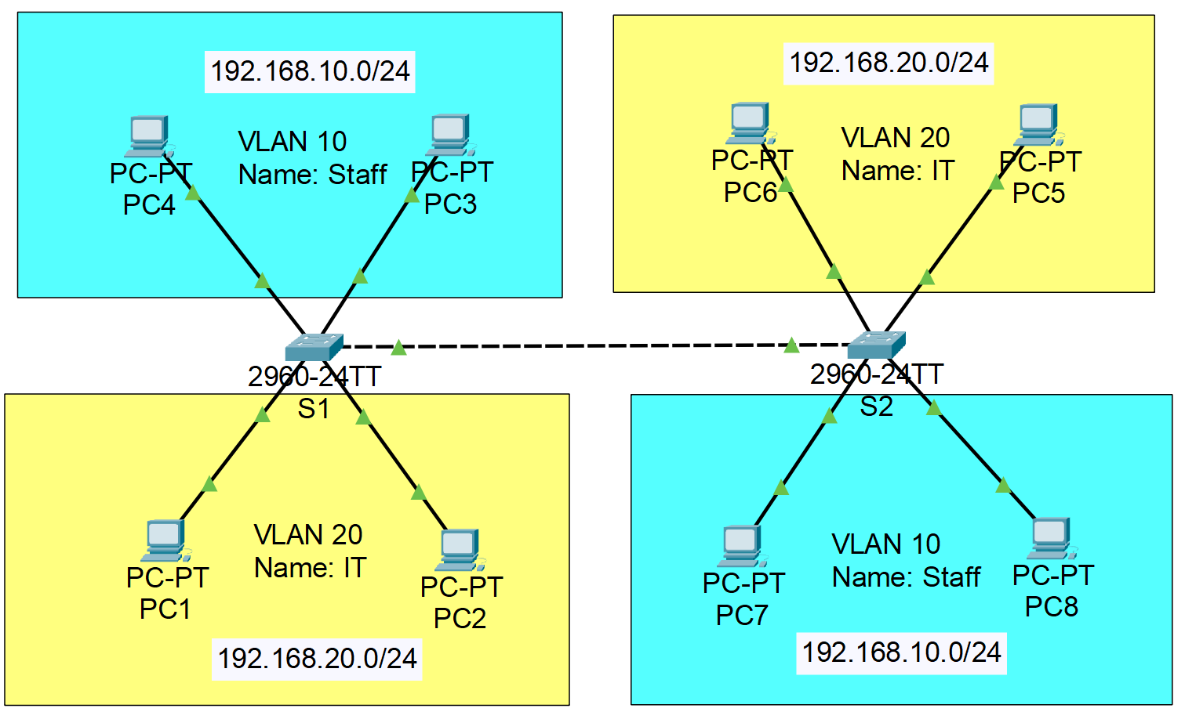
- Note:
  - VLAN 10: port 4, 5
  - VLAN 20: port 7, 8
  - Trunk: port 15
- Step 1: Configure IP for all PCs

- Step 2: Create VLANs on 2 Switches S1 and S2
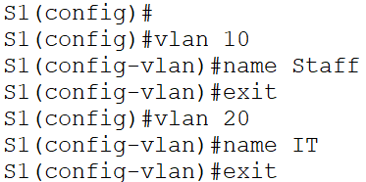
  - Repeat these steps on Switch S2. Result:
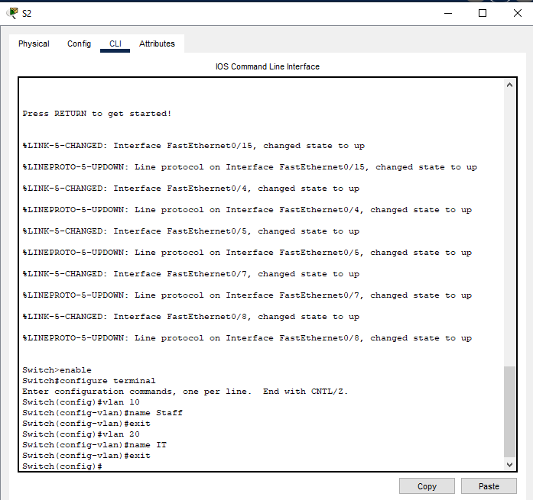
- Step 3: Assign ports to VLAN 10 and VLAN 20 on Switch 1
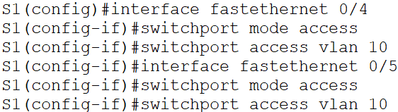
  - Repeat these steps for VLAN 20. Result:
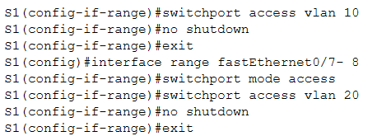
- Step 4: Assign ports to VLAN 10 and VLAN 20 on Switch 2.
  - Result:
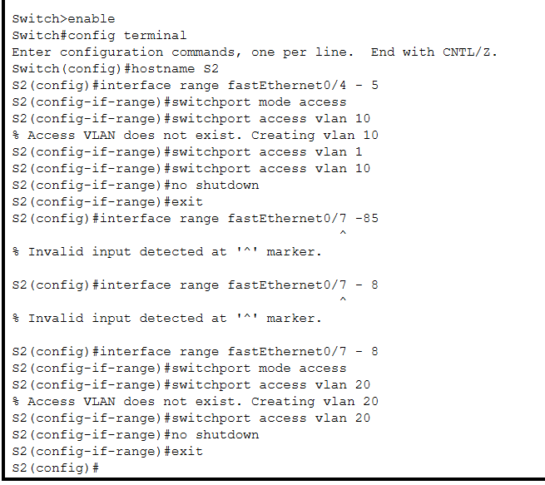
- Step 5: Check connection between PCs
  - Ping PC1 and PC5, then explain the result. Result:
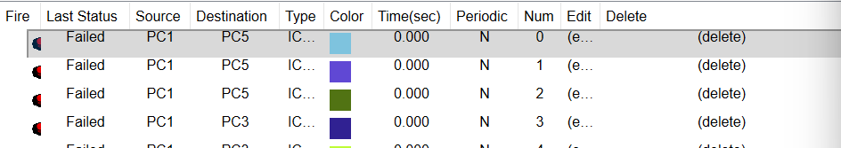
- PC1 and PC5 are in the same IP network (192.168.20.0/24) but they are connected to different switches.
- The link between S1 and S2 is still an access port in VLAN 1, not a trunk port, so traffic for VLAN 20 cannot pass between the two switches.
- Therefore, VLAN 20 on S1 and VLAN 20 on S2 are not in the same broadcast domain, so PC1 cannot ping PC5.
  - Ping PC1 and PC3, then explain the result. Result:
- PC1 belongs to VLAN 20 – network 192.168.20.x, while PC3 belongs to VLAN 10 – network 192.168.10.x.
- These are two different VLANs and two different IP networks.
- There is no router or Layer 3 device to perform inter-VLAN routing, so PC1 cannot reach PC3.
- Step 6: Create Trunk ports
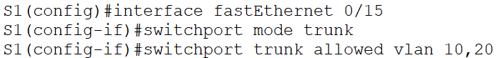
  - Repeat these steps on Switch S2. Result:
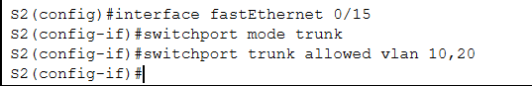
- Step 7: Check connection between PCs after creating Trunk ports
  - Ping PC1 and PC5, then explain the result. Result:
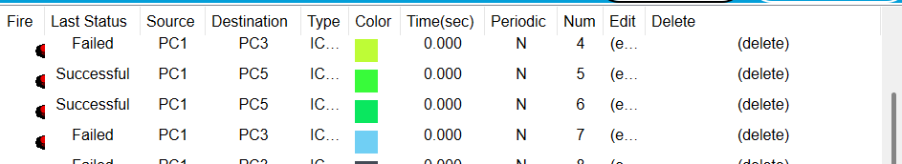
- PC1 and PC5 are both in VLAN 20 and use the same IP network 192.168.20.0/24.
- After configuring the link between S1 and S2 as a trunk port, VLAN 20 traffic can now be carried across the link.
- Therefore, VLAN 20 on both switches is in the same broadcast domain, so PC1 can successfully ping PC5.
  - Ping PC1 and PC3, then explain the result. Result:
- PC1 is in VLAN 20 – 192.168.20.x, while PC3 is in VLAN 10 – 192.168.10.x.
- These two PCs are in different VLANs and different IP networks.
- The trunk only allows VLAN tags to pass between switches; it does not route traffic between VLANs.
- Because there is still no router or Layer 3 device for inter-VLAN routing, PC1 cannot ping PC3.

