CSE 204 – Computer Network

Lab Test

Objective
- Implementing VLAN and VLAN Trunking
- Implementing DHCP
- Implementing Static Routing and Dynamic Routing
- Implementing Access Control List
- Implementing Static NAT, Dynamic NAT and PAT

Requirements:
Create a folder with format as follow: StudentID-FullName-LabTest. After completing the test, this folder MUST contain all required Cisco Packet Tracer (.pkt) files as shown below.
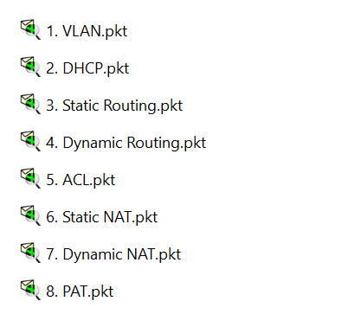

Assignment list
II.1. Implementing VLAN and VLAN Trunking
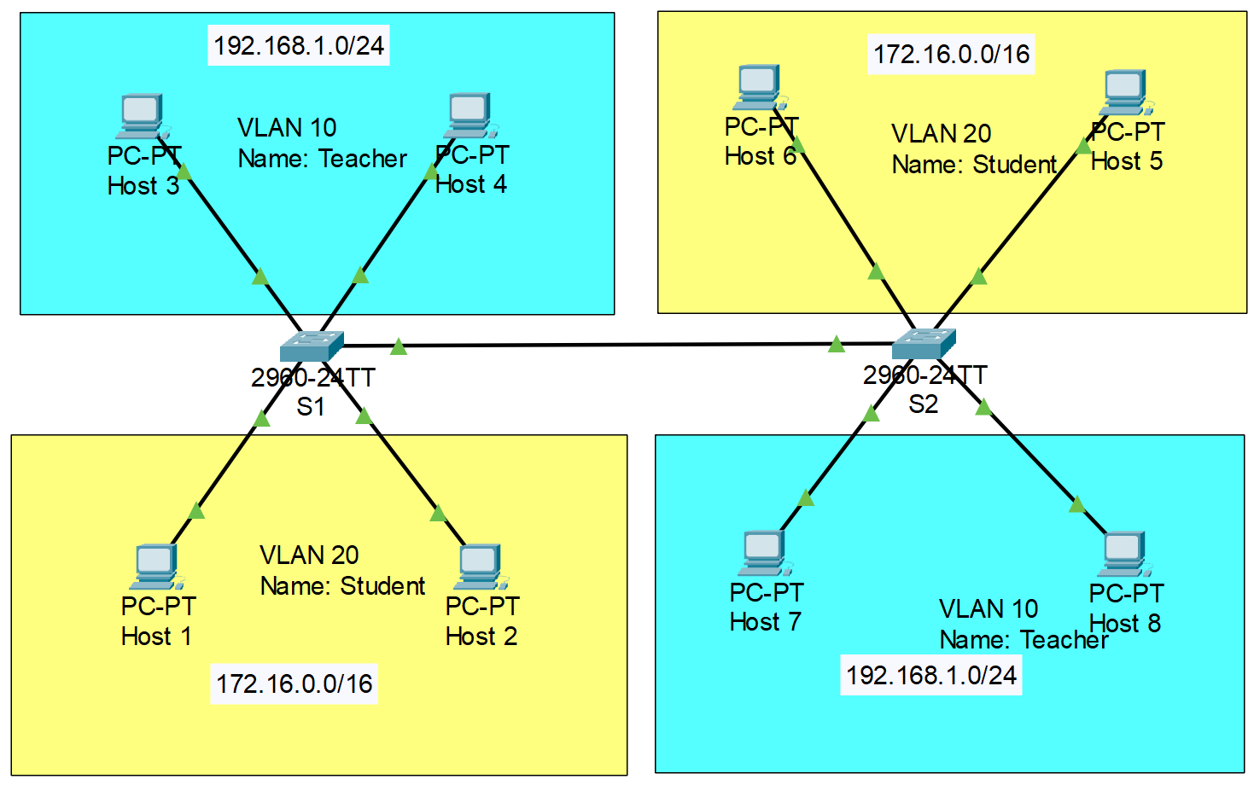
- Note: VLAN 10: port 2, 3. VLAN 20: port 6, 7. Trunk: port 1
- Configure VLAN as shown in the figure above. Then, implement VLAN Trunking on 2 Switches, so that 2 PCs in the same VLAN, but different Switch can ping to each other.
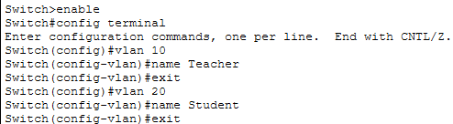
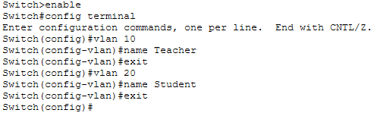
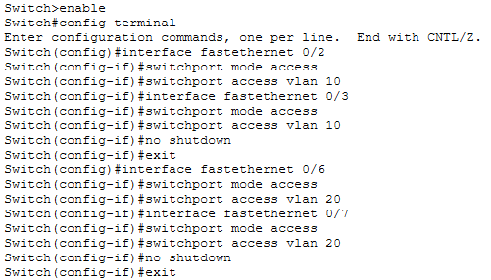
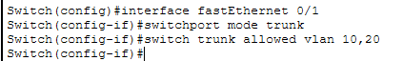
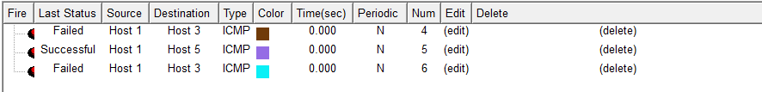
II.2. Implementing DHCP
- Configure DHCP in each router based on the given information in the figure below.
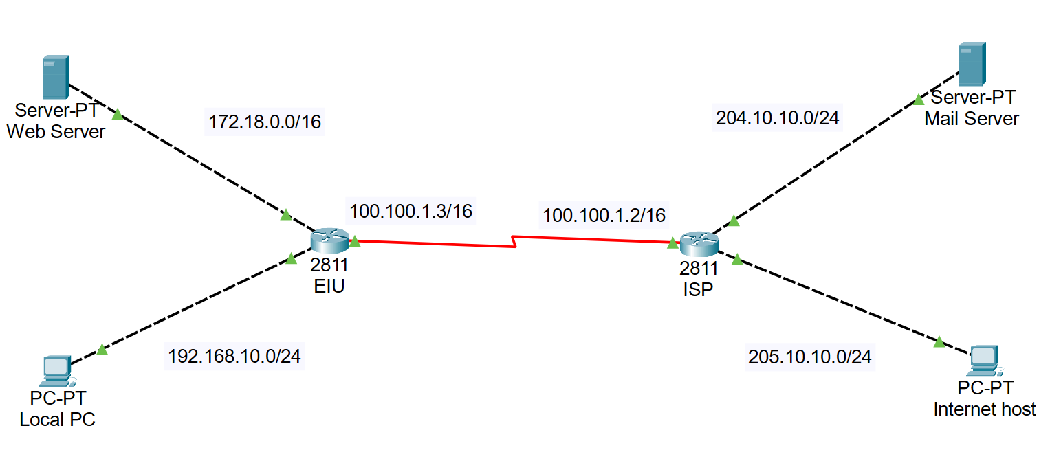
- Note: Before proceeding to the tasks below, please save and CLONE the file after configuring DHCP into 6 separate files.
II.3. Implementing Static Routing and Dynamic Routing
Note: Use the clone model from Task II.2 to configure Static Routing and Dynamic Routing separately.
- Use the model in Task II.2 to configure Static Routing
- Use the model in Task II.2 to configure Dynamic Routing
II.4. Implementing Access Control List (ACL)
Use the model in Task II.3 (after finishing Routing configuration) to configure Access Control List, so that Local PC cannot connect to other devices.
II.5. Implementing Static NAT, Dynamic NAT and PAT
Note: Use the clone model from Task II.2 to configure Static NAT, Dynamic NAT and PAT.
- Static NAT
- Assume that Router EIU will use the public IP address 200.10.10.2/24 for Static NAT. Configuring Static NAT at Router EIU to translate private IP address of Web Server to public IP address.
- Dynamic NAT
- Assume that Router EIU can use the IP address range MyPool (200.10.10.2 to 200.10.10.10/24). Using Dynamic NAT at Router R1 to translate local IP address of Web Server to MyPool. If configure successfully, Internet PC can ping to public IP of Web Server.
- PAT
- Configuring PAT at Router EIU to translate private IP address of Web Server to public IP address.

