Tên: Phan Ngọc Hạnh Nhi

MSSV: 2131209002

Practice Assignment 1

Capture the screen shots of the results for the following questions. Save each screen shot as the question number. Save all the screen shots in a word file and upload the file into Moodle.

Part I:

**Total Points : 100**

# Capture a screenshot of VMWare Workstation Player after running it.

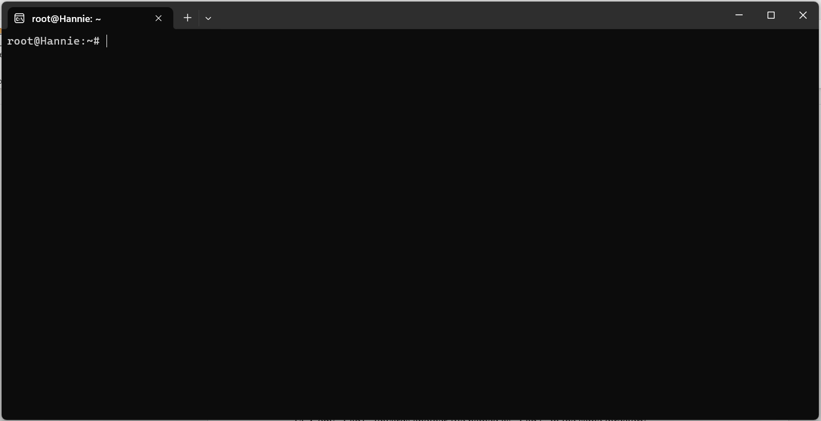

# Capture the screenshot of Ubuntu after it starts successfully. (10 points)

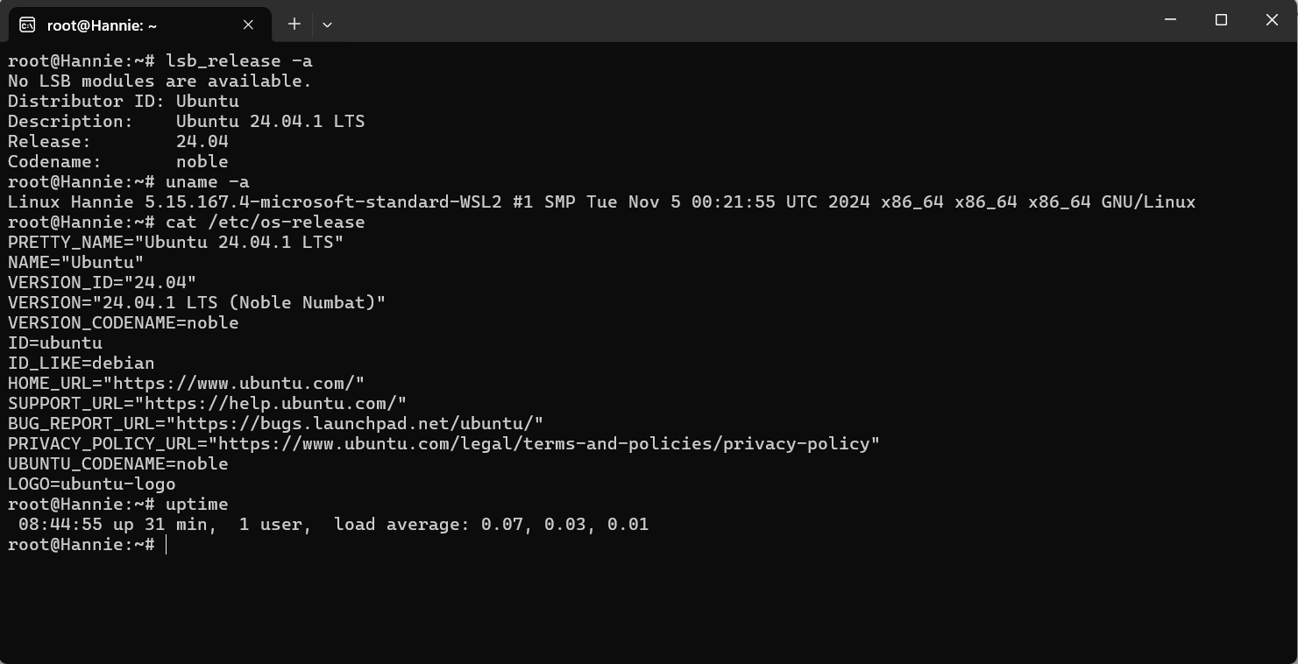

# List all contents of your current working directory.

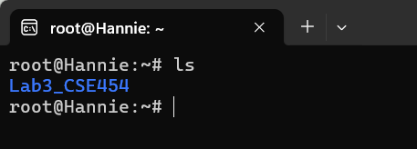

* We use the command is:

ls

ls: Lists the contents of a directory.

# List all contents of your current working directory, including hidden files.

* We use the command is:

ls -al

ls: Lists the contents of a directory.

-a: Shows all files, including hidden files.

-l: Displays detailed information about each file.

# Create a directory named as “CSE302”.

* We use the command is:

mkdir + directory’s name

# View the directory.

# Change your current directory towards “CSE302”.

# Return from “CSE302” directory towards your home directory.

# Create another directory named as “SCIT”.

# View the directory.

# Change your current directory towards “SCIT”.

# Go to your home directory, and display full path of your current directory.

# Go to directory “CSE302” and create a file named as “Lab1”.

# Copy “Lab1” towards another file named as “Lab2” in the same directory.

# Copy “Lab1” towards another file named as “Practice1” in another directory “SCIT”.

# Rename the file “Lab1” as “Practice Lab 1”.

# Delete the file “Lab2”.

# Delete the directory “SCIT”.

# Read documentation on the command “ls”.

# Search document for the matching command that have something do with “sort”.

# Install a software package named as “build-essential”.

# Print the version of “gcc” compiler.

# Download the following file “https://cdn.kernel.org/pub/linux/kernel/v4.x/linux4.17.2.tar.xz” from internet.

# Can you view the file inside your current directory?

# Edit the file “LabInstruction.txt”.

Place the following text in “LabInstruction.txt” and save it.

The laboratory courses offered cover a wide range of disciplines and methodologies aimed at providing students with the knowledge and practical skills required for advanced studies and future careers in biotechnology, biomedicine, and academia.

# Count the number of characters, words, or lines in the file “LabInstruction.txt”.

# View the content of the file “LabInstruction.txt” in the terminal.

# Write the output of “man wc” towards a new file “docs_for_wc_program.txt”.

[Hints: You need to create the file “docs_for_wc_program.txt” first.]

# View the content of the file “docs_for_wc_program.txt”.

# Append the output of “man ls” towards the file “docs_for_wc_program.txt”. Again, view the content of the file.

# Create a text file named “mylist.txt” that contains the following lines:

Cat

Dog

Horse

Cow

Observe that the animals are not listed in alphabetical order.

What do if you need to list them in order?

[Hints: You can pull the contents of the file into the sort command by using the <operator.

Part II:

# Install the software named mc (midnight). Capture the screenshot of mc after it starts.

# Display the current user ‘s name.

# Display the Operating System Information.Display the default version of the shell.

# Display the path of the Shell.

# Display the user id and corresponding name.

# Display the available disk space.

# Display currently running all processes with both user and root privilege.

# Display how much system resources have been used by the current running processes.

# Display the current date only

# Display the current time only

# Ensure that you are in your home directory.

# Create a new directory called “final” in your home directory.

# View the permissions of the newly created directory, “final”.

# Create a new blank file named 'display.sh' in the “final” directory

# Create a copy of “display.sh” called “report.sh.”

# Delete the file 'display.sh'.

# List the files in “/etc” directory in the ascending order of their access time.

# Find out all text files in /etc directory.

# Copy the file /var/log/bootstrap.log to your current directory.

# Show the system's host name.

# Show the system's IP address only.

# Test if a host is reachable.

# Display the number of lines in the /etc/passwd file.

# Display the lines that contain the string 'not installed' in /var/log/bootstrap.log.