EASTERN INTERNATIONAL UNIVERSITY  SCHOOL OF COMPUTING AND INFORMATION TECHNOLOGY | Practice Assignment – Quarter 2, 2024-2025  Course Name: Coding Practice  Course Code: CSE 422  Student’s Full Name: Phan Ngoc Hạnh Nhi  Student ID: 2131209002
Practice Assignment 1

I. Prepare
1.1 Install Visual Studio Community 2022 (Skip if you have already installed it)
- Go to https://visualstudio.microsoft.com/downloads/
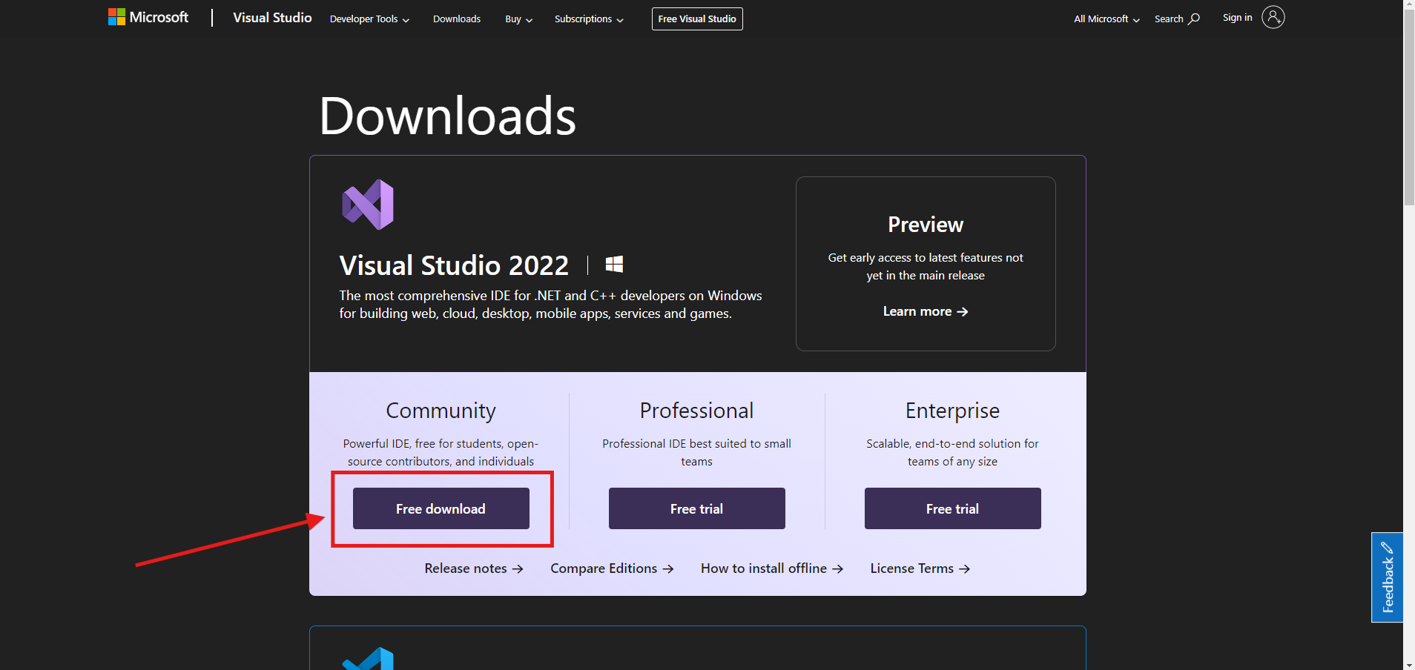
- After downloaded, open the file “VisualStudioSetup.exe”  for install. 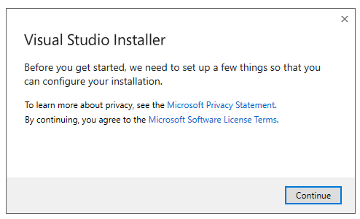
- Click continue and wait for download the package for install.

After that click install button and wait until that finish.
Okay! After you finish the preparation, let’s do the exercise below.

II. Exercise
Read
https://csharpcodingguidelines.com
https://www.dofactory.com/csharp-coding-standards
http://java.sun.com/docs/codeconv/html/CodeConvTOC.doc.html.
https://geosoft.no/javastyle.html#Naming_Conventions

Exercise 1: Based on the sources referenced above.
- Compare conventions of naming and formatting between common languages C# and Java.
- Create a detailed comparison with descriptions in words and save it as a Word or PDF file.

Exercise 2: Use the Visual Studio IDE to create a C# console project, paying attention to naming conventions and folder structure.

Exercise 3: Use the project created in Exercise 2, then add new source files to solve the following problem. Solve the problems effectively and pay attention to naming conventions.

Problem 1: Given two sorted arrays nums1 and nums2 of size m and n respectively, return the median of the two sorted arrays.
The overall run time complexity should be O(log (m+n)).

Example 1:
Input: nums1 = [1,3], nums2 = [2]
Output: 2.00000
Explanation: merged array = [1,2,3] and median is 2.

Example 2:
Input: nums1 = [1,2], nums2 = [3,4]
Output: 2.50000
Explanation: merged array = [1,2,3,4] and median is (2 + 3) / 2 = 2.5.

Constraints:
nums1.length == m
nums2.length == n
0 <= m <= 1000
0 <= n <= 1000
1 <= m + n <= 2000
-106 <= nums1[i], nums2[i] <= 106

Problem 2: Given two integers dividend and divisor, divide two integers without using multiplication, division, and mod operator.

The integer division should truncate toward zero, which means losing its fractional part. For example, 8.345 would be truncated to 8, and -2.7335 would be truncated to -2.

Return the quotient after dividing dividend by divisor.

Note: Assume we are dealing with an environment that could only store integers within the 32-bit signed integer range: [${-2}^{31}$, $2^{31}$ − 1]. For this problem, if the quotient is strictly greater than $2^{31}$ - 1, then return $2^{31}$ - 1, and if the quotient is strictly less than ${-2}^{31}$, then return ${-2}^{31}$.

Example 1:
Input: dividend = 10, divisor = 3
Output: 3
Explanation: 10/3 = 3.33333.. which is truncated to 3.

Example 2:
Input: dividend = 7, divisor = -3
Output: -2
Explanation: 7/-3 = -2.33333.. which is truncated to -2.

Constraints:
- ${-2}^{31}$ <= dividend, divisor <= $2^{31}$ - 1
- divisor != 0

Problem 3: Given an m x n grid of characters board and a string word, return true if word exists in the grid.

The word can be constructed from letters of sequentially adjacent cells, where adjacent cells are horizontally or vertically neighboring. The same letter cell may not be used more than once.

Example 1:

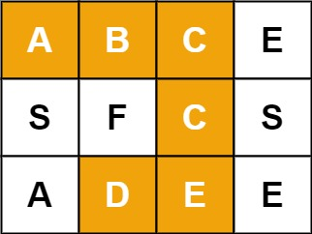

Input: board = [["A","B","C","E"],["S","F","C","S"],["A","D","E","E"]],
word = "ABCCED"
Output: true

Example 2:
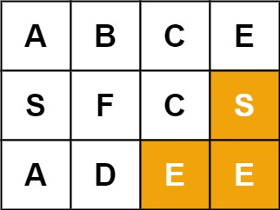
Input: board = [["A","B","C","E"],["S","F","C","S"],["A","D","E","E"]], word = "SEE"
Output: true

Example 3:
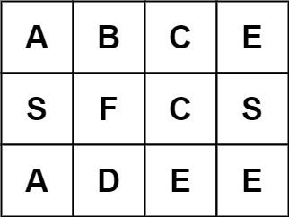

Input: board = [["A","B","C","E"],["S","F","C","S"],["A","D","E","E"]], word = "ABCB"
Output: false

Constraints:

- m == board.length
- n = board[i].length
- 1 <= m, n <= 6
- 1 <= word.length <= 15
- board and word consists of only lowercase and uppercase English letters.

