EASTERN INTERNATIONAL UNIVERSITY    SCHOOL OF COMPUTING AND INFORMATION TECHNOLOGY | Practice Assignment – Quarter 2, 2024-2025  Course Name: Coding Practice  Course Code: CSE 422  Student’s Full Name: Phan Ngọc Hạnh Nhi  Student ID: 2131209002
Practice Assignment 2

Building a Device Management Software

1. Introduction
- The Device Management System is a web-based application developed to assist organizations in tracking hardware assets and managing employee records. The project aims to replace manual tracking methods with a centralized, digital solution that ensures data integrity and provides efficient search and filtering capabilities.

2. System Design (Class Diagram)
The system is built upon three core entities: Device, DeviceCategory, and User.
- DeviceCategory: Represents groups of hardware (e.g., Laptop, Monitor).
- Device: Represents individual assets. It has a One-to-Many relationship with Categories (one category contains multiple devices).
- User: Represents employees or administrators. It utilizes a UserRole Enum to define access levels (Admin/Employee). The User entity operates independently to manage personnel records.
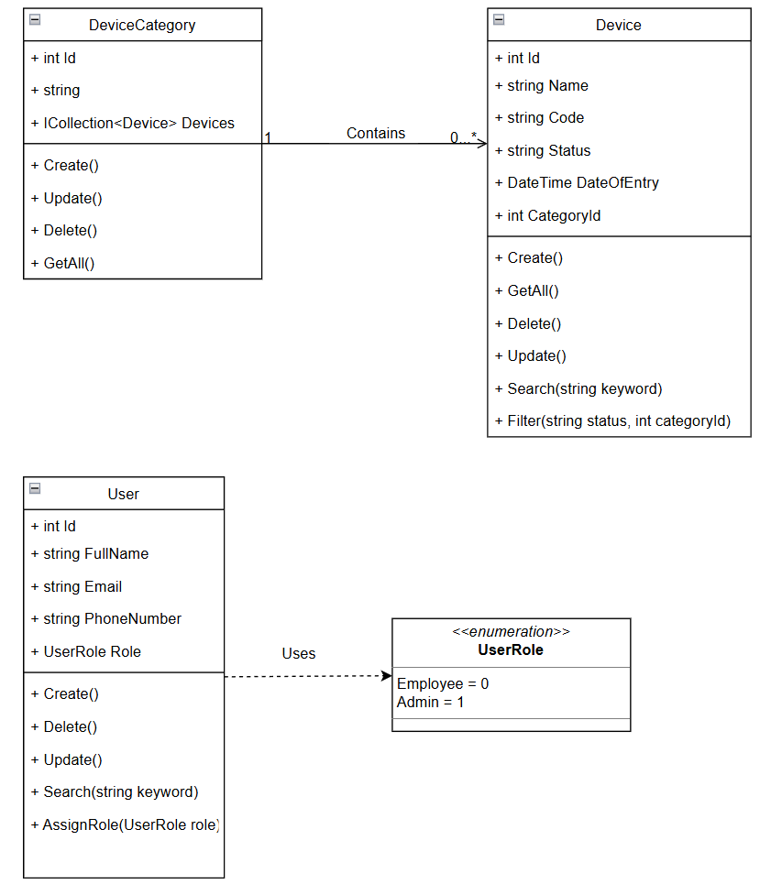
Figure 1. Class Diagram illustrating relationships and methods

3. Technology Stack
The project is implemented using modern web development technologies:
- Framework: ASP.NET Core 8.0 MVC (Model-View-Controller).
- Database: SQL Server with Entity Framework Core (Code-First Migration).
- Front-end: HTML5, Razor Views.
- Styling: Tailwind CSS for a responsive, modern, and clean user interface.
- Tools: Visual Studio 2022, Git.

4. Key Features
The application includes the following functional modules:

4.1. Device Management (Core Feature)
- CRUD Operations: Users can Create, Read, Update, and Delete devices.
- Advanced Filtering: The device list can be filtered by Category (e.g., Show only Laptops) or Status (e.g., In Use, Broken).
- Search: A search bar allows finding devices by Name or Device Code.
- Validation: Ensures all devices have unique codes and required fields.

4.2. User Management with Roles
- Employee Records: Manage Full Name, Email, and Phone Numbers.
- Role Assignment: Administrators can assign roles to users:
  - Admin: Highlighted with a Purple badge.
  - Employee: Highlighted with a Blue badge.
- Independent Management: Users can be managed independently from devices.

4.3. Category Management
- Allows grouping of devices.
- Data Integrity: The system prevents the deletion of a Category if it currently contains devices, ensuring no “orphaned” data exists.

5. Implementation Highlights (Clean Code)
- Async/Await: All database operations use asynchronous programming (ToListAsync, SaveChangesAsync) to improve performance and scalability.
- Dependency Injection: AppDbContext is injected into Controllers, following the Inversion of Control (IoC) principle.
- UI/UX Enhancements:
  - Modal Popups: Instead of a separate “Delete” page, a JavaScript Modal is used for confirmation, providing a smoother experience.
  - Toast Notifications: Success messages appear as floating notifications (Toasts) instead of simple text.
  - Responsive Forms: Input forms use a wide layout (max-w-5xl) with visual icons for better usability.

6. User Interface

6.1. Device Management Dashboard
Shows the list of devices with Status badges and Search/Filter bar.
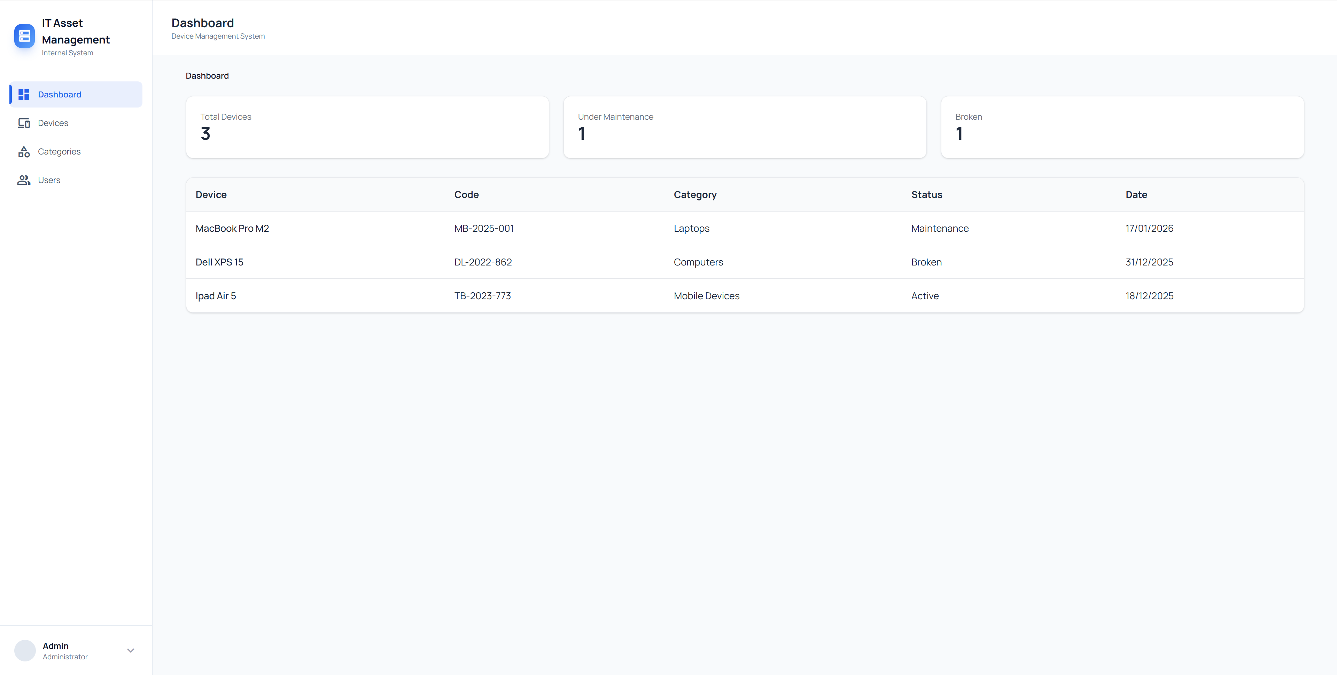
Figure 2. Device Management Dashboard
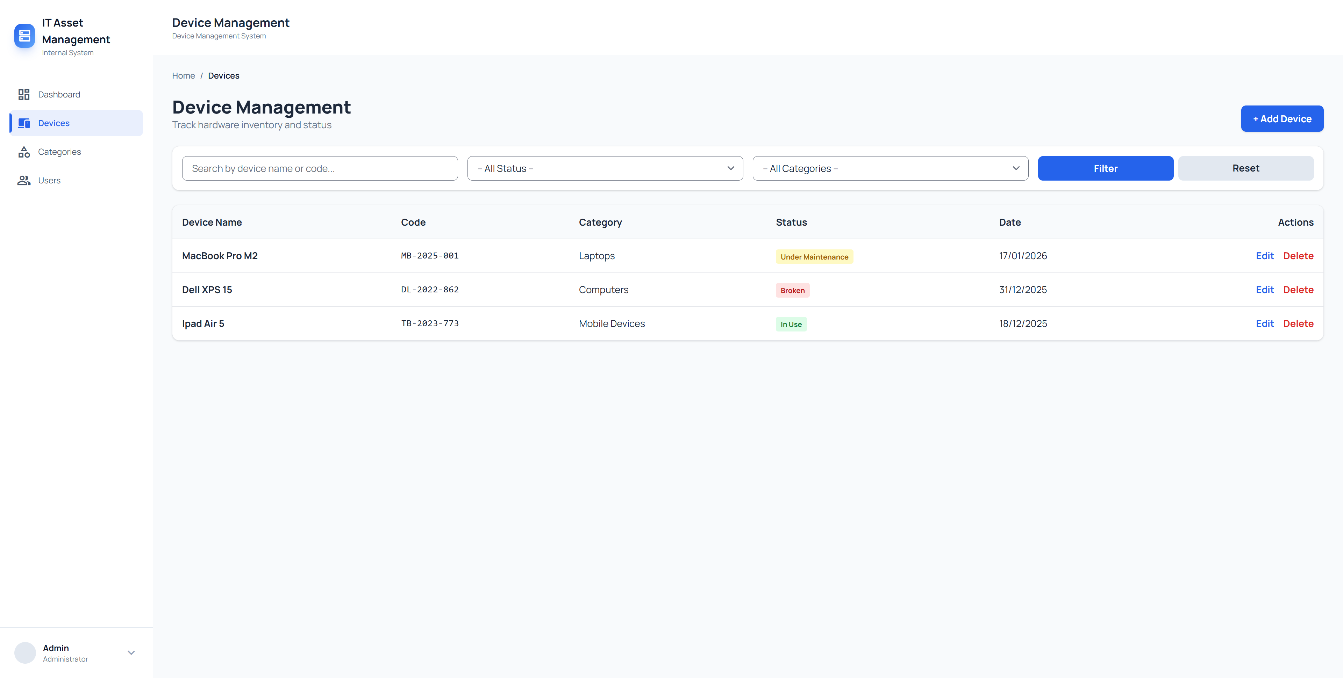
Figure 3. Device Management Page
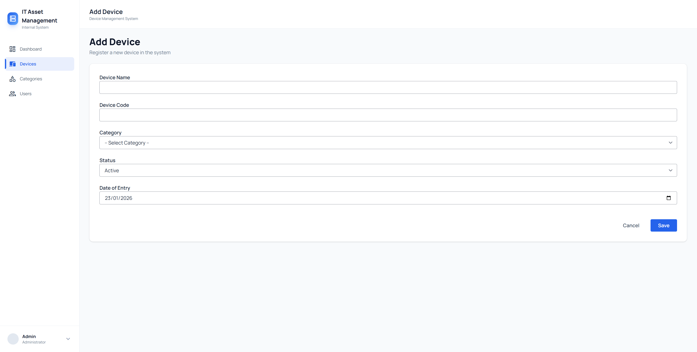
Figure 4. Create Device Page
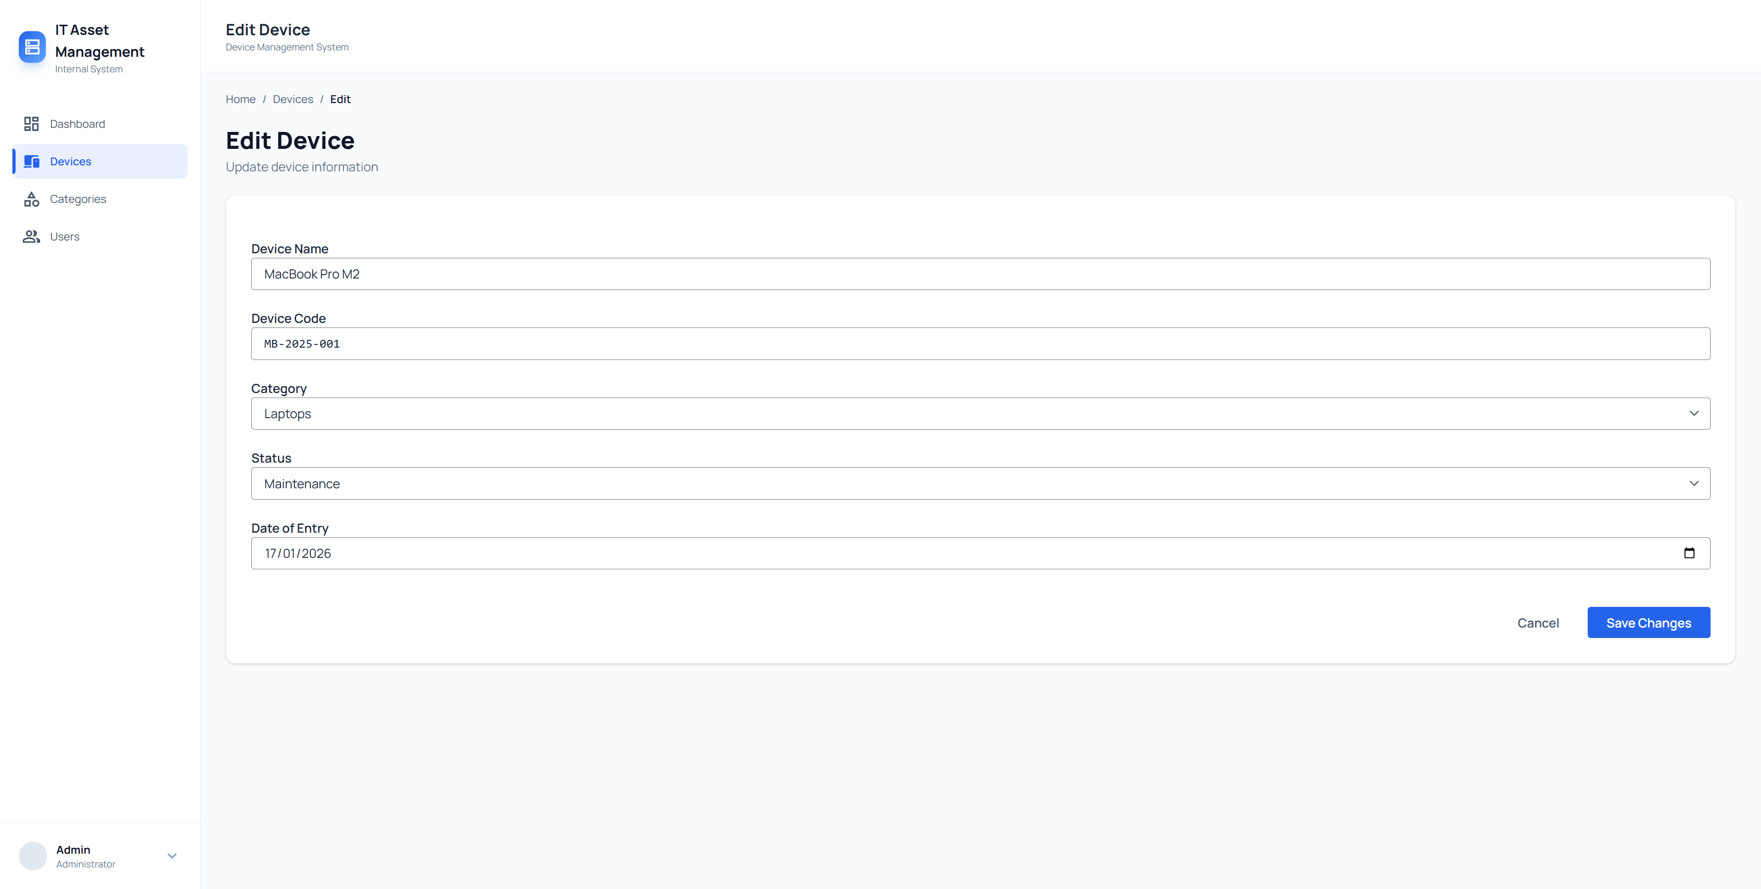
Figure 5. Edit Device Page
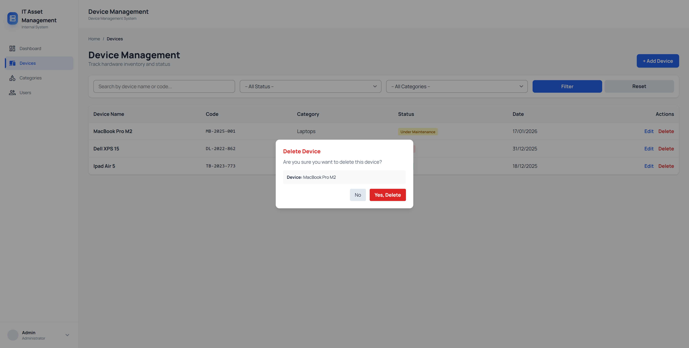
Figure 6. Delete Device Popup

6.2. Category Management
Shows the Categories list.
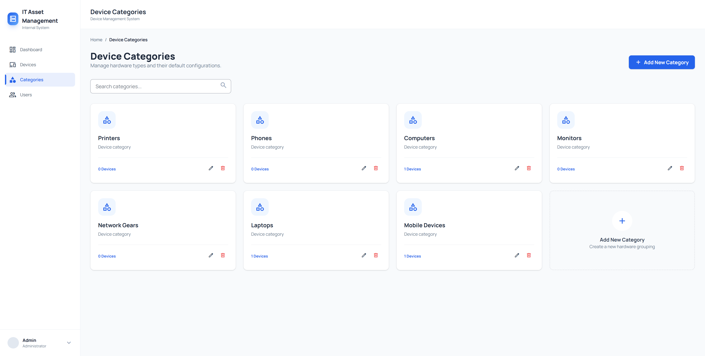
Figure 7. Category Management Page
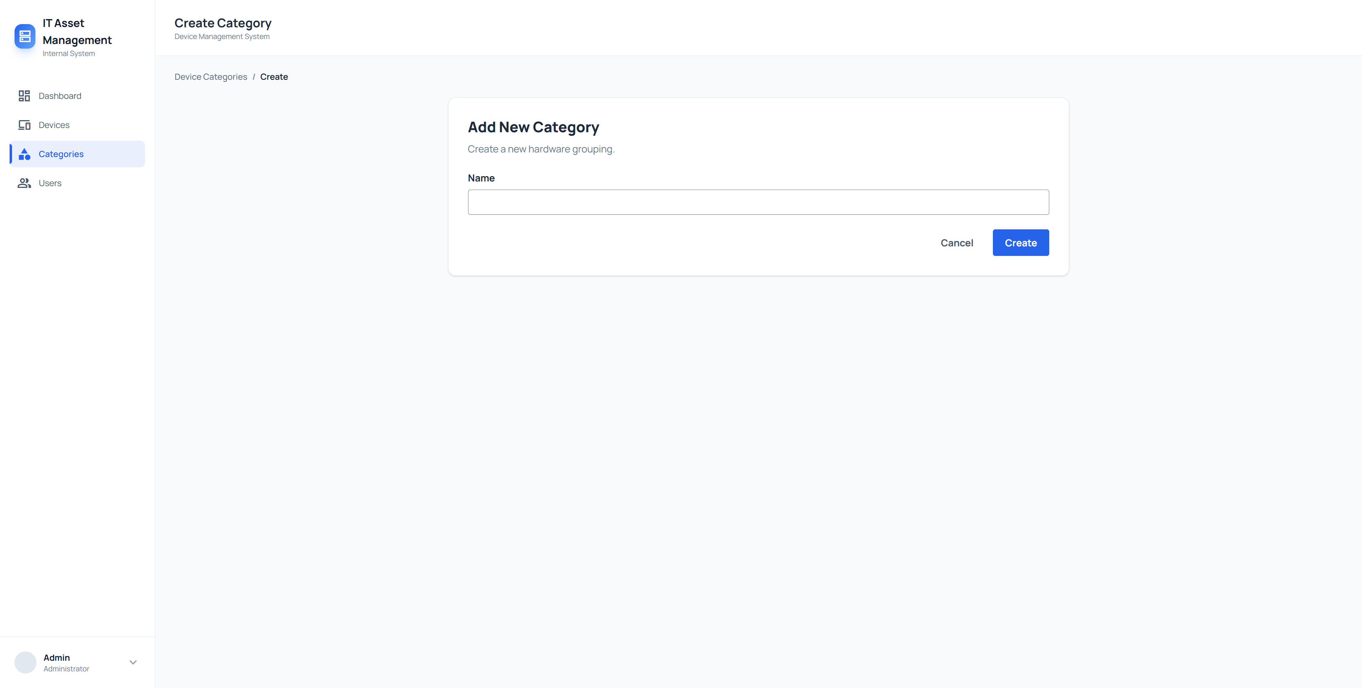
Figure 8. Create Category Page
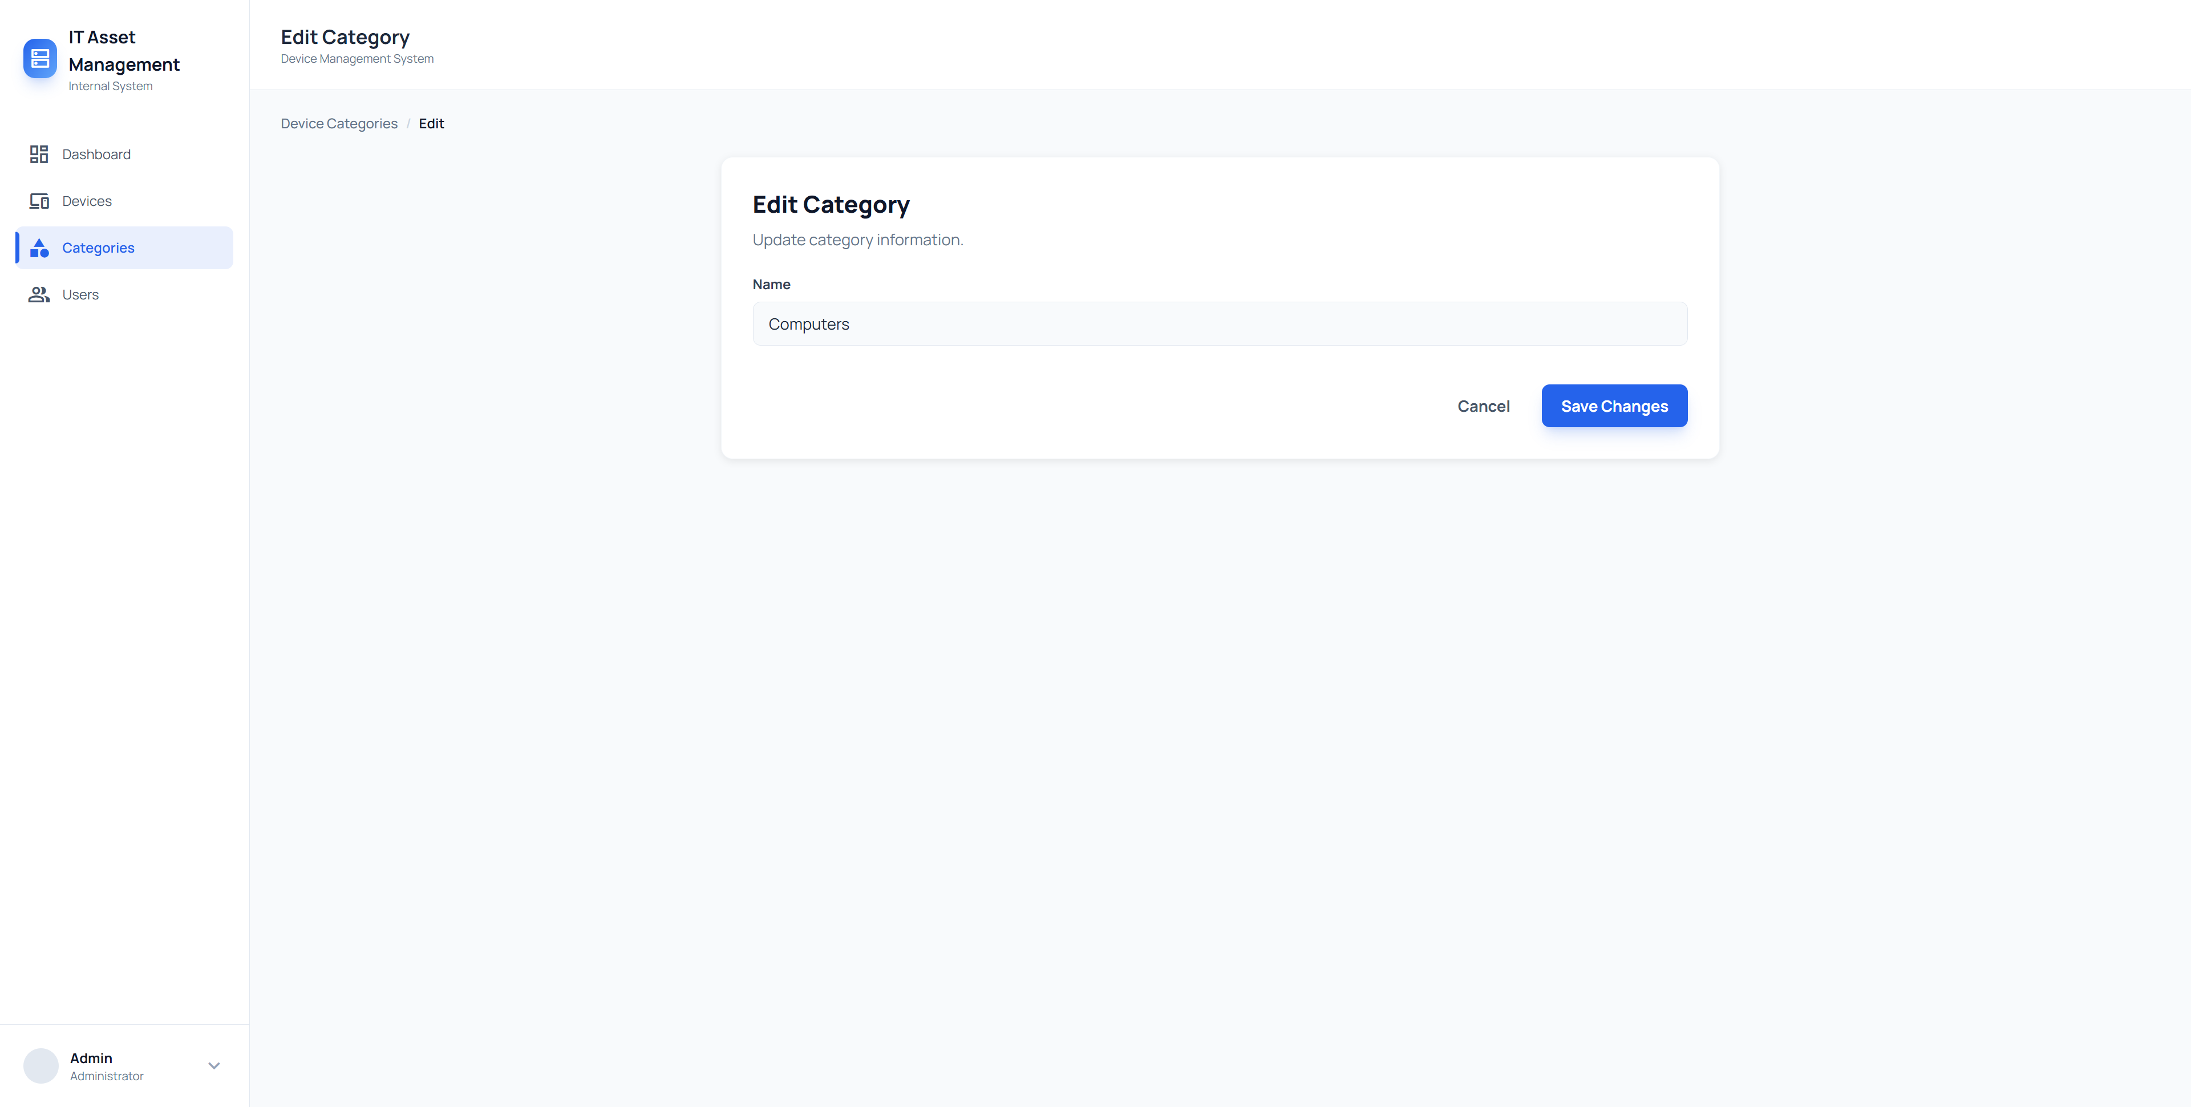
Figure 9. Edit Category Page
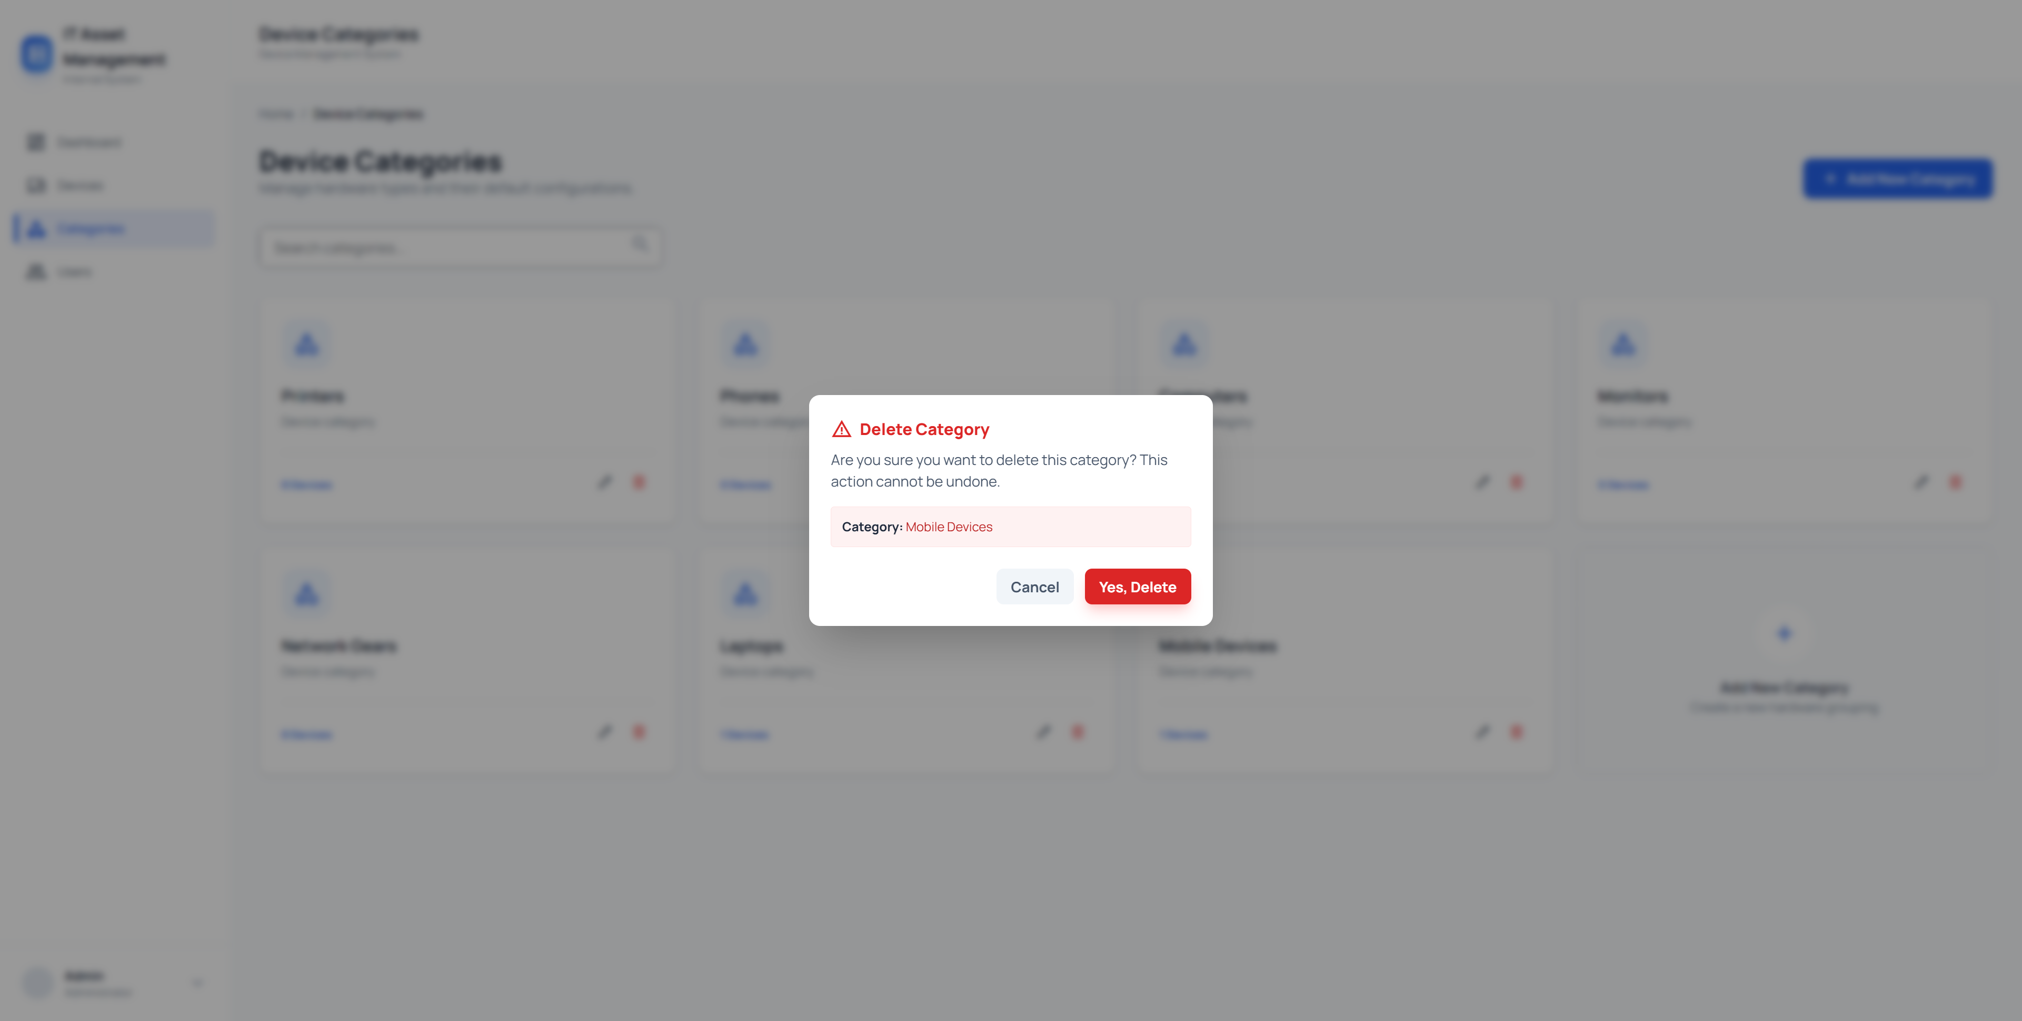
Figure 10. Delete Category Page

6.3. User Management & Roles
Shows the User list with “Admin” and “Employee” badges.
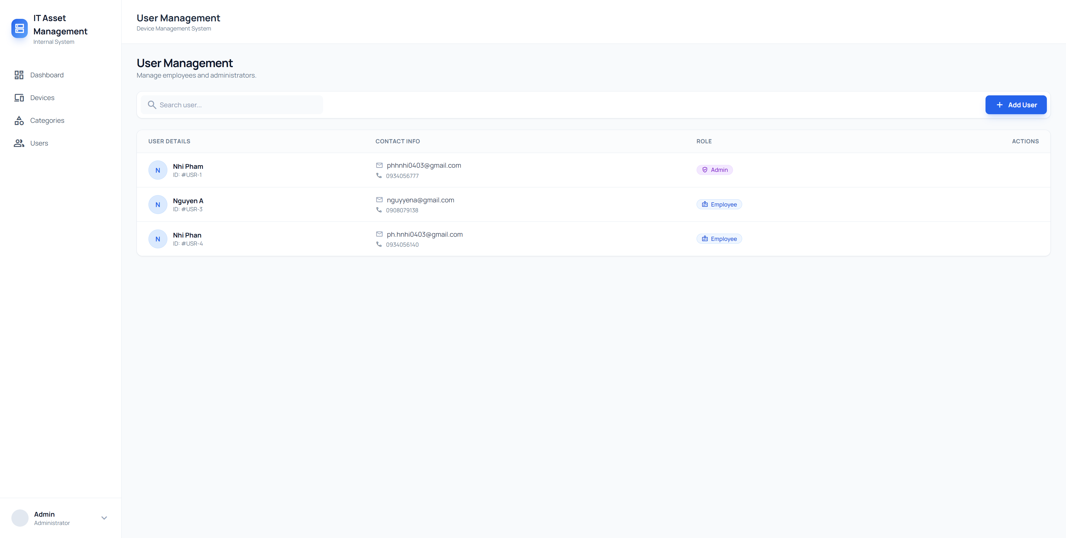
Figure 11. Category Management Page
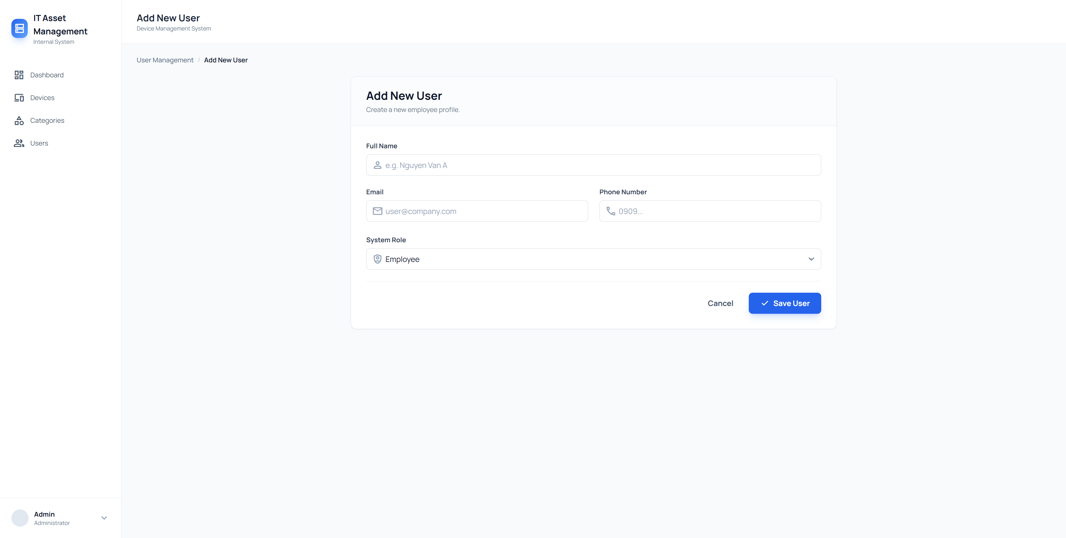
Figure 12. Add User Page
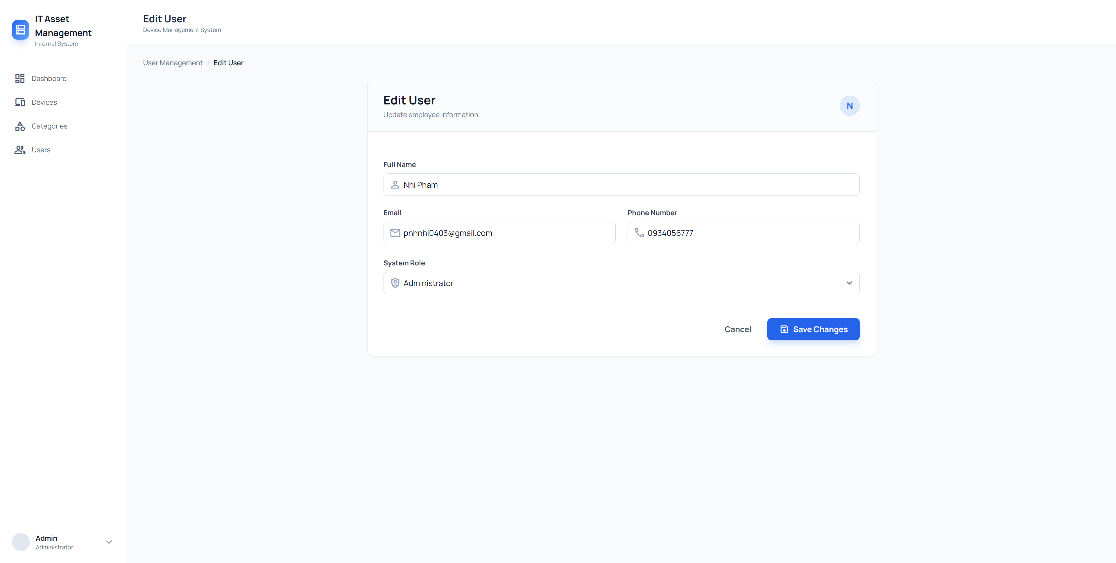
Figure 13. Edit User Page

7. Conclusion
The Device Management System successfully fulfills all assignment requirements. It demonstrates a solid understanding of ASP.NET Core MVC architecture, database relationships, and modern UI design principles. The inclusion of User Roles and Advanced Filtering adds significant value to the application, making it ready for future expansion.

