EASTERN INTERNATIONAL UNIVERSITY    SCHOOL OF COMPUTING AND INFORMATION TECHNOLOGY | Practice Assignment – Quarter 2, 2024-2025  Course Name: Coding Practice  Course Code: CSE 422  Student’s Full Name: Phan Ngọc Hạnh Nhi  Student ID: 2131209002
Practice Assignment 4

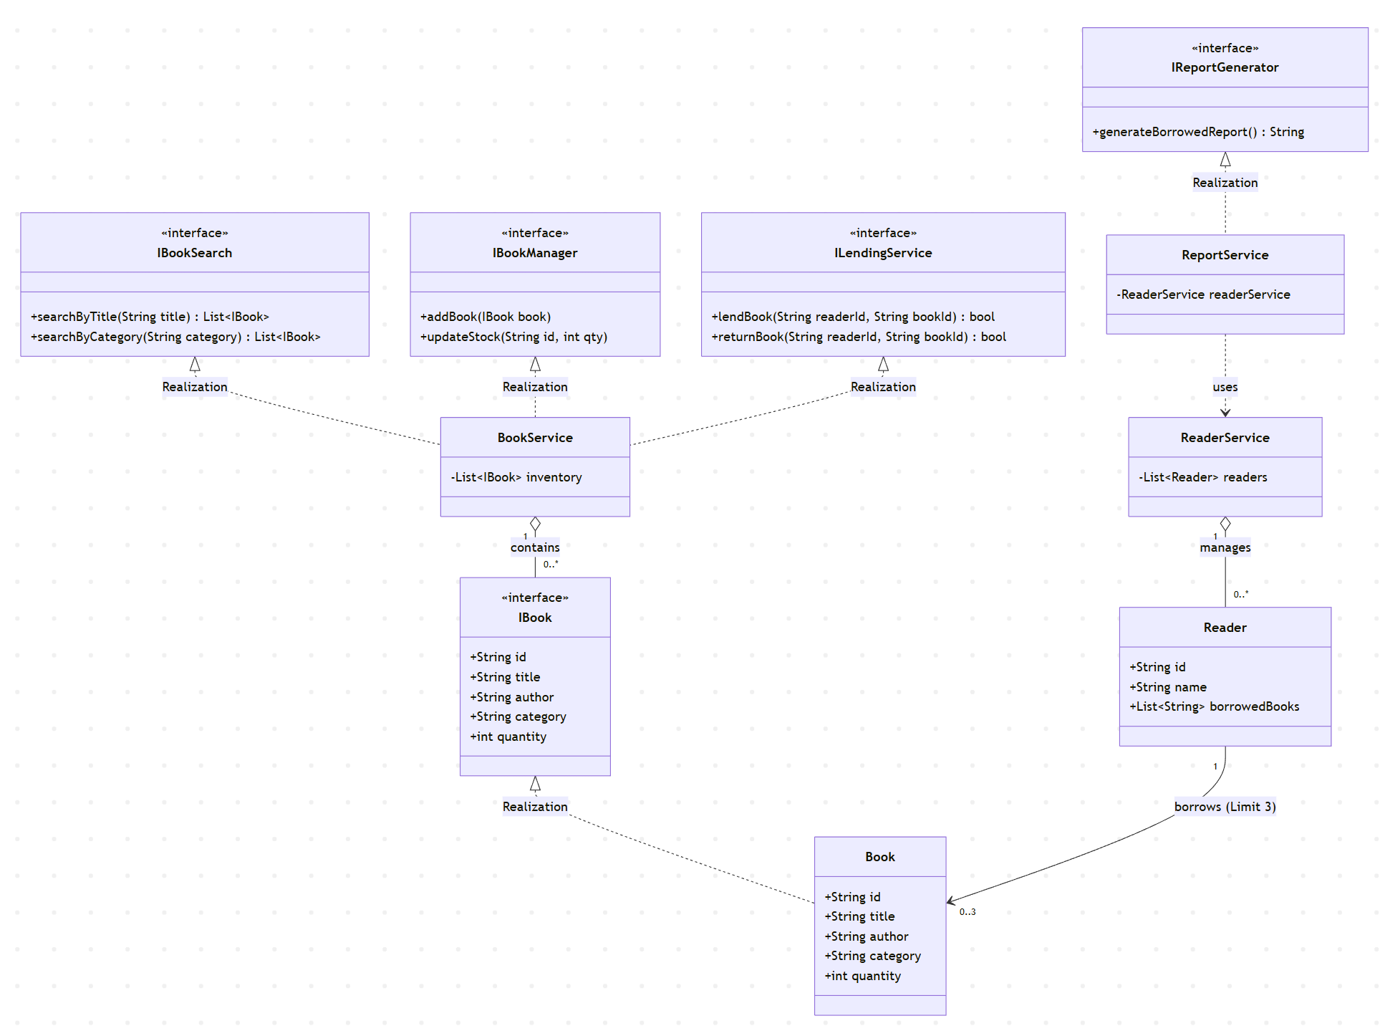
3.1. Application of SOLID Principles
Principle | Implementation in this Design
S - Single Responsibility | Each class has a single focus. BookService handles inventory logic, while ReportService is solely responsible for data aggregation and output formatting.
O - Open/Closed | New book types (e.g., eBooks, Magazines) can be added by creating new classes that implement the IBook interface. We do not need to modify the existing BookService to support them.
L - Liskov Substitution | The LendingService processes any IBook type. Whether it is a physical Book or a digital eBook, the system functions correctly without knowing the specific subtype.
I - Interface Segregation | We split functionalities into specific interfaces: IBookSearch for users and IBookManager for administrators. This ensures clients only depend on the methods they actually use.
D - Dependency Inversion | High-level modules (the main application logic) depend on abstractions (IBook, ILendingService) rather than concrete implementations, allowing for easy swaps of logic or storage.
3.2. Future Extensibility Proposals
To ensure the system remains robust as requirements grow, I propose the following:
- Handling eBooks and Magazines:
  - Strategy: Create EBook and Magazine classes implementing IBook.
  - Logic: For EBook, the updateStock method can be overridden to represent “unlimited” quantity, or the lendBook method can provide a download link instead of tracking physical inventory.
- Book Reservation System:
  - Strategy: Introduce an IReservation interface.
  - Logic: If a book's quantity is 0, the system creates a Reservation object linking a Reader ID to a Book ID in a queue, without modifying the core Book class attributes.
- Persistence Layer:
  - Strategy: Implement a Repository Pattern.
  - Logic: Transition from in-memory List storage to a database (SQL/NoSQL) by creating a DatabaseBookRepository that implements the IBookManager and IBookSearch interfaces.

