EASTERN INTERNATIONAL UNIVERSITY    SCHOOL OF COMPUTING AND INFORMATION TECHNOLOGY | Practice Assignment – Quarter 2, 2024-2025  Course Name: Coding Practice  Course Code: CSE 422  Student’s Full Name: Phan Ngọc Hạnh Nhi  Student ID: 2131209002
Practice Assignment 6

Design Pattern
I.DON’T REPEAT YOURSELF (DRY)

Exercise 1: Applying “Reflection” to Reduce Redundancy in Logging
You have a logging system as follows:

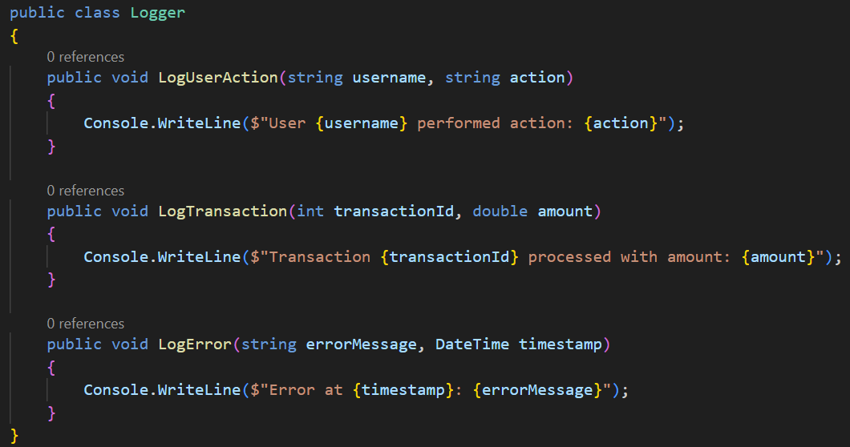

Requirements:
- What are Reflection and Expression Trees?
- Reflection
Reflection is a feature in .NET that allows you to inspect metadata about assemblies, modules, and types at runtime. With Reflection, you can dynamically:
- Identify the properties, methods, and events of an object.
- Instantiate types and invoke methods that aren't known at compile time.
- Access attributes applied to classes or members.
- Expression Trees
Expression Trees represent code in a tree-like data structure, where each node is an expression (e.g., a method call or a binary operation).
- They allow you to represent lambda expressions as data rather than executable code.
- They are commonly used to build dynamic queries (like in LINQ to SQL) or to compile high-performance dynamic code at runtime.
- Analyze the redundancy in the above code.
The provided Logger class suffers from several DRY (Don't Repeat Yourself) violations:
- Structural Repetition: Each method (LogUserAction, LogTransaction, LogError) follows the exact same pattern: taking parameters and printing a string to the console.
- Boilerplate Code: Every time a new type of event needs to be logged, a developer must manually write a new method, define the string format, and call Console.WriteLine.
- Maintenance Burden: If you decided to change the logging output (e.g., writing to a file or adding a global timestamp), you would have to modify every single method individually.
- Rewrite the code using Reflection or Expression Trees to eliminate redundancy in logging.
- using System;
- using System.Linq.Expressions;
- using System.Reflection;

- public class Logger
- {
- public void LogUserAction(string username, string action)
- {
- Console.WriteLine($"User {username} performed action: {action}");
- }

- public void LogTransaction(int transactionId, double amount)
- {
- Console.WriteLine($"Transaction {transactionId} processed with amount: {amount}");
- }

- public void LogError(string errorMessage, DateTime timestamp)
- {
- Console.WriteLine($"Error at {timestamp}: {errorMessage}");
- }
- }

- public class ReflectionLogger
- {
- public void LogUserAction(string username, string action)
- => Log(MethodBase.GetCurrentMethod()!, username, action);

- public void LogTransaction(int transactionId, double amount)
- => Log(MethodBase.GetCurrentMethod()!, transactionId, amount);

- public void LogError(string errorMessage, DateTime timestamp)
- => Log(MethodBase.GetCurrentMethod()!, errorMessage, timestamp);

- private static void Log(MethodBase method, params object?[] args)
- {
- ParameterInfo[] parameters = method.GetParameters();

- var parts = new System.Text.StringBuilder();
- for (int i = 0; i < parameters.Length; i++)
- {
- if (i > 0) parts.Append(", ");
- parts.Append($"{parameters[i].Name} = {args[i]}");
- }

- Console.WriteLine($"[Reflection] {method.Name} => {parts}");
- }
- }

- public static class ExpressionLogger
- {
- public static void Log(Expression<Action> expression)
- {
- var call = (MethodCallExpression)expression.Body;

- string methodName = call.Method.Name;
- ParameterInfo[] parameters = call.Method.GetParameters();

- var parts = new System.Text.StringBuilder();
- for (int i = 0; i < parameters.Length; i++)
- {
- object? value = Expression.Lambda(call.Arguments[i]).Compile().DynamicInvoke();
- if (i > 0) parts.Append(", ");
- parts.Append($"{parameters[i].Name} = {value}");
- }

- Console.WriteLine($"[ExpressionTree] {methodName} => {parts}");
- }
- }

- public static class Exercise1Runner
- {
- public static void Run()
- {
- Console.WriteLine("══════════════════════════════════════════════════════");
- Console.WriteLine(" Exercise 1 – Reflection & Expression Trees Logging");
- Console.WriteLine("══════════════════════════════════════════════════════\n");

- var logger = new Logger();
- var reflLogger = new ReflectionLogger();

- Console.WriteLine("─── Original Logger (redundant) ───");
- logger.LogUserAction("Alice", "Login");
- logger.LogTransaction(1001, 250.75);
- logger.LogError("Null reference exception", new DateTime(2026, 3, 7, 13, 0, 0));

- Console.WriteLine();

- Console.WriteLine("─── Refactored with Reflection ───");
- reflLogger.LogUserAction("Alice", "Login");
- reflLogger.LogTransaction(1001, 250.75);
- reflLogger.LogError("Null reference exception", new DateTime(2026, 3, 7, 13, 0, 0));

- Console.WriteLine();

- Console.WriteLine("─── Refactored with Expression Trees ───");
- ExpressionLogger.Log(() => logger.LogUserAction("Alice", "Login"));
- ExpressionLogger.Log(() => logger.LogTransaction(1001, 250.75));
- ExpressionLogger.Log(() => logger.LogError("Null reference exception", new DateTime(2026, 3, 7, 13, 0, 0)));

- Console.WriteLine();
- Console.WriteLine("══════════════════════════════════════════════════════");
- }
- }

Exercise 2: Applying Dependency Injection to Remove Redundancy in the Repository Pattern
You have two repositories storing data from SQL Server:

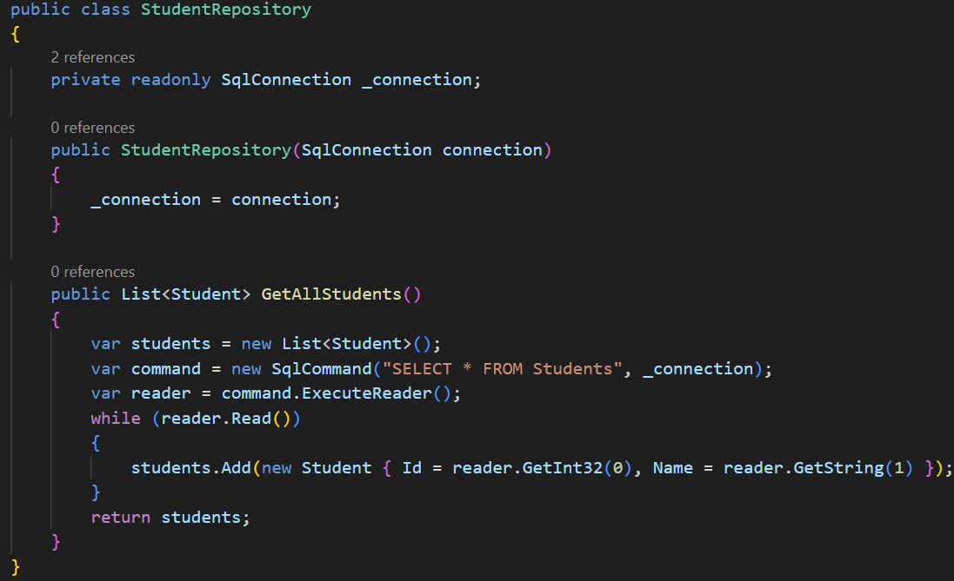
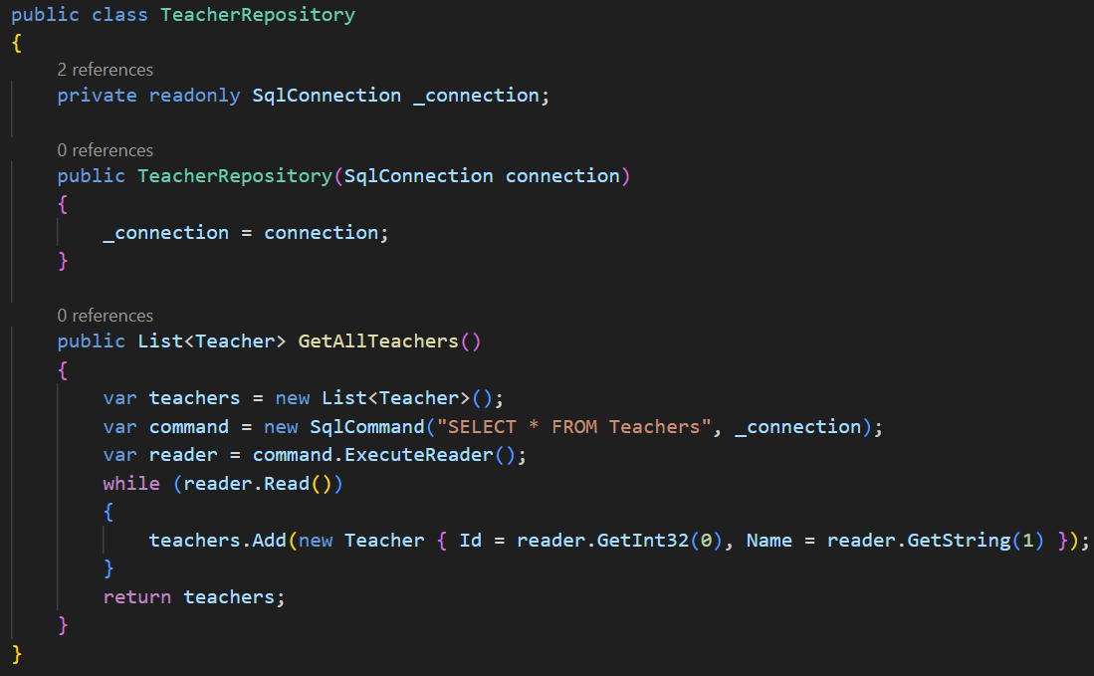

Requirements:
- Identify DRY violations in the above code.
The StudentRepository and TeacherRepository exhibit several Don’t Repeat Yourself (DRY) violations:
- Connection Boilerplate: Both classes manually declare, store, and initialize a SqlConnection via the constructor.
- Logic Duplication: The internal logic for GetAllStudents() and GetAllTeachers() is nearly identical:
  - Initializing a List<T>.
  - Creating and executing a SqlCommand.
  - Iterating through a SqlDataReader.
- Mapping Redundancy: The way properties (Id, Name) are read from the database is hardcoded in both places, making the code brittle if the database schema changes slightly across different tables.
- Rewrite the code using Generic Repository Pattern combined with Dependency Injection to reduce redundancy.
- using System;
- using System.Collections.Generic;
- using System.Data;
- using System.Linq;

- public class Student : IEntity
- {
- public int Id { get; set; }
- public string Name { get; set; } = "";
- }

- public class Teacher : IEntity
- {
- public int Id { get; set; }
- public string Name { get; set; } = "";
- }

- public class StudentRepository
- {
- private readonly IDbConnection _connection;

- public StudentRepository(IDbConnection connection)
- {
- _connection = connection;
- }

- public List<Student> GetAllStudents()
- {
- var students = new List<Student>();
- var command = _connection.CreateCommand();
- command.CommandText = "SELECT * FROM Students";
- var reader = command.ExecuteReader();
- while (reader.Read())
- {
- students.Add(new Student { Id = (int)reader[0], Name = (string)reader[1] });
- }
- reader.Close();
- return students;
- }
- }

- public class TeacherRepository
- {
- private readonly IDbConnection _connection;

- public TeacherRepository(IDbConnection connection)
- {
- _connection = connection;
- }

- public List<Teacher> GetAllTeachers()
- {
- var teachers = new List<Teacher>();
- // Simulated query: SELECT * FROM Teachers
- var command = _connection.CreateCommand();
- command.CommandText = "SELECT * FROM Teachers";
- var reader = command.ExecuteReader();
- while (reader.Read())
- {
- teachers.Add(new Teacher { Id = (int)reader[0], Name = (string)reader[1] });
- }
- reader.Close();
- return teachers;
- }
- }

- public interface IEntity
- {
- int Id { get; set; }
- }

- public interface IRepository<T> where T : class, IEntity
- {
- List<T> GetAll();
- T? GetById(int id);
- void Add(T entity);
- void Delete(int id);
- }

- public class InMemoryRepository<T> : IRepository<T> where T : class, IEntity
- {
- private readonly List<T> _store;

- public InMemoryRepository(List<T> seedData)
- {
- _store = seedData;
- }

- public List<T> GetAll() => new List<T>(_store);

- public T? GetById(int id) => _store.FirstOrDefault(e => e.Id == id);

- public void Add(T entity)
- {
- _store.Add(entity);
- Console.WriteLine($"[Repository] Added {typeof(T).Name}: Id={entity.Id}");
- }

- public void Delete(int id)
- {
- var entity = GetById(id);
- if (entity != null)
- {
- _store.Remove(entity);
- Console.WriteLine($"[Repository] Deleted {typeof(T).Name}: Id={id}");
- }
- }
- }

- public class StudentService
- {
- private readonly IRepository<Student> _repository;

- public StudentService(IRepository<Student> repository)
- {
- _repository = repository;
- }

- public void PrintAll()
- {
- Console.WriteLine(" Students:");
- foreach (var s in _repository.GetAll())
- Console.WriteLine($" Id={s.Id}, Name={s.Name}");
- }

- public void Add(Student student) => _repository.Add(student);
- public void Delete(int id) => _repository.Delete(id);
- }

- public class TeacherService
- {
- private readonly IRepository<Teacher> _repository;

- public TeacherService(IRepository<Teacher> repository)
- {
- _repository = repository;
- }

- public void PrintAll()
- {
- Console.WriteLine(" Teachers:");
- foreach (var t in _repository.GetAll())
- Console.WriteLine($" Id={t.Id}, Name={t.Name}");
- }

- public void Add(Teacher teacher) => _repository.Add(teacher);
- public void Delete(int id) => _repository.Delete(id);
- }

- // =====================================================================
- // SIMPLE DI CONTAINER (manual composition root)
- // =====================================================================
- public static class ServiceContainer
- {
- public static StudentService BuildStudentService()
- {
- var seedData = new List<Student>
- {
- new Student { Id = 1, Name = "Alice" },
- new Student { Id = 2, Name = "Bob" },
- };
- IRepository<Student> repo = new InMemoryRepository<Student>(seedData);
- return new StudentService(repo);
- }

- public static TeacherService BuildTeacherService()
- {
- var seedData = new List<Teacher>
- {
- new Teacher { Id = 1, Name = "Dr. Smith" },
- new Teacher { Id = 2, Name = "Prof. Johnson" },
- };
- IRepository<Teacher> repo = new InMemoryRepository<Teacher>(seedData);
- return new TeacherService(repo);
- }
- }

- public static class Exercise2Runner
- {
- public static void Run()
- {
- Console.WriteLine("══════════════════════════════════════════════════════");
- Console.WriteLine(" Exercise 2 – Generic Repository + Dependency Injection");
- Console.WriteLine("══════════════════════════════════════════════════════\n");

- var studentService = ServiceContainer.BuildStudentService();
- var teacherService = ServiceContainer.BuildTeacherService();

- Console.WriteLine("── GetAll ──");
- studentService.PrintAll();
- teacherService.PrintAll();

- Console.WriteLine();
- Console.WriteLine("── Add ──");
- studentService.Add(new Student { Id = 3, Name = "Charlie" });
- teacherService.Add(new Teacher { Id = 3, Name = "Dr. Lee" });

- Console.WriteLine();
- Console.WriteLine("── After Add ──");
- studentService.PrintAll();
- teacherService.PrintAll();

- Console.WriteLine();
- Console.WriteLine("── Delete (Id = 1) ──");
- studentService.Delete(1);
- teacherService.Delete(1);

- Console.WriteLine();
- Console.WriteLine("── After Delete ──");
- studentService.PrintAll();
- teacherService.PrintAll();

- Console.WriteLine();
- Console.WriteLine("══════════════════════════════════════════════════════");
- }
- }

Exercise 3: Using Generic Constraints to Eliminate Redundancy in API Request Handling
You have an API Controller handling two different object types as follows:
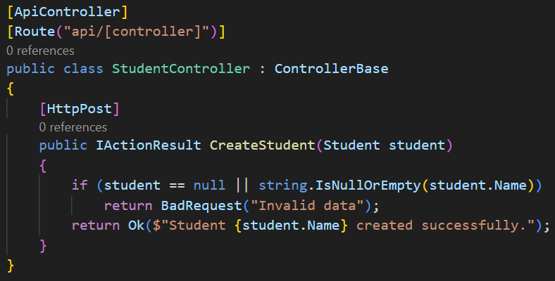
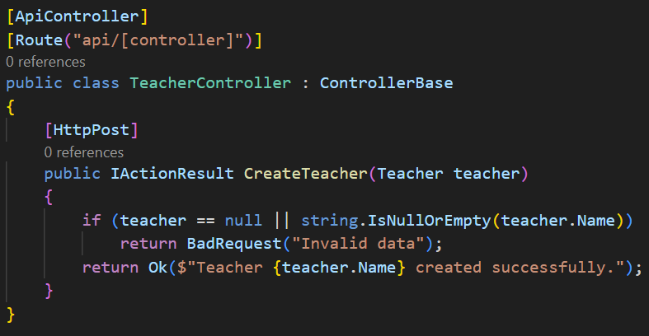

Requirements:
- Identify redundancy in the above code.
The StudentController and TeacherController exhibit significant DRY (Don't Repeat Yourself) violations in their request handling logic:
- Logic Duplication: Both the CreateStudent and CreateTeacher methods perform the exact same validation steps: checking if the object is null and verifying if the Name property is null or empty.
- Response Pattern Redundancy: The return patterns are identical; both return a BadRequest with the message "Invalid data" for failures and an Ok result with a success string upon completion.
- Boilerplate Controller Setup: Every time a new entity type is added (e.g., Course), a developer would currently have to create an entirely new controller class and manually rewrite this validation logic.
- Rewrite the code using a Generic Base Controller and Generic Constraints to reduce duplication in API request handling.
- using System;
- public interface IActionResult
- {
- void Execute();
- }

- public class OkResult : IActionResult
- {
- private readonly string _message;
- public OkResult(string message) { _message = message; }
- public void Execute() => Console.WriteLine($" 200 OK: {_message}");
- }

- public class BadRequestResult : IActionResult
- {
- private readonly string _error;
- public BadRequestResult(string error) { _error = error; }
- public void Execute() => Console.WriteLine($" 400 Bad Request: {_error}");
- }

- public abstract class ControllerBase
- {
- protected IActionResult Ok(string message) => new OkResult(message);
- protected IActionResult BadRequest(string error) => new BadRequestResult(error);
- }

- public interface INamedEntity : IEntity
- {
- string Name { get; set; }
- }

- public class StudentController : ControllerBase
- {
- public IActionResult CreateStudent(Student student)
- {
- if (student == null || string.IsNullOrEmpty(student.Name))
- return BadRequest("Invalid data");
- return Ok($"Student {student.Name} created successfully.");
- }
- }

- public class TeacherController : ControllerBase
- {
- public IActionResult CreateTeacher(Teacher teacher)
- {
- if (teacher == null || string.IsNullOrEmpty(teacher.Name))
- return BadRequest("Invalid data");
- return Ok($"Teacher {teacher.Name} created successfully.");
- }
- }

- public abstract class GenericController<T> : ControllerBase where T : class, INamedEntity
- {
- public IActionResult Create(T entity)
- {
- if (entity == null || string.IsNullOrEmpty(entity.Name))
- return BadRequest("Invalid data");
- return Ok($"{typeof(T).Name} {entity.Name} created successfully.");
- }

- public IActionResult GetById(T entity)
- {
- if (entity == null)
- return BadRequest("Entity not found");
- return Ok($"Found {typeof(T).Name}: Id={entity.Id}, Name={entity.Name}");
- }
- }

- public class StudentApiController : GenericController<Student> { }
- public class TeacherApiController : GenericController<Teacher> { }

- public static class Exercise3Runner
- {
- public static void Run()
- {
- Console.WriteLine("══════════════════════════════════════════════════════");
- Console.WriteLine(" Exercise 3 – Generic Base Controller + Constraints");
- Console.WriteLine("══════════════════════════════════════════════════════\n");

- Console.WriteLine("─── Original Controllers (redundant) ───");
- var origStudent = new StudentController();
- var origTeacher = new TeacherController();

- origStudent.CreateStudent(new Student { Id = 1, Name = "Alice" }).Execute();
- origStudent.CreateStudent(new Student { Id = 2, Name = "" }).Execute();
- origTeacher.CreateTeacher(new Teacher { Id = 1, Name = "Dr. Smith" }).Execute();
- origTeacher.CreateTeacher(null!).Execute();

- Console.WriteLine();
- Console.WriteLine("─── Generic Controllers (no duplicated logic) ───");
- var studentApi = new StudentApiController();
- var teacherApi = new TeacherApiController();

- studentApi.Create(new Student { Id = 1, Name = "Alice" }).Execute();
- studentApi.Create(new Student { Id = 2, Name = "" }).Execute();
- teacherApi.Create(new Teacher { Id = 1, Name = "Dr. Smith" }).Execute();
- teacherApi.Create(null!).Execute();

- Console.WriteLine();
- Console.WriteLine("─── GetById (bonus – shared by all controllers via base) ───");
- studentApi.GetById(new Student { Id = 1, Name = "Alice" }).Execute();
- teacherApi.GetById(new Teacher { Id = 1, Name = "Dr. Smith" }).Execute();

- Console.WriteLine();
- Console.WriteLine("══════════════════════════════════════════════════════");
- }

Exercise 4: Combining Strategy Pattern with Factory Pattern to Avoid Redundancy in Payment Processing
You have a payment system that supports multiple payment methods:
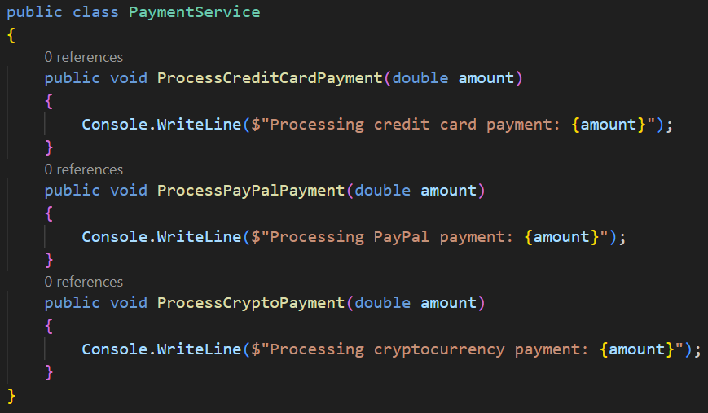

Requirements:
- What are Strategy Pattern and Factory Pattern?
- Strategy Pattern
The Strategy Pattern is a behavioral design pattern that defines a family of algorithms, encapsulates each one, and makes them interchangeable.
- It allows the client to choose an algorithm at runtime without modifying the class that uses it.
- In this exercise, each payment method (Credit Card, PayPal, Crypto) becomes its own "Strategy."
- Factory Pattern
The Factory Pattern is a creational design pattern that provides an interface for creating objects in a superclass but allows subclasses to alter the type of objects that will be created.
- It centralizes object instantiation logic.
- Instead of the main service "knowing" how to create every payment type, it asks a Factory for the correct one.
- Identify DRY violations in the above code.
The PaymentService class in the image has several DRY (Don't Repeat Yourself) violations:
- Method Explosion: Every new payment method requires a brand-new method (ProcessCreditCardPayment, ProcessPayPalPayment, etc.) with nearly identical signatures.
- Logic Duplication: The core "intent" (logging the processing message) is repeated three times, differing only by a string.
- Rigid Maintenance: To add a fourth payment method (e.g., Apple Pay), you must modify the PaymentService class directly, violating the Open/Closed Principle.
- Rewrite the code using Strategy Pattern combined with Factory Pattern to eliminate redundancy and allow easy expansion for new payment methods.
- using System;
- using System.Collections.Generic;

- public class PaymentService
- {
- public void ProcessCreditCardPayment(double amount)
- {
- Console.WriteLine($"Processing credit card payment: {amount}");
- }

- public void ProcessPayPalPayment(double amount)
- {
- Console.WriteLine($"Processing PayPal payment: {amount}");
- }

- public void ProcessCryptoPayment(double amount)
- {
- Console.WriteLine($"Processing cryptocurrency payment: {amount}");
- }
- }

- public interface IPaymentStrategy
- {
- void Process(double amount);
- }

- public class CreditCardPayment : IPaymentStrategy
- {
- public void Process(double amount)
- => Console.WriteLine($"Processing credit card payment: {amount}");
- }

- public class PayPalPayment : IPaymentStrategy
- {
- public void Process(double amount)
- => Console.WriteLine($"Processing PayPal payment: {amount}");
- }

- public class CryptoPayment : IPaymentStrategy
- {
- public void Process(double amount)
- => Console.WriteLine($"Processing cryptocurrency payment: {amount}");
- }

- public static class PaymentFactory
- {
- private static readonly Dictionary<string, Func<IPaymentStrategy>> _registry
- = new(StringComparer.OrdinalIgnoreCase)
- {
- ["creditcard"] = () => new CreditCardPayment(),
- ["paypal"] = () => new PayPalPayment(),
- ["crypto"] = () => new CryptoPayment(),
- };

- public static IPaymentStrategy Create(string method)
- {
- if (_registry.TryGetValue(method, out var factory))
- return factory();

- throw new NotSupportedException($"Payment method '{method}' is not supported.");
- }

- public static void Register(string method, Func<IPaymentStrategy> factory)
- => _registry[method] = factory;
- }

- public class PaymentProcessor
- {
- public void Process(string method, double amount)
- {
- IPaymentStrategy strategy = PaymentFactory.Create(method);
- strategy.Process(amount);
- }
- }

- public static class Exercise4Runner
- {
- public static void Run()
- {
- Console.WriteLine("══════════════════════════════════════════════════════");
- Console.WriteLine(" Exercise 4 – Strategy Pattern + Factory Pattern");
- Console.WriteLine("══════════════════════════════════════════════════════\n");

- Console.WriteLine("─── Original PaymentService (redundant) ───");
- var original = new PaymentService();
- original.ProcessCreditCardPayment(100.0);
- original.ProcessPayPalPayment(200.0);
- original.ProcessCryptoPayment(300.0);

- Console.WriteLine();
- Console.WriteLine("─── Refactored PaymentProcessor (Strategy + Factory) ───");
- var processor = new PaymentProcessor();
- processor.Process("creditcard", 100.0);
- processor.Process("paypal", 200.0);
- processor.Process("crypto", 300.0);

- Console.WriteLine();
- Console.WriteLine("─── Adding a new payment method without changing existing code ───");
- PaymentFactory.Register("bankwire", () => new BankWirePayment());
- processor.Process("bankwire", 500.0);

- Console.WriteLine();
- Console.WriteLine("─── Unsupported method (exception handling) ───");
- try
- {
- processor.Process("bitcoin", 999.0);
- }
- catch (NotSupportedException ex)
- {
- Console.WriteLine($" Error: {ex.Message}");
- }

- Console.WriteLine();
- Console.WriteLine("══════════════════════════════════════════════════════");
- }
- }

- public class BankWirePayment : IPaymentStrategy
- {
- public void Process(double amount)
- => Console.WriteLine($"Processing bank wire payment: {amount}");
- }

Exercise 5: Eliminating Redundancy in Cache Handling with Decorator Pattern
You have a service handling data queries with caching as follows:
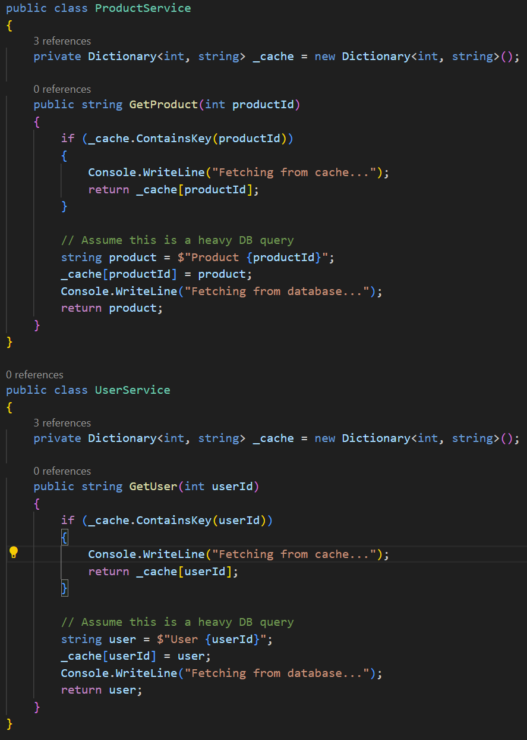

Requirements:
- Identify redundancy in cache handling.
The ProductService and UserService in the image show several DRY violations:
- Cross-Cutting Concern: Caching is a "cross-cutting concern" that has been mixed directly into the core business logic (fetching the data).
- Identical Caching Logic: Both services repeat the exact same three-step process: check the dictionary, return if found, otherwise query the DB and update the dictionary.
- Scalability Issues: If you wanted to change the caching mechanism (e.g., using Redis instead of a Dictionary), you would have to modify every single service class in the system.
- Rewrite the code using the Decorator Pattern to avoid duplication in caching for both ProductService and UserService.
- using System;
- using System.Collections.Generic;

- public class ProductService
- {
- private Dictionary<int, string> _cache = new Dictionary<int, string>();

- public string GetProduct(int productId)
- {
- if (_cache.ContainsKey(productId))
- {
- Console.WriteLine("Fetching from cache...");
- return _cache[productId];
- }

- string product = $"Product {productId}";
- _cache[productId] = product;
- Console.WriteLine("Fetching from database...");
- return product;
- }
- }

- public class UserService
- {
- private Dictionary<int, string> _cache = new Dictionary<int, string>();

- public string GetUser(int userId)
- {
- if (_cache.ContainsKey(userId))
- {
- Console.WriteLine("Fetching from cache...");
- return _cache[userId];
- }

- string user = $"User {userId}";
- _cache[userId] = user;
- Console.WriteLine("Fetching from database...");
- return user;
- }
- }

- public interface IDataService
- {
- string Get(int id);
- }

- public class ProductDataService : IDataService
- {
- public string Get(int id)
- {
- Console.WriteLine("Fetching from database...");
- return $"Product {id}";
- }
- }

- public class UserDataService : IDataService
- {
- public string Get(int id)
- {
- Console.WriteLine("Fetching from database...");
- return $"User {id}";
- }
- }

- public class CachedDataService : IDataService
- {
- private readonly IDataService _inner;
- private readonly Dictionary<int, string> _cache = new Dictionary<int, string>();

- public CachedDataService(IDataService inner)
- {
- _inner = inner;
- }

- public string Get(int id)
- {
- if (_cache.ContainsKey(id))
- {
- Console.WriteLine("Fetching from cache...");
- return _cache[id];
- }

- string result = _inner.Get(id);
- _cache[id] = result;
- return result;
- }
- }

- public static class Exercise5Runner
- {
- public static void Run()
- {
- Console.WriteLine("══════════════════════════════════════════════════════");
- Console.WriteLine(" Exercise 5 – Decorator Pattern for Cache Handling");
- Console.WriteLine("══════════════════════════════════════════════════════\n");

- Console.WriteLine("─── Original (cache logic duplicated in each service) ───");
- var productSvc = new ProductService();
- Console.WriteLine(productSvc.GetProduct(1));
- Console.WriteLine(productSvc.GetProduct(1));

- var userSvc = new UserService();
- Console.WriteLine(userSvc.GetUser(10));
- Console.WriteLine(userSvc.GetUser(10));

- Console.WriteLine();
- Console.WriteLine("─── Refactored with Decorator Pattern ───");

- IDataService cachedProduct = new CachedDataService(new ProductDataService());
- Console.WriteLine(cachedProduct.Get(1));
- Console.WriteLine(cachedProduct.Get(1));

- IDataService cachedUser = new CachedDataService(new UserDataService());
- Console.WriteLine(cachedUser.Get(10));
- Console.WriteLine(cachedUser.Get(10));

- Console.WriteLine();
- Console.WriteLine("══════════════════════════════════════════════════════");
- }
- }

II. PACKAGES
Exercise 6: Based on the principles of Packages in Architecture, design a solution in .NET consisting of multiple projects, where each project serves as a package responsible for a specific functionality. Determine the minimum number of projects required to build a complete library management system, and explain the role of each project within the overall architecture. Ensure that the system is scalable, maintainable, and can be easily upgraded in the future.

