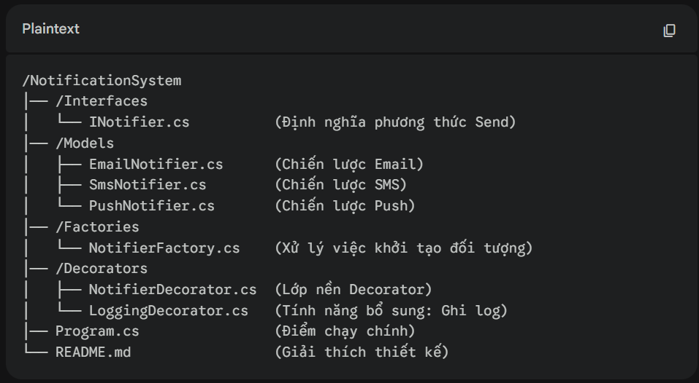
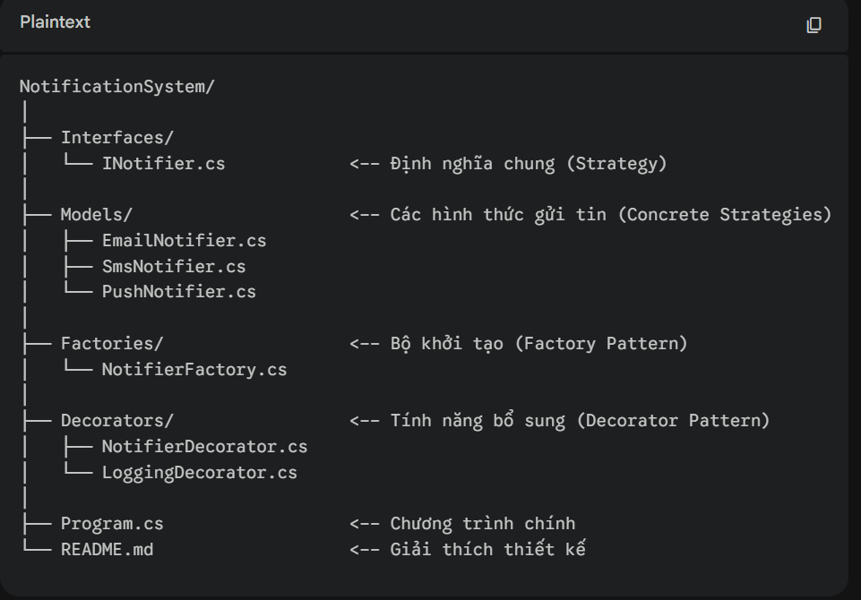
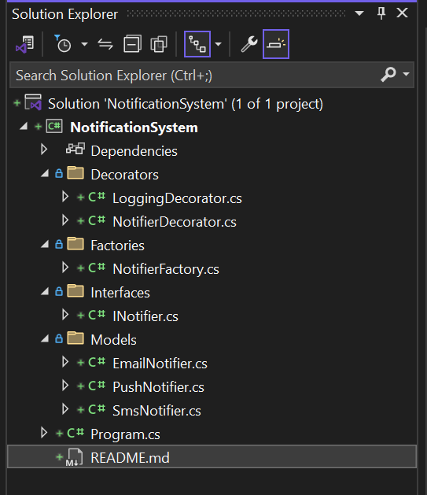
/NotificationSystem
│── /Interfaces
│ └── INotifier.cs (Định nghĩa phương thức Send)
│── /Models
│ ├── EmailNotifier.cs (Chiến lược Email)
│ ├── SmsNotifier.cs (Chiến lược SMS)
│ └── PushNotifier.cs (Chiến lược Push)
│── /Factories
│ └── NotifierFactory.cs (Xử lý việc khởi tạo đối tượng)
│── /Decorators
│ ├── NotifierDecorator.cs (Lớp nền Decorator)
│ └── LoggingDecorator.cs (Tính năng bổ sung: Ghi log)
│── Program.cs (Điểm chạy chính)
└── README.md (Giải thích thiết kế)

Inotifier.cs
namespace NotificationSystem.Interfaces
{
public interface INotifier
{
void Send(string message);
}
}
2. Thư mục Models/
File: EmailNotifier.cs
using System;
using NotificationSystem.Interfaces;

namespace NotificationSystem.Models
{
public class EmailNotifier : INotifier
{
public void Send(string message) =>
Console.WriteLine($"[Email] Sending: {message}");
}
}
File: SmsNotifier.cs
using System;
using NotificationSystem.Interfaces;

namespace NotificationSystem.Models
{
public class SmsNotifier : INotifier
{
public void Send(string message) =>
Console.WriteLine($"[SMS] Sending: {message}");
}
}
File: PushNotifier.cs
using System;
using NotificationSystem.Interfaces;

namespace NotificationSystem.Models
{
public class PushNotifier : INotifier
{
public void Send(string message) =>
Console.WriteLine($"[Push] Sending: {message}");
}
}
3. Thư mục Factories/
File: NotifierFactory.cs
using System;
using NotificationSystem.Interfaces;
using NotificationSystem.Models;

namespace NotificationSystem.Factories
{
public static class NotifierFactory
{
public static INotifier CreateNotifier(string type)
{
return type.ToLower() switch
{
"email" => new EmailNotifier(),
"sms" => new SmsNotifier(),
"push" => new PushNotifier(),
_ => throw new ArgumentException("Loại thông báo không hợp lệ!")
};
}
}
}
4. Thư mục Decorators/
File: NotifierDecorator.cs
using NotificationSystem.Interfaces;

namespace NotificationSystem.Decorators
{
public abstract class NotifierDecorator : INotifier
{
protected readonly INotifier _notifier;

protected NotifierDecorator(INotifier notifier)
{
_notifier = notifier;
}

public virtual void Send(string message)
{
_notifier.Send(message);
}
}
}
File: LoggingDecorator.cs (Tính năng bổ sung)
using System;
using NotificationSystem.Interfaces;

namespace NotificationSystem.Decorators
{
public class LoggingDecorator : NotifierDecorator
{
public LoggingDecorator(INotifier notifier) : base(notifier) { }

public override void Send(string message)
{
// Thêm logic Log trước khi gửi
Console.WriteLine($"[LOG] {DateTime.Now}: Chuẩn bị gửi tin nhắn...");

base.Send(message); // Gọi hàm gửi của đối tượng gốc

// Thêm logic Log sau khi gửi
Console.WriteLine("[LOG]: Đã gửi thành công.");
}
}
}
5. File Program.cs (Ở ngoài cùng)
using System;
using NotificationSystem.Interfaces;
using NotificationSystem.Factories;
using NotificationSystem.Decorators;

namespace NotificationSystem
{
class Program
{
static void Main(string[] args)
{
// Thiết kế để Console hiển thị được tiếng Việt (nếu cần)
Console.OutputEncoding = System.Text.Encoding.UTF8;

try
{
// Bước 1: Dùng Factory để tạo ra một loại Notifier (ví dụ SMS)
INotifier myNotifier = NotifierFactory.CreateNotifier("sms");

// Bước 2: Dùng Decorator bọc tính năng Log cho Notifier đó
INotifier loggedNotifier = new LoggingDecorator(myNotifier);

// Bước 3: Thực thi gửi tin
Console.WriteLine("--- KHỞI CHẠY HỆ THỐNG THÔNG BÁO ---");
loggedNotifier.Send("Chào bạn! Đây là bài thi Design Patterns của Nhi.");
}
catch (Exception ex)
{
Console.WriteLine($"Lỗi: {ex.Message}");
}

Console.WriteLine("\nNhấn phím bất kỳ để kết thúc...");
Console.ReadKey();
}
}
}

README.md
# Notification System - Design Patterns Implementation

## 1. Project Overview
This project is a .NET Console Application designed to demonstrate the integration of multiple Design Patterns (Factory, Strategy, and Decorator) into a unified notification system. The system supports sending messages via Email, SMS, and Push Notifications while providing extensible features like Logging.

## 2. Applied Design Patterns

### Strategy Pattern
- **Purpose**: To define a family of notification algorithms (Email, SMS, Push) and make them interchangeable.
- **Implementation**: Each notification type implements the `INotifier` interface. This allows the `Program` to switch between different notification methods without changing the execution logic.

### Factory Pattern
- **Purpose**: To centralize and encapsulate the object creation logic.
- **Implementation**: The `NotifierFactory` class provides a static method `CreateNotifier(string type)`. This decouples the client code from the concrete classes, making the system easier to maintain when new notification types are added.

### Decorator Pattern
- **Purpose**: To add additional responsibilities (Logging) to an object dynamically without modifying its structure.
- **Implementation**: The `LoggingDecorator` wraps an instance of `INotifier`. It adds timestamped logs before and after the core `Send()` method execution. This follows the **Open/Closed Principle**.

## 3. Folder Structure & Separation of Concerns
The project is organized into specific folders to ensure high maintainability and readability:

- **`/Interfaces`**: Contains `INotifier.cs`. This is the "Contract" that all notification types and decorators must follow.
- **`/Models`**: Contains concrete implementations (`EmailNotifier`, `SmsNotifier`, `PushNotifier`). This separates the core business logic of each channel.
- **`/Factories`**: Contains `NotifierFactory.cs`. This handles the instantiation logic, separating "how an object is created" from "how it is used".
- **`/Decorators`**: Contains `NotifierDecorator.cs` (Base) and `LoggingDecorator.cs`. This allows for "Plug-and-Play" features that can be wrapped around any notifier.

## 4. Design Decisions
- **Scalability**: To add a new method like "WhatsApp", we only need to create a new class in `/Models` and add one case to the `Factory`. No existing code in `Program.cs` or `Decorators` needs to change.
- **Extensibility**: If we need a "Retry" mechanism, we can simply add a `RetryDecorator` without touching the `LoggingDecorator` or the base Notifiers.
- **Clean Code**: By using Dependency Injection (passing objects into constructors), the code remains loosely coupled and easy to Unit Test.

Other program.cs
using System;
using NotificationSystem.Interfaces;
using NotificationSystem.Factories;
using NotificationSystem.Decorators;

namespace NotificationSystem
{
class Program
{
static void Main(string[] args)
{
// Thiết kế để Console hiển thị được tiếng Việt (nếu cần)
Console.OutputEncoding = System.Text.Encoding.UTF8;

Console.WriteLine("========================================");
Console.WriteLine(" HỆ THỐNG THÔNG BÁO - DESIGN PATTERNS");
Console.WriteLine("========================================\n");

string[] channels = { "email", "sms", "push" };

foreach (var channel in channels)
{
try
{
Console.WriteLine($"--- [{channel.ToUpper()}] ---");

// Factory Pattern: tạo đúng loại Notifier theo tên kênh
INotifier notifier = NotifierFactory.CreateNotifier(channel);

// Decorator Pattern: bọc thêm tính năng Logging
INotifier loggedNotifier = new LoggingDecorator(notifier);

// Strategy Pattern: gọi Send() — hành vi khác nhau tuỳ loại
loggedNotifier.Send($"Chào bạn! Đây là bài thi Design Patterns của Nhi.");

Console.WriteLine();
}
catch (Exception ex)
{
Console.WriteLine($"Lỗi: {ex.Message}");
}
}

Console.WriteLine("========================================");
Console.WriteLine("Nhấn phím bất kỳ để kết thúc...");
Console.ReadKey();
}
}
}

