Phan Ngọc Hạnh Nhi
2131209002
LAB 1
PART I: EXERCISE
1. Getting Start
1.1. Install Python
You can download and install the latest version of Python here.
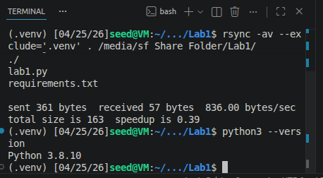
1.2. Install IDE
The two most popular IDEs for running Python are PyCharm, VSCode.
1.3. Create and run your first program
To get started with PyCharm, please follow the instructions provided here.
To get started with VScode, please follow the instructions provided here.
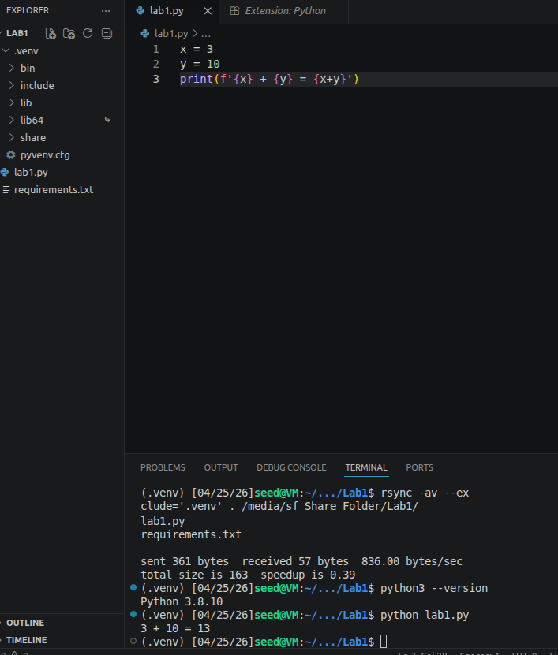
2. Exercises
2.1. Exercise 1
Assign variable x with 15, and variable y with 30. Find their sum and assign the result to a variable z. Then print the variable z.
Hint: print(x) will print the value of x to the console.
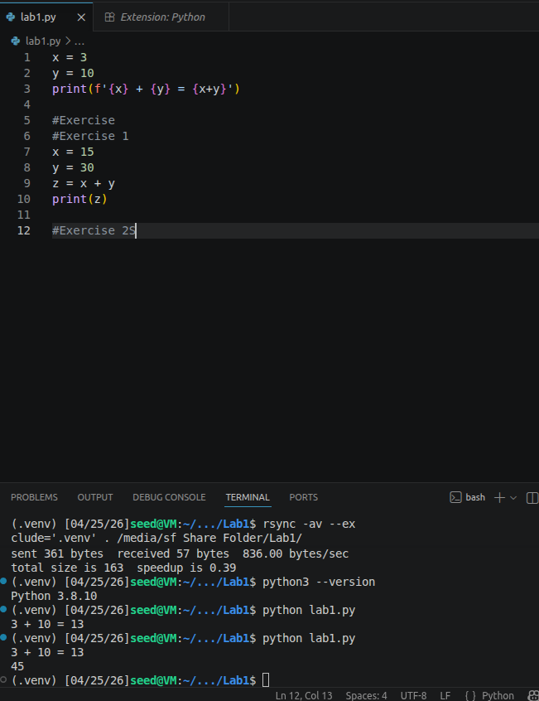
2.2. Exercise 2
We have a variable named x which is assigned a floating point number, and a variable y which is assigned with an integer. We find the sum of these two numbers, and store the result in variable z. Then we print the data type of variable z using type() built-in function. What would be the type of z?
Hint: if x is an integer, type(x) will return the type of x, which is integer.
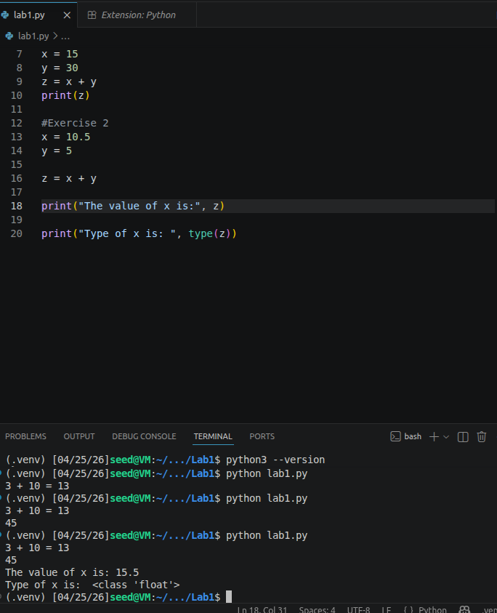
2.3. Exercise 3
Write a program to multiply four pre-defined numbers and assign the result to a variable. Then, print both the value stored in the variable and its data type.
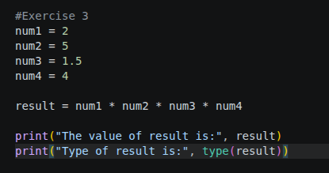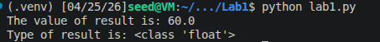
PART II: LAB 1
2.1. Assignment 1
Let the user enter two integers: x and y. Calculate the sum of the two variables and print it to the terminal
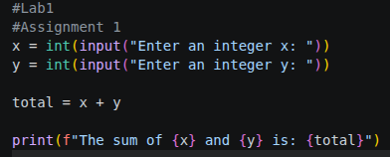
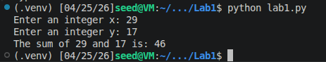
2.2. Assignment 2
Let the user enter values. Calculate the average of two variables (z): float x and integer y, print the result (z) and also the type of it.
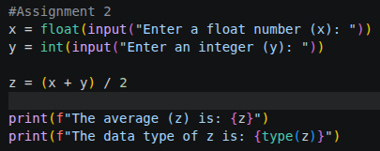
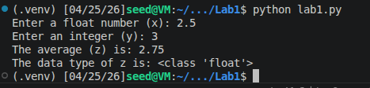
2.3. Assignment 3
Given an array of numbers from 1 to 10. Calculate and print the sum of even and odd numbers.
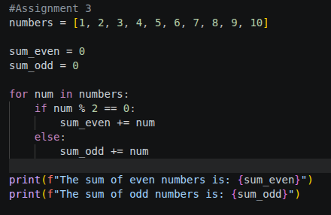
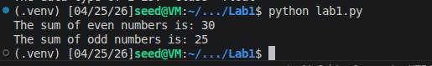
2.4. Assignment 4
Given an array of random numbers: 2, 6, 9, 15, 21, 28, 30, 33. Suppose that the user enters any number, find and print the closest number to the given number and calculate the distance of it.
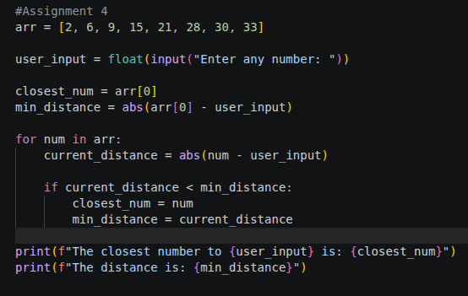
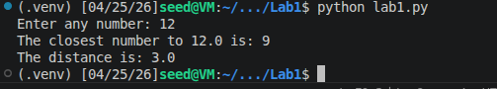
2.5. Assignment 5
Suppose there is a ”student”dictionary containing keys (name, course, point)
student = { ”name”: ”Your name”,
¨course”: CSE306”, ¨
”point”: 0
} update its value by coding and adding a new key (”GPA”: 3.2), delete the ”point”key to the studentdictionary. Print the result.
