EASTERN INTERNATIONAL UNIVERSITY Practice Assignment – Quarter 1, 2025-2026
SCHOOL OF COMPUTING Course Name: ISAD
AND INFORMATION TECHNOLOGY Course Code: CSW 309
Student’s Full Name: Phan Ngọc Hạnh Nhi
Student ID: 2131209002
LAB 02
Topic: Identify actors, define use cases, and draw the Use Case Diagram for the Equipment Borrowing Management System
  - Identify actors and the system boundary based on the Lab 01 scenario.
    - Actor:
Actor | Description | Main Goals / Interactions
Borrower (Teacher / Student) | A user who needs equipment for teaching or learning activities | Search for available equipment, place borrowing requests, view request progress, return equipment after use
Approver / IT Staff | Person responsible for managing equipment allocation | Review and approve requests, adjust schedules if there is a conflict, confirm returned items, update equipment status
Administrator | System manager controlling overall operations | Maintain user roles, manage system configurations, generate analytics reports
Notification Service | External module or system component | Automatically sends alerts such as request updates or due-date reminders
System Timer (Scheduler) | Background automation mechanism | Periodically checks overdue items and triggers reminder workflows
    - System Boundary
The EBMS supports the entire lifecycle of borrowing and returning teaching equipment.
Functional Capabilities Included in System Scope
Online borrowing request submission
Equipment approval workflow with scheduling
Equipment availability lookup and real-time status tracking
Automatic notifications (request status, reminders, overdue warnings)
Reporting dashboard and usage analytics
Role-based authentication and authorization
Secure data storage and activity logging
  - List and group business use cases according to each actor’s goals.
    - Actor: Borrower (Teacher / Student)
Business Goals: Borrow and manage equipment for teaching/learning activities
Goal Group | Use Case
Access & Authentication | UC01 – Login / Logout
Borrowing Operations | UC02 – Search equipment UC03 – Submit borrowing request
Monitoring Status | UC04 – Check request progress UC05 – View borrowing history
Adjust Borrowing Plan | UC06 – Cancel a pending request UC07 – Request borrowing time extension
Maintenance Reporting | UC08 – Report damaged/malfunctioning items
Return Process | UC09 – Return equipment
    - Actor: IT Staff (Approver)
Business Goals: Ensure proper allocation & safe device return
Goal Group | Use Case
Request Management | UC10 – View all requests UC11 – Approve request UC12 – Reject / Reschedule request
Inventory & Status Maintenance | UC13 – Update equipment condition UC14 – Confirm returned equipment UC15 – Mark lost or heavily damaged items
Operational Tracking | UC16 – Monitor overall loan process & workload
    - Actor: Administrator
Business Goals: Govern system operations and data integrity
Goal Group | Use Case
User & Role Management | UC17 – Manage user accounts & permissions
Equipment Database Management | UC18 – Manage equipment catalog
Policy & Configuration | UC19 – Define borrowing rules UC20 – Configure notification preferences
Monitoring & Reporting | UC21 – View action logs UC22 – Generate usage reports & analytics
    - Actor: Notification Service (External System)
Business Goals: Automated communication to stakeholders
Use Case
UC23 – Send approval/rejection updates
UC24 – Send due-date reminders
UC25 – Send overdue notices
UC26 – Send equipment condition/status alerts
    - Actor: System Timer (Scheduler)
Business Goals: Handle background automated tasks
Use Case
UC27 – Execute scheduled reminder & overdue checks
  - Model a Use Case Diagram (including include/extend relationships when appropriate).
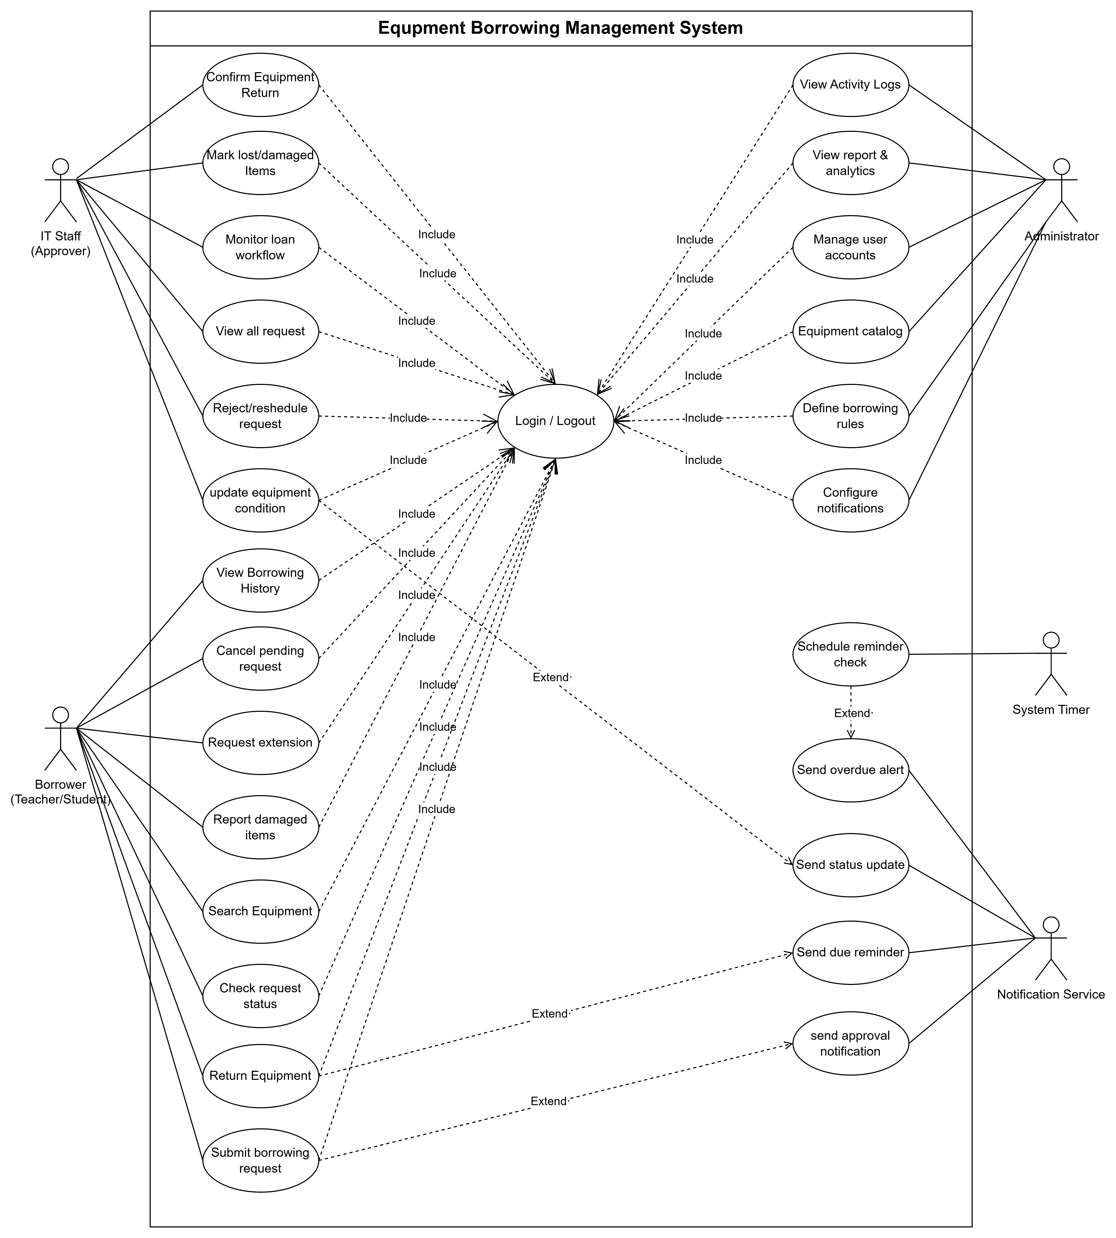
  - Write fully dressed use case specifications for 2–3 key use cases (Borrow Equipment, Approve Request, Return Equipment).
    - Borrow Equipment (Submit Borrowing Request)
Field | Description / Content
Use Case ID / Name | UC03 – Submit Borrowing Request
Scope / System | Equipment Borrowing Management System
Level | User Goal
Primary Actor | Borrower (Teacher / Student)
Supporting Actors | IT Staff, Notification Service
Stakeholders & Interests | Borrower – wants to reserve needed equipment quickly; IT Staff – wants accurate, complete requests; Admin – wants a smooth approval workflow.
Goal in Context | Allow users to request equipment online for specific time, purpose, and location.
Preconditions | Borrower is authenticated; equipment is available in inventory.
Trigger | Borrower clicks “Request Equipment” on the system.
Main Success Scenario (Basic Flow) | 1. System displays the borrowing form. 2. Borrower fills in request details (equipment, date, purpose). 3. System validates information and checks availability. 4. Borrower submits the request. 5. System records it as Pending. 6. System notifies IT Staff and sends confirmation to Borrower.
Extensions (Alternate Flows / Exceptions) | 3a. Equipment not available → System suggests next available date. 2a. Missing or invalid fields → System prompts correction. 5a. Network issue → Request temporarily stored in local cache until connection resumes.
Postconditions / Guarantees | Request saved as Pending with unique ID; Borrower and IT Staff are notified.
Special Requirements (NFR) | Form submission < 3 seconds; must validate every required field; accessible on desktop and mobile.
Technology / Data Variations | Borrowing form fields may vary between teacher and student.
Assumptions | Internet connection stable; user has valid system credentials.
Notes / Issues | Future upgrade: auto-check conflicts across departments.
    - Approve Request
Field | Description / Content
Use Case ID / Name | UC11 – Approve Request
Scope / System | Equipment Borrowing Management System
Level | User Goal
Primary Actor | IT Staff
Supporting Actors | Notification Service
Stakeholders & Interests | IT Staff – needs accurate info to approve fairly; Borrower – expects timely response; Admin – monitors system consistency.
Goal in Context | Review and decide whether to approve, reject, or reschedule borrowing requests.
Preconditions | At least one request is pending approval.
Trigger | IT Staff selects a pending request from the list.
Main Success Scenario (Basic Flow) | 1. System shows list of pending requests. 2. IT Staff reviews details (equipment, date, borrower info). 3. System checks schedule and availability. 4. IT Staff selects Approve, Reject, or Reschedule. 5. System updates request status. 6. Notification Service alerts the Borrower with the result.
Extensions (Alternate Flows / Exceptions) | 3a. Equipment unavailable → System offers next available slot. 2a. Request missing details → IT Staff returns for borrower revision. 5a. Approval error (conflict detected) → System prevents saving until resolved.
Postconditions / Guarantees | Request status updated; borrower notified; system logs decision.
Special Requirements (NFR) | Changes reflected instantly; decision logged for audit.
Technology / Data Variations | Interface may display a calendar or equipment timeline view.
Assumptions | IT Staff has sufficient permissions.
Notes / Issues | Optional enhancement: automated approval for repeat borrowers.
    - Return Equipment
Field | Description / Content
Use Case ID / Name | UC09 – Return Equipment
Scope / System | Equipment Borrowing Management System
Level | User Goal
Primary Actor | Borrower (Teacher / Student)
Supporting Actors | IT Staff, Notification Service, System Timer
Stakeholders & Interests | Borrower – wants quick confirmation of return; IT Staff – ensures condition check; Admin – tracks device lifecycle; Notification Service – sends reminders.
Goal in Context | Record the return of borrowed equipment and update system availability.
Preconditions | Equipment is currently borrowed and not yet marked as returned.
Trigger | Borrower selects “Return Equipment” or physically returns the item.
Main Success Scenario (Basic Flow) | 1. Borrower initiates a return request. 2. IT Staff inspects equipment and confirms condition. 3. System updates status to Returned. 4. System Timer cancels overdue tracking. 5. Notification Service sends confirmation to Borrower.
Extensions (Alternate Flows / Exceptions) | 2a. Item damaged → IT Staff logs issue and updates repair report. 3a. Item not found → System flags as “Missing” and alerts Admin. 1a. Borrower fails to return on time → System Timer triggers overdue alert.
Postconditions / Guarantees | Equipment status = “Available”; all return actions logged; borrower notified.
Special Requirements (NFR) | Return confirmation visible instantly; response time ≤ 2 seconds.
Technology / Data Variations | Return page may include checklist or photo upload for proof.
Assumptions | IT Staff available for inspection; stable connection.
Notes / Issues | Future upgrade: self-return kiosk integration with QR code scan.

