EASTERN INTERNATIONAL UNIVERSITY Practice Assignment – Quarter 1, 2025-2026
SCHOOL OF COMPUTING Course Name: ISAD
AND INFORMATION TECHNOLOGY Course Code: CSW 309
Student’s Full Name: Phan Ngọc Hạnh Nhi
Student ID: 2131209002
LAB 03
- System Requirements Context
The Equipment Borrowing Management System supports the process of requesting, approving, and tracking teaching equipment used by lecturers and students in a university. Currently, equipment is borrowed using paper forms or informal messages. This results in lost requests, double bookings, and a lack of usage reports. The system should digitalize the workflow as follows:
  - User Roles
    - Borrower (Lecturer/Student): searches for equipment, checks availability, submits borrow requests, and returns items.
    - Approver (Department Head / Lab Technician): reviews and approves borrow requests.
    - Inventory Staff: maintains equipment records, updates return status, and handles maintenance reports.
    - Admin: manages user accounts, system data, and reports.
  - Functional Requirements
    - Users must log in to the system before submitting or approving requests.
    - Borrowers can search for equipment and view real-time availability.
    - Borrowers can submit borrowing requests with purpose, date/time, and quantity.
    - Approvers can approve or reject borrow requests.
    - Borrowers and staff can view request status (Pending / Approved / Rejected / Returned).
    - The system sends reminders for due dates automatically.
    - Inventory Staff can record returns and update equipment availability.
    - Admin can generate reports on borrowing frequency, late returns, and utilization.
  - Non-Functional Requirements
    - System must respond within 3 seconds per transaction.
    - Access is web-based, available to all users within the campus network.
    - Data must be consistent and validated before updates.
  - Students will use this requirement context to identify:
    - External entities (Borrower, Approver, Inventory Staff, Admin, Notification Service, etc.)
    - Processes (Handle Requests, Approve Request, Update Inventory, etc.)
    - Data flows (Request Form, Approval Notice, Borrow Slip, etc.)
    - Data stores (Equipment, Borrow Records, Users, etc.)
  - These elements will be represented through DFDs and the Data Dictionary.
- Tasks
  - Task 1 – Context Diagram
    - Identify system boundary and external entities (Borrower, Approver, Inventory Dept, etc.).
      - System Boundary
Equipment Borrowing Management System (EBMS)
Digitizes the process of requesting, approving, tracking, and returning teaching equipment at universities.
      - External Entities
External Entity | Description / Role
Borrower (Lecturer / Student) | Searches for equipment, submits loan requests, views status, returns items
Approver (Department Head / Lab Technician) | Reviews and approves or rejects borrowing requests
Inventory Staff | Records returned items, updates availability and maintenance reports
Admin | Manages system users, equipment data, and reports
Notification Service | Sends email/app notifications and reminders
System Timer (Scheduler) | Automatically triggers due-date reminders and overdue checks

    - Draw the Context Diagram with one process representing the Equipment Borrowing Management System.
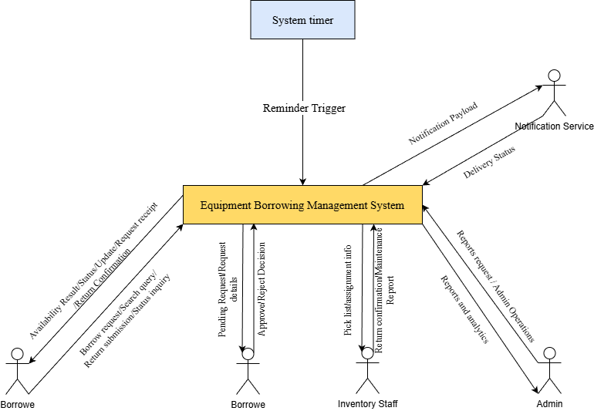
    - Major Data Inflows / Outflows
External Entity | Input to System | Output from System
Borrower | Borrow Request, Search Query, Return Submission, Status Inquiry | Request Receipt, Availability Result, Status Update, Return Confirmation
Approver | Approval / Reject Decision | Pending Request List, Request Details
Inventory Staff | Return Confirmation, Maintenance Report | Picklist / Assignment
Admin | Report Requests, Admin Configuration | Reports & Analytics
Notification Service | Delivery Status | Notification Payload
System Timer | Reminder Trigger | N/A
    - Check the balance with the next level.
  - Task 2 – Level-0 DFD
    - Processes
P1 – Handle Borrow Request
P2 – Approve / Review Request
P3 – Manage Inventory & Returns
P4 – Notifications & Reminders
P5 – Admin & Reporting
    - Data Stores
D1 – Equipment
D2 – Borrow Requests
D3 – Users
D4 – Notifications Log
    - Level 0 DFD
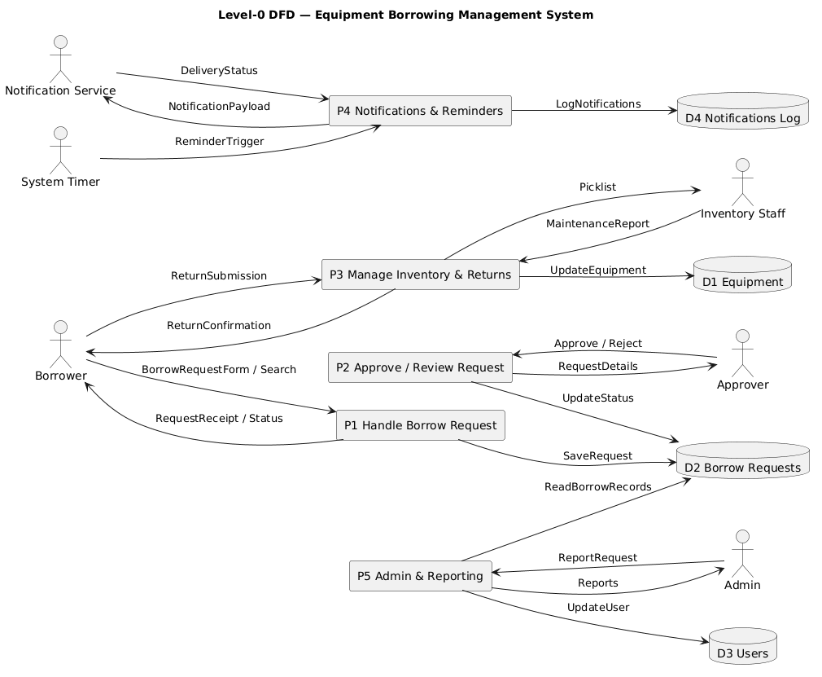
  - Task 3 – Data Dictionary
        - A. Data Elements (DE)
ID | Element Name | Description | Type / Format | Domain / Constraint | Example
DE01 | RequestID | Unique borrow request ID | String(20) | NOT NULL | REQ-2025-001
DE02 | DeviceID | Equipment identifier | String(20) | NOT NULL | EQP-101
DE03 | UserID | Unique user ID | String(20) | NOT NULL | ST12345
DE04 | StaffID | Approver/Inventory Staff ID | String(20) | FK | ST67890
DE05 | BorrowDate | Borrow date | Date | ≥ today | 45971
DE06 | ReturnDate | Planned return date | Date | ≥ BorrowDate | 45976
DE07 | Quantity | Number of items | Integer | ≤ stock | 2
DE08 | Status | Request status | Enum | Pending / Approved / Returned | Approved
DE09 | Purpose | Borrowing purpose | String(100) | Optional | Classroom lecture
DE10 | MaintenanceStatus | Equipment condition | Enum | Available / Under Maintenance | Available
DE11 | ReportType | Report category | Enum | Borrowing / Utilization / Late | Borrowing
DE12 | ReportPeriod | Reporting period | String(20) | Optional | Q1-2025
DE13 | NotificationID | Notification identifier | String(20) | Auto-generated | NTF-101
DE14 | MessageContent | Notification message | Text | Required | “Your request was approved.”
DE15 | DeliveryStatus | Notification result | Enum | Delivered / Pending / Failed | Delivered

        - B. Data Structures (DS)
ID | Structure | Components (DE) | Mandatory | Notes
DS01 | BorrowRequest | DE01, DE02, DE03, DE05, DE06, DE07, DE08, DE09 | Yes | Borrower’s submission
DS02 | ApprovalRecord | DE01, DE04, DE08 | Yes | Approval decision
DS03 | EquipmentRecord | DE02, DE10 | Yes | Equipment details
DS04 | ReportRequest | DE11, DE12 | Optional | Requested by Admin
DS05 | NotificationMessage | DE13, DE14, DE15 | Yes | Notification log

        - C. Data Stores (D)
ID | Name | Description | Key Field | Updated by (Process)
D1 | Equipment | Equipment details and status | DeviceID | P3 Manage Inventory
D2 | Borrow Requests | Borrow requests and status | RequestID | P1, P2, P3
D3 | Users | User accounts and roles | UserID | P5
D4 | Notifications Log | Notification details | NotificationID | P4

        - D. Data Flows (F)
ID | Name | Source | Destination | Structure | Purpose
F01 | Borrow Request Form | Borrower | P1 | DS01 | Submit request
F02 | Request Receipt | P1 | Borrower | DS01 | Confirm submission
F03 | Return Submission | Borrower | P3 | DS01 | Submit return
F04 | Approval Decision | Approver | P2 | DS02 | Approve/reject request
F05 | Equipment Update | Inventory Staff | P3 | DS03 | Update status
F06 | Report Request | Admin | P5 | DS04 | Request system report
F07 | Notification Payload | P4 | Notification Service | DS05 | Send notification
F08 | Delivery Status | Notification Service | P4 | DS05 | Confirm delivery
F09 | Reminder Trigger | System Timer | P4 | N/A | Start notification

        - E. Processes (P)
ID | Process Name | Description | Inputs | Outputs | Trigger
P1 | Handle Borrow Request | Validate and record borrower requests | F01 | F02, D2 | Borrower submits
P2 | Approve / Review Request | Approver reviews and decides | F04 | D2, F07 | Approver action
P3 | Manage Inventory & Returns | Update equipment and returns | F03, F05 | D1, D2 | Return or update
P4 | Notifications & Reminders | Send notifications and reminders | F09, D2 | F07, F08 | Timer event
P5 | Admin & Reporting | Manage users and generate reports | F06 | D3, D4 | Admin request

  - Notes for Students
    - Every flow, store, and process listed here must also appear in your DFD.
    - Use consistent names and IDs (e.g., P1 ↔ Handle Borrow Request).
    - The Data Dictionary is the textual counterpart of your DFD.
    - You may add more elements or structures if your team’s scenario includes special features (e.g., reminders, maintenance reports, notifications).
- Submission
The Equipment Borrowing Management System (EBMS) provides a structured digital workflow for borrowing, approving, and returning equipment within the university.
Through the Context Diagram, Level-0 DFD, and Data Dictionary, the system’s data movements and responsibilities among entities were clearly defined.
This model supports real-time tracking, eliminates double bookings, automates reminders, and enhances transparency for both staff and students.
It demonstrates the importance of proper system analysis and design in creating efficient, user-centered management systems.

