Task 1:
● Action lists for Borrow Equipment:
- User opens the system and logs in (enter credentials).
- System authenticates user and loads dashboard.
- Borrower searches for equipment (by name, category, availability date).
- System displays matching results with real-time availability.
- Borrower selects an equipment item and clicks "Request Borrow".
- Borrower fills borrow details: purpose, start date/time, end date/time, quantity.
- Borrower submits the borrow request.
- System validates the request (user authorized, date/time valid, quantity ≤ available, no conflicting bookings).
- If validation fails, System shows error and borrower corrects input (loop back to step 6).
- If valid, System creates a BorrowRequest object with status = Pending and notifies the Approver(s).
- Approver reviews the request and either approves or rejects.
- Approver records decision and optional comments.
- System updates the BorrowRequest status to Approved or Rejected and notifies the Borrower.
- If Approved, System temporarily reserves the equipment for the requested period and updates availability.
- Final node: Borrower receives confirmation (Approved) or rejection with reason.
● Action lists for Return Equipment:
- Borrower returns equipment physically to the Equipment Room on/around the due date.
- Inventory Staff receives returned items and verifies borrower identity and BorrowRequest reference.
- Inventory Staff checks item quantity and inspects condition.
- System checks the original due date vs. actual return date.
- Decision: [OnTime] or [Late]. If Late, System calculates late fee or marks as late and notifies borrower.
- Decision: [GoodCondition] or [Damaged]. If Damaged, Inventory Staff records condition and creates a MaintenanceRecord (with notes, severity, estimated repair cost/time).
- System updates BorrowRequest status to Returned and logs return timestamp.
- System updates Equipment availability (increments available quantity) and updates utilization statistics.
- Parallel flows (after receiving items):
(a) update availability,
(b) log return history,
(c) (optional) send notification/email to borrower and admin.
- Final node: Inventory Staff completes the return process and closes the record.
Task 2:
Activity Diagram (no swimlanes) for Borrow Equipment:
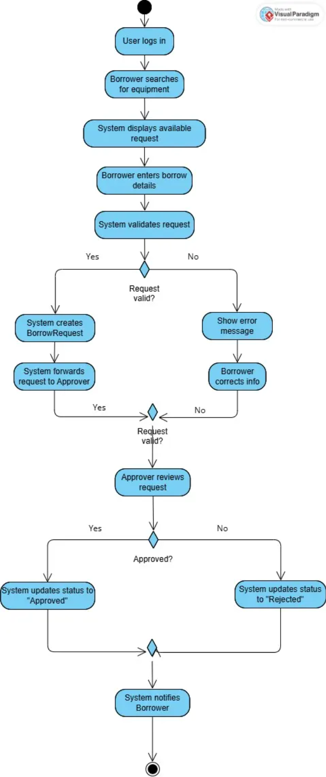
Task 3:
Activity Diagram (with swimlanes) for Borrow Equipment:
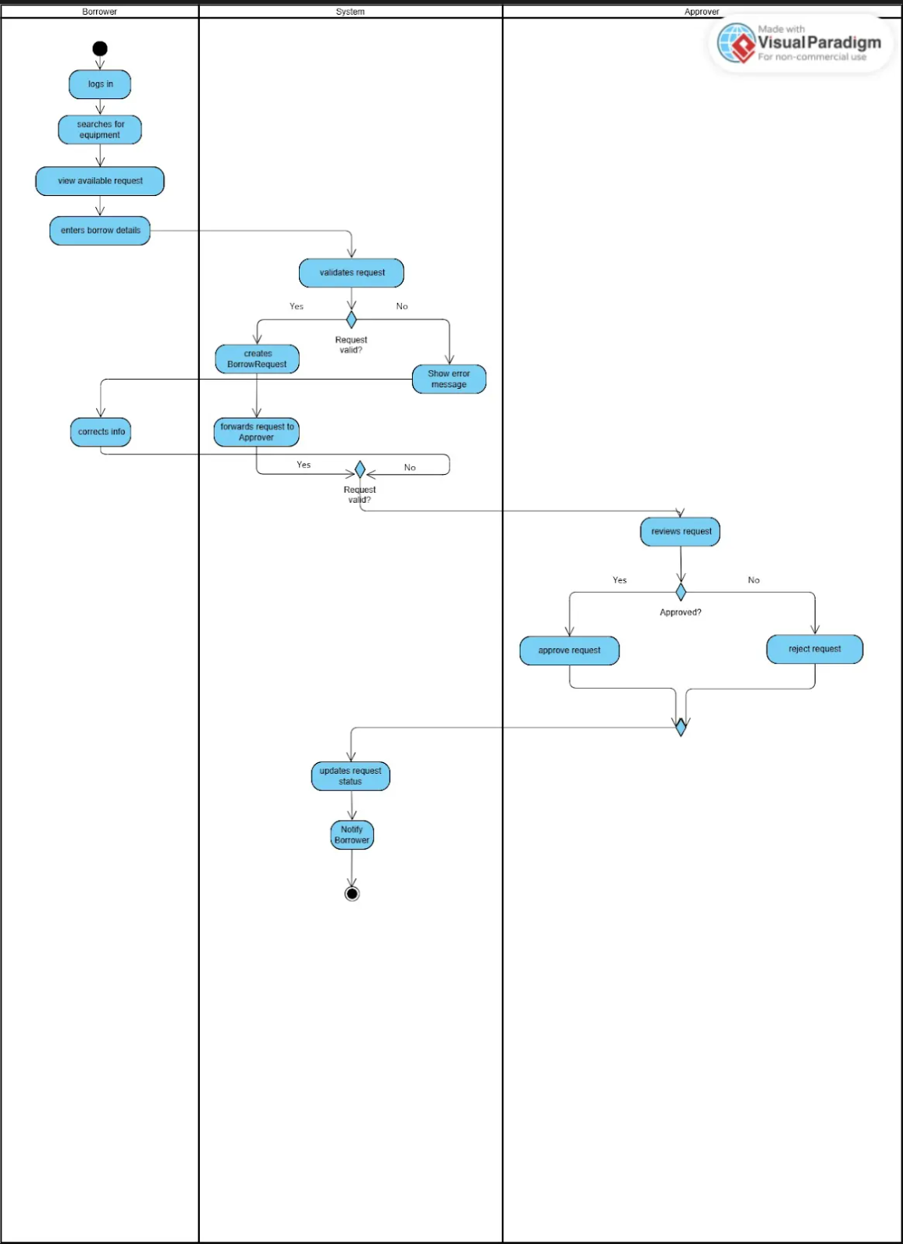
Task 4:
Activity Diagram (with fork/join) for Return Equipment.
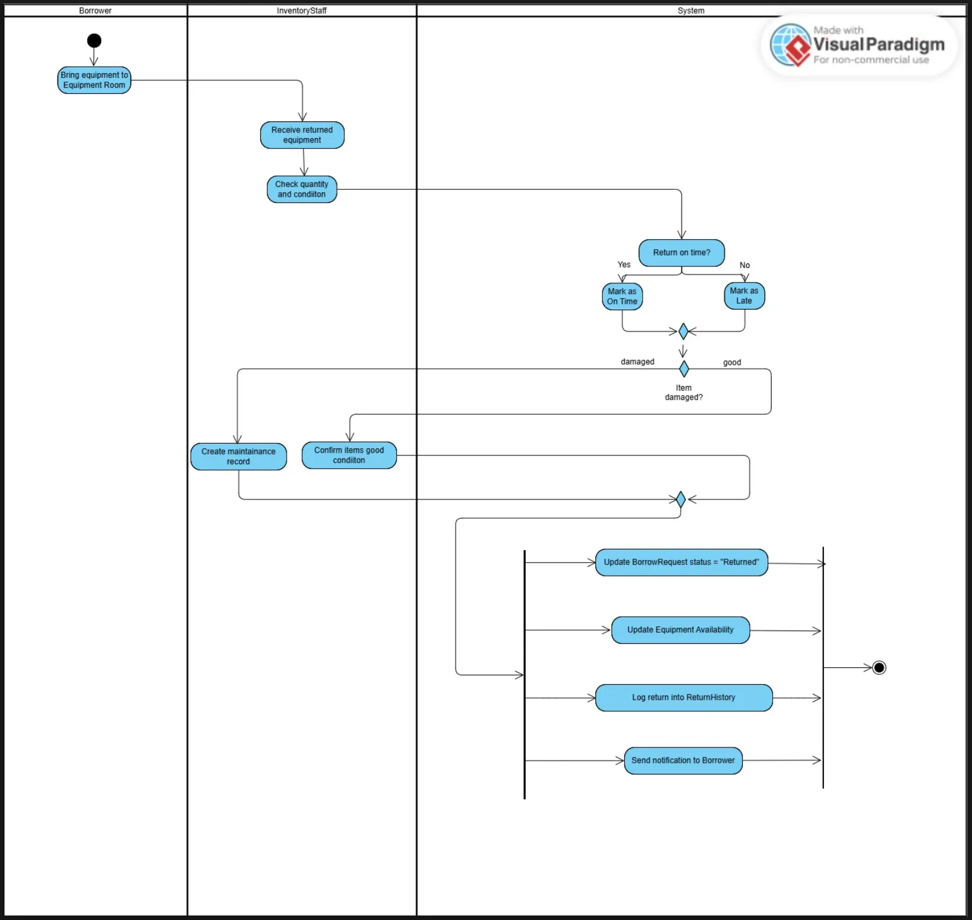
Task 5:
● Checklist:
# | Item | Check
1 | All actions in the activity diagrams match the classes from Lab 04 (Equipment, BorrowRequest, User, MaintenanceRecord) | Done
2 | Swimlanes use the correct roles from the requirements (Borrower, Approver, Inventory Staff, System) | Done
3 | Status names (Pending, Approved, Rejected, Returned) match the class diagram | Done
4 | All important steps are included (validation, approval, return check, update availability) | Done
5 | The activity diagrams follow the logic shown in the class diagram | Done
● Reflection:
Activity diagrams help me understand the system better because they show the process from start to finish. Unlike class diagrams, which only show structure, activity diagrams show the real flow of actions. Swimlanes make it clear who does each step, so I do not get confused between the Borrower, Approver, and Staff. They also show parallel actions, like in the Return Equipment process, where the system updates availability, logs the return, and sends a notification at the same time.

