Tên: Phan Ngọc Hạnh Nhi

MSSV: 2131209002

Lab 1

# Ubuntu 24.04 Server

# Command line and Shell script

## Create a directory “Your name” in “/var/www”:

* cd /var
* mkdir var/www
* cd ../var/www
* mkdir var/www/hnhi

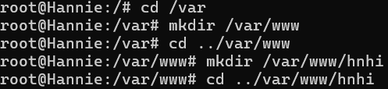

## Create a file firstcode.html in “Your name” directory

* touch firstcode.html
* ls

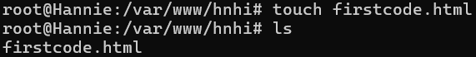

## Insert the following texts to firstcode.html (use nano or vi editor)

* nano firstcode.html



## Create a directory Project inside “Your name” directory



## Move the firstcode.html to Project





## Rename the firstcode.html to index.html



## Create a directory Test inside “Your name” directory

## Creating a symbolic link from Project to Test

## Copy index.html to Test

## Edit the content of index.html in Test as below:

## Copy all contents of index.html in Test to index.html in Project (use Read File command of nano)

## Delete the Test directory

## Create a new file firstproject.conf in Project and edit with nano Editor

# Remoting server by OpenSSH and PuTTY

