Tên: Phan Ngọc Hạnh Nhi

MSSV: 2131209002

Lab 2

## Compress Project by using tar

## Download WordPress and extract it to Project



## Change ownership of Project and the files inside it to www-data

## Set permissions for Project and the files inside it as the follow:

* Owner: read, write, execute
* Group: read and execute
* Other: read and execute

## Create a file rootFile.txt with the root privilege in Project



## List files / directories in Project and sort them by owner

## Write a script to list all files and directories in Project and sort them in Descending Order



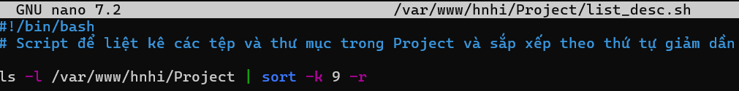

## Create a script to install services as the following:

# 2. GitHub

