Tên: Phan Ngọc Hạnh Nhi

MSSV: 2131209002

Lab 3

# GitHub

## Creating a new repository

## Exploring GitHub Desktop

## Making, committing, and pushing changes

## Reverting a commit

* Merge

# Using Git Command Line to connect to GitHub

## Installing and Configuring Git



## Generating a new SSH key

## Adding a new SSH key to GitHub account

## Connecting to GitHub

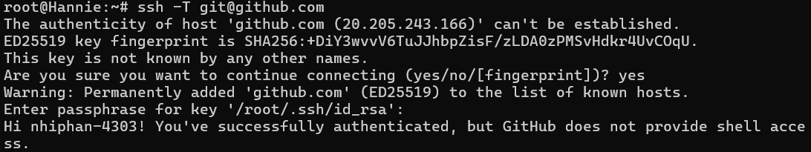

## Creating a personal access token

## Using a token on the command line

1. Basic Git commands

## Clone repository to local machine



## Tracking changes with git add and git commit

# Creating README

# Creating a Wiki

# Creating Boards

