Tên: Phan Ngọc Hạnh Nhi

MSSV: 2131209002

Lab 4

# Install web server (LAMP):

* Install Apache (apache2):



* Install MySQL (mysql-server)

* Install PHP



* Install libpache2-mod-php



* Install php-mysql



* Config Apache server



* Restart the Apache web server

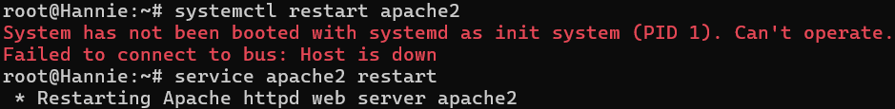

* Set up Virtual Hosts:
* Create the directory for your_domain

* Assign ownership to your_domain directory

* Assign permission to the your_domain directory (755 or 744)

* Create an index.html file in the your_domain directory with any content

* Set up Virtual Hosts:

Create a virtual host file: copy and rename 000-default.conf to your_domain.conf

Modify the file:

Enable the file with the a2ensite tool

Test for configuration errors

Reload the configuration

* ifconfig

* open hosts file of windows

* add Server_IP your_domain

* rename host domain to hnhi.com

* reload apache2



* open http://hnhi.com

# Install web server (LEMP)

* Install the Nginx



* Enable this
* A black background with white text

  Description automatically generated
* Verify the change

* Install MySQL

* Install php

* Install the php-fpm module along with an additional helper package

* Configure domain (configure Nginx)

* Enable new server block by creating a symbolic link from new server block configuration file to (in the /etc/nginx/sites-available/ directory) to the /etc/nginx/sitesenabled/ directory



* Test new configuration file for syntax errors



* Reload Nginx to make the necessary changes

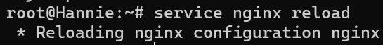

* Create a PHP file to Test Configuration

* Change ownership

* Use existing phpMyAdmin

Đổi lại version php trong file nano 



Change ownership

Ifconfig lấy IP

Vào File host thêm IP và domain

Reload lại nginx



# Install and Secure phpMyAdmin

* Install phpMyAdmin (phpmyadmin, php-mbstring, php-zip, php-gd, php-json, php-curl)

* Enable the mbstring PHP extension (phpenmod mbstring)



* Stop nginx and restart Apache for changes

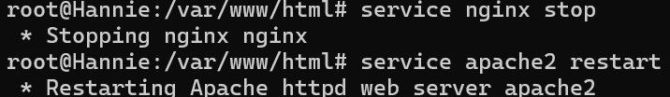

* Access the web interface by visiting server’s domain name or public IP address followed by /phpMyAdmin

* Configuring Password Access for the MySQL Root Account

Open the MySQL prompt from terminal: sudo mysql

Change root password



Create a new user account and grant all privileges

