Phan Ngoc Hanh Nhi

2131209002

**Assignment 1**

1. **Boolean/Logic Expression:**

**Z = X . Y**

1. **Truth Table:**

| **X** | **Y** | **Z** |
| --- | --- | --- |
| 0 | 0 | 0 |
| 0 | 1 | 0 |
| 1 | 0 | 0 |
| 1 | 1 | 1 |

1. **Diagram**

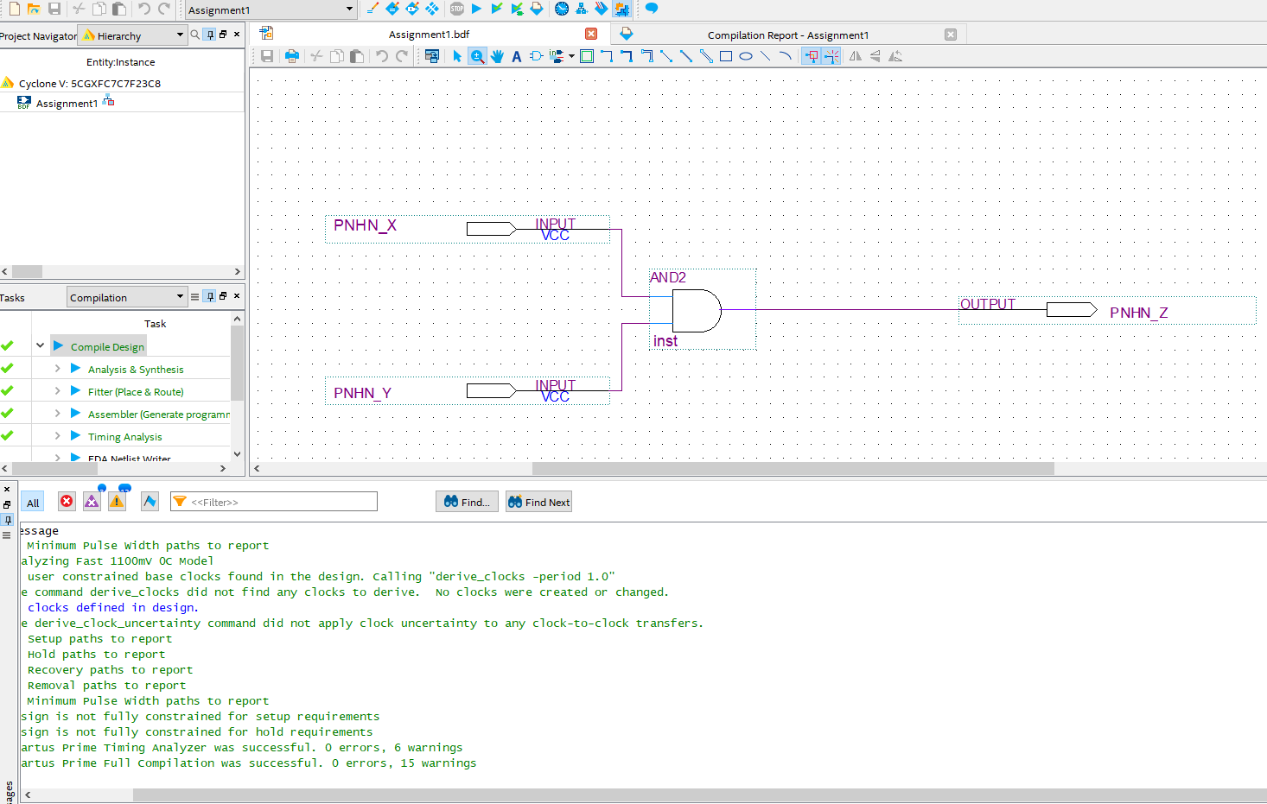

1. **Simulations:**

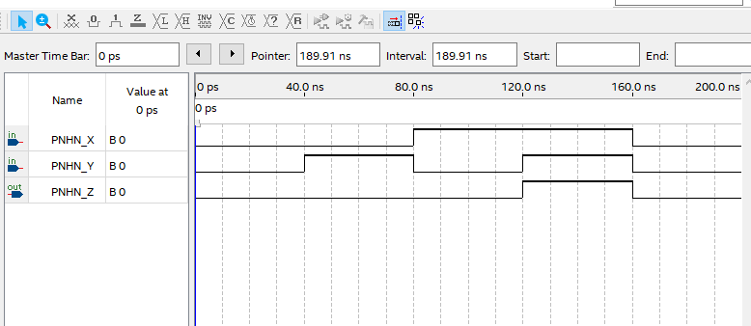

1. **Verilog:**

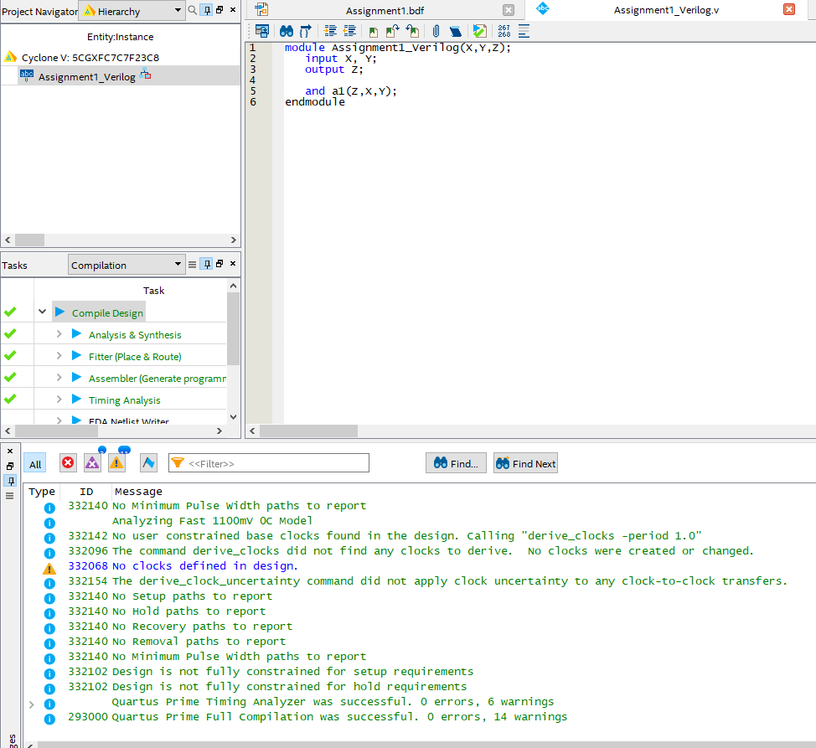

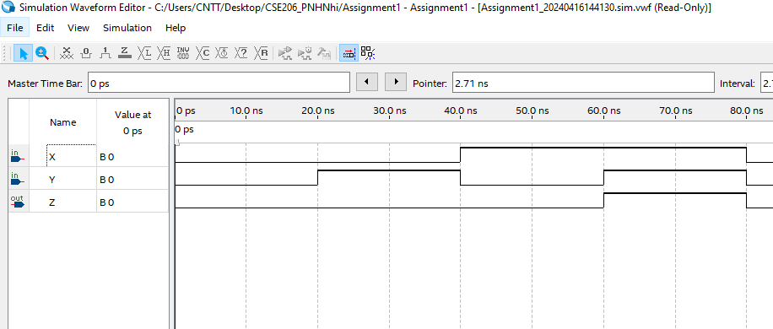

**Assignment 2**

1. **Boolean/Logic Expression:**

**Z = X + Y**

1. **Truth Table:**

| **X** | **Y** | **Z** |
| --- | --- | --- |
| 0 | 0 | 0 |
| 0 | 1 | 1 |
| 1 | 0 | 1 |
| 1 | 1 | 1 |

1. **Diagram:**

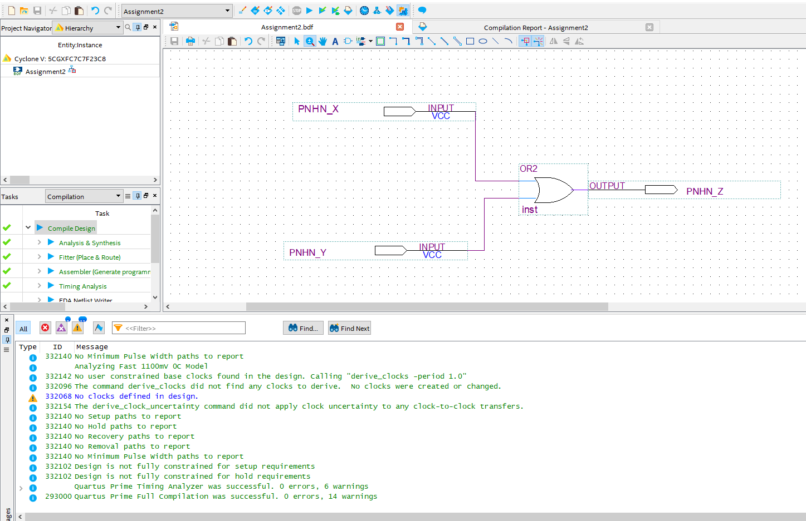

1. **Simulations:**

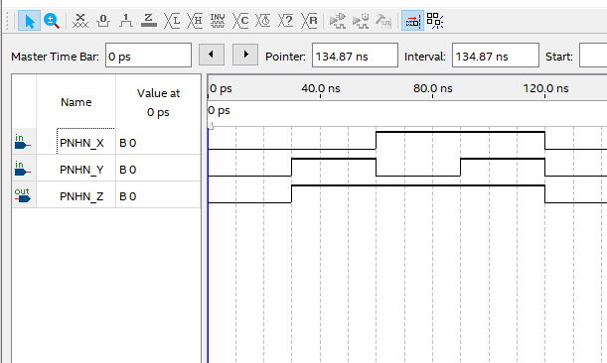

**Assignment 3**

1. **Boolean/Logic Expression:**

**Z = (X . Y)’**

1. **Truth Table:**

| **X** | **Y** | **Z** |
| --- | --- | --- |
| 0 | 0 | 1 |
| 0 | 1 | 1 |
| 1 | 0 | 1 |
| 1 | 1 | 0 |

1. **Diagram:**
2. **Simulations:**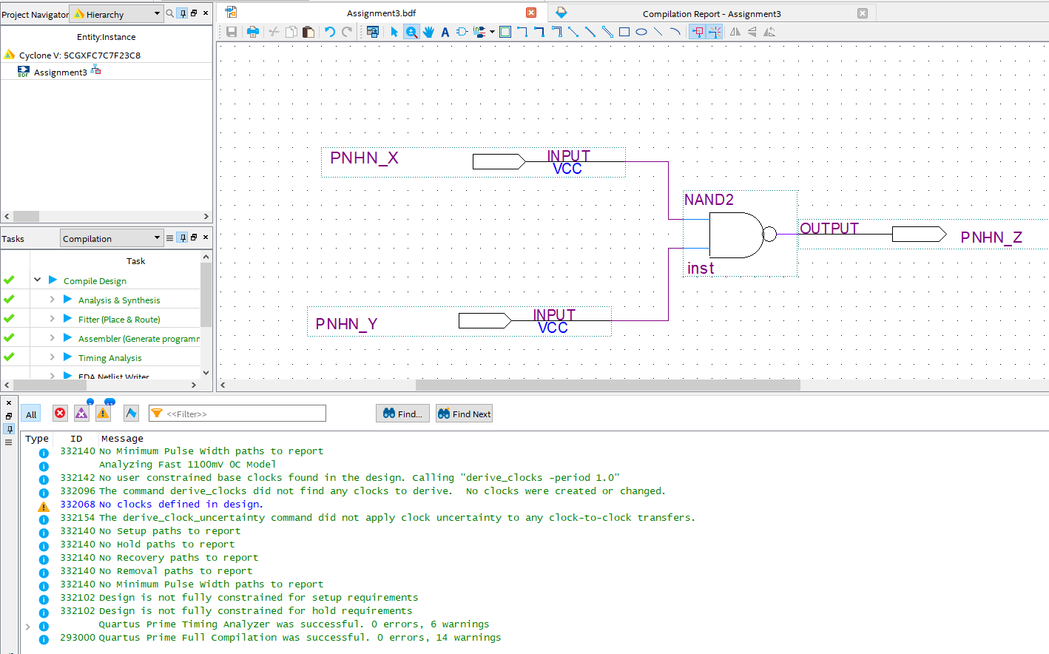

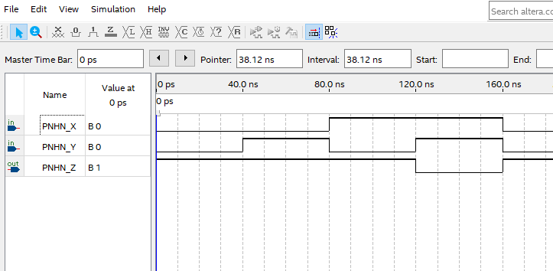

**Assignment 4**

1. **Boolean/Logic Expression:**

**Z = (X+ Y)’**

1. **Truth Table:**

| **X** | **Y** | **Z** |
| --- | --- | --- |
| 0 | 0 | 1 |
| 0 | 1 | 0 |
| 1 | 0 | 0 |
| 1 | 1 | 0 |

1. **Diagram:**

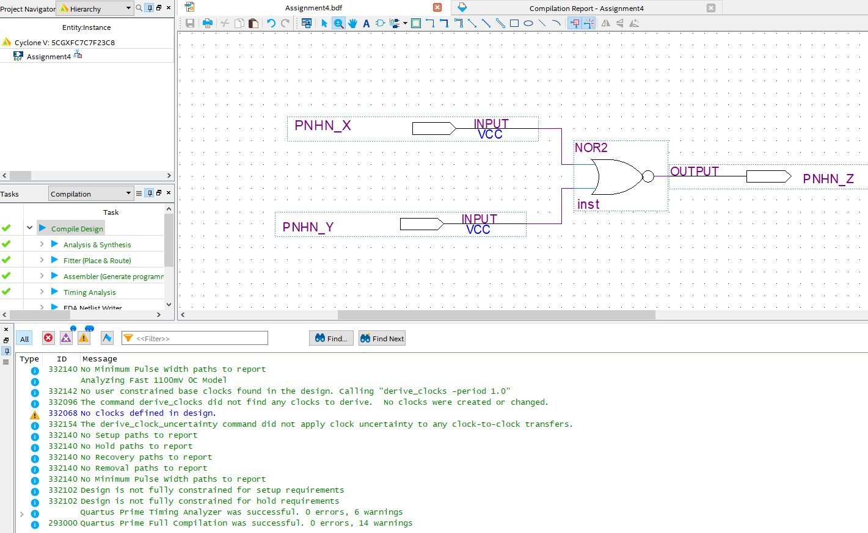

1. **Simulations:**

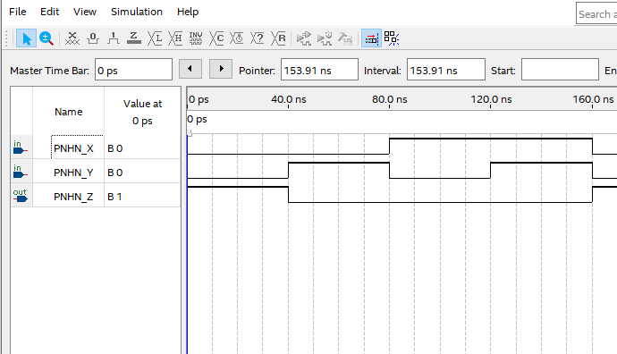

**Assignment 5**

1. **Boolean/Logic Expression:**

**Z = X’**

1. **Truth Table:**

| **X** | **Z** |
| --- | --- |
| 0 | 1 |
| 1 | 0 |

1. **Diagram:**

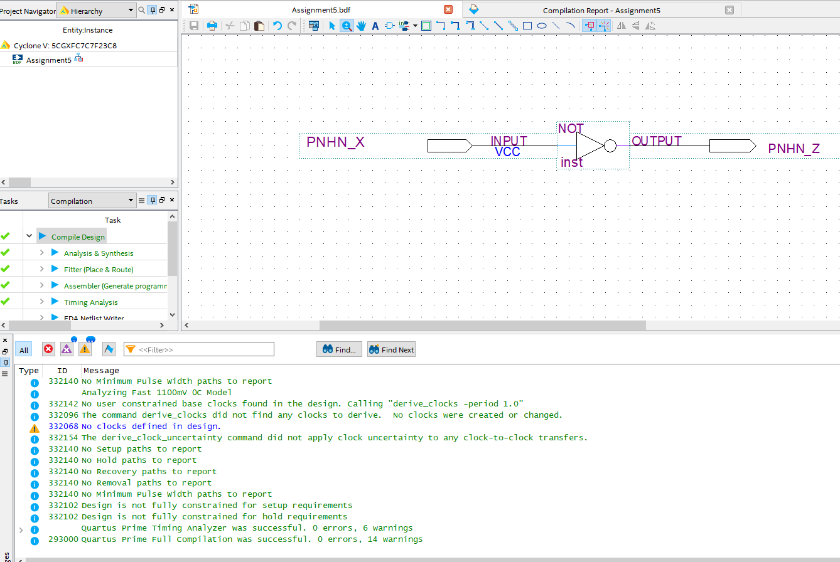

1. **Simulations:**

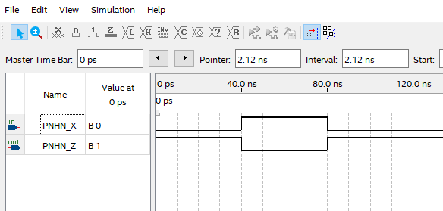

**Assignment 6**

1. **Boolean/Logic Expression:**

**Z = XOR**

1. **Truth Table:**

| **X** | **Y** | **X⊕Y** |
| --- | --- | --- |
| 0 | 0 | 0 |
| 0 | 1 | 1 |
| 1 | 0 | 1 |
| 1 | 1 | 0 |

1. **Diagram:**

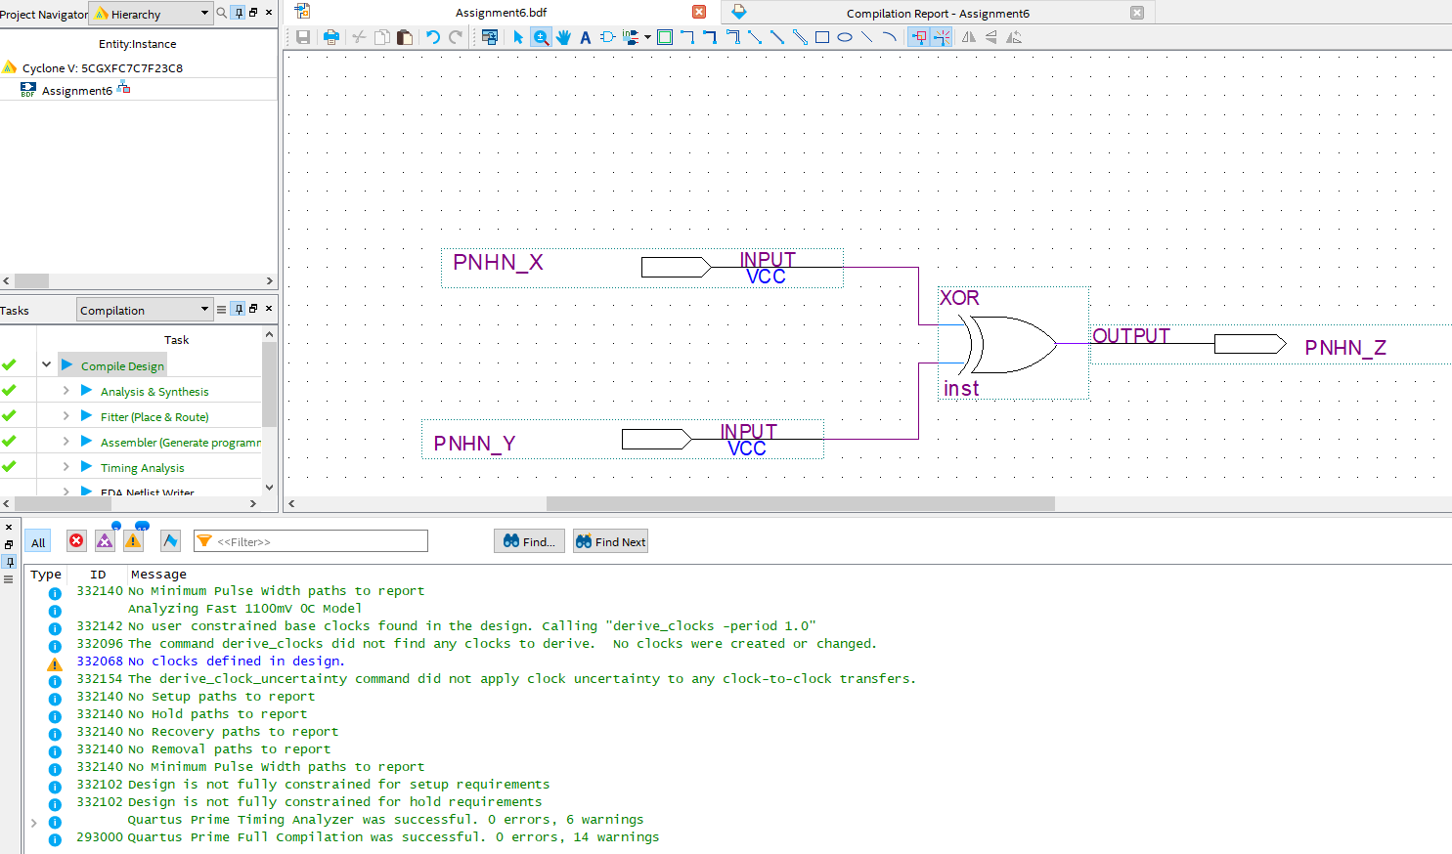

1. **Simulations:**

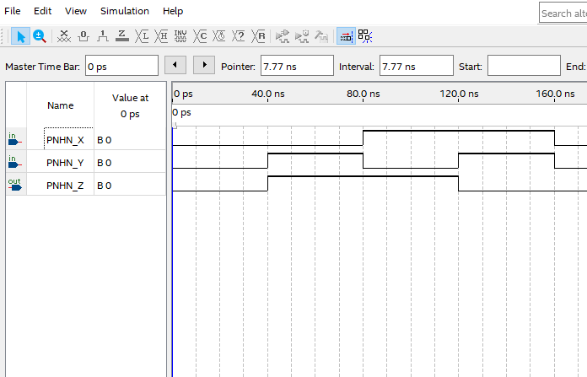

**Assignment 7**

1. **Boolean/Logic Expression:**

**Z = XNOR**

1. **Truth Table:**

| **X** | **Y** | $\underline{X⊕Y}$ |
| --- | --- | --- |
| 0 | 0 | 1 |
| 0 | 1 | 0 |
| 1 | 0 | 0 |
| 1 | 1 | 1 |

1. **Diagram:**

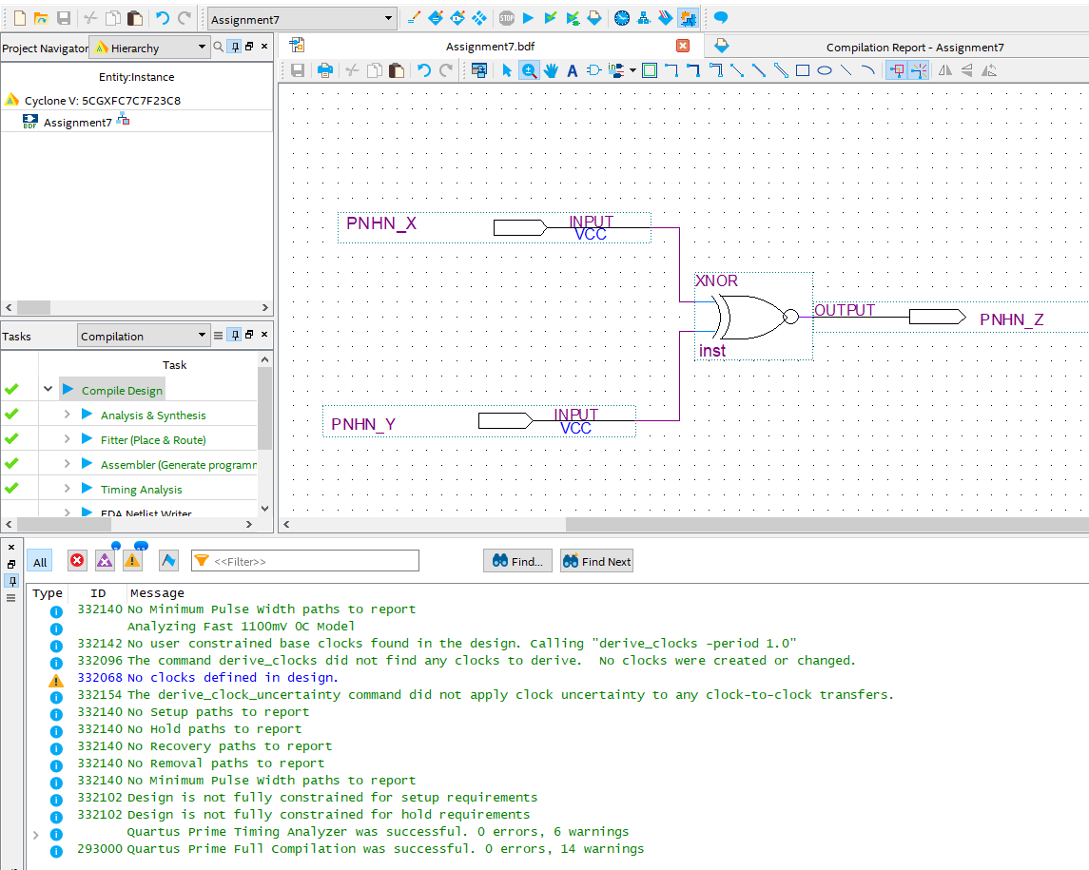

1. **Simulations:**

