VAN NHI NGUYEN

101256529@student.swin.edu.au

Abstract

[Draw your reader in with an engaging abstract. It is typically a short summary of the document.   
When you’re ready to add your content, just click here and start typing.]

Assignment 2: shoponline

COS30020: Web Application Development

# List of files:

* register.htm
* register.js
* register.php
* login.htm
* login.js
* login.php
* listing.htm
* listing.js
* listing.php
* bidding.htm
* bidding.js
* biddisplay.php
* bidding.php
* buying.php
* bidding.xsl
* maintenance.htm
* maintenance.js
* maintenance.php
* maintenance.xsl
* logout.php
* username.js
* username.php
* customer.xml
* auction.xml

# how to use shoponline

## Login or register

Upon entering ShopOnline you will see the login page. You can either log in if you have an account or create a new one.

For logging in:

* Enter all of the required fields and press Log in to proceed

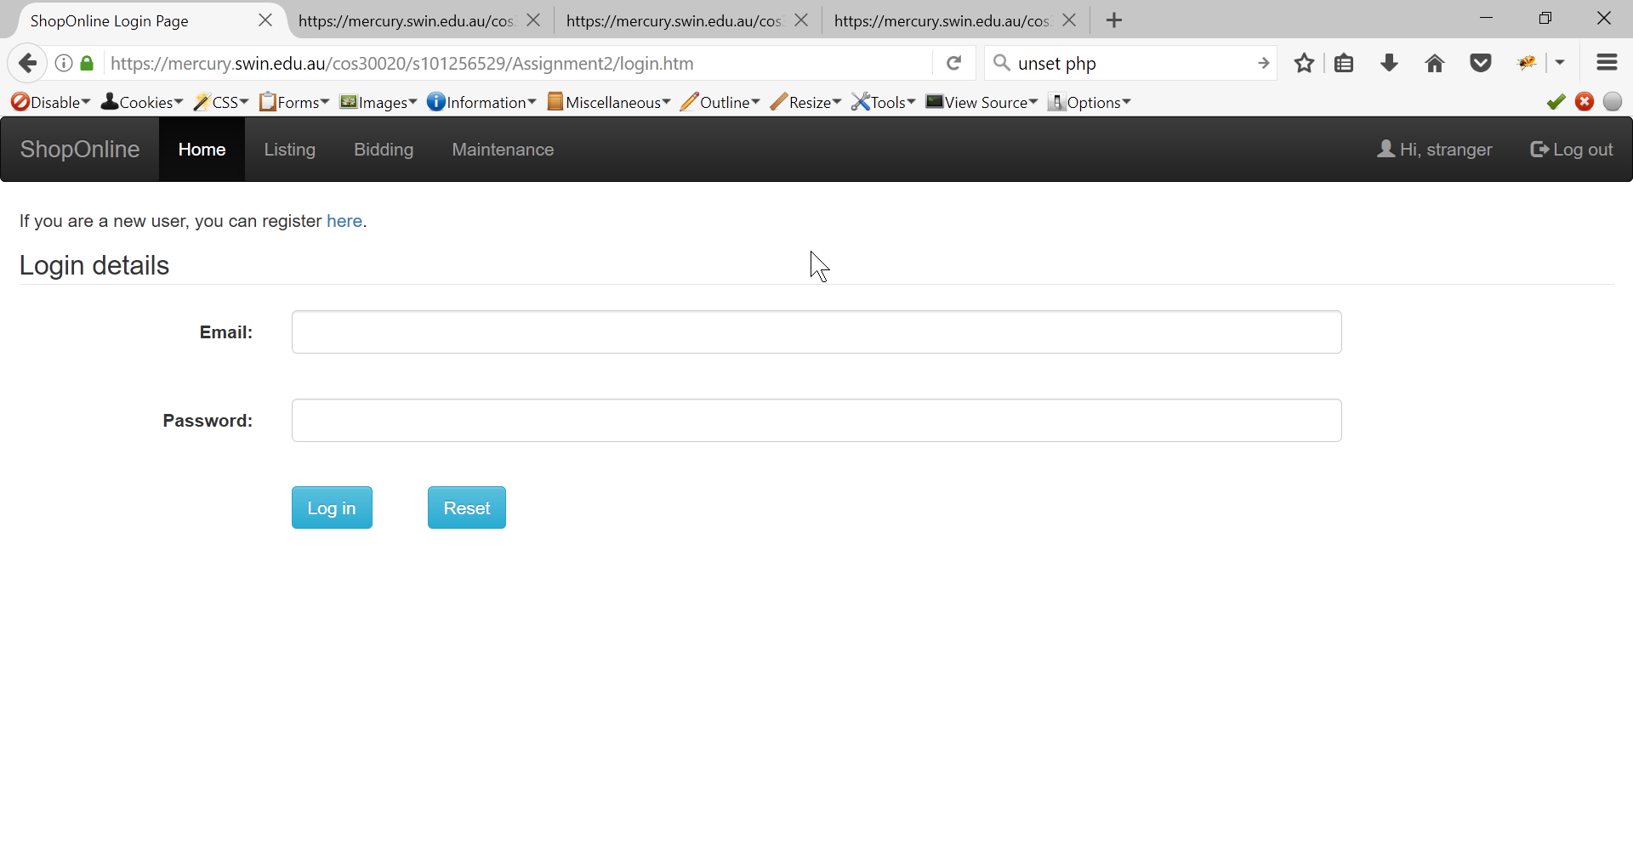

If you want to register:

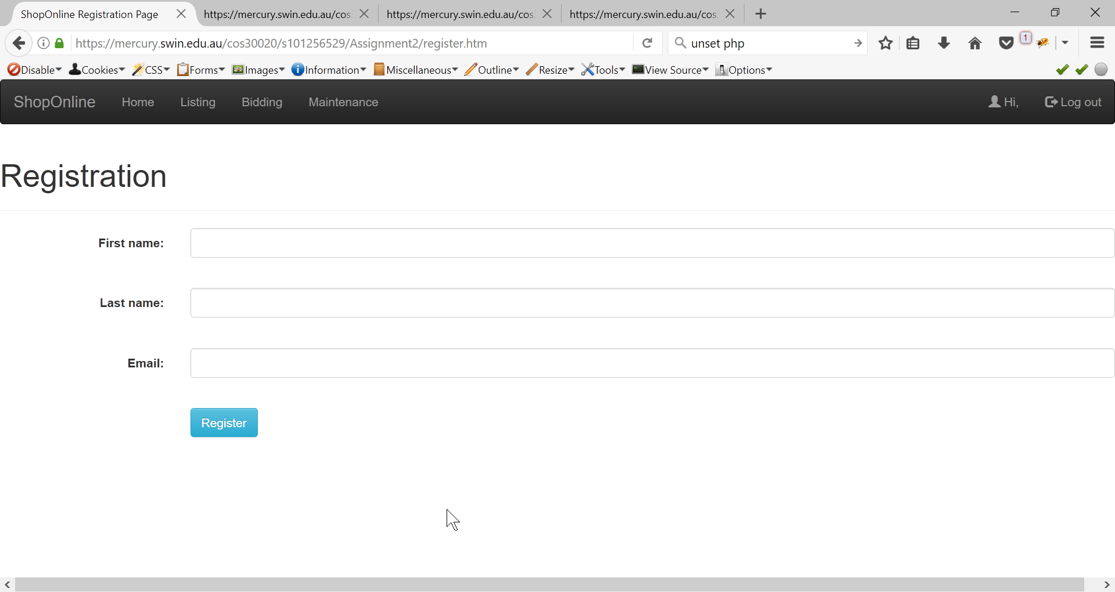

* You will only need to enter your name and email. The system will generate a new ID and password and send them to you via email.

## List a new item to bid

If you want to put an item on the website to sell, go to the Bidding page by clicking on the corresponding link on the navigation. But if you haven’t logged in, the system won’t allow you to upload an item for sale.

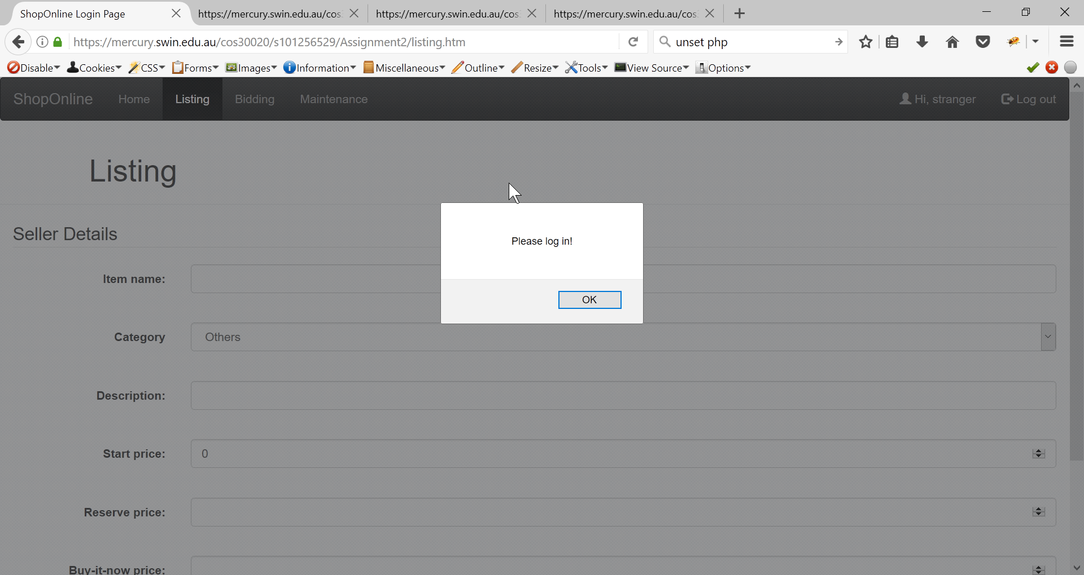

Once you have logged in, you can start filling in all the details of your item. If the category you want is not on the dropdown list, you can choose the option Others and enter the category of your item.

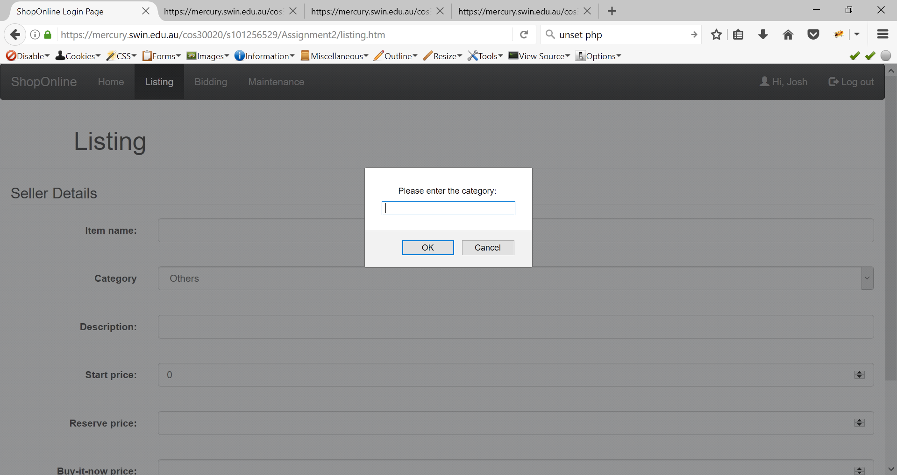

You should keep in mind that the start price must be lesser or equal to the reserve price and the buy it now price is greater than the reserve price. If your inputs don’t follow these requirements, the item won’t be included in the system and error messages will be displayed on the screen.

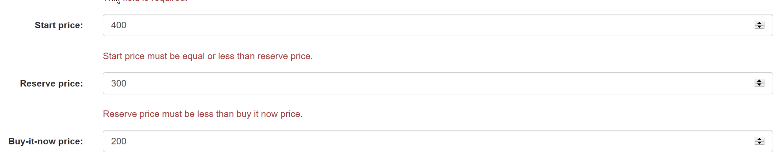

Once you have filled in all details, click the Listing button and a popup success message should be returned to you on the screen.

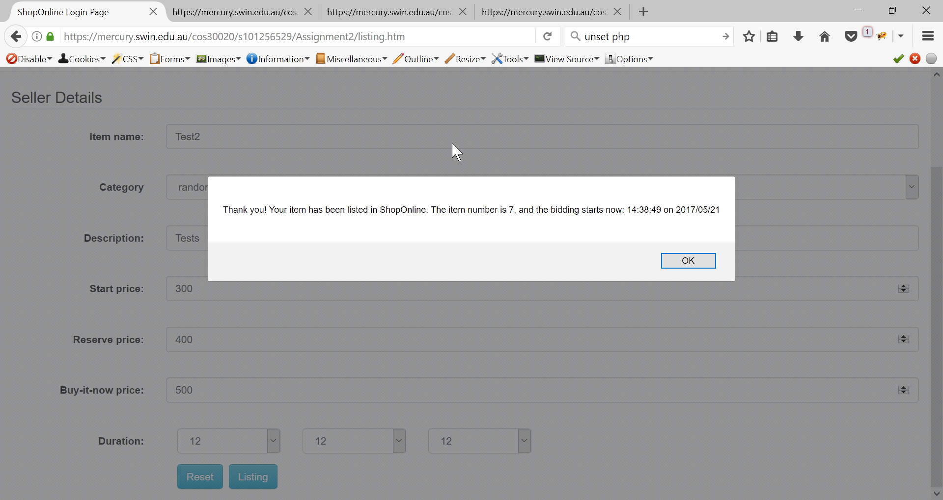

## Bid an item or buy an item

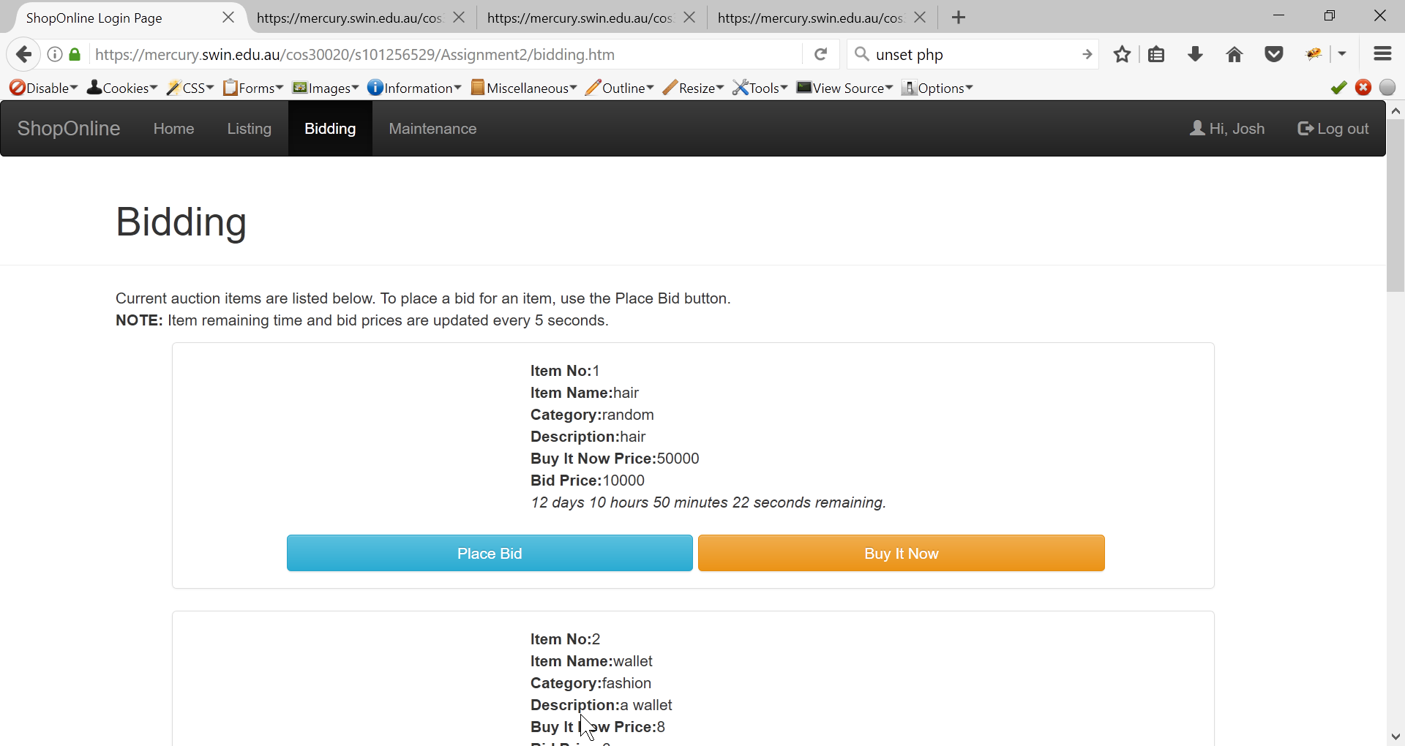

### Bid the item

Click on the place bid button if you want to bid, a popup will appear to take in your bidding price and return a success message if your bid price is valid (as in your bid price must be greater than the current bid price displayed on the screen). The system will display your bid price after you have bid straight away.

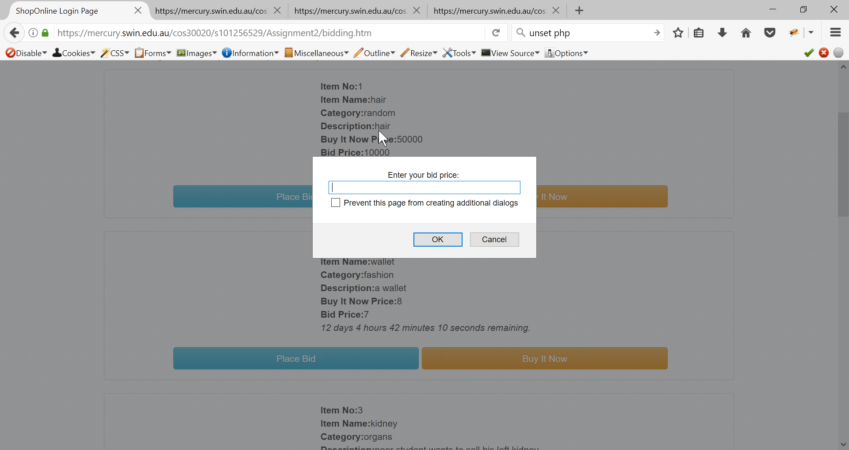

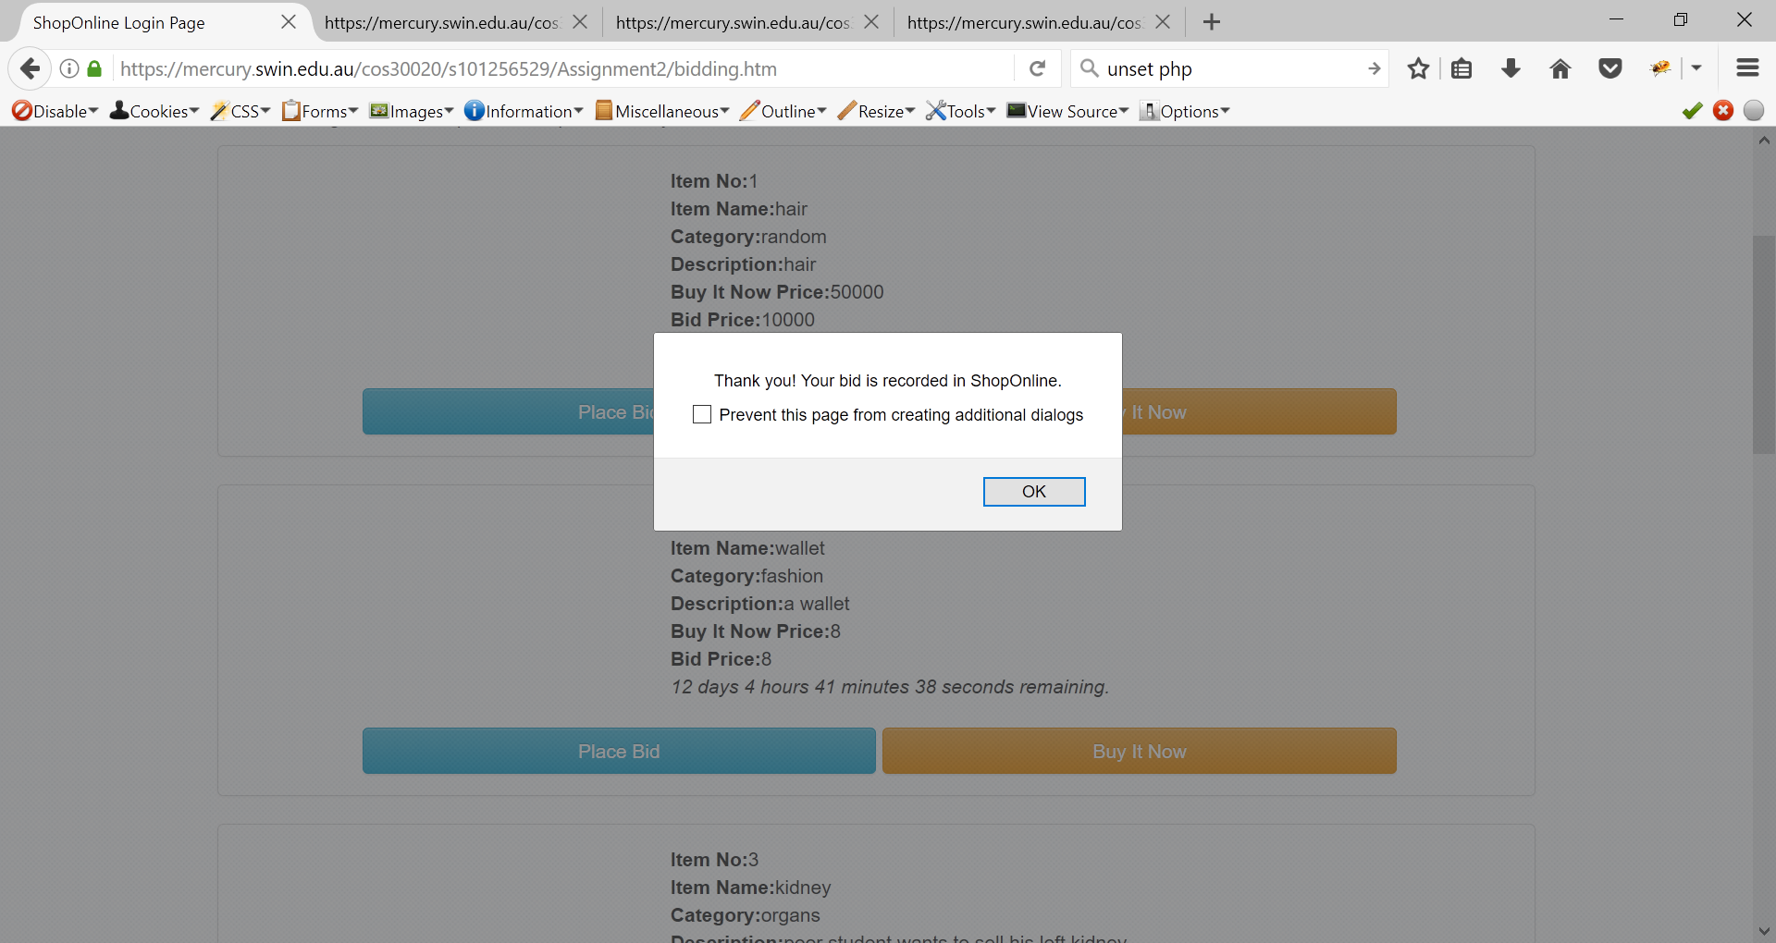

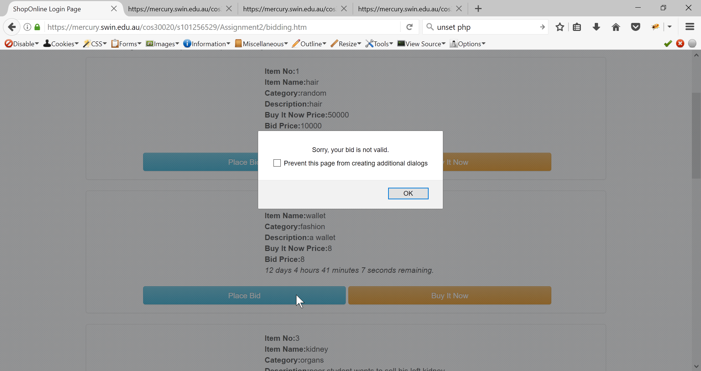

### Buy the item now

You just have to click on the Buy It Now button and you can buy the item.

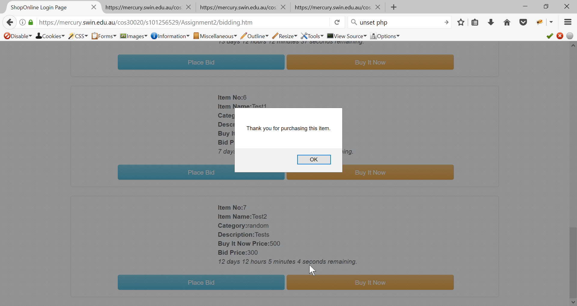

## Maintenance

In this page, if you click on the Process Auction button. It will update the system data on which item is sold or failed based on the time remaining of the item and the bid price.

If you want to generate a report, the system will make a table showing all of sold or failed item with a summary at the bottom.

