Group 4 Project Write Up

# Project Description:

We will be analyzing the impact of electric vehicles and their surge in our society. Are electric cars as green as we think they are?

# Research Questions to Answer:

1. 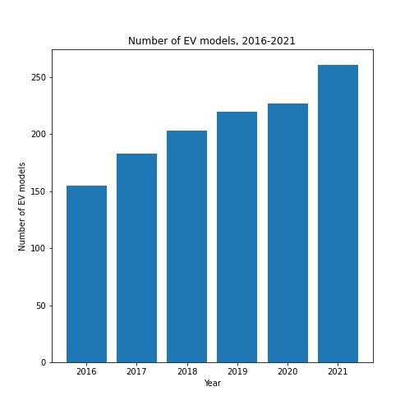Is Electric Vehicles (EV) popular?

As expected, the graphs show us that EVs are on the rise over time. From 2016 to 2021, there has been a great increase in EVs and Plug-in Hybrid vehicles registration is the US, from approximately 500,000 vehicles per year in 2016 to almost 2.2 million vehicles in 2021. When we compared it with Gasoline car, EVs registrations increased by 15%-60% every year while gasoline vehicle registration only increased by less than 10% yearly. During the same period, automakers flooded the market with new models. There were about 150 models in the US in 2016, but automakers have since released another 100 models in a 5-year span, so customers have more options to choose from.

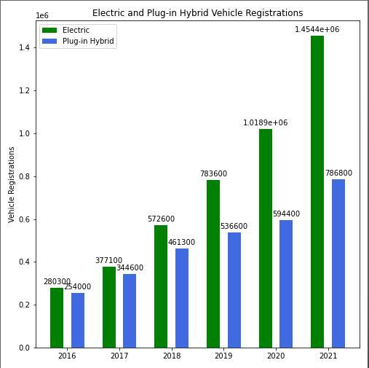

1. Chart, line chart

   Description automatically generatedHas the introduction of electric cars brought on a decrease in emissions overall?

With the introduction of electric vehicles, the emissions are beginning to show changes. Viewing the figures above, the emissions from the transportation sector nationally and at the state level have decreased. However, this does not occur until year 2019. The reason may be the number of EVs up until that point were not enough to stop emissions from increasing. Eventually, emissions have decreased with the introduction of electric cars. However, a huge factor for this decrease could ultimately be the pandemic which began in 2020.

1. What impact does a switch to alternative fuel vehicles have on overall emissions from vehicles nationally?

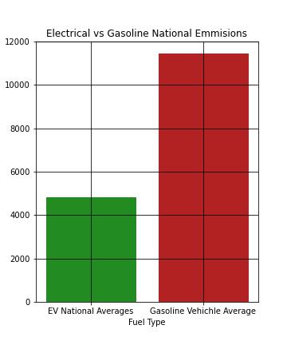When looking at vehicle emissions two categories that are observed are air pollutants such as smog, haze and greenhouse gasses like carbon dioxide and methane. Looking at data from the Vehicle Technology Office in the US Department of Energy they have focused on the greenhouse gasses and have collected the total amount of carbon dioxide emitted by an electrical vehicle (EV) by state in 2016. As you can see, the highest amount of carbon dioxide emitted was 11,435 lbs. This is the average amount of carbon dioxide that is emitted from a car that uses only gasoline as a fuel source. Compared to the national average of 4,815 lbs. of carbon dioxide emitted by EVs. A switch to electrical cars would decrease the amount of carbon dioxide that is emitted overall, but it would not affect every state in the same way.

Looking at carbon dioxide by state, some states like West Virginia, Kentucky, and Wyoming stand out for having electric cars emissions that are near the average for cars that use gasoline. This is due to these states using coal as the main source of energy to produce electricity. Then there are states such as Vermont, Washington, and Idaho that use hydropower (the use of the natural flow of water to produce electricity) to produce electricity. The states have the lowest production of carbon dioxide While states like Texas, New Jersey, Oklahoma that use natural gas, nuclear power, or wind power sources to produce electricity, are close to the national average for emissions or below it. Getting all states to switch to electrical vehicles could help but a real change in greenhouse emission will not take place until states focus on using renewable courses of energy to produce electricity.

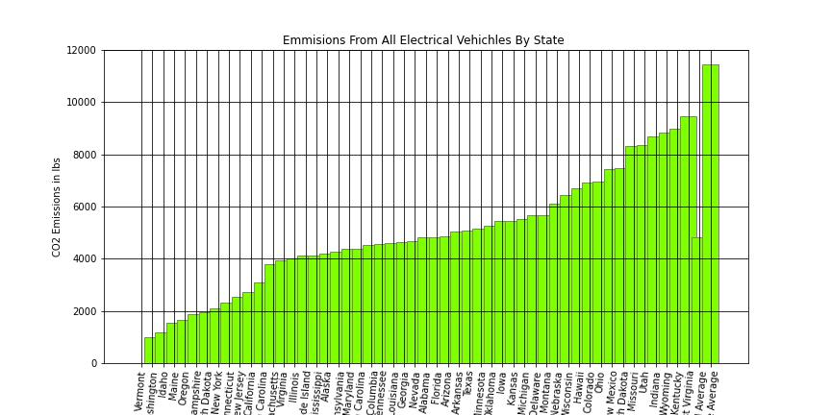

From the data presented thus far, there is a clear correlation between the increase in electric vehicle registration and decrease in overall transportation sector emissions in the United States of America, whether it be plug-in electric vehicles (PHEV), hybrid-electric vehicles (HEV), or all electric-vehicles (EV).

An immediate assessment of all electric vehicle emissions, it appears the electric vehicles help to reduce the overall carbon dioxide (CO2) emissions. This can be seen by comparing each state’s all-electric vehicle (EV) emissions from the average gasoline fuel vehicle in 2016. As stated previously, average national gasoline vehicle emits 11,435 lbs of CO2 gas annually, whereas the national average all electric vehicle emits 4,815 lbs of CO2 gas annually. However, this significant difference varies from state to state.

The Emissions from All Electric Vehicles by State figure reflects this variation in emissions for the year 2016. It would be expected that an electric car performs to the same caliber – and therefore emits the same amount of carbon dioxide from state to state. This is true when assessing the tailpipe emissions of automotive vehicles, electric or not.

Yet, an overall assessment or **well to wheel analysis** or electric vehicles reveals that a layered commitment to lowering greenhouse emissions in the transportation sector. In summary, Tailpipe emissions only consider the emissions from a vehicle when it is driven. Well-to-Wheel (WTW) analysis considers the environmental impact of the vehicle on the road and impacts of extracting resources to fuel the vehicle (petroleum oil, coal, natural gas, solar, etc.). Hence, a true analysis of vehicle emissions must consider the source of electricity used to fuel the vehicle as well as the immediate emissions from operating the vehicle.

The pie charts below a breakdown of electricity sources for the United States, Texas, Arizona, Florida, Washington, Vermont, and Kentucky.

The secondary pie charts categorize the electricity sources as Renewable or Non-renewable. As more electricity is derived from renewable resources, the emissions for alternative fuel vehicles decreases. When electricity is mainly derived from non-renewable resources, the emissions of alternative fuel vehicles increase in comparison to those in states dependent mainly on renewable resources.

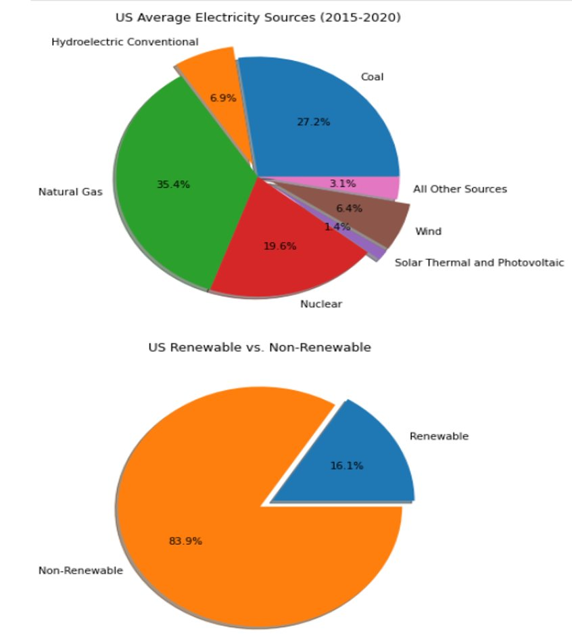

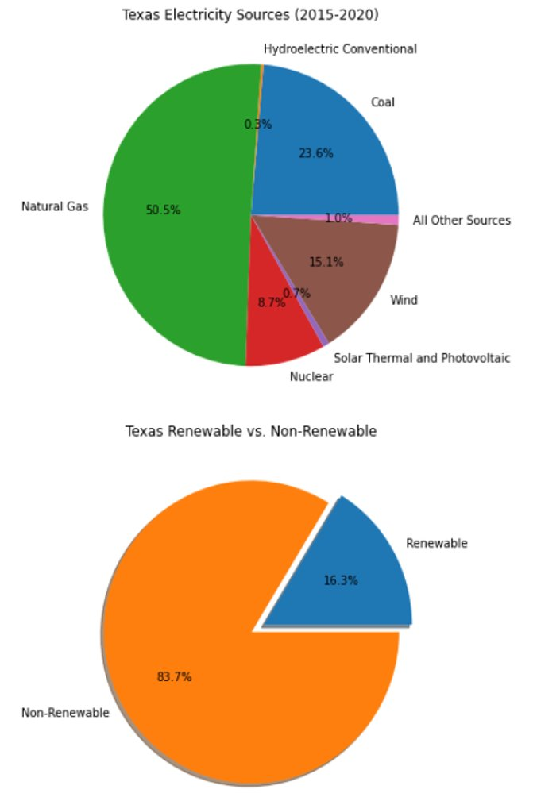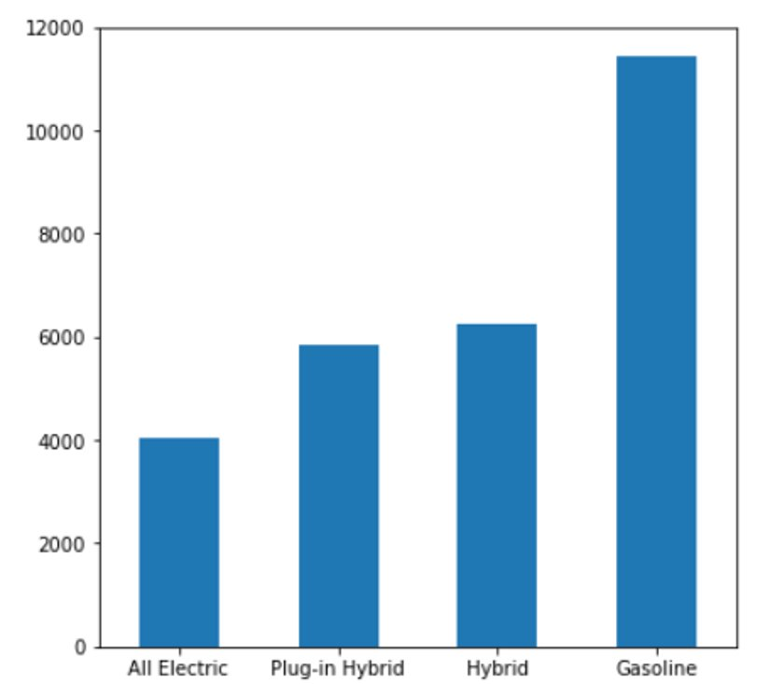

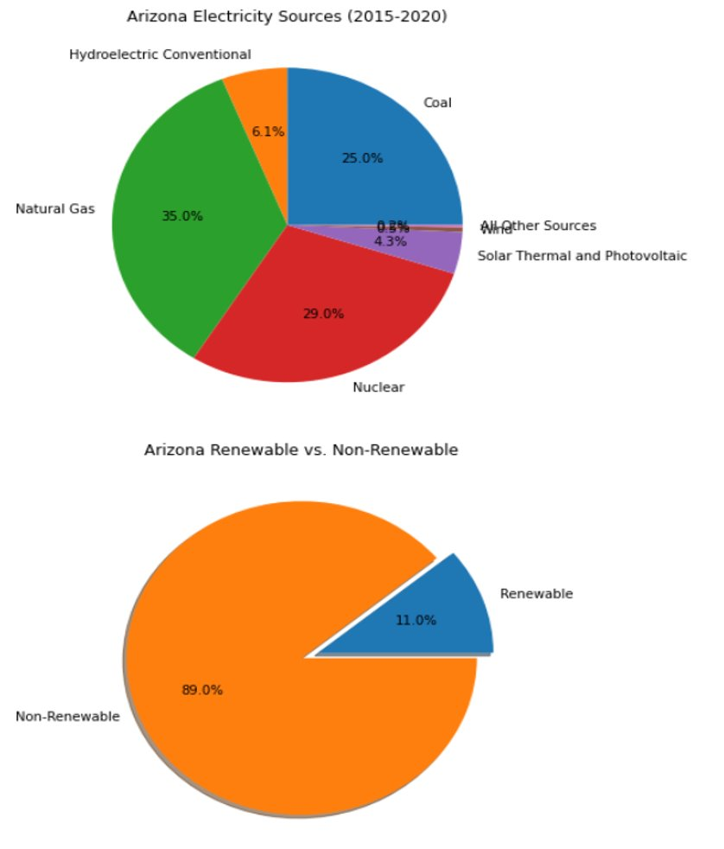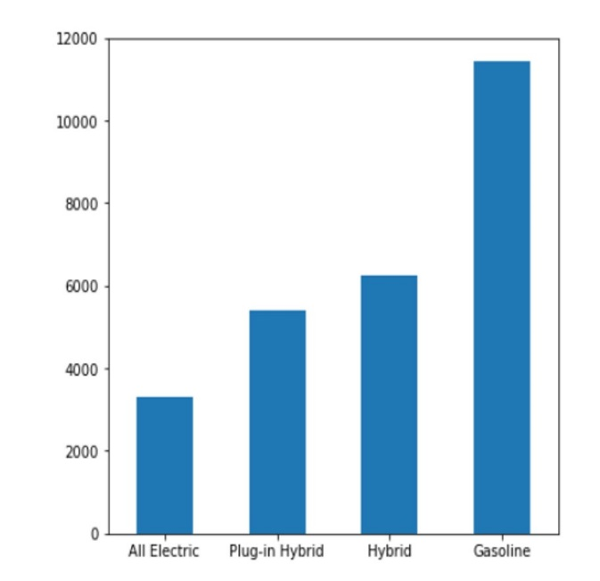

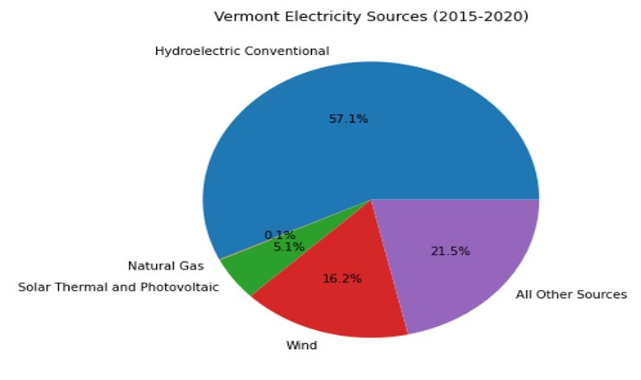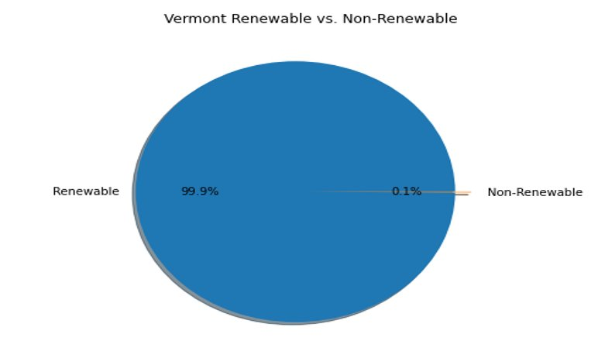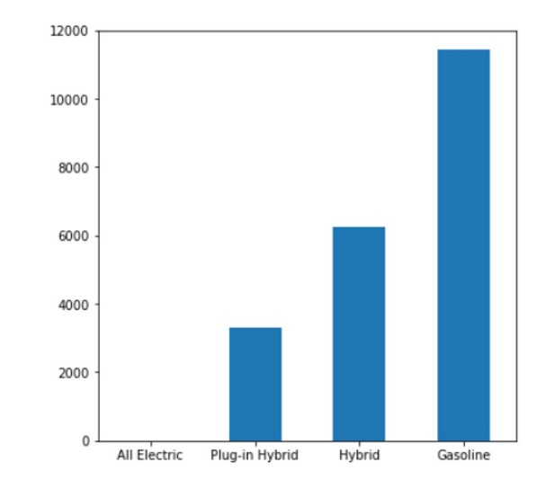

The correlation between the increase in electric car registrations and the and the decrease in emissions can in mainly be accredited to the electric vehicles in states with electricity mainly derived from renewable resources.

# Limitations:

During the project, datasets on particular topics were scarce. Evidently, we did stray away from the initial proposal questions, due to insufficient datasets. Datasets on the production of electric car, from start to finish, and what emissions are involved in the production of the cars as well as the battery could not be found.