-----------ESE501 System Specification and Modeling------------

PROJECT 1 Smart Robot System

FINAL REPORT

Group member: Jiaming Li Student ID#110948308

Hanbing Lin Student ID#111155163

1. **INTRODUCTION OF THE SYSTEM**

Our system is divided into 4 modules including server, sensor, robot and human. Totally, there are 4 robots and 4 humans in the system. Robot are turned on separately and the 4 humans are keeping moving regularly.

Connection between different modules:

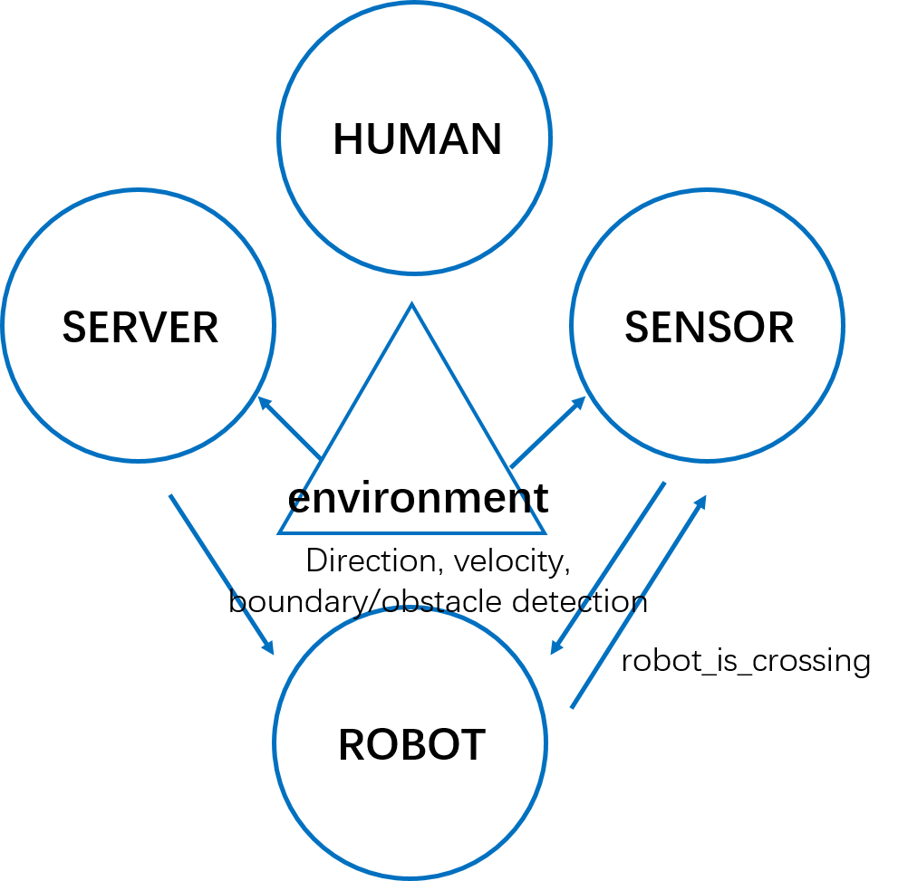

1. SENSOR is a module that feels the ambient changes. It detects the moving obstacles(human), distance to the boundary of the grid that every robot currently in and the direction setting for the robot according to the path.
   * When there is an obstacle appears in the range of 0.5 of a robot, a signal called “obstacle” is sent to module ROBOT.
   * Also, when a robot gets closed to the boundary a signal called “robot_is_crossing” is sent to the module ROBOT.
   * Finally, direction of every robot according to the path (compare next grid number in the path to the grid next to the current grid number and decide the robots’ direction) is also sent to direct their motion through the signal “direction” to the module ROBOT.
2. SERVER is a module that controls the robots’ velocity avoiding system crushing through the signal “velocity”.
   * After accept the signal knowing that the robot is crossing the boundary, calculate the velocity of each robot. If there exists an overlap of path in all the robots, calculate the distance from the current location to the meeting grid entering boundary “distanceToMeetingPoint” & to the leaving boundary “distanceToLeaveMeetingPoint”.
   * Set the former robot ‘s velocity that it leaves the meeting grid exactly when the latter robot reaches the meeting grid with the assumption that the latter one is moving at the original velocity 1. If the calculated velocity exceeds the max velocity, the module will try to lower the latter one’s to achieve the goal in the assumption that the former one is moving at the maximum velocity 2.
   * Sending the velocity of all the robots through the signal “velocity” to the module ROBOT.
3. ROBOT is an actuator module that accepting the signal from both SERVER and SENSOR including direction and velocity.
4. HUMAN is a separate module beyond the whole system, controlling the humans’ motion without affected by the other three parts. The 4 humans keep moving in the map in different rate in a regular routine.

In addition to these four modules, ENVIRONMENT is a package storing the map, robots’ path and all the calculating functions that the system needs including updating the location of robots and humans.

1. **SIMULATON RESULT**

In order to show the result clearly we use MATLAB to relatively plot the location of all the humans and location and the velocity curve of all the robots.

The detail movement of all the objectives can be seen in the MATLAB program.

It obeys the following rules:

* + Two robots cannot stand in the same grid.
  + Starting moment and stopping moment can be set separately.
  + Velocity can be adjusted flexibly if a crushing is foreseen.
  + If a human gets close to a robot, the robot will stop immediately.

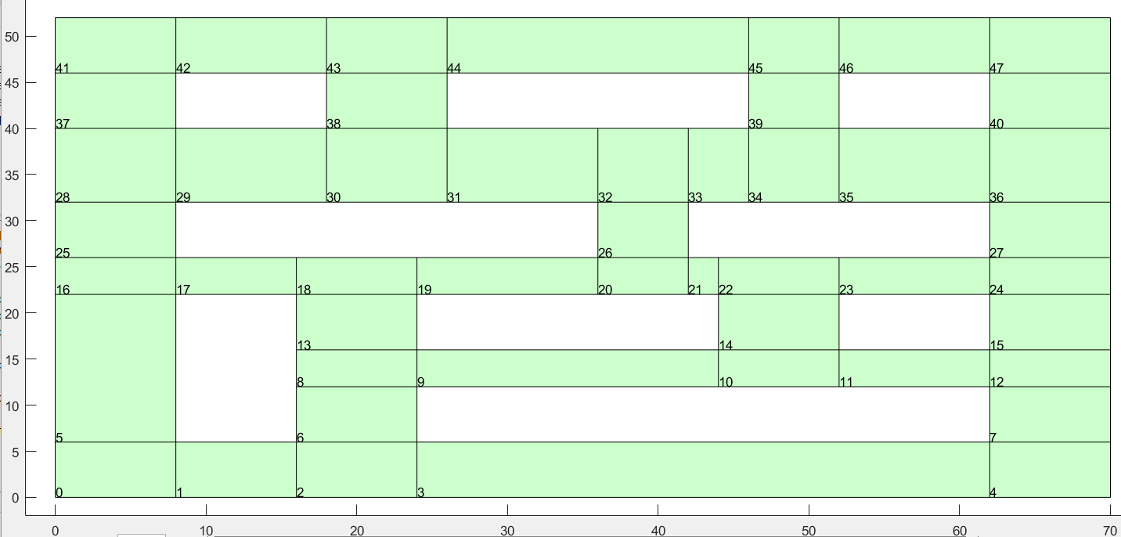

***Figure 1*** *Original map*

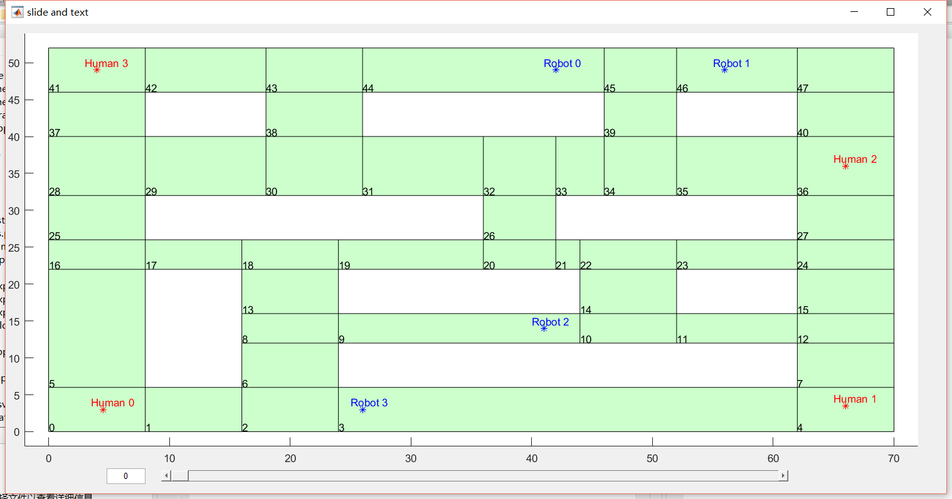

Running time

***Figure 2*** *Original location of all the objectives*

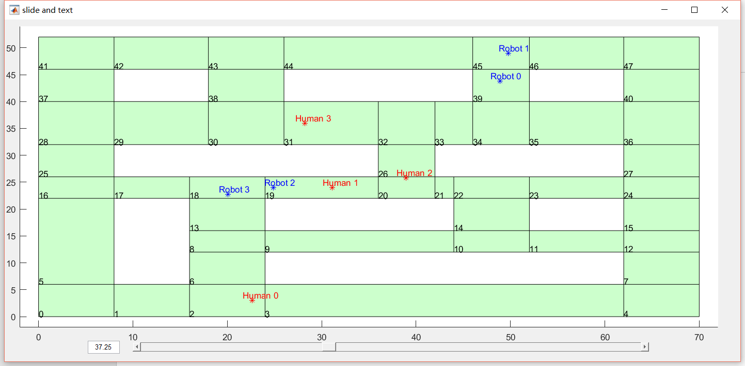

***Figure 3*** *Current location in real time*



Overlapping grids of #2&#3

Overlapping grids of #0&#2

Overlapping grids of #0&#1

***Figure 4*** *Moving path of robots & meeting grids*

According to ***Figure 4***, there is some few overlapping in the path of Robot0 & Robot1; Robot0 & Robot2; Robot2 & Robot3. Therefore, in order to avoid the deadlock and crushing and keep robots moving smoothly, we use some function to control the velocity of robots.

During the system’s operation time, the robots’ velocity is showed as following:

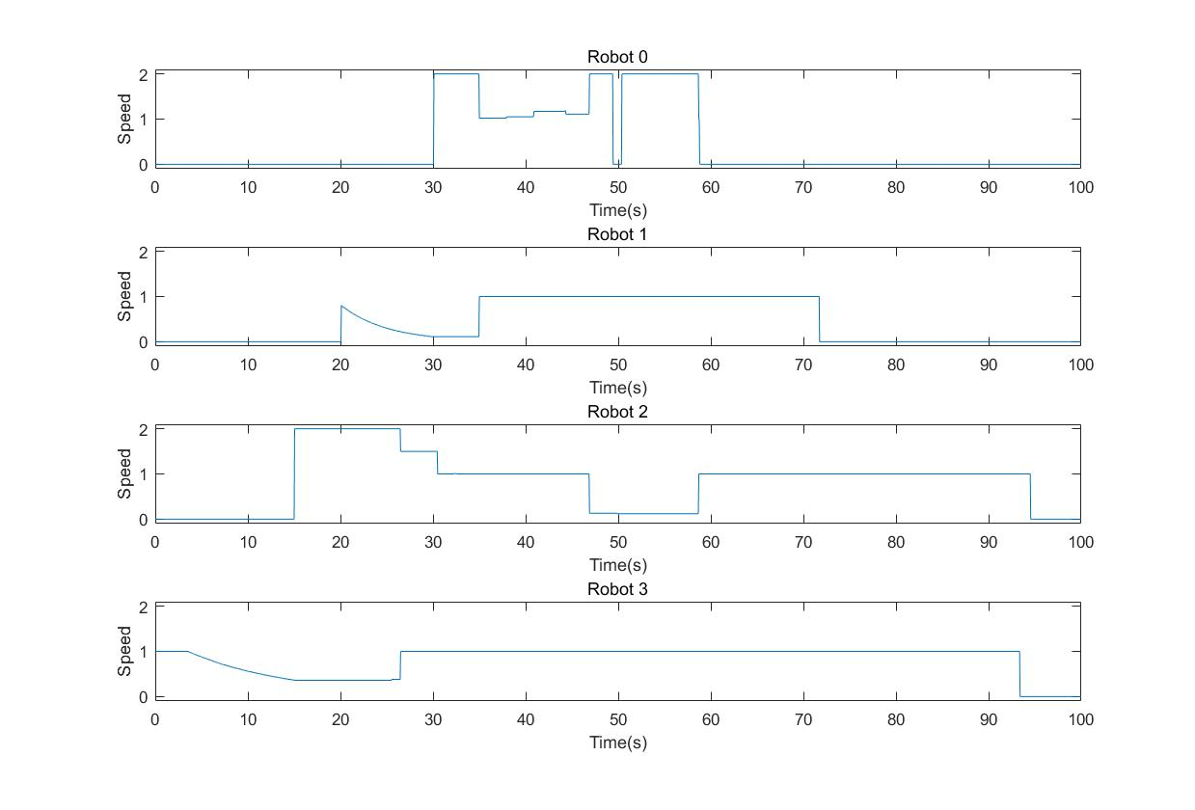

Started moment

Come across at grid 45

Come across at grid 8 26

Come across at grid 26

Obstacle appears

***Figure 5*** *real time velocity of each robot*

Showing in ***Figure 5***, robots are moving in a dynamic speed. Taking robot2&Robot3 as an example.

* After Robot3 is started, SERVER detected that there is an overlap of Robot3&Robot2. The calculated speed of Robot2 exceeds maximum result 2, so Robot3 slows down. Robots 2 moves at the highest velocity after it is started at 15-th sec.
* Before Robot2 leaves grid 8, Robot3 keeps moving in a low velocity going closed to boundary of grid 8.
* As soon as Robot2 leaves grid 8, Robot3 recovers to the origin velocity 1.

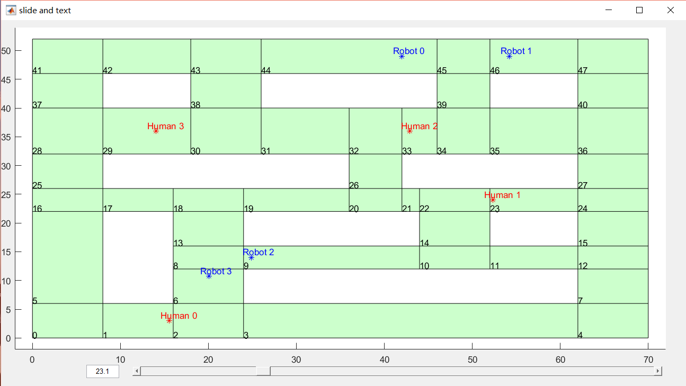

***Figure 6*** *Robot3 is waiting for Robot2 to go through grid 8*

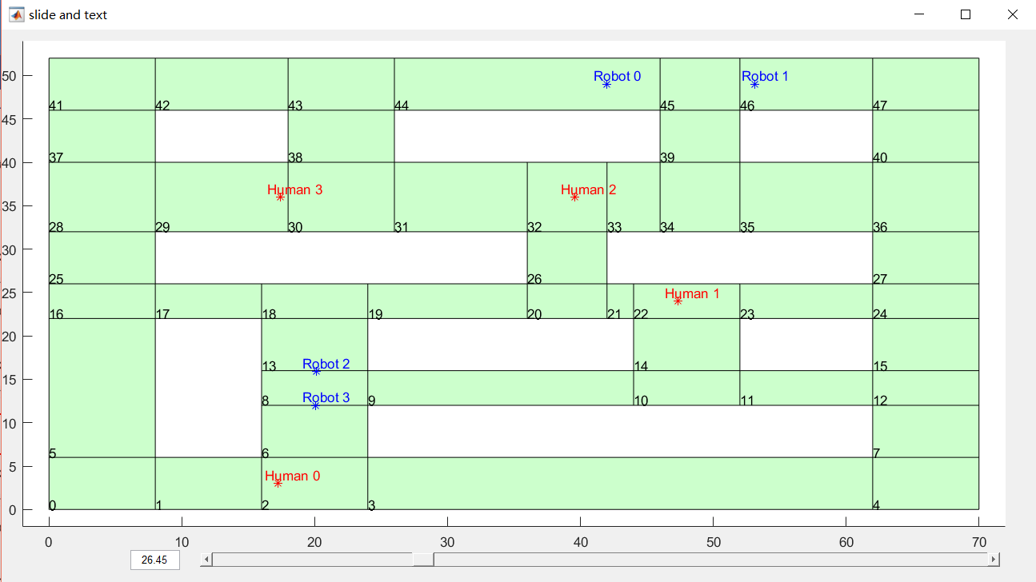

***Figure 7*** *Once Robot2 leaves the meeting grid, Robot3 speeds up and enters grid 8*

The similar result can be seen from Robot0&Robot1.

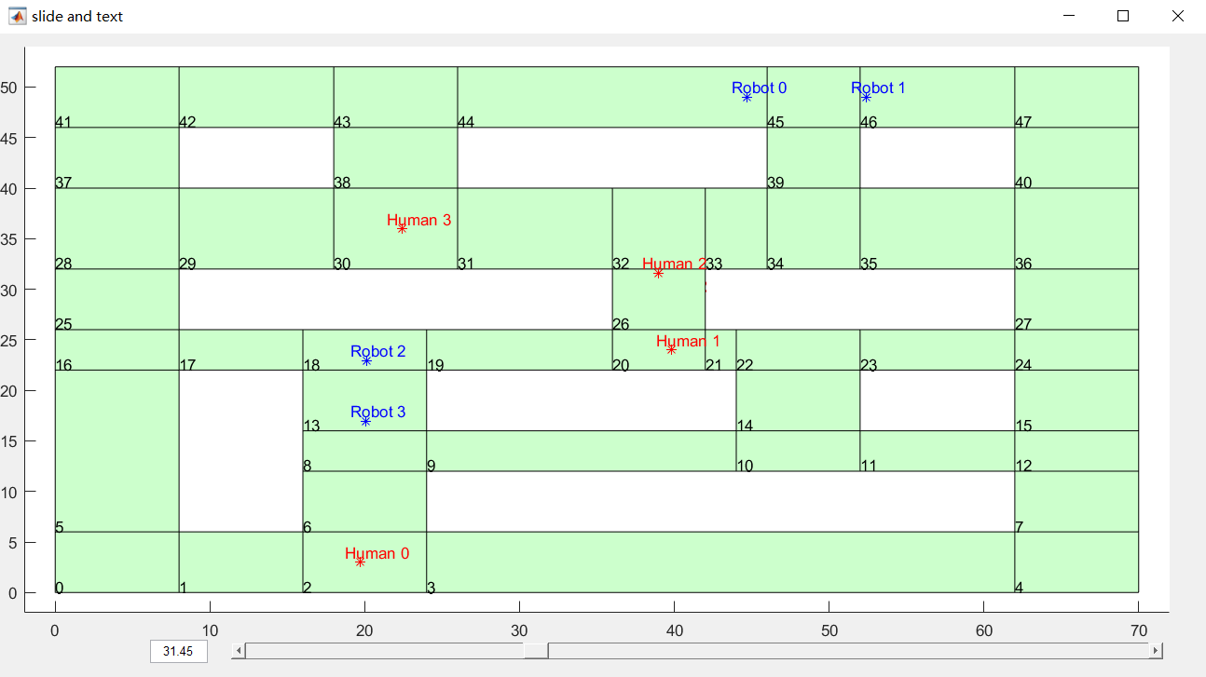

***Figure 8*** *Robot1 is waiting for Robot0 to cross the grid 45*

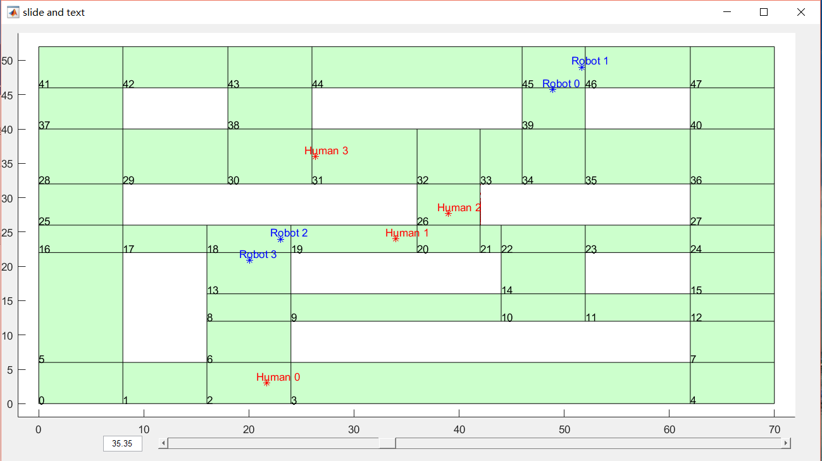

***Figure 9*** *Once Robot0 leaves the overlapped grid, Robot1 speed up*

Specially, in the case of Robot2 & Robot0, they may have a face to face deadlock without a speed control. Therefore, the SENSOR detect all the overlapped path and find the last overlapped grid (grid 20). Therefore, the meeting grid is set as grid 20.

The following story is similar to the case above. Robot0 speed up as soon as the overlap is detected. Before Robot0 leaves grid 20 at a high velocity, Robot2 will slowly moving closed to the boundary of grid 20 (which is showed in the following figure).

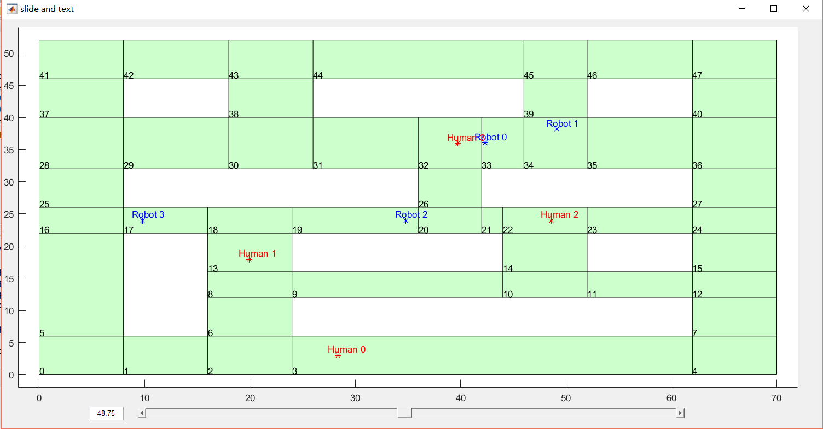

***Figure 10*** *overlapped path of Robot0 & Robot2 is detected*

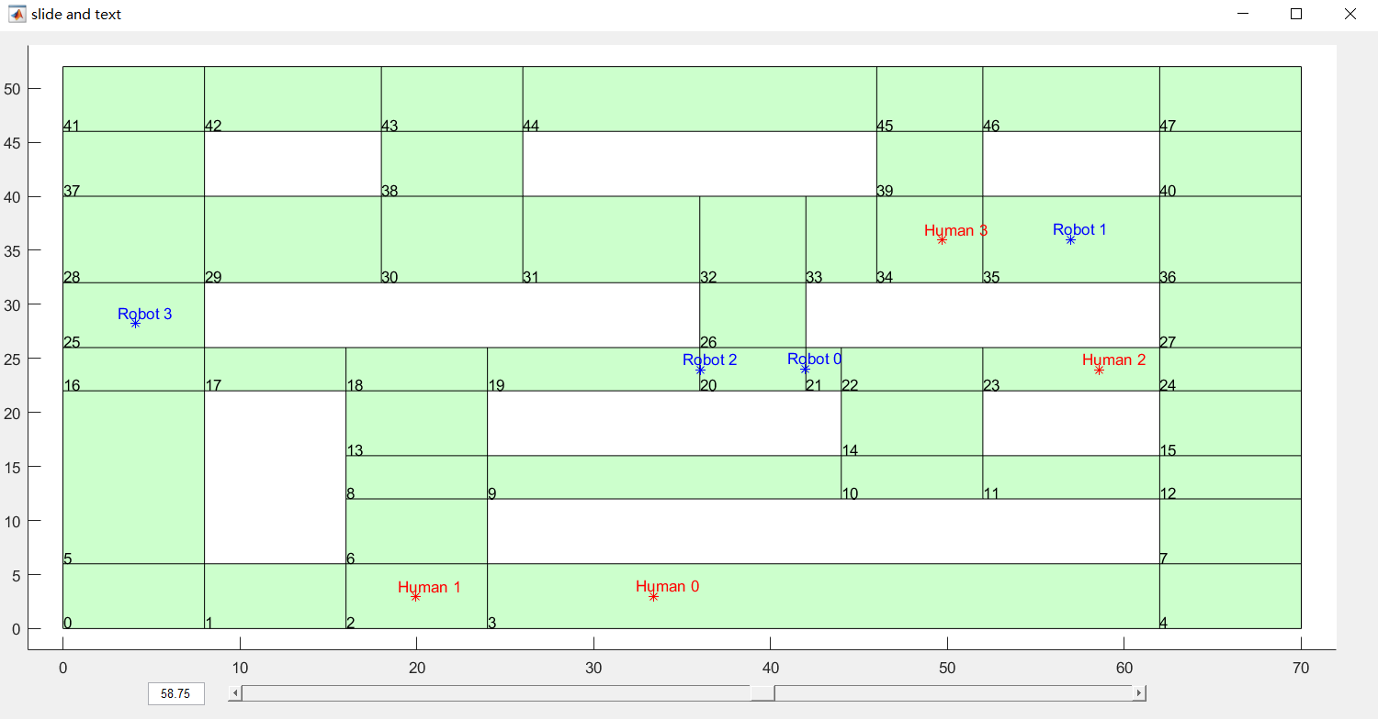

***Figure 11*** *Robot0 leaves grid 20 so Robot2 continues its movement at the original velocity 1*

Noticed that at the moment around 50-th sec, Robot0 comes across a human. Robot0 stop immediately and keep standing when the human come closed until he leaves the detection range of the SENSOR.

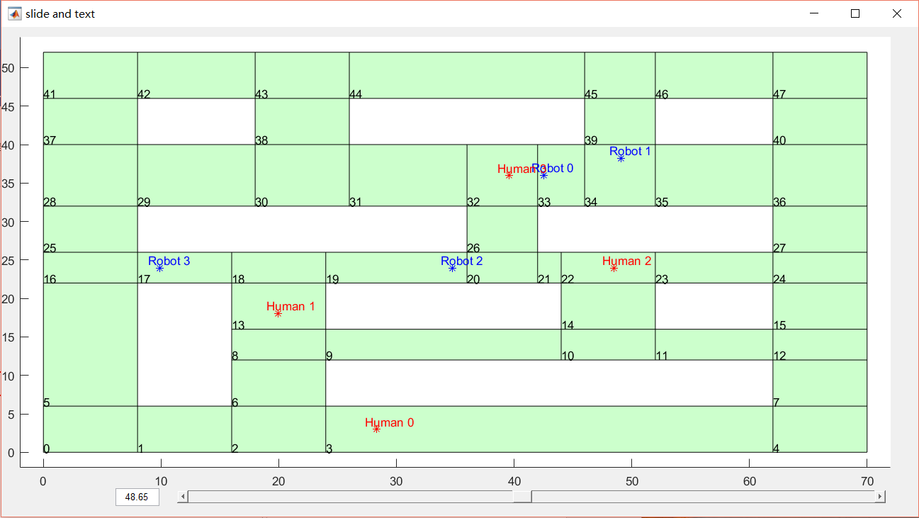

***Figure 12*** *Robot0 comes across an obstacle and stops*