**WebApp**

Interviewers: Palavalasa, Mukesh; Kumarasamy, Muthuramasankar; Keegan, Joseph.

Candidates: Le Cong Hau, Nguyen Hoang Long.

1. **Problem**

We need a separate Web Application which will help to display Widgets/portlets similar to the one in JIRA Dashboard. Very high level requirements are:

1. There should be authentication for the application (CSL/CIP)
2. People should be able to display sonar statistics and crucible overdue reviews (Requirements are same as the one currently in tiger JIRA).
3. People should be able to share the dashboard with others. Ie common dashboards. Unless shared dashboard should remain specific for users and not visible to others.
4. **Solution**

After discuss, me and Hau determine that:

* Hau take the frontend part and I handle the backend.

To solve this part of exercise, I have to do research in some new knowledges and technologies such as REST API, JIRA, SONAR, Crucible, etc. Then, I have to analyze problems and compose a general plan to complete my part.

With this problem, I need to get the basic ideas first.

* JIRA is a proprietary issue tracking product, developed by Atlassian. It provides bug tracking, issue tracking, and project management functions.
* According to Atlassian, JIRA is used for issue tracking and project management by over 25,000 customers in 122 countries around the globe. Some of the organizations using JIRA for bug-tracking and project management are Fedora Commons, Hibernate,JBoss, Skype, Spring Framework.
* JIRA dashboard in our system provide so many gadgets to make the view more clearly like charts, boards, card view, coverage.
* In JIRA, Crucible is particularly tailored to distributed teams and facilitates asynchronous review and commenting on code. It’s also integrates with popular source control tools.
* Crucible is a collaborative code review application by Australian software company Atlassian. Like other Atlassian products, Crucible is a Web-based application primarily aimed at the enterprise, and certain features that enable peer review of a codebase may be considered enterprise social software.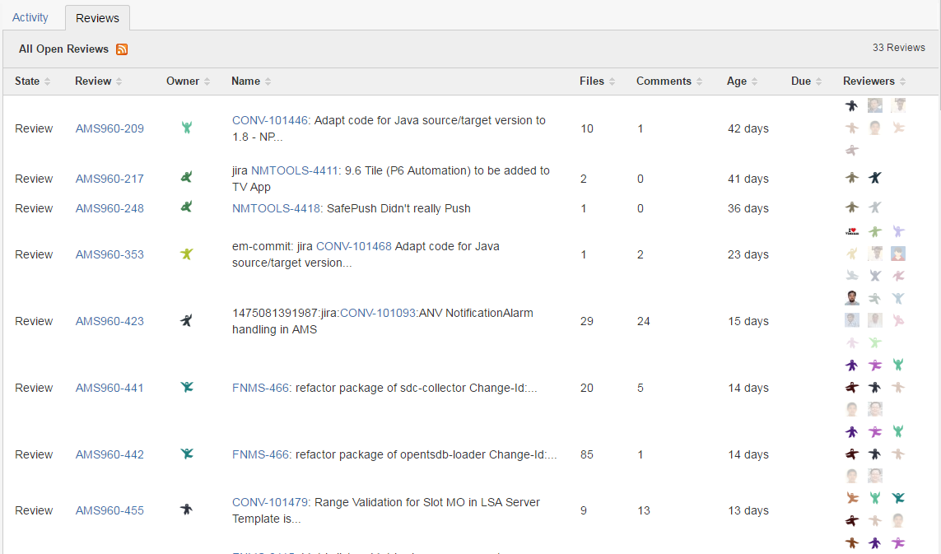
* SONAR is the plugin of JIRA, it’s enables to cover quality on 7 axes and so to report on:
* Duplicated code
* Coding standards
* Unit tests
* Complex code
* Potential bugs
* Comments
* Design and architecture

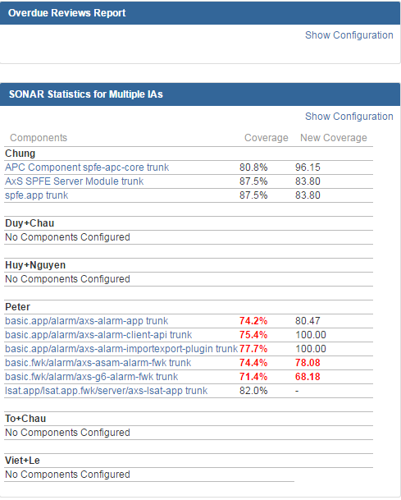

With my backend part, I have some works to handle such as:

* Authentication the Webapp/REST requests with CSL/CIP.
* Get the database from SONAR statistics and Crucible overdue reviews gadgets.
* Development the ways how to client work with database.
* Research and Create the Crucible Plugin and REST APIs/REST Services.
* Keep research to add the remaining features and discus with Hau to make the convenient for the Frontend.

1. **Plan**

|  |  |  |
| --- | --- | --- |
| Day | Tasks | Percentage of completion |
| Sep 22 | -Receive assignment.  -Get the fundamental ideals. | 0% |
| Sep 23 | -Find the solutions.  -Do research Crucible REST API.  -Do some examples.  https://developer.atlassian.com/fecrudev/remote-api-reference/rest-api-guide | 10% |
| Sep 26 | -Get and development the database.  -Authentication the WebApp. | 30% |
| Sep 27 | -Create the Crucible REST backend. | 50% |
| Sep 28 |  | 70% |
| Sep 29 |  | 100% |