**IT159IU: Artificial Intelligence**

**Lab#2/Assignment#2**

**Uninformed Search in Pac-Man**

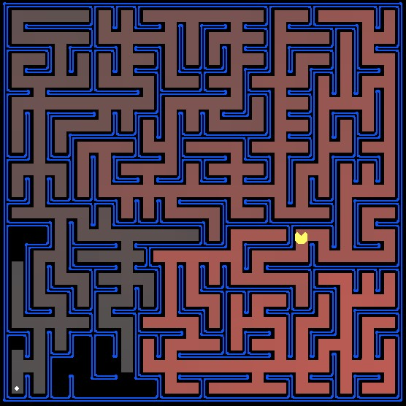

There are two exercises in this lab:

1. Depth-First Search (DFS)
2. Breadth-First Search (BFS)
3. Uniform-Cost Search (UCS)

# Introduction

In this assignment, you will continue to work with the archive in the first lab assignment to help your Pac-Man agent find paths through his maze world to reach a particular location. You will build general search algorithms and apply them to many different Pac-Man scenarios.

Files you'll edit:

search.py Where all your search algorithms will reside.

searchAgents.py Where all your search-based agents will reside.

**Files you should look at but NOT edit:**

|  |  |
| --- | --- |
| util.py | Useful data structures for implementing search algorithms. |
| pacman.py | The main file that runs Pac-Man games. This file describes a PacMan GameState type, which you use in this lab. |
| game.py | The logic behind how the Pac-Man world works. This file describes several supporting types like AgentState, Agent, Direction, and |

Grid.

# Finding a fixed food dot using Uninformed Search

In searchAgents.py, you'll find a fully implemented SearchAgent, which plans out a path through Pac-Man's world and then executes that path step-by-step. The search algorithms for formulating a plan are not implemented -- that's your job. As you work through the following questions, you might need to refer to the [glossary of objects in the code](http://web.cs.swarthmore.edu/%7Emeeden/cs63/s15/search.html#Glossary) (at the end of this handout).

First, test that the SearchAgent is working correctly by running:

python pacman.py -l tinyMaze -p SearchAgent -a fn=tinyMazeSearch

The command above tells the SearchAgent to use tinyMazeSearch as its search algorithm, which is implemented in search.py. This simply follows a fixed sequence of actions to demonstrate how the code works. Pac-Man should navigate the maze successfully.

Now it's time to write the generic search functions to help Pac-Man plan routes! Pseudocode for the depth-first search, breadth-first search and uniform-cost search algorithms might be useful for the implementation is shown below.

**function** UninformedSearch(problem) **returns** a list of actions  
 initialize the **frontier** using the initial state of the problem  
 initialize **exploredSet** to empty  
 *#For explored, use Pacman position as the key with a value True  
 #initialize a set of states already explored* **while** frontier is notempty **do**  
 choose a leaf **node** andremove it fromthe frontier  
 **if** the node contains a goal state  
 **return** list of actions fromstart state to goal state  
 add the state to the **exploredSet**  
 **for** each successor of the node state  
 **if** the successor state is not in **exploredSet**  
 add node of the successor onto the frontier  
 **return** an empty list (i.e. no solution!)

**Important note*:*** All your search functions need to return a list of *actions* that will lead the agent from the start to the goal. These actions must be legal moves (valid directions, no moving through walls).

**Hint:** Algorithms for DFS, BFS and UCS differ only in the details of how the frontier is managed. So, concentrate on getting DFS right and then BFS should be relatively straightforward. Indeed, one possible implementation requires only a single generic search method which is configured with an algorithm-specific queuing strategy. Your implementation need *not* be of this form to receive full credit.

**Hint:** Make sure to check out the Stack, Queue, and PriorityQueue types provided to you in util.py.

**EXERCISE 1:** Implement the depth-first search algorithm in the depthFirstSearch function in search.py. Although DFS and BFS ignore the costs, you'll need them for later search methods. Your code should quickly find a solution for:

python pacman.py -l tinyMaze -p SearchAgent –a fn=dfs

python pacman.py -l mediumMaze -p SearchAgent -a fn=dfs

python pacman.py -l bigMaze -p SearchAgent -z .5 -a fn=dfs

The Pac-Man board will show an overlay of color for the states explored and the order in which they were explored (brighter red means earlier exploration). Is the exploration order what you would have expected? Does Pac-Man actually go to all the explored squares on his way to the goal?

**Hint:** The solution found by your DFS algorithm for mediumMaze should have a length of 130 (provided you push successors onto the frontier in the order provided by getSuccessors(); you might get 244 if you push them in the reverse order). Is this a least cost solution? If not, think about what depth-first search is doing wrong.

**EXERCISE 2:** Implement the breadth-first search algorithm in the breadthFirstSearch function in search.py. Use the same algorithm as shown in the above pseudocode. Test your code the same way you did for depth-first search.

python pacman.py -l tinyMaze -p SearchAgent -a fn=bfs

python pacman.py -l mediumMaze -p SearchAgent -a fn=bfs python pacman.py -l bigMaze -p SearchAgent -z .5 -a fn=bfs

Does BFS find a least cost solution?

**Hint:** If Pac-Man moves too slowly for you, try the option --frameTime 0.

**EXERCISE 3:** Implement the uniform-cost search algorithm in the uniformCostSearch function in search.py. Does UCS find a least cost solution? How many nodes are expanded? You should now observe successful behavior in all three of the following layouts, where the agents below are all UCS agents that differ only in the cost function they use (the agents and cost functions are written for you):

python pacman.py -l mediumMaze -p SearchAgent -a fn=ucs

python pacman.py -l mediumDottedMaze -p StayEastSearchAgent

python pacman.py -l mediumScaryMaze -p StayWestSearchAgent

*Note:* You should get very low and very high path costs for the StayEastSearchAgent and StayWestSearchAgent respectively, due to their exponential cost functions (see searchAgents.py for details).

# Object Glossary

Here's a glossary of the key objects in the code base related to search problems, for your reference:

SearchProblem (search.py)

A SearchProblem is an abstract object that represents the state space, successor function, costs, and goal state of a problem. You will interact with any SearchProblem only through the methods defined at the top of search.py.

PositionSearchProblem (searchAgents.py)

A specific type of SearchProblem that you will be working with --- it corresponds to searching for a single pellet in a maze.

Search Function

A search function is a function which takes an instance of SearchProblem as a parameter, runs some algorithm, and returns a sequence of actions that lead to a goal. Example of search functions are depthFirstSearch and breadthFirstSearch, which you have to write. You are provided tinyMazeSearch which is a very bad search function that only works correctly on tinyMaze.

SearchAgent

SearchAgent is a class which implements an Agent (an object that interacts with the world) and does its planning through a search function. The SearchAgent first uses the search function provided to make a plan of actions to take to reach the goal state, and then executes the actions one at a time.

# What to submit

1. Fill out the table below:

Import visualize tree node by adding tool

|  |  |  |  |  |  |  |  |  |  |  |
| --- | --- | --- | --- | --- | --- | --- | --- | --- | --- | --- |
|  | **Depth-First Search** | | | | **Breadth-First Search** | | | **Uniform-Cost Search** | | |
| **Maze** | **#nodes explored** | **Solution length** | **Is it optimal?** | **#nodes explored** | | **Solution length** | **Is it optimal?** | **#nodes explored** | **Solution length** | **Is it optimal?** |
| **tiny** |  |  |  |  | |  |  |  |  |  |
| **medium** |  |  |  |  | |  |  |  |  |  |
| **big** |  |  |  |  | |  |  |  |  |  |

1. Based on the above, a short discussion/reflection of how the searches compare.
2. Source code: two files include **search.py** and **searchAgents.py**
3. Please create a folder called "yourname**_**studentID" that includes all the required files and generate a zip file called "yourname_ studentID.zip".
4. Please submit your work (.zip) to Blackboard.