Các lệnh cơ bản thao tác với Docker
docker --version

docker run hello-world
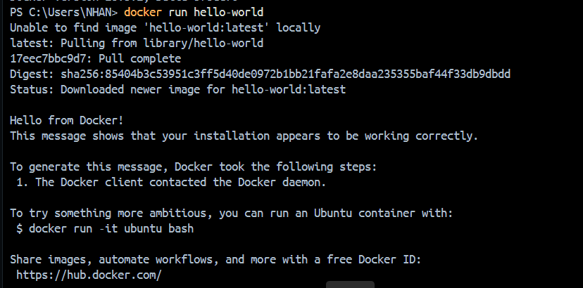

docker pull nginx
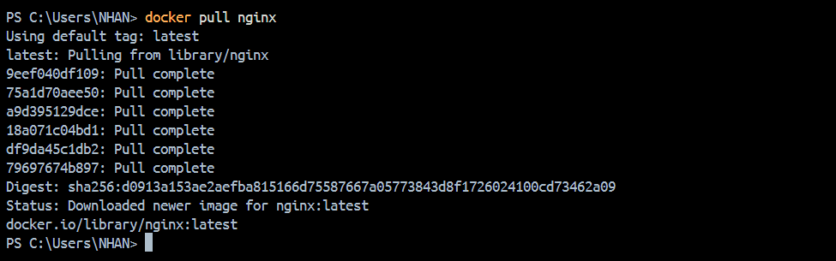

docker images
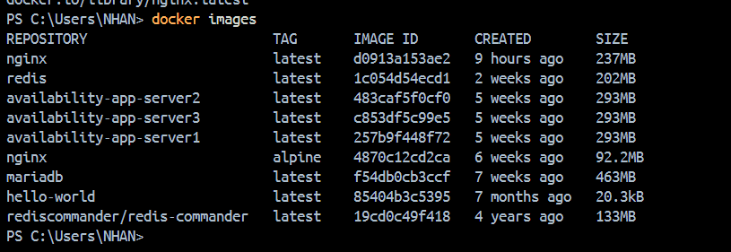

docker run -d nginx

docker ps
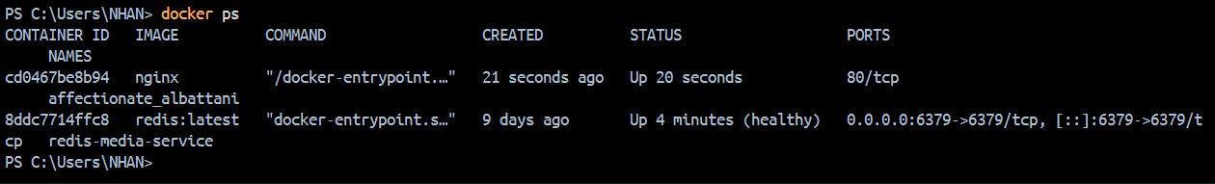

docker ps -a
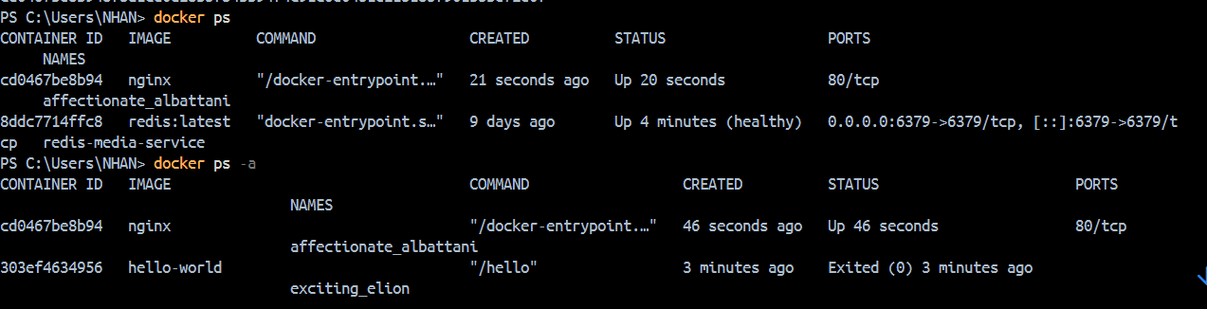

docker logs <container_id>
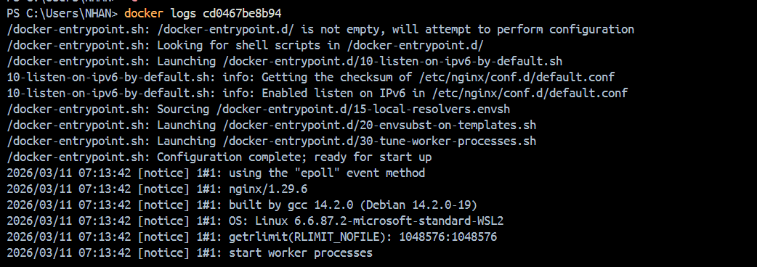

docker exec -it <container_id> /bin/sh

docker stop <container_id>
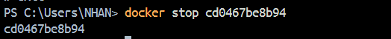

docker restart <container_id>
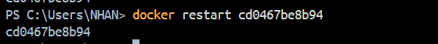

docker rm <container_id>

docker container prune
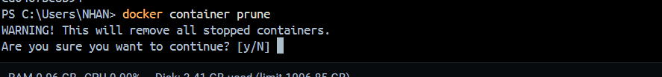

docker rmi <image_id>
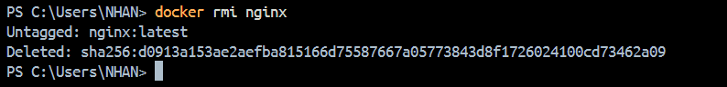

docker image prune -a
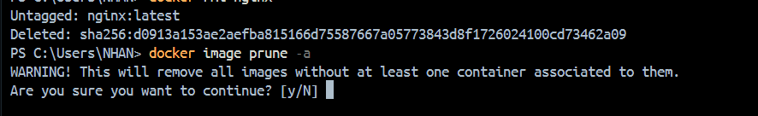

docker run -d -p 8080:80 nginx
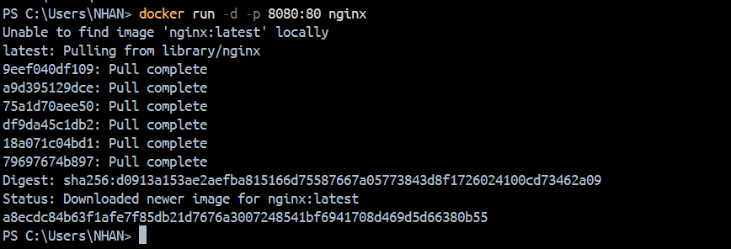

docker inspect <container_id>
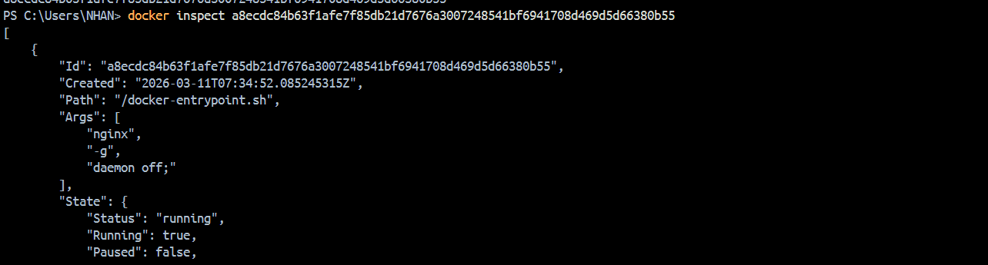

docker run -d -v mydata:/data nginx

docker volume ls
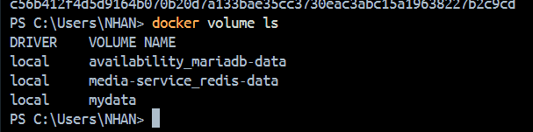

docker volume prune
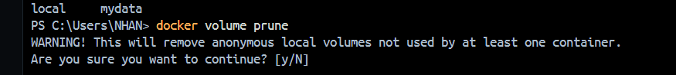

docker run -d --name my_nginx nginx
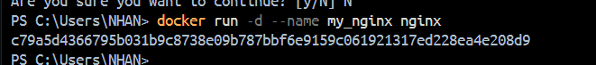

docker stats
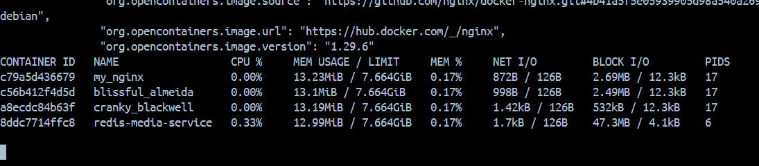

docker network ls
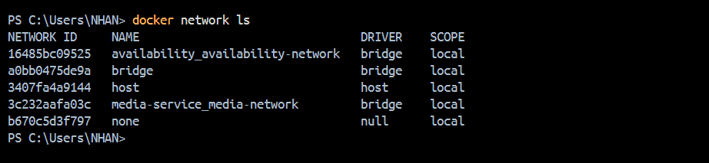

docker network create my_network
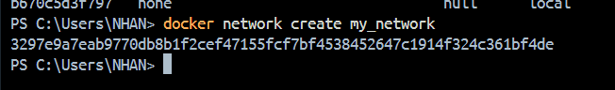

docker run -d --network my_network --name my_container nginx
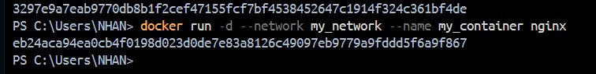

docker network connect my_network my_nginx

docker run -d -e MY_ENV=hello_world nginx

docker logs -f my_nginx
