Phần 1: Một số lệnh Docker Compose cơ bản
- docker compose version:
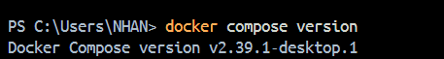

- docker compose up:
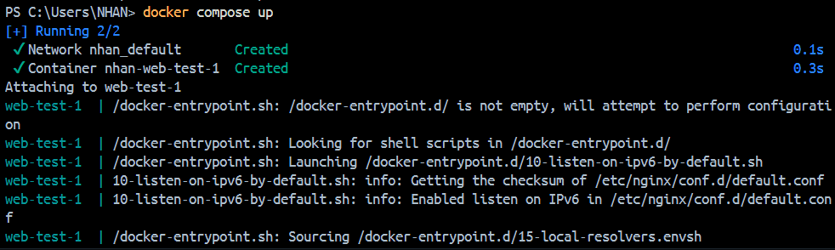

- docker compose up:
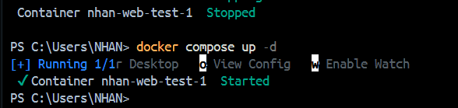

- docker compose ps
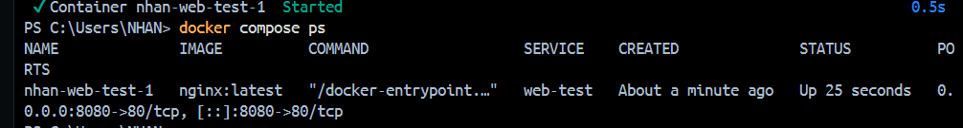

-docker compose down
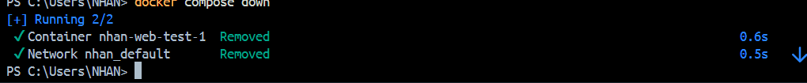

- docker compose restart
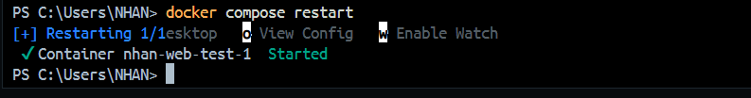

docker compose logs -f
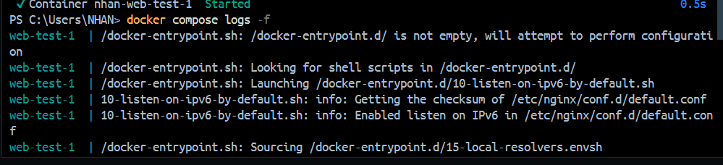
docker compose build

docker compose exec web-test nginx -v
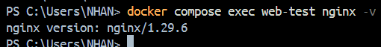

docker compose down -v
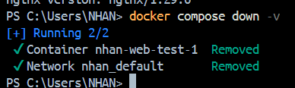

docker compose run <service_name> <command>
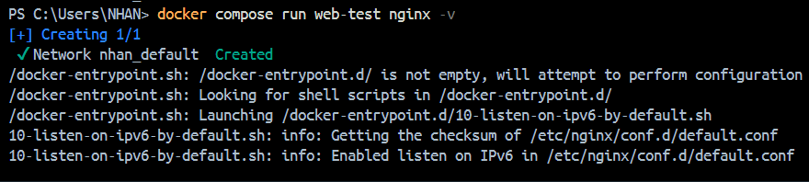

docker compose stop <service_name>
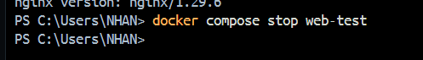

docker compose rm <service_name>
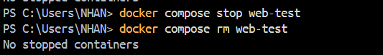

docker compose config
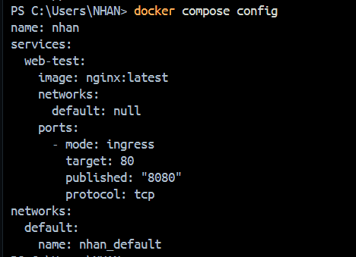

docker compose up -d --build
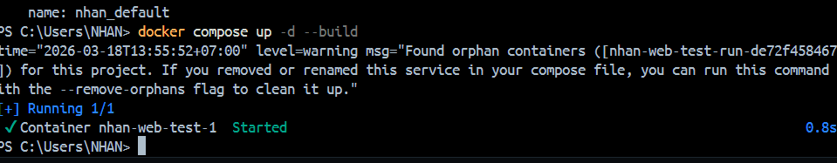

Phần 2: Docker compose file
Bài 1: Chạy một container đơn giản với Docker Compose

