Report No.2 Task Plan

# Problem Definition

## Name of this Capstone Project

* Official name: **Device controlled by arm muscle tissue gestures**
* Vietnamese name: **Thiết bị điều khiển bằng cách nhận dạng xung cơ.**
* Abbreviation: **DCG**

## Problem Abstract

To solve those problems about controller currently mentioned in the earlier section. We proposed a device which will becomes controller bases on user personal muscle tissues electricity signal. By using this electricity signal we can identify what gesture that our user is performing. And by the gesture user performing, we can map their gesture to whatever they intents to control. This technique basically use “EMG” study that have been used in many medical and prosthetics majors.

Our team will provide the system including device to demonstrate the main idea of using user muscle tissue to control things. Also, our team will provide a computer application as an interface for user and this device interact with each other. More specific, this computer will holds mission of helping user mapping their gesture, which was recognized by the DCG devices, with their keyboard action. And moreover, the computer application also provide window that help user seeing what gesture they are performing.

However, at starting point, our team has discover some major problem that our team need to concern while developing this system:

* What and how to get the EMG data of a human body?
* What we need to do with the raw EMG data?
* How we connect our DCG device with our DCG computer application? Although our team have decided using Bluetooth over Wifi, but we still need to learn how Bluetooth work, the protocol…
* What components we will need to use in our system?

In this document, our team want to describe our working process in 4 month including with our perspective on how we going to build this DCG device, components that we are using and the code workflow inside the system.

## Project Overview

### Current Situation and Disadvantages

#### Advantages

* There is a similar device in the world call MYO, our team can references something about this device to help building our DCG system.

#### Disadvantages

* EMG is not our team major, so team has no information about of the signal our team will facing.
* Medical research about human anatomy is large and wide, our team need to screening needed information.
* Team member lack of experience in noise reduction, which have been warned.

### The Proposed System

To get user gesture, user must wear our DCG devices, and then pairing it with a laptop, which already installed our DCG window application, via Bluetooth. If they are successfully paired, the DCG device will vibrate and led blinking. While user is performing the gesture, our DCG device will read user raw data using component name “Electrode” and then transform it into the signal needed to be sent to the DCG computer application. Right after getting EMG data, DCG application will analyze it and mapping it to the particular gesture, showing it for user. For now, the gesture in the DCG application will be define by our team for the best performance in front of the council. Whenever user has paired DCG device and DCG application, user can map the defined gesture with particular keyboard action they want to perform. And the action will be performed when user performing this gesture after it was defined.

#### Computer application

* For User:
* Guide to pair DCG device and DCG application.
* Define keyboard action mapping with the gesture.
* Showing what gesture user is performing.
* For Device:
* Pair with device
* Get the EMG signal via Bluetooth.

#### Device:

* For User:
* Get user EMG signal.
* Processing EMG signal.
* For Computer application
* Transform the EMG signal to Bluetooth signal.
* Send it to DCG computer application.

### Boundaries of the System:

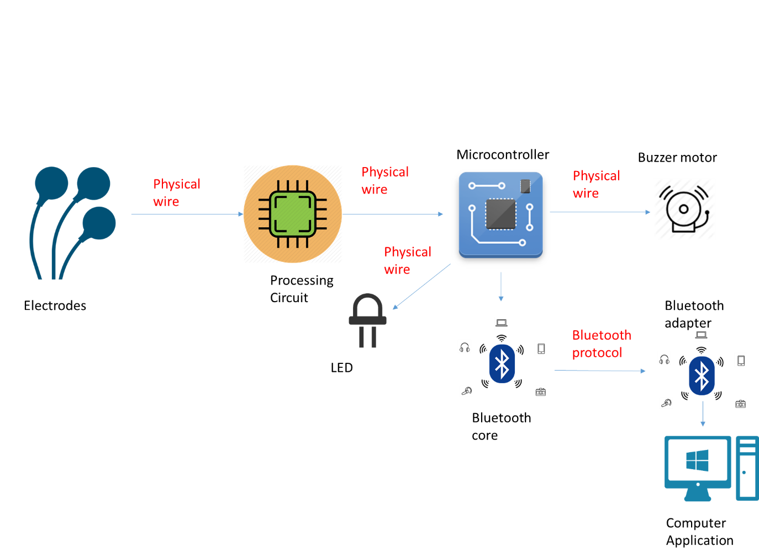

### Future Plan

Currently, the system can only performed with a single device pair with a single application. Besides that, the EMG signal studies still developing. We only demonstrate the idea of using this EMG signal to control things. Further in the future, it will be scale in many way to develop:

* Better noise reduction for better signal.
* Better component for better performance.
* Connect more than one device to the software.
* Control other thing than just computer keyboard action.

### Development Environment

#### Hardware requirements

|  |  |  |
| --- | --- | --- |
|  | Name / Version | Description |
| Main Processor | CC2650-ARM CORTEX M3 | Main processor will help us digital, transform EMG signal to computer application. |
| Sensor | Electrode  MPU6050 | Highly sensitive six-axis IMU containing three-axis gyroscope, three-axis accelerometer. |
| Source | Coin cell |  |
| Others | Led  Buzzer Motor | For vibrating. |

#### Software requirements

|  |  |  |
| --- | --- | --- |
|  | Name / Version | Description |
| Modeling tool | Star UML | Used to implement website and web service |
| IDE | IAR Workbench  Visual Studio  CCS Code Composer Studio | Programming tools |
| Hardware design tool | OrCAD |  |
| Source control | Tortoise SVN  GitHub | Used for source control |
| Team communication | Slack  Trello | Team communication tool.  Task assignment tool. |

# Project organization

## Software Process Model

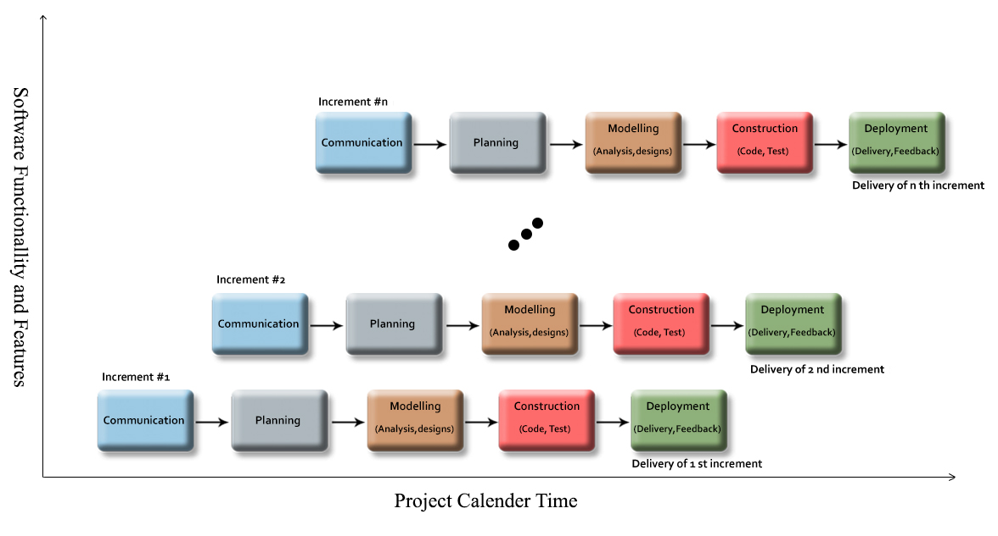

For more information:

* <https://en.wikipedia.org/wiki/Incremental_build_model>
* http://www.technotrice.com/incremental-model-in-software-engineering/

### Reason for Choosing

* The project using EMG technology, which is not our team major, some requirement may mismatch.
* Human anatomy also needed, research is necessary for electrode arrangement.
* EMG surface signal processing still need development.
* Team has to design our PCB and physical wearable devices which is also suitable to wear and meet our requirement.

For those reason, the requirements of the project cannot be stable, clear or fixed. Moreover, they can rapidly change.

## Roles and responsibilities

|  |  |  |  |
| --- | --- | --- | --- |
| No | Full name | Role in Group | Responsibilities |
| 1 | Mr. Nguyễn Đức Lợi | Product Owner – Technical Expert | * Define user requirement * Define the business * Control the development process * Give advices on techniques, solutions and business analysis support |
| 2 | Võ Trần Chí | Team Leader, BA, DEV, Tester | * Managing process * Clarifying requirements * Researching solutions and techniques * Assigning task for members * Design architecture * Support team members. * Reviewing the task result of members * Creating/ Editing documents and reports * Reviewing documents and reports * Committing all individual work. * Design and Implement board schematic and PCB layout. |
| 3 | Đinh Bảo Trân | Team Member, BA, DEV, Tester | * Clarifying requirements * Researching solutions and techniques * Design architecture * Designing database * Reviewing documents and reports * Committing all individual work. * Reviewing test plan * Reviewing test case * Testing |
| 4 | Ngô Tấn Khôi | Team Member, BA, DEV, Tester | * Clarifying requirements * Reviewing documents and reports * Committing all individual work. * Creating test plan * Creating test case * Testing * Reviewing test plan * Reviewing test case * Testing Coding * Testing |

Table: Roles and Responsibilities Details.

## Tools and Techniques

1. IAR Workbench
2. CCS Code Composer Studio
3. GitHub
4. SVN tortoise
5. Slack
6. Trello
7. Visual Studio
8. StarUML

# Project Management Plan

## Software development life cycle

|  |  |  |  |  |  |
| --- | --- | --- | --- | --- | --- |
| **Phase** | **Description** | **Deliverables** | **Resource needed** | **Dependencies**  **and Constrains** | **Risk** |
| **Increment 0** | * Collect requirement * Research the same system * Research tools and technique * Clarify requirement * Create Introduction report | * Make-or-buy decision report * Introduction report | 21 man-days | Supervisor Approved. | - Missing requirement.  - Unclear scope of project.  - Lack of member share of understand. |
| **Increment 1** | * Create Software project management plan report * Define output for the next increment * Define test approach * Define test/ untested function * Design test case * Design user interface window application | * Software project management plan. * Research report through presentation. | 21 man-days | - Depend on introduction report, Gantt chart, research reports | - Lack of Experience.  - Measure is not exactly  - Test case cannot cover all cases |
| **Increment 2** | * Create Software Requirement Specification report. * Design new test case * Define requirement * Redefine test case * Demo and Prototyping. * Testing | * Software Requirement Specification report * Test cases. * Demo each component. * Prototype window application. | 21 mans-day | - Depend on introduction report, Gantt chart, research reports | - Lack of Experience.  - Measure is not exactly  - Hardware work not good  - Test case cannot cover all cases |
| **Increment 3** | * Create Software Design Description report * Define output for the next increment * Design and implement EMG schematic and PCB layout with CC2650 * Design CC2650-MPU 6050 process * Design the Pairing CC2650 with computer application process * Design the Bluetooth transferring from CC2650 to Computer Application process * Design the Mapping EMG data to particular gesture function * Design the Mapping particular gesture to particular computer action process * Implement the Showing user gesture function. * Testing. | * Software Design Description report * Board for hardware * Window application * - Test report | 42 mans-day | - Depend on introduction report, Gantt chart, research reports | - Lack of Experience.  - Measure is not exactly  - Hardware is not exactly  - Test case cannot cover all cases |
| **Increment 4** | * Create System Implementation & Test report * Define output for the next increment * Implement pairing CC2650 with computer application. * Implement Bluetooth transferring from CC2650 to Computer Application. * Implement Mapping EMG data to particular gesture process. * Implement the Mapping particular gesture to particular computer actions process. * Implement the Showing user gesture function. * Integrating devices   Testing | Main Board.  Computer Application.  Test report.  Code.  Test report. | 63 mans-day | - Depend on introduction report, Gantt chart, research reports | - Delay task from above increment.  - Bug covered. |
| **Increment 5** | * Create Software User’s Manual report | Software User’s Manual report | 7 mans-day | - All functions and reports are completed | - Delay task from above increment.  - Critical Bug still remains. |

Table 3: Software Development Life Cycle Detail

## Increment Detail

### Increment 1

|  |  |  |
| --- | --- | --- |
| **Task** | **Description** | **Author** |
| Collect requirements | Write down all requirement | ChiVT, TranDB, KhoiNT |
| Research the same system | Find which systems currently provide similar service, their strength and weakness. | ChiVT |
| Clarify requirements | Define which main functions system should provide. | ChiVT, TranDB, KhoiNT |
| Research tools and techniques | Find tools and techniques and how to use it | ChiVT, TranDB, KhoiNT |
| Research coding convention | Find coding convention rules to apply into project | ChiVT |
| Design overall diagram |  | ChiVT |
| Research related document | Research about UML, Software development cycle, some document related with implementation code | ChiVT, TranDB, KhoiNT |
| Create Gantt Chart | Estimate duration and who will take which task | ChiVT |
| Create make-or-buy decision | Define all components which will be bought for project | ChiVT, TranDB, KhoiNT |
| Create Introduction report |  | ChiVT |
| Create Software project management plan report |  | ChiVT, TranDB, KhoiNT |

### Increment 2

|  |  |  |
| --- | --- | --- |
| **Task** | **Description** | **Author** |
| Create Software Requirement Specification report |  | ChiVT, TranDB, KhoiNT |
| Define output for the next increment | Need approval from the supervisor | ChiVT |
| Define test approach |  | KhoiNT |
| Define test/ untested function | Define in all functions which will be implemented in this increment, what should be tested or not. | KhoiNT ,ChiVT |
| Design test case | Design test case to test function which will be implemented in this phase | KhoiNT, ChiVT |
| Design user interface window application |  | TranDB |
| Prototype for window application | Create a prototype for supervisor approval. | TranDB |
| Study and Demo for EMG acquisition process. | Create and demo for EMG acquisition to develop requirement. | ChiVT |
| Study and Demo MPU6050 process |  | ChiVT |
| Study and Demo for Bluetooth transferring process | Create and demo for Bluetooth transfer | KhoiNT |

### Increment3

|  |  |  |
| --- | --- | --- |
| **Task** | **Description** | **Author** |
| Create Software Design Description report |  | ChiVT, TranDB, KhoiNT |
| Define output for the next increment | Need approval from the supervisor | ChiVT |
| Design and implement EMG schematic and PCB layout with CC2650 |  | ChiVT |
| Design CC2650-MPU 6050 process |  | ChiVT |
| Design the Pairing CC2650 with computer application process | Pairing from DCG device with computer application | TranDB, KhoiNT |
| Design the Bluetooth transferring from CC2650 to Computer Application process | Send message to computer application via Bluetooth protocol. | TranDB, KhoiNT |
| Design the Mapping EMG data to particular gesture function |  | TranDB, ChiVT |
| Design the Mapping particular gesture to particular computer action process |  | TranDB |
| Implement the Showing user gesture function. |  | TranDB, ChiVT |
| Create Software Design Description report |  | ChiVT, TranDB, KhoiNT |

### Increment 4

|  |  |  |
| --- | --- | --- |
| **Task** | **Description** | **Author** |
| Create System Implementation & Test report |  | ChiVT, TranDB, KhoiNT |
| Define output for the next increment | Need approval from the supervisor | ChiVT |
| Implement pairing CC2650 with computer application. | Pairing from DCG device with computer application | TranDB, KhoiNT |
| Implement Bluetooth transferring from CC2650 to Computer Application. | Send messages to computer application via Bluetooth protocol. | TranDB, KhoiNT |
| Implement Mapping EMG data to particular gesture process |  | TranDB, ChiVT |
| Implement the Mapping particular gesture to particular computer actions process. |  | TranDB |
| Implement the Showing user gesture function |  | TranDB, ChiVT |
| Integrating devices |  | ChiVT, TranDB, KhoiNT |
| Test |  | ChiVT, TranDB, KhoiNT |

### Increment 5

|  |  |  |
| --- | --- | --- |
| **Task** | **Description** | **Author** |
| Create Software User’s Manual report | Include installation guide and user guide | ChiVT, TranDB, KhoiNT |

## All Meeting Minutes

All the meeting minutes contain in the CD.

# Coding Convention

Embedded coding convention will follow SAT – Embedded Software Coding Convention.

## File Header

* Each file should contain the standard legal words. Think of them as special garlic designed to keep away lawyers.

## General Convention

* All functions will have comments explaining the inputs, outputs, and basic operation of the function.
* Software, associated comments, and documentation shall be written in English using US spellings.

## Function Naming

* The first word of the function should be in lower case.
* Function name continue with mixed case names (first letter of each word capitalized). Underscores may be used to separate words.
* Software that is grouped together to control one peripheral, device, or functionality should use the same starting word. That word should identify the similar component. That will allow these functions to appear together in alphabetical listing.
* Functions that operate on the same peripheral, component, or functionality should reside in their own C file, with their own individual header file.

## Variable Name

* Local variables start with a lower case letter. The rest of the variable name can be mixed case or all lower case.
* Global variable names start with a capital letter. The rest of the variable name can be mixed case or all upper case.
* Variable names can have words separated by underscores or mixed case.

## Structure Names

* The structure name itself is mixed case. Underscores may be used to separate words.
* Elements within a structure use mixed case. Underscores may be used to separate words. In either case, each word will begin with a capital letter.

## Define Names

* As with almost all software, defines are in ALL_CAPITAL_LETTERS.

C# coding convention will follow Microsoft Coding Convention.

For more information:

* Embedded coding convention:

<http://processors.wiki.ti.com/index.php/SAT_-_Embedded_Software_Coding_Conventions>

* C# coding convention:

<https://msdn.microsoft.com/en-us/library/ff926074.aspx>