### Engage Stakeholders with Azure Test Plans

In a professional DevOps environment, you have quality control steps in every stage. You don’t want to pass problems downstream. When it comes to manual testing, you don’t want to leave it to the end. In his book, “Out of the Crisis,” W. Edwards Deming writes, “quality can not be inspected into a product or service; it must be built into it.” When you only test something after it has been built, you’re essentially attempting to inspect what has been built and then assume that quality will be the result. How, then, should you ensure quality? By baking a quality control step into every stage. For example, when defining the work, you can “test” the requirements or the concept or the idea by specifying the steps of a functional test. This forces you to validate that you understand what is to be built and the detailed behavior that should exist. If you can’t specify exactly how you would test the feature before it’s built, you’ll have discovered a defect in the description or understanding of the feature. Proceeding on to code would be fruitless because the defect in the requirements or analysis would then be propagated downstream. Often, the defect is magnified by the assumptions that would have to be made in the coding process.

In this section, you won’t cover all the capabilities of Azure Test Plans, but you will highlight some of the universally useful capabilities. **Figure 31** shows how you can specify the test criteria for an application feature before the coding step.

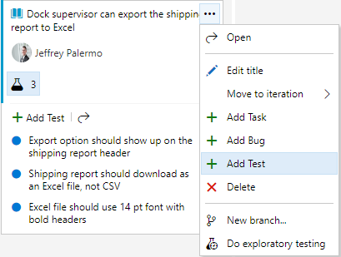

Figure 31: Tests can be added to Product Backlog Items or User Stories.

The tests for the software behavior are important pieces of information. The coding time is normally reduced when the test cases are explicitly spelled out. And the method of attaching them to the work item keeps it very simple and fast. There’s no need for a cumbersome test plan document when the equivalent of bullet point items can bring clarity to the expected behavior. Additionally, many of the specified tests likely can be codified into automated test cases, so only a subset of the tests will have to be manually verified with every build.

In order to run these tests, you can just use another right mouse click. **Figure 32** shows the mechanism to use to begin your manual test session.

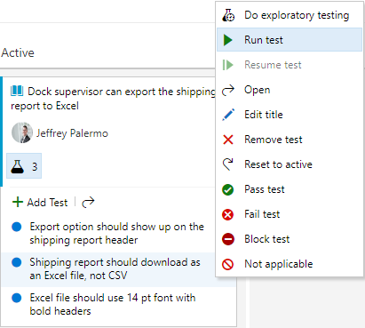

Figure 32: You can run the test straight from the work item.

When you run the test, Azure Test Plans is going to pop up an additional browser pane that aids you as you exercise the software. **Figure 33** shows the Test Plans Runner.

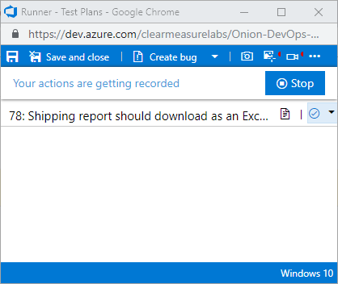

Figure 33: The Test Plans Runner allows the capturing of the screen as you test.

Notice the red indicator in the top right of the pane. I’ve selected both the video camera and the screenshot icons and enabled them. These toolbar items enable screen recording and the capturing of user actions, respectively. As I’m testing the application, Azure Test Plans is recording the screen and taking a screenshot of the area around my mouse any time I perform a click. Then, if I find anything wrong, I can create a bug right there from the toolbar and attach my user actions as well as a complete video of what I was doing. It even includes an option to record audio from my microphone if I elect to narrate my actions. This can be used to record a demo of a feature or for a stakeholder to report exactly the experience they are seeing. **Figure 34** shows the test session automatically recorded.

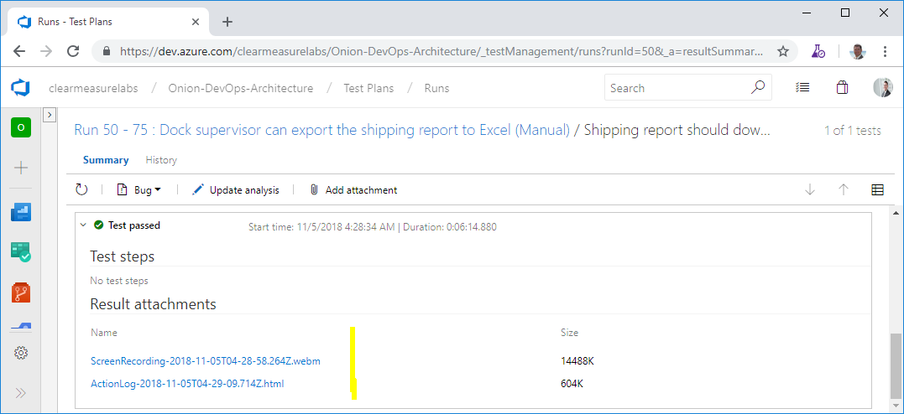

Figure 34: The screen recording and user action log are automatically attached to the test run.

Regardless of whether or not the stakeholder records a bug, the capture of the screen and actions is recorded in Azure Test Plans. If this is habitually done, stakeholders have a very easy time providing feedback. When they encounter a bug, they don’t have to go back and reproduce it. All they have to do is log it, and the reproduction steps have already been captured. The stakeholder doesn’t even have to remember what he was doing.

Another option exists for exploratory testing of software application. This is done through the Test & Feedback tool, which is a Google Chrome or FireFox extension. You can install it for yourself at [https://marketplace.visualstudio.com/items?itemName=ms.vss-exploratorytesting-youb](https://marketplace.visualstudio.com/items?itemName=ms.vss-exploratorytesting-web). Once you connect it to your Azure DevOps organization, you can click the “play” icon and start capturing your exploratory testing session. Your stakeholders should do this when they begin running the software through its paces. **Figure 35** illustrates how to specify the work item that is being reviewed.

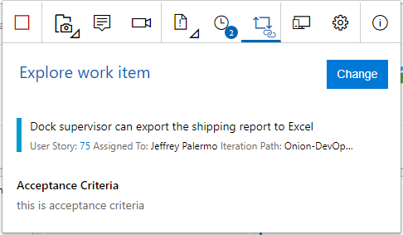

Figure 35: Stakeholders can review any work item and provide feedback seamlessly.

Just as in the previous workflow, a full audio and video capture runs seamlessly as the stakeholder narrates what he’s doing as he moves through the application. This is especially useful to capture subjective feedback and observe the user experience even in the absence of feedback. You may have ideas on how to streamline the experience of some features just by seeing the sequence of clicks and types that a stakeholder uses in order to perform a transaction. As your stakeholders adopt the Test & Feedback tool, encourage them to use the journaling feature to write any notes that come to mind. All of this is seamlessly captured by Azure Test Plans.