

CrossWords
Documentation

Class C1101QK Group_496
Group Member | Tai Le Tuan  Tung Nguyen Xuan  Hai Nguyen Duy  Nghia Nguyen Trong
Faculty | Binh Ngo Van

- Hanoi, 3/2013-

INDEX
1. Problem Definition 2
1.1. Problem Abstraction 2
1.2. The Current System 2
1.3. The Proposed System 3
1.4. Boundaries of the System 3
1.5. Hardware and Software Requirements 4
1.5.1. Minimum Requirements 4
1.5.2. Recommended Requirements 4
2. Customer Requirements Specification 5
2.1. User of the systems 5
2.1.1. Administrator: 5
2.1.2. Player: 5
2.2. System function 5
2.2.1. Administrator. 5
2.2.2. Player - User 8
3. Architecture & Design of Project 10
3.1. Data Flow Diagram 10
3.2. Database Diagrams (Table Design) 18
3.3. Database Structure 19
3.4. Screen Design 22
4. Task Sheet Review 29
4.1. Task Sheet Review 1 29
4.2 .Task Sheet Review 2 29
5. Checklists 30
5.1 Check List of Validation 30
5.2 Submission Checklist 30

Problem Definition

Problem Abstraction
Our client, Mr. Luther is the owner of a website “Luther.com”. He is a mathematician by profession. He is working in one of the famous institutions situated at a location near by his residence. He generally uses this website for the purpose of displaying his work, or he conducts some exercise, and as well some of the ad words he has subscribed for. He also conducts various quiz related to mathematics for the sake of entertainment to the users of the website. This quiz can be attempted by any of the users who generally visit his website.

Recently he has visited a site, in which he came across a Game called “Cross Words”. And he felt it interesting. And thought it would be better if this can be implemented in his website. So he has approached us, so that we can help him by developing a desktop application for conducting this Game, so that he can upload it on his site, so that the users can play this Game.

Base Java programming language can run on any platform. Your application can execute even on many platform difference if they setup Java Runtime.
Environment Therefore system will implemented widely and reality higher

The Current System
Today, with the strong development of science and industry information technology has liberated the labor of people and bring high economic efficiency.

Evidence that many agencies and enterprises have been using forms of Game management bring more convenience in the export and import goods.
Form the new management has completely replaced the classical style, solve the difficulties in managing game and details of the scores.
On that basis and with the knowledge they have learned, our team of project implementation Game management.

The Proposed System
Now a days use of computers is the best to manage the large amount of data easily and effectively.
And hence looking at the situation at the store, the owner of the shop has decided to move a step ahead and make use of computer to maintain the data. At the same time he has also thought of expanding the products in the stores by including the fruits, juices etc. He has thought of development of game and Game Management System which will store all the information and required data can be retrieved with ease. We are expected to develop a ‘Game Management System’ so that users can manage the details and admin functionalities

Boundaries of the System
This application of our still limited in many professional, and it only meets for fewer users.

Hardware and Software Requirements

Minimum Requirements
Hardware | - Minimum of a Pentium 166 PC or higher.  - 128MB RAM or higher
Software | - OS: Windows XP  - Java Virtual Machine  - Java SE 6  - Net beans 7.1  - DBMS: SQL Server 2005

Recommended Requirements

Hardware | - Minimum of Core2 Duo or higher  - 3G of RAM or higher  - HDD 10G free space available
Software | - OS: Windows XP  - Java Virtual Machine  - Java SE 6 OS: Windows7  - Java Virtual Machine  - Java SE 6  - Net beans 7.3  - DBMS: SQL Server 2008

Customer Requirements Specification

User of the systems

2.1.1. Administrator:
After logging into the system, administrator can:
- View Information the account.
- Management questions, Game such as add.

2.1.2. Player:
After logging into the system, player can:
- Play game.
- Change Information.

System function
CrossWords management system is built including the following functions:

2.2.1. Administrator.
- Login
Description | Login to system
Input | Enter username and password
Process | Connect to the database and compare username & password in database with username & password have just entered
Output | Login complete if username and password are correct, otherwise login fail and show the alert: “Username or password is incorrect”

- LogOut
Description | Alow Admin logout
Input
Process | Quit from system
Output | Display success message

- The Game Management
a.Add new Game

Description | Add new Game
Input | Complete information
Process | Check the suitable of information
Output | Note successfully if the information is suitable or note try again

b. View Game

Description | View information of the Game
Input
Process | Connect to the database and get the data with game id
Output | Game ID, Game Name, Questions, Answer
c. Edit Game

Description | Edit information of the Game
Input | GameID, GameName, GameStatus
Process | Check information from data, if valid, change info in table Games
Output | Show message success full or fail

- View Account
Description | View information account
Input
Process | Connect to the database show all information
Output | User ID, User Name, Email
- Edit Account
Description | Edit information
Input | UserID, UserName, New Email
Process | Connect to the database and update the new email
Output | User ID, User Name, Email
- Reset Password
Description | Change password to default
Input | UserName, UserID
Process | Connect to the database and change password of user to default
Output | Display success message

- Delete Account
Description | Delete Account from system
Input | UserName, UserID
Process | Delete Information Account from database
Output | Display success message or fail

2.2.2. Player - User
- Login
Description | Login to system
Input | Enter username and password
Process | Connect to the database and compare username & password in database with username & password have just entered
Output | Login complete if username and password are correct, otherwise login fail and show the alert

- LogOut
Description | Alow User logout
Input
Process | Quit from system
Output | Display success message

- Change Information
Description | Change information of user
Input | Old Password, new password or new email
Process | Check User with userid, username and oldpass in data, if valie, update new information
Output | Display success message
- Answer Questions – Play Game
Description | Answer questions in each games
Input | Character
Process | Check answer with answer from data, if valid, add result with play time in data
Output | Display success message
- View Score
Description | Show all account with score
Input
Process | Get all data from data show to form
Output | User Name, Score (Time)

Architecture & Design of Project

Data Flow Diagram
The application have two tier architecture
User interface_Gui
Tier
Presentation Tier
Tier
Presentation Tier
Components
Database Access

External Entity 
Process 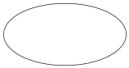
Data flow 
Data store 

Two_Tier Architecture The of Project

Request Info

CrossWords Management
Management Info

Admin

Users

Feedback Info
Feedback Info

DFD 0 – Context Diagram
1
Game Management

2
Account Management

Admin

Game Info

Feedback Info Account Info In Feedback Info

DFD 1 – Admin Process 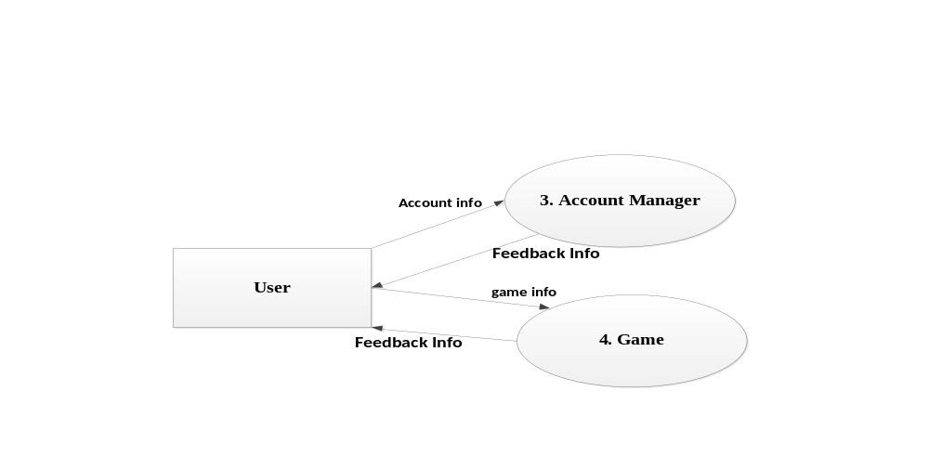 DFD 1 – User Process
Admin Info Admin Info A
DFD 2 - Login

Admin
Result Message
Result Message
Admin Info
Required Logout
Logout

Users
Request Logout
Request Logout

DFD 2 - LogOut

Login

Admin
Admin
Admin
Info
Users
Users
Info

Users
Users Info

Games GameContents Game Detail New Game Information Result Message DFD 2 – 1.1 Add New Game Process
New
Game
Info
New Game Info
1.1 Add New Game

Admin
Game GameContents

Game
Info
Game
Info

Require Game Info
1.2 View Game

Admin
Feedback Info

DFD 2 – 1.2 View Game Process

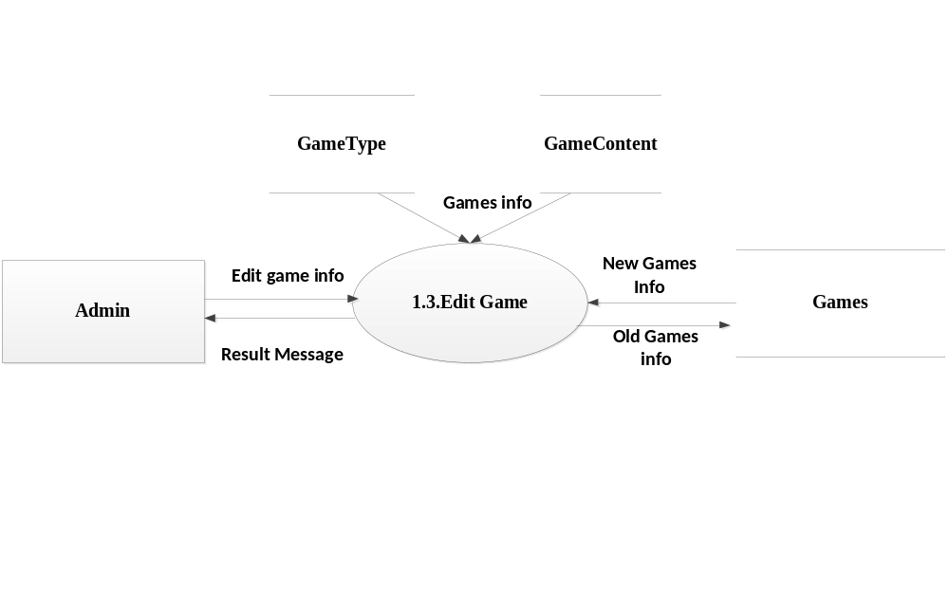
DFD 2 – 1.3 Edit Game

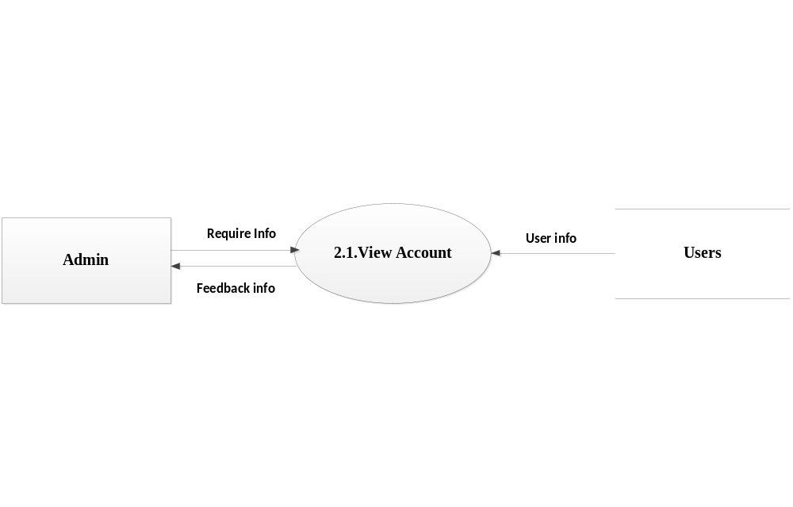
DFD 2 – 2.1 View Account
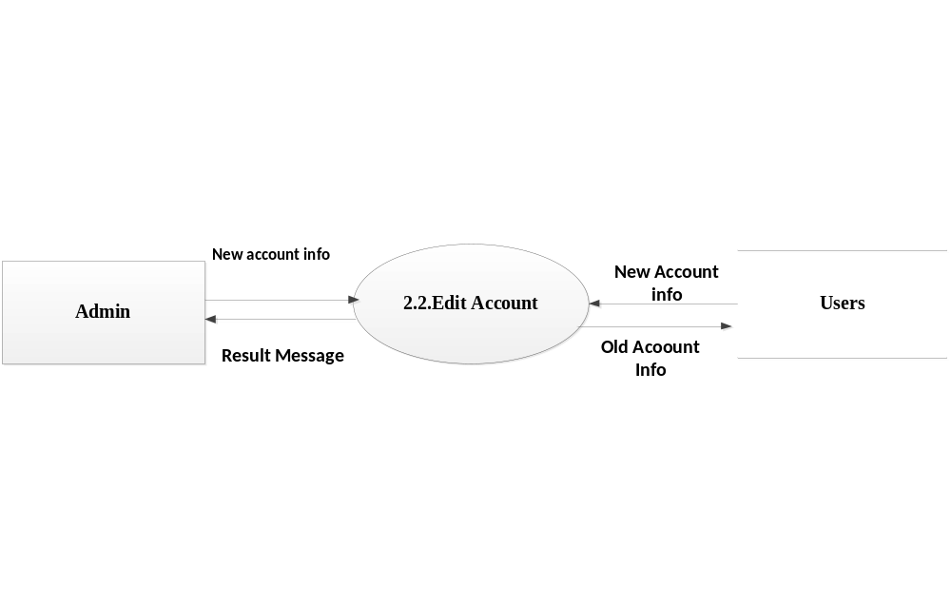
DFD 2 – 2.2 Edit Account

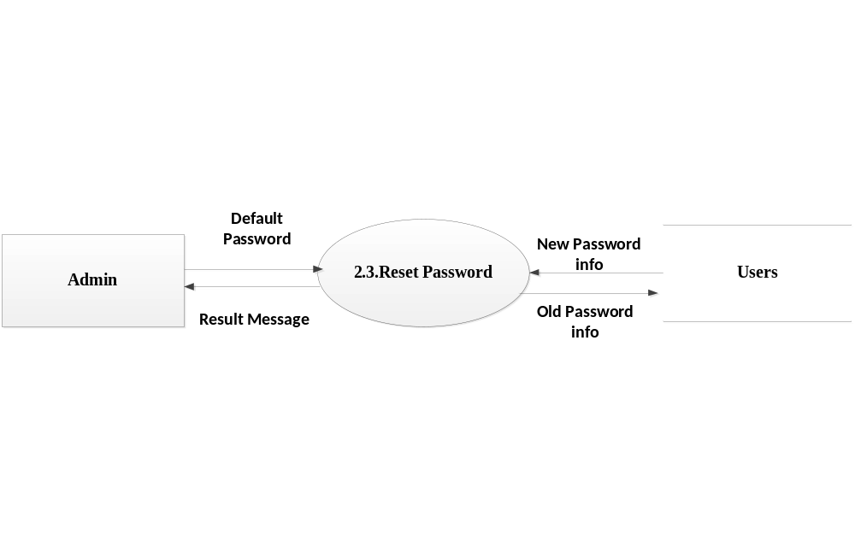
DFD 2 – 2.3 Reset Password
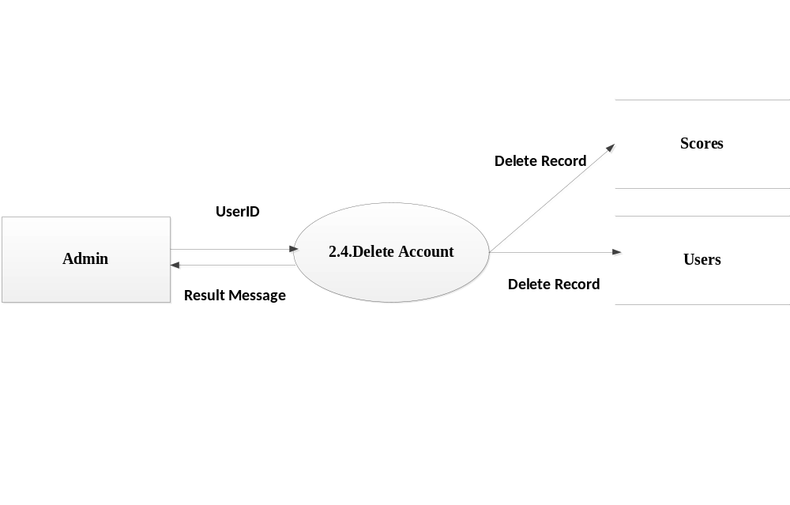
DFD 2 – 2.4 Delete Account

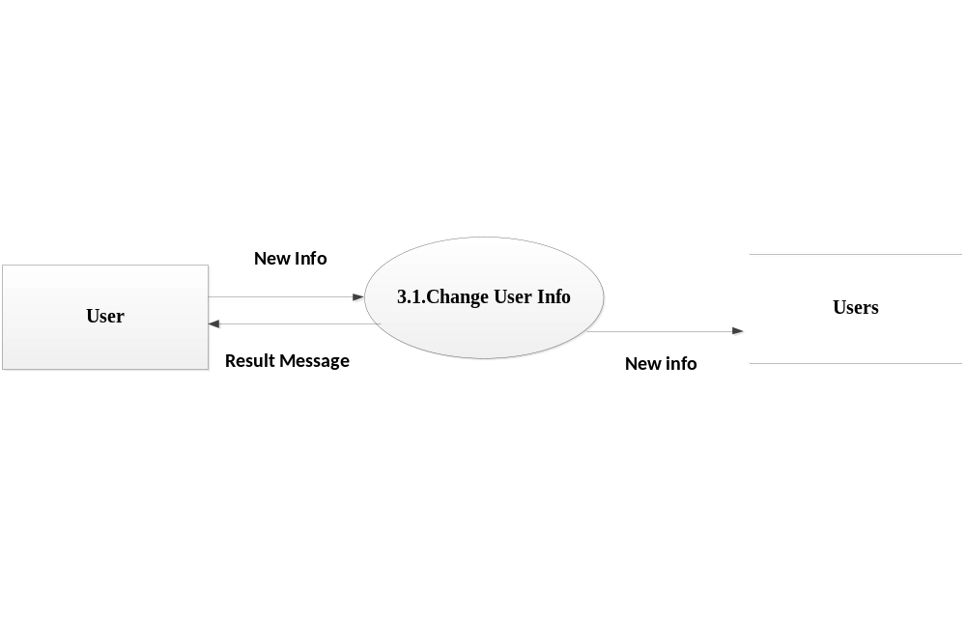
DFD 2 – 3.1 Change User Info

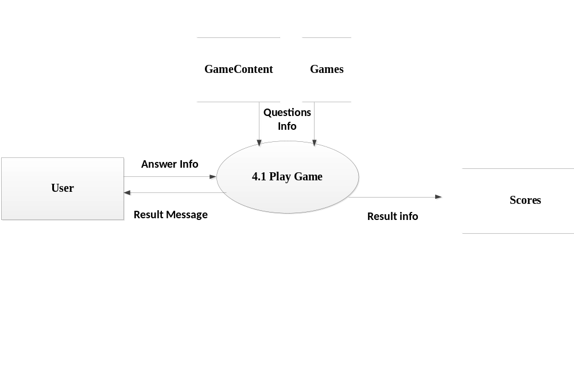
DFD 2 – 4.1 Play Game

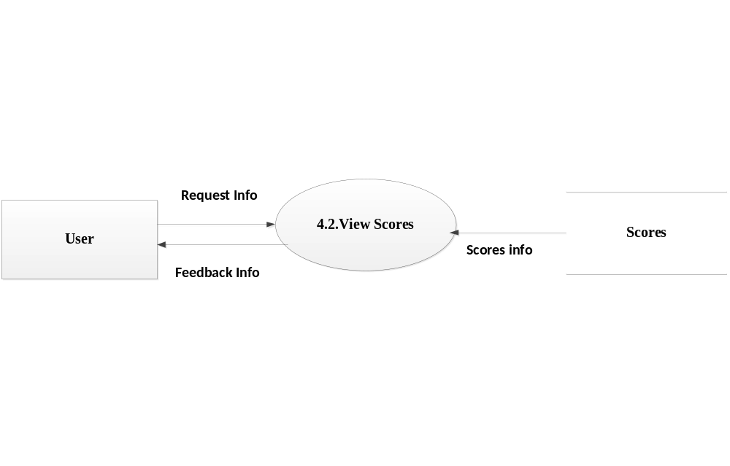
DFD 2 – 4.2 View Scores

Database Diagrams (Table Design)

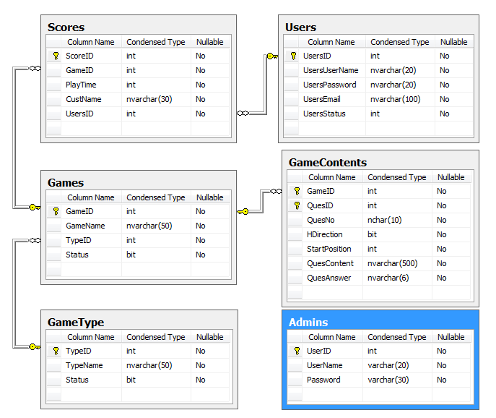

Database Structure

- Table Admins

Name Field | Nature | Data Type | Size | Description
UserID | Primary key  Not Null | Int | 4 | Indentification Of the administrator
UserName | Not Null | Varchar | 20 | Username of the administrator
Password | Not Null | Varchar | 30 | Password of the administrator

- Table Games

Name Field | Nature | Data Type | Size | Description
GameID | Primary key  Not Null | Int | 4 | Indentification of the game
GameName | Not Null | Varchar | 50 | Name of the game
TypeID | Not Null | Int | 4 | 1 - game 4x4 or  2- game 6x6
Status | Default(1) | Bit

- Table GameContents

Name Field | Nature | Data Type | Size | Description
GameID | Primary key  Not Null | Int | 4 | Indentification of the question and the answer
QuesID | Primary key  Not Null | Int | 4 | Indentification of the question and the answer
QuesNo |  | Nchar | 10 | The Number of Question
HDirection |  | Bit |  | 1 : horizontal  0: vertical
StartPosition |  | Int | 4 | The Start position of question
QuesContent |  | Nvarchar | 500 | The question’s Content
QuesAnswer |  | Nvarchar | 6 | The question’s Answer

- Table Scores
Name Field | Nature | Data Type | Size | Description
ScoresID | Primary key  Not Null | Int | 4 | Indentification of the Score
GameID | Foreign key  Not Null | Int | 4 | Reference to GameID of Table Games
PlayerTime | Not Null | Int | 4 | Playing Time
CustName | Not Null | Nvarchar | 30 | Player’name
UsersID | Foreign key  Not Null | Int | 4 | Reference to UsersID of Table Users

- Table Users

Name Field | Nature | Data Type | Size | Description
UsersID | Primary key  Not Null | Int | 4 | User ID
UsersUserName | Not Null | Nvarchar | 20 | User Name
UsersPassword | Not Null | Nvarchar | 20 | Password of User
UsersEmail | Not Null | Nvarchar | 100 | Email of User
UsersStatus | Default(1) | Int | 4 | 1 : can login  0 : banned user

Screen Design
Boot Screen
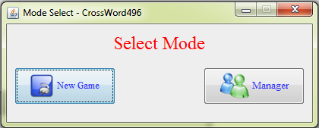
- User Part
1. Login User screen
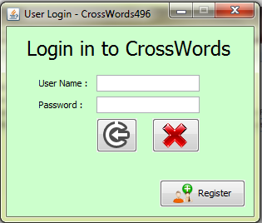

2. Register Screen
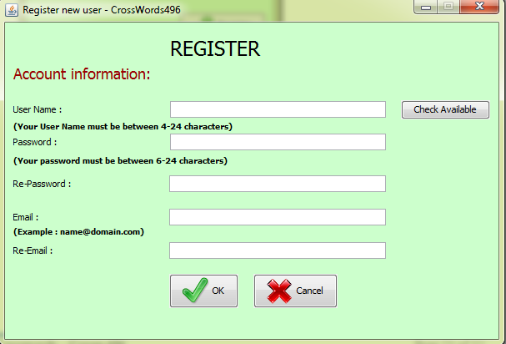

3.Boot User Screen
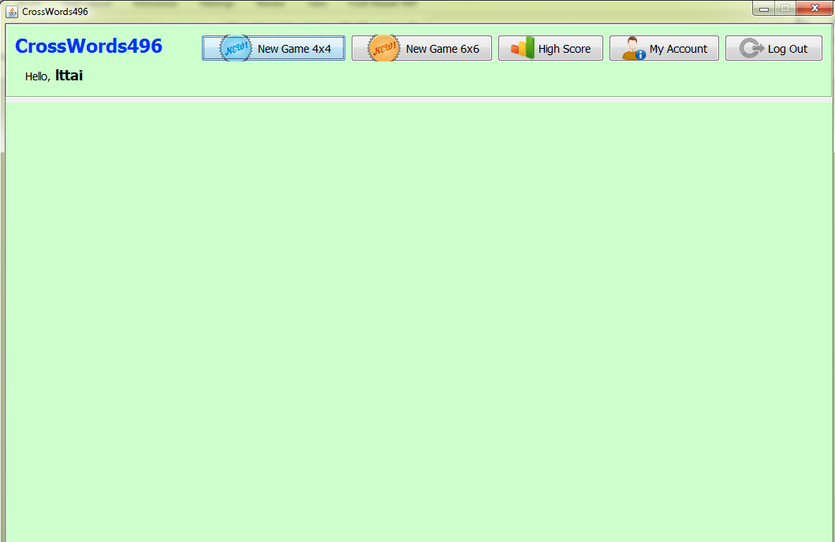

4. The game interface size 4x4
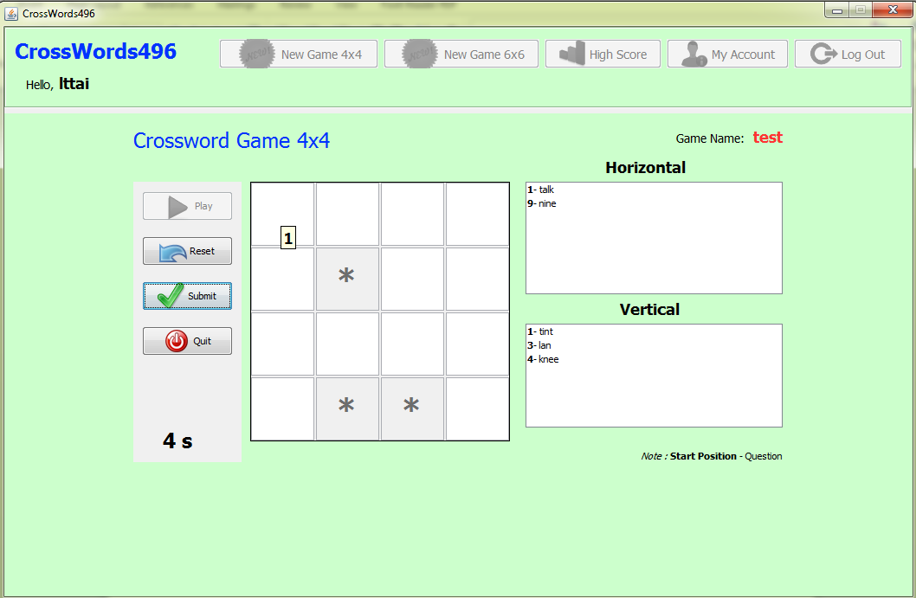
3. The game interface size 6x6
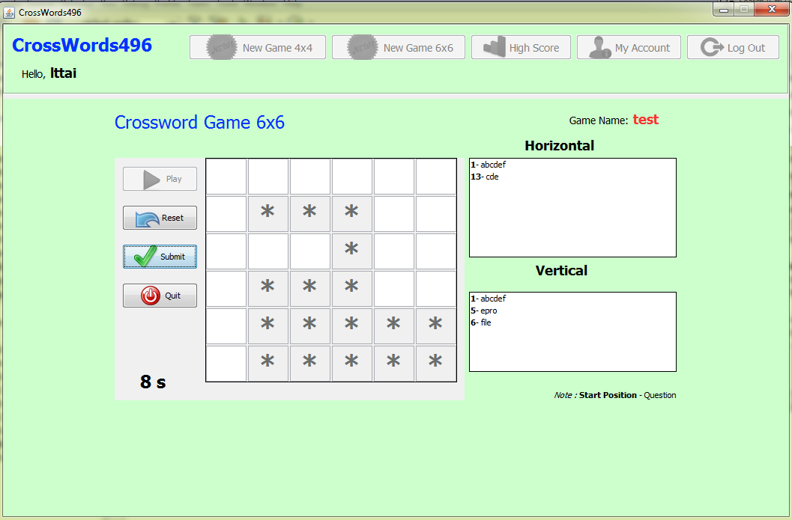

- Screen the list score of players
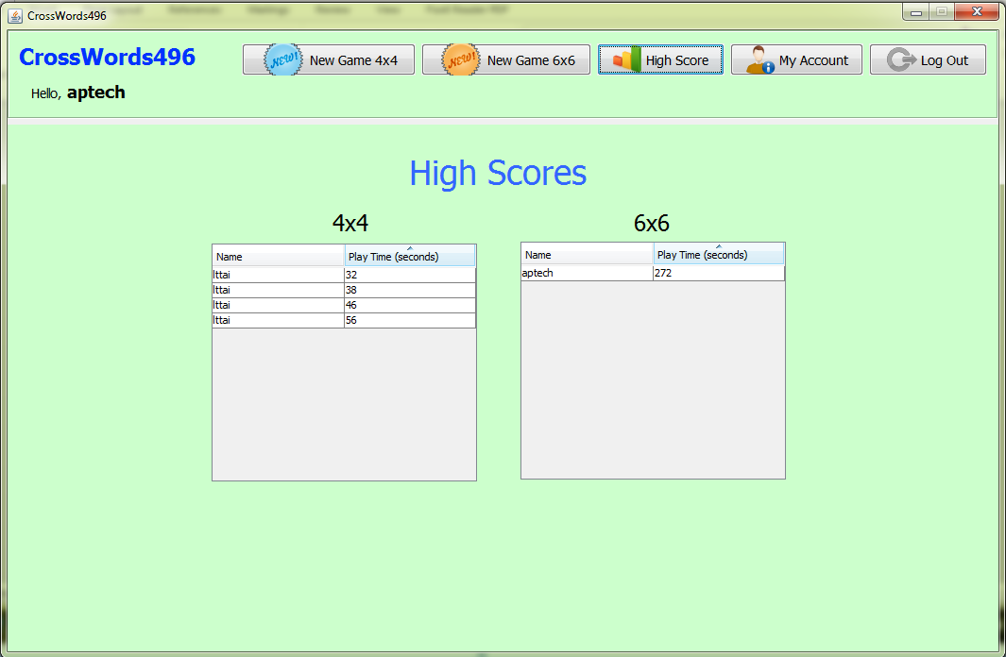
4.Change Information screen
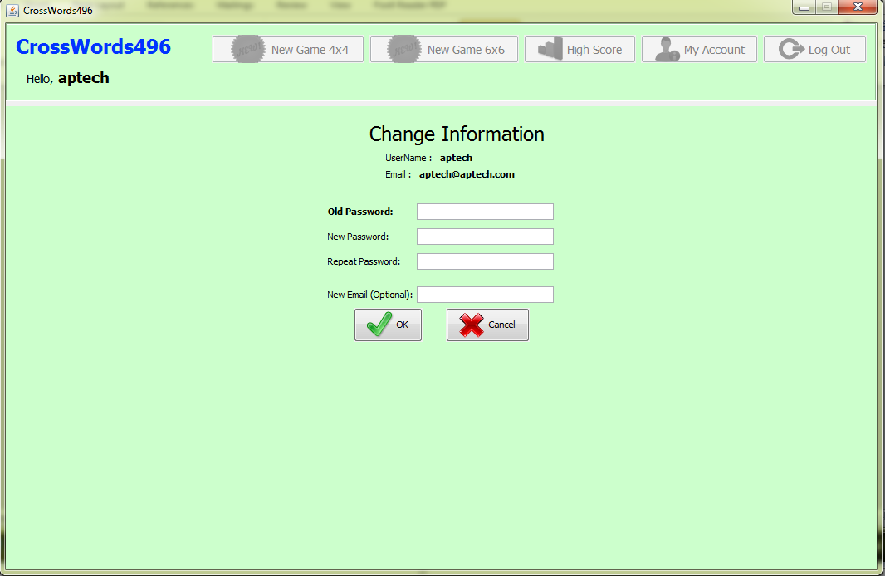
- Admin Part
1.Admin Screen

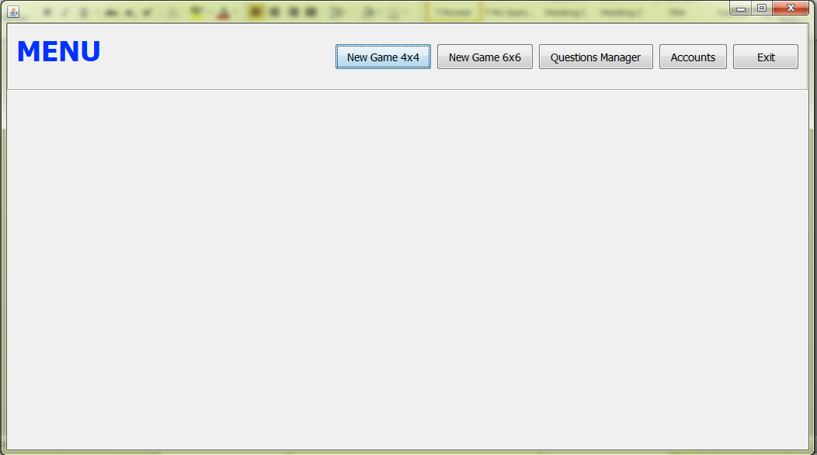
2.New Game 4x4 Screen

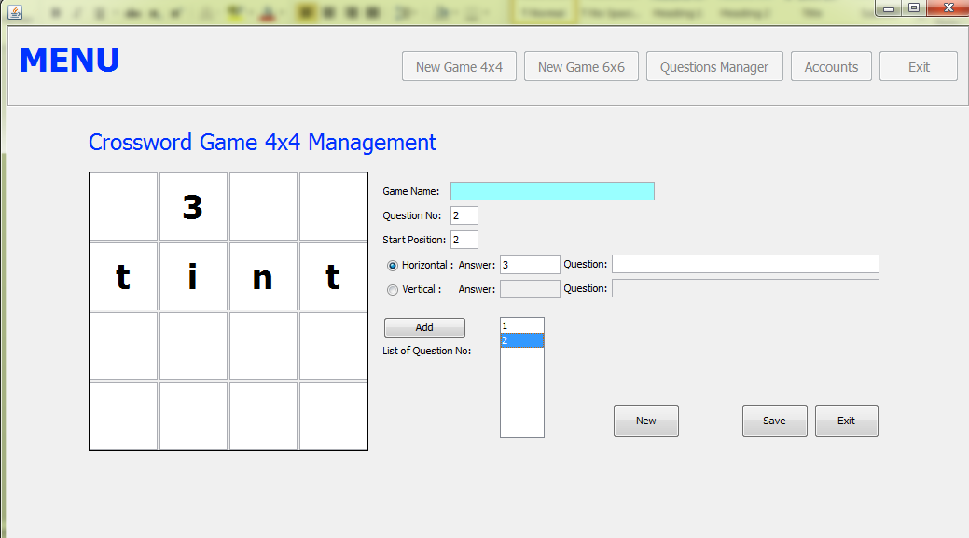

3.New Game 6x6 Screen

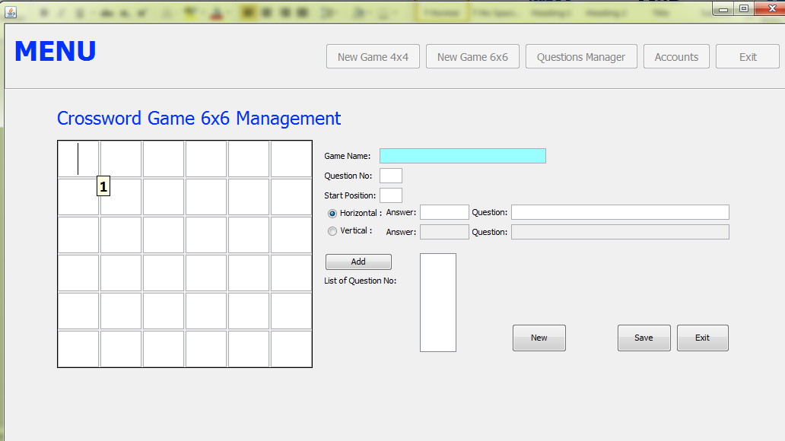

4.Questions Manager Screen
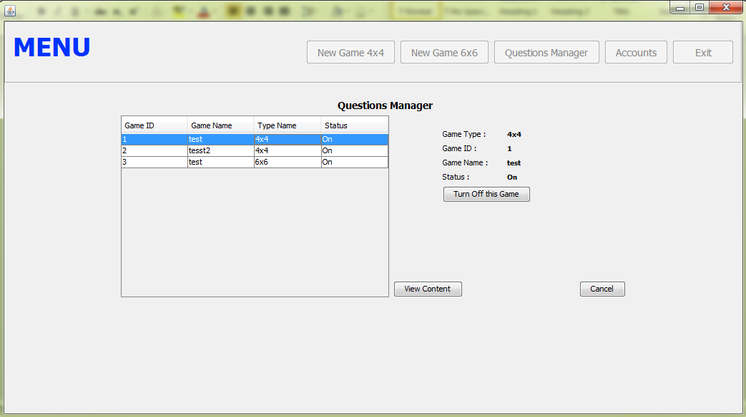

5.Account Manager Screen
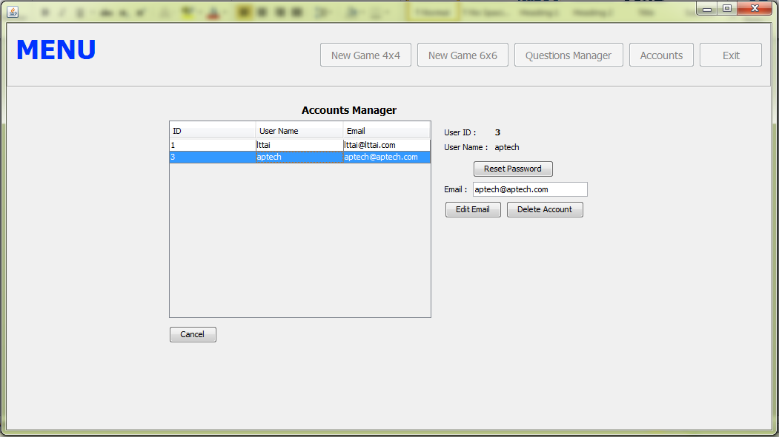

4. Task Sheet Review

4.1. Task Sheet Review 1

Project  Ref No: 347 | Project Title:  CrossWord System | Date of Preparation of Activity Plan
Sr. No. | Task | Actual Start Date | Actual Days | Team Member Names | Status
01 | Problem Definition | 18-March-2013 | 14 | All Members | Completed
02 | Customer Requirement Specification | 18-March-2013 | 14 | All Members | Completed
03 | -Data Flow Diagram  -Entity Relationship Diagram (Table Design)  -Database Structure | 18-March-2013 | 14 | All Members | Completed

4.2 .Task Sheet Review 2

Project  Ref No: 347 |  | Project Title:  CorssWord Management | Date of Preparation of Activity Plan
Sr. No. | Task  (Coding Form) |  | Actual Start Date | Actual Days | Team Member Names | Status
01 | Login |  | 12-April-2013 | 16 | Tung Nguyen Xuan | Completed
02 | Manager Game |  | 12-April-2013 | 16 | Tai Le Tuan/Tung Nguyen Xuan/Hai Nguyen Duy | Working
03 | Manage Account |  | 12-April-2013 | 16 | Tai Le Tuan/Tung Nguyen Xuan | Completed
05 | New Game4x4 |  | 12-April-2013 | 16 | Tai Le Tuan/ Hai Nguyen Duy | Completed
06 | New Game 6x6 |  | 12-April-2013 | 16 | Tai Le Tuan/ Tung Nguyen Xuan | Completed
08 | Hight Score |  | 12-April-2013 | 16 | Tai Le Tuan/Nghia Nguyen Trong | Completed
09 | Instruction |  | 12-April-2013 | 16 | Hai Nguyen Duy/Nghia Nguyen Trong | Completed
10 | Change User Info |  |  |  | Tai Le Tuan | Completed

Checklists

Check List of Validation
Option | Validate
All fields in forms are validated | Yes
GameID, QuesID is unique | Yes
Data input is validated | Yes
Ensure data in constraint | Yes

Submission Checklist
No | Particulars | Yes | No | NA | Comments
1 | All pages are activate | Yes
2 | Are the all users able to login to the application after validation is performed on the username and password? | Yes
3 | The form will not spell | Yes
4 | All pages have not mistake | Yes
5 | Is the application user-friendly? | Yes
6 | Incorrect data to be reminded | Yes
7 | All links are working properly | Yes

