Exercise: File Analysis

Background: You work for a small company that creates software to analyze files. Your manager has given you a task to develop a console application that analyzes a text file and outputs some basic statistics about the file.

Task: Write a C# console application that reads a text file, analyzes its contents, and outputs the following statistics:

1. The total number of characters in the file.
2. The number of lines in the file.
3. The number of words in the file (words are separated by whitespace).
4. The average word length in the file (to two decimal places).
5. Additionally, your application should:

Prompt the **user to enter the file path**.

**Handle any exceptions** that may occur when opening or reading the file.

Hint:

Use an array to store the words in the file.

Use a loop to iterate through the array of words and calculate the average word length.

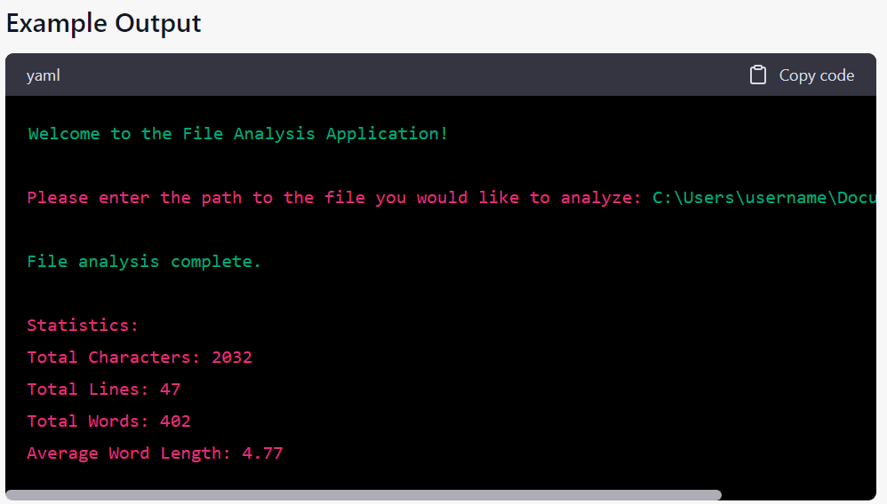

Finally, write unit tests to verify the functionality of your application.

Tips

Use the File.ReadAllText method to read the contents of the file as a single string.

Use the string.Split method to split the string into an array of words.

Use the File.Exists method to check if the file exists before attempting to read it.

Use the try-catch block to catch exceptions that may occur when opening or reading the file.

Use the foreach loop to iterate through the array of words.

Use the int.TryParse method to check if a string can be converted to an integer.

Use the FluentAssertions to write unit tests.