Welcome to MySQL workbench! After you connect it looks like this:

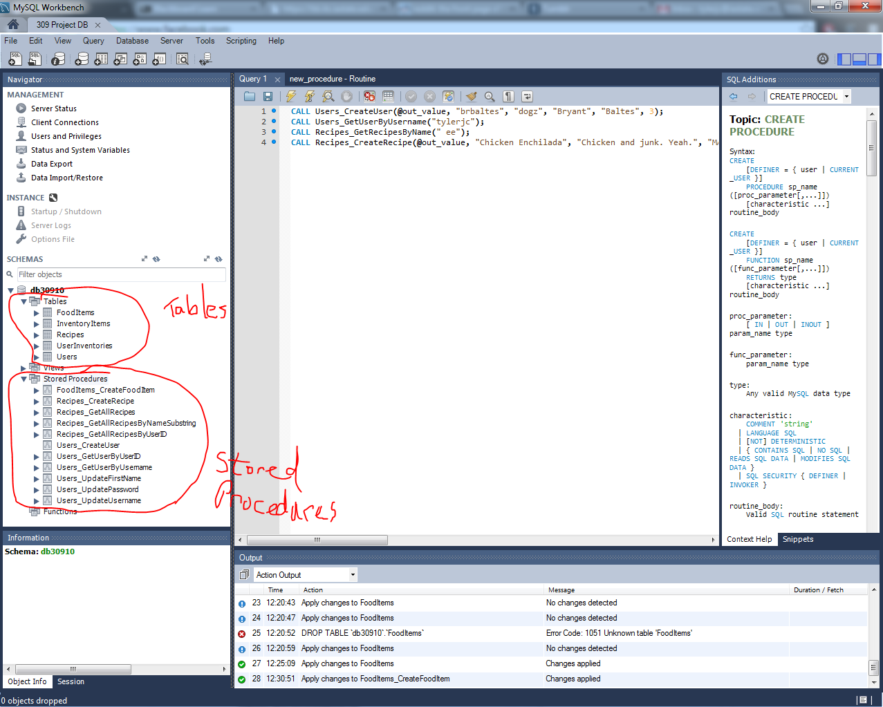

Notice naming schema of stored procedures: Tablename_WhatYou’reDoingAndByWhatCriteria

This makes it easier to remember when not in MySQL and just easier to remember overall. For example:
- Users (table you’re dealing with) _GetUser (returning a single user) ByUserID (what you’re using to get the user)
- Recipes_GetAllRecipesByNameSubstring returns a table full of recipes that include the inputted substring.

Now let’s take a look at creating stored procedures.

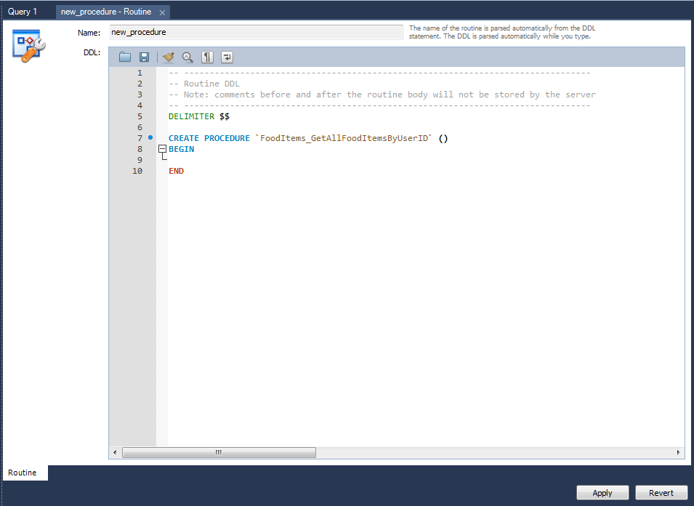

It will first look like this (except I changed the text in the ‘’ from new_procedure to the name of what I’m making)

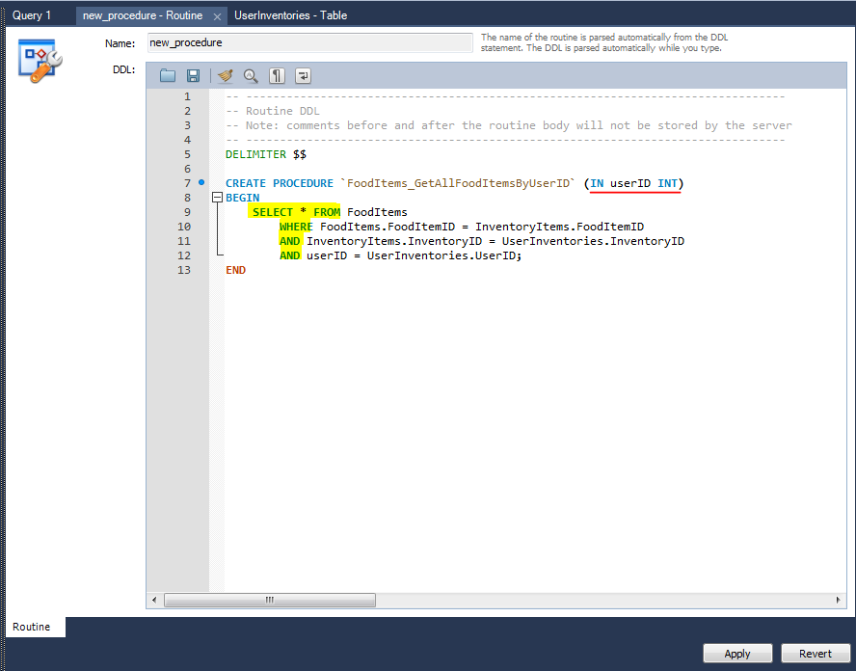

The things to note are the order of the parameters:
- IN/OUT variable, then the name to refer to it by, then the data type
- Capitalize any key word in MySQL, notice IN, INT, SELECT, FROM, AND

This Stored Procedure will select all the rows in FoodItems where the food item ID is in the inventory and the inventory belongs to the userID passed in.

I can’t think of any other schema things… but just follow what I’ve done if you have any issues. GLHF!

