**Stage 1: Merging content from a few excel files into one template.**

1. We want to drag and drop xlsx file/s to the GUI or select a number of files from a Windows directory interface. (See example of such file “Original File.xlsx”)
2. The program will read the file and provide a "sample look" showing first 10 rows and all columns detected in the excel. See below screenshot of an example of GUI

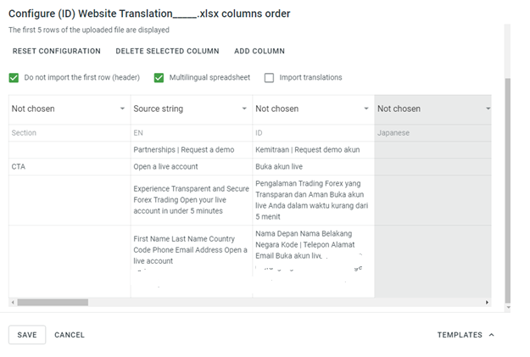

1. Within the "sample look" the user will select a definition for each column, from the following available definitions: source text (”EN Source”), the “Reference / key”, “Context” and “Character limit”.
2. After the user identified the columns, the software must copy the content (images and/or text ,**retaining any formatted text, i.e bold, red, italic etc.**) to the template of these columns to the equivalent columns of a (Template.xlsx). Anything which is not defined using the above definitions, will be ignored by the script.
3. If the excel file has a few tabs, A new “template” file must be created for each tab, using the sheet name as the file name of the excel file.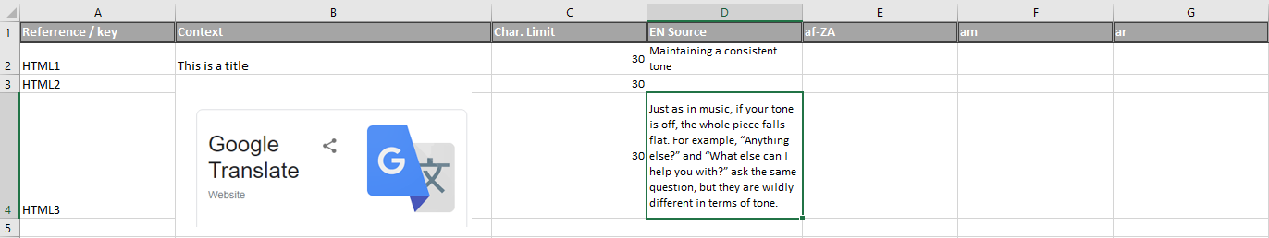

Assumptions:

* Only 1 column contains the source text
* In case the original excel file has multiple tabs the column header names will be the same (same names, same order) on all tabs.