CAN THO UNIVERSITY
COLLEGE OF INFORMATION AND COMMUNICATION TECHNOLOGY


PROJECT REPORT
PROJECT: A RETRIEVAL-AUGMENTED GENERATION SYSTEM FOR SUPPORTING CTU STUDENTS WITH ADMINISTRATIVE PROCEDURES
COURSE: | PROJECT – BASIC TOPICS
COURSE CODE: | CT239H
COURSE CLASS: | CT239HM01
MAJOR: | SOFTWARE ENGINEERING (HIGH-QUALITY PROGRAM)
COHORT: | 49

SUPERVISOR  Ph.D. Phan Phuong Lan | GROUP MEMBERS  1. Le Thi Ngoc Anh – B2303861  2. Nguyen Nhu Quynh – B2303777
SEMESTER III, ACADEMIC YEAR [2025–2026]
CAN THO, 2026

ABSTRACT
This project develops a retrieval-augmented generation (RAG) chatbot to support Can Tho University students in finding reliable information about administrative procedures. The system separates document governance from student question answering. Administrators manage reviewed canonical Markdown files and publish eligible document versions through a React-based administration interface. The FastAPI backend uses PostgreSQL for authoritative document and ingestion metadata and Qdrant for dense vectors generated with BGE-M3. For question answering, Vietnamese queries are resolved and rewritten before hybrid dense and sparse retrieval. Retrieved results are combined using Reciprocal Rank Fusion, optionally reranked, expanded with parent context, and supplied as evidence to a Qwen language model accessed through an OpenAI-compatible API. A Flutter application presents generated answers, citations, and source-document details to students. The implemented system provides an end-to-end workflow from document ingestion and controlled publication to evidence-grounded question answering while restricting retrieval to eligible document versions. The backend has been deployed on Render and the web interfaces on Vercel, demonstrating practical cloud deployability. This architecture improves response traceability and reliability by linking answers to approved sources and reducing dependence on unverified model knowledge, while providing a maintainable foundation for future expansion and evaluation.
Keywords—retrieval-augmented generation, administrative procedures, CTU students, hybrid retrieval, FastAPI, Flutter, PostgreSQL, Qdrant.

TABLE OF CONTENTS
GROUP MEMBER i
ABSTRACT ii
TABLE OF CONTENTS iii
LIST OF TABLES vi
LIST OF FIGURES vii
LIST OF ABBREVIATIONS viii
CHAPTER 1: INTRODUCTION 1
1.1. PROBLEM STATEMENT 1
1.2. OBJECTIVES 1
1.2.1. General objective 1
1.2.2. Specific objectives 2
1.3. RESEARCH METHODOLOGY 2
1.4. PLAN 3
1.4.1. Project task assignment and schedule 3
1.4.2. Gantt chart 4
1.5. SCOPE AND LIMITATIONS 4
1.6. REPORT ORGANIZATION 5
CHAPTER 2: THEORETICAL FOUNDATION 6
2.1. RETRIEVAL-AUGMENTED GENERATION 6
2.2. DOCUMENT INGESTION AND CANONICAL MARKDOWN 6
2.3. STRUCTURAL PARENT-CHILD CHUNKING 6
2.4. EMBEDDINGS AND BGE-M3 7
2.5. HYBRID INFORMATION RETRIEVAL 7
2.5.1. Dense retrieval 7
2.5.2. Sparse retrieval 8
2.5.3. Reciprocal Rank Fusion 8
2.6. QUERY RESOLUTION, REWRITING, AND FILTERING 8
2.7. RERANKING AND STRUCTURAL CONTEXT EXPANSION 9
2.8. GROUNDED GENERATION AND CITATIONS 9
2.9. TOOLS AND TECHNOLOGIES 9
CHAPTER 3: APPLICATION RESULTS 11
3.1. SOFTWARE REQUIREMENT SPECIFICATION 11
3.1.1. Overall description 11
3.1.1.1. Product perspective 11
3.1.1.2. User classes and responsibilities 11
3.1.1.3. Operating environment 11
3.1.1.4. Assumptions and dependencies 12
3.1.2. Specific requirements 12
3.1.2.1. Use case model 12
3.1.2.2. Main workflow constraints 16
3.1.3. Functional requirements 17
3.1.4. Non-functional requirements 18
3.2. SOFTWARE DESIGN 19
3.2.1. Application architecture 19
3.2.2. Data design 20
3.2.2.1. Input data and canonical document structure 20
3.2.2.2. Database and chunk structure 21
3.2.2.3. Entity-relationship design 22
3.2.2.4. Document lifecycle statuses 23
3.2.3. Detailed design 23
3.2.3.1. Administrative ingestion workflow 23
3.2.3.2. Retrieval and answer-generation workflow 26
3.2.3.3. RAG workflow overview 28
3.2.3.4. API design 29
3.2.3.5. Frontend design 29
3.2.3.6. Deployment design 33
3.3. TESTING 34
3.3.1. Test plan 34
3.3.1.1. Representative test cases 34
3.3.2. Test results and analysis 35
3.3.2.1. Source-backed verification 35
3.3.2.2. RAG quality evaluation framework 36
CHAPTER 4: CONCLUSION 38
4.1. ACHIEVED OUTCOMES 38
4.2. LIMITATIONS 38
4.3. FUTURE WORK 39
REFERENCES 40
APPENDICES 41
APPENDIX A. CONFIGURATION AND EXECUTION SUMMARY 41
A.1. Required environment groups 41
APPENDIX B. STATUS AND ELIGIBILITY RULES 41

LIST OF TABLES
Table 1.1. Project objectives and measurable outcomes 2
Table 1.2. Project task assignment and schedule 3
Table 2.1. Technology stack and roles 10
Table 3.1. User classes and responsibilities 11
Table 3.2. Use case specification summary 16
Table 3.3. Functional requirements 18
Table 3.4. Non-functional requirements 19
Table 3.5. Input data and canonical representations 21
Table 3.6. document_chunks storage structure 22
Table 3.7. Main database entities 23
Table 3.8. Main API endpoints 29
Table 3.9. Test strategy 34
Table 3.10. Representative test cases 35
Table 3.11. Source-backed verification status 36
Table 3.12. RAG quality evaluation metrics 37

LIST OF FIGURES
Figure 1.1. Project Gantt chart 4
Figure 3.1. System use case diagram 12
Figure 3.2. Overall application architecture 20
Figure 3.3. Entity-relationship diagram 22
Figure 3.4. Administrative ingestion sequence 25
Figure 3.5. Retrieval and answer-generation pipeline 26
Figure 3.6. RAG workflow overview 28
Figure 3.7. Student home interface 30
Figure 3.8. Student chatbot interface 31
Figure 3.9. Document detail interface 32
Figure 3.10. Administrative document upload interface 33
Figure 3.11. Document management interface 33

LIST OF ABBREVIATIONS
Abbreviation | Full form
API | Application Programming Interface
CTU | Can Tho University
DTO | Data Transfer Object
ERD | Entity-Relationship Diagram
FTS | Full-Text Search
LLM | Large Language Model
OCR | Optical Character Recognition
R2 | Cloudflare R2 Object Storage
RAG | Retrieval-Augmented Generation
REST | Representational State Transfer
RRF | Reciprocal Rank Fusion
SRS | Software Requirements Specification
UAT | User Acceptance Testing
UI | User Interface
YAML | YAML Ain’t Markup Language

LIST OF MEMBER
No. | Member | Student ID | Assigned tasks
1 | Le Thi Ngoc Anh | B2303861 | Backend integration, Admin ingestion, RAG pipeline, report consolidation.
2 | Nguyen Nhu Quynh | B2303777 | Flutter student application and API integration, RAG pipeline, report consolidation

INTRODUCTION

PROBLEM STATEMENT
Can Tho University students must consult numerous regulations, decisions, announcements, forms, and procedural guides when completing academic and administrative tasks. These documents are published by different administrative units, often use formal terminology, and may exist in multiple versions. Students who do not know the exact document title, relevant regulation, or responsible unit may therefore spend considerable time searching for, comparing, and interpreting the available information.
A conventional keyword-search interface primarily returns documents rather than concise answers and does not necessarily indicate which specific passages support a procedural claim. In contrast, a general-purpose language model can generate fluent responses but may rely on external knowledge, outdated information, or unsupported details. These limitations are particularly significant in the context of administrative procedures, where incorrect information about deadlines, required documents, fees, eligibility conditions, or responsible units may directly affect students.
These limitations create a need for a controlled question-answering system that retrieves information from reviewed and approved university documents and provides traceable citations to the supporting sources. The system must also support administrators who prepare, review document versions so that student-facing answers remain aligned with approved sources.

OBJECTIVES

General objective
The general objective is to design and implement a retrieval-augmented generation system that helps CTU students obtain clear, Vietnamese-language answers about administrative procedures while preserving source traceability and document-governance controls.

Specific objectives
- Develop a Flutter application that allows students to submit questions and view answers with citations.
- Develop a React-based administration interface for document upload, review, and publication.
- Establish traceable storage using PostgreSQL, R2-compatible object storage, and Qdrant Cloud.
- Implement a RAG pipeline with parent-child chunking, hybrid retrieval, and evidence-grounded answer generation.
- Evaluate the implemented retrieval and question-answering pipeline through repeatable testing and benchmark procedures.

RESEARCH METHODOLOGY
This project applies three main research methods: document research, system analysis, and experimentation.
- Document research: Related concepts and technologies, including Retrieval-Augmented Generation, large language models, embeddings, vector databases, and information retrieval, are studied to establish the theoretical and technical foundation of the system. Official CTU regulations, decisions, procedural guides, and administrative documents are also reviewed as the governed information sources of the RAG system.
- System analysis: Student needs are analyzed with respect to searching for administrative procedures, regulations, forms, and support information. Administrative requirements are also examined, particularly document upload, metadata validation, review, version management, indexing, publication, and source maintenance.
- Experimentation: Experimentation is conducted throughout system design, implementation, and testing. The team evaluates document processing, structural chunking, dense and sparse retrieval, Reciprocal Rank Fusion, optional reranking, grounded answer generation, and citation construction. Representative administrative-procedure questions are used to inspect the relevance of retrieved evidence, responses, and citations.

PLAN
The project was organized as a twelve-week implementation plan from 11 May to 2 August 2026. Tasks were assigned according to the main backend, administration, retrieval, and Flutter responsibilities of the two team members.

Project task assignment and schedule
Week | Date | Task name | Responsible
Week 1 | 11/5 - 17/5 | Requirement analysis and data contract | Le Thi Ngoc Anh
Week 2 | 18/5 - 24/5 | Architecture, database, and infrastructure setup | Le Thi Ngoc Anh; Nguyen Nhu Quynh
Week 3 | 25/5 - 31/5 | OCR and canonical Markdown preparation | Nguyen Nhu Quynh
Week 4 | 01/6 - 07/6 | Ingestion upload and review service | Le Thi Ngoc Anh
Week 5 | 08/6 - 14/6 | Document parsing and chunking | Le Thi Ngoc Anh
Week 6 | 15/6 - 21/6 | Embedding, indexing, and publication | Le Thi Ngoc Anh
Week 7 | 22/6 - 28/6 | Administration frontend | Le Thi Ngoc Anh
Week 8 | 29/6 - 05/7 | Retrieval pipeline | Nguyen Nhu Quynh
Week 9 | 06/7 - 12/7 | RAG generation and citations | Nguyen Nhu Quynh
Week 10 | 13/7 - 19/7 | Flutter app and backend API integration | Nguyen Nhu Quynh
Week 11 | 20/7 - 26/7 | System experimentation and evaluation | Le Thi Ngoc Anh; Nguyen Nhu Quynh
Week 12 | 27/7 - 02/8 | Final report | Le Thi Ngoc Anh; Nguyen Nhu Quynh
Table 1.2. Project task assignment and schedule
The schedule assigns backend ingestion, chunking, indexing, and administration work mainly to Le Thi Ngoc Anh; Flutter integration and the later retrieval/generation work are assigned mainly to Nguyen Nhu Quynh. Architecture, evaluation, and report consolidation are shared activities.

Gantt chart
Figure 1.1 visualizes the same plan by project week and shows the member responsible for each work package.
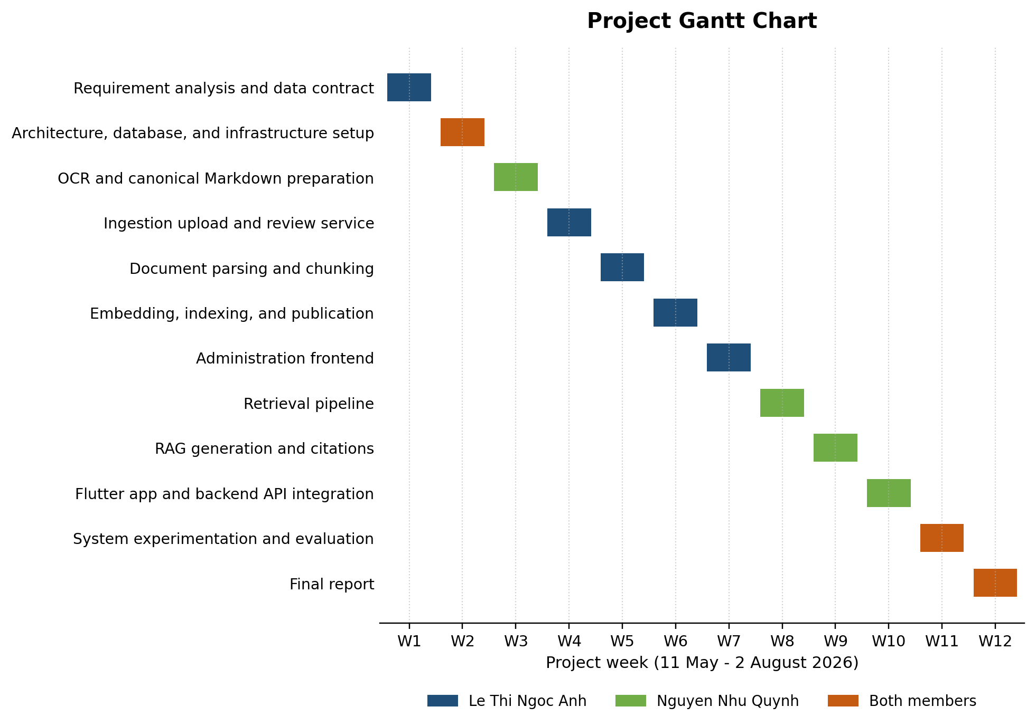
Figure 1.1. Project Gantt chart

SCOPE AND LIMITATIONS
The implemented scope includes the student Flutter application, the React administration interface, the FastAPI backend, PostgreSQL metadata storage, Qdrant vector storage, Cloudflare R2 object storage integration, BGE-M3 embeddings through Cloudflare Workers AI, parent-child chunking, query resolution and rewriting, hybrid retrieval, optional semantic reranking, grounded answer generation, citation metadata, lightweight recent-topic carry-over for follow-up questions, session-local document bookmarking, and document lifecycle operations such as publication, unpublication, deindexing, and deletion.
The OCR and LlamaParse workflow is outside the backend repository. The backend receives canonical Markdown that has already been processed and reviewed. Authentication and full role-based access control are not yet implemented as production security boundaries. Saved documents are held only in Flutter application state for the current session rather than in a user account. Indexing runs as an in-process FastAPI BackgroundTask and therefore is not restart-safe. The current backend CORS rule is development-scoped to localhost and 127.0.0.1; the administration deployment avoids this through a same-origin Vercel proxy, while a direct hosted Flutter web deployment requires an allowed production origin or equivalent reverse proxy. Advanced evaluation, large-scale load testing, HNSW tuning, distributed job workers, and comprehensive production observability remain outside the current MVP.

REPORT ORGANIZATION
Chapter 1 introduces the problem, objectives, research methodology, project plan, scope, and report organization. Chapter 2 presents the theoretical foundation and selected technologies. Chapter 3 specifies requirements, describes the software design and implemented workflows, and presents the testing approach and source-backed results. Chapter 4 summarizes achieved outcomes, limitations, and future development directions.

THEORETICAL FOUNDATION

RETRIEVAL-AUGMENTED GENERATION
Retrieval-Augmented Generation combines a generative language model with an external information-retrieval component. Instead of depending only on knowledge encoded in model parameters, the system retrieves passages from a controlled corpus and conditions the generated answer on those passages. The original RAG formulation demonstrates how parametric generation can be combined with non-parametric memory for knowledge-intensive tasks [1]. Later surveys classify RAG systems by their indexing, retrieval, augmentation, and generation stages and emphasize the value of updateable domain knowledge and source traceability [2].
In this project, the external corpus is composed of approved CTU administrative documents. The retrieved context acts as the only permitted evidence for the answer. This design reduces the risk of unsupported claims and makes it possible to associate each response with a document version, chunk, page range, and source path.

DOCUMENT INGESTION AND CANONICAL MARKDOWN
Document ingestion transforms reviewed content and metadata into searchable units. The project uses canonical Markdown because headings, lists, tables, code blocks, and page markers can be represented in a text format that is readable by humans and straightforward to validate. YAML frontmatter stores structured metadata such as the document key, version key, title, document type, responsible departments, dates, source information, and status fields.
The backend intentionally separates OCR from ingestion. An external workflow produces and reviews the canonical Markdown, after which the administration interface uploads the file and optional source document. This boundary prevents OCR uncertainty from being silently treated as approved content inside the indexing service.

STRUCTURAL PARENT-CHILD CHUNKING
Chunking divides a long document into retrieval units. Very large chunks provide context but reduce retrieval precision, whereas very small chunks are easy to match but may omit important surrounding conditions. The implemented parent-child strategy addresses this trade-off. Parent chunks represent heading-based sections, while child chunks represent smaller structural units such as numbered items, paragraphs, tables, or code blocks.
Dense vectors are generated for child chunks because they are more specific retrieval targets. After a child is retrieved, the system can hydrate its parent content and related structural context. The context builder places a parent before its child when space is available and avoids duplicating the same parent. This preserves local precision while giving the language model sufficient context to interpret the retrieved item.

EMBEDDINGS AND BGE-M3
An embedding model maps text to a numeric vector so that semantically related texts can be compared in vector space. BGE-M3 was selected because it is designed for multilingual, multi-functionality, and multi-granularity retrieval [3]. These characteristics are suitable for Vietnamese student questions and administrative documents that contain both short rules and long sections.
Before embedding, the implementation enriches each child chunk with document title, responsible department, document type, heading path, page range, and chunk content. The current source calls Cloudflare Workers AI with the model @cf/baai/bge-m3 and expects 1,024-dimensional vectors. The resulting vector is stored in Qdrant together with a payload that preserves the identifiers required for later PostgreSQL hydration and citation construction.

HYBRID INFORMATION RETRIEVAL

Dense retrieval
Dense retrieval embeds the user query and searches Qdrant for child vectors with high semantic similarity. This branch is useful when the question and the document use different wording but express the same intent.

Sparse retrieval
Sparse retrieval uses PostgreSQL full-text search over indexed child chunks. Before a result is eligible for the student-facing path, PostgreSQL conditions require review_status = approved, rag_status = published, and an audience containing sinh_vien. This branch is effective for exact terms such as regulation codes, form names, department names, and procedural keywords.

Reciprocal Rank Fusion
Dense and sparse scores have different scales and therefore should not be added directly. Reciprocal Rank Fusion combines ranked lists by assigning each document a score based on its position in every list [4]. The implementation uses a rank constant of 60 and removes duplicate chunks by chunk key.
RRF(d) = Σᵢ 1 / (k + rankᵢ(d)), where k = 60
A chunk receives a higher fused score when it appears near the top of one or more result lists. The same principle is used to combine results from multiple meaning-preserving query variants.

QUERY RESOLUTION, REWRITING, AND FILTERING
Before retrieval, the query resolver normalizes the message, expands supported abbreviations, handles greetings, and recognizes a small set of underspecified questions that require clarification. When the Flutter client carries a recent_topic from the previous response, the resolver can use it to complete a short follow-up question. For a searchable Vietnamese question, the configured language model can generate up to two meaning-preserving alternatives in addition to the original query. A timeout or rewriting error does not block retrieval; the original query remains the fallback.
The retrieval module also extracts aliases for department, document type, and domain, but the current dense and sparse retrievers deliberately do not apply these inferred labels as hard filters because a wrong inference could exclude the correct source. The hard student-facing eligibility rule is review_status = approved AND rag_status = published AND audience contains sinh_vien. Explicit document_key or version_key constraints can be applied when they are supplied through retrieval context; the public answer endpoint currently supplies recent_topic rather than explicit document/version keys. The is_latest and validity_status fields are maintained as governance metadata but are not hard retrieval filters or ranking signals in the current source.

RERANKING AND STRUCTURAL CONTEXT EXPANSION
After RRF, the current retriever hydrates fused candidates from PostgreSQL before optional Jina reranking, ensuring that reranking uses canonical database-backed content and metadata rather than trusting Qdrant payload alone. If JINA_API_KEY is not configured or the external reranking service fails, an identity fallback preserves the existing hybrid RRF order. The top-ranked direct hits are then expanded structurally.
Structural expansion may retrieve parent items, direct children, siblings, or neighboring split fragments. The expansion logic is especially useful for list questions and nested administrative rules, where a single retrieved item may depend on an introductory statement or adjacent sub-items.

GROUNDED GENERATION AND CITATIONS
The language-model prompt instructs the assistant to use only the supplied context, answer in Vietnamese, avoid speculation, preserve procedural order, and explicitly state when only partial information is available. When no relevant evidence is found, the system returns a predefined no-context message instead of inventing an answer.
Citations are constructed by the backend from retrieved results rather than generated by the language model. Each citation includes the document key, version key, chunk key, title, page range, source file, issuing authority, document type, source URL, source path, and canonical Markdown path when available. This design allows the Flutter client to display a source card and request a short-lived preview URL for the original or canonical document.

TOOLS AND TECHNOLOGIES
Technology | Role in the project
Flutter and Dart | Cross-platform student application for web, Android, and Windows; Riverpod manages chat and shell state [8].
React 18 and Vite | Administration interface for upload, review, chunk approval, indexing, publication, and document management [9].
FastAPI | Versioned asynchronous REST API and dependency-based database-session injection [5].
SQLAlchemy and Alembic | Asynchronous ORM access and version-controlled PostgreSQL schema migrations.
PostgreSQL 17 | Source of truth for documents, versions, chunks, recipients, assets, jobs, and sparse retrieval [6].
Qdrant | Dense vector storage and similarity search for child chunks [7].
LangChain components | Text splitters, prompt templates, OpenAI-compatible chat integration, and document objects [10].
Cloudflare Workers AI / BGE-M3 | Hosted multilingual embedding service using @cf/baai/bge-m3; the current implementation expects 1,024-dimensional vectors.
Cloudflare R2 / boto3 | S3-compatible storage for canonical Markdown and original source files [12].
Docker Compose | Local orchestration of PostgreSQL and Qdrant services [11].
OpenAI-compatible LLM provider | Provider-independent answer generation and query rewriting; the sample environment defaults to OpenRouter with a Qwen model.
Jina reranker | Optional semantic reranking with an identity/RRF-preserving fallback.
Table 2.1. Technology stack and roles

APPLICATION RESULTS

SOFTWARE REQUIREMENT SPECIFICATION

Overall description

Product perspective
The product is a multi-client RAG system composed of a Flutter student application, a React administration interface, a FastAPI backend, PostgreSQL, Qdrant, S3-compatible object storage, an embedding endpoint, and an OpenAI-compatible language-model provider. The backend is the authority for validation, document status, retrieval eligibility, and citation construction.

User classes and responsibilities
User class | Responsibilities
Student | Ask procedure-related questions; read grounded answers; inspect citations; open source or canonical document previews; carry lightweight recent-topic context for follow-up questions; and bookmark cited documents during the current Flutter session.
Administrator | Upload canonical Markdown and an optional source file; edit metadata; review content; inspect chunks; index, publish, unpublish, deindex, update, or delete document versions.
Reviewer (optional role) | Conceptual review responsibility for checking canonical Markdown and metadata. The current source does not enforce a separate reviewer account or RBAC role; valid review submissions are approved by the same administrative workflow.
External content-preparation operator | Perform OCR or parsing outside the backend and deliver reviewed canonical Markdown to the administrative workflow.
Table 3.1. User classes and responsibilities

Operating environment
- Backend: Python 3.10 or later, FastAPI, SQLAlchemy async, and Uvicorn.
- Data services: PostgreSQL 17, Qdrant, and S3-compatible object storage.
- Administration UI: Node.js 18 or later, React 18, and Vite.
- Student UI: Flutter SDK with web, Android, or Windows toolchains as required.
- Local infrastructure: Docker Desktop and Docker Compose for PostgreSQL and Qdrant. In the current source, embedding is provided by Cloudflare Workers AI, so a local GPU or TEI service is not required.

Assumptions and dependencies
- Canonical Markdown is produced and reviewed before backend ingestion.
- Reference data such as departments and document types has been seeded.
- Environment variables provide database, Qdrant, object-storage, embedding, reranker, and LLM credentials.
- Student-facing answers require at least one relevant document version that is approved, published, and available to the sinh_vien audience.

Specific requirements

Use case model
Figure 3.1 summarizes the interactions supported by the current source. Student use cases focus on question answering and source inspection. Administrative use cases cover the governed document lifecycle from upload to publication and maintenance.
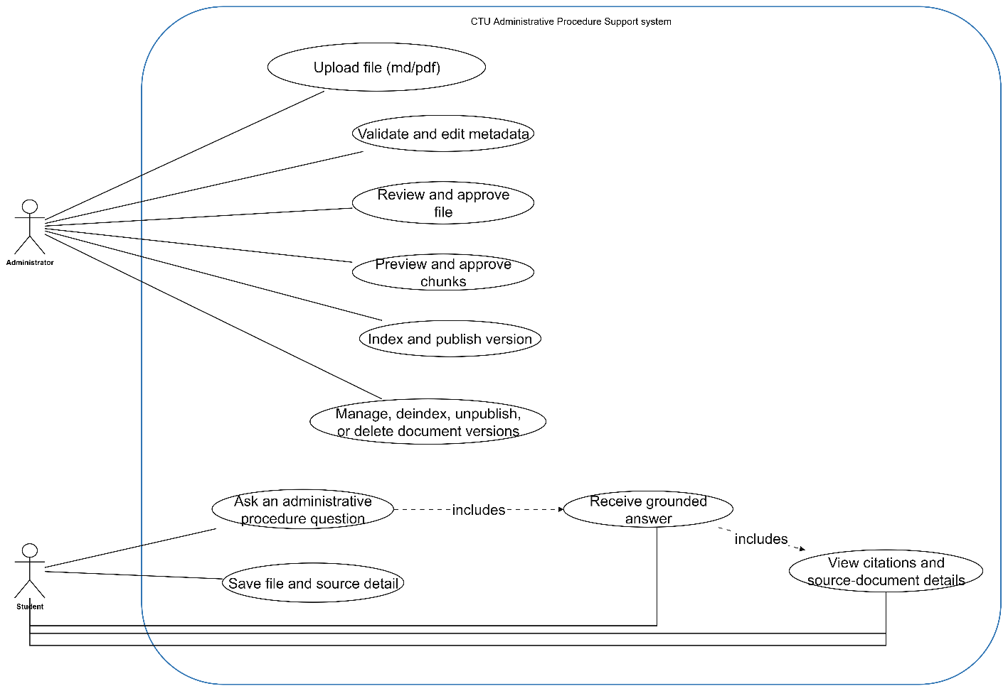
Figure 3.1. System use case diagram
The following specification table complements Figure 3.1 by defining the actor-visible behavior and the lifecycle conditions implemented in the submitted source. System-internal steps such as query rewriting, retrieval, and citation construction are described inside the relevant user use case rather than treated as separate actors.
ID | Use case | Primary actor | Specification
UC-01 | Ask an administrative-procedure question | Student | Preconditions: The Flutter client can reach POST /api/v1/rag/answer.  Main flow: The student submits a non-empty question (maximum 2,000 characters). The client sends question, top_k, and optional recent_topic. The backend resolves the query, may rewrite it, retrieves eligible evidence, generates a grounded Vietnamese answer, and returns citations plus an updated recent_topic.  Alternative/exception: Greetings or underspecified input may return should_search = false with a direct response or clarification. Retrieval/generation errors are shown as client-readable messages.  Postcondition: The answer is displayed and the returned recent_topic can support the next follow-up question.
UC-02 | Inspect citations and source-document details | Student | Preconditions: An evidence-backed answer contains at least one citation.  Main flow: The student opens a source card or document-detail view, reads title and citation metadata, and may open the original source URL. For a stored source or canonical Markdown file, the client requests a five-minute preview URL from the backend and opens it.  Alternative/exception: If a file or URL is unavailable, invalid, or cannot be opened, the client displays an explanatory message.  Postcondition: The student can trace the answer to its governed document/version and cited page or section.
UC-03 | Save or remove a cited document | Student | Preconditions: A cited document is open in the Flutter document-detail view.  Main flow: The student toggles the bookmark icon. The SourceRef is added to or removed from savedDocumentsProvider and can be revisited from the Documents screen.  Alternative/exception: Duplicate documents are avoided by document_key, falling back to version_key.  Postcondition: The bookmark is retained only for the current application session; it is not persisted to an account or backend database.
UC-04 | Upload canonical content and optional source file | Administrator | Preconditions: Reference data is available. Canonical content is UTF-8 .md/.markdown and no larger than 20 MB. The optional source file is a supported PDF/DOC/DOCX/PPT/PPTX/Markdown file and no larger than 100 MB.  Main flow: The administrator selects files, enters metadata and a source-department code, and submits a multipart request. The backend validates input, creates or links the logical document and version, regenerates canonical frontmatter from validated metadata, stores files in R2, and stores metadata in PostgreSQL.  Alternative/exception: Invalid file types, oversized files, missing/invalid metadata, missing reference data, or duplicate version_key values are rejected without creating a duplicate version.  Postcondition: A non-indexed document version and its storage paths are available for review.
UC-05 | Validate and edit metadata / canonical Markdown | Administrator | Preconditions: A canonical document version has been uploaded and has not been indexed.  Main flow: YAML metadata may be previewed to prefill the form. The administrator edits metadata and canonical content while immutable provenance fields such as document_key, version_key, and checksum remain protected by backend validation.  Alternative/exception: Validation errors keep the version out of approval/indexing and require corrected input.  Postcondition: The reviewed content is internally consistent and ready for approval.
UC-06 | Review and approve canonical content | Administrator / conceptual reviewer | Preconditions: The version has rag_status = not_indexed and valid canonical Markdown/metadata.  Main flow: The review endpoint validates the content, synchronizes responsible departments and optional assets, replaces the canonical Markdown in storage, sets ocr_status = done and review_status = approved, and keeps rag_status = not_indexed.  Alternative/exception: If validation or storage/database synchronization fails, the operation is rejected and the previous canonical file is restored when necessary.  Postcondition: The version is approved and eligible for chunk preview/indexing. A distinct reviewer account is not enforced in the current source.
UC-07 | Preview and confirm parent-child chunks | Administrator | Preconditions: The canonical version is approved and readable from storage.  Main flow: The administrator requests a preview. The backend parses canonical Markdown and returns parent and child counts, stable chunk keys, heading paths, page ranges, item metadata, warnings, and errors. The UI records the administrator's confirmation before continuing.  Alternative/exception: Chunking errors prevent indexing. The chunk-confirmation flag itself is frontend workflow state rather than a separately persisted backend approval record.  Postcondition: The administrator has inspected the structural chunks to be indexed.
UC-08 | Index and publish a document version | Administrator | Preconditions: ocr_status = done, review_status = approved, and chunking has no blocking errors.  Main flow: The index endpoint creates an ingestion job and persists chunks, then an in-process FastAPI BackgroundTask embeds child chunks through Cloudflare Workers AI, upserts vectors to Qdrant, updates progress, and finishes with rag_status = indexed. The administrator then publishes the indexed version, which updates PostgreSQL and the Qdrant payload status to published.  Alternative/exception: Embedding/Qdrant failures set job/version failure state. Publication is rejected unless the version is indexed.  Postcondition: The approved, published, student-audience version can participate in student retrieval.
UC-09 | Maintain document versions and assets | Administrator | Preconditions: A document version exists.  Main flow: The administrator can list/filter versions, inspect details, update non-indexed content/metadata, update linked assets, publish or unpublish eligible versions, deindex vectors/chunks, and delete versions allowed by lifecycle rules.  Alternative/exception: Content changes are blocked after indexing until deindexing. Deletion is allowed only for not_indexed or failed versions. Assets can be changed without deindexing because they are not part of chunk/vector content.  Postcondition: PostgreSQL, R2, and Qdrant are kept consistent with the selected lifecycle operation.
Table 3.2. Use case specification summary

Main workflow constraints
- Canonical upload accepts UTF-8 .md/.markdown content up to 20 MB; the optional source file is limited to the supported PDF/DOC/DOCX/PPT/PPTX/Markdown types and 100 MB.
- A version must have ocr_status = done and review_status = approved before indexing can start. In the current workflow, a valid review submission sets these states directly.
- Only indexed versions can be published. Student retrieval additionally requires review_status = approved, rag_status = published, and an audience containing sinh_vien.
- A version with RAG data must be deindexed before content-changing metadata or canonical Markdown edits; linked assets can be updated without deindexing because they are outside the chunk/vector content.
- Publishing and unpublishing synchronize rag_status between PostgreSQL and the Qdrant payload; deindexing removes child vectors and relational chunk records before returning the version to not_indexed.
- Preview URLs for files stored in R2 are generated by the backend and expire after five minutes.
- Flutter document bookmarks are session-local application state and are not a persistent user-account feature.

Functional requirements
ID | Name | Requirement
FR-01 | Submit student question | The system shall accept a non-empty question of at most 2,000 characters and a top_k value from 1 to 20.
FR-02 | Resolve or clarify query | The system shall determine whether to search or return a direct clarification response.
FR-03 | Rewrite query | The system shall optionally generate meaning-preserving Vietnamese search variants without blocking retrieval on failure.
FR-04 | Apply eligibility policy | The system shall retrieve only versions whose review_status is approved, rag_status is published, and audience includes sinh_vien.
FR-05 | Perform hybrid retrieval | The system shall execute dense Qdrant search and sparse PostgreSQL search and combine candidates using RRF.
FR-06 | Expand retrieval context | The system shall hydrate database metadata and may add parent, sibling, child, or neighboring structural context.
FR-07 | Generate grounded answer | The system shall generate a Vietnamese answer using only the retrieved context.
FR-08 | Return citations | The system shall return traceable citation metadata with every evidence-backed answer.
FR-09 | Preview stored documents | The system shall generate a temporary URL for an available source file or canonical Markdown object.
FR-10 | Upload canonical content | The administrator shall upload canonical Markdown, metadata, responsible-department code, and an optional source file.
FR-11 | Review canonical content | The administrator or reviewer shall edit and approve canonical Markdown and metadata before indexing.
FR-12 | Preview chunks | The administrator shall inspect the parent-child chunk preview and confirm it in the administration UI before starting indexing.
FR-13 | Index document version | The system shall create chunks, embeddings, PostgreSQL records, Qdrant points, and ingestion-job progress.
FR-14 | Manage publication | The administrator shall publish and unpublish eligible versions.
FR-15 | Maintain versions | The administrator shall list, filter, view, update, deindex, or delete document versions under lifecycle constraints.
FR-16 | Manage reference data and assets | The system shall expose active departments and document types and associate document assets when configured.
FR-17 | Bookmark cited document | The student shall be able to save or remove a cited document in the current Flutter application session and revisit saved documents from the Documents screen.
FR-18 | Carry lightweight follow-up topic | The Flutter client and RAG endpoint shall exchange an optional recent_topic value so short follow-up questions can be resolved without implementing persistent conversation history.

Table 3.3. Functional requirements

Non-functional requirements
ID | Quality attribute | Requirement
NFR-01 | Grounding | The system must not present a procedural claim without retrieved source evidence.
NFR-02 | Traceability | Every citation must be traceable to a stored document version and chunk.
NFR-03 | Security | Secrets must be stored outside Git; input files, queries, metadata, dates, and enumeration values must be validated.
NFR-04 | Availability | Failure of query rewriting or optional reranking must not prevent the original RRF retrieval path.
NFR-05 | Performance | Question answering should use asynchronous I/O and bounded timeouts; expensive synchronous model calls should not block the FastAPI event loop.
NFR-06 | Maintainability | Public API paths must remain under /api/v1 and responsibilities must be separated by backend modules.
NFR-07 | Scalability | PostgreSQL, Qdrant, object storage, embedding, and LLM services must be independently replaceable or deployable.
NFR-08 | Usability | Student answers and error messages should be clear Vietnamese; administrative workflow progress and status badges should be visible.
NFR-09 | Data integrity | Document, version, chunk, asset, and job relationships must be protected by database constraints and controlled lifecycle operations.
NFR-10 | Recoverability | Production deployment should back up PostgreSQL, Qdrant snapshots, and document storage.
NFR-11 | Web deployment compatibility | Hosted browser clients shall use an explicitly allowed production origin or a same-origin reverse proxy; development-only localhost CORS settings are not sufficient for a direct production web call.
Table 3.4. Non-functional requirements

SOFTWARE DESIGN

Application architecture
The architecture follows a layered and service-oriented structure. Client applications communicate with the FastAPI API, while ingestion, retrieval, LLM, database, embedding, object-storage, and vector-store responsibilities are separated into dedicated modules. PostgreSQL acts as the authoritative source for document/version metadata and chunk content; Qdrant is a derived dense index; Cloudflare R2 stores canonical and original files; and Cloudflare Workers AI provides BGE-M3 embeddings. The LLM and optional reranker are external services accessed through configuration rather than hard-coded provider logic.

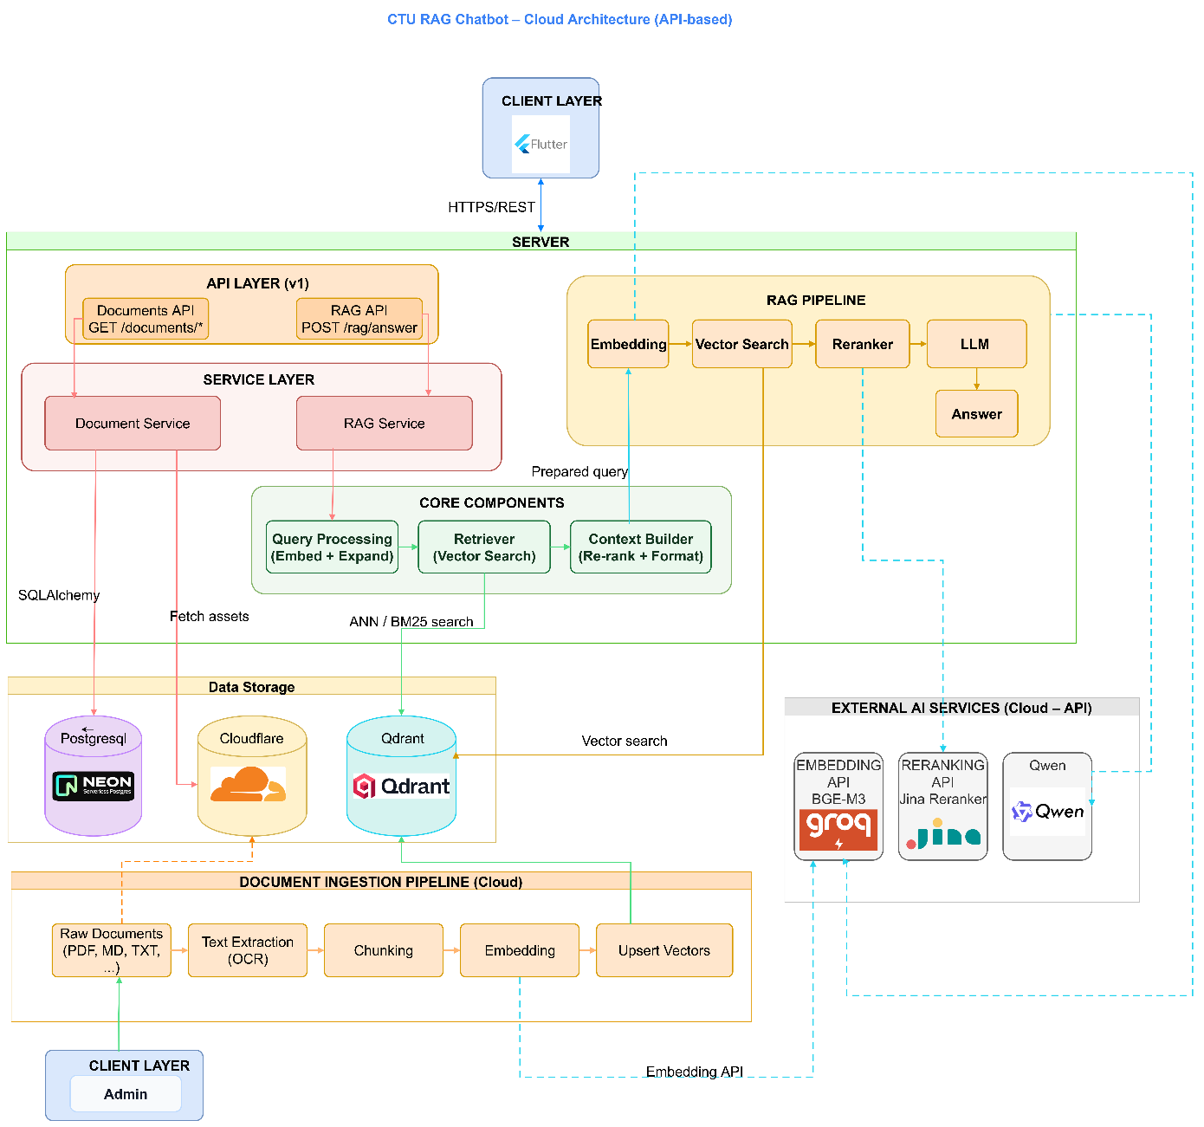
Figure 3.2. Overall application architecture
The student path starts in the Flutter client, calls POST /api/v1/rag/answer, executes retrieval and grounded generation, and returns an answer with citations. The administration path starts with canonical Markdown and uses the React workflow to validate, review, preview chunks, index, and publish. OCR and LlamaParse remain outside the backend boundary.

Data design

Input data and canonical document structure
The backend does not perform OCR as part of ingestion. An external preparation workflow produces reviewed canonical Markdown, which becomes the governed textual input for metadata validation, chunking, indexing, and retrieval. The original source file is optional and is preserved for traceability and preview.
Input / representation | Format and limit | Role in the system
Canonical document | UTF-8 .md/.markdown; maximum 20 MB | Required reviewed text. YAML frontmatter and Markdown body are validated; canonical metadata is regenerated from the administration form before storage.
Original source file | Optional PDF, DOC, DOCX, PPT, PPTX, or Markdown; maximum 100 MB | Preserved in Cloudflare R2 for provenance, document preview, and source traceability. It is not directly used as retrieval text.
Metadata | Validated form fields plus YAML frontmatter representation | Identifies document/version keys, title, type, departments, dates, audience, source information, and governance statuses. PostgreSQL is authoritative for these records.
Derived vector representation | 1,024-dimensional BGE-M3 child embedding | Stored in Qdrant with identifiers/structural payload. It is a derived search index; canonical content is hydrated from PostgreSQL before reranking and generation.
Table 3.5. Input data and canonical representations

Database and chunk structure
Parent and child chunks are stored in PostgreSQL table document_chunks. A parent chunk represents a broader heading-based section, while a child chunk is the retrieval unit and references its parent through parent_chunk_id. Only child chunks receive dense vectors; qdrant_point_id links an indexed child to its Qdrant point.
Field | Purpose
id | Primary key of the chunk record.
document_version_id | Foreign key linking the chunk to one governed document version.
parent_chunk_id | Self-reference: NULL for a parent; the corresponding parent ID for a child.
chunk_key / chunk_index | Stable per-version chunk identifier and ordered index; both are constrained to be unique within a document version.
chunk_type | parent or child; database constraints enforce the parent-child relationship.
heading_path / section_title | Structural location of the chunk within the canonical Markdown document.
content | Canonical chunk text stored in PostgreSQL and used during hydration/context construction.
page_start / page_end | Optional page range used for traceability and citation display.
token_count | Optional token-count metadata used to support bounded context handling.
qdrant_point_id | Unique Qdrant point identifier for an embedded child chunk; NULL when no vector is stored.
index_status | Chunk indexing state: not_indexed, indexed, deactivated, or failed.
created_at / updated_at | Timestamps for record creation and the latest update.
Table 3.6. document_chunks storage structure

Entity-relationship design
The current relational schema contains nine tables. Documents represent logical records, whereas document_versions preserve edition-specific metadata and lifecycle status. Parent and child chunks belong to a version. Ingestion jobs track asynchronous indexing progress. Departments, recipients, assets, and document-asset relationships preserve organizational and supplementary information.
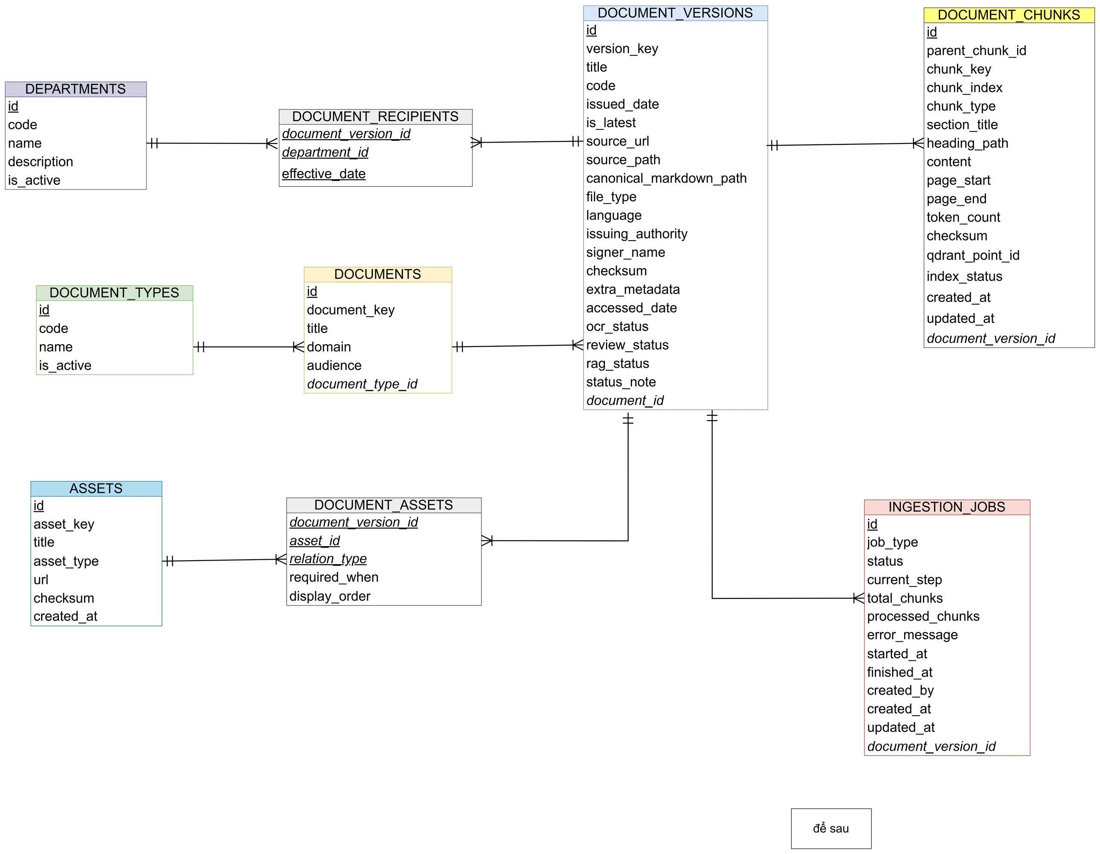
Figure 3.3. Entity-relationship diagram
Entity | Purpose
departments | Reference data for responsible or recipient organizational units.
document_types | Reference data for document classification.
documents | Logical document identity, title, domain, audience, and type.
document_versions | Version metadata, source paths, dates, latest flag, and OCR/review/RAG statuses.
document_chunks | Parent-child structural chunks, page ranges, content, checksums, and Qdrant identifiers.
ingestion_jobs | Indexing status, current step, progress counters, errors, and timestamps.
document_recipients | Many-to-many receipt history between versions and departments, including effective date.
assets | Reusable forms, links, or files associated with procedures.
document_assets | Version-to-asset relationship, relation type, requirement condition, and display order.
Table 3.7. Main database entities

Document lifecycle statuses
The current lifecycle state is stored in document_versions. The status enums define OCR states such as not_started, processing, done, failed, and need_review; review states such as not_reviewed, reviewing, need_fix, approved, and rejected; and RAG states such as not_indexed, chunked, embedded, indexed, published, deactivated, and failed. In the implemented administrative path, uploading reviewed canonical Markdown sets OCR completion, a valid review submission transitions directly to approved, indexing follows not_indexed → chunked → indexed (or failed), publication sets published, unpublication returns to indexed, and deindexing returns to not_indexed. The is_latest and validity_status metadata are maintained for governance but are not currently enforced as retrieval ranking/filter signals.

Detailed design

Administrative ingestion workflow
The React administration interface implements four principal workflow steps: upload, review, chunk review, and ingest. The upload step accepts canonical Markdown and an optional original source file, validates type/size/UTF-8 and metadata, checks reference data and duplicate version keys, regenerates canonical YAML frontmatter from validated form metadata, and stores files through the S3-compatible R2 layer. During review, immutable provenance fields are protected, responsible departments and optional assets are synchronized, and valid content is stored as approved canonical Markdown. After approval, the administrator requests a chunk preview and confirms it in the UI. Starting indexing creates relational chunk records and an ingestion job, then schedules the remaining embedding/Qdrant work as an in-process FastAPI BackgroundTask.
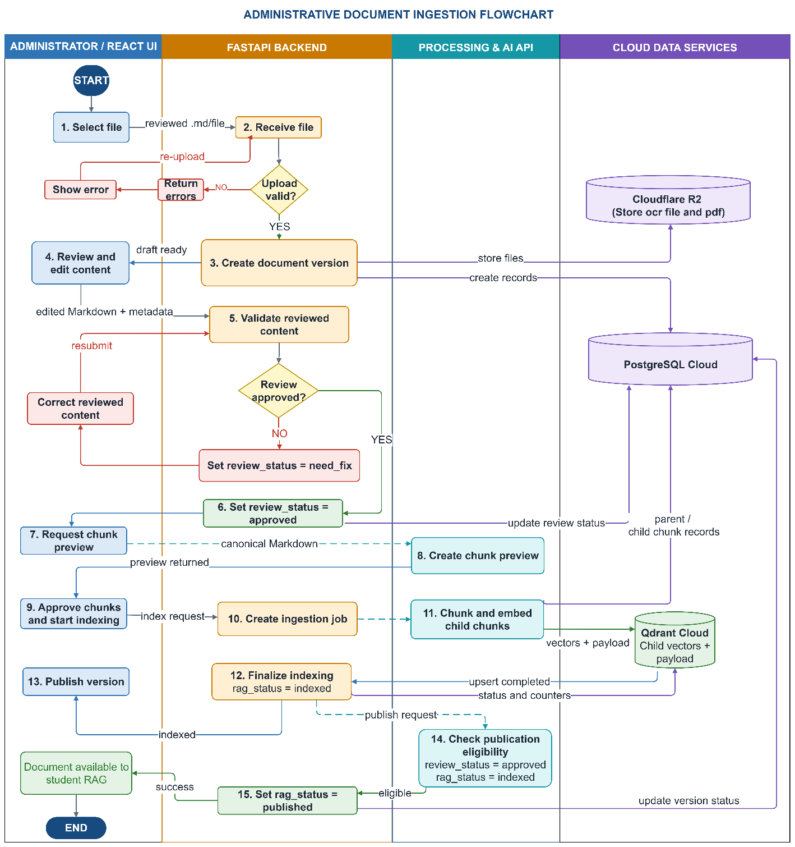
Figure 3.4. Administrative ingestion sequence
The indexing service creates parent-child chunks, embeds child chunks in batches, stores relational chunk records, upserts vectors into Qdrant, and updates ingestion_jobs.current_step and progress counters. The source notes that the current background task is in-process; a restart-safe queue should replace it when production resilience is required.

Retrieval and answer-generation workflow
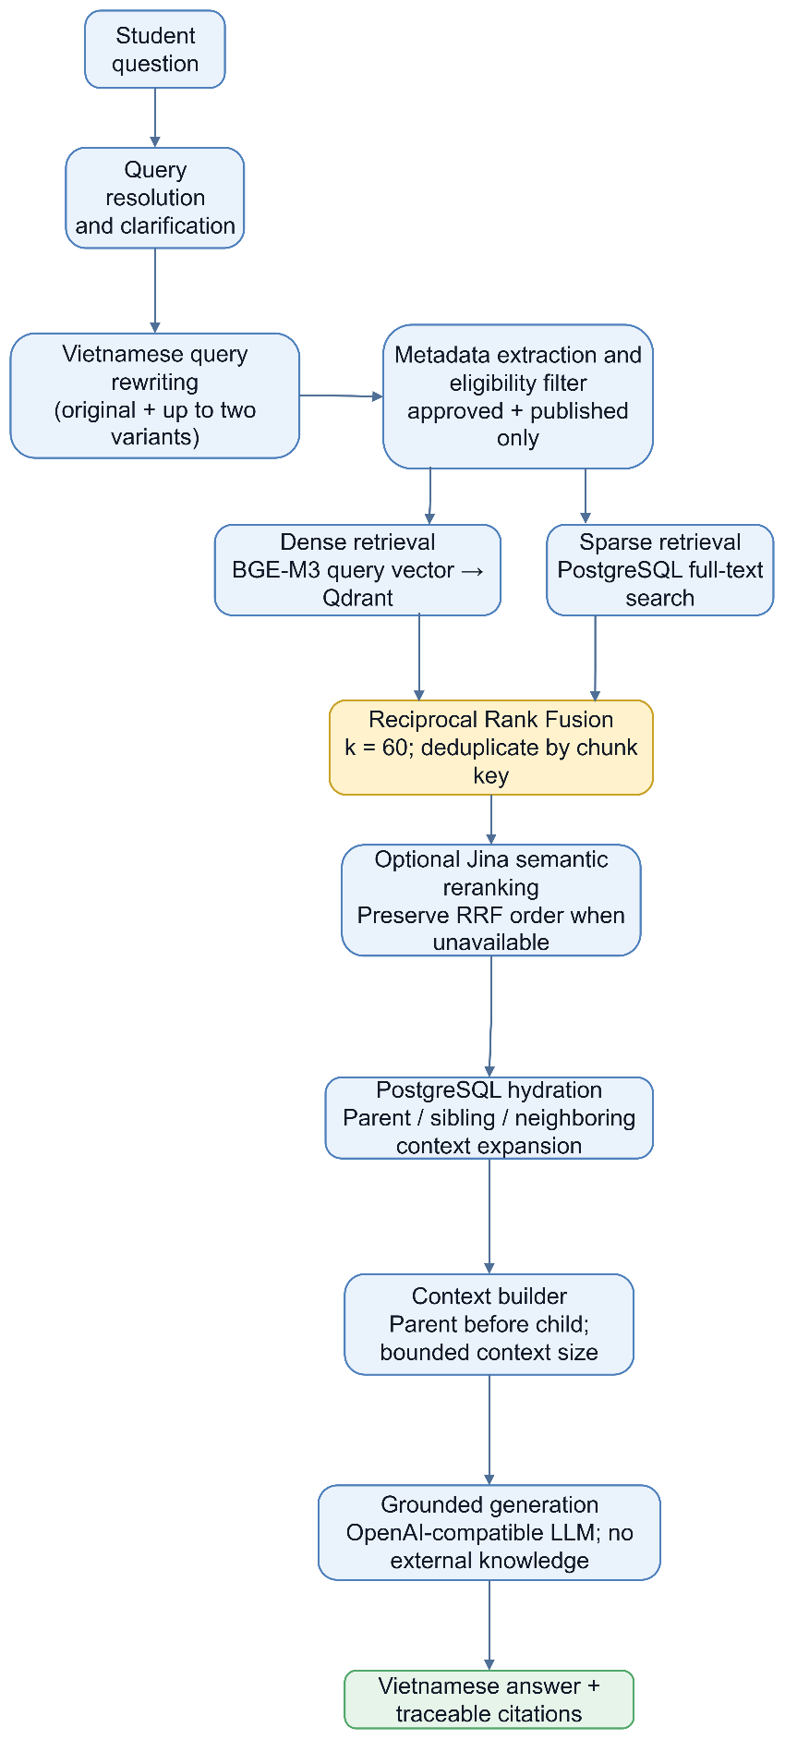
Figure 3.5. Retrieval and answer-generation pipeline
- Resolve the question, handle direct greeting/clarification cases, and decide whether retrieval is required.
- Generate meaning-preserving Vietnamese query variants when rewriting is enabled; preserve the original query on timeout or error.
- Apply hard eligibility for approved, published, sinh_vien-audience versions and any explicit document/version constraints supplied by context.
- Retrieve dense child candidates from Qdrant and sparse child candidates from PostgreSQL for each query variant.
- Fuse dense and sparse rankings with RRF, then fuse equivalent-query result lists and deduplicate by chunk_key.
- Hydrate fused candidates from PostgreSQL so canonical chunk content, document/version metadata, parent content, and citation data are available.
- Optionally rerank the hydrated direct hits with Jina; when Jina is unavailable, preserve the RRF order.
- Keep the requested top_k direct hits, expand parent/child/sibling/split-neighbor structural context, and build a bounded context with parent sections before child passages when possible.
- Generate the Vietnamese answer only from the built context and construct deduplicated citations in the backend.

RAG workflow overview
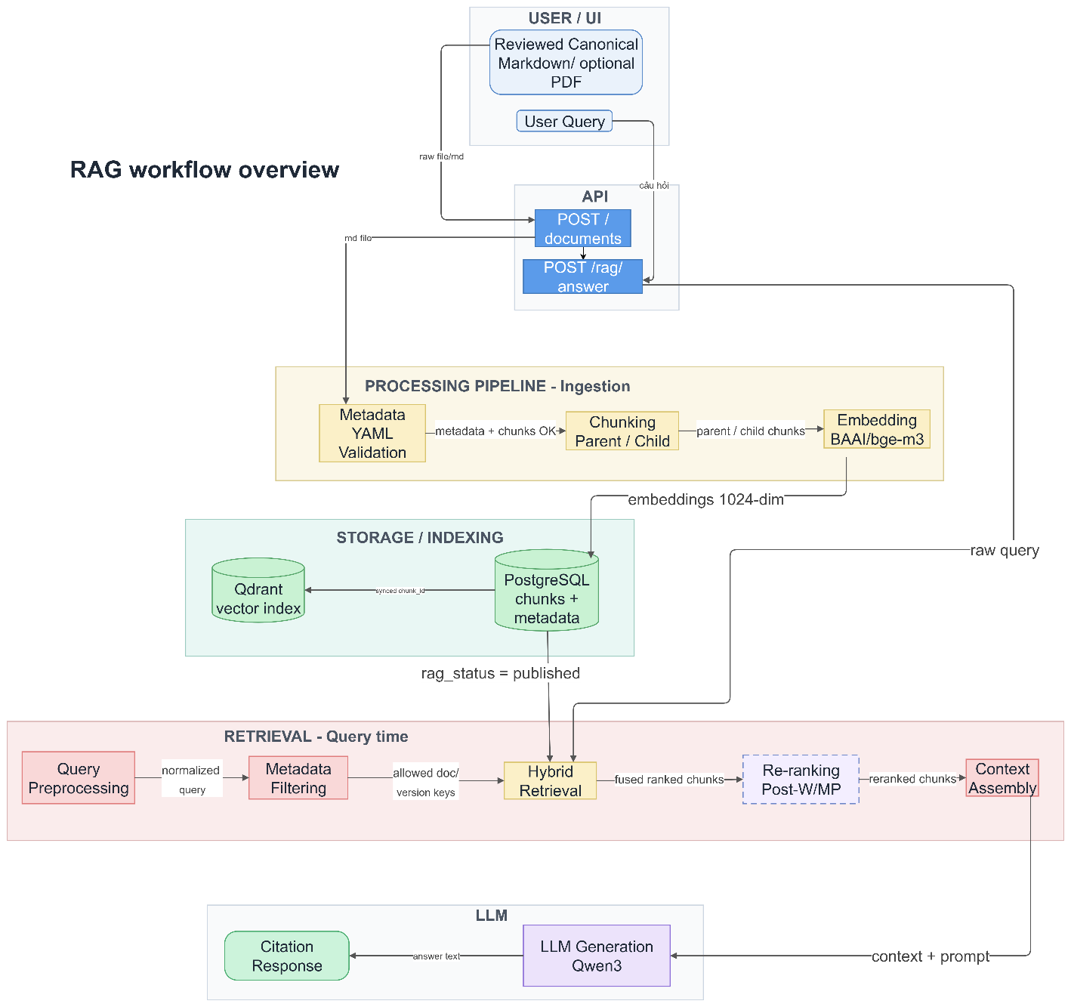
Figure 3.6. RAG workflow overview
The workflow maintains a clear distinction between authoritative relational data and the derived vector index. PostgreSQL retains canonical metadata and chunk content required for hydration and citation. Qdrant stores child embeddings and structural payload used for dense search and expansion. Direct dense/sparse candidates are eligibility-filtered before fusion; fused candidates are then hydrated from PostgreSQL before optional semantic reranking. The final prompt context is assembled from hydrated relational records rather than treating Qdrant payload as the canonical source.

API design
Method | Endpoint | Purpose
GET | /health | Return backend health status.
POST | /api/v1/rag/answer | Answer a student question and return citations.
POST | /api/v1/admin/canonical-markdown/metadata-preview | Extract supported YAML metadata from a Markdown upload.
POST | /api/v1/admin/canonical-markdown | Upload canonical Markdown, metadata, department code, and optional source file.
PUT | /api/v1/admin/canonical-markdown/{id}/review | Review and approve edited canonical content.
POST | /api/v1/admin/document-versions/{id}/chunk-preview | Generate structural chunk preview.
POST | /api/v1/admin/document-versions/{id}/index | Start indexing and return job progress.
GET | /api/v1/admin/ingestion-jobs/{id} | Read indexing-job progress.
GET | /api/v1/versions | List and filter document versions.
GET/PUT/DELETE | /api/v1/versions/{id} | Read, update, or delete an eligible version.
POST | /api/v1/versions/{id}/publish | Publish an indexed and approved version.
POST | /api/v1/versions/{id}/unpublish | Remove a version from student retrieval.
POST | /api/v1/versions/{id}/deindex | Remove relational chunks and Qdrant vectors so the version can be edited.
GET | /api/v1/versions/preview-url/{version_key} | Create a temporary preview URL. The required file_type query parameter accepts source or canonical_markdown.
GET | /api/v1/health/database | Check PostgreSQL connectivity for the administration interface and diagnostics.
GET | /api/v1/reference/document-types, /departments, /enums | Return active reference data and supported enumeration values used by the administration forms.
PUT | /api/v1/versions/{id}/assets | Replace the linked assets of a document version without requiring content deindexing.
Table 3.8. Main API endpoints

Frontend design
The Flutter student application contains home, chat, document-detail, saved-document, and navigation-shell features. Riverpod providers expose the RAG API client, chat controller, shell state, theme state, and a session-local savedDocumentsProvider. The chat controller sends recent_topic returned by the backend with the next request to support lightweight follow-up resolution, but it does not persist full conversation history. The client maps answer JSON to typed messages and SourceRef objects, displays source cards, and requests short-lived preview URLs when a student opens stored source or canonical content. The application supports web, Android, and Windows project targets, and a hosted build can supply the backend address through the Dart API_BASE_URL compile-time define.
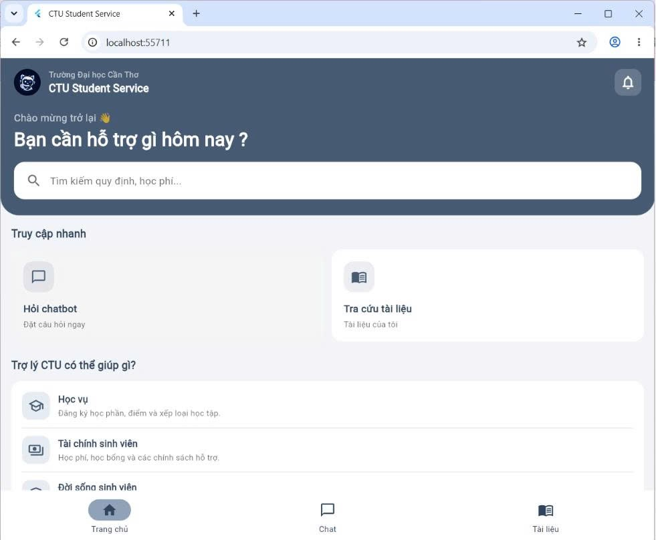
Figure 3.7. Student home interface

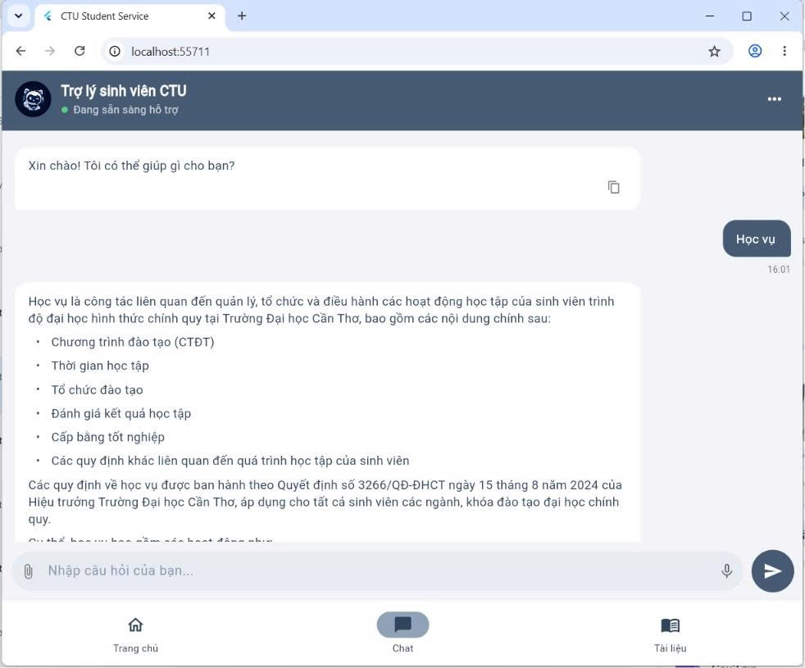
Figure 3.8. Student chatbot interface
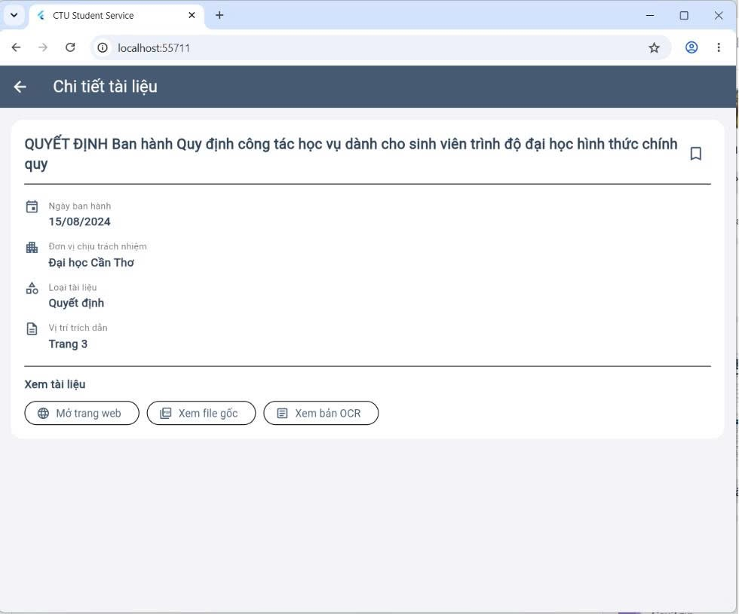
Figure 3.9. Document detail interface
The React administration interface uses a sidebar and workflow progress component. UploadStep, ReviewStep, ChunkReviewStep, and IngestStep correspond to the controlled ingestion lifecycle. Separate list and edit pages support document maintenance. The interface prevents returning to earlier content-changing steps after a version has been indexed unless it is first deindexed.
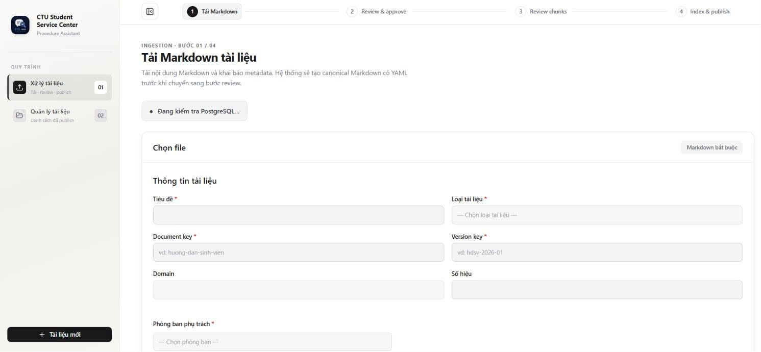
Figure 3.10. Administrative document upload interface
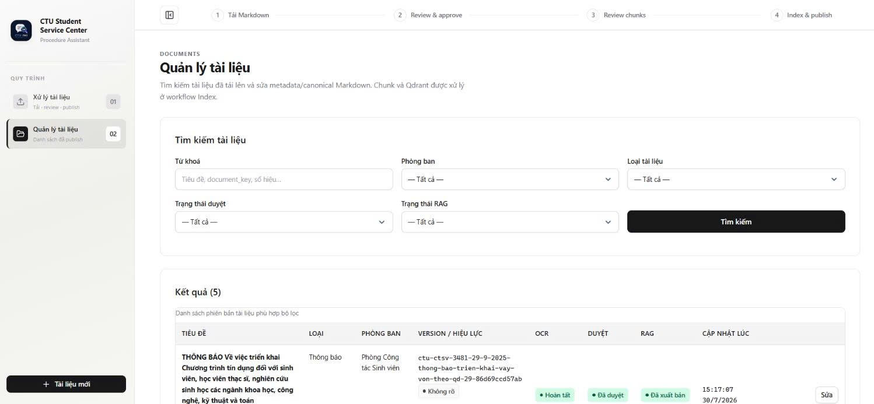
Figure 3.11. Document management interface

Deployment design
For local development, Docker Compose starts PostgreSQL and Qdrant. The FastAPI backend and React administration frontend run from their respective environments, while the Flutter client selects an API base URL appropriate to web, emulator, device, or Windows execution. In the submitted cloud source, admin-frontend/vercel.json rewrites same-origin /api/* requests to https://css-ctu-student-service-api.onrender.com/api/*, providing a Vercel-to-Render deployment path without browser cross-origin calls from the admin UI. Cloudflare Workers AI supplies BGE-M3 embeddings and R2 stores canonical/source files; PostgreSQL and Qdrant can be hosted independently. A direct Flutter web deployment that calls Render rather than a same-origin proxy must extend the current development-only CORS policy to the production web origin.

TESTING

Test plan
Testing should combine source-level unit tests, API integration tests, end-to-end workflow tests, client widget/controller tests, user acceptance tests, and deployment smoke tests. The principal risk areas are document lifecycle constraints, cross-store consistency, retrieval eligibility, citation accuracy, fallback behavior, Vietnamese answer quality, and browser deployment configuration. The current source snapshot contains limited automated backend coverage, so the strategy below distinguishes the intended test matrix from source-backed verification evidence.
Test type | Coverage | Suggested tools
Unit testing | Query processing, fusion, DTO/client behavior and selected service rules | pytest, Flutter test
Integration testing | FastAPI with PostgreSQL, Qdrant, R2 and model-service fallbacks | pytest/http client, deployed services
System / acceptance testing | Upload → review → chunk preview → index → publish → student question → citation preview. | Browser, API calls, production preview
RAG quality & performance evaluation | Retrieval relevance, ranking quality, answer correctness, faithfulness, citation correctness, no-answer behavior | Fixed Vietnamese gold test set, evaluation scripts, manual review
Table 3.9. Test strategy

Representative test cases
ID | Scenario | Precondition | Action | Expected result
TC-01 | End-to-end document ingestion and publication | Administration interface, PostgreSQL, Qdrant, R2, and embedding service are available. A valid canonical Markdown file is prepared. | Upload → Review → Chunk preview → Index → Publish | document version created;  canonical file stored;  chunks created;  child vectors stored in Qdrant;  ingestion job completed;  rag_status = published
TC-02 | Grounded student question | At least one relevant document version is approved, published, and available to the sinh_vien audience. | Submit a valid Vietnamese administrative-procedure question to POST /api/v1/rag/answer. | The API returns HTTP 200 with should_search = true; a non-empty Vietnamese answer is generated from retrieved evidence; citations are non-empty and traceable to the relevant document/version.
TC-03 | Retrieval eligibility enforcement | Two relevant versions exist: A: approved + published + sinh_vien; B: approved but not published; | Ask a question whose evidence can be found in these versions. | Only version A is eligible for dense/sparse retrieval and citation. Versions B must not appear in the returned citations.
TC-04 | Ambiguous or no-context question handling | Backend is running. For the no-context case, no eligible document contains evidence for the question. | Submit (1) an ambiguous/incomplete question and (2) a question outside the governed document corpus. | The system returns a clarification/direct non-search response for ambiguous input or the predefined no-context response when evidence is unavailable; no unsupported answer or fabricated citation is returned.
TC-05 | Optional reranker fallback | A searchable question and relevant published documents exist. The Jina reranker is disabled or unavailable. | Submit a valid searchable question while the reranker cannot be used. | The system preserves the hybrid RRF ordering/fallback path and continues retrieval and answer generation successfully instead of failing the entire request.
TC-06 | Deindex and cross-store consistency | An indexed or published document version exists with relational chunks in PostgreSQL and child vectors in Qdrant. | Unpublish the version if required, then execute the deindex operation. | Related PostgreSQL chunk records and Qdrant vectors are removed consistently; the document version returns to rag_status = not_indexed and is no longer retrievable by the student-facing RAG pipeline.
Table 3.10. Representative test cases

Test results and analysis

Source-backed verification
Verification was reviewed against the submitted source snapshot rather than inferred from the planned test matrix. The backend repository currently contains one discovered pytest unit test, while the Flutter repository contains seven test cases covering home-screen rendering, chat-controller concurrency/reset behavior, API request/response mapping, recent_topic propagation, missing metadata display, and FastAPI validation-message extraction. The React administration package defines a Vite production build command and includes a Vercel reverse-proxy configuration. The broader end-to-end cases in Table 3.10 remain acceptance scenarios; the source snapshot itself does not contain machine-readable evidence that each manual/cloud scenario has been executed.
During this report review, python -m pytest -q was executed against the submitted backend source and returned 1 passed. Pytest also reported that the configured testpaths contained no files and therefore fell back to recursive test discovery. Because the submitted snapshot does not include a Flutter SDK execution log, an admin build log, or end-to-end cloud test artifacts, this report does not mark those scenarios as passed solely because their code paths or test files exist. This distinction keeps the testing claims aligned with verifiable evidence.
Verification item | Evidence / procedure | Observed result | Assessment
Backend automated test | Execute python -m pytest -q in the submitted backend source. | 1 test passed. The discovered test verifies that a logical parent Document is deleted only when its last DocumentVersion is removed. Pytest emitted a testpaths discovery warning. | Verified
Flutter automated test suite | Inspect frontend/test in the submitted Flutter source. | Seven test cases are present across widget_test.dart, chat_controller_test.dart, and rag_api_client_test.dart. | Present; execution log not included
Administration production build path | Inspect admin-frontend/package.json and deployment configuration. | The package defines npm run build = vite build; vercel.json defines the /api/* proxy to the Render backend. | Configuration verified
End-to-end ingestion and RAG scenarios | Compare Table 11 scenarios with the implemented APIs/services and source workflow. | Upload/review/chunk/index/publish/RAG/deindex code paths are present, but no execution log or test artifact for all scenarios is included in the source snapshot. | Not execution-verified
Production preview routing | Inspect admin-frontend/vercel.json and backend FastAPI routes. | Admin /api/* requests are configured to proxy to css-ctu-student-service-api.onrender.com; backend exposes the corresponding /api/v1 routes. | Configuration verified

Table 3.11. Source-backed verification status

RAG quality evaluation framework
Functional verification alone does not measure retrieval or answer quality. For the final RAG benchmark, a curated Vietnamese question set should associate each question with relevant document/chunk evidence and, where applicable, reference facts. Table 3.12 defines the metrics to be reported when that benchmark is executed. Measured values are intentionally not fabricated in this report because the submitted source snapshot does not include a completed gold evaluation set or reproducible benchmark log.
Metric | Definition / measurement | Interpretation
Precision@5 | Relevant direct-hit chunks among the top five retrieved chunks divided by five. | Measures how much of the retrieved top-five evidence is relevant.
Recall@5 | Relevant gold chunks retrieved in the top five divided by all relevant gold chunks. | Measures coverage of the evidence required for the question.
MRR | Mean reciprocal rank of the first relevant direct-hit chunk across test questions. | Rewards placing the first useful evidence near the top of the ranking.
Answer correctness | Proportion of reference facts represented correctly in the generated answer, using manual or explicitly defined judging criteria. | Measures factual completeness/correctness relative to a reviewed reference answer.
Faithfulness | Supported factual claims divided by all factual claims in the generated answer. | Measures whether the answer stays grounded in retrieved context rather than unsupported model knowledge.
Citation precision | Returned citations that actually support the answer divided by all returned citations. | Measures the usefulness and correctness of source attribution.
No-answer accuracy | Correct abstentions/clarifications among questions that are unanswerable or outside the governed corpus. | Measures safe behavior when evidence is unavailable.
Response latency | Mean, P50, and P95 end-to-end time for POST /api/v1/rag/answer. | Measures user-perceived responsiveness and slow-tail behavior.
Table 3.12. RAG quality evaluation metrics
When evaluation data are available, the same fixed test set should be used to compare dense-only retrieval, sparse-only retrieval, hybrid retrieval with RRF, and the full hybrid pipeline with optional Jina reranking. This comparison would quantify the contribution of the retrieval components without changing the test questions between configurations.

CONCLUSION

ACHIEVED OUTCOMES
The project establishes an end-to-end foundation for a CTU administrative procedure chatbot. The installed source separates student interaction, administrative document governance, backend orchestration, relational metadata, dense vector search, object storage, and language-model generation. The student application can submit questions and display citations, while the administration interface supports the principal stages of canonical-document ingestion and document-version maintenance.
The backend implements structural parent-child chunking, BGE-M3 embedding through Cloudflare Workers AI, dense and sparse retrieval, RRF fusion across retrieval branches and query variants, PostgreSQL hydration, optional Jina semantic reranking, structural context expansion, grounded generation, and backend-constructed citations. The hard retrieval policy excludes versions that are not approved, not published, or not available to the sinh_vien audience. The Flutter client additionally supports lightweight recent-topic follow-ups and session-local bookmarks. These outcomes address the project objective of improving access to administrative information without removing the need for authoritative source documents.

LIMITATIONS
OCR and parsing remain external to the backend. Authentication and full role-based authorization are not yet complete, and the conceptual reviewer role is not enforced separately. Indexing uses an in-process BackgroundTask rather than a restart-safe worker queue. Saved-document bookmarks and recent-topic context are not persistent user accounts or full conversation memory. The current CORS configuration is development-scoped unless a same-origin proxy is used. Retrieval does not currently enforce validity_status or use is_latest as a ranking signal, so publication governance must prevent expired or replaced versions from remaining available. Automated backend test coverage is also narrow, and the quality of answers still depends on document coverage, metadata accuracy, chunk structure, and the availability of relevant approved sources.

FUTURE WORK
- Add authentication, authorization, audit logs, production secret management, and an enforced separation of administrator/reviewer permissions when required.
- Move indexing to a restart-safe task queue with retry, cancellation, idempotency, and recovery controls.
- Create a curated Vietnamese evaluation set for retrieval recall, citation precision, answer faithfulness, no-answer behavior, and version/audience eligibility.
- Persist user bookmarks and, if required, conversation state through explicit user/session models while keeping question-level source grounding.
- Add validity-aware publication/retrieval rules for expired or replaced versions and evaluate whether is_latest should become a ranking preference.
- Expand automated backend integration/end-to-end coverage and archive reproducible test/build logs for the final deployment.
- Configure explicit production CORS origins or a consistent same-origin proxy strategy for every hosted web client.
- Add monitoring, tracing, rate limiting, PostgreSQL backups, Qdrant snapshots, and disaster-recovery procedures.
- Expand the governed document corpus and establish a recurring review process with responsible CTU units.

REFERENCES
[1] P. Lewis et al., “Retrieval-Augmented Generation for Knowledge-Intensive NLP Tasks,” in Advances in Neural Information Processing Systems 33, 2020, pp. 9459–9474.
[2] Y. Gao et al., “Retrieval-Augmented Generation for Large Language Models: A Survey,” arXiv:2312.10997, 2023.
[3] J. Chen, S. Xiao, P. Zhang, K. Luo, D. Lian, and Z. Liu, “BGE M3-Embedding: Multi-Lingual, Multi-Functionality, Multi-Granularity Text Embeddings Through Self-Knowledge Distillation,” arXiv:2402.03216, 2024.
[4] G. V. Cormack, C. L. A. Clarke, and S. Büttcher, “Reciprocal Rank Fusion Outperforms Condorcet and Individual Rank Learning Methods,” in Proc. 32nd Int. ACM SIGIR Conf. Research and Development in Information Retrieval, 2009, pp. 758–759, doi: 10.1145/1571941.1572114.
[5] FastAPI, “FastAPI Documentation,” 2026. [Online]. Available: https://fastapi.tiangolo.com/. [Accessed: Aug. 1, 2026].
[6] PostgreSQL Global Development Group, “PostgreSQL 17 Documentation,” 2026. [Online]. Available: https://www.postgresql.org/docs/17/. [Accessed: Aug. 1, 2026].
[7] Qdrant, “Qdrant Documentation,” 2026. [Online]. Available: https://qdrant.tech/documentation/. [Accessed: Aug. 1, 2026].
[8] Google, “Flutter Documentation,” 2026. [Online]. Available: https://docs.flutter.dev/. [Accessed: Aug. 1, 2026].
[9] Meta Platforms, Inc., “React Documentation,” 2026. [Online]. Available: https://react.dev/. [Accessed: Aug. 1, 2026].
[10] LangChain, “Text Splitters and Retrieval Documentation,” 2026. [Online]. Available: https://python.langchain.com/docs/. [Accessed: Aug. 1, 2026].
[11] Docker, Inc., “Docker Compose Documentation,” 2026. [Online]. Available: https://docs.docker.com/compose/. [Accessed: Aug. 1, 2026].
[12] Cloudflare, “Cloudflare R2 Documentation,” 2026. [Online]. Available: https://developers.cloudflare.com/r2/. [Accessed: Aug. 1, 2026].

APPENDICES

APPENDIX A. CONFIGURATION AND EXECUTION SUMMARY

A.1. Required environment groups
Configuration group | Representative variables
Database | DATABASE_URL, POSTGRES_DB, POSTGRES_USER, POSTGRES_PASSWORD
Qdrant | QDRANT_URL, QDRANT_COLLECTION, optional QDRANT_API_KEY
Embedding | CLOUDFLARE_ACCOUNT_ID, CLOUDFLARE_API_TOKEN, EMBEDDING_MODEL, EMBEDDING_BATCH_SIZE
Object storage | R2/S3 endpoint, access key, secret key, bucket, public or preview settings
LLM | LLM_BASE_URL, LLM_API_KEY, LLM_MODEL, timeout
Optional reranker | JINA_API_KEY, JINA_RERANK_MODEL, JINA_RERANK_URL, timeout
Query rewriting | QUERY_REWRITE_ENABLED, QUERY_REWRITE_MAX_QUERIES, rewrite timeout
Flutter client API | API_BASE_URL (Dart compile-time define for hosted builds)

The administration web source also contains a Vercel rewrite that proxies /api/* to the Render backend, allowing same-origin browser requests from the admin interface.

APPENDIX B. STATUS AND ELIGIBILITY RULES
Student retrieval uses the following hard eligibility condition in both dense and sparse retrieval:
review_status = approved AND rag_status = published AND audience contains "sinh_vien"
The current implementation does not add validity_status or is_latest to the hard retrieval filter, and is_latest is not currently used as a ranking signal. Therefore, governance and publication actions must ensure that expired, replaced, confidential, or internal versions are not left published to the student-facing RAG system. A future revision should make validity-aware publication/retrieval rules explicit.

