CAN THO UNIVERSITY
COLLEGE OF INFORMATION AND COMMUNICATION TECHNOLOGY


PROJECT REPORT
PROJECT: A RETRIEVAL-AUGMENTED GENERATION SYSTEM FOR SUPPORTING CTU STUDENTS WITH ADMINISTRATIVE PROCEDURES
COURSE: | PROJECT – BASIC TOPICS
COURSE CODE: | CT239H
COURSE CLASS: | CT239HM01
MAJOR: | SOFTWARE ENGINEERING (HIGH-QUALITY PROGRAM)
COHORT: | 49

SUPERVISOR  Ph.D. Phan Phuong Lan | GROUP MEMBERS  1. Le Thi Ngoc Anh – B2303861  2. Nguyen Nhu Quynh – B2303777
SEMESTER III, ACADEMIC YEAR [2025–2026]
CAN THO, 2026

GROUP MEMBER
No. | Member | Student ID | Assigned tasks
1 | Le Thi Ngoc Anh | B2008603 | Backend integration, Admin ingestion, RAG pipeline, report consolidation.
2 | Nguyen Nhu Quynh | B2303861 | Flutter student application and API integration, RAG pipeline, report consolidation
Table 1. Member contribution details

ABSTRACT
This project develops a retrieval-augmented generation (RAG) chatbot to support Can Tho University students in finding reliable information about administrative procedures. The system separates document governance from student question answering. Administrators manage reviewed canonical Markdown files and publish eligible document versions through a React-based administration interface. The FastAPI backend uses PostgreSQL for authoritative document and ingestion metadata and Qdrant for dense vectors generated with BGE-M3. For question answering, Vietnamese queries are resolved and rewritten before hybrid dense and sparse retrieval. Retrieved results are combined using Reciprocal Rank Fusion, optionally reranked, expanded with parent context, and supplied as evidence to an OpenAI-compatible language model. A Flutter application presents generated answers, citations, and source-document details to students. The implemented system provides an end-to-end workflow from document ingestion and controlled publication to evidence-grounded question answering, while restricting retrieval to eligible document versions. The backend has been deployed on Render and the web interfaces on Vercel, demonstrating practical cloud deployability. This architecture improves response traceability and reliability by linking answers to approved sources and reducing dependence on unverified model knowledge, while providing a maintainable foundation for future expansion and evaluation.
Keywords—retrieval-augmented generation, administrative procedures, CTU students, hybrid retrieval, FastAPI, Flutter, PostgreSQL, Qdrant.

TABLE OF CONTENTS
GROUP MEMBER i
ABSTRACT ii
TABLE OF CONTENTS iii
LIST OF TABLES vi
LIST OF FIGURES vii
LIST OF ABBREVIATIONS viii
CHAPTER 1: INTRODUCTION 1
1.1. PROBLEM STATEMENT 1
1.2. OBJECTIVES 1
1.2.1. General objective 1
1.2.2. Specific objectives 1
1.3. SCOPE AND LIMITATIONS 2
1.4. REPORT ORGANIZATION 3
CHAPTER 2: THEORETICAL FOUNDATION 4
2.1. RETRIEVAL-AUGMENTED GENERATION 4
2.2. DOCUMENT INGESTION AND CANONICAL MARKDOWN 4
2.3. STRUCTURAL PARENT-CHILD CHUNKING 4
2.4. EMBEDDINGS AND BGE-M3 5
2.5. HYBRID INFORMATION RETRIEVAL 5
2.5.1. Dense retrieval 5
2.5.2. Sparse retrieval 5
2.5.3. Reciprocal Rank Fusion 6
2.6. QUERY RESOLUTION, REWRITING, AND FILTERING 6
2.7. RERANKING AND STRUCTURAL CONTEXT EXPANSION 6
2.8. GROUNDED GENERATION AND CITATIONS 7
2.9. TOOLS AND TECHNOLOGIES 7
CHAPTER 3: APPLICATION RESULTS 9
3.1. SOFTWARE REQUIREMENT SPECIFICATION 9
3.1.1. Overall description 9
3.1.1.1. Product perspective 9
3.1.1.2. User classes and responsibilities 9
3.1.1.3. Operating environment 9
3.1.1.4. Assumptions and dependencies 9
3.1.2. Specific requirements 10
3.1.2.1. Use case model 10
3.1.2.2. Main workflow constraints 10
3.1.3. Functional requirements 11
3.1.4. Non-functional requirements 12
3.2. SOFTWARE DESIGN 13
3.2.1. Application architecture 13
3.2.2. Data design 14
3.2.2.1. Document lifecycle statuses 15
3.2.3. Detailed design 15
3.2.3.1. Administrative ingestion workflow 15
3.2.3.2. Retrieval and answer-generation workflow 17
3.2.3.3. RAG workflow overview 18
3.2.3.4. API design 19
3.2.3.5. Frontend design 19
3.2.3.6. Deployment design 23
3.3. TESTING 24
3.3.1. Test plan 24
3.3.1.1. Representative test cases 24
CHAPTER 4: CONCLUSION 26
4.1. ACHIEVED OUTCOMES 26
4.2. LIMITATIONS 26
4.3. FUTURE WORK 26
REFERENCES 28
APPENDICES 29
APPENDIX A. CONFIGURATION AND EXECUTION SUMMARY 29
A.1. Required environment groups 29
APPENDIX B. STATUS AND ELIGIBILITY RULES 29

LIST OF TABLES
Table 1. Member contribution details i
Table 2. Project objectives and measurable outcomes 2
Table 3. Technology stack and roles 8
Table 4. User classes and responsibilities 9
Table 5. Functional requirements 12
Table 6. Non-functional requirements 12
Table 7. Main database entities 15
Table 8. Main API endpoints 18
Table 9. Test strategy 19
Table 10. Representative test cases 20
Table 11. Test execution results 21

LIST OF FIGURES
Figure 3.1. System use case diagram………………………………………………………10
Figure 3.2. Overall application architecture………………………………………………..13
Figure 3.3. Entity-relationship diagram……………………………………………………14
Figure 3.4. Administrative ingestion sequence……………………………………………16
Figure 3.5. Retrieval and answer-generation pipeline……………………………………..17
Figure 3.6. RAG workflow overview……………………………………………………...18
Figure 3.7. Student home interface………………………………………………………...20
Figure 3.8. Student chatbot interface………………………………………………………21
Figure 3.9. Document detail interface……………………………………………………..22
Figure 3.10. Administrative document upload interface…………………………………..23
Figure 3.11. Document management interface ……………………………………………23

LIST OF ABBREVIATIONS
Abbreviation | Full form
API | Application Programming Interface
CTU | Can Tho University
DTO | Data Transfer Object
ERD | Entity-Relationship Diagram
FTS | Full-Text Search
LLM | Large Language Model
OCR | Optical Character Recognition
R2 | Cloudflare R2 Object Storage
RAG | Retrieval-Augmented Generation
REST | Representational State Transfer
RRF | Reciprocal Rank Fusion
SRS | Software Requirements Specification
UAT | User Acceptance Testing
UI | User Interface
YAML | YAML Ain’t Markup Language

CHAPTER 1: INTRODUCTION

1.1. PROBLEM STATEMENT
Can Tho University students must consult many regulations, decisions, announcements, forms, and procedural guides when completing academic and administrative tasks. These documents are normally published by different units, use formal terminology, and may have multiple versions. A student who does not know the exact document title or responsible department can spend considerable time searching, comparing, and interpreting the available information.
A conventional keyword-search interface returns documents rather than a concise answer and does not necessarily show which passage supports a procedural claim. A general-purpose language model can produce fluent responses, but it may rely on external knowledge, use outdated information, or generate unsupported details. These limitations are particularly significant for administrative procedures because incorrect deadlines, required documents, fees, or responsible units can directly affect students.
The project therefore addresses the need for a controlled question-answering system that retrieves information only from governed university documents and provides traceable citations. The system must also support administrators who prepare, review, index, publish, update, and deactivate document versions so that student-facing answers remain aligned with approved sources.

1.2. OBJECTIVES

1.2.1. General objective
The general objective is to design and implement a retrieval-augmented generation chatbot that helps CTU students obtain clear, Vietnamese-language answers about administrative procedures while preserving source traceability and document-governance controls.

1.2.2. Specific objectives
ID | Objective | Measurable outcome
O1 | Provide a Flutter-based student interface for asking questions, reading answers, and opening citation details. | Student can submit a question and receive a structured response from the RAG API.
O2 | Provide a React-based administration workflow for canonical Markdown upload, metadata review, chunk preview, indexing, and publication. | An administrator can move an eligible document version through the implemented workflow.
O3 | Store document governance data in PostgreSQL, source files in R2-compatible storage, and dense vectors in Qdrant. | Each indexed chunk remains traceable to its document and version.
O4 | Implement parent-child chunking and hybrid dense-sparse retrieval with RRF. | The retriever returns deduplicated, ranked candidates from both retrieval branches.
O5 | Generate answers only from approved and published document versions and return citations. | The eligibility filter enforces review_status = approved and rag_status = published.
O6 | Prepare a repeatable testing and deployment foundation. | The repository contains automated tests, configuration guidance, migrations, and containerized infrastructure definitions.

Table 3. Project objectives and measurable outcomes

1.3. SCOPE AND LIMITATIONS
The implemented scope includes the student Flutter application, the React administration interface, the FastAPI backend, PostgreSQL metadata storage, Qdrant vector storage, Cloudflare R2 object storage integration, parent-child chunking, query rewriting, hybrid retrieval, optional semantic reranking, grounded answer generation, citation metadata, and document lifecycle operations such as publication, unpublication, deindexing, and deletion.
The OCR and LlamaParse workflow is outside the backend repository. The backend receives canonical Markdown that has already been processed and reviewed. Authentication and full role-based access control are not yet implemented as production security boundaries. Advanced evaluation, large-scale load testing, restart-safe distributed job queues, HNSW tuning, and comprehensive production observability are also outside the current MVP.

1.4. REPORT ORGANIZATION
Chapter 1 introduces the problem, objectives, scope, and limitations. Chapter 2 presents the theoretical foundation and selected technologies. Chapter 3 specifies requirements, describes the software design and implemented workflows, and defines the testing approach. Chapter 4 summarizes the outcomes, limitations, and future development directions.

CHAPTER 2: THEORETICAL FOUNDATION

2.1. RETRIEVAL-AUGMENTED GENERATION
Retrieval-Augmented Generation combines a generative language model with an external information-retrieval component. Instead of depending only on knowledge encoded in model parameters, the system retrieves passages from a controlled corpus and conditions the generated answer on those passages. The original RAG formulation demonstrates how parametric generation can be combined with non-parametric memory for knowledge-intensive tasks [1]. Later surveys classify RAG systems by their indexing, retrieval, augmentation, and generation stages and emphasize the value of updateable domain knowledge and source traceability [2].
In this project, the external corpus is composed of approved CTU administrative documents. The retrieved context acts as the only permitted evidence for the answer. This design reduces the risk of unsupported claims and makes it possible to associate each response with a document version, chunk, page range, and source path.

2.2. DOCUMENT INGESTION AND CANONICAL MARKDOWN
Document ingestion transforms reviewed content and metadata into searchable units. The project uses canonical Markdown because headings, lists, tables, code blocks, and page markers can be represented in a text format that is readable by humans and straightforward to validate. YAML frontmatter stores structured metadata such as the document key, version key, title, document type, responsible departments, dates, source information, and status fields.
The backend intentionally separates OCR from ingestion. An external workflow produces and reviews the canonical Markdown, after which the administration interface uploads the file and optional source document. This boundary prevents OCR uncertainty from being silently treated as approved content inside the indexing service.

2.3. STRUCTURAL PARENT-CHILD CHUNKING
Chunking divides a long document into retrieval units. Very large chunks provide context but reduce retrieval precision, whereas very small chunks are easy to match but may omit important surrounding conditions. The implemented parent-child strategy addresses this trade-off. Parent chunks represent heading-based sections, while child chunks represent smaller structural units such as numbered items, paragraphs, tables, or code blocks.
Dense vectors are generated for child chunks because they are more specific retrieval targets. After a child is retrieved, the system can hydrate its parent content and related structural context. The context builder places a parent before its child when space is available and avoids duplicating the same parent. This preserves local precision while giving the language model sufficient context to interpret the retrieved item.

2.4. EMBEDDINGS AND BGE-M3
An embedding model maps text to a numeric vector so that semantically related texts can be compared in vector space. BGE-M3 was selected because it is designed for multilingual, multi-functionality, and multi-granularity retrieval [3]. These characteristics are suitable for Vietnamese student questions and administrative documents that contain both short rules and long sections.
Before embedding, the implementation enriches each child chunk with document title, responsible department, document type, heading path, page range, and chunk content. The resulting vector is stored in Qdrant together with a payload that preserves the identifiers required for later hydration and citation construction.

2.5. HYBRID INFORMATION RETRIEVAL

2.5.1. Dense retrieval
Dense retrieval embeds the user query and searches Qdrant for child vectors with high semantic similarity. This branch is useful when the question and the document use different wording but express the same intent.

2.5.2. Sparse retrieval
Sparse retrieval uses PostgreSQL full-text search over approved document chunks. It is effective for exact terms such as regulation codes, form names, department names, and procedural keywords. Metadata and eligibility conditions are applied before results become available to the student-facing pipeline.

2.5.3. Reciprocal Rank Fusion
Dense and sparse scores have different scales and therefore should not be added directly. Reciprocal Rank Fusion combines ranked lists by assigning each document a score based on its position in every list [4]. The implementation uses a rank constant of 60 and removes duplicate chunks by chunk key.
RRF(d) = Σᵢ 1 / (k + rankᵢ(d)), where k = 60
A chunk receives a higher fused score when it appears near the top of one or more result lists. The same principle is used to combine results from multiple meaning-preserving query variants.

2.6. QUERY RESOLUTION, REWRITING, AND FILTERING
Before retrieval, the system determines whether the message is sufficiently informative for search. It can return a clarification response for incomplete input. For a searchable Vietnamese question, the configured language model can generate up to two meaning-preserving alternatives in addition to the original query. A timeout or rewriting error does not block retrieval; the original query remains the fallback.
The metadata stage extracts known document or version constraints when present. The hard student-facing eligibility rule is review_status = approved AND rag_status = published. The is_latest flag is a ranking preference rather than a hard exclusion, allowing an older but still approved and published version to remain retrievable when appropriate.

2.7. RERANKING AND STRUCTURAL CONTEXT EXPANSION
After RRF, an optional Jina reranker can reorder candidate passages by semantic relevance. If the API key is not configured or the service fails, the system preserves the hybrid RRF ranking instead of degrading to a keyword-only method. This fallback keeps retrieval deterministic and prevents an external reranking dependency from blocking the answer pipeline.
Structural expansion may retrieve parent items, direct children, siblings, or neighboring split fragments. The expansion logic is especially useful for list questions and nested administrative rules, where a single retrieved item may depend on an introductory statement or adjacent sub-items.

2.8. GROUNDED GENERATION AND CITATIONS
The language-model prompt instructs the assistant to use only the supplied context, answer in Vietnamese, avoid speculation, preserve procedural order, and explicitly state when only partial information is available. When no relevant evidence is found, the system returns a predefined no-context message instead of inventing an answer.
Citations are constructed by the backend from retrieved results rather than generated by the language model. Each citation includes the document key, version key, chunk key, title, page range, source file, issuing authority, document type, source URL, source path, and canonical Markdown path when available. This design allows the Flutter client to display a source card and request a short-lived preview URL for the original or canonical document.

2.9. TOOLS AND TECHNOLOGIES
Technology | Role in the project
Flutter and Dart | Cross-platform student application for web, Android, and Windows; Riverpod manages chat and shell state [8].
React 18 and Vite | Administration interface for upload, review, chunk approval, indexing, publication, and document management [9].
FastAPI | Versioned asynchronous REST API and dependency-based database-session injection [5].
SQLAlchemy and Alembic | Asynchronous ORM access and version-controlled PostgreSQL schema migrations.
PostgreSQL 17 | Source of truth for documents, versions, chunks, recipients, assets, jobs, and sparse retrieval [6].
Qdrant | Dense vector storage and similarity search for child chunks [7].
LangChain components | Text splitters, prompt templates, OpenAI-compatible chat integration, and document objects [10].
BGE-M3 | Multilingual embedding model for Vietnamese and cross-granularity retrieval [3].
Cloudflare R2 / boto3 | S3-compatible storage for canonical Markdown and original source files [12].
Docker Compose | Local orchestration of PostgreSQL and Qdrant services [11].
OpenAI-compatible LLM provider | Provider-independent answer generation and query rewriting through configurable endpoint variables.
Jina reranker | Optional semantic reranking with an identity/RRF-preserving fallback.
Table 4. Technology stack and roles

CHAPTER 3: APPLICATION RESULTS

3.1. SOFTWARE REQUIREMENT SPECIFICATION

3.1.1. Overall description

3.1.1.1. Product perspective
The product is a multi-client RAG system composed of a Flutter student application, a React administration interface, a FastAPI backend, PostgreSQL, Qdrant, S3-compatible object storage, an embedding endpoint, and an OpenAI-compatible language-model provider. The backend is the authority for validation, document status, retrieval eligibility, and citation construction.

3.1.1.2. User classes and responsibilities
User class | Responsibilities
Student | Ask procedure-related questions; read the answer; inspect citations; open source or canonical document previews; save or revisit cited documents in the Flutter interface.
Administrator | Upload canonical Markdown and an optional source file; edit metadata; review content; inspect chunks; index, publish, unpublish, deindex, update, or delete document versions.
Reviewer (optional role) | Review canonical Markdown and metadata, approve or reject content before indexing when the deployment enables a separate reviewer role.
External content-preparation operator | Perform OCR or parsing outside the backend and deliver reviewed canonical Markdown to the administrative workflow.
Table 5. User classes and responsibilities

3.1.1.3. Operating environment
- Backend: Python 3.10 or later, FastAPI, SQLAlchemy async, and Uvicorn.
- Data services: PostgreSQL 17, Qdrant, and S3-compatible object storage.
- Administration UI: Node.js 18 or later, React 18, and Vite.
- Student UI: Flutter SDK with web, Android, or Windows toolchains as required.
- Local infrastructure: Docker Desktop and Docker Compose; an embedding endpoint is required for indexing and dense retrieval.

3.1.1.4. Assumptions and dependencies
- Canonical Markdown is produced and reviewed before backend ingestion.
- Reference data such as departments and document types has been seeded.
- Environment variables provide database, Qdrant, object-storage, embedding, reranker, and LLM credentials.
- Student-facing answers require at least one approved and published document version that contains relevant evidence.

3.1.2. Specific requirements

3.1.2.1. Use case model
Figure 3.1 summarizes the interactions supported by the current source. Student use cases focus on question answering and source inspection. Administrative use cases cover the governed document lifecycle from upload to publication and maintenance.
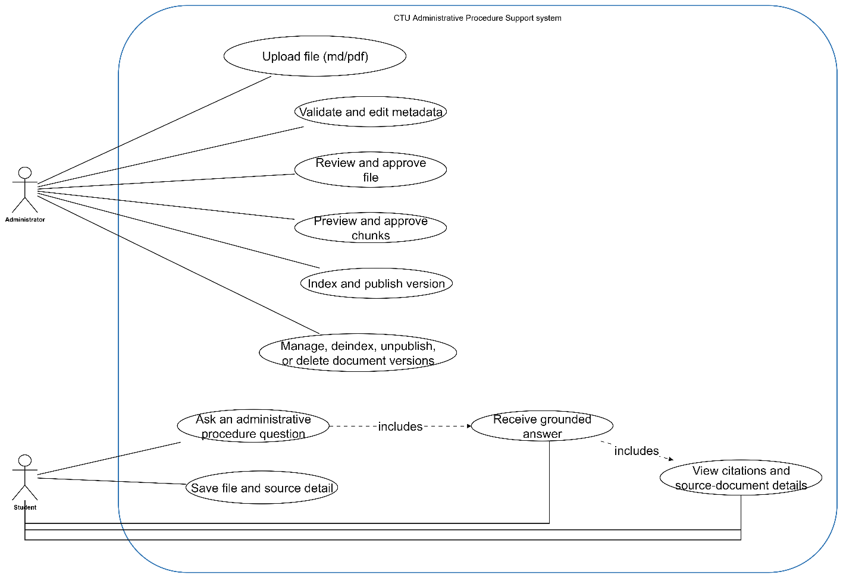
Figure 3.1. System use case diagram

3.1.2.2. Main workflow constraints
- Only Markdown or Markdown-compatible canonical files within the configured size limit can enter the canonical upload workflow.
- A version must be reviewed and approved before indexing can start.
- Only indexed versions can be published, and only approved plus published versions are eligible for student retrieval.
- A version with RAG data must be deindexed before content-changing operations that would make stored chunks or vectors inconsistent.
- Preview URLs are short-lived and are generated by the backend for files stored in R2.

3.1.3. Functional requirements
ID | Name | Requirement
FR-01 | Submit student question | The system shall accept a non-empty question of at most 2,000 characters and a top_k value from 1 to 20.
FR-02 | Resolve or clarify query | The system shall determine whether to search or return a direct clarification response.
FR-03 | Rewrite query | The system shall optionally generate meaning-preserving Vietnamese search variants without blocking retrieval on failure.
FR-04 | Apply eligibility policy | The system shall retrieve only versions whose review_status is approved and rag_status is published.
FR-05 | Perform hybrid retrieval | The system shall execute dense Qdrant search and sparse PostgreSQL search and combine candidates using RRF.
FR-06 | Expand retrieval context | The system shall hydrate database metadata and may add parent, sibling, child, or neighboring structural context.
FR-07 | Generate grounded answer | The system shall generate a Vietnamese answer using only the retrieved context.
FR-08 | Return citations | The system shall return traceable citation metadata with every evidence-backed answer.
FR-09 | Preview stored documents | The system shall generate a temporary URL for an available source file or canonical Markdown object.
FR-10 | Upload canonical content | The administrator shall upload canonical Markdown, metadata, responsible-department code, and an optional source file.
FR-11 | Review canonical content | The administrator or reviewer shall edit and approve canonical Markdown and metadata before indexing.
FR-12 | Preview chunks | The administrator shall inspect parent-child chunk output before approving indexing.
FR-13 | Index document version | The system shall create chunks, embeddings, PostgreSQL records, Qdrant points, and ingestion-job progress.
FR-14 | Manage publication | The administrator shall publish and unpublish eligible versions.
FR-15 | Maintain versions | The administrator shall list, filter, view, update, deindex, or delete document versions under lifecycle constraints.
FR-16 | Manage reference data and assets | The system shall expose active departments and document types and associate document assets when configured.

Table 5. Functional requirements

3.1.4. Non-functional requirements
ID | Quality attribute | Requirement
NFR-01 | Grounding | The system must not present a procedural claim without retrieved source evidence.
NFR-02 | Traceability | Every citation must be traceable to a stored document version and chunk.
NFR-03 | Security | Secrets must be stored outside Git; input files, queries, metadata, dates, and enumeration values must be validated.
NFR-04 | Availability | Failure of query rewriting or optional reranking must not prevent the original RRF retrieval path.
NFR-05 | Performance | Question answering should use asynchronous I/O and bounded timeouts; expensive synchronous model calls should not block the FastAPI event loop.
NFR-06 | Maintainability | Public API paths must remain under /api/v1 and responsibilities must be separated by backend modules.
NFR-07 | Scalability | PostgreSQL, Qdrant, object storage, embedding, and LLM services must be independently replaceable or deployable.
NFR-08 | Usability | Student answers and error messages should be clear Vietnamese; administrative workflow progress and status badges should be visible.
NFR-09 | Data integrity | Document, version, chunk, asset, and job relationships must be protected by database constraints and controlled lifecycle operations.
NFR-10 | Recoverability | Production deployment should back up PostgreSQL, Qdrant snapshots, and document storage.
Table 6. Non-functional requirements

3.2. SOFTWARE DESIGN

3.2.1. Application architecture
The architecture follows a layered and service-oriented structure. Client applications communicate only with the FastAPI API. Ingestion, retrieval, LLM, database, and vector-store responsibilities are implemented in separate modules. PostgreSQL acts as the source of truth, while Qdrant is a derived dense index and R2 stores canonical and original files. External model services are accessed through configuration rather than hard-coded provider logic.

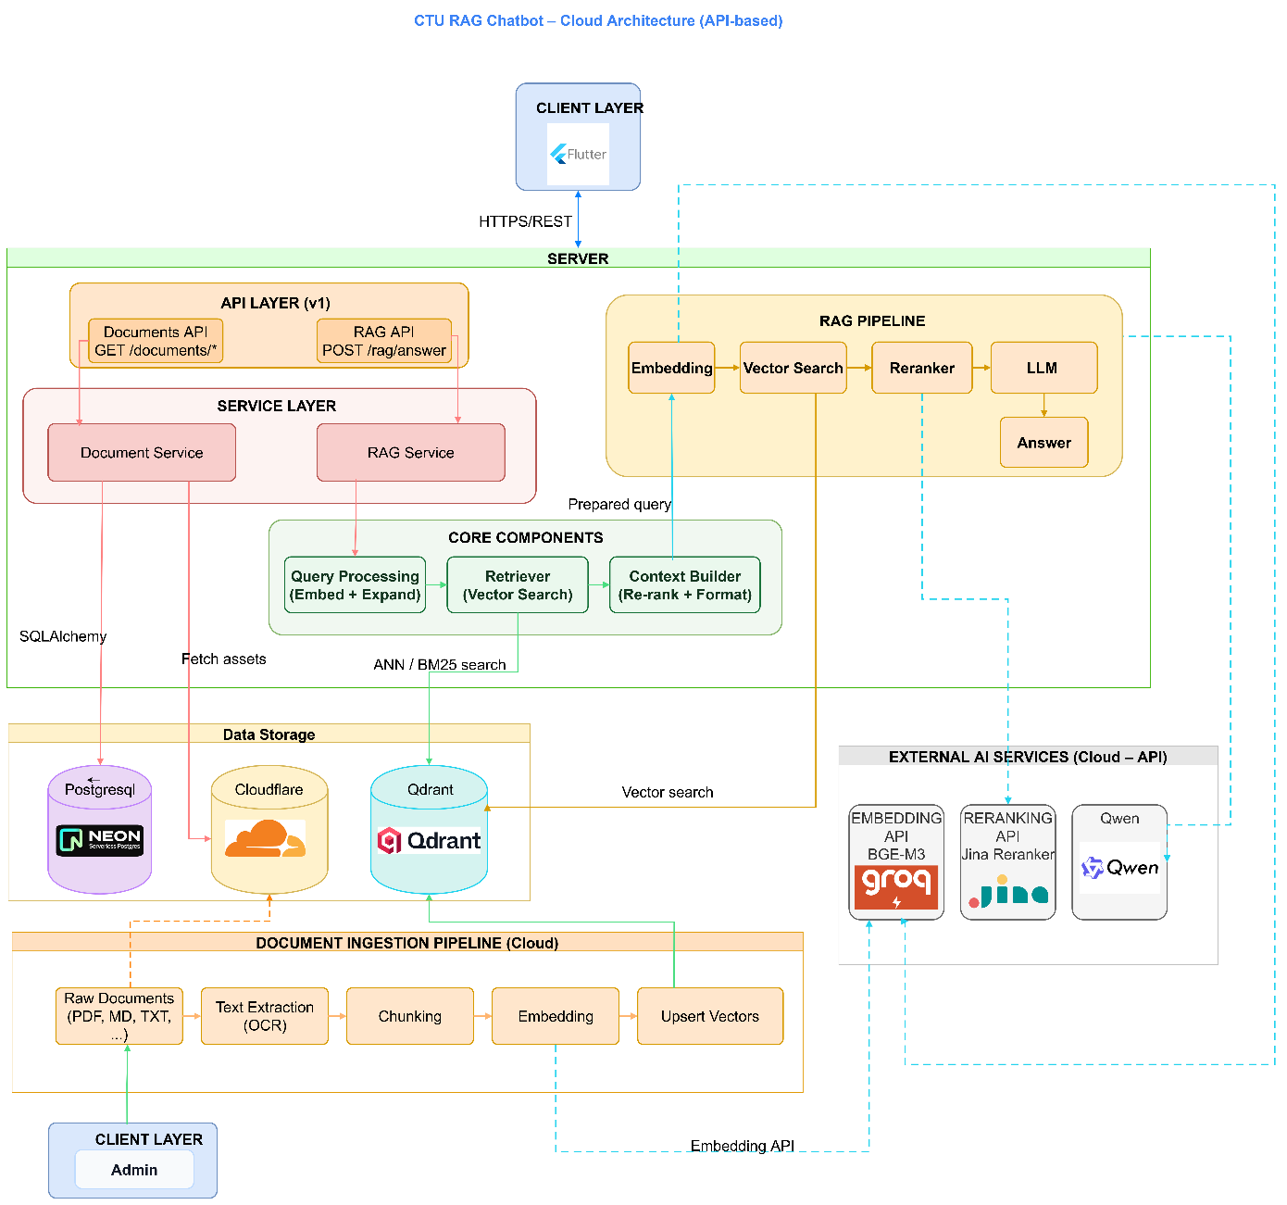
Figure 3.2. Overall application architecture
The student path starts in the Flutter client, calls POST /api/v1/rag/answer, executes retrieval and grounded generation, and returns an answer with citations. The administration path starts with canonical Markdown and uses the React workflow to validate, review, preview chunks, index, and publish. OCR and LlamaParse remain outside the backend boundary.

3.2.2. Data design
The current relational schema contains nine tables. Documents represent logical records, whereas document_versions preserve edition-specific metadata and lifecycle status. Parent and child chunks belong to a version. Ingestion jobs track asynchronous indexing progress. Departments, recipients, assets, and document-asset relationships preserve organizational and supplementary information.
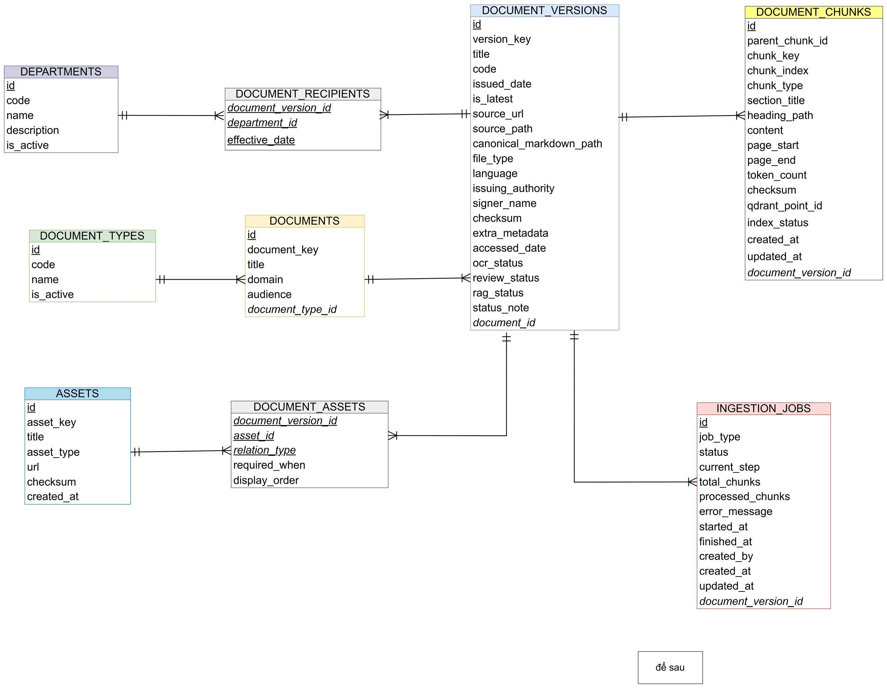
Figure 3.3. Entity-relationship diagram
Entity | Purpose
departments | Reference data for responsible or recipient organizational units.
document_types | Reference data for document classification.
documents | Logical document identity, title, domain, audience, and type.
document_versions | Version metadata, source paths, dates, latest flag, and OCR/review/RAG statuses.
document_chunks | Parent-child structural chunks, page ranges, content, checksums, and Qdrant identifiers.
ingestion_jobs | Indexing status, current step, progress counters, errors, and timestamps.
document_recipients | Many-to-many receipt history between versions and departments, including effective date.
assets | Reusable forms, links, or files associated with procedures.
document_assets | Version-to-asset relationship, relation type, requirement condition, and display order.
Table 7. Main database entities

3.2.2.1. Document lifecycle statuses
The current status is stored directly in document_versions. OCR status indicates whether content preparation is complete. Review status represents not reviewed, reviewing, need fix, approved, or rejected conditions. RAG status represents not indexed, chunked, embedded, indexed, published, deactivated, or failed conditions. The student retrieval policy uses only approved and published versions.

3.2.3. Detailed design

3.2.3.1. Administrative ingestion workflow
The React administration interface implements four principal workflow steps: upload, review, chunk review, and ingest. The backend validates file type, UTF-8 encoding, file size, submitted metadata, reference data, duplicate version keys, and metadata values. If the uploaded Markdown contains YAML frontmatter, the backend extracts its body and regenerates canonical frontmatter from the validated administration-form metadata. Canonical Markdown and an optional source file are stored through the S3-compatible storage layer. After approval, a chunk preview is created, and the administrator can start indexing as an in-process background task.
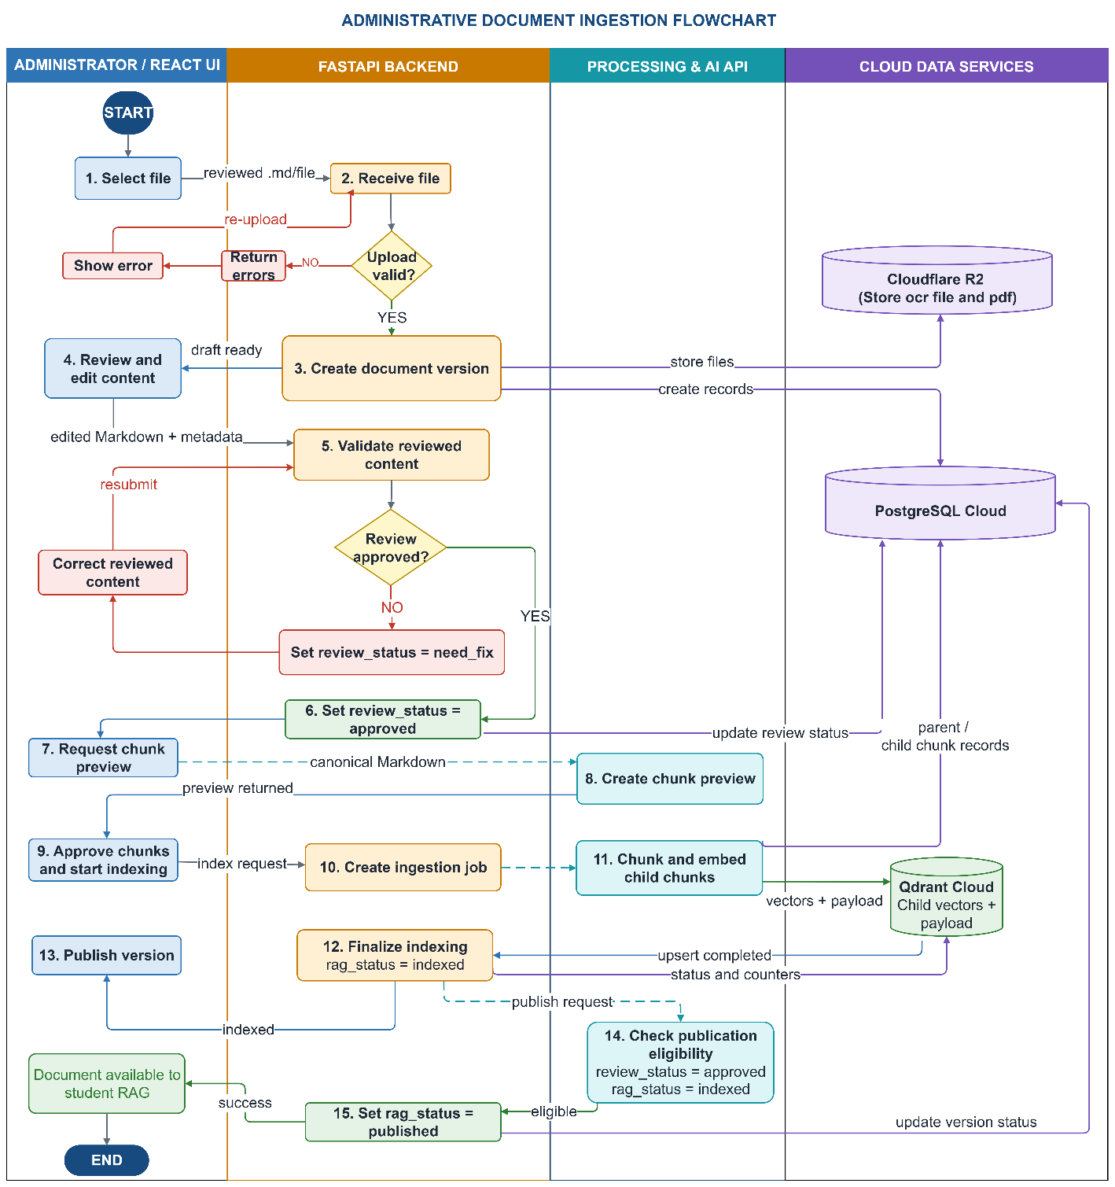
Figure 3.4. Administrative ingestion sequence
The indexing service creates parent-child chunks, embeds child chunks in batches, stores relational chunk records, upserts vectors into Qdrant, and updates ingestion_jobs.current_step and progress counters. The source notes that the current background task is in-process; a restart-safe queue should replace it when production resilience is required.

3.2.3.2. Retrieval and answer-generation workflow
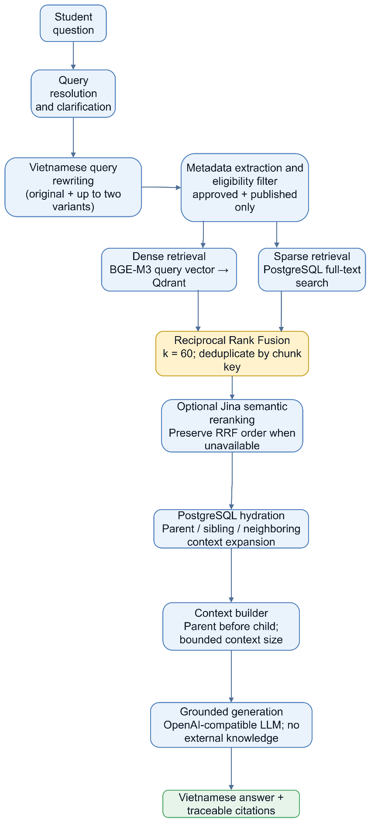
Figure 3.5. Retrieval and answer-generation pipeline
- Resolve the question and decide whether retrieval is required.
- Generate meaning-preserving Vietnamese query variants when rewriting is enabled.
- Extract metadata filters and enforce approved-and-published eligibility.
- Retrieve dense candidates from Qdrant and sparse candidates from PostgreSQL.
- Fuse ranked candidates with RRF and optionally apply the Jina reranker.
- Hydrate PostgreSQL metadata and expand structural context around selected child chunks.
- Build a bounded context with parent sections before child passages when possible.
- Generate the answer from the context and construct deduplicated citations in the backend.

3.2.3.3. RAG workflow overview
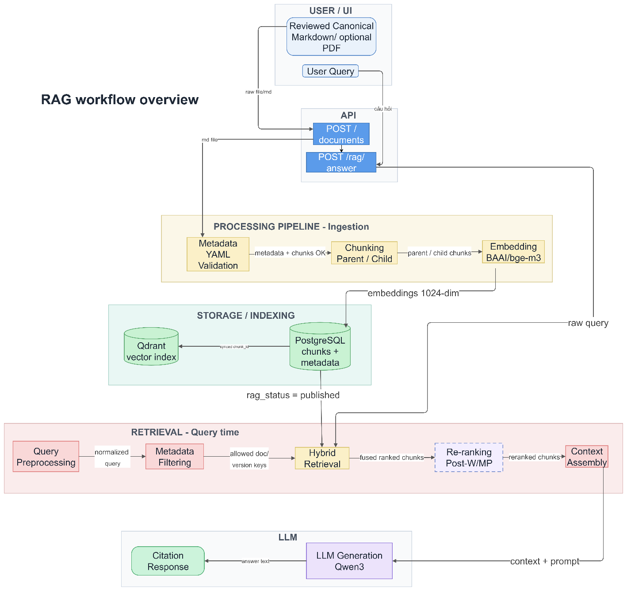
Figure 3.6. RAG workflow overview
The workflow maintains a clear distinction between the authoritative relational data and the derived vector index. PostgreSQL retains canonical metadata and chunk content required for hydration and citation. Qdrant stores child embeddings and retrieval payload. The final context is assembled from hydrated relational records rather than trusting vector payload alone.

3.2.3.4. API design
Method | Endpoint | Purpose
GET | /health | Return backend health status.
POST | /api/v1/rag/answer | Answer a student question and return citations.
POST | /api/v1/admin/canonical-markdown/metadata-preview | Extract supported YAML metadata from a Markdown upload.
POST | /api/v1/admin/canonical-markdown | Upload canonical Markdown, metadata, department code, and optional source file.
PUT | /api/v1/admin/canonical-markdown/{id}/review | Review and approve edited canonical content.
POST | /api/v1/admin/document-versions/{id}/chunk-preview | Generate structural chunk preview.
POST | /api/v1/admin/document-versions/{id}/index | Start indexing and return job progress.
GET | /api/v1/admin/ingestion-jobs/{id} | Read indexing-job progress.
GET | /api/v1/versions | List and filter document versions.
GET/PUT/DELETE | /api/v1/versions/{id} | Read, update, or delete an eligible version.
POST | /api/v1/versions/{id}/publish | Publish an indexed and approved version.
POST | /api/v1/versions/{id}/unpublish | Remove a version from student retrieval.
POST | /api/v1/versions/{id}/deindex | Remove relational chunks and Qdrant vectors so the version can be edited.
GET | /api/v1/versions/preview-url/{version_key} | Create a temporary preview URL. The required file_type query parameter accepts source or canonical_markdown.
Table 8. Main API endpoints

3.2.3.5. Frontend design
The Flutter student application contains home, chat, document-detail, saved-document, and navigation-shell features. Riverpod providers expose the RAG API client and chat controller. The client maps answer JSON to messages and source references, displays source cards, and requests preview URLs when a student opens a document. The application supports web, Android, and Windows project targets.
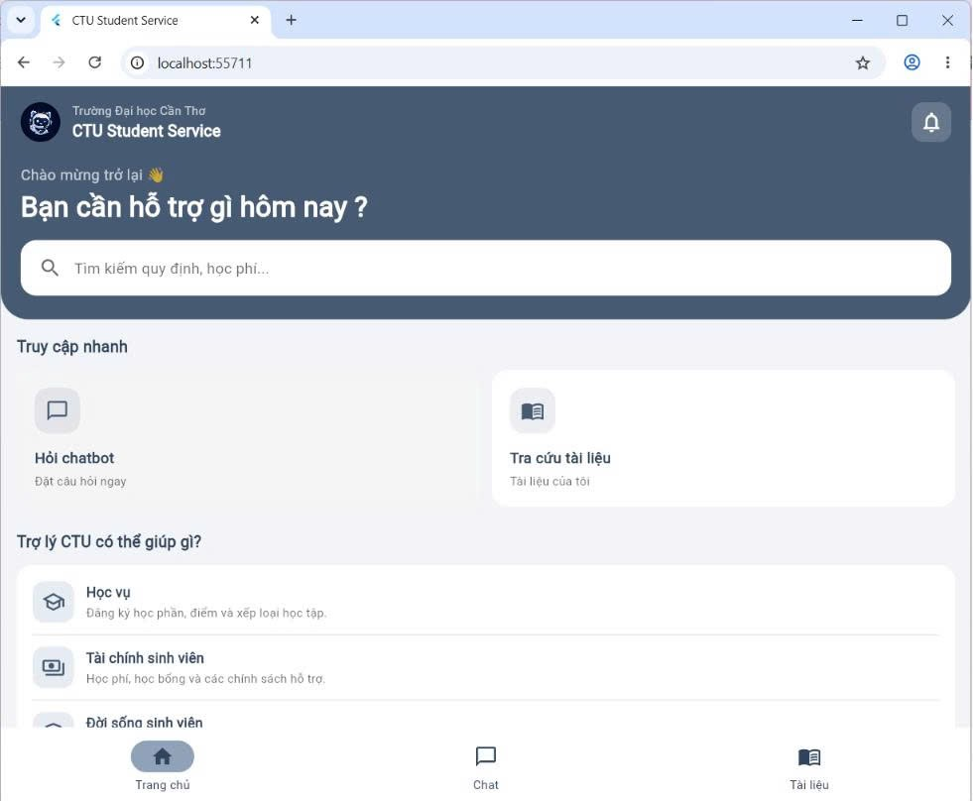
Figure 3.7. Student home interface

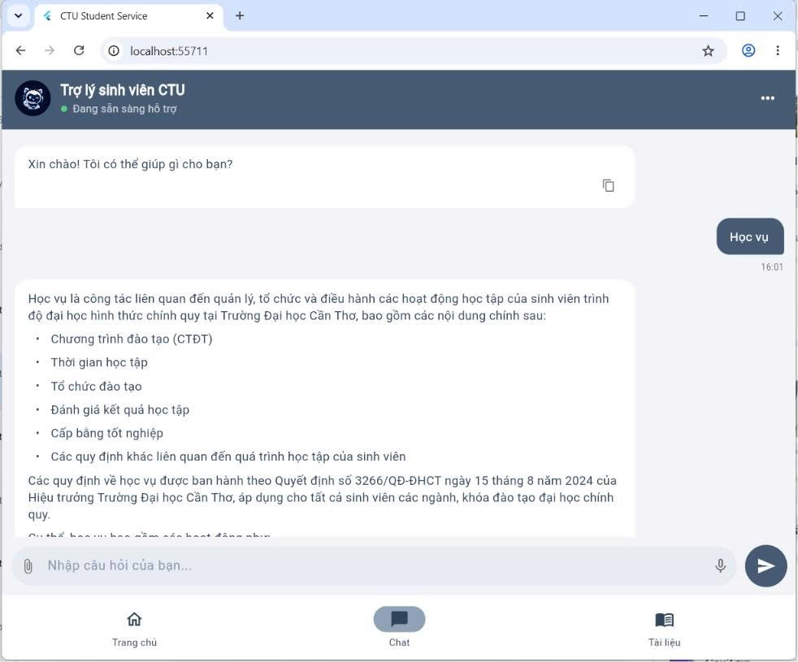Figure 3.8. Student chatbot interface 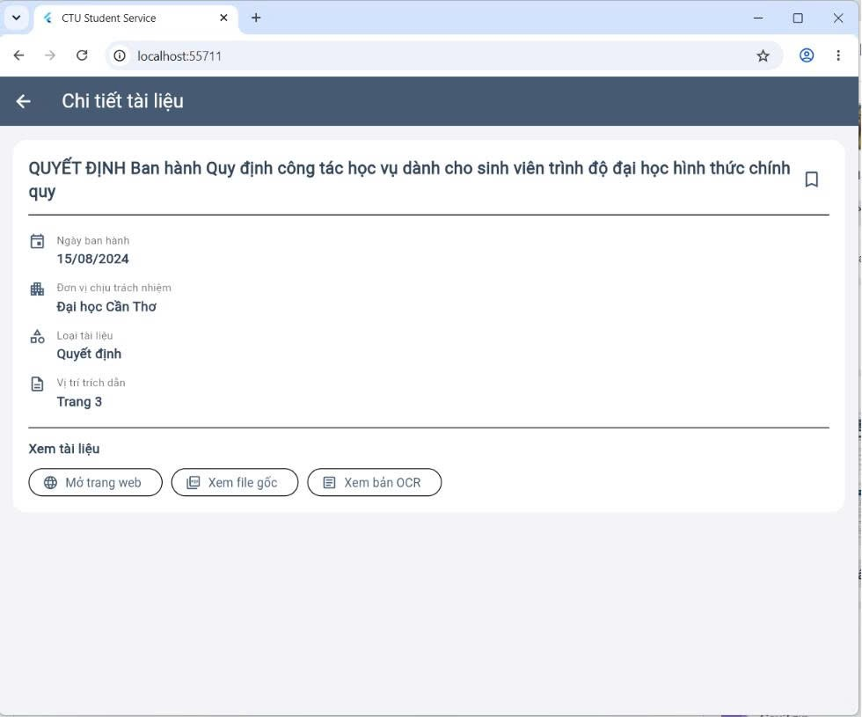Figure 3.9. Document detail interface
The React administration interface uses a sidebar and workflow progress component. UploadStep, ReviewStep, ChunkReviewStep, and IngestStep correspond to the controlled ingestion lifecycle. Separate list and edit pages support document maintenance. The interface prevents returning to earlier content-changing steps after a version has been indexed unless it is first deindexed.
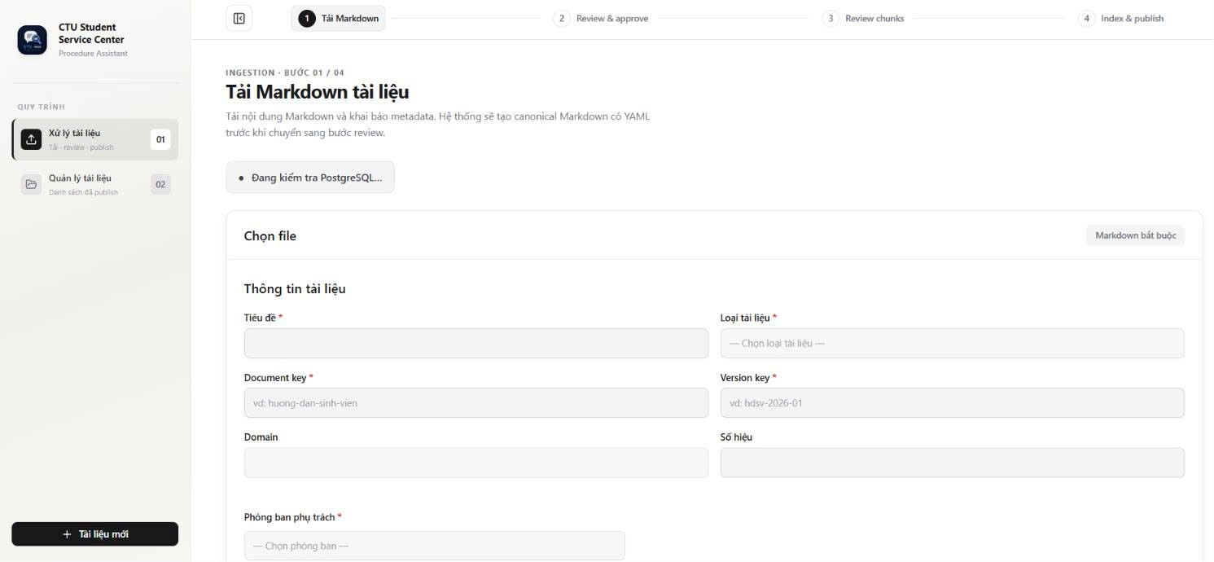
Figure 3.10. Administrative document upload interface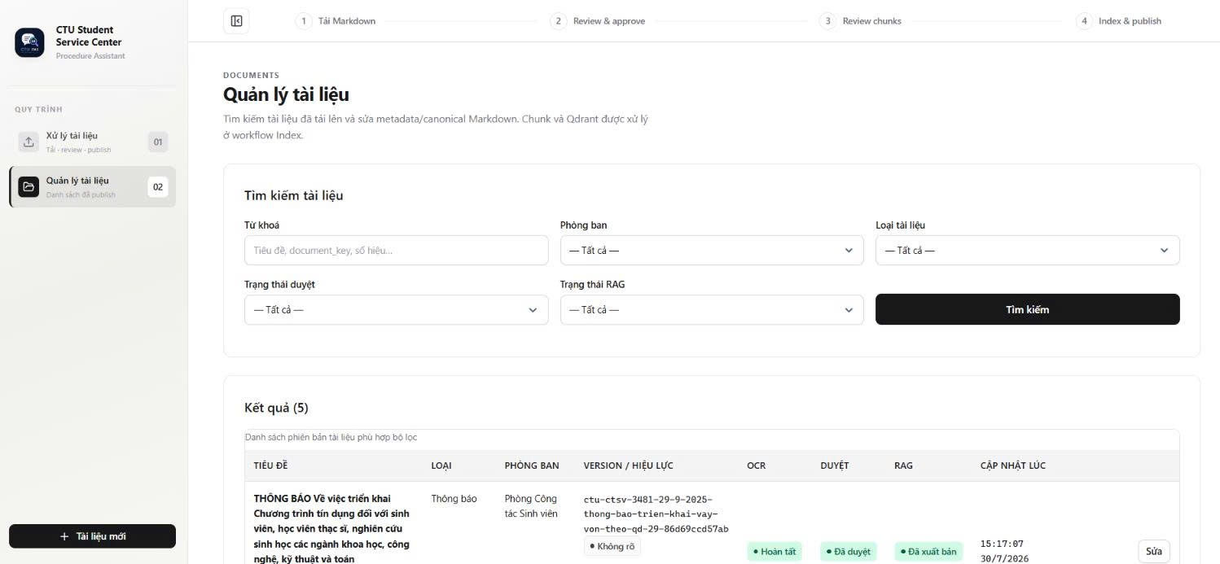
Figure 3.11. Document management interface

3.2.3.6. Deployment design
For local development, Docker Compose starts PostgreSQL and Qdrant. The FastAPI backend and React administration frontend run from their respective environments, while the Flutter client selects an API base URL appropriate to web, emulator, device, or Windows execution. In a hosted deployment, PostgreSQL, Qdrant, R2, the embedding endpoint, the FastAPI service, the administration frontend, and the Flutter web build may be deployed independently.

3.3. TESTING

3.3.1. Test plan
Testing should combine source-level unit tests, API integration tests, end-to-end workflow tests, client widget tests, and user acceptance tests. The main risk areas are document lifecycle constraints, cross-store consistency, retrieval eligibility, citation accuracy, error handling, and Vietnamese question-answer quality.
Test type | Coverage | Suggested tools
Unit testing | Chunk parsing, metadata validation, service rules, query resolution, fusion, context building, DTO parsing. | pytest, pytest-asyncio, Flutter test
Integration testing | FastAPI routes with PostgreSQL, Qdrant, R2-compatible storage, embedding, and mocked LLM/reranker. | HTTP client, isolated test database, Qdrant test collection
System testing | Upload → review → chunk preview → index → publish → student question → citation preview. | Docker Compose and controlled document fixtures
Regression testing | Document deletion/deindexing, query rewriting fallback, reranker fallback, Flutter API mapping. | Automated test suite and saved fixtures
User acceptance testing | Clarity, navigation, source visibility, administrative workflow usability, and correctness of representative procedures. | Student and administrator scenarios
Performance testing | Answer latency, indexing throughput, concurrent requests, and data-volume growth. | Load-test tool and runtime metrics
Table 9. Test strategy

3.3.1.1. Representative test cases
ID | Scenario | Precondition | Action | Expected result
TC-01 | Valid student question | Published relevant document exists. | POST /rag/answer with a valid Vietnamese question. | 200 response, should_search = true, answer is grounded, citations are non-empty.
TC-02 | Incomplete question | Backend running. | Submit an ambiguous or incomplete query. | Direct clarification or non-search response; no fabricated citation.
TC-03 | Eligibility enforcement | Relevant version is approved but not published. | Ask a question whose answer exists only in that version. | Version is excluded; answer does not cite it.
TC-04 | Upload validation | Admin UI open. | Upload a non-Markdown file as canonical content. | 422 validation response and user-readable message.
TC-05 | Duplicate version key | Version key already exists. | Upload another version with the same key. | Conflict/validation error; no duplicate database record.
TC-06 | Chunk preview | Approved canonical Markdown exists. | Request chunk preview. | Parents and children contain stable keys, page ranges, and heading paths.
TC-07 | Index and publish | Approved version and model services available. | Start indexing, poll job, then publish. | Chunks and vectors exist; status becomes published.
TC-08 | Deindex consistency | Indexed or published version exists. | Unpublish when needed, then deindex. | Qdrant points and document chunks are removed; status returns to not_indexed.
TC-09 | Reranker fallback | Jina unavailable. | Ask a searchable question. | System preserves RRF order and still produces a result.
TC-10 | Flutter response mapping | Mock answer JSON available. | Run RagApiClient parsing test. | Answer and citation fields map to typed Flutter models.

Table 10. Representative test cases

3.3.2. Test results and analysis
The selected automated tests and end-to-end workflow scenarios were executed on the implemented system. All evaluated scenarios completed successfully. The results confirm that the principal document-ingestion lifecycle, retrieval eligibility policy, answer-generation workflow, Flutter API integration, and administration frontend build operate according to the specified requirements.
The administrative workflow was verified from canonical Markdown upload through review, chunk preview, indexing, and publication. The student-facing workflow successfully returned grounded Vietnamese answers with traceable citations. Eligibility testing confirmed that document versions that had not been published were excluded from retrieval. Deindexing also removed the corresponding PostgreSQL chunk records and Qdrant vectors as expected.
Verification item | Test procedure | Actual result | Status
TC-01 – Valid student question | Submit a valid Vietnamese question to POST /api/v1/rag/answer. | The API returned HTTP 200, should_search = true, a grounded answer, and non-empty citations. | Pass
TC-03 – Eligibility enforcement | Ask a question whose evidence exists only in an approved but unpublished version. | The unpublished version was excluded and did not appear in the returned citations. | Pass
TC-04 – Upload validation | Upload a non-Markdown file as canonical content. | The backend rejected the upload and returned a validation error with a user-readable message. | Pass
TC-06 – Chunk preview | Request chunk preview for an approved canonical Markdown version. | Parent and child chunks were generated with stable chunk keys, heading paths, and page ranges. | Pass
TC-07 – Index and publish | Start indexing, monitor the ingestion job, and publish the indexed version. | PostgreSQL chunk records and Qdrant vectors were created; the ingestion job completed and the version became published. | Pass
TC-08 – Deindex consistency | Unpublish and deindex an indexed document version. | Related PostgreSQL chunks and Qdrant vectors were removed; the version returned to the non-indexed state. | Pass
Flutter automated tests | Execute the Flutter API-client and widget test suites. | All executed Flutter tests completed successfully. | Pass
Administration frontend build | Execute the production build command for the React administration interface. | The Vite production build completed without compilation errors. | Pass

Table 11. Test execution results

CHAPTER 4: CONCLUSION

4.1. ACHIEVED OUTCOMES
The project establishes an end-to-end foundation for a CTU administrative procedure chatbot. The installed source separates student interaction, administrative document governance, backend orchestration, relational metadata, dense vector search, object storage, and language-model generation. The student application can submit questions and display citations, while the administration interface supports the principal stages of canonical-document ingestion and document-version maintenance.
The backend implements structural parent-child chunking, BGE-M3 embedding integration, dense and sparse retrieval, RRF fusion, optional semantic reranking, structural context expansion, grounded generation, and backend-constructed citations. The eligibility policy prevents unapproved or unpublished versions from entering student answers. These outcomes address the project objective of improving access to administrative information without removing the need for authoritative source documents.

4.2. LIMITATIONS
OCR and parsing remain external to the backend. Authentication and full role-based authorization are not yet complete. The quality of an answer also depends on document coverage, metadata accuracy, chunk structure, and the availability of relevant approved sources.

4.3. FUTURE WORK
- Add authentication, authorization, audit logs, and production secret management.
- Move indexing to a restart-safe task queue with retry, cancellation, and idempotency controls.
- Create a curated Vietnamese evaluation set for retrieval recall, citation precision, answer faithfulness, and no-answer behavior.
- Add conversation memory with bounded history and summarization while preserving question-level source grounding.
- Improve metadata-aware retrieval, version conflict handling, reranker evaluation, and structured answer templates for procedures.
- Add monitoring, tracing, rate limiting, backups, Qdrant snapshots, and disaster-recovery procedures.
- Expand the governed document corpus and establish a recurring review process with responsible CTU units.

REFERENCES
[1] P. Lewis et al., “Retrieval-Augmented Generation for Knowledge-Intensive NLP Tasks,” in Advances in Neural Information Processing Systems 33, 2020, pp. 9459–9474.
[2] Y. Gao et al., “Retrieval-Augmented Generation for Large Language Models: A Survey,” arXiv:2312.10997, 2023.
[3] J. Chen, S. Xiao, P. Zhang, K. Luo, D. Lian, and Z. Liu, “BGE M3-Embedding: Multi-Lingual, Multi-Functionality, Multi-Granularity Text Embeddings Through Self-Knowledge Distillation,” arXiv:2402.03216, 2024.
[4] G. V. Cormack, C. L. A. Clarke, and S. Büttcher, “Reciprocal Rank Fusion Outperforms Condorcet and Individual Rank Learning Methods,” in Proc. 32nd Int. ACM SIGIR Conf. Research and Development in Information Retrieval, 2009, pp. 758–759, doi: 10.1145/1571941.1572114.
[5] FastAPI, “FastAPI Documentation,” 2026. [Online]. Available: https://fastapi.tiangolo.com/. [Accessed: Aug. 1, 2026].
[6] PostgreSQL Global Development Group, “PostgreSQL 17 Documentation,” 2026. [Online]. Available: https://www.postgresql.org/docs/17/. [Accessed: Aug. 1, 2026].
[7] Qdrant, “Qdrant Documentation,” 2026. [Online]. Available: https://qdrant.tech/documentation/. [Accessed: Aug. 1, 2026].
[8] Google, “Flutter Documentation,” 2026. [Online]. Available: https://docs.flutter.dev/. [Accessed: Aug. 1, 2026].
[9] Meta Platforms, Inc., “React Documentation,” 2026. [Online]. Available: https://react.dev/. [Accessed: Aug. 1, 2026].
[10] LangChain, “Text Splitters and Retrieval Documentation,” 2026. [Online]. Available: https://python.langchain.com/docs/. [Accessed: Aug. 1, 2026].
[11] Docker, Inc., “Docker Compose Documentation,” 2026. [Online]. Available: https://docs.docker.com/compose/. [Accessed: Aug. 1, 2026].
[12] Cloudflare, “Cloudflare R2 Documentation,” 2026. [Online]. Available: https://developers.cloudflare.com/r2/. [Accessed: Aug. 1, 2026].

APPENDICES

APPENDIX A. CONFIGURATION AND EXECUTION SUMMARY

A.1. Required environment groups
Configuration group | Representative variables
Database | DATABASE_URL, POSTGRES_DB, POSTGRES_USER, POSTGRES_PASSWORD
Qdrant | QDRANT_URL, QDRANT_COLLECTION, optional QDRANT_API_KEY
Embedding | CLOUDFLARE_ACCOUNT_ID, CLOUDFLARE_API_TOKEN, EMBEDDING_MODEL, EMBEDDING_BATCH_SIZE
Object storage | R2/S3 endpoint, access key, secret key, bucket, public or preview settings
LLM | LLM_BASE_URL, LLM_API_KEY, LLM_MODEL, timeout
Optional reranker | JINA_API_KEY, JINA_RERANK_MODEL, JINA_RERANK_URL, timeout
Query rewriting | QUERY_REWRITE_ENABLED, QUERY_REWRITE_MAX_QUERIES, rewrite timeout

APPENDIX B. STATUS AND ELIGIBILITY RULES
Student retrieval uses the following hard eligibility condition:
review_status = approved AND rag_status = published
The is_latest flag is used as a preference rather than an absolute filter. Confidential or internal documents must not be published to the student-facing RAG system.

