CAN THO UNIVERSITY
COLLEGE OF INFORMATION AND COMMUNICATION TECHNOLOGY


PROJECT REPORT
PROJECT: A RETRIEVAL-AUGMENTED GENERATION SYSTEM FOR SUPPORTING CTU STUDENTS WITH ADMINISTRATIVE PROCEDURES
COURSE: | PROJECT – BASIC TOPICS
COURSE CODE: | CT239H
COURSE CLASS: | CT239HM01
MAJOR: | SOFTWARE ENGINEERING (HIGH-QUALITY PROGRAM)
COHORT: | 49

SUPERVISOR  Ph.D. Phan Phuong Lan | GROUP MEMBERS  1. Le Thi Ngoc Anh – B2303861  2. Nguyen Nhu Quynh – B2303777
SEMESTER III, ACADEMIC YEAR [2025–2026]
CAN THO, 2026

ABSTRACT
This project develops a retrieval-augmented generation (RAG) system to support Can Tho University students in finding reliable information about administrative procedures. The system separates document governance from student question answering. Administrators manage reviewed canonical Markdown files and publish eligible document versions through a React-based administration interface. The FastAPI backend uses PostgreSQL for authoritative document and ingestion metadata and Qdrant for dense vectors generated with BGE-M3. For question answering, Vietnamese queries are resolved and rewritten before hybrid dense and sparse retrieval. Retrieved results are combined using Reciprocal Rank Fusion, optionally reranked, expanded with parent context, and supplied as evidence to a Qwen language model accessed through an OpenAI-compatible API. A Flutter application presents generated answers, citations, and source-document details to students. The implemented system provides an end-to-end workflow from document ingestion and controlled publication to evidence-grounded question answering while restricting retrieval to eligible document versions. The backend has been deployed on Render and the web interfaces on Vercel, demonstrating practical cloud deployability. This architecture improves response traceability and reliability by linking answers to approved sources and reducing dependence on unverified model knowledge, while providing a maintainable foundation for future expansion and evaluation.
Keywords—retrieval-augmented generation, administrative procedures, CTU students, hybrid retrieval, FastAPI, Flutter, PostgreSQL, Qdrant.

TABLE OF CONTENTS
ABSTRACT i
TABLE OF CONTENTS ii
LIST OF TABLES v
LIST OF FIGURES vi
LIST OF ABBREVIATIONS vii
LIST OF MEMBER viii
CHAPTER 1: INTRODUCTION 1
1.1. PROBLEM STATEMENT 1
1.2. OBJECTIVES 1
1.2.1. General objective 1
1.2.2. Specific objectives 1
1.3. RESEARCH METHODOLOGY 2
1.4. PLAN 2
1.4.1. Project task assignment and schedule 3
1.4.2. Gantt chart 3
CHAPTER 2: THEORETICAL FOUNDATION AND TECHNOLOGIES 5
2.1. DOCUMENT PROCESSING 5
2.2. RETRIEVAL-AUGMENTED GENERATION 5
2.2.1. Canonical Markdown. 6
2.2.2. Structural Parent-child chunking. 6
2.3. EMBEDDINGS 7
2.4. SPARSE AND HYBRID RETRIEVAL WITH RECIPROCAL RANK FUSION 7
2.5. RERANKING 8
2.6. LARGE LANGUAGE MODELS, GROUNDING, AND CITATIONS 8
2.7. OBJECT STORAGE AND DOCUMENT TRACEABILITY 9
CHAPTER 3: APPLICATION RESULTS 10
3.1. SOFTWARE REQUIREMENT SPECIFICATION 10
3.1.1. Overall description 10
3.1.2. Functional requirements 10
3.1.3. Non-functional requirements 19
3.1.4. Software and Deployment Environment 20
3.2. SOFTWARE DESIGN 20
3.2.1. Application architecture 20
3.2.2. Data design 22
3.2.2.1. Input data and canonical document structure 22
3.2.2.2. Entity-relationship design 22
3.2.2.3. Document lifecycle statuses 24
3.2.3. Detailed design 24
3.2.3.1. OCR workflow 24
3.2.3.2. Administrative ingestion workflow 26
3.2.3.3. Chunking workflow 28
3.2.3.4. Retrieval and answer-generation workflow 30
3.2.3.5. RAG workflow overview 32
3.2.3.6. API design 33
3.2.3.7. Front-end design 34
3.2.3.8. Deployment design 37
3.3. TESTING 38
3.3.1. Test plan 38
3.3.1.1. Representative test cases 39
3.3.2. Test results and analysis 41
3.3.2.1. RAG quality evaluation results and analysis 41
CHAPTER 4: CONCLUSION 44
4.1. ACHIEVED OUTCOMES 44
4.2. LIMITATIONS 44
4.3. FUTURE WORK 45
REFERENCES 46
APPENDICES 47
APPENDIX A. CONFIGURATION AND EXECUTION SUMMARY 47
A.1. Required environment groups 47
APPENDIX B. STATUS AND ELIGIBILITY RULES 47

LIST OF TABLES
Table 1.1. Project task assignment and schedule 4
Table 3.1. Input data and canonical representations 22
Table 3.2. Main database entities 24
Table 3.3. Main API endpoints 34
Table 3.4. Test strategy 38
Table 3.5. Representative test cases 40

LIST OF FIGURES
Figure 1.1. Project Gantt chart 5
Figure 2.1. RAG overview 6
Figure 3.1. System use case diagram 11
Figure 3.2. Overall application architecture 21
Figure 3.3. Entity-relationship diagram 23
Figure 3.4. OCR processing pipeline 25
Figure 3.5. Administrative ingestion sequence 27
Figure 3.6. Chunking workflow 28
Figure 3.7. Retrieval and answer-generation pipeline 29
Figure 3.8. RAG workflow overview 31
Figure 3.9. Student home interface 33
Figure 3.10. Student chatbot interface 34
Figure 3.11. Document detail interface 35
Figure 3.12. Administrative document upload interface 36
Figure 3.13. Document management interface 36
Figure 3.14. Retrieval and end-to-end evaluation results 43

LIST OF ABBREVIATIONS
Abbreviation | Full form
API | Application Programming Interface
CTU | Can Tho University
DTO | Data Transfer Object
ERD | Entity-Relationship Diagram
FTS | Full-Text Search
LLM | Large Language Model
OCR | Optical Character Recognition
R2 | Cloudflare R2 Object Storage
RAG | Retrieval-Augmented Generation
REST | Representational State Transfer
RRF | Reciprocal Rank Fusion
SRS | Software Requirements Specification
UAT | User Acceptance Testing
UI | User Interface
YAML | YAML Ain’t Markup Language

LIST OF MEMBER
No. | Member | Student ID | Assigned tasks
1 | Le Thi Ngoc Anh | B2303861 | Backend integration, Admin ingestion, RAG pipeline, report consolidation.
2 | Nguyen Nhu Quynh | B2303777 | Flutter student application and API integration, RAG pipeline, report consolidation

INTRODUCTION

PROBLEM STATEMENT
Can Tho University students must consult numerous regulations, decisions, announcements, forms, and procedural guides when completing academic and administrative tasks. These documents are published by different administrative units, often use formal terminology, and may exist in multiple versions. Students who do not know the exact document title, relevant regulation, or responsible unit may therefore spend considerable time searching for, comparing, and interpreting the available information.
A conventional keyword-search interface primarily returns documents rather than concise answers and does not necessarily indicate which specific passages support a procedural claim. In contrast, a general-purpose language model can generate fluent responses but may rely on external knowledge, outdated information, or unsupported details. These limitations are particularly significant in the context of administrative procedures, where incorrect information about deadlines, required documents, fees, eligibility conditions, or responsible units may directly affect students.
These limitations create a need for a controlled question-answering system that retrieves information from reviewed and approved university documents and provides traceable citations to the supporting sources. The system must also support administrators who prepare, review document versions so that student-facing answers remain aligned with approved sources.

OBJECTIVES

General objective
The general objective is to design and implement a retrieval-augmented generation system that helps CTU students obtain clear, Vietnamese-language answers about administrative procedures while preserving source traceability and document-governance controls.

Specific objectives
- Develop a Flutter application that allows students to submit questions and view answers with citations.
- Develop a React-based administration interface for document upload, review, and publication.
- Establish traceable storage using PostgreSQL, R2-compatible object storage, and Qdrant Cloud.
- Implement a RAG pipeline with parent-child chunking, hybrid retrieval, and evidence-grounded answer generation.
- Evaluate the implemented retrieval and question-answering pipeline through repeatable testing and benchmark procedures.

RESEARCH METHODOLOGY
This project applies three main research methods: document research, system analysis, and experimentation.
- Document research: Study related technologies such as Retrieval-Augmented Generation, large language models, embeddings, vector databases, and information retrieval. Official student regulations and administrative documents are also reviewed as the system’s data source.
- System analysis: Analyze students’ needs in searching for procedures, regulations, forms, and support information. Administrator needs are also considered, especially document upload, review, version management, and publication.
- Experimentation: The implemented RAG pipeline is evaluated through retrieval and end-to-end experiments using representative administrative-procedure questions. Retrieval configurations are compared using Precision@5, Recall@5, and MRR, while the generated answers are evaluated in terms of correctness, faithfulness, citation quality, and response latency.

PLAN
The project was organized as a twelve-week implementation plan from 11 May to 2 August 2026. Tasks were assigned according to the main backend, administration, retrieval, and Flutter responsibilities of the two team members.

Project task assignment and schedule
Week | Date | Task name | Responsible
Week 1 | 11/5 - 17/5 | Requirement analysis and data contract | Le Thi Ngoc Anh
Week 2 | 18/5 - 24/5 | - Architecture, database, and infrastructure setup  - OCR base on Paddle, VietOCR | Le Thi Ngoc Anh; Nguyen Nhu Quynh
Week 3 | 25/5 - 31/5 | - OCR and canonical Markdown preparation  - Design chunking pipeline | Nguyen Nhu Quynh;  Le Thi Ngoc Anh;
Week 4 | 01/6 - 07/6 | - Enhance chunking pipeline  - OCR base on Llama Index | Le Thi Ngoc Anh;  Nguyen Nhu Quynh
Week 5 | 08/6 - 14/6 | - OCR and canonical Markdown preparation  - Validate yaml for markdown file | Le Thi Ngoc Anh; Nguyen Nhu Quynh
Week 6 | 15/6 - 21/6 | - Embedding, indexing, and store to database  - Research retrieval strategies and build a quick prototype | Le Thi Ngoc Anh; Nguyen Nhu Quynh
Week 7 | 22/6 - 28/6 | - Administration frontend  - Implement and test the end-to-end RAG pipeline via CLI | Le Thi Ngoc Anh; Nguyen Nhu Quynh
Week 8 | 29/6 - 05/7 | - Edit chunking pipeline  - Flutter app design  - Refine and complete the RAG Retrieval | Le Thi Ngoc Anh; Nguyen Nhu Quynh
Week 9 | 06/7 - 12/7 | - RAG generation and citations | Le Thi Ngoc Anh; Nguyen Nhu Quynh
Week 10 | 13/7 - 19/7 | - Integration Admin interface and backend API  - Impliment RAG service | Le Thi Ngoc Anh; Nguyen Nhu Quynh
Week 11 | 20/7 - 26/7 | - Continue refining the application  - Integration flutter app and backend API  - Draw diagram | Le Thi Ngoc Anh; Nguyen Nhu Quynh
Week 12 | 27/7 - 02/8 | - Test the application  - Write report | Le Thi Ngoc Anh; Nguyen Nhu Quynh
Week 13 | 03/08 - 09/08 | - Fix issues identified during application testing  - System experimentation and evaluation | Le Thi Ngoc Anh; Nguyen Nhu Quynh
Week 14 | 10/08 – 14 - 08 | Edit final report | Le Thi Ngoc Anh; Nguyen Nhu Quynh
 | 15/08 – 17/08 | Rewrite and submit  report | Le Thi Ngoc Anh; Nguyen Nhu Quynh
Table 1.1. Project task assignment and schedule
The schedule assigns backend ingestion, chunking, indexing, and administration work mainly to Le Thi Ngoc Anh; Flutter integration and the later retrieval/generation work are assigned mainly to Nguyen Nhu Quynh. Architecture, evaluation, and report consolidation are shared activities.

Gantt chart
Figure 1.1 visualizes the same plan by project week and shows the member responsible for each work package.
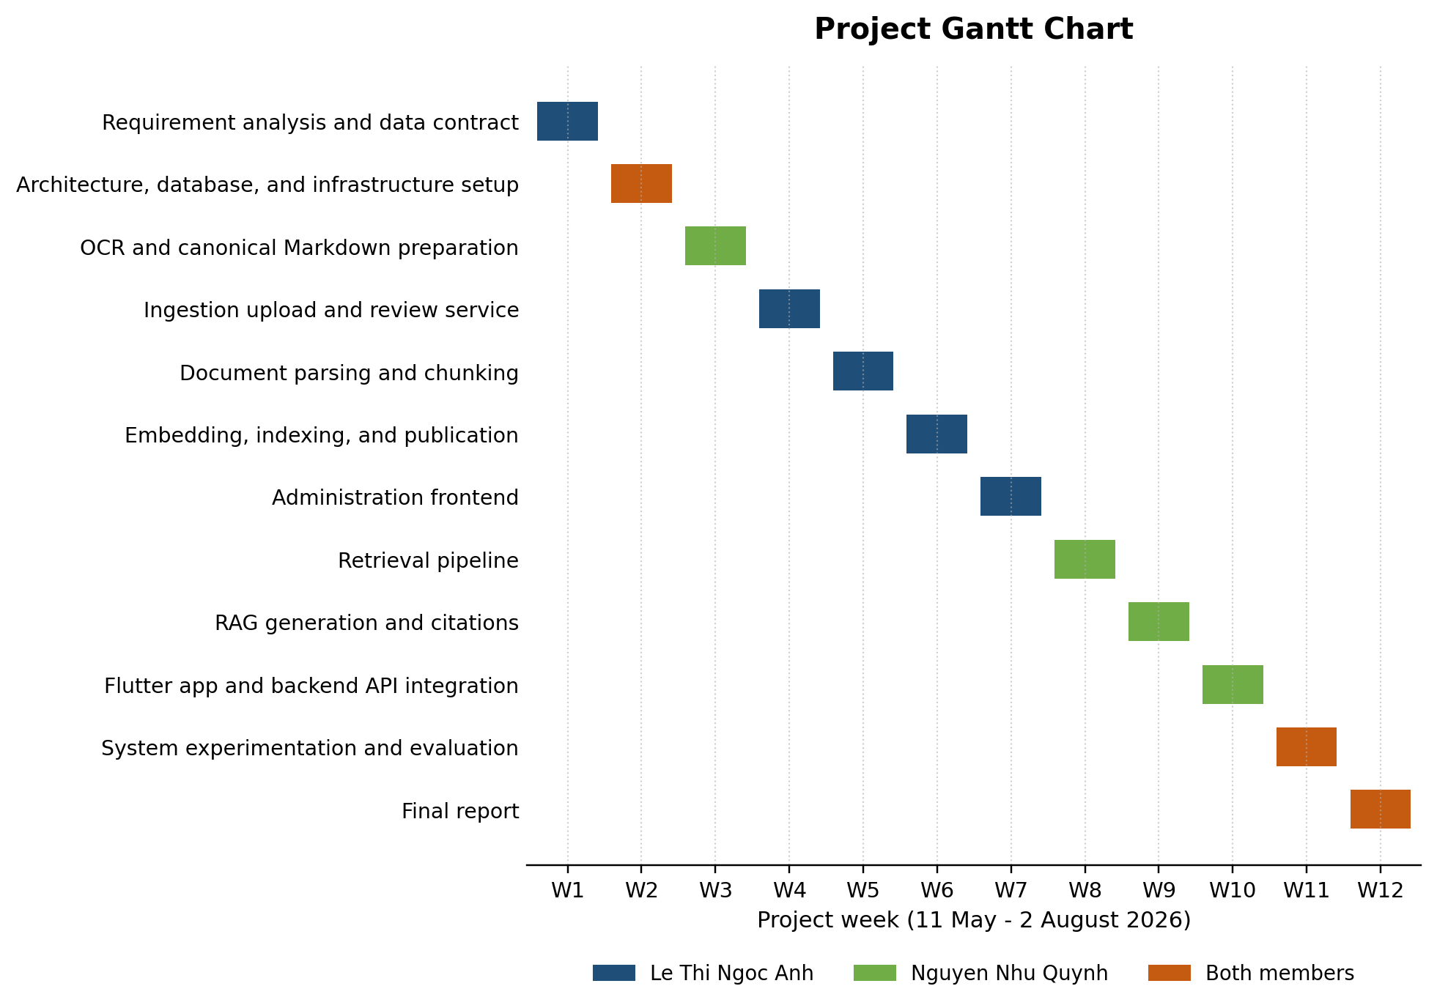
Figure 1.1. Project Gantt chart

THEORETICAL FOUNDATION AND TECHNOLOGIES

DOCUMENT PROCESSING
Optical Character Recognition (OCR) is the process of converting text from images or scanned documents into a machine-readable text format. This allows the extracted content to be searched, edited, copied, and processed by other applications instead of being stored only as an image.
OCR and document parsing are performed through the LlamaParse API. LlamaParse is a document parsing service developed by LlamaIndex that provides layout-aware OCR and can process complex documents such as PDFs, scanned files, tables, and charts into structured outputs such as text, Markdown, or JSON, helping Large Language Models (LLMs) better understand and use the data in RAG systems.

RETRIEVAL-AUGMENTED GENERATION
Retrieval-Augmented Generation (RAG) combines information retrieval with a generative language model. Instead of relying only on knowledge stored in model parameters, a RAG system retrieves relevant passages from an external corpus and supplies them as evidence for answer generation [1], [2]. This approach is suitable for administrative procedures because the underlying documents can be updated independently of the language model.
Large Language Models (LLMs) are trained on large amounts of data to perform tasks such as question answering, translation, and text generation. RAG enhances LLMs by retrieving relevant external information, helping generate more accurate, relevant, and up-to-date responses without retraining the model.
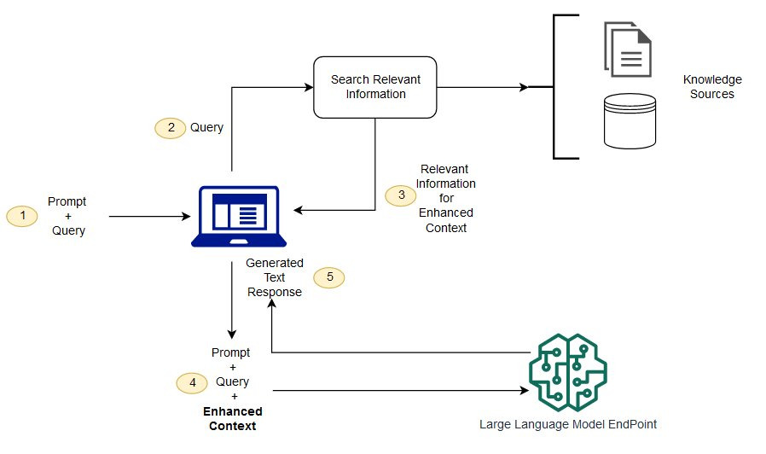
Figure 2.1. RAG overview

Canonical Markdown.
A canonical document is the reviewed textual representation used as the authoritative input for chunking and indexing. Markdown is suitable because it is human-readable and preserves headings, lists, tables, and page markers while remaining easy to process programmatically. In this project, the original file is retained for provenance, whereas reviewed canonical Markdown is used as the governed retrieval text.

Structural Parent-child chunking.
Chunking divides a long document into smaller retrieval units so that relevant information can be located and processed more efficiently. A parent-child chunking strategy organizes the document into larger parent chunks that preserve broader contextual information and smaller child chunks that provide more specific retrieval targets. During retrieval, child chunks can be used to identify relevant content, while their associated parent context can later be restored to provide sufficient information for answer generation.

For long text segments that still exceed a desired chunk size, recursive text splitting can be applied. LangChain provides the RecursiveCharacterTextSplitter, which attempts to divide text using progressively smaller separators, such as paragraph breaks, line breaks, sentence boundaries, spaces, and finally individual characters. This approach helps preserve natural textual boundaries where possible. Overlap between consecutive chunks may also be used to reduce information loss at chunk boundaries. Combining structural chunking with recursive splitting therefore provides a balance between retrieval specificity and contextual completeness.

EMBEDDINGS
An embedding represents text as a dense numerical vector in a continuous vector space. Texts with similar meanings are expected to have nearby vector representations. The project uses BGE-M3 because it supports multilingual retrieval and is appropriate for Vietnamese questions and administrative documents [3].
Semantic similarity is commonly measured using cosine similarity between a query vector q and a document vector d:
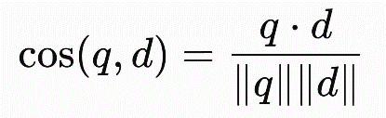
A vector database stores embeddings together with identifiers and metadata so that the system can efficiently search for the nearest vectors. In this project, BGE-M3 embeddings are generated through Cloudflare Workers AI and child-chunk vectors are stored in Qdrant Cloud, which acts as the dense retrieval index [7].

SPARSE AND HYBRID RETRIEVAL WITH RECIPROCAL RANK FUSION
Sparse retrieval. Sparse retrieval matches lexical features such as words, phrases, document codes, and administrative terms. It is useful when the query contains exact terminology. The implemented system uses PostgreSQL full-text search for this retrieval branch.
Dense retrieval. Dense retrieval compares the embedding of a user query with stored chunk embeddings. Because it operates in semantic vector space, it can retrieve relevant passages even when the query and document use different wording.
Hybrid retrieval. Hybrid retrieval combines sparse lexical matching with dense semantic retrieval so that exact terms and meaning-based matches can complement each other. Because the score scales of the two retrievers are different, the rankings are combined using Reciprocal Rank Fusion (RRF) rather than directly adding raw scores [4].
For a document or chunk d, the RRF score is:
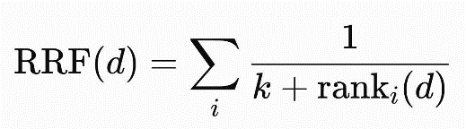
where rankᵢ(d) is the position of d in ranked list i and k is a rank constant. The implemented retrieval pipeline uses k = 60 and deduplicates candidates by chunk key before later processing.

RERANKING
RRF performs rank fusion, while reranking is a later stage that reassesses already retrieved candidates using a stronger relevance model. After dense and sparse results are fused by RRF, a reranker can evaluate the query together with each candidate and reorder the list according to semantic relevance.
The project optionally uses the Jina Reranker API after RRF fusion. If the reranking service is unavailable, the existing RRF order is preserved so that the core retrieval workflow can continue. This design makes reranking an optional quality-improvement stage rather than a dependency required for retrieval.

LARGE LANGUAGE MODELS, GROUNDING, AND CITATIONS
A Large Language Model (LLM) generates natural-language output from a prompt and contextual input. Although LLMs can produce fluent answers, they may also generate unsupported or outdated information. Grounding reduces this risk by instructing the model to answer from retrieved evidence rather than unrestricted external knowledge.
In this project, Qwen3 is accessed through an OpenAI-compatible endpoint provided by OpenRouter. The generated prompt contains the retrieved administrative evidence and requires a Vietnamese answer based only on that context. When sufficient evidence is unavailable, the system returns a predefined no-context response instead of inventing procedural information.
Citations provide traceability between an answer and its supporting sources. Rather than asking the language model to invent citation metadata, the backend constructs citations from retrieved document and chunk records. A citation can therefore be linked to the corresponding document version, chunk, page range, and stored source.

OBJECT STORAGE AND DOCUMENT TRACEABILITY
Object storage is designed for durable storage of files and binary objects that are accessed through object keys rather than relational rows. Cloudflare R2 provides S3-compatible object storage and is used in this project to preserve original source files and reviewed canonical Markdown documents [12].
Traceability is maintained by linking stored object paths with PostgreSQL document-version and chunk records. The relational database remains authoritative for lifecycle metadata, while R2 preserves the corresponding files for preview and provenance. This separation allows a student citation to be traced from the retrieved chunk to its document version and, when available, to the original or canonical stored file.

APPLICATION RESULTS

SOFTWARE REQUIREMENT SPECIFICATION

Overall description
The product is a multi-client RAG system consisting of a Flutter student application, a React administration interface, and a FastAPI backend. The backend integrates PostgreSQL hosted on Neon for authoritative metadata, Qdrant Cloud for vector retrieval, Cloudflare R2 for object storage, Cloudflare Workers AI with BGE-M3 for embedding generation, and an OpenAI-compatible Qwen3 endpoint through OpenRouter for language-model operations. It is responsible for request validation, document lifecycle management, retrieval eligibility, RAG orchestration, and citation construction.

Functional requirements
Figure 3.1 summarizes the interactions supported by the current source. Student use cases focus on question answering and source inspection. Administrative use cases cover the governed document lifecycle from upload to publication and maintenance.
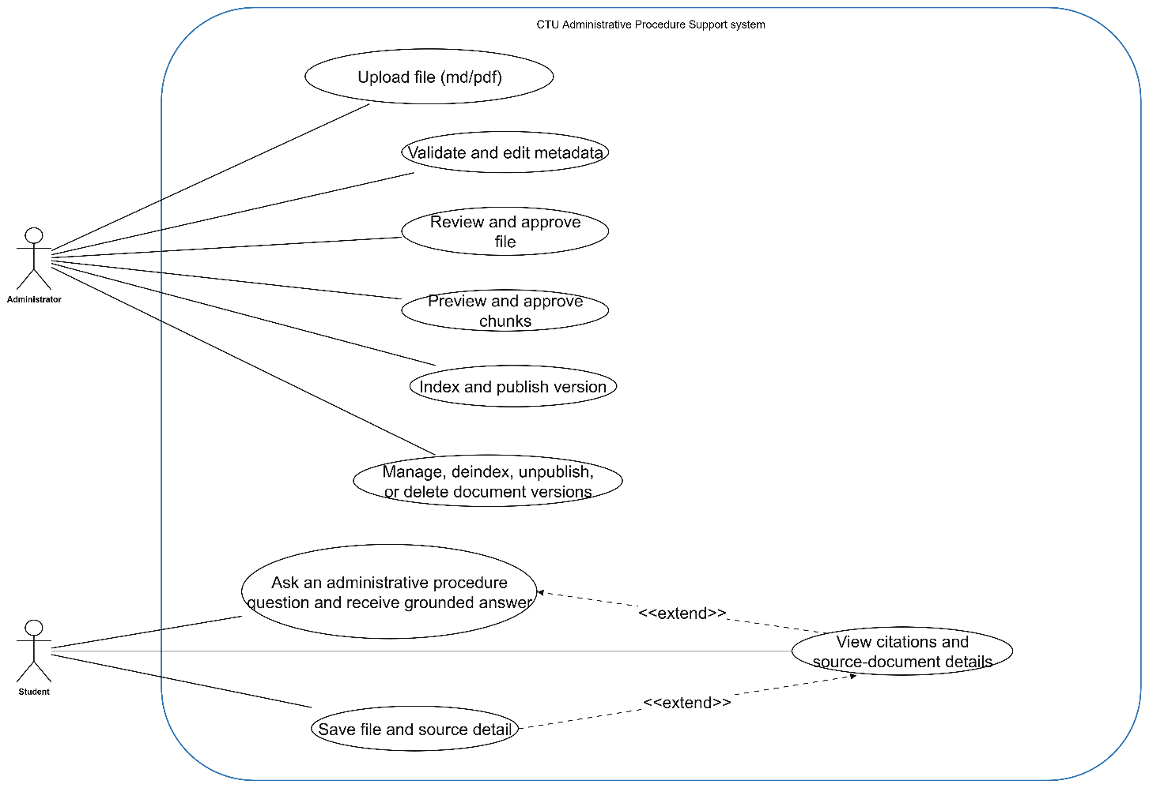
Figure 3.1. System use case diagram

Use case upload content
(….)
Use Case: Ask an administrative procedure question and receive a grounded answer | ID: UC-01
Main actor: Student | Priority: Essential
Brief description: The student submits an administrative-procedure question and receives a Vietnamese answer grounded in eligible CTU documents.
Trigger: The student submits a non-empty question. | Type: Inside
Relationship:
- Association: Student - UC-01
- Extend: UC-02 extends UC-01
- Generalization: None
- Include: None
Normal flow:
1. The student enters a question in the Flutter chat interface.
2. The client sends the question, top_k, and optional recent_topic to POST /api/v1/rag/answer.
3. The backend resolves the query, optionally rewrites it, and retrieves evidence only from eligible document versions.
4. The backend builds grounded context, generates the Vietnamese answer, and constructs traceable citations.
5. The application displays the answer and keeps the returned recent_topic for a possible follow-up question.
Use Case: View citations and source-document details | ID: UC-02
Main actor: Student | Priority: Essential
Brief description: The student inspects citation metadata and opens the corresponding source or canonical document when available.
Trigger: The student selects a citation or source card from an answer. | Type: Inside
Relationship:
- Association: Student - UC-02
- Extend: UC-02 extends UC-01
- Generalization: None
- Include: None
Normal flow:
1. The student selects a citation or opens a document-detail view.
2. The application displays the title, document metadata, cited page or section information, and available source links.
3. If the source is stored in R2, the client requests a temporary preview URL from the backend.
4. The student opens the source URL or stored document to inspect the supporting information.
Table 3.1.2.1.1. Use case Upload content
Use Case: Save source document | ID: UC-03
Main actor: Student | Priority: Optional
Brief description: The student bookmarks or removes a cited document for quick access during the current application session.
Trigger: The student taps the bookmark control in the document-detail view. | Type: Inside
Relationship:
- Association: Student - UC-03
- Extend: UC-03 extends UC-02
- Generalization: None
- Include: None
Normal flow:
1. The student opens a cited document detail.
2. The student taps the bookmark control.
3. The application adds the document reference to the session-local saved document list, avoiding duplicates by document_key or version_key.
4. Tapping the bookmark again removes the saved document.

Use Case: Upload canonical content and optional source file | ID: UC-04
Main actor: Administrator | Priority: Essential
Brief description: The administrator creates a governed document version from reviewed canonical Markdown and an optional original source file.
Trigger: The administrator starts a new document-ingestion workflow. | Type: Inside
Relationship:
- Association: Administrator - UC-04
- Extend: None
- Generalization: None
- Include: None
Normal flow:
1. The administrator selects a canonical Markdown file and, if available, an original source file.
2. The administrator enters the required document metadata and submits the upload.
3. The backend validates file type, size, UTF-8 content, metadata, reference data, and version uniqueness.
4. The backend creates or links the document/version records, regenerates canonical frontmatter, stores files in R2, and stores authoritative metadata in PostgreSQL.

Use Case: Validate and edit metadata and canonical Markdown | ID: UC-05
Main actor: Administrator | Priority: Essential
Brief description: The administrator reviews and corrects metadata or canonical content before the document version is indexed.
Trigger: The administrator opens an uploaded, non-indexed document version for editing. | Type: Inside
Relationship:
- Association: Administrator - UC-05
- Extend: None
- Generalization: None
- Include: None
Normal flow:
1. The administration interface loads the current metadata and canonical Markdown.
2. The administrator edits supported metadata fields or reviewed content.
3. The backend validates the submitted values while protecting immutable provenance identifiers.
4. Valid changes are stored and the version remains ready for review and approval.

Use Case: Review and approve canonical content | ID: UC-06
Main actor: Administrator | Priority: Essential
Brief description: The administrator approves the reviewed canonical document so that it can proceed to chunk preview and indexing.
Trigger: The administrator submits the reviewed canonical content for approval. | Type: Inside
Relationship:
- Association: Administrator - UC-06
- Extend: None
- Generalization: None
- Include: None
Normal flow:
1. The administrator reviews the canonical Markdown and metadata.
2. The administrator submits the reviewed content.
3. The backend validates the content, synchronizes related metadata and assets, and replaces the stored canonical revision when valid.
4. The backend sets ocr_status to done and review_status to approved while keeping rag_status as not_indexed.

Use Case: Preview and approve chunks | ID: UC-07
Main actor: Administrator | Priority: Essential
Brief description: The administrator inspects the structural parent-child chunks that will be used for indexing.
Trigger: The administrator requests chunk preview for an approved document version. | Type: Inside
Relationship:
- Association: Administrator - UC-07
- Extend: None
- Generalization: None
- Include: None
Normal flow:
1. The administrator requests a chunk preview.
2. The backend parses the canonical Markdown and creates parent and child chunk previews with keys, headings, page ranges, metadata, warnings, and errors.
3. The administration interface displays the generated chunk structure.
4. The administrator inspects the preview and confirms the chunks before indexing.

Use Case: Index and publish document version | ID: UC-08
Main actor: Administrator | Priority: Essential
Brief description: The administrator indexes an approved document version and publishes it for student-facing retrieval.
Trigger: The administrator confirms the chunk preview and starts indexing. | Type: Inside
Relationship:
- Association: Administrator - UC-08
- Extend: None
- Generalization: None
- Include: None
Normal flow:
1. The administrator starts indexing for an approved document version.
2. The backend creates the ingestion job and parent-child chunk records.
3. A background task generates BGE-M3 embeddings for child chunks and upserts their vectors into Qdrant.
4. After indexing completes, the administrator publishes the version.
5. The backend updates the document version and Qdrant payload to published, making an approved student-audience version eligible for retrieval.

Use Case: Manage document versions | ID: UC-09
Main actor: Administrator | Priority: Essential
Brief description: The administrator maintains existing document versions through supported update, unpublish, deindex, asset, and delete operations.
Trigger: The administrator opens the document-management interface. | Type: Inside
Relationship:
- Association: Administrator - UC-09
- Extend: None
- Generalization: None
- Include: None
Normal flow:
1. The administrator lists, filters, and opens an existing document version.
2. The administrator selects an allowed lifecycle operation such as metadata update, asset update, unpublish, deindex, or delete.
3. The backend checks the current lifecycle status and validates whether the operation is permitted.
4. The selected operation is applied while keeping PostgreSQL, R2, and Qdrant consistent with the document state.

Non-functional requirements
- Performance: The system should provide acceptable response time for student questions and apply bounded timeouts to external AI services.
- Compatibility: The backend should communicate with independently deployed database, vector storage, object storage, embedding, reranking, and LLM services through their supported interfaces.
- Usability: Student-facing answers and error messages should be clear, while the administration interface should clearly display document status and workflow progress.
- Reliability: Answers should be grounded in retrieved evidence with traceable citations. The system should return a no-context response when sufficient evidence is unavailable and continue the core retrieval flow when optional components fail.
- Security: Sensitive credentials should remain outside the source repository, and uploaded files, metadata, and API inputs should be validated before processing.
- Maintainability and Portability: Backend responsibilities should be modular, and external services should remain configurable. The backend and web interface should support independent deployment, while the student application should be distributable as an Android APK.

Software and Deployment Environment
- Backend: Python 3.10 or later, FastAPI, asynchronous SQLAlchemy, and Uvicorn.
- Data services: PostgreSQL hosted on Neon, Qdrant Cloud for vector storage, and Cloudflare R2 for S3-compatible object storage.
- Administration interface: Node.js 18 or later, React 18, and Vite. The production web application is deployed on Vercel.
- Student application: Flutter SDK and Dart. The application can be built and distributed as an Android APK.
- AI services: Cloudflare Workers AI with BGE-M3 for embedding generation, Jina API for optional reranking, and Qwen3 through an OpenAI-compatible API provided by OpenRouter.
- Backend deployment: The FastAPI backend is deployed on Render.

SOFTWARE DESIGN

Application architecture
The architecture follows a layered and service-oriented structure. Client applications communicate with the FastAPI API, while ingestion, retrieval, LLM, database, embedding, object-storage, and vector-store responsibilities are separated into dedicated modules. PostgreSQL acts as the authoritative source for document/version metadata and chunk content; Qdrant is a derived dense index; Cloudflare R2 stores canonical and original files; and Cloudflare Workers AI provides BGE-M3 embeddings. The LLM and optional reranker are external services accessed through configuration rather than hard-coded provider logic.

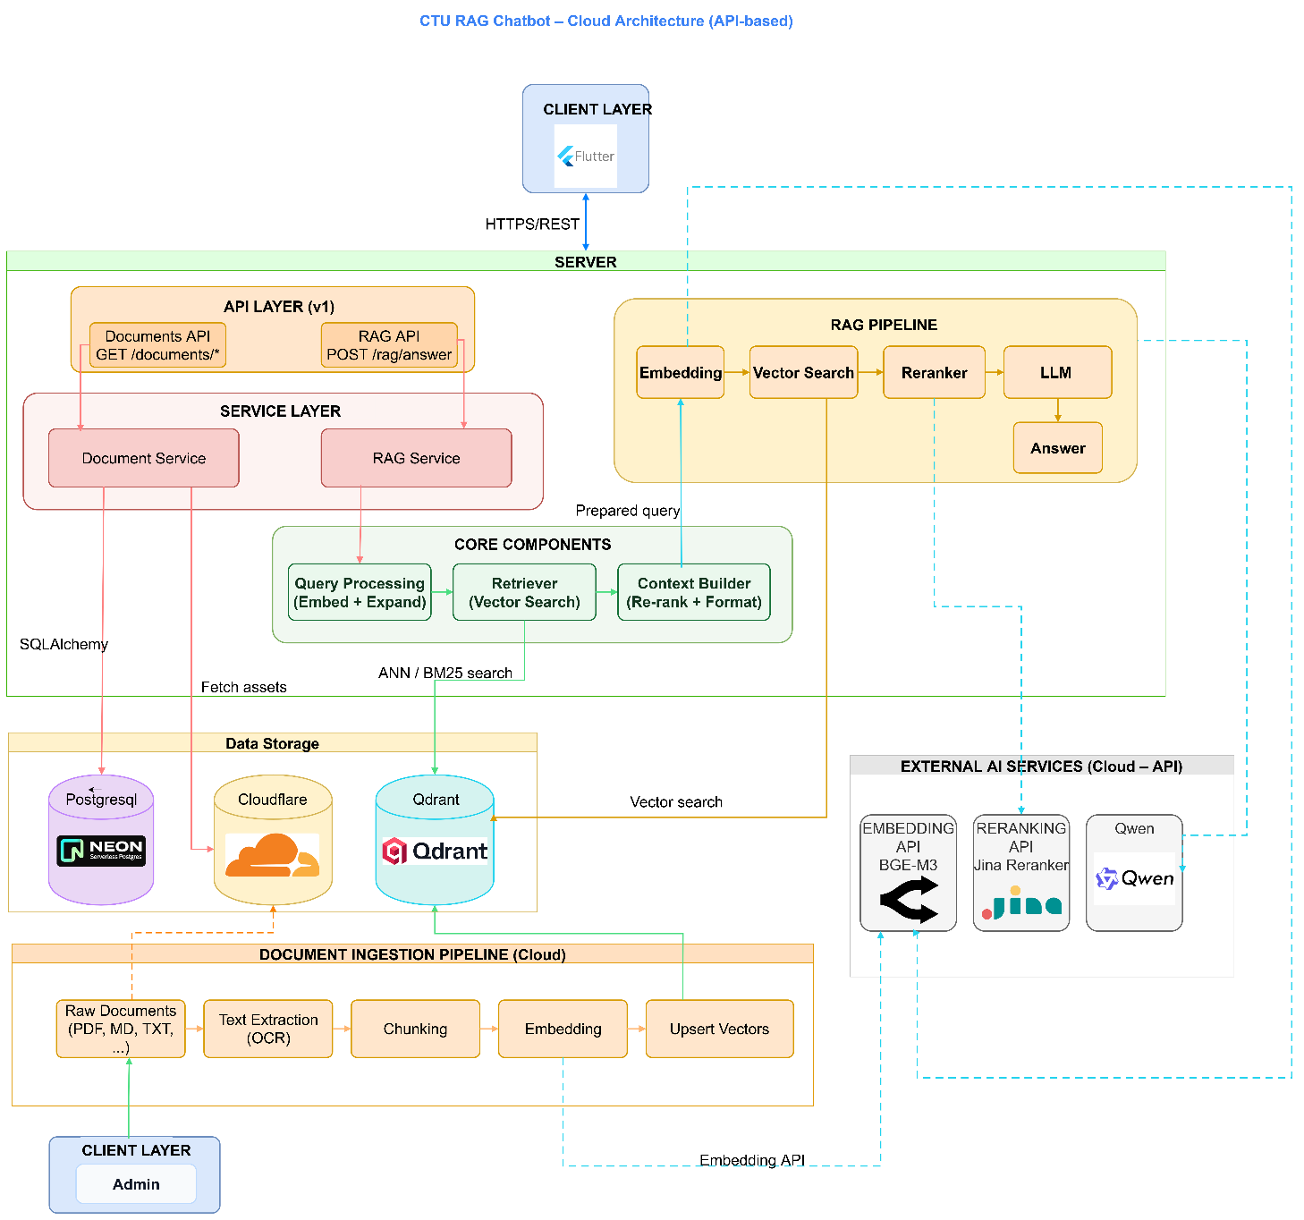
Figure 3.2. Overall application architecture
The student path starts in the Flutter client, calls POST /api/v1/rag/answer, executes retrieval and grounded generation, and returns an answer with citations. The administration path starts with canonical Markdown and uses the React workflow to validate, review, preview chunks, index, and publish. OCR and LlamaParse remain outside the backend boundary.

Data design

Input data and canonical document structure
An external preparation workflow produces reviewed canonical Markdown, which becomes the governed textual input for metadata validation, chunking, indexing, and retrieval. The original source file is optional and is preserved for traceability and preview.
Input / representation | Format and limit | Role in the system
Canonical document | UTF-8 .md/.markdown; maximum 50 MB | Required reviewed text. YAML frontmatter and Markdown body are validated; canonical metadata is regenerated from the administration form before storage.
Original source file | Optional PDF, DOC, DOCX, PPT, PPTX, or Markdown; maximum 100 MB | Preserved in Cloudflare R2 for provenance, document preview, and source traceability. It is not directly used as retrieval text.
Metadata | Validated form fields plus YAML frontmatter representation | Identifies document/version keys, title, type, departments, dates, audience, source information, and governance statuses. PostgreSQL is authoritative for these records.
Derived vector representation | 1,024-dimensional BGE-M3 child embedding | Stored in Qdrant with identifiers/structural payload. It is a derived search index; canonical content is hydrated from PostgreSQL before reranking and generation.
Table 3.3.2.2.1.1. Input data and canonical representations

Entity-relationship design
The current relational schema contains nine tables. Documents represent logical records, whereas document_versions preserve edition-specific metadata and lifecycle status. Parent and child chunks belong to a version. Ingestion jobs track asynchronous indexing progress. Departments, recipients, assets, and document-asset relationships preserve organizational and supplementary information.

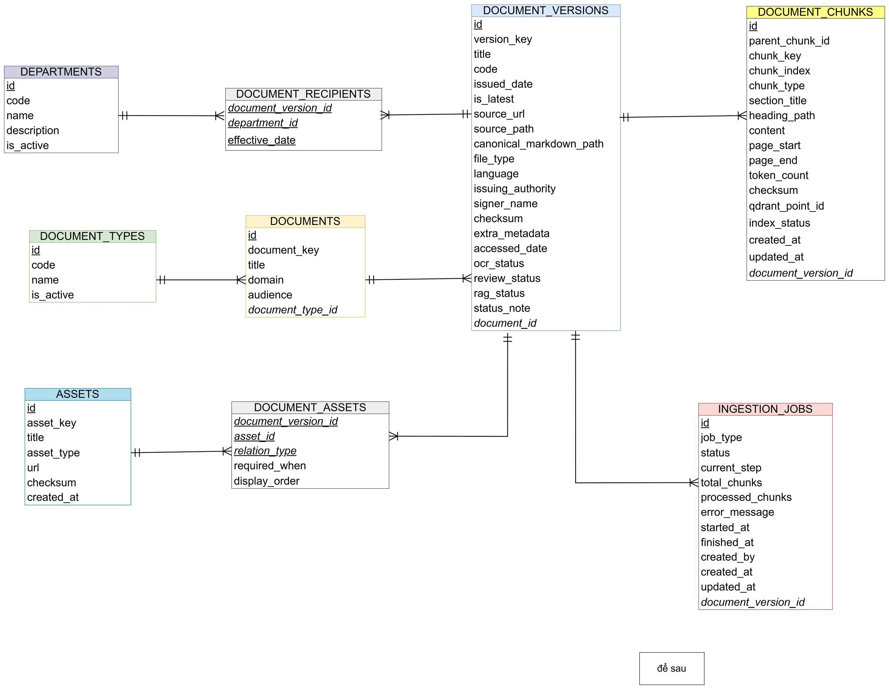
Figure 3.3. Entity-relationship diagram
Entity | Purpose
departments | Reference data for responsible or recipient organizational units.
document_types | Reference data for document classification.
documents | Logical document identity, title, domain, audience, and type.
document_versions | Version metadata, source paths, dates, latest flag, and OCR/review/RAG statuses.
document_chunks | Parent-child structural chunks, page ranges, content, checksums, and Qdrant identifiers.
ingestion_jobs | Indexing status, current step, progress counters, errors, and timestamps.
document_recipients | Many-to-many receipt history between versions and departments, including effective date.
assets | Reusable forms, links, or files associated with procedures.
document_assets | Version-to-asset relationship, relation type, requirement condition, and display order.
Table 3.3.2.2.2.1. Main database entities

Document lifecycle statuses
The current status is stored directly in document_versions. OCR status indicates whether content preparation is complete. Review status represents not reviewed, reviewing, need fix, approved, or rejected conditions. RAG status represents not indexed, chunked, embedded, indexed, published, deactivated, or failed conditions. The student retrieval policy uses only approved, published, latest versions intended for the sinh_vien audience.

Detailed design

OCR workflow
The OCR flow starts when the user provides input documents such as PDFs, images, or Office files through the CLI application. The documents are sent to the LlamaParse Engine, which uses the Llama Cloud API to perform OCR and document parsing.
After parsing, the output is generated either as plain text or processed into Markdown. For Markdown output, the content is further cleaned, structured with page markers and headings, and enriched with metadata before producing the final .md file.
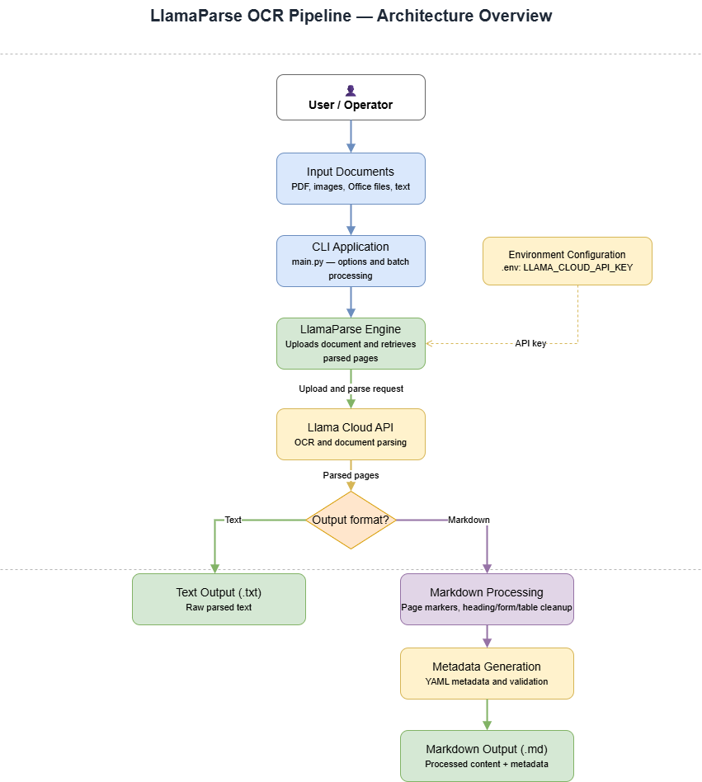
Figure 3.4. OCR processing pipeline

Administrative ingestion workflow
The React administration interface implements four principal workflow steps: upload, review, chunk review, and ingest. The upload step accepts canonical Markdown and an optional original source file, validates type/size/UTF-8 and metadata, checks reference data and duplicate version keys, regenerates canonical YAML frontmatter from validated form metadata, and stores files through the S3-compatible R2 layer. During review, immutable provenance fields are protected, responsible departments and optional assets are synchronized, and valid content is stored as approved canonical Markdown. After approval, the administrator requests a chunk preview and confirms it in the UI. Starting indexing creates relational chunk records and an ingestion job, then schedules the remaining embedding/Qdrant work as an in-process FastAPI BackgroundTask.
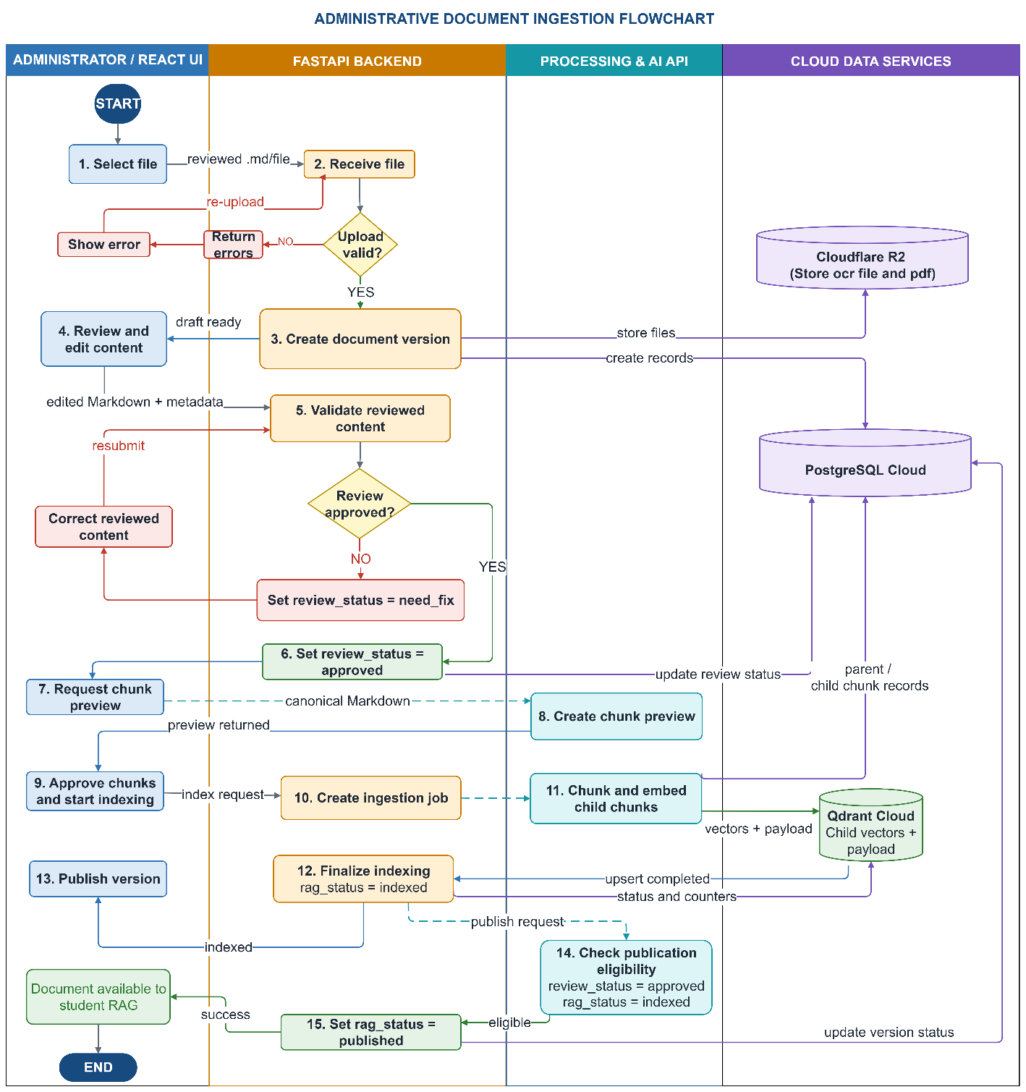
Figure 3.5. Administrative ingestion sequence
The indexing service creates parent-child chunks, embeds child chunks in batches, stores relational chunk records, upserts vectors into Qdrant, and updates ingestion_jobs.current_step and progress counters. The source notes that the current background task is in-process; a restart-safe queue should replace it when production resilience is required.

Chunking workflow
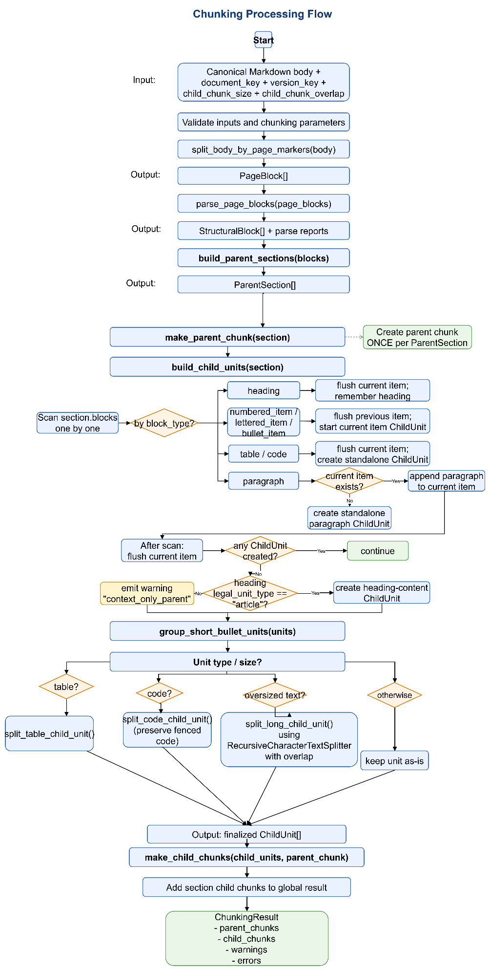
Figure 3.6. Chunking workflow
Chunking starts after the canonical Markdown file is parsed into page-aware structural blocks. Heading blocks define section boundaries and become the basis for parent sections, while paragraphs, numbered items, tables, and other structural elements are normalized into candidate child units. This keeps the logical document structure visible to the retrieval pipeline.
When a generic child unit is still too large, the backend applies LangChain RecursiveCharacterTextSplitter to divide the text into smaller spans while preserving local order and partial overlap. Each child chunk is then assigned identifiers, section metadata, and page ranges, stored in PostgreSQL, and embedded for Qdrant. During answer generation, the retriever can return a specific child chunk and then rehydrate its parent section to restore the broader context.

Retrieval and answer-generation workflow
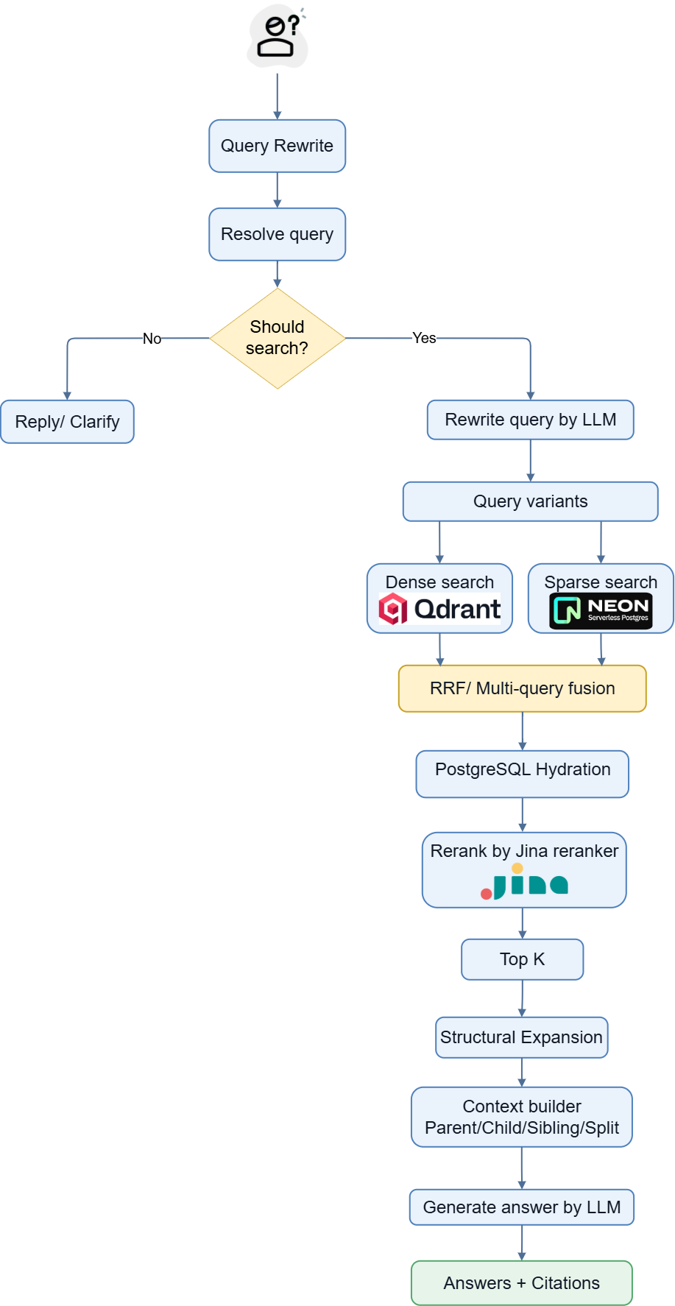
Figure 3.7. Retrieval and answer-generation pipeline
- Resolve the question, handle direct greeting/clarification cases, and decide whether retrieval is required.
- Generate meaning-preserving Vietnamese query variants when rewriting is enabled; preserve the original query on timeout or error.
- Apply hard eligibility for approved, published, latest, sinh_vien-audience versions and any explicit document/version constraints supplied by context.
- Retrieve dense child candidates from Qdrant and sparse child candidates from PostgreSQL for each query variant.
- Fuse dense and sparse rankings with RRF, then fuse equivalent-query result lists and deduplicate by chunk_key.
- Hydrate fused candidates from PostgreSQL so canonical chunk content, document/version metadata, parent content, and citation data are available.
- Optionally rerank the hydrated direct hits with Jina; when Jina is unavailable, preserve the RRF order.
- Keep the requested top_k direct hits, expand parent/child/sibling/split-neighbor structural context, and build a bounded context with parent sections before child passages when possible.
- Generate the Vietnamese answer only from the built context and construct deduplicated citations in the backend.

RAG workflow overview
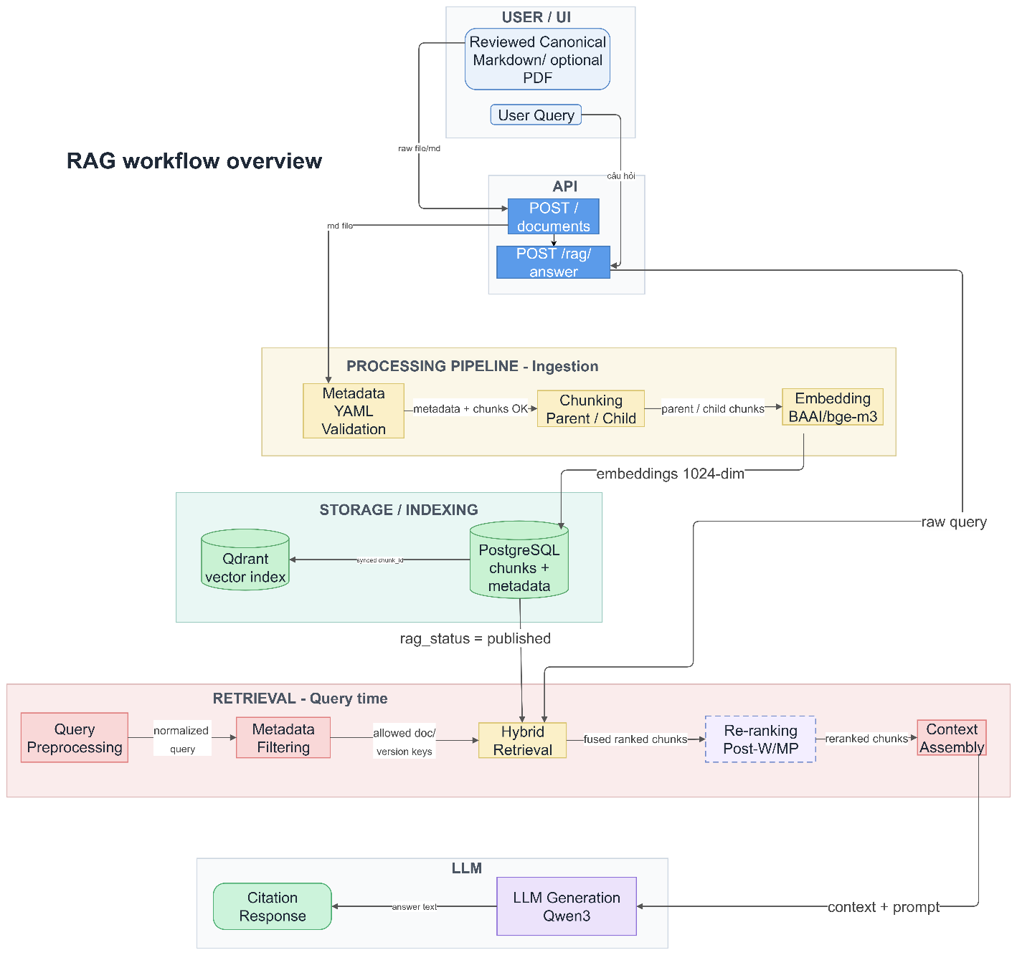
Figure 3.8. RAG workflow overview
The workflow maintains a clear distinction between authoritative relational data and the derived vector index. PostgreSQL retains canonical metadata and chunk content required for hydration and citation. Qdrant stores child embeddings and structural payload used for dense search and expansion. Direct dense/sparse candidates are eligibility-filtered before fusion; fused candidates are then hydrated from PostgreSQL before optional semantic reranking. The final prompt context is assembled from hydrated relational records rather than treating Qdrant payload as the canonical source.

API design
Method | Endpoint | Purpose
GET | /health | Return backend health status.
POST | /api/v1/rag/answer | Answer a student question and return citations.
POST | /api/v1/admin/canonical-markdown/metadata-preview | Extract supported YAML metadata from a Markdown upload.
POST | /api/v1/admin/canonical-markdown | Upload canonical Markdown, metadata, department code, and optional source file.
PUT | /api/v1/admin/canonical-markdown/{id}/review | Review and approve edited canonical content.
POST | /api/v1/admin/document-versions/{id}/chunk-preview | Generate structural chunk preview.
POST | /api/v1/admin/document-versions/{id}/index | Start indexing and return job progress.
GET | /api/v1/admin/ingestion-jobs/{id} | Read indexing-job progress.
GET | /api/v1/versions | List and filter document versions.
GET/PUT/DELETE | /api/v1/versions/{id} | Read, update, or delete an eligible version.
POST | /api/v1/versions/{id}/publish | Publish an indexed and approved version.
POST | /api/v1/versions/{id}/unpublish | Remove a version from student retrieval.
POST | /api/v1/versions/{id}/deindex | Remove relational chunks and Qdrant vectors so the version can be edited.
GET | /api/v1/versions/preview-url/{version_key} | Create a temporary preview URL. The required file_type query parameter accepts source or canonical_markdown.
GET | /api/v1/health/database | Check PostgreSQL connectivity for the administration interface and diagnostics.
GET | /api/v1/reference/document-types, /departments, /enums | Return active reference data and supported enumeration values used by the administration forms.
PUT | /api/v1/versions/{id}/assets | Replace the linked assets of a document version without requiring content deindexing.
Table 3.3.2.3.6.1. Main API endpoints

Front-end design
The Flutter student application contains home, chat, document-detail, saved-document, and navigation-shell features. Riverpod providers expose the RAG API client and chat controller. The client maps answer JSON to messages and source references, displays source cards, and requests preview URLs when a student opens a document. The application supports web, Android, and Windows project targets.
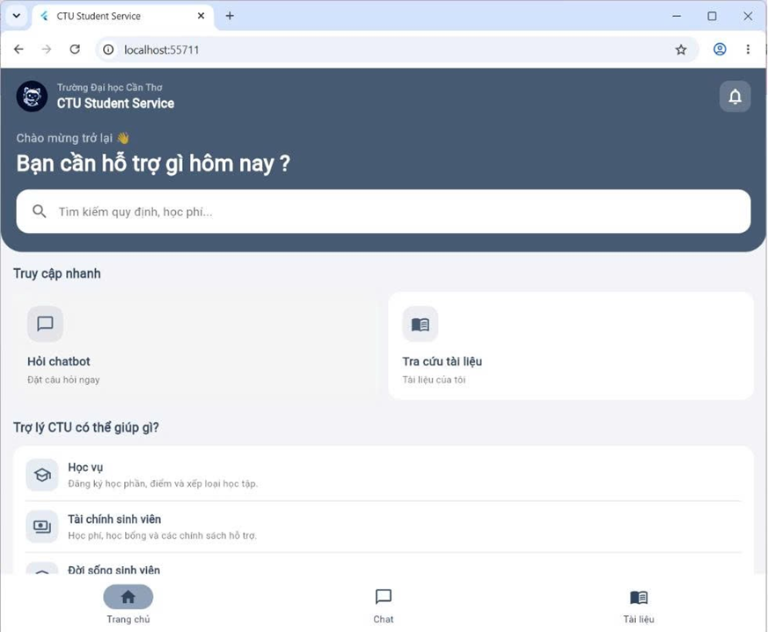
Figure 3.9. Student home interface

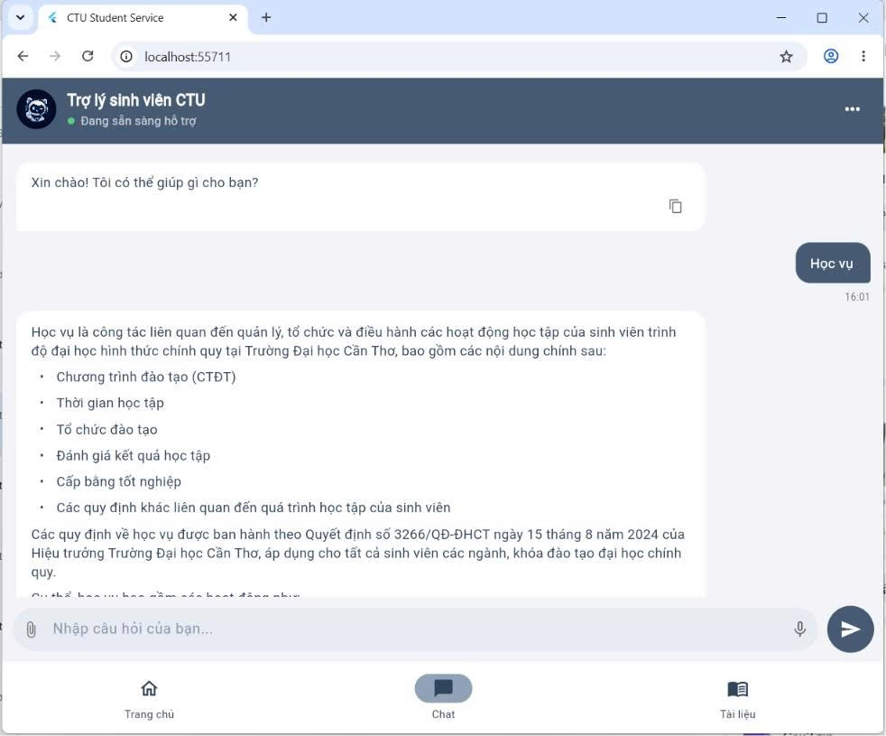
Figure 3.10. Student chatbot interface
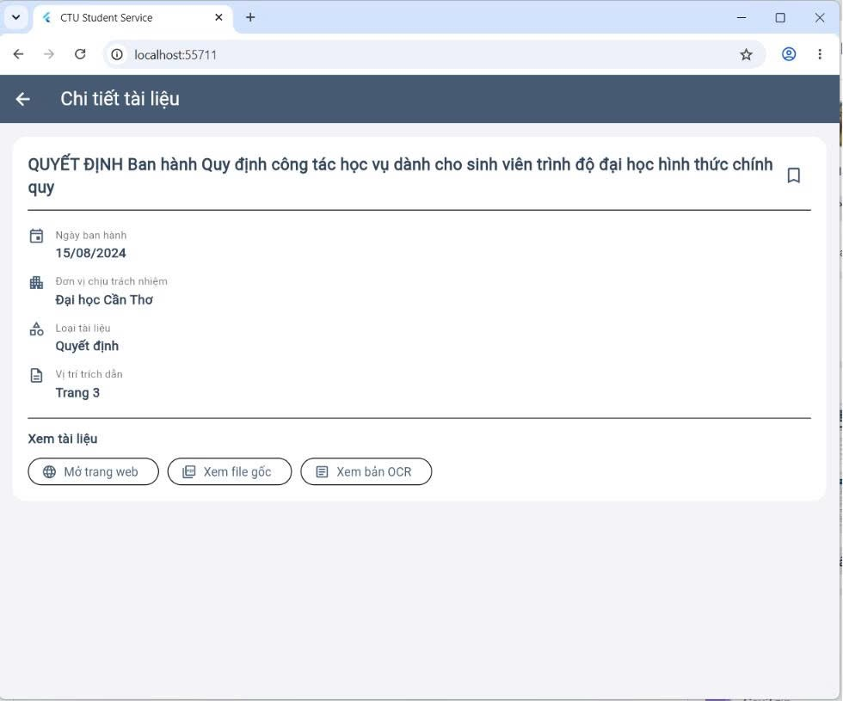
Figure 3.11. Document detail interface
The React administration interface uses a sidebar and workflow progress component. UploadStep, ReviewStep, ChunkReviewStep, and IngestStep correspond to the controlled ingestion lifecycle. Separate list and edit pages support document maintenance. The interface prevents returning to earlier content-changing steps after a version has been indexed unless it is first deindexed.
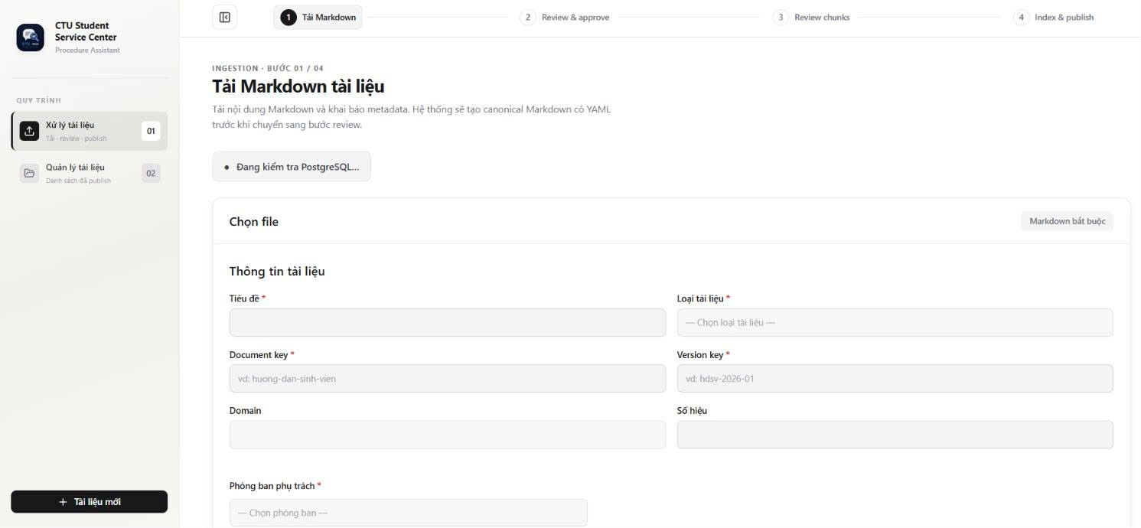
Figure 3.12. Administrative document upload interface
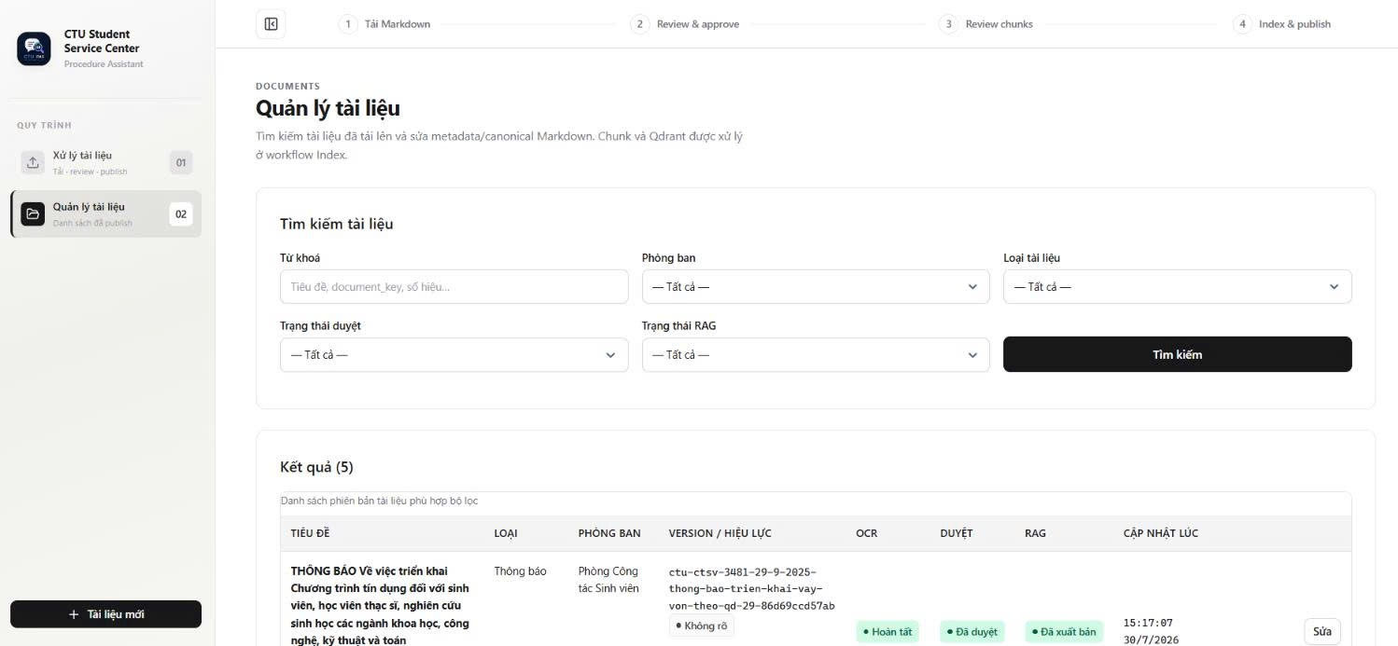
Figure 3.13. Document management interface

Deployment design
The FastAPI backend and React administration frontend run from their respective environments, while the Flutter client selects an API base URL appropriate to web, emulator, device, or Windows execution. In the submitted cloud source, admin-frontend/vercel.json rewrites same-origin /api/* requests to https://css-ctu-student-service-api.onrender.com/api/*, providing a Vercel-to-Render deployment path without browser cross-origin calls from the admin UI. Cloudflare Workers AI supplies BGE-M3 embeddings and R2 stores canonical/source files; PostgreSQL and Qdrant can be hosted independently. A direct Flutter web deployment that calls Render rather than a same-origin proxy must extend the current development-only CORS policy to the production web origin.

TESTING

Test plan
Testing should combine source-level unit tests, API integration tests, end-to-end workflow tests, client widget/controller tests, user acceptance tests, and deployment smoke tests. The principal risk areas are document lifecycle constraints, cross-store consistency, retrieval eligibility, citation accuracy, fallback behavior, Vietnamese answer quality, and browser deployment configuration. The current source snapshot contains limited automated backend coverage, so the strategy below distinguishes the intended test matrix from source-backed verification evidence.
Test type | Coverage | Suggested tools
Unit testing | Query processing, fusion, DTO/client behavior and selected service rules | pytest, Flutter test
Integration testing | FastAPI with PostgreSQL, Qdrant, R2 and model-service fallbacks | pytest/http client, deployed services
System / acceptance testing | Upload → review → chunk preview → index → publish → student question → citation preview. | Browser, API calls, production preview
RAG quality & performance evaluation | Retrieval relevance, ranking quality, answer correctness, faithfulness, citation correctness, no-answer behavior | Fixed Vietnamese gold test set, evaluation scripts, manual review
Table 3.3.2.3.8.1. Test strategy

Representative test cases
ID | Scenario | Precondition | Action | Expected result
TC-01 | End-to-end document ingestion and publication | Administration interface, PostgreSQL, Qdrant, R2, and embedding service are available. A valid canonical Markdown file is prepared. | Upload → Review → Chunk preview → Index → Publish | document version created;  canonical file stored;  chunks created;  child vectors stored in Qdrant;  ingestion job completed;  rag_status = published
TC-02 | Grounded student question | At least one relevant document version is approved, published, latest, and available to the sinh_vien audience. | Submit a valid Vietnamese administrative-procedure question to POST /api/v1/rag/answer. | The API returns HTTP 200 with should_search = true; a non-empty Vietnamese answer is generated from retrieved evidence; citations are non-empty and traceable to the relevant document/version.
TC-03 | Retrieval eligibility enforcement | Two relevant versions exist: A: approved + published + sinh_vien; B: approved but not published; | Ask a question whose evidence can be found in these versions. | Only version A is eligible for dense/sparse retrieval and citation. Versions B must not appear in the returned citations.
TC-04 | Ambiguous or no-context question handling | Backend is running. For the no-context case, no eligible document contains evidence for the question. | Submit (1) an ambiguous/incomplete question and (2) a question outside the governed document corpus. | The system returns a clarification/direct non-search response for ambiguous input or the predefined no-context response when evidence is unavailable; no unsupported answer or fabricated citation is returned.
TC-05 | Optional reranker fallback | A searchable question and relevant published documents exist. The Jina reranker is disabled or unavailable. | Submit a valid searchable question while the reranker cannot be used. | The system preserves the hybrid RRF ordering/fallback path and continues retrieval and answer generation successfully instead of failing the entire request.
TC-06 | Deindex and cross-store consistency | An indexed or published document version exists with relational chunks in PostgreSQL and child vectors in Qdrant. | Unpublish the version if required, then execute the deindex operation. | Related PostgreSQL chunk records and Qdrant vectors are removed consistently; the document version returns to rag_status = not_indexed and is no longer retrievable by the student-facing RAG pipeline.
Table 3.3.3.1.1.1. Representative test cases

Test results and analysis

RAG quality evaluation results and analysis
Functional verification alone does not measure retrieval or answer quality, so the final benchmark used a fixed evaluation set of 30 retrieval questions with query rewriting disabled and 10 end-to-end student questions executed through the deployed RAG pipeline. The evaluation metrics used in this report are summarized in Table 3.7.
Metric | Definition / measurement | Interpretation
Precision@5 | Relevant direct-hit chunks among the top five retrieved chunks divided by five. | Measures how much of the retrieved top-five evidence is relevant.
Recall@5 | Relevant gold chunks retrieved in the top five divided by all relevant gold chunks. | Measures coverage of the evidence required for the question.
MRR | Mean reciprocal rank of the first relevant direct-hit chunk across test questions. | Rewards placing the first useful evidence near the top of the ranking.
Answer correctness | Proportion of reference facts represented correctly in the generated answer, using manual or explicitly defined judging criteria. | Measures factual completeness/correctness relative to a reviewed reference answer.
Faithfulness | Supported factual claims divided by all factual claims in the generated answer. | Measures whether the answer stays grounded in retrieved context rather than unsupported model knowledge.
Citation precision | Returned citations that actually support the answer divided by all returned citations. | Measures the usefulness and correctness of source attribution.
No-answer accuracy | Correct abstentions/clarifications among questions that are unanswerable or outside the governed corpus. | Measures safe behavior when evidence is unavailable.
Response latency | Mean, P50, and P95 end-to-end time for POST /api/v1/rag/answer. | Measures user-perceived responsiveness and slow-tail behavior.
Table 3.6. RAG quality evaluation metrics
Table 3.8 presents the retrieval benchmark results across four configurations, and Table 3.9 summarizes the end-to-end quality and latency measurements.
Table 3.7. Retrieval benchmark results
Configuration | Precision@5 | Recall@5 | MRR
Dense only | 22.00% | 91.67% | 81.11%
Sparse only | 10.00% | 48.33% | 27.33%
Hybrid + RRF | 21.33% | 90.56% | 65.83%
Hybrid + RRF + Jina | 21.33% | 90.56% | 84.17%
Table 3.8. End-to-end RAG evaluation results
Metric | Result
Answer correctness | 85.00%
Faithfulness | 68.75%
Citation precision | 68.75%
No-answer accuracy | 0.00%
Mean latency | 10.45 s
P95 latency | 20.34 s
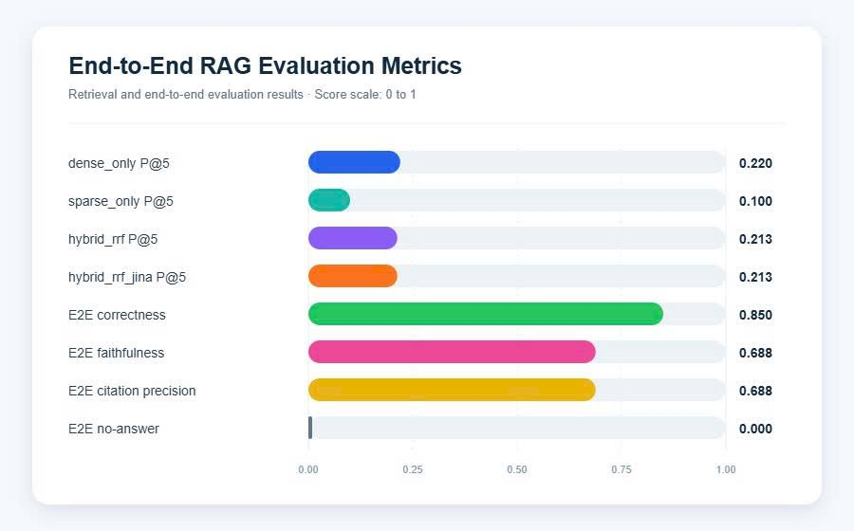
Figure 3.14. Retrieval and end-to-end evaluation results
Figure 3.14 highlights the same benchmark results visually. The chart shows that dense retrieval already provides strong coverage, while the addition of Jina reranking improves MRR and therefore improves how early the first useful evidence is placed in the ranking. The end-to-end bars confirm that the implemented pipeline is strongest in answer correctness, but weaker in safe abstention, indicating that future work should prioritize no-answer handling and confidence gating.
Tables 3.8 and 3.9 report the executed benchmark results. In the retrieval benchmark, Dense only achieved the highest Recall@5 at 91.67%, while the full Hybrid + RRF + Jina configuration achieved the best overall ranking quality with an MRR of 84.17%. Sparse only lagged behind both dense and hybrid settings, indicating that Vietnamese full-text retrieval still requires additional tuning. In the end-to-end benchmark, the deployed pipeline achieved 85.00% answer correctness, 68.75% faithfulness, and 68.75% citation precision. However, no-answer accuracy remained 0.00%, showing that safe abstention behavior still needs improvement. Mean latency was 10.45 seconds and P95 latency was 20.34 seconds, which is acceptable for a prototype but still leaves room for optimization.

CONCLUSION

ACHIEVED OUTCOMES
The project establishes an end-to-end foundation for a CTU administrative procedure chatbot that separates student question answering from governed document administration. The implemented system integrates a Flutter student application, a React administration interface, a FastAPI backend, PostgreSQL metadata storage, Qdrant dense retrieval, Cloudflare R2 object storage, and external model APIs into a deployable cloud workflow on Render and Vercel.
The implemented pipeline now demonstrates measurable retrieval and answer quality. On the 30-question retrieval benchmark with query rewriting disabled, Dense only achieved Precision@5 = 22.00%, Recall@5 = 91.67%, and MRR = 81.11%, while Hybrid + RRF + Jina achieved the best ranking quality with MRR = 84.17%. On the 10-question end-to-end benchmark, answer correctness reached 85.00%, with faithfulness and citation precision both at 68.75%. Mean response latency was 10.45 seconds and P95 latency was 20.34 seconds. These results show that the system can retrieve highly relevant governed evidence and generate generally correct grounded answers, although answer safety and abstention still require improvement.

LIMITATIONS
OCR and parsing remain external to the backend. Authentication and full role-based authorization are not yet complete, and the conceptual reviewer role is not enforced separately. Indexing uses an in-process BackgroundTask rather than a restart-safe worker queue. Saved-document bookmarks and recent-topic context are not persistent user accounts or full conversation memory. The current CORS configuration is development-scoped unless a same-origin proxy is used. Retrieval does not currently enforce validity_status as a hard filter; however, it does enforce is_latest together with approved, published, and audience eligibility. Publication governance must therefore prevent expired or replaced versions from remaining available. Automated backend test coverage is also narrow, and the quality of answers still depends on document coverage, metadata accuracy, chunk structure, and the availability of relevant approved sources.

FUTURE WORK
- Add authentication, authorization, audit logs, production secret management, and an enforced separation of administrator/reviewer permissions when required.
- Move indexing to a restart-safe task queue with retry, cancellation, idempotency, and recovery controls.
- Expand the current Vietnamese benchmark set with more administrative domains, harder questions, follow-up queries, and dedicated no-answer cases.
- Persist user bookmarks and, if required, conversation state through explicit user/session models while keeping question-level source grounding.
- Add explicit validity-aware publication and retrieval rules for expired or replaced versions, and surface status warnings in the administration workflow.
- Expand automated backend integration and end-to-end coverage, and archive reproducible test and deployment logs for future releases.
- Configure explicit production CORS origins or a consistent same-origin proxy strategy for every hosted web client.
- Add monitoring, tracing, rate limiting, PostgreSQL backups, Qdrant snapshots, and disaster-recovery procedures.
- Expand the governed document corpus and establish a recurring review process with responsible CTU units.

REFERENCES
[1] P. Lewis et al., “Retrieval-Augmented Generation for Knowledge-Intensive NLP Tasks,” in Advances in Neural Information Processing Systems 33, 2020, pp. 9459–9474.
[2] Y. Gao et al., “Retrieval-Augmented Generation for Large Language Models: A Survey,” arXiv:2312.10997, 2023.
[3] J. Chen, S. Xiao, P. Zhang, K. Luo, D. Lian, and Z. Liu, “BGE M3-Embedding: Multi-Lingual, Multi-Functionality, Multi-Granularity Text Embeddings Through Self-Knowledge Distillation,” arXiv:2402.03216, 2024.
[4] G. V. Cormack, C. L. A. Clarke, and S. Büttcher, “Reciprocal Rank Fusion Outperforms Condorcet and Individual Rank Learning Methods,” in Proc. 32nd Int. ACM SIGIR Conf. Research and Development in Information Retrieval, 2009, pp. 758–759, doi: 10.1145/1571941.1572114.
[5] FastAPI, “FastAPI Documentation,” 2026. [Online]. Available: https://fastapi.tiangolo.com/. [Accessed: Aug. 1, 2026].
[6] PostgreSQL Global Development Group, “PostgreSQL 17 Documentation,” 2026. [Online]. Available: https://www.postgresql.org/docs/17/. [Accessed: Aug. 1, 2026].
[7] Qdrant, “Qdrant Documentation,” 2026. [Online]. Available: https://qdrant.tech/documentation/. [Accessed: Aug. 1, 2026].
[8] Google, “Flutter Documentation,” 2026. [Online]. Available: https://docs.flutter.dev/. [Accessed: Aug. 1, 2026].
[9] Meta Platforms, Inc., “React Documentation,” 2026. [Online]. Available: https://react.dev/. [Accessed: Aug. 1, 2026].
[10] LangChain, “Text Splitters and Retrieval Documentation,” 2026. [Online]. Available: https://python.langchain.com/docs/. [Accessed: Aug. 1, 2026].
[11] Docker, Inc., “Docker Compose Documentation,” 2026. [Online]. Available: https://docs.docker.com/compose/. [Accessed: Aug. 1, 2026].
[12] Cloudflare, “Cloudflare R2 Documentation,” 2026. [Online]. Available: https://developers.cloudflare.com/r2/. [Accessed: Aug. 1, 2026].

APPENDICES

APPENDIX A. CONFIGURATION AND EXECUTION SUMMARY

A.1. Required environment groups
Configuration group | Representative variables
Database | DATABASE_URL, POSTGRES_DB, POSTGRES_USER, POSTGRES_PASSWORD
Qdrant | QDRANT_URL, QDRANT_COLLECTION, optional QDRANT_API_KEY
Embedding | CLOUDFLARE_ACCOUNT_ID, CLOUDFLARE_API_TOKEN, EMBEDDING_MODEL, EMBEDDING_BATCH_SIZE
Object storage | R2/S3 endpoint, access key, secret key, bucket, public or preview settings
LLM | LLM_BASE_URL, LLM_API_KEY, LLM_MODEL, timeout
Optional reranker | JINA_API_KEY, JINA_RERANK_MODEL, JINA_RERANK_URL, timeout
Query rewriting | QUERY_REWRITE_ENABLED, QUERY_REWRITE_MAX_QUERIES, rewrite timeout
Flutter client API | API_BASE_URL (Dart compile-time define for hosted builds)

The administration web source also contains a Vercel rewrite that proxies /api/* to the Render backend, allowing same-origin browser requests from the admin interface.

APPENDIX B. STATUS AND ELIGIBILITY RULES
Student retrieval uses the following hard eligibility condition in both dense and sparse retrieval:
review_status = approved AND rag_status = published AND audience contains "sinh_vien" AND is_latest = True
The current implementation does not add validity_status to the hard retrieval filter. However, is_latest is enforced as part of the hard eligibility condition. Therefore, governance and publication actions must ensure that expired, replaced, confidential, or internal versions are not left published to the student-facing RAG system. A future revision should make validity-aware publication and retrieval rules explicit.

