REGULATIONS ON THE FORMAT AND CONTENT
OF THE REPORT

The report must follow the general regulations outlined below.

FORMATTING THE REPORT
Chapter title (Heading 1): Font Arial, Size 14, Bold, Uppsssercase.
Section title (Heading 2): Font Arial, Size 13, Bold, Uppercase.
Subsection title (Heading 3): Font Arial, Size 13, Bold, Italic, Lowercase.
Sub-subsection title (Heading 4): Font Arial, Size 13, Italic, Lowercase.
Normal text: Font Times New Roman, Size 13, Lowercase.
Use the “Format/Style” function to define these styles.
The table of contents should be presented in four levels (Heading 1, 2, 3, 4). Use the "Table of Contents" tool to generate an automatic table of contents.
Number chapters and sections in an Outline style (e.g., 1.2.1 refers to sub-section 1 in section 2 of chapter 1).
The content should be clear, concise, and free from spelling errors.

THE LAYOUT AND CONTENT OF THE REPORT

COVER PAGE
Present formally with all the following information:
  - Name of the university (with logo).
  - Class name (major, cohort, and course class).
  - Type: Project – Basic Topics.
  - Title of the project.
  - Academic degree and full name of the advisor.
  - Student ID, full name of the students involved.
  - Semester and academic year of the report.
CAN THO UNIVERSITY
COLLEGE OF INFORMATION AND COMMUNICATION TECHNOLOGY



BASIC TOPICS PROJECT REPORT

Project: A RETRIEVAL-AUGMENTED GENERATION SYSTEM FOR SUPPORTING CTU STUDENTS WITH ADMINISTRATIVE PROCEDURES

COURSE: | PROJECT – BASIC TOPICS
COURSE CODE: | CT239H
MAJOR: | SOFTWARE ENGINEERING (HIGH-QUALITY PROGRAM)
COHORT: | 49

Instructor: Group Members:
1. Nguyễn Văn A – B2008603
Ph.D. Phan Phuong Lan 2.

SEMESTER III, ACADEMIC YEAR [2025–2026]
CAN THO, 2026
Member
Table detail tassk for each member
Kế hoạch dự án

ABSTRACT
Write a concise summary of the entire project. The abstract should include:
  - The primary objective or goal of the project.
  - A brief description of the methodology or approach taken.
  - Key results or findings from the project.
  - The significance or impact of the project.
  - Length: 150-200 words, written last but presented at the beginning.

This project develops a retrieval-augmented generation chatbot that supports Can Tho University students in finding reliable information about administrative procedures. The system separates document governance from student question answering. Administrators upload reviewed canonical Markdown and optional source files, validate metadata, inspect structural parent-child chunks, and publish eligible document versions. The backend is implemented with FastAPI and stores authoritative metadata, document versions, chunks, and ingestion jobs in PostgreSQL, while Qdrant stores dense vectors generated with BGE-M3. During question answering, the system resolves and rewrites Vietnamese queries, applies document eligibility rules, performs dense and sparse retrieval, combines ranked results by Reciprocal Rank Fusion, optionally reranks candidates, expands parent context, and sends only retrieved evidence to an OpenAI-compatible language model. The Flutter application presents answers, citations, and source-document details to students, whereas the React administration interface manages the ingestion workflow. The implemented architecture improves traceability because every answer is associated with approved and published university documents. It also provides a maintainable foundation for extending document coverage, evaluation, authentication, and production deployment.
Keywords—retrieval-augmented generation, administrative procedures, CTU students, hybrid retrieval, FastAPI, Flutter, PostgreSQL, Qdrant.

TABLE OF CONTENTS
Use an automated table of contents feature to ensure consistency. It should list all main sections and subsections with page numbers. The table of contents should be presented in four levels (Heading 1, 2, 3, 4).

LIST OF TABLES
A list of all the tables (e.g., diagrams, charts, graphs, or illustrations) included in the report. This helps readers quickly locate specific figures within the document and provides an overview of the visual content included. Each figure is numbered sequentially (e.g., Figure 1, Figure 2, etc.) to maintain order.

Thừa kế thừa chaper
Vd chương 2:

2.1

LIST OF FIGURES
A list of all the figures (e.g., diagrams, charts, graphs, or illustrations) included in the report. This helps readers quickly locate specific figures within the document and provides an overview of the visual content included. Each figure is numbered sequentially (e.g., Figure 1, Figure 2, etc.) to maintain order.

LIST OF ABBREVIATIONS
A list of all the abbreviations and acronyms used in the report, along with their full forms. This table is used to: ensure that readers understand the shortened terms without confusion, especially if they are unfamiliar with the terminology; maintain consistency in the use of abbreviations, promoting uniformity in the report

CHAPTER 1: INTRODUCTION

1.1. Problem Statement
Clearly articulate the problem your project aims to solve. Describe its real-world impact and why it needs a solution.
Can Tho University students must consult many regulations, decisions, announcements, forms, and procedural guides when completing academic and administrative tasks. These documents are normally published by different units, use formal terminology, and may have multiple versions. A student who does not know the exact document title or responsible department can spend considerable time searching, comparing, and interpreting the available information.
A conventional keyword-search interface returns documents rather than a concise answer and does not necessarily show which passage supports a procedural claim. A general-purpose language model can produce fluent responses, but it may rely on external knowledge, use outdated information, or generate unsupported details. These limitations are particularly significant for administrative procedures because incorrect deadlines, required documents, fees, or responsible units can directly affect students.
The project therefore addresses the need for a controlled question-answering system that retrieves information only from governed university documents and provides traceable citations. The system must also support administrators who prepare, review, index, publish, update, and deactivate document versions so that student-facing answers remain aligned with approved sources.

1.2. Objectives
Define what the project intends to achieve. Ensure the objectives are specific, achievabl, time-bound.
The general objective is to design and implement a retrieval-augmented generation chatbot that helps CTU students obtain clear, Vietnamese-language answers about administrative procedures while preserving source traceability and document-governance controls.

1.3. Research Methodology
Phương pháp nghiên cứu, thực nghiệm, nghiên cứu lý thuyết

1.4. Plan
Sơ đồ gantt

CHAPTER 2: THEORETICAL FOUNDATION
Summarize the theoretical foundation applied to the project. Review existing research, tools, or technologies relevant to your project.
For example: Related to tools and technologies, list and explain the tools, programming languages, frameworks, or platforms used in the project. Justify your choices.

2.1. RETRIEVAL-AUGMENTED GENERATION

2.2. STRUCTURAL PARENT-CHILD CHUNKING

2.3. EMBEDDINGS AND BGE-M3

2.4 2.5. HYBRID INFORMATION RETRIEVAL 2.5. HYBRID INFORMATION RETRIEVAL. HYBRID INFORMATION RETRIEVAL
Viết ngắn gọn các công nghệ. Là gì dùng làm gì hỗ trợ gì cho dự án
Công nghệ, mô hình làm hệ thống RAG
Liệt kê công thức tham khảo
Có thể gom nhóm ròi chia nhỏ ra thêm.
(Nói chung là tham khảo của người ta đó)

CHAPTER 3: APPLICATION RESULTS

3.1. Software Requirement Specification

3.1.1. Overall Description

3.1.2. Functional Requirement
Draw use case, lập bảng

3.1.3. Nonfunctional Requirements

3.2. Software Design

3.2.1. Application Architecture
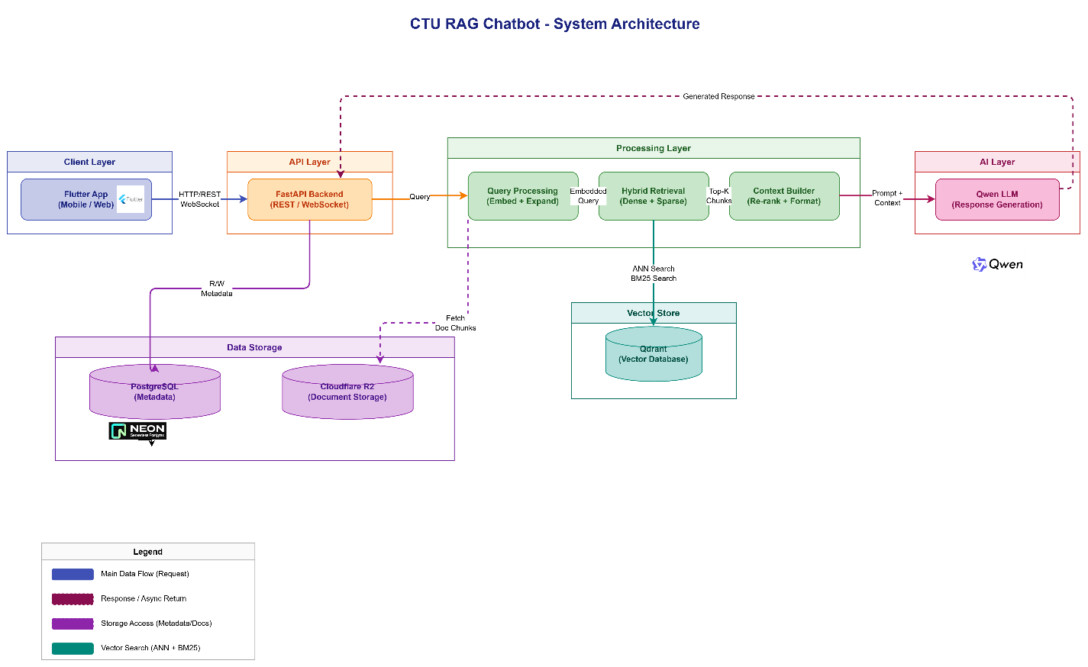
Sửa lại chữ bự hơn

3.2.2. Data Design
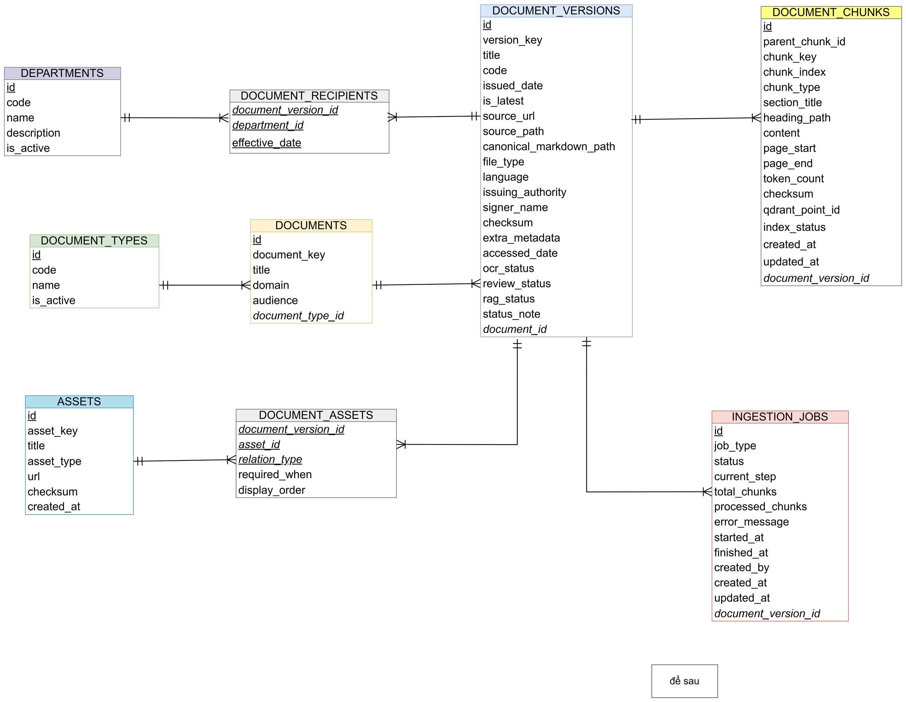
Dữ liệu đầu vào: file gì, mô tả file dạng gì.
Chunk lưu vào DB có cấu trúc như thế nào.
Học máy: Mô tả csv, mô hình

3.2.3. Detailed Design
Vẽ flow chart
Giao diện
Vẽ, lưu đồ thuật toán (sequence, flowchart), tương ứng từng chức năng

Note: Accompany each diagram with an explanation. Provide explanations for key parts of algorithm used. Mention specific techniques, libraries, or APIs utilized.

3.3. Testing Viết như nào
Explain how you ensured the project works as intended.

3.3.1. Test Plan
Detail the testing strategy, including: test types (unit, integration, system, and user acceptance testing); tools used for testing, if any; and test cases.

3.3.2. Results and Analysis
Present the results. Use graphs, charts, or tables to illustrate outcomes. Provide an interpretation of the data.

CHAPTER 4: CONCLUSION
Summarize the project. Mention:
  - How the objectives were achieved.
  - The key outcomes or deliverables.
  - Suggestions for future work or enhancements.

REFERENCES
References follow the IEEE style.

APPENDICES
Include additional information such as:
  - User manuals or guides (if applicable).
  - Additional diagrams or schematics.
  - Any other supplementary material.

50 trang, phụ lục

