Prerequisites:

**Packages:** GDAL, numpy, tkinter

**Folders:**

**Rasters**

The program will look for rasters in the .tif format in the 'rasters' in folder in the main directory. You may add or remove raster options as you see fit.

The default rasters included with this demo are>

Rasters:

* Honolulu_GAT.tif:  Depth grid developed for Honolulu City/County based on potential inundation from the Great Aleutian tsunami scenario.
* NYC.tif:  Depth grid created for the 5 Boroughs of New York City based on the FEMA 100 year mapping.

**UDF:**

**This folder contains some sample UDF input files:**

**Each row must have columns corresponding to the fields below:**

|  |  |
| --- | --- |
| **Input** | **Required?** |
| **A UDF in a .csv file-format** | **Yes** |
| **User Defined Flty Id:** | **Yes** |
| **Occupancy Class:**  **One of 33 Hazus-defined types, e.g., {RES1, RES2, COM3, IND4, AGR1, GOV2, REL1}. Script will skip row if not specified, or if an unrecognized value is provided.** | **Yes** |
| **Cost:**  **Replacement Cost of Structure, in US dollars. Records with '0' cost: the script will accept a zero value, but the record is essentially useless, as any estimated dollar damage to the structure will be 0. Consider correcting the UDF record or deleting it.** | **Yes** |
| **Number of Stories:**  **Number of stories of building. Must be an integer.** | **Yes** |
| **Foundation Type:**  **Foundation Type of the building. Text type, per Hazus-MH Flood Model convention. Must be an integer from 1 to 7, inclusively.** | **Yes** |
| **First Floor Height:**  **Must be a float greater than 0.** | **Yes** |
| **Area:**  **Total Area for the structure, in square feet. Used for Inventory Loss calculation when Inventory Cost is not supplied. Must be greater than 0.** | **Yes** |
| **Coastal Flooding attribute (flC):**  **Identifies particular UDFs in a coastal flooding zone. If BldgDamageFnID, ContDamageFnId are not provided or populated, the script will use coastal flooding DDFs instead of Riverine DDFs. Only CoastalV, CoastalA, and Riverine are recognized by the script. For all other values, Riverine DDFs will be used.** | **Yes** |
| **Content Cost:**  **If attribute is supplied, DOGAMI script will use the attribute value; otherwise, the script will assume Content Cost is 50% or 100% or 150% of Building Cost, depending on Occupancy Class. Must be greater than or equal to 0.** | **No** |
| **Inventory Cost:**  **If user has better information than what Hazus estimates based on Occupancy Class and Square Foot. Must be greater than or equal to 0.** | **No** |
| **Building DDF:**  **User-supplied Building Depth Damage Function ID. Used by Hazus-MH flood model and DOGAMI script to override the standard Damage Depth Functions for buildings. Text type, per Hazus convention. This is an optional attribute: if attribute exists, and the record is populated with a legitimate value, the script will use it, else the script will use the standard (default) DDF for the given Occupancy Class/Number of Stories/FoundationType. The ‘ID’ capitalization is per the Hazus naming convention. If the attribute is supplied, not all records need to be populated; supply with NoData or "" (blank) where there is no need to override the standard (default) DDF assignment.** | **No** |
| **Content DDF:**  **User-supplied Content Depth Damage Function ID. Used by Hazus-MH flood model and DOGAMI script to override the standard Damage Depth Functions for building content. Text type, per Hazus convention. This is an optional attribute: if attribute exists, and the record is populated with a legitimate value, the script will use it, else the script will use the standard (default) DDF for the given Occupancy Class/Number of Stories/FoundationType. If the attribute is supplied, not all records need to be populated; supply with NoData or "" (blank) where there is no need to override the standard (default) DDF assignment.** | **No** |
| **Inventory DDF:**  **User-supplied Inventory Depth Damage Function ID. Used by Hazus-MH flood model and DOGAMI script to override the standard Damage Depth Functions for building inventory. Text type, per Hazus convention. This is an optional attribute: if attribute exists, and the record is populated with a legitimate value, the script will use it, else the script will use the standard (default) DDF for the given Occupancy Class/Number of Stories/FoundationType. If the attribute is supplied, not all records need to be populated; supply with NoData or "" (blank) where there is no need to override the standard (default) DDF assignment.** | **No** |

HNL_UDF_OpenHazus.csv:  A csv file containing (>80K) buildings with required attributes

NYC_UDF_OpenHazus.csv:  A csv file containing (>800K) buildings with required attributes

Lookup Tables

The program will look for the lookup tables in the .csv format in the 'lookuptables' folder in the main directory.

1. **How to start:**

Double click on OpenHazus_POC.bat in the main directory.

A windowed GUI should launch with field inputs.

A console log should also launch; check here for errors.

1. **The GUI:**

The GUI of the program allows for custom field mapping and checking. If valid input UDF (in a .csv format) is not selected, the fields will be color coded as RED.

If an input UDF is selected the, the program will search through the input UDF’s field names and cross-check them against what is currently in the corresponding text entry box. It also checks against the default name of the field, according to its field name on the left of the entry box.

If the field is colored YELLOW, that field is has not been successfully mapped, but is NOT critical. NOTE: you may add additional field-names to be recognized by default by changing the code in gui_program.py.

If the field is colored RED and a UDF is already selected, the field has not been usefully mapped and IS critical.

If the field is colored GREEN, the field has been mapped successfully.

1. **Input:**

CSV file with fields corresponding to program requirements.

You will be asked to browse for this file. The included UDF folder has some ready-to-go samples with pre-mapped fields. You must be sure to select a depth grid that spans the coordinates in the UDF. NOTE: multiple grids can be selected if you want to run them sequentially; they may be selected by shift or control clicking multiple selections

1. **Output:**

If the program runs successfully, you will find the final product in .csv file-format in the same location of the original input .csv file. The name should be the original name of the .csv file with an added _RASTERNAME to the end.

**DEMO INSTRUCTIONS:**

Open the program using OpenHazus_POC.bat,

1. leave all the entry text fields blank select the Honolulu_GAT.tif raster. The window should look like this: 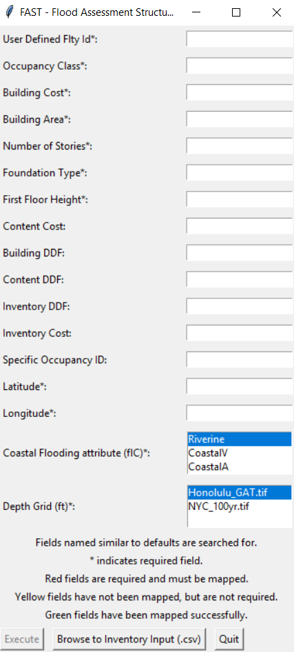
2. press the "Browse to Inventory Input (.csv)" button and you will be brought to the UDF folder in the main directory; pick the HNL_UDF_OpenHazus.csv. It should look something like this: 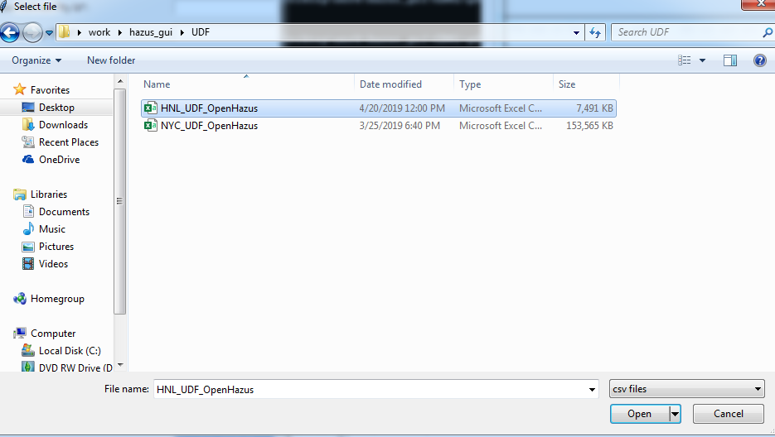
3. open it, the window should then look like this: 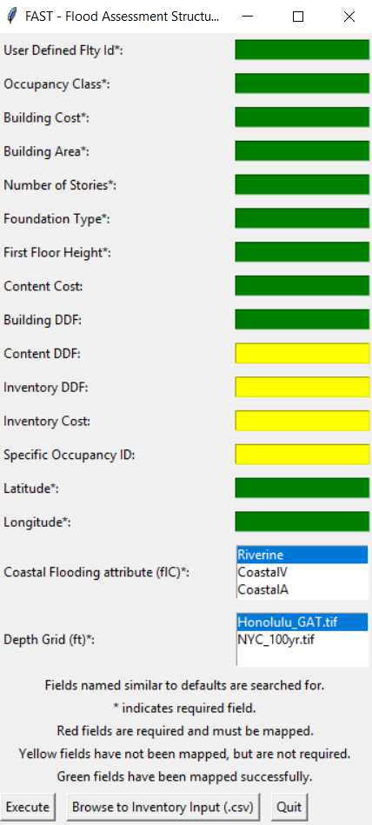
4. double-click on the HNL_UDF.csv file, then press execute. After the program finished you should have a summary window like this: 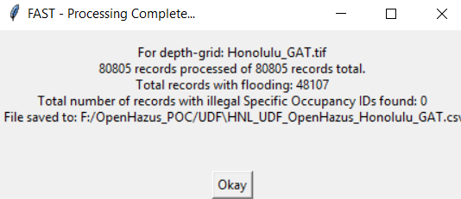

Wait for the program to run (check the log window for any changes or errors),

then go to the HNL_UDF folder for the new processed .csv file, named HNL_UDF_gat_feet1.csv

**Troubleshooting:**

If the required fields aren't found using either the given or default field names, the program cannot run. Send log info to the administration.

If a .csv file is not selected, the program cannot run.

NOTES:

Rasters used for processing must have coordinate systems of either Latitude, Longitude, or UTM. The input UDF must be in Latitude Longitude format.

Raster files and input .csv files must share the same coordinate system or the program will fail to run.

For example, if the raster file in question is using a UTM coordinate system, and the input .csv has fields mapped to latitude and longitude, the program will fail to run.