[https://hazus.s3.us-east-2.amazonaws.com/index.html](https://hazus.s3.us-east-2.amazonaws.com/index.html" \t "_blank)

GUI like windows explorer. Source data does not have structure or links to files

<https://hazus.s3.us-east-2.amazonaws.com/>

XML file that appears to contain elements with file paths

This entry makes me think it will only list 1000 files on one page <MaxKeys>1000</MaxKeys>

<https://hazus.s3-us-east-2.amazonaws.com/laura/29/laura_adv29.tif>

link that exists in above xml child element to download tif file

Boto3 is a python library (would need to be added to hazpy install) to interact with AWS S3 Buckets.

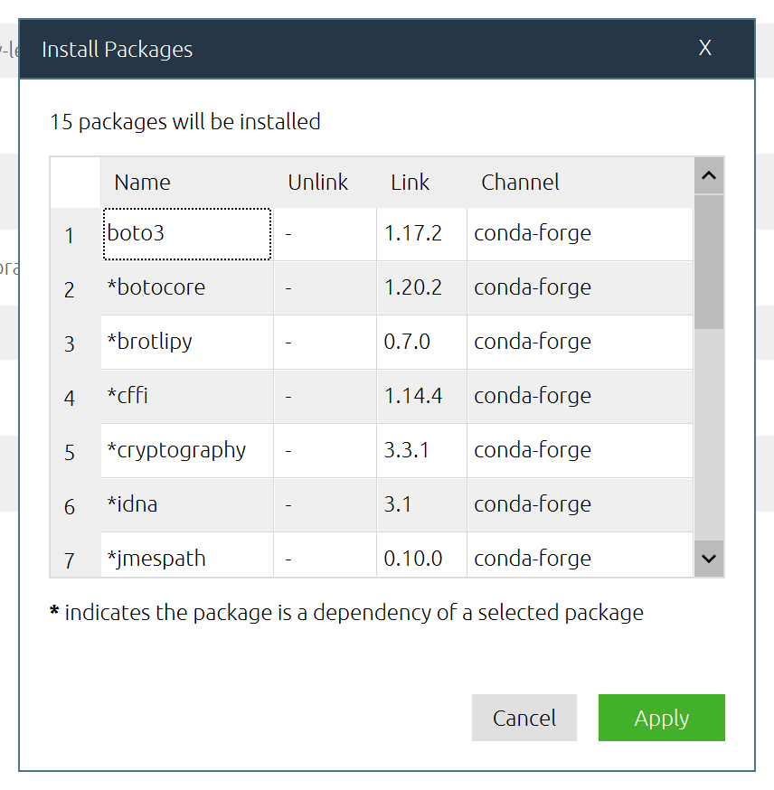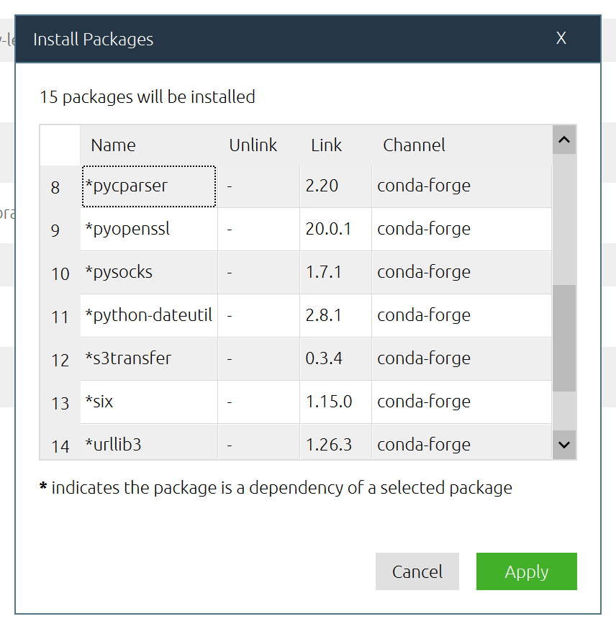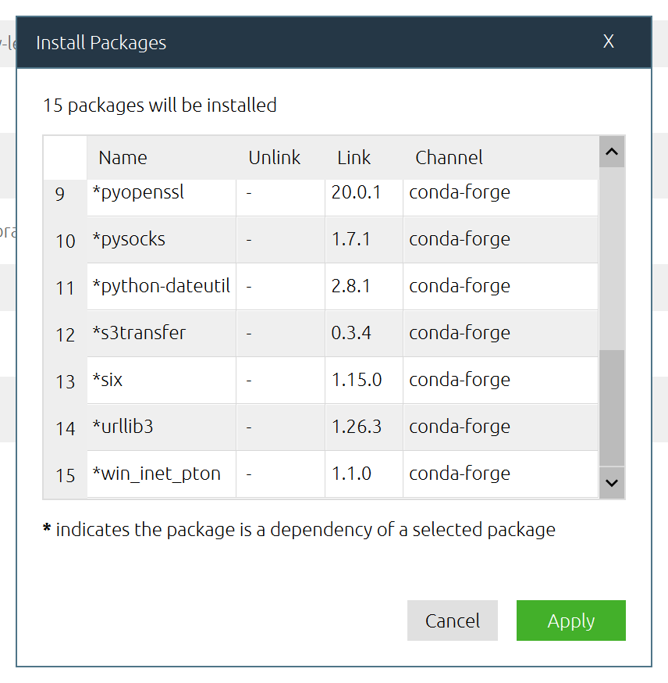

Possible json file structure

{

"Storms": {

"2020": {

"2021": {

"AL": {},

"EP": {}

},

"AL": {

"Laura": {

"1": {

"DepthGridPath": "laura/00/laura\_hc00.tif",

"Resolution": 30,

"Projection": "3426",

"Extent": "Some rectangle extent standard in wkt"

},

"1A": {

"DepthGridPath": "laura/01a/laura\_hc00.tif",

"Resolution": 30,

"Projection": "3426",

"Extent": "Some rectangle extent standard in wkt"

}

},

"Michael": {

"1": {

"DepthGridPath": "michael/00/Michael\_hc00.tif",

"Resolution": 30,

"Projection": "3426",

"Extent": "Some rectangle extent standard in wkt"

},

"2": {

"DepthGridPath": "michael/02/Michael\_hc00.tif",

"Resolution": 30,

"Projection": "3426",

"Extent": "Some rectangle extent standard in wkt"

}

}

},

"EP": {

"Michael": {

"1": {

"DepthGridPath": "michael/00/Michael\_hc00.tif",

"Resolution": 30,

"Projection": "3426",

"Extent": "Some rectangle extent standard in wkt"

},

"2": {

"DepthGridPath": "michael/02/Michael\_hc00.tif",

"Resolution": 30,

"Projection": "3426",

"Extent": "Some rectangle extent standard in wkt"

}

}

}

}

}

}