HAST – Hurricane Assessment Structure Tool

HAST is a python-based structure level assessment tool for hurricanes. It has a pre-processing tool that helps the user prepare the inventory data for the analysis tool. HAST is developed in an open source framework for both the analysis and pre- processing tool. The pre-processing tool helps the user assign terrain and wind building attributes for each structure in the input dataset based on census block, if the user does not already have them assigned. The HAST Prototype 1.0 provides probabilistic analysis of structure level data using return period wind speeds data or provides analysis for data that has site-specific peak gusts already assigned.

**Python Packages used:** GDAL, scipy, geopandas, numpy, tkinter, pillow

**Folders:**  ../Input, ../WindField/Probabilistic, ../Log, ../Help, ../LUT

**State level data** (../WindField/Probabilistic, ../LUT/HI)

The state level data that is used to apply the surface roughness values is provided from Hazus at the Census Block level. The other dataset that is required for the probabilistic analysis is the return period wind speed data. The tool uses the probabilistic wind speed data for 7 return periods at the Census Tract level and surface roughness at the Census Block level for the particular state since these are the highest resolutions currently available from Hazus. However, the user can pre-assign these if they have a higher resolution source. The HAST prototype will include the state level data for the Hawaii state DB (HI) in the zip file of the tool. In the future these datasets will be available for all hurricane States as a download from a cloud location.

**Input data (Structure Level data):**

The ../Input folder contains sample input files including specific hurricane building types for all Hawaii Essential Facilities (EF) for the prototype in .CSV format:

Each row must have columns corresponding to the fields below:

|  |  |
| --- | --- |
| **Input** | **Required?** |
| OBJECTID, EFID | Yes |
| Longitude:  The longitude of the structure in decimal degrees. Used to assign the terrain information | Yes |
| Latitude:  The latitude of the structure in decimal degrees. Used to assign the terrain information | Yes |
| Occupancy:  One of 33 Hazus-defined types, e.g., {RES1, RES2,  COM3, IND4, AGR1, GOV2, REL1}. | Yes |
| Building Value:  Replacement Cost of Structure, in U.S. dollars. Used to calculate building losses. Must not be null and should be greater than zero. | Yes |
| Building Area:  Total Area for the structure, in square feet. Used for debris estimates. Must not be null and should be greater than zero. | Yes |
| Content Cost:  Replacement value of contents of a structure, in U.S. dollars. Used to calculate content losses. Must not be null and should be greater than zero. | Yes |
| Hurricane Specific Building Type:  One of the 39 HU specific building types in Hazus (please see ../LUT/HU_DefaultWbID.csv below under Sample Data) | Yes |
| Census Block ID:  The census block number for the structure. If the user does not provide it the tool will use the GeoJSON Census Block data for the respective state as reference to assign the terrain and wind building characteristics | No |
| Terrain ID:  The terrain id is assigned at the Census Block level using the Census Block level surface roughness data of respective state. The HU_TerrainId_Dist.csv look up table is used to fetch the IDs if not provided by the user. | No |
| Wind Building ID (wbID):  The wind building ID is assigned using the HU_DefaultWBID.csv. This look up table stores the wind build IDs for each HU specific building types. The prototype does not provide the full set of wbIDs for wind building characteristics in this version, however, it will use specific wbIDs if provided by the user. | No |

**Sample data:**

hzCensusblock_TIGER.geojson:  The census block information for Hawaii in GeoJSON format.

HI_HuCB_SurfaceRoughness.csv:  The surface roughness values at block level for Hawaii in csv format.

../Windfield/Probabilistic/ HI_PWS_Tract_8RP.csv: The wind field data for Hawaii for 7 return periods in csv format.

Sample HI dataset - ../Input/HI_EF_Input.csv

../LUT/HU_DefaultWbID.csv: Contains the default wbIDs that are assigned based on the hurricane specific building types. Note there are many wbIDs for each hurricane specific building type based on wind building characteristics (eg. shutters, strapping, etc.).

|  |  |
| --- | --- |
| **wbID** | **sbtName** |
| 1 | WSF1 |
| 161 | WSF2 |
| 321 | WMUH1 |
| 345 | WMUH2 |
| 369 | WMUH3 |
| 393 | MSF1 |
| 713 | MSF2 |
| 1033 | MMUH1 |
| 1081 | MMUH2 |
| 1129 | MMUH3 |
| 1177 | MLRM1 |
| 1273 | MLRM2 |
| 1433 | MLRI |
| 1437 | MERBL |
| 1461 | MERBM |
| 1485 | MERBH |
| 1509 | MECBL |
| 1533 | MECBM |
| 1557 | MECBH |
| 1581 | CERBL |
| 1605 | CERBM |
| 1629 | CERBH |
| 1653 | CECBL |
| 1677 | CECBM |
| 1701 | CECBH |
| 1725 | SPMBS |
| 1727 | SPMBM |
| 1729 | SPMBL |
| 1731 | SERBL |
| 1755 | SERBM |
| 1779 | SERBH |
| 1803 | SECBL |
| 1827 | SECBM |
| 1851 | SECBH |
| 1875 | MHPHUD |
| 1877 | MH76HUD |
| 1879 | MH94HUDI |
| 1881 | MH94HUDII |
| 1883 | MH94HUDIII |

**Lookup Tables**

The tool uses lookup tables in .csv and GeoJSON format in the ../LUT, ../LUT/<state name>, ../Windfield/Probabilistic/ folders respectively.

1. **UI Details:**

The GUI of HAST starts with a main screen that presents the options to choose between pre-processing or analyzing HU losses for the structure level dataset. The pre-processing functionality allows the user to assign hurricane attributes needed for analyzing losses. The UI allows the use of custom field names in the input data for any of the required fields and this can be matched either by typing the name in the box provided next to the field or by editing the respective tag in the setttings.xml file under ../HAST/Python folder so that the change is maintained for the future runs. If valid input dataset (in a .csv format) is not selected, the fields will be color coded as **RED**.

If an input dataset is selected the program will search through the input field names and cross-check them against what is currently in the corresponding text entry box. It also checks against the default name of the field, according to its field name on the left of the entry box.

If the field is colored **YELLOW**, that field is has not been successfully mapped, but is NOT critical as the program will develop and assign defaults. NOTE: We encourage the user to customize field-names to be recognized by default by changing the SETTINGS.XML file in the ../HAST/Python.

If the field is colored **GREEN**, the field has been mapped successfully.

1. **Input:**

A structure level file in .csv format with fields corresponding to program requirements is a valid input for the tool.

You will be asked to browse for this file. The included **Input** folder has some ready-to-go samples with pre-mapped fields.

1. **Output:**

Once the tool runs successfully (pre-process and analysis), the output will be generated in .csv file-format under the ../HAST/Output directory. For the probabilistic scenario, separate csv files will be created for each of the 7-return periods. The name of the result file(s) is the input file name appended with the _RP<RPnumber>Results to the end. If a file with the same name exists in the Output folder it will be overwritten.

For the user-defined analysis one file is generated. The result file is named same as the pre-processed input file with “_results” appended.

1. **Using the tool:**
2. Download the HAST.zip from the link: *******
3. Unzip and open the HAST folder.
4. Double click the HAST.bat and you will see the main screen with the options to pre-process your input data or analyze.

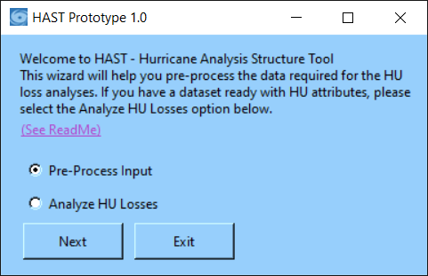

1. To Pre-Process the data, choose Pre-Process Input and click Next. This will bring you to the Pre-Process screen as below:

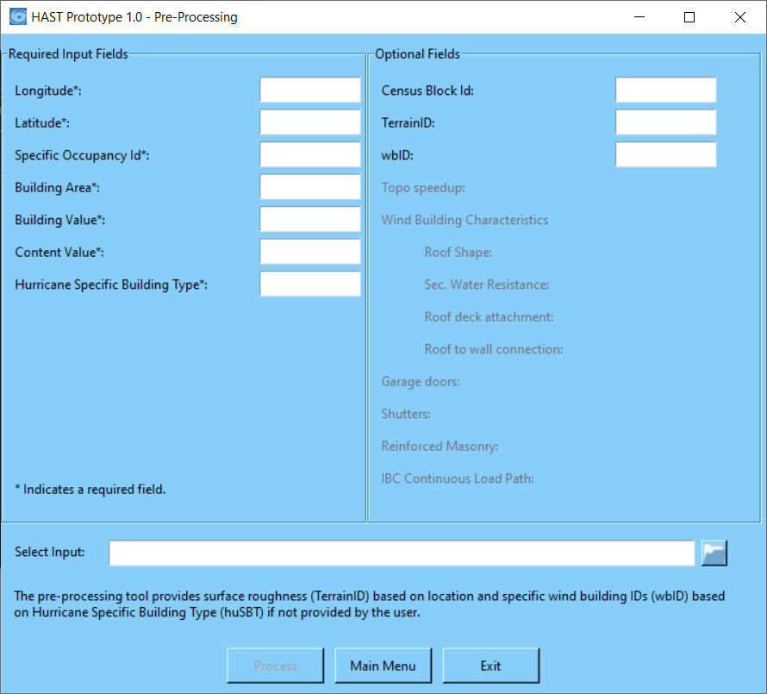

1. Select the input file by clicking the open button beside the “Select Input” box. Choose the HI_EF_input.csv file.

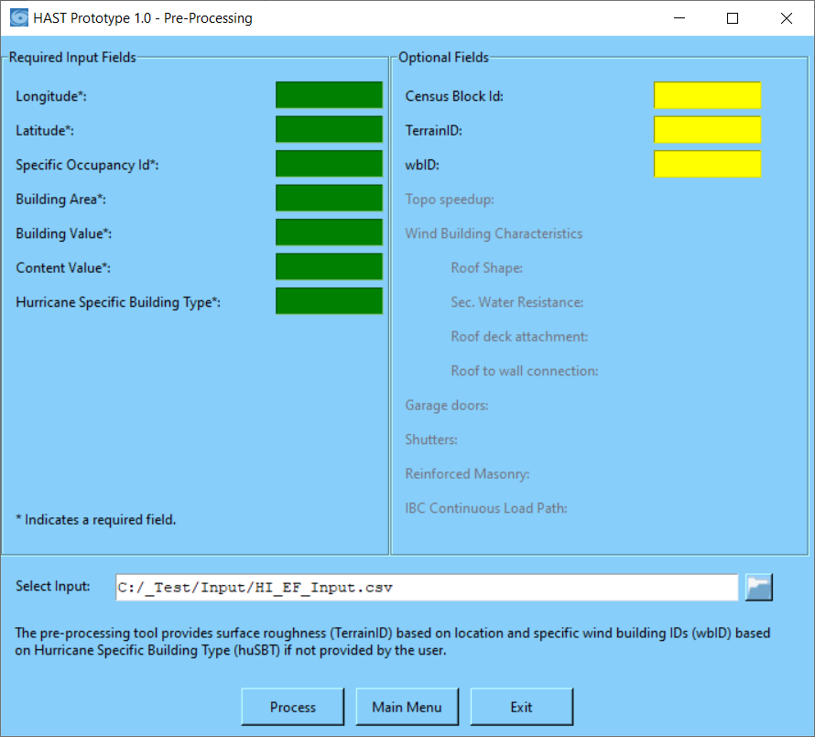

1. Press the Process button to assign the HU attributes. Once done the pre-processed input file is generated in the ../Input folder with _pre_processed appended to the name of the input file used. Once the process is complete you will see a dialog that takes you to the Analysis screen or lets you cancel and exit.

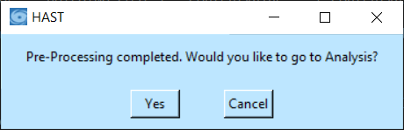

1. Once you press Yes on the above screen, the Analysis screen launches as follows:

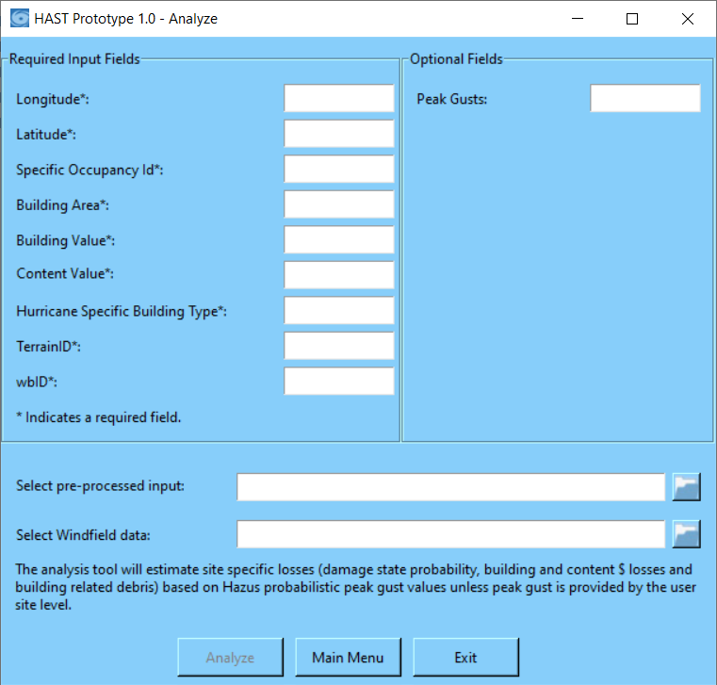

1. Select the input file as selected in step 5. HAST provides the option of probabilistic or user defined analysis. If you choose an input that does not have site-specific peak gusts, HAST expects the probabilistic wind fields file in the Select Windfield data box. If an input with site-specific peak gusts is chosen HAST expects “peakgusts” the field input dataset.

The following image display’s the screen when performing probabilistic analysis. Click the Analyze button to generate the losses for the 9 loss categories: Affected, Minor, Major, Destroyed, Building Loss, Content Loss, Loss of Use, Brick & Wood Debris, Concrete & Steel debris.

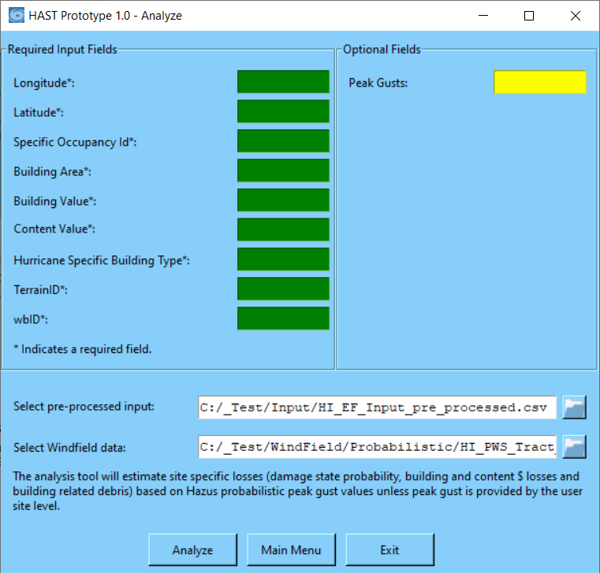

1. **Settings.xml – How to…**

The Settings.xml governs majority of the settings under which the tool runs. For example, after installing HAST if you wish to change your input folder to refer to a folder on your disk where you have many other datasets, that can be modified by changing the <InputPath> tag under <GeneralSettings>.

Keeping the global settings in an xml file gives the flexibility of expansion.

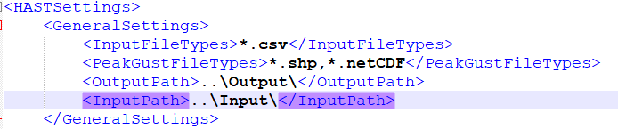

1. **Troubleshooting:**

If the required fields do not match the Settings.xml, the program cannot run.

If a .csv file is not selected, the program cannot run.

**NOTES:**

The zip file version of HAST comes with the complete python environment packaged in it

The GitHub version of HAST does not come with the python environment. You will have to download another tool called Hazus-toolkit from the following link: <https://github.com/nhrap-dev/hazus-toolkit> and install Anaconda v3.7 to setup the environment.