**Merging branches on GitHub**

1. You can either click on “Compare & pull request” or on the branches tab

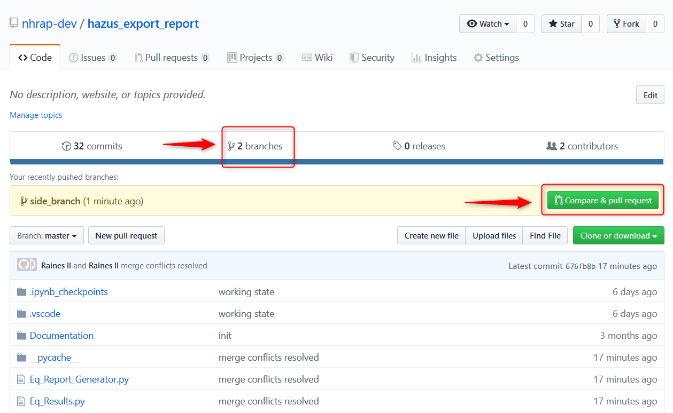

1. If you click on the branches tab you will have to click “New pull request”

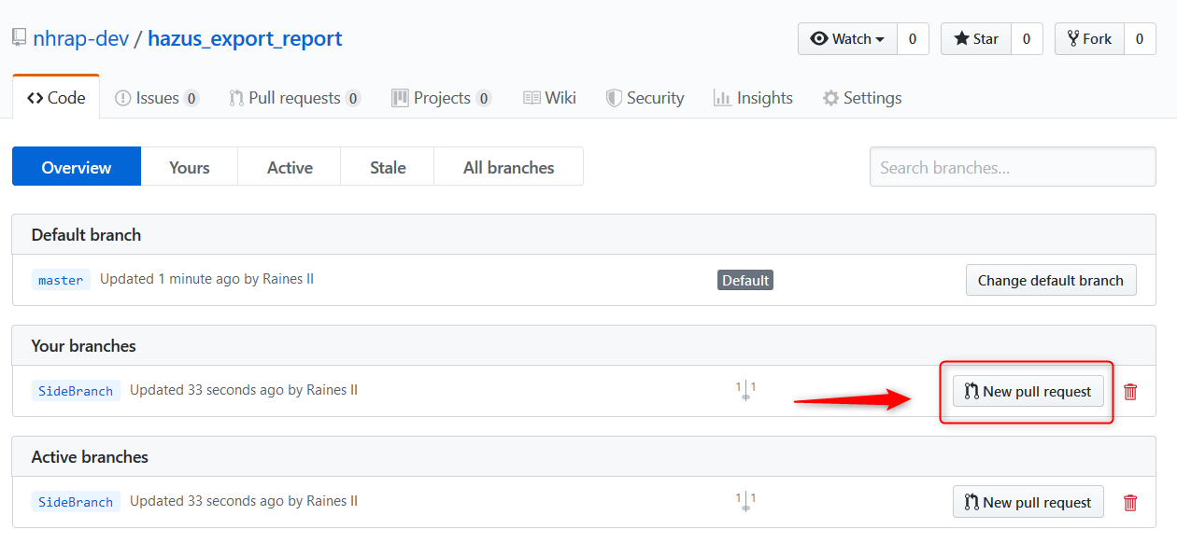

1. If there are no conflicts, you will see “Able to merge”. You can click “Create pull request” and click through the rest

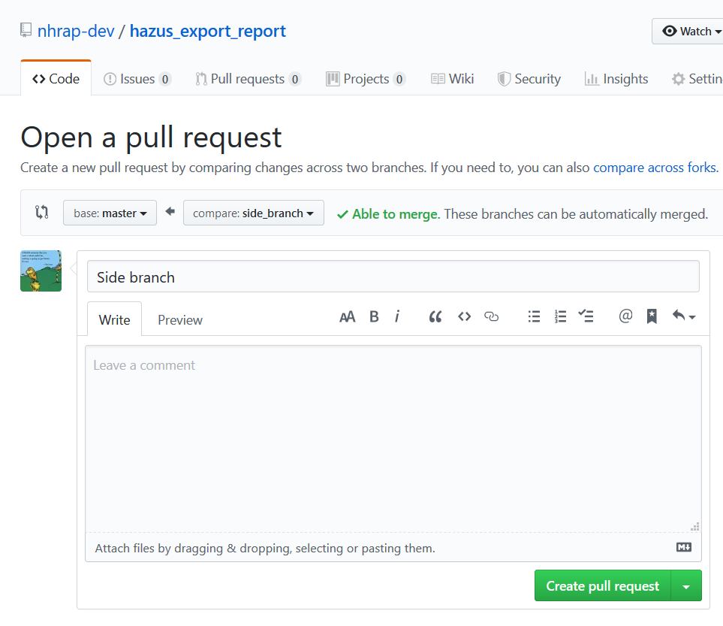

1. If conflicts exist, you will see “Can’t automatically merge” and you will click on “Create pull request”

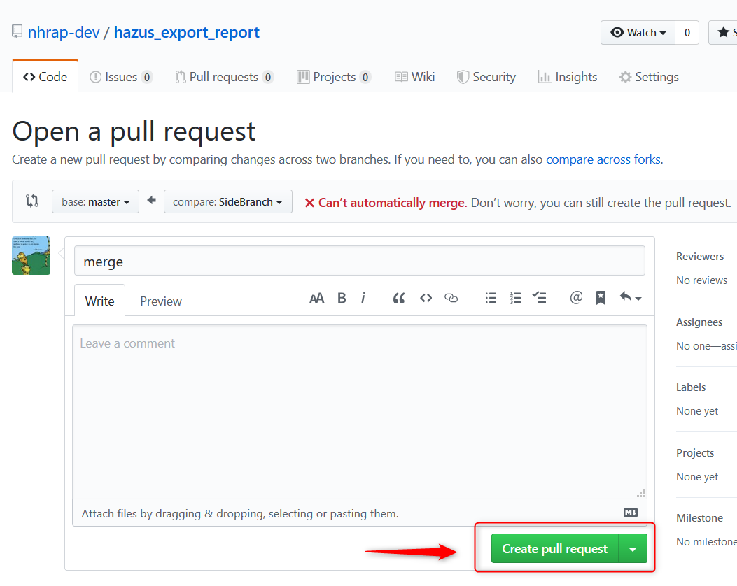

1. You will then click on “Resolve conflicts”

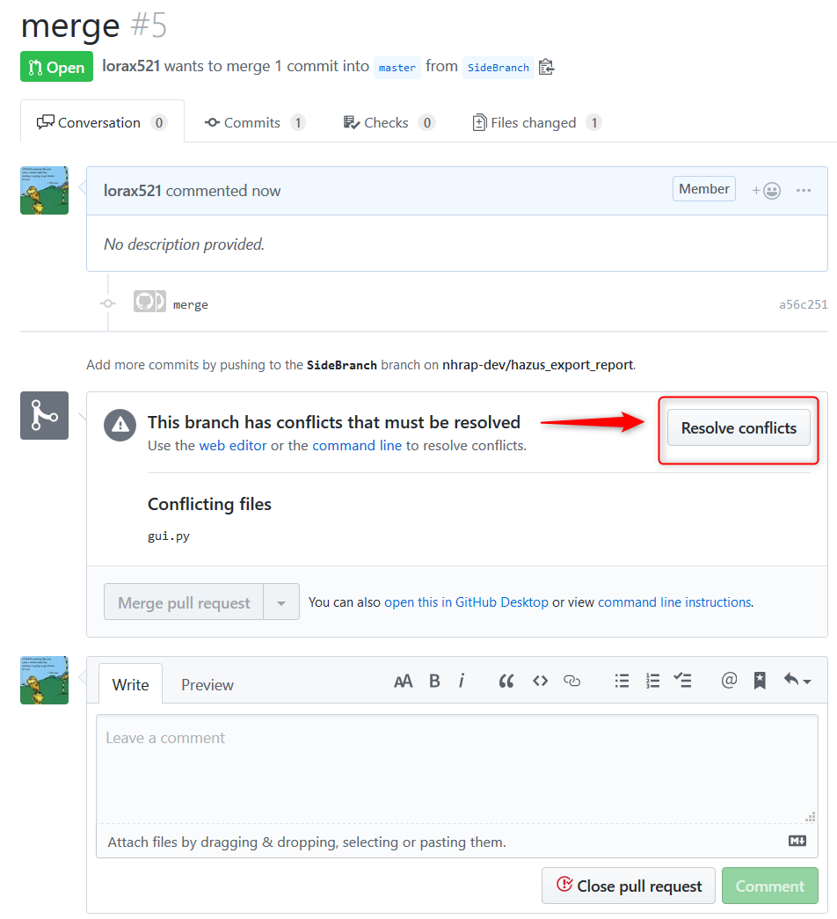

1. You will scroll through the code and look for arrows and brackets like the ones below. The <<<<<<< SideBranch shows all the code on the new branch that doesn’t match the master. >>>>>> Master shows all the code in the master branch that doesn’t match the new branch.

======= will separate the branches.

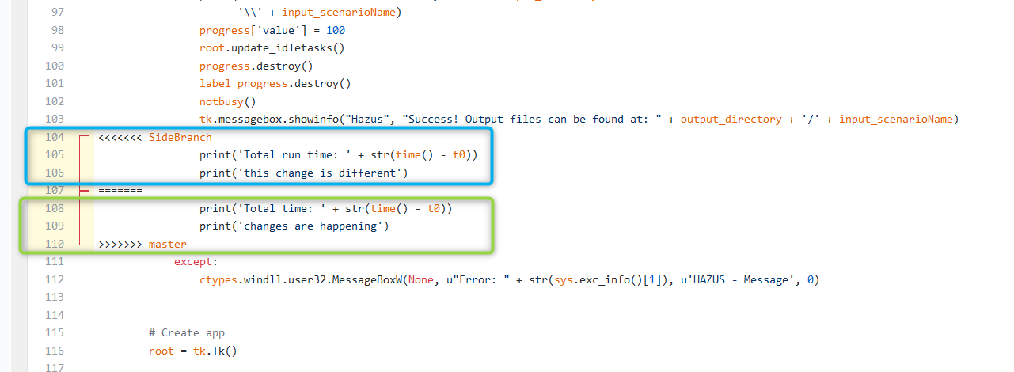

1. Delete the code you don’t want, like the highlighted code below.

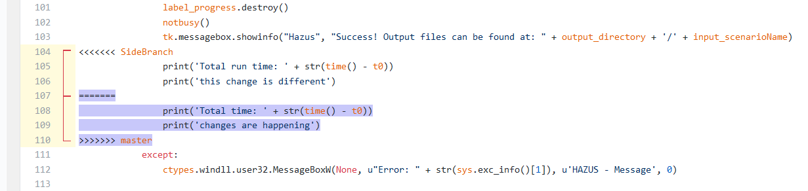

1. Finished changes should look like this

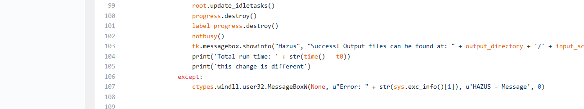

1. Click “Mark as resolved” in the top right once you’ve reconciled the conflicts

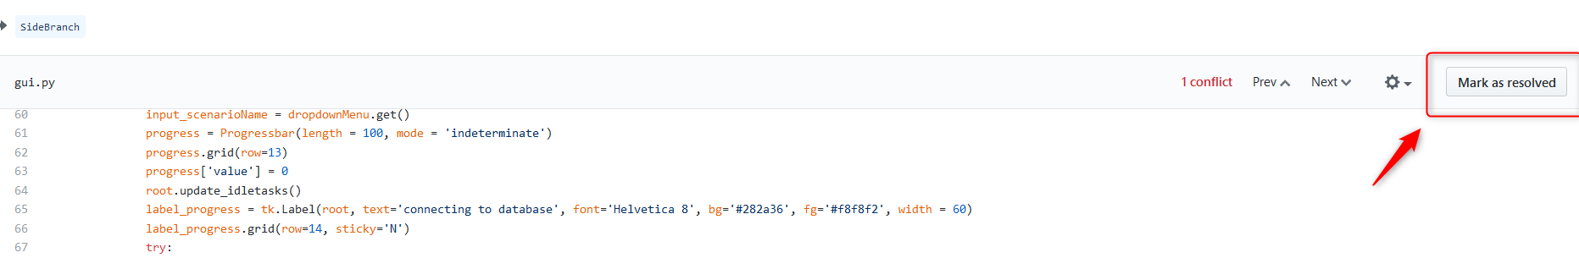

1. 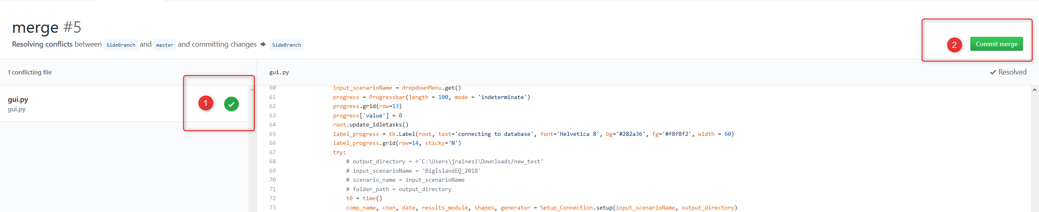Then you should see a check mark for the file. Repeat this for all files that need conflicts resolved, then click “Commit merge” in the top right.
2. Once all conflicts have been resolved click “Merge pull request”

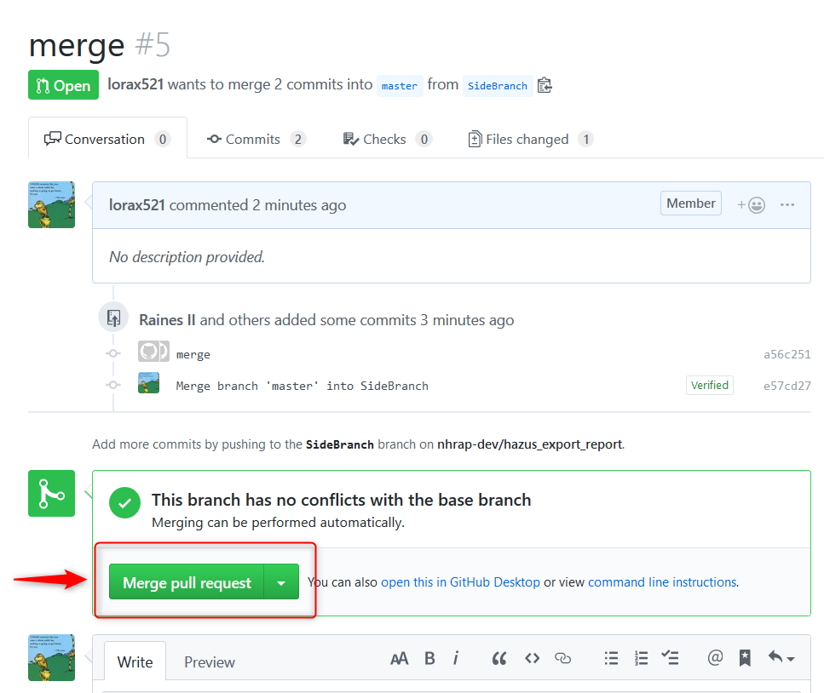

1. Click “Confirm merge”

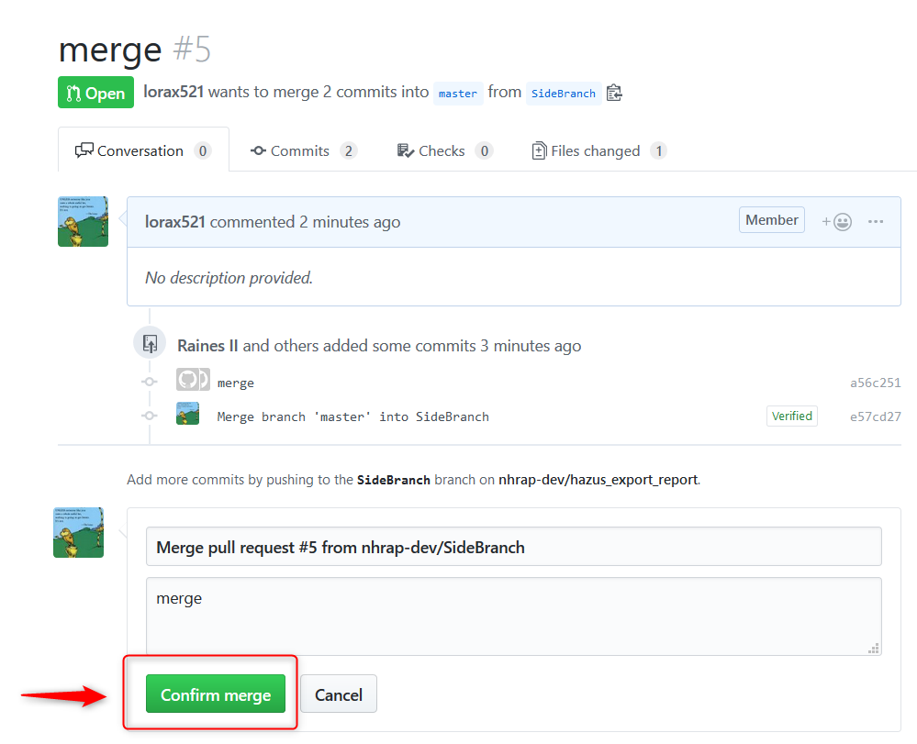

1. Then you can delete the branch you no longer need

