
NHRC-2.1
User Guide

Software Version: | 1.02
User Guide Version: | 2012-Sep-22

Copyright Notice

Copyright © 2012 by NHRC LLC
This document contains proprietary information that is the confidential property of NHRC LLC.
No part of this document may be used or reproduced, by any means, for any purpose, without the expressed written consent of NHRC LLC.
No part of this document should be considered to be specifications for the proper or correct operation of the NHRC-2.1 Repeater Controller. In no way will NHRC LLC be liable for direct or indirect damages to the controller or attached equipment.

Printed in the U.S.A.

Thank You!

Thank you for purchasing the NHRC-2.1 Repeater Controller. This controller has been designed using the very latest state-of-the-art technology. Please review this manual carefully before putting your controller into operation.
This manual represents a very large documentation effort. Your comments are important to us. If you find an error or find any passages that are not clearly understandable, we would like to hear about it. Please send your comments to software-support@nhrc.net.
Support for the controller is available by email or telephone. Please direct software-related questions via email to software-support@nhrc.net. Please direct hardware-related questions via email to hardware-support@nhrc.net . Your question(s) will be answered promptly.
Questions of a more urgent nature can be answered by telephone support. Telephone support is available Monday through Thursday, from 6 PM until 9:30 PM, Eastern time.

1. Introduction 4
1.1 Sending commands 5
1.2 ID Messages 5
1.3 Controller Modes 6
1.4 Programming Mode 6
1.5 Simplex Repeater Controller operation 7
2. Electrical Connections 8
2.1 Input and Output Signal Levels. 8
2.2 J1: Repeater Connector 9
2.2.1 Use of the Fan Control Digital Output 9
2.3 J2: NHRC-DAD Interface 10
2.4 J3: DC Power Connector 10
2.5 Audio Level Adjustment 11
2.5.1 Description of Audio Processing: 11
2.5.2 Description of Controls: 11
2.5.3 Audio Level Setup: 12
2.6 The LED Indicators 13
3. Programming the Controller 14
3.1 Quick Setup 14
3.2 Initializing the Controller 16
3.3 *0: Programming Mode Control Operator Access 17
3.3.1 Set Control Operator Switches 17
3.4 *1: Save Setup 18
3.4.1 Save configuration setup 18
3.5 *2: Program Command Prefixes 19
3.5.1 Set command prefix 20
3.6 *3: Set timers, Morse code speed and Pitch. 21
3.6.1 Description of Timers 21
3.6.2 Program a timer or Morse code speed and Pitch. 22
3.7 *4: (Reserved for NHRC) 23
3.8 *5: (Reserved for NHRC) 23
3.9 *6: (Reserved for NHRC) 23
3.10 *7: Program Morse code and Beep Messages 24
3.10.1 Program a Morse code ID 24
3.10.2 Program or play courtesy tones 25
*8: Play/Record Voice Tracks 27
3.10.3 Play a message 27
3.10.4 Record a message 28
3.11 *9: (Reserved for NHRC) 28
3.12 **: Reset Controller 28
4. Control Operator Commands 29
4.1 Group 0 Switches: Repeater Control 30
4.2 Group 1 Switches: More Repeater Control 31
4.3 Group 2 Switches: Voice ID and Misc. Control 33
4.4 Group 3 Switches: IDer Control 34
4.5 Group 4 Switches: Reserved 35
4.6 Group 5 Switches: Reserved 36
4.7 Group 6 Switches: Programming Write Protect 37
4.8 Group 7 Switches: Control Operator Group Access 38
5. User Commands 39
5.1 DTMF Access 39
5.2 Load Saved Setup 40
6. Appendices 41
6.1 Factory Defaults 41
6.1.1 Default Command Prefixes Table 41
6.1.2 Timer Defaults Table 42
6.1.3 Courtesy Tone Component Tones Table 43
6.1.4 Morse Code Character Table 44
6.2 Control Operator Controls 45
6.2.1 Control Operator Group 0 (Repeater Control) Operations Table 45
6.2.2 Control Operator Group 1 (Repeater Control II) Operations Table 45
6.2.3 Control Operator Group 2 (Voice and Tail ID Messages) Operations Table 46
6.2.4 Control Operator Group 3 (IDer Control) 46
6.2.5 Control Operator Group 4 (Reserved for NHRC) Operations Table 47
6.2.6 Control Operator Group 5 (Reserved for NHRC) Operations Table 47
6.2.7 Control Operator Group 6 (Programming Write Protect) Operations Table 48
6.2.8 Control Operator Group 7 (Control Operator Group Access) Operations Table 48
6.3 Terminology and Abbreviations 49
7. Circuit Board 50
7.1 Interconnections 50
7.2 Jumpers 50
7.3 NHRC-2.1 Detailed Top-View Diagram 51
8. Schematics 52
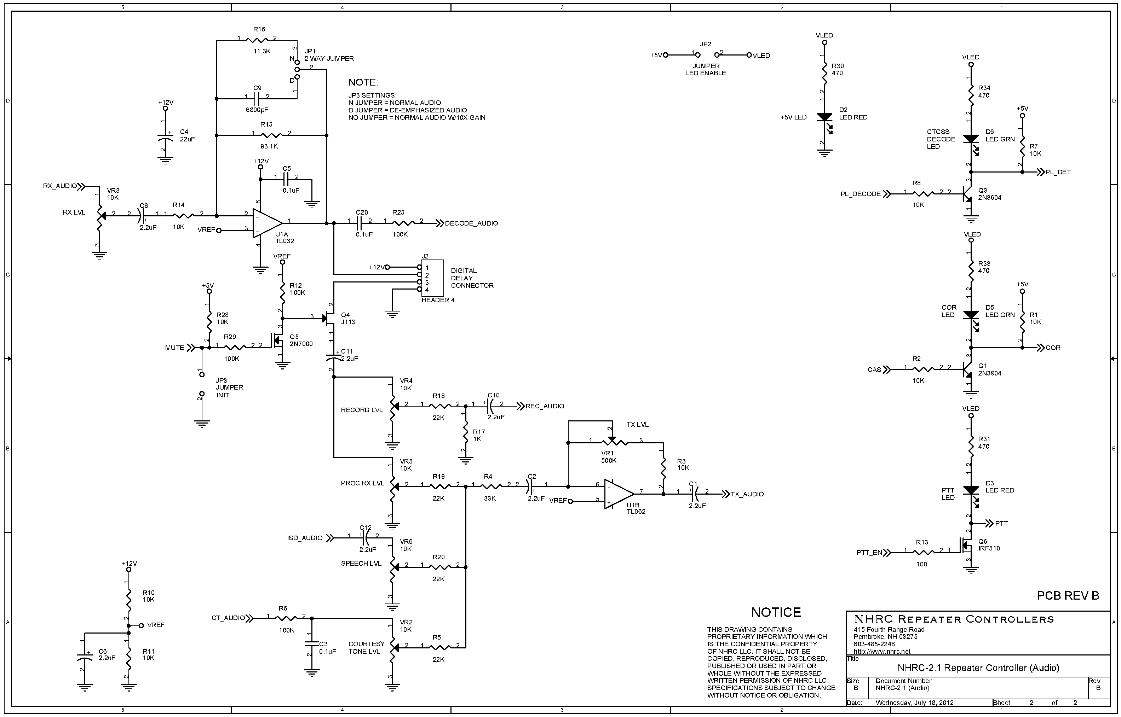 54
9. Parts List 55
10. Electrical Specifications 58
11. NHRC LLC Limited Warranty 59

Introduction
The NHRC-2.1 Repeater Controller represents the current state-of-the-art in repeater controller designs. It utilizes the latest available technology to provide maximum functionality with the lowest number of parts. This results in very reliable operation.
The key features of the NHRC-2.1 are:
- Recording of two real speech ID messages, one real speech time-out message, and one real speech tail message.
- Local language support using a custom recording capability.
- Simplex repeater mode.
- Transmitter fan control output automatically runs fan while transmitting and for a programmable delay after.
- DTMF, "Carrier,” “Carrier and CTCSS,” and “Carrier or CTCSS” access modes.
- Granular security features that allow tailored control operator access.

Sending commands
All of the controller’s commands are sent by DTMF (Touch-Tone®) sequences that are received on the main repeater. DTMF tones received will be evaluated, and if correct, executed, when either the DTMF inter-digit timer expires (2.0 seconds) or the CAS (receiver unsquelched) signal drops; whichever comes first. This allows the controller to be commanded even when a weak on-channel signal is holding the receiver’s squelch open.
To send a command over the main repeater input:
- Key your transmitter.
- Enter the DTMF command digits.
- Unkey your transmitter.
This will cause the command to be evaluated immediately.
If you pause for more than 2.0 seconds while sending a command, the command you entered prior to the pause will be evaluated, the command buffer will be emptied, and you can immediately enter another command.
When a command is successfully evaluated, the controller will send a response. Each command’s possible responses are detailed with the command description.
In general, if you do not receive a command response, then the controller did not accept your command.

ID Messages
The controller supports two voice ID messages and one Morse code ID.
The voice messages are comprised of:
- an “initial” ID message, that plays when the controller has been idle for a period longer than the ID timer, and
- a “normal” ID messages, that plays during repeater use.
Each of the ID messages can be individually enabled or disabled. The Morse code ID will play when a voice ID message is required but disabled. The Morse Code ID will also play if the ID timer expires during a user’s transmission. The controller tries to be “polite” when identifying; if it is almost time to ID when a user unkeys, the ID is sent immediately.
Be sure to either record the voice ID messages or disable them. If the ID messages are not recorded, but left enabled, an empty message will play instead of an ID.

Controller Modes
The NHRC-2.1 repeater controller operates in two distinct modes. These are the “normal mode” and the “programming mode”.
The “normal” mode is just that – the mode the controller operates in normally.

Programming Mode
All of the controller’s important programming information is protected by a special password, the “enter program mode” command. Programming mode allows the repeater owner to change the timer values, command codes, CW ID messages, and voice messages. These cannot be programmed in “normal” mode.
The “enter program mode” command has additional protection – changing it requires physical access to the controller to place a jumper on the circuit board. This prevents an unauthorized user from locking you out of your own controller.
Take extra care when changing the “enter program mode” command -- write down your new command code and keep it in a safe place in case the code is forgotten, as there is no other way to change this code without physical access to the controller.
When the “enter program mode” command is successfully sent to the controller, the controller will transmit “OK” in Morse code, and the courtesy tone will change to a special tone to indicate the controller is in programming mode.
When the controller is in programming mode, it can be returned to normal operating mode by:
- Sending the “#” command, or
- The controller will exit programming mode itself after two minutes of inactivity.
When the controller leaves the programming mode:
- The courtesy tone will revert to the normal tone for the controller’s current state.

Simplex Repeater Controller operation
The NHRC-2.1 can operate as a “Simplex Repeater Controller”. When configured as a simplexc repeater, the controller will record up to 40 seconds of audio from the receiver, and then repeat that audio to the transmitter. The controller normally waits in “listen” mode, and when the receiver becomes active, it records up to 40 seconds of the received audio into the ISD voice storage chip. When the receiver becomes inactive, the controller will then key the transmitter and play the recorded message. (See section 4.2 for information on setting Simplex Repeater operation.)
The NHRC-2.1 can provide a “voice ID” when operating as a simplex repeater. When this feature is enabled, the controller will play message 0 “initial ID”. Note that the total record time when using the “voice ID” feature is reduced to 32 seconds, in order to accommodate the voice ID message. (See section 4.2 for information on configuring Simplex Repeater operation.) If the voice ID mode is not selected, the NHRC-2.1 will ID the simplex repeater in Morse code.
⇒ Note: All message tracks will be erased upon entering simplex repeat mode.
For US Amateur Radio operation, you should read and understand the FCC Part 97 regulations prior to operating a simplex repeater.

Electrical Connections
This section of the User Guide describes the electrical interfaces used to connect the controller to:
- Power
- Repeater
- Communications Specialists TS-64 CTCSS Encoder/Decoder
- NHRC-DAD digital audio delay board.
It is intended for the repeater operator to use in the planning and installation of the NHRC-2.1 Repeater Controller into a repeater system.

Input and Output Signal Levels.
Control signals into the controller are active-high signals. The repeater activity inputs (CAS and CTCSS Decode) are buffered to allow the connection of popular radios to the controller. The active high signals, the levels should be 0.0 to 0.5 volts for off, and 2.0 to 16.0 volts for on.
The controller’s PTT and FAN CONTROL outputs are “open-drain” connections to power MOSFETs. These outputs are active-low, and when activated, will pull the control signals to within a few ohms of ground. These outputs can sink 100 mA or so. NHRC recommends that reverse-biased rectifier diodes be used to protect the MOSFETs from back-EMF if these signals are used to drive relays.
Audio signals into the controller should be in the range of 0.2 to 2.0 volts peak-to-peak. The controller’s transmit audio outputs are adjustable from about 0.1 volt to about 5 volts peak-to-peak. For best results an input level of 1V p-p or greater will yield the best overall audio performance.

J1: Repeater Connector
The main repeater is connected to the controller through the “J1 REPEATER” connector.
J1 is a Female DB9 Connector.
A Male DB9 Connector is included with the controller.
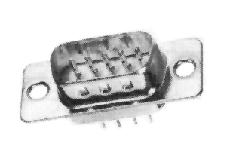
Male DB-9 Connector

J1 REPEATER Connector Pin-out
Pin # | Use | Comments
1 | Ground
2 | CTCSS Decode | Active High
3 | PTT | Active Low
4 | Transmit Audio | From Controller
5 | Receiver Audio | To Controller
6 | No Connection | reserved
7 | CAS | Active High
8 | Ground
9 | Fan Control | Active Low

Use of the Fan Control Digital Output
The NHRC-2.1 has a digital output that is intended to control a fan on the repeater’s transmitter. This output will be activated (the output MOSFET will close the pin to ground) when the transmitter is on and for a programmable amount of time after the transmitter shuts off. See section 3.7 for information on programming the fan timer.
The digital output can be configured to be under control operator control, and not used as the fan timer. Control operator group 2 option 4 can disable the automatic fan control, and control operator group 2 option 5 can then be used to turn the output on of off. See section 6.2.3 for more information on these options.

J2: NHRC-DAD Interface
J2 is provided for the connection of an optional NHRC-DAD digital audio delay. The NHRC-2.1 uses the audio delay provided by the NHRC-DAD to more completely mute DTMF and reduce or eliminate squelch crashes from the repeater audio.
J2 DELAY Electrical Connections
Pin | Use
1 | +12 Volts to delay board
2 | Audio to delay board
3 | Audio from delay board
4 | Ground/Audio Return

⇒ Note: If an NHRC-DAD is not connected, then a jumper should be installed between pin 2 and pin 3. If there is not an NHRC-DAD or a jumper installed, then the controller will not pass audio.

J3: DC Power Connector
A mating power connector is supplied with the controller.
DC Power is supplied to the controller at connector “J3 +12V,” with a 5.5 mm coaxial power connector.
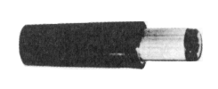
5.5 mm Coaxial Power plug

⇒ Caution: Reverse polarity could damage the controller, and will probably blow the controller’s fuse.

J3 +12V Connector Pin-out
Pin # |  | Use
Sleeve | “Outer Barrel” | Ground
Tip | “Inner Connector” | +12V

Audio Level Adjustment

Description of Audio Processing:
The NHRC-2.1 uses analog switching and audio mixing to route audio from audio sources to the transmitter port and voice recorder.
The controller’s audio path is described in detail below:
The main receiver’s audio is passed into the controller through potentiometer VR3 “RX LEVEL”, and then buffered through audio amplifier U1A for impedance isolation and equalization. This amplifier can be set up to provide flat audio response or 6 dB/octave de-emphasis with a roll-off of approximately 250 Hz, allowing the use of discriminator audio. The buffered audio is then passed to touch-tone decoder U2, and through connector J2 “DELAY” to the optional digital audio delay board for squelch tail elimination. If the digital audio delay is not present, J2 pins 2 and 3 must be jumpered to allow audio to continue to pass through the controller. After the digital audio delay connector, the main receiver audio is gated through analog switch Q4. The gated audio is supplied to the transmitter mix bus via, potentiometer VR5 “PROC RX ”, and into the digital voice recorder (DVR) chip via potentiometer VR4 “RECORD”.
Flat or de-emphasized audio on the repeater port is simply selected by moving the shorting jumper JP1 from (N) normal position to (D) de-emphasized position. Note: if the jumper is completely removed, the audio processing circuit will provide approximately a 10X audio gain with flat response.
Courtesy tones are generated directly by the microprocessor U5, filtered, and provided to the transmitter mix bus through potentiometer VR2 “BEEP”.
DVR output is provided to the transmitter mix bus through potentiometer VR6 “SPEECH”.
The transmitter mix bus is provided to the main transmitter through buffer amplifier U1B, with it’s level adjusted with potentiometer VR1 “TX LEVEL”.

Description of Controls:
VR1 “TX LEVEL” sets the transmit audio master level.
VR2 “BEEP” sets the beep level into the transmitter mix bus.
VR3 “RX LEVEL” sets the receiver audio input level into the controller, and more critically, into the DTMF decoder.
VR4 “RECORD” sets the receiver audio level into the ISD voice recorder IC.
VR5 “PROC RX” sets the receiver audio level into the transmitter mix bus.
VR6 “SPEECH” sets the recorded speech level into the transmitter mix bus.

Audio Level Setup:
Recommended equipment:
- Signal generator or another method of generating a RF signal for the main receiver, modulated with a 1 KHz tone at 3 KHz deviation.
- Deviation meter.
- A Service Monitor is recommended for overall ease of alignment.
Procedure:
The reference level will be a 1 KHz tone at 3 KHz deviation.
- Prepare the controller for audio alignment by setting all potentiometers to the midrange position, and properly configuring the input equalization (normal or de-emphasized) by setting jumper JP1 to the appropriate pins for the equalization you want.
- Transmit the reference tone through the repeater, and adjust VR3 “RX LEVEL” for reasonable transmitted deviation, about 3 KHz. The final adjustment of VR3 will occur later. Turn off the reference signal.
- Transmit some DTMF tones into the repeater, and adjust VR3 for reliable DTMF decoding, as indicated by LED D3. Test every DTMF key, including *, #, A, B, C, and D. If the level of VR3 is set too high, voice clipping, squelch noise bleed-through, and/or false DTMF decoding may occur.
- Use VR5 “PROC RX ” to set the received audio repeat level.
- Use VR2 “BEEP” to set the courtesy tone to a reasonable level.
- Enter programming mode and then have the controller transmit the recorded voice ID with the *800 command. Set the DVR playback level with VR6 “SPEECH”. Exit programming mode by sending DTMF “#”.
- Set the DVR input level with VR4 “RECORD”. This is best set by setting the controller into simplex mode, recording a test message and allowing it to play back. Adjust the input level so that the test message is played back at the same level as it originally passed thorough the repeater. Overdriving the DVR will result in compression of recorded audio, complete with “noise pumping” effects, so it is important that the level is not set too high. Conversely, setting the DVR record level too low will result in noisy playback performance.
Hint: With the controller in duplex mode (not simplex), set up your signal generator with the test tone. Note the deviation of the repeater’s transmitted signal. Shut off the generator. Now set the controller into simplex mode and send the test tone for 15 or 20 seconds, then turn off the test tone. The DVR will now play back the recorded test tone. Note the deviation. Repeat this test and adjust the DVR input until the record and playback deviation is the same. Be careful to remember to subtract out your CTCSS deviation to get a true DVR deviation measurement.
- If necessary, the output level of the controller can be adjusted with VR1 “TX LEVEL”.

The LED Indicators
The NHRC-2.1 has five LED indicators. These LEDs indicate the state of various inputs and outputs of the controller. The LEDs are particularly useful during setup. The LEDs display the following information:
NHRC-2.1 LED Indicator Functions
LABEL | COLOR | USE
+5V | Red | Power Indicator
PTT | Red | Transmit Indicator
DTMF | Yellow | DTMF Detect Indicator
COR | Green | Receiver Unsquelched Indicator
CTCSS | Green | CTCSS Detect Indicator

All LEDs can be disabled to reduce power consumption by removing jumper JP2 “LED EN”.

Programming the Controller
This section of the User Guide describes how the repeater operator programs the repeater.
It is intended for repeater operators and users who have an interest in how the controller is customized for specific configurations.
⇒ Note: *n commands are only available when the controller is in the “Programming Mode.”

Quick Setup
This section of the User Guide is intended to get a first-time user “up and running” quickly using a minimum of the customizable features.
Factory assembled NHRC-2.1 controllers are shipped from the factory enabled, with test audio tracks recorded for all messages, and all command prefixes programmed to the default values. Once your controller is installed and functioning, you should follow the procedure described in this section to begin to customize its operation to suit your needs.
WARNING: Read this!
The initialization process described below will completely reset the controller to the factory defaults. All the test voice messages will be deleted, and the repeater will be set as disabled. This allows users with a simplex repeater to program their controller. Once initialized, the controller will appear to be dead except when valid commands are entered, until the “repeater enable” control operator command is sent.
You are not required to use this procedure. It is completely possible to program the NHRC-2.1 as shipped from the factory without initialization, unless you plan to use it on a simplex repeater. In the case of simplex repeater use, initialization will help since it will cause the controller to power up with the repeater disabled.
Procedure:
- Make all the necessary electrical connections. See Section 2.
- Install the initialize jumper (JP3 “INIT”, located in the lower right hand corner of the board.)
- Apply power to the NHRC-2.1. After a short pause, the controller will transmit “NHRC 2.1 V x.xx” in Morse code. (The “x.xx” will be replaced with the firmware version number.)
- Leave the initialize jumper installed for this operation.
- Send the default programming mode code (07) to the controller. The controller should respond with “OK” in Morse code.
- Use the *2 command to program command prefix 07: the “enter programming mode” code. (See section 3.6 for information on programming command prefixes.)
- Example: To program the “enter programming mode” code to 314, send the following command: “*207314”.
- Send the “#” command to exit programming mode. The controller should respond with “OK” in Morse code.
- Remove the initialize jumper (JP3 “INIT”, located in the lower right hand corner of the board.)
You should record the voice ID messages (#0, and #1), the time-out message (#2), possibly the tail message (#3) and program the Morse code ID at this time. (See Sections 3.11.1 and 3.11.4 for information on programming the Morse code ID and recording voice messages.)
We recommend that you use the default prefixes until you become familiar with this manual and controller operation. Once you are familiar with the operation of the controller, consult section 3.6 for information on programming command prefixes.
⇒ Note: After initialization, the controller will respond to commands, but will not function as a repeater until repeater operation is enabled. This allows the controller to be configured in simplex repeaters. See section 4.1 for information on enabling the repeater.

Initializing the Controller
Initializing the controller will re-program the controller’s non-volatile EEPROM memory with the factory defaults. All customized settings are lost, including command prefixes, timer presets, the Morse code ID, and the voice messages.
⇒ Note: The controller should never require initialization except for newly assembled controllers.
⇒ Note: After initialization, the controller will respond to commands, but will not function as a repeater until repeater operation is enabled. This allows the controller to be configured in simplex repeaters. See section 4.1 for information on enabling the repeater.
Procedure:
- Install the initialize jumper (JP3 “INIT”, located in the lower right hand corner of the board.)
- Apply power to the controller. After a short delay of about 10 seconds, the controller will send the Morse code message “NHRC 2.1 V x.xx” (where “x.xx” will be replaced with the firmware version number.)
- Remove the initialize jumper.
⇒ Note: DO NOT LEAVE THE INITIALIZE JUMPER INSTALLED, otherwise the controller will initialize again the next time it is powered up, CLEARING ALL OF YOUR PREVIOUSLY STORED SETTINGS.

See the Appendix for the factory defaults for the controller.

Programming Commands
The NHRC-2.1 has 6 commands that are entered only during programming modes. These commands all start with a asterisk (*). The commands are summarized immediately below, and described in following sections.
Programming Commands
Command | Function
*0 | Set Control Operator Options
*1 | Save Configuration Setup
*2 | Set Command Prefix
*3 | Set Timers
*7 | Program CW and tone messages
*8 | Play/Record Voice Tracks

*0: Programming Mode Control Operator Access

Set Control Operator Options
The *0 command allows access to all control operator option groups, including groups 6 and 7 which are not accessible using the control operator prefix. Groups 6 and 7 help to implement controller security by controlling write access to controller data and control operator access to the other six groups.
This command exists to allow the control operator options to be adjusted when in programming mode. It produces the same effect as the “control operator code”.
The format of this command is
*0<group><option><state> where:
<group> | specifies the group number. Valid range is 0 to 7.
<option> | specifies the option number. Valid range is 0 to 7.
<state> | is optional. If present, it is the new state of the option. Valid values are 0 and 1.

⇒ Note: Upon receipt of a valid *0 command without the state <s>, the controller will transmit the current state of the selected control operator option.

Examples:
Sending the command “*000” will inquire the state of control operator group 0 option 0, and the controller will read back the current state: either “ON” or “OFF” in Morse code.
Sending the command “*0011” will set the state of control operator group 0 option 1 to ON, and the controller will send “ON” in Morse code.
Sending the command “*0230” will set the state of control operator group 2 option 3 to OFF, and the controller will send “OFF” in Morse code.

See Section 4 for more information about control operator options.

*1: Save Setup
The NHRC-2.1 Repeater Controller has five “saved configuration setups” that allow the repeater operator to save two presets of all 64 of the control operator options.

Save configuration setup
*1<n> where:
<n> | specifies the setup number to save. Valid range is 0 through 4.

After a valid command is received, the controller will respond with “OK” in Morse code.
A saved setup can be loaded by using the load saved setup command:
(See Section 5.2 for information about the Load Saved Setup command.)

Example:
To save the current controller state (all 8 control operator option groups) as state #0, send the following command with the controller in programming mode: “*10”. The controller will transmit "OK" in Morse code if the command is accepted.

⇒ Note: Saved setup 0 is automatically loaded into the controller at power up. Be sure to save the state you wish to have the controller in after a power interruption into saved setup 0.

*2: Program Command Prefixes
Every command accepted by the NHRC-2.1 controller when it is in “normal” mode consists of a command prefix and optional command arguments.
Each prefix can be programmed to restrict access to certain functions to only those users who know the prefix. This gives the repeater operator the ability to only allow specific users to access certain features.
Command Prefix Rules:
- A command prefix must be one to seven digits long.
- A command prefix cannot be left blank.
- No two command prefixes may be programmed the same, or be programmed the same as the beginning of a different prefix. For example, do not program the control operator prefix to “1234” and the DTMF access mode control prefix to “12345”, because the controller would not understand whether “123456” was intended to set control operator options or activate the DTMF access mode.
Section 6.1.1 describes the Factory Default Command Prefixes.

Set command prefix
*2<pp><prefix> where:
<pp> | specifies the prefix number to set. Valid values are in the range 00 to 15. Two digits must be used. See the Command “Prefixes by Number Table” to determine the prefix number you want to set.
<prefix> | specifies the new prefix to assign. Must be 1 to 7 digits in length.  The valid digits are 0-9, A-D, * and #.

After a valid command is received, the controller will respond “OK.”
Command Prefixes by Number
Prefix  Number | Description
00 | Control Operator
01 | DTMF Access
02 | (reserved for NHRC)
03 | Load Saved Setup
04 | (reserved for NHRC)
05 | (reserved for NHRC)
06 | (reserved for NHRC)
07 | Enter Programming Mode

⇒ Note: For security reasons, command prefixes will never be sent over the air by the controller.
Example: To set the DTMF access prefix to 4321, send the following command with the controller in programming mode: "*2014321”. The controller will respond with "OK" in Morse code if the command is accepted.
⇒ Note: For security reasons, command prefix 07 (the “enter programming mode” code) cannot be changed unless the initialize jumper (JP3 “INIT”) is installed. This means that the enter programming mode code cannot be changed without physical access to the controller. To change the code, install the jumper, enter the command, and remove the jumper. Do not leave the initialize jumper installed, and do not power up the controller with the initialize jumper installed, unless you want to reset the controller to factory defaults.
⇒ Caution: As noted in the Command Prefix Rules, do not set any prefix to use the same initial digits as any other prefix, because the controller will not be able to tell the difference between them. For example, if the load saved setup code is set to “123”, and the DTMF access mode code is set to “1234”, then when a user sends “1234123456” the controller will try to load saved setup 4 rather than enabling the controller in DTMF access mode.

*3: Set timers, Morse code speed and Pitch.
The NHRC-2.1 has ten programmable “timer” settings, some of which are not really timers, but are event counters.
Each timer has its own resolution that is the amount of time each timer count represents.
For example, the hang timer’s resolution is 0.1 seconds. To program a hang time of 5.0 seconds, the hang timer would actually be programmed to 50 because there are (50) 0.1 second intervals in 5.0 seconds.
The tail message counter is used to play the tail messages every n^{th} time the tail timer expires.

Description of Timers
Timer 00 (hang timer long) and 01 (hang timer short) are “hang” timers. One of these timers can be selected. The hang timer specifies the amount of time the transmitter stays on after the receiver input signal goes away. This is sometimes called the “tail” timer. You can select either the long hang timer or the short hang timer. The resolution of the hang timers is 0.1 seconds.
Timer 02 is the ID timer. This timer controls how long the period is before a Morse code ID message is sent. This timer is set in tens of seconds. For example, to set a 9 minute ID timer interval: 9 minutes is 540 seconds, so the timer would be set for 54.
Timer 03 is the DTMF access mode timer. In DTMF access mode, sending a DTMF command activates the repeater. The repeater can be de-activated with another DTMF command, or if a period of inactivity occurs. The DTMF access mode timer sets the amount of inactivity before the repeater automatically deactivates. This timer has a 10 second resolution.
Timers 04 (timeout timer long) and 05 (timeout timer short) control the timeout period. Timeout is the maximum amount of time the receiver can be active before the repeater assumes a stuck mike and stops repeating. These timers are set with a 1 second resolution.
Timer 06 (fan timer) controls how long the fan control output will remain active after the controller’s PTT signal is released. This timer uses 10-second resolution.
Timer 07 is the tail message counter. This timer is actually a counter. It sets the number of times the repeater “tail” (hang time) must end before the tail message plays.
Timer 09 (Morse code pitch) and Timer 10 (Morse code speed) allow the repeater owner to tailor the tone of the transmitted Morse code characters. They are technically not timers, but parameter settings. The Morse code pitch can be set to any of the 32 tones shown in section 6.1.3, and the Morse code speed set from 5 to 30 WPM.
Program a timer or Morse code speed and Pitch.
The NHRC-2.1 timers are programmed as follows:
*3<nn><time> where:
<nn> | specifies the timer to set. Valid range is 00 to 12. Both digits must be present. Consult the NHRC-2.1 Timers by Number Table for the timer number.
<time> | The value to program the timer to. The valid range for <time> is 0 to 255.

After a valid set timer command is received, the controller will respond with the word “OK” in Morse code.
NHRC-2.1 Timers, by Number
Timer  No. | Description | Timer  Resolution
00 | Hang timer long | 0.1 sec
01 | Hang timer short | 0.1 sec
02 | ID timer | 10 sec
03 | DTMF access timer | 10 sec
04 | Time-out timer long | 1 sec
05 | Time-out timer short | 1 sec
06 | Fan timer | 10 sec
07 | Tail Message Counter | 1 unuits
08 | (reserved for NHRC) | N/A
09 | Morse code Pitch | table index
10 | Morse code Speed | 1 WPM

Examples:
To program the ID timer to six minutes (360 seconds), send the following command with the controller in programming mode: "*30236”. If the command is accepted, the controller will respond with “OK” in Morse code.
To set the long hang timer for 20 seconds, send the following command with the controller in programming mode: "*300200”. If the command is accepted, the controller will respond with “OK” in Morse code.

*4: (Reserved for NHRC)
This command is reserved by NHRC for future expansion.

*5: (Reserved for NHRC)
This command is reserved by NHRC for future expansion.

*6: (Reserved for NHRC)
This command is reserved by NHRC for future expansion.

*7: Program Morse code and Beep Messages
The *7 command is used to program or play the Morse code ID and courtesy tones.

Program a Morse code ID
The Morse code ID can be programmed or played with the *70 command, as follows:
*70<dd..dd..dd..> where:
<dd…dd…dd…> | is the Morse code ID message. If left blank, the current Morse code ID message will play. When present, the part of the command represented by <dd..dd..dd..> consists of 1 to 12 digit pairs. Each pair of digits represents one Morse code character.

(See the Morse Code Character Table, below, or in Section 6.1.4, to look up the code for each Morse code character.)

Example: To program “DE N1KDO/R” as the Morse code ID, the following command would be entered with the controller in programming mode: *70 31 32 11 62 01 52 63 12 72. Note: Please do not use this example and program N1KDO’s ID on your repeater. He has no sense of humor about this.

Morse Code Character Table

Number | Code |  | Number | Code |  | Number | Code |  | Number | Code
0 | 00 |  | A | 21 |  | K | 52 |  | U | 82
1 | 01 |  | B | 22 |  | L | 53 |  | V | 83
2 | 02 |  | C | 23 |  | M | 61 |  | W | 91
3 | 03 |  | D | 31 |  | N | 62 |  | X | 92
4 | 04 |  | E | 32 |  | O | 63 |  | Y | 93
5 | 05 |  | F | 33 |  | P | 71 |  | Z | 90
6 | 06 |  | G | 41 |  | Q | 70 |  | Space | 11
7 | 07 |  | H | 42 |  | R | 72 |  | / | 12
8 | 08 |  | I | 43 |  | S | 73
9 | 09 |  | J | 51 |  | T | 81

Program or play courtesy tones
The NHRC-2.1 supports two different courtesy tones. Courtesy tones are composed of up to four segments of tones. Each segment has a tone frequency and duration.
The courtesy tones are played and programmed with command *71 as follows:
*71<n><ddtt ddtt ddtt ddtt> where:
<n> | is the courtesy tone number to play or program. The valid range of values is 0 to 7.
<ddtt ddtt ddtt ddtt> | is up to four sets of duration and tone.
Duration is in 10 ms increments; valid range is 01-99. Both digits must be specified. Tone is the number of the tone from the Courtesy Tone Components Table below; or Section 6.1.3.

Example: The default courtesy tone #0, (four 50mS bursts of notes E5, G5, B5, D6) would be programmed like: *7100517052005240527. (with controller in programming mode)
Courtesy Tone Uses
Tone | Use
0 | Normal courtesy tone
1 | (reserved for NHRC)
2 | (reserved for NHRC)
3 | (reserved for NHRC)
4 | (reserved for NHRC)
5 | (reserved for NHRC)
6 | (reserved for NHRC)
7 | Programming Mode courtesy tone
Courtesy Tone Components Table
Tone Code | Tone |  | Tone Code | Tone |  | Tone Code | Tone |  | Tone Code | Tone
00 | None |  | 08 | C5 |  | 16 | G#5 |  | 24 | E6
01 | F4 |  | 09 | C#5 |  | 17 | A5 |  | 25 | F6
02 | F#4 |  | 10 | D5 |  | 18 | A#5 |  | 26 | F#6
03 | G4 |  | 11 | D#5 |  | 19 | B5 |  | 27 | G6
04 | G#4 |  | 12 | E5 |  | 20 | C6 |  | 28 | G#6
05 | A4 |  | 13 | F5 |  | 21 | C#6 |  | 29 | A6
06 | A#4 |  | 14 | F#5 |  | 22 | D6 |  | 30 | A#6
07 | B4 |  | 15 | G5 |  | 23 | D#6 |  | 31 | B6

*8: Play/Record Voice Messages
The NHRC-2.1 supports four stored voice messages. The *8 command allows the repeater operator to play or record the stored voice messages.
The repeater operator should record all of the controller’s speech IDs, tail messages, time-out message, etc.

Play a message
Command *80 is used to play messages:
*80<n> where:
<n> | is the message to be played. Valid range for <n> is 0 – 3.

Example: To play back the initial ID message (message #0), send the following command with the controller in programming mode: "*800”. The controller will play back the initial ID message.

NHRC-2.1 Stored Speech Messages
Message  Number | Usage
0 | Initial ID message
1 | Normal ID message
2 | Time-out message
3 | Tail Message

Record a message
Command *81 is used to record messages.
*81<n> where:
<n> | is the message to be recorded. Valid range for <n> is 0 – 3.
To record a message, enter *81, followed by the message number you want to record. The controller will prompt you sending “OK” in Morse code. After the prompt, key your radio and speak clearly to record the message. The recording is terminated when either you stop transmitting or the message slot is full (that is, the slot’s message time is all used). The controller will transmit “OK” again after the message is recorded.
Example: To record the timeout message (message # 2), send the following command with the controller in programming mode: "*812”. The controller will respond with a Morse code “OK”. Key your radio, and transmit your voice message you want to record. Recording ends either when you unkey, or the maximum message length for the message is reached, whichever comes first. The controller will acknowledge recording your message with a Morse code “OK.”

*9: (Reserved for NHRC)
This command is reserved by NHRC for future expansion.

**: Reset Controller
Command ** is used to reset the controller, like removing and then reapplying power.
The controller will send “NHRC 2.1 V x.xx” (where the “x.xx” is replaced with the firmware version number) in Morse code, and then play the initial ID.

Control Operator Commands
The control operator settings control the controller’s features, functions, and settings options. They can be accessed two different ways: through the “programming mode control operator access” commands (see section 3.3) or with the “normal” control operator commands.
The control operator commands are provided to allow the repeater owner to delegate control authority to a trusted group. The repeater owner should program the control operator prefix (see section 3.6) and share the prefix with the trusted group of control operators.
The NHRC-2.1 supports 64 different control operator settings arranged into eight groups of eight “options.” Each “options” is a setting in the controller that can be turned on or off. Every option is addressed by number of the group, and the number of the option in that group.
The format for all control operator commands is:
<ctl-op-prefix><group><option><state>
<ctl-op-prefix> | The control operator prefix assigned by the repeater operator. (See Section 3.6 for information on Programming Command Prefixes.)
<group> | The group number for the option to set or inquire. The valid range for <group> is 0 to 5. Groups 6 and 7 can only be accessed with the programming *0 command. (See Section 3.3 for information about *0: Programming Mode Control Operator Access.)
<option> | The option number to set or inquire. The valid range for <option> is 0 to 7.
<state> | optional. If present, it is the state (1=on, 0=off) to which the option is to be set.

When the <state> is not present, or after a successful control operator command that sets the option state, the controller will respond by transmitting either the word “ON” or the word “OFF”, depending on the state of the particular option.
Example: To set group 0 option 0 to enabled, the following command would be sent: <ctl-op-prefix>001. The controller will respond by transmitting the word “ON” in Morse code.
⇒ Note: All 64 of the control operator options are saved when the controller’s state is saved. Saved state 0 is automatically loaded on power up, so if you want to make your changes to the control operator options be restored after a power failure, it is important to save the controller’s state. See section 3.5 for information on the Save State Command.

Group 0 Options: Repeater Control
Group 0 contains options that control the main repeater and access to the main repeater.
Group 0 Options:
Option | Name | Description
0 | Repeater Enable | This is the repeater’s master enable/disable control. Set this to 0 to disable the repeater.
1 | Repeater CTCSS Required | Allows the repeater to be set into a CTCSS required mode when enabled. When disabled, the repeater is carrier access. Note: If CTCSS Required and “dual squelch” mode are both selected, then the controller will require valid CTCSS for access, unless the hang timer is running. This mode allows the repeater to be activated by a user with the valid CTCSS tone, but then accessed by users without CTCSS, or to be activated with a 1750 Hz. tone for countries that require tone-burst access.
2 | Key Up Delay (“Kerchunker Filter”) | Allows the “kerchunker filter” to be enabled. The “kerchunker filter” requires a signal for more than ½ second before the repeater will begin to repeat, but only when the transmitter is not on.
3 | Hang Timer Enabled | Normally enabled, but can be disabled when the repeater runs on battery power, or to discourage “kerchunkers.”
4 | Hang Timer Select | Allows the control operator to select which hang timer value is used. Allows the long (1) or short (0) timer to be selected.
5 | DTMF Access Mode Select | Allows the control operator to place the repeater into DTMF access mode. In DTMF access mode, the repeater, when idle, can only be activated by sending the DTMF access prefix, followed by a 1 to enable the repeater. The repeater will remain active until either disabled with the DTMF access prefix followed by a 0, or the repeater remains idle for longer than the time specified in the DTMF access timer.
6 | Courtesy Tone Enabled | Allows the courtesy tone to be enabled or disabled.
7 | Control Operator CTCSS required | When this option is enabled, control operator commands will only be accepted when the command is received with a valid CTCSS tone.

Group 1 Options: More Repeater Control
Group 1 contains options that control the main repeater and access to the main repeater.
Group 1 Options:
Option | Name | Description
0 | Repeater Time-out Timer Enable | Allows the time-out timer on the main repeater to be enabled or disabled. Normally the time-out timer will be enabled. However, certain applications may require that the time-out timer be disabled (nets, shuttle rebroadcast, etc.). Set this option to 1 to enable the repeater time-out timer.
1 | Time-out Timer Long Select | Allows the long (1) or short (0) timer to be selected.
2 | “Dual Squelch” Enable | Setting this option to 1 enables dual squelch mode. In “Dual-Squelch” mode, either the CAS or the CTCSS signal will cause the repeater to be accessed. This is sometimes called “OR-Squelch” mode.  Note that when this option is set (1) and the “Repeater CTCSS Required” option is set (1), (see Group 0 Options, section 4.1), then the controller will require valid CTCSS for access, unless the hang timer is running. This mode allows the repeater to be activated by a user with the valid CTCSS tone, but then accessed by users without CTCSS, or to be activated with a 1750 Hz. tone for countries that require tone-burst access
3 | DTMF Muting Enable | When enabled (1), the controller will mute the receiver audio to prevent received DTMF command tones from being broadcast over the repeater.
4 | Tail Message Enable | Enables Tail Message 1 (message #4) for playback when the tail message counter counts down to zero. If both tail message 1 and tail message 2 are enabled, they are alternated.
5 | (Reserved for NHRC)
6 | Simplex Repeater Mode | When enabled (1), the controller will function as a “simplex repeater”, recording up to 90 seconds of audio from the input, and playing it out the output when the input CAS drops.
7 | Simplex Repeater Voice ID Mode | When enabled (1), the controller will reserve message #0 (the initial ID track) from the space used for simplex mode, and it will play this track for the ID, rather than the Morse code ID.

Group 2 Options: Voice ID and Misc. Control
Group 2 controls the voice ID and tail messages.

Group 2 Options:
Option | Name | Description
0 | Enable Voice Initial ID | When enabled (1), the initial voice ID message is present. If disabled (0), the Morse code ID will play instead of the voice initial ID.
1 | Enable Voice Normal ID | When enabled (1), the controller will play the normal ID message voice track (#1) for the “normal” ID. If disabled (0), the controller will play the Morse code ID for the normal ID.
2 | (Reserved for NHRC)
3 | Allow ID Stomp by Keyup | When enabled (1), will allow the controller to cancel a voice ID and play the Morse code ID if a user begins to transmit while the voice ID is playing.
4 | Enable Voice Time-out Message | When set (1), enables the voice time-out message, instead of the Morse code time-out message “TO.”
5 | Digital Output Fan Control | When enabled (1), configures the digital output on the main repeater connector to be a fan control output. A fan connected to this output will run while the transmitter is keyed, and a programmable amount of time after the transmitter is unkeyed. When disabled, this input is controlled by the state of the Group 2 Option 6 (the next) option.
6 | Digital Output Control | When the digital output fan control mode is disabled, this option allows the control operator to set the state of the digital output on the main repeater connector.
7 | Digital Audio Delay Present | When enabled (1), changes the timing of the CAS logic in the controller to support the use of an NHRC-DAD on the repeater port.

Group 3 Options: IDer Control
Group 3 contains options related to ID control.
Group 3 Options:
Option | Name | Description
0 | European ID Mode | When enabled (1), the repeater will ID in a mode that is compatible with European rules.  When the repeater is idle, activating the repeater will cause the recorded Initial ID to play, and the ID timer reset to the programmed value. The Morse code ID can be played instead of the Initial ID by setting group 2 option 0 to 0.  When the repeater becomes idle, either the recorded Normal ID or the Morse code ID message will be played, and the ID timer reset to the programmed value. The recorded voice Normal ID can be selected instead of the Morse code ID by setting group 3 option 1 to 1.  When the ID timer times out (counts down to zero), the recorded Normal ID message will be played, and the ID timer reset to the programmed value. The Morse code ID can be selected instead of the Normal ID be setting group 2 option 1 to 0.  The ID will continue to play every time the ID timer times out.  The ID timer is set to 10 seconds at power up.
1 | European ID Mode End ID Selector | This option selects which ID plays when the hang timer times out, and the repeater becomes idle.  Set this option to 0 to play the Morse code ID, or set this option to 1 to play the recorded voice Normal ID.
2 | Reserved for NHRC
3 | Reserved for NHRC
4 | Reserved for NHRC
5 | ID Beacon Mode | When enabled (1) this option causes the controller to continuously ID every ID timer interval, regardless of input activity.
6 | NO Morse Code ID Mode | When enabled (1), the Morse code ID will NEVER play, only voice IDs will play
7 | NO ID Mode | When enabled (1), NO ID messages will play, ever.

Group 4 Options: Reserved
Group 4 contains options that are reserved by NHRC for future use.
Group 4 Options:
Option | Name | Description
0 | Reserved for NHRC
1 | Reserved for NHRC
2 | Reserved for NHRC
3 | Reserved for NHRC
4 | Reserved for NHRC
5 | Reserved for NHRC
6 | Reserved for NHRC
7 | Reserved for NHRC

Group 5 Options: Reserved
Group 5 contains options that are reserved by NHRC for future use.
Group 5 Options:
Option | Action | Description
0 | Reserved for NHRC
1 | Reserved for NHRC
2 | Reserved for NHRC
3 | Reserved for NHRC
4 | Reserved for NHRC
4 | Reserved for NHRC
5 | Reserved for NHRC
6 | Reserved for NHRC
7 | Reserved for NHRC

Group 6 Options: Programming Write Protect
Group 6 contains options that enable or disable modification to controller data. These options serve as a “write protect” to help prevent accidental reprogramming of repeater features. Each option, when enabled (1), write protects its associated setup information. This entire group cannot be accessed by the control operator, it can only be accessed when the repeater is in programming mode, by using the *0 command. (See Section 3.3 for information on the programming mode control operator access.)
Group 6 Options:
Option | Name | Description
0 | Write Protect Control Group Setups | When enabled (1), causes the *1 command (Save Setup) to fail, effectively disallowing control groups to be saved.
1 | Write Protect Command Prefixes | When enabled (1), causes the *2 Program Command Prefix command to fail, effectively disallowing modification of the command prefixes.
2 | Write Protect Timers | When enabled (1), causes the *3 Set Timers command to fail, effectively disallowing modification of the timer values.
3 | Reserved for NHRC
4 | Reserved for NHRC
5 | Reserved for NHRC
6 | Write Protect Morse code Messages and Courtesy Tones | When enabled (1), causes the *70 and *71 commands to fail when new messages are specified, effectively disallowing modification of the Morse code ID and courtesy tones.
7 | Write Protect Voice Messages | When enabled (1), causes the *81 “record voice message” command to fail, effectively disallowing modification of the voice message tracks.

Group 7 Options: Control Operator Group Access
Group 7 contains options which enable or disable control operator access to the control operator groups. This entire group cannot be accessed by the control operator, it can only be accessed when the repeater is in programming mode, by using the *0 command. These options allow the repeater operator to selectively disable control operator functions on a group-by-group basis, allowing more granularity of controller security. (See Section 3.3 for information on the programming mode control operator access.)
Group 7 Options:
Option | Name | Description
0 | Enable Control Operator Access to Group 0 | When enabled (1), allow the control operator to change the settings in Group 0.
1 | Enable Control Operator Access to Group 1 | When enabled (1), allow the control operator to change the settings in Group 1.
2 | Enable Control Operator Access to Group 2 | When enabled (1), allow the control operator to change the settings in Group 2.
3 | Enable Control Operator Access to Group 3 | When enabled (1), allow the control operator to change the settings in Group 3.
4 | Enable Control Operator Access to Group 4 | When enabled (1), allow the control operator to change the settings in Group 4.
5 | Enable Control Operator Access to Group 5 | When enabled (1), allow the control operator to change the settings in Group 5.
6 | Reserved for NHRC
7 | Reserved for NHRC

User Commands
This section of the manual describes commands that are available to the repeater users. Every command has a command prefix that is set by the repeater operator. The prefixes can be kept secret, so only certain users have access to certain functions. (See Section 3.6 for more information on programming command prefixes.)
Throughout this section of the manual, the command prefix will be shown as <prefix>, which must be replaced with the actual command prefix as programmed by the repeater operator.

DTMF Access
The NHRC-2.1 Repeater Controller supports a DTMF access mode which allows the repeater to be left in a secured disabled state, but users who know the DTMF access code can enable the repeater. The repeater reverts to the secured disabled state when either the repeater is idle for longer than the DTMF Access Mode Timer, or a user sends the DTMF access code followed by a zero.
The repeater is put into DTMF Access Mode by setting control operator group 0, option 5 to enabled (1). (See Section 4.1 for information about this control operator option, and section 3.6 for information on programming the DTMF Access Prefix and section 3.7 for information on setting the DTMF Access Timer.)
When the repeater is in the DTMF access mode, the DTMF access command is used as follows:
<prefix><state> where:
<prefix> | is the DTMF access mode prefix.
<state> | is 1 to enable the repeater. <state> is 0 to return the repeater to the secure disabled mode.

Example: If the repeater is in DTMF Access Mode, and the DTMF Access Prefix is “567”, the repeater can be activated by sending “5671”. At that time the repeater will remain on until either no activity occurs on the repeater for a period longer than the DTMF Access Mode timer or the repeater is manually deactivated by sending “5670”.

Load Saved Setup
The NHRC-2.1 supports five saved setups of all 64 control operator options. (See Section 3.5 for information about saving the controller state.)
This command allows users or control operators to select one of the preset repeater states.
The format for the load saved state command is:
<prefix><state-number> where:
<prefix> | is the load saved state prefix as programmed by the repeater operator.
<state-number> | is the state to load. Valid state numbers are 0 thru 4.

Example: Assuming the Load Saved Setup prefix is set to 314159, and you want to select your “net mode”, saved as setup #1, send “3141591”. The controller will respond with “OK” in Morse code.

Appendices

Factory Defaults

Default Command Prefixes Table

Index | Description | Default  Prefix
00 | Control Operator | 00
01 | DTMF Access | 01
03 | Load Saved Setup | 03
07 | Enter Programming Mode | 07

Timer Defaults Table

Timer  Number | Description | Multiplier | Timer  Value | Effective  Value
00 | Hang Timer Long | .1 | 100 | 10.0
01 | Hang Timer Short | .1 | 50 | 5.0
02 | ID Timer | 10 | 54 | 540
03 | DTMF Access Timer | 10 | 60 | 600
04 | Time-Out Timer Long | 1 | 180 | 180
05 | Time-Out Timer Short | 1 | 30 | 30
06 | Fan Timer | 10 | 12 | 120
07 | Tail Message Counter | 1 | 0 | 0
08 | Reserved for NHRC | N//A | N/A | N/A
09 | Morse code Pitch | N/A | 20 | C5
10 | Morse code Speed | N/A | 20 | 20 WPM

Courtesy Tone Component Tones Table
Tone Code | Tone
00 | No tone
01 | F4
02 | F#4
03 | G4
04 | G#4
05 | A4
06 | A#4
07 | B4
08 | C5
09 | C#5
10 | D5
11 | D#5
12 | E5
13 | F5
14 | F#5
15 | G5
16 | G#5
17 | A5
18 | A#5
19 | B5
20 | C6
21 | C#6
22 | D6
23 | D#6
24 | E6
25 | F6
26 | F#6
27 | G6
28 | G#6
29 | A6
30 | A#6
31 | B6

Morse Code Character Table
Letter | Code
0 | 00
1 | 01
2 | 02
3 | 03
4 | 04
5 | 05
6 | 06
7 | 07
8 | 08
9 | 09
A | 21
B | 22
C | 23
D | 31
E | 32
F | 33
G | 41
H | 42
I | 43
J | 51
K | 52
L | 53
M | 61
N | 62
O | 63
P | 71
Q | 70
R | 72
S | 73
T | 81
U | 82
V | 83
W | 91
X | 92
Y | 93
Z | 90
Space | 11
/ | 12

Control Operator Controls

Control Operator Group 0 (Repeater Control) Operations Table
Group  # | Option  # | Function | Default | Comments
0 | 0 | Repeater Enable | 0 | Initialization will leave repeater disabled!
0 | 1 | Repeater CTCSS Required | 0
0 | 2 | Key Up Delay (Kerchunk Filter) | 0
0 | 3 | Hang Timer Enabled | 1
0 | 4 | Hang Timer Short/Long Select | 0 | 0=short, 1=long, see related timer values.
0 | 5 | DTMF Access Mode | 0 | see related DTMF access code and timer information
0 | 6 | Courtesy Tone Enabled | 1
0 | 7 | Control Op CTCSS Required | 0

Control Operator Group 1 (Repeater Control II) Operations Table
Group  # | Option  # | Function | Default | Comments
1 | 0 | Repeater Time-Out Timer Enable | 1 | see related timer value
1 | 1 | Time-Out Long / Short | 1 | 0=short, 1=long, see related timer values short time-out
1 | 2 | Enable “Dual Squelch” | 0 | allows CTCSS or CAS to provide valid CAS
1 | 3 | Enable DTMF Muting | 1 | Repeater mutes touch tones
1 | 4 | Tail Message Enable | 0
1 | 5 | Reserved for NHRC | 0
1 | 6 | Simplex Repeater Mode | 0 | Set to 1 for Simplex Repeater Mode
1 | 7 | Simplex Repeater Voice Id | 0

Control Operator Group 2 (Voice and Tail ID Messages) Operations Table
Group  # | Option  # | Function | Default | Comments
2 | 0 | Enable Voice Initial Id | 1 | Plays Morse code ID if disabled. See Morse code ID programming
2 | 1 | Enable Voice Normal Id | 1 | Plays Morse code ID if disabled.
2 | 2 | Reserved for NHRC | 1
2 | 3 | Allow ID Stomp By Key Up | 1 | ID reverts to Morse code when keyed over.
2 | 4 | Enable Voice Time-Out Message | 1 | Plays Morse code “TO” when disabled
2 | 5 | Digital Output/Fan Control | 0 | 0=digital output, 1=fan control
2 | 6 | Digital Output Control | 0 | 1=on, 0=off
2 | 7 | Delay Present On Repeater Port | 0 | NHRC-DAD installed on repeater.

Control Operator Group 3 (IDer Control)
Group  # | Option  # | Function | Default | Comments
3 | 0 | European ID mode | 0 | Uses European rules to decide when to ID
3 | 1 | European ID end ID Voice Select | 0 | Set to 1 to play Voice ID 1 on repeater tail drop.
3 | 2 | Reserved for NHRC | 0
3 | 3 | Reserved for NHRC | 0
3 | 4 | Reserved for NHRC | 0
3 | 5 | ID Beacon Mode | 0 | Set to1 to ID regardless of activity
3 | 6 | NO Morse code ID Mode | 0 | Set to 1 to always play voice IDs, never Morse code IDs
3 | 7 | No ID mode | 0 | Set to 1 to never ID

Control Operator Group 4 (Reserved for NHRC) Operations Table
Group  # | Option  # | Function | Default | Comments
4 | 0 | Reserved for NHRC | 0
4 | 1 | Reserved for NHRC | 0
4 | 2 | Reserved for NHRC | 0
4 | 3 | Reserved for NHRC | 0
4 | 4 | Reserved for NHRC | 0
4 | 5 | Reserved for NHRC | 0
4 | 6 | Reserved for NHRC | 0
4 | 7 | Reserved for NHRC | 0

Control Operator Group 5 (Reserved for NHRC) Operations Table
Group  # | Option  # | Function | Default | Comments
5 | 0 | Reserved for NHRC | 0
5 | 1 | Reserved for NHRC | 0
5 | 2 | Reserved for NHRC | 0
5 | 3 | Reserved for NHRC | 0
5 | 4 | Reserved for NHRC | 0
5 | 5 | Reserved for NHRC | 0
5 | 6 | Reserved for NHRC | 0
5 | 7 | Reserved for NHRC | 0

Control Operator Group 6 (Programming Write Protect) Operations Table
Group  # | Option  # | Function | Default | Comments
6* | 0 | Write Protect Control Group Setups | 0
6* | 1 | Write Protect Prefixes | 0
6* | 2 | Write Protect Timers | 0
6* | 3 | Reserved | 0 | Reserved for NHRC
6* | 4 | Reserved | 0 | Reserved for NHRC
6* | 5 | Reserved | 0 | Reserved for NHRC
6* | 6 | Write Protect Morse code Messages & Courtesy Tones | 0
6* | 7 | Write Protects Pre-Recorded Vocabulary Tracks | 1 | Protects tracks 0-6 against accidental modification

Control Operator Group 7 (Control Operator Group Access) Operations Table
Group  # | Option  # | Function | Default | Comments
7* | 0 | Enable Access To Group 0 | 1
7* | 1 | Enable Access To Group 1 | 1
7* | 2 | Enable Access To Group 2 | 1
7* | 3 | Enable Access To Group 3 | 1
7* | 4 | Enable Access To Group 4 | 1
7* | 5 | Enable Access To Group 5 | 1
7* | 6 | Reserved | 0 | Reserved for NHRC
7* | 7 | Reserved | 0 | Reserved for NHRC

* The controller must be in programming mode to access groups 6 and 7.

Terminology and Abbreviations
Term | Description
CAS | Carrier Activated Squelch, where receipt of a signal, with or without CTCSS tones will activate the controller.
Digital Audio Delay (DAD) | Digital Audio Delay (DAD) removes squelch crashes and allows DTMF tones to be fully muted.
DTMF | Also known as “Touch Tone®” codes.
Dual Squelch | “Dual Squelch,” also known as CAS or CTCSS mode, allows the repeater to be configured with a tight squelch for users without CTCSS, but allows a valid CTCSS to access the repeater even when the signal is not quiet enough to open the carrier squelch.
ID | Identification
PTT | Push-to-Talk

Circuit Board

Interconnections
Connector | Name | Purpose
J1 | “Repeater” | Connects the repeater transmit and receive audio, PTT, CAS, fan control, and power signals to the controller.
J2 | “Delay” | Connects power and audio signals for operation of the optional Digital Audio Delay (NHRC-DAD) board.
J3 | “+12V” | Power supply input. 10 to 16 volts, DC

Jumpers
Jumper | Purpose
JP1 | Audio Equalization jumper. Set between center pin and “D” for discriminator audio, center pin and “N” for normal (already deemphasized) audio.
JP2 | LED Enable jumper. LEDs are enabled if jumper is present. Remove for lower-current operation. (Each LED uses about 10 mA when lit.)
JP3 | Initialize/Change “enter programming mode” code jumper. If this jumper is present at controller power-up, then the controller’s non-volatile settings are reset to the factory defaults. This jumper can be installed after the power is up to change the “enter programming mode” copde . Do not leave this jumper installed after initialization or changing the “enter programming mode” code, or the controller will re-initialize on the next power-up.

NHRC-2.1 Detailed Top-View Diagram
The following diagram is a detailed top view of the Revision “B” printed wiring board for the NHRC-2.1 Repeater Controller.

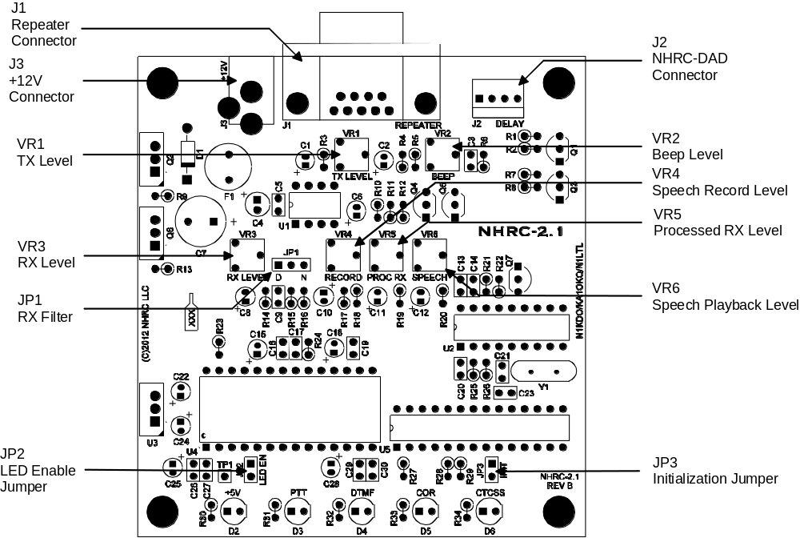

Schematics
The following two pages are the schematic diagrams for the NHRC-2.1 Repeater Controller.

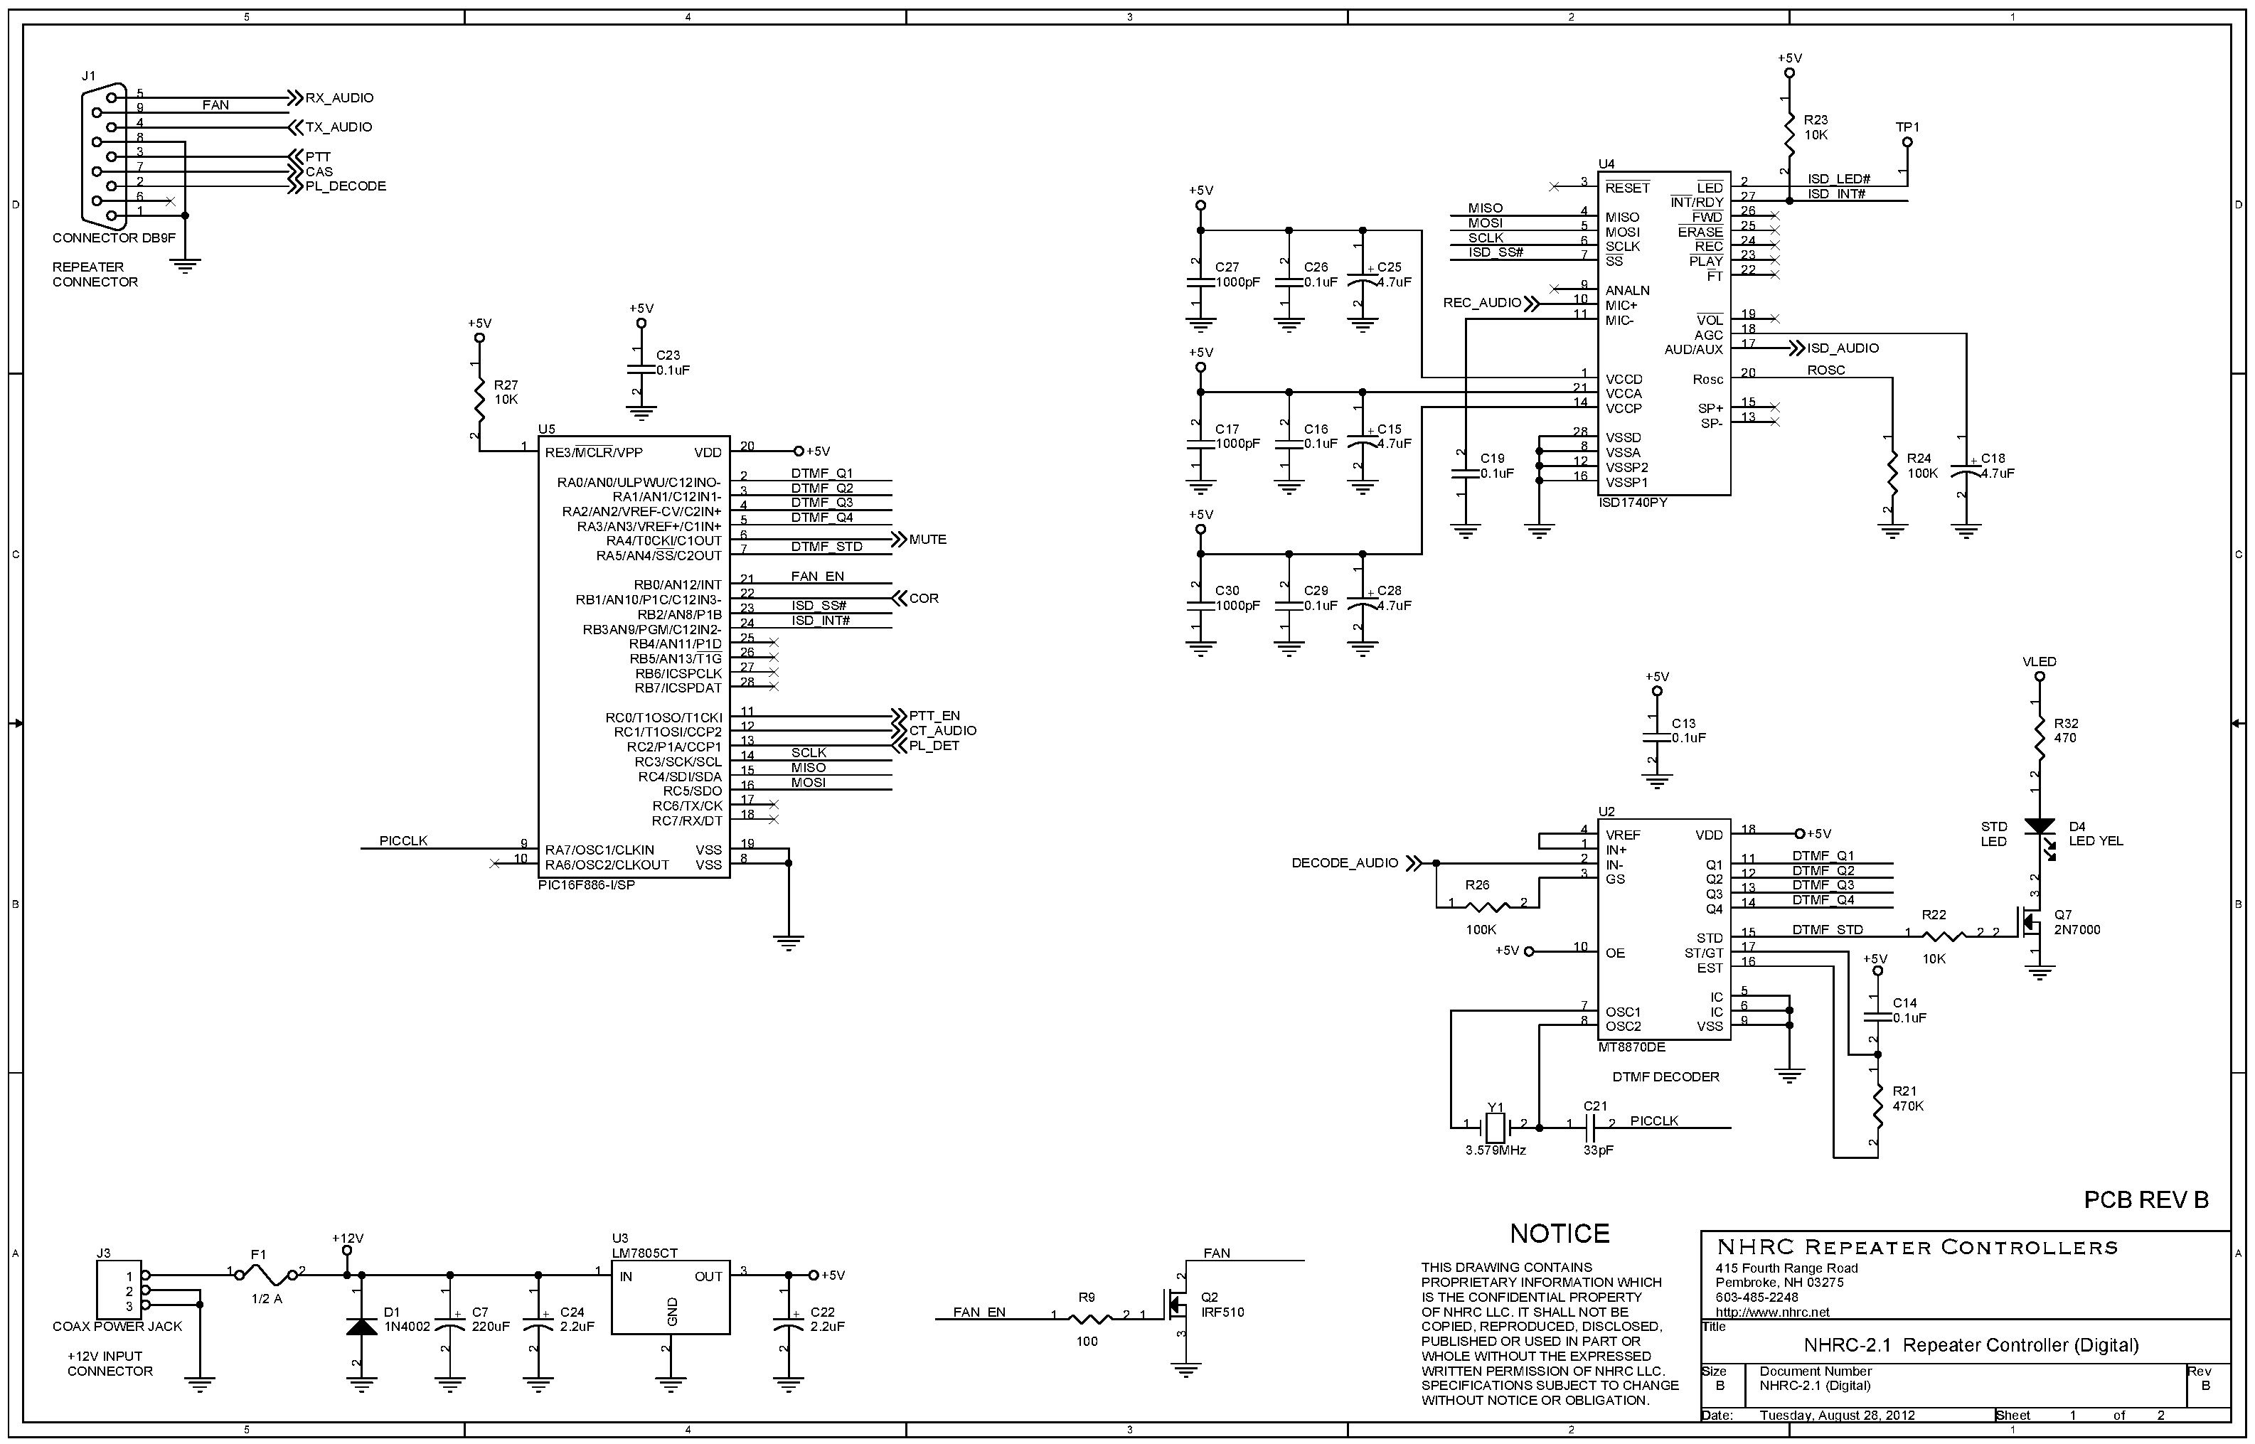

Parts List
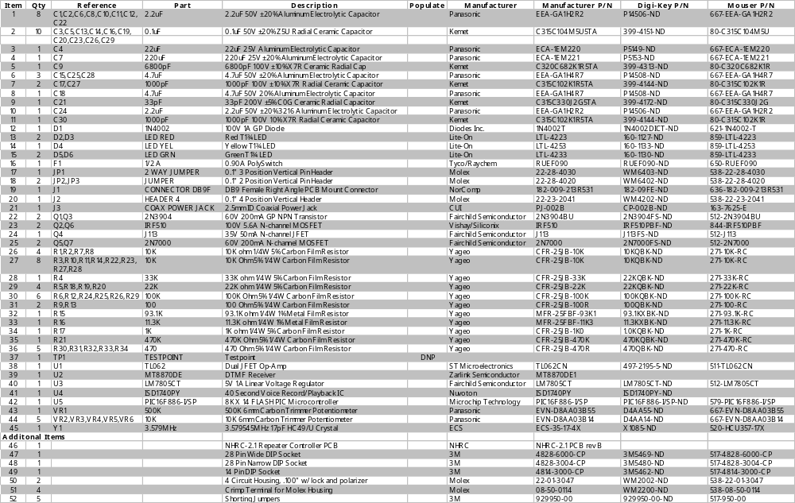

Electrical Specifications
Input voltage – minimum | 10 VDC
Input voltage – nominal | 13.8 VDC
Input voltage – maximum | 16 VDC
Current draw – idle, LEDs disabled | < 20 mA
Current draw – recording, LEDs enabled  (worst case) | < 60 mA
Audio Input impedance | approximately 10 K ohms
Audio Input requirements | 1Vp-p nominal.
Audio Output Impedance | approximately 70 ohms
Audio output | variable, up 3V p-p (for 1v input)
PTT / Fan control output: | Active low closure to ground, 1amp maximum
CAS / CTCSS input | off: less than 0.2 volts  on: greater than 3 volts, less than 16 volts
Receiver audio equalization,  jumper “N” selected | flat
Receive audio equalization,  jumper “D” selected | -6dB/octave

NHRC LLC Limited Warranty
NHRC LLC warrants that its assembled and tested products will be free from defects in materials and workmanship for a period of NINETY (90) DAYS from the date of shipment. During this period, NHRC LLC will repair or replace, at our option, any of our products that fail as a result of defects in materials or workmanship. NHRC LLC’s liability will be limited to parts, labor, and return shipping for this period.
NHRC LLC warrants that its kit products will contain components that are free from defects in materials and workmanship for a period of THIRTY (30) DAYS from the date of shipment. During this period, NHRC will replace any of the components in a kit ONCE. Subsequent replacement of any component any subsequent times is completely at the discretion of NHRC LLC, and may require the complete return of the kit.
In no case will NHRC LLC be liable for products damaged by improper wiring (including, but not limited to, over-voltage or application of reverse polarity), physical damage resulting from misuse and/or abuse of the product, neglect, or acts of God (lightning, floods, etc.).
Unauthorized modification of a NHRC product will void the warranty on the modified product.
In no case will NHRC LLC be liable for any direct, consequential, or incidental loss or damage resulting from the use or inability to use any of its products.
Some states or countries do not allow the limitation of incidental or consequential damages, so the paragraph above may not apply to you.
This warranty applies only to the original purchaser of the product; proof of purchase must be presented to receive warranty service.

