
NHRC-4
Installation and
Setup Guide

Hardware Version: | Rev. D
Guide Version: | 2012-Jul-17

Copyright Notice

Copyright © 1999, 2012, by NHRC LLC
This document contains proprietary information, which is the confidential property of NHRC LLC.
No part of this document may be used or reproduced, by any means, or for any purpose, without the expressed written consent of NHRC LLC.
No part of this document should be considered to be specifications for the proper or correct operation of the NHRC-4 Repeater Controller. In no way will NHRC LLC be liable for direct or indirect damages to the controller or attached equipment.

Printed in the U.S.A.

Thank You!

Thank you for purchasing the NHRC-4 Repeater Controller. This controller has been designed using the very latest state-of-the-art technology. Please review this manual carefully before putting your controller into operation.
This manual represents a very large documentation effort. Your comments are important to us. If you find an error or find any passages that are not clearly understandable we would like to hear about it. Please send your comments to software-support@nhrc.net.
Support for the controller is available by email or telephone. Please direct software-related questions via email to software-support@nhrc.net. Please direct hardware-related questions via email to hardware-support@nhrc.net . Your question(s) will be answered promptly.
Questions of a more urgent nature can be answered by telephone support. Telephone support is available Monday through Friday, from 6 PM until 9:30 PM, Eastern Time.

1. Introduction 2
2. Installation 2
2.1 Primary Radio Port Connections 2
2.2 Secondary Radio Port Wiring 4
2.3 TS-32/TS-64 hookup 5
2.3.1 TS-64 Notes 5
2.3.2 TS-32 Notes 6
2.4 Using a NHRC-DAD with the NHRC-4 6
2.5 Using the Digital Output 6
2.6 The LED Status Indicators 7
2.7 Adjusting the Audio Levels 7
3. Appendices 9
3.1 Terminology and Abbreviations 9
4. Circuit Board 10
4.1 Interconnections 10
4.2 Board Layout 11
5. Schematics 12
Parts List 14
Parts List 15
NHRC LLC Limited Warranty 16

Introduction
This manual describes how to install and set up the NHRC-4 repeater controller. This manual should be used in conjunction with the NHRC-4 Operating Manual, which describes the programming and operation of the controller.

Installation
This section of the User Guide describes the electrical interfaces used to connect the controller to:
- Power and primary repeater
- Link/Remote Base radio
- Communications Specialists TS-64 CTCSS Encoder/Decoder
- Optional NHRC-DAD digital audio delay board(s).
It is intended for the repeater operator to use in the planning and installation of the NHRC-4 Repeater Controller into a repeater system.
The controller uses a 8 pin 0.100" header for all the primary radio's signals and DC power, a 6 pin 0.100" header for the secondary radio's signals, and a 6 pin 0.100" header for an external TS-64 CTCSS encoder/decoder for the primary radio. In addition, it has two 4 pin 0.100" connectors to support optional NHRC-DAD digital audio delays for both radio ports.
Each radio port requires audio and a signal present indication (CAS) from it's receiver, and supplies transmit audio and PTT to it's transmitter. The controller requires 13.8 volts DC for power, which is provided on the primary radio's connector.. Be very careful when wiring DC power to the controller, reverse polarity will severely damage the controller. The connector pinouts are shown in the tables below.

Primary Radio Port Connections
The J1 connector contains the power and radio interface signals for the “Primary” radio port.
J1 Primary Radio Port (“Repeater”) Connections
J1 Pin # | Use
1 | +13.8 Volts
2 | CAS (active high)
3 | PTT (active low)
4 | Receiver Audio
5 | Transmitter Audio
6 | Fan/Digital output (active low)
7 | Ground/Audio Return
8 | Ground/Audio Return

Receiver audio can typically be taken from the high side of the squelch control. This audio must be de-emphasized with the controller's de-emphasis circuit, which provides a -6dB/octave slope. Optionally, audio can be taken from later in the receiver's audio chain, where it is already de-emphasized. Care must be taken that this source of audio is not subject to adjustment by the radio's volume control. If the receiver audio has not been properly de-emphasized, either in the receiver itself or on the controller board, the repeater will have a very "tinny", unnatural sound to it. The NHRC-4 repeater controller is shipped without the de-emphasis circuit populated on the printed circuit board, for "flat" audio response. To install the de-emphasis filter, two 100K ohm resistors must be removed, and a 51K ohm, a 510K ohm, and a 6800pF capacitor must be installed on the board. Consult the NHRC-4 Repeater Controller (Audio) schematic for modification instructions.
The receiver must provide a signal present indication (also called CAS, COR, RUS) to the controller. The controller requires an "active-high" signal here. If your radio only has "active-low" signaling available, a simple inverter can be constructed with a 2N3906 and a 4.7K resistor. Connect the emitter of the transistor to a source of positive voltage, the collector to the controller's CAS terminal, and the base to the active-low signal through the 4.7K resistor.
Transmitter audio can be fed directly into the microphone input of the transmitter. VR5 is the master level control for the primary radio, used to set the audio level into the transmitter. VR2 is the master level control for the secondary radio. The transmitter's deviation limiter (sometimes called IDC) should be set such that the transmitter cannot overdeviate, regardless of input signal level. One way to adjust transmitter deviation is to set the transmitter deviation limiter wide open (unlimited), adjust the controller's master output until the transmitter is slightly overdeviating, then set the transmitter's deviation limiter to limit just below 5 KHz deviation. Then reduce the controller's master output until the transmitted audio does not sound compressed or clipped. Transmitter deviation should be adjusted with a service monitor or deviation meter.
Transmitter keying is provided by a power MOSFET (Q2/Q6) configured in an open-drain circuit. This can be used to key many transmitters directly. The MOSFET essentially provides a closure to ground for PTT. For other transmitters, the MOSFET can drive a small relay to key the radio. Although this MOSFET can handle several amps, we recommend that no more than 500 mA of current be drawn through it.

Secondary Radio Port Wiring
The J2 connector contains the radio interface signals for the “Secondary” radio.
J2 Secondary Radio Port Connections
J2  Pin # | Use
1 | CAS (active high)
2 | PTT (active low)
3 | CTCSS detect (active high)
4 | Receiver audio
5 | T transmitter audio
6 | Ground

TS-32/TS-64 hookup
Connector J3 is a 6-pin header that allows the easy installation of an optional Communications Specialists TS-32 or TS-64 for CTCSS decode, encode, CTCSS audio filtering, and reverse-burst. (Reverse burst is only available with the TS-64.) Wire J3 to the TS-32/TS-64 as follows:
J3 Connections
JTS64  Pin # | TS-32  Signal | Description
1 | +V Power | +10 volts to CTCSS board
2 | CTCSS decoder input | Receiver audio to CTCSS decoder
3 | To audio filter input | Receiver audio to audio filter input  (separate lead for TS-64)
4 | From audio filter output | Filtered audio to controller
5 | CTCSS detect | Decode signal from CTCSS decoder  See important warning below!
6 | Ground and “Hang Up” | Ground

WARNING:
DO NOT APPLY VOLTAGE TO THE CTCSS DETECT INPUT!
This input is pulled low by the CTCSS decoder when CTCSS is NOT PRESENT. It will float high when CTCSS is detected. Application of voltage to this input will render the controller inoperative. Damage of this nature is not covered by the NHRC Limited Warranty.

The TS-32 and the TS-64 both have a high-pass filter to remove the CTCSS tone from the repeated audio. By removing jumper JP1, the controller's audio can be passed through the audio filter on the TS-32/TS-64.
Note: If the audio filter is not used, then jumper JP1 must be installed in order for audio to be passed through the controller.
The Communications Specialists CTCSS boards are not supplied by NHRC. Contact Communications Specialists at 800-854-0547 directly to order these boards.

TS-64 Notes
Consult the NHRC-4 TS-64 Application note for detailed connection instructions.
The TS-64 has a reverse-burst/PTT delay feature that can be used with the NHRC-4 with some additional wiring. This feature is useful to eliminate the squelch crash received by the user's radio when the repeater transmitter drops. Note that the user's radios must have CTCSS decoding enabled for this to work. The PTT signal from the NHRC-4 must be routed through the TS-64, and the TS-64 encoder output must be wired to the transmitter’s CTCSS input.
Consult the TS-64 INSTRUCTION SHEET for details on setting the CTCSS frequency and the reverse burst.

TS-32 Notes
The TS-32 must have the JU-2 jumper cut. Use the OUT-2 signal from the TS-32 into the CTCSS detect of the NHRC-4. If you want to be able to disable the CTCSS requirement, install a switch on the HANGUP lead.
Consult the TS-32 INSTRUCTION SHEET for details on setting the CTCSS frequency.

Using a NHRC-DAD with the NHRC-4
The NHRC-4 supports the NHRC-DAD digital audio delay on both the primary and secondary radio ports. The NHRC-DAD is used to reduce or eliminate squelch crashes and to allow the controller to fully mute DTMF tones.

J4 Primary Radio DAD Connector
J4 Secondary Radio DAD Connector
Pin | Use
1 | +13.8 Volts to delay board
2 | Audio to delay board
3 | Audio from delay board
4 | Ground/Audio Return

The audio delay for the primary radio simply plugs in to J4. The audio delay for the secondary radio plugs in to J5. If the audio delay is not installed, a jumper between pins 2 and 3 of the port's delay connector must be installed, or the controller will not pass audio.
It is strongly recommended that the CTCSS filter be used, as described above, if both CTCSS encode/decode and the audio delay are used.
The repeater controller needs to “know” that the delay is present in order to adjust the CAS timing requirements to fully mute squelch crashes. Consult the NHRC-4 User Guide for further information on programming the controller to indicate that the delay is present.

Using the Digital Output
The NHRC-4 Repeater Controller has a digital output that can be used for various remote control applications or to control a fan on the repeater's transmitter. The digital output is an open-drain into a power MOSFET, which is capable of sinking quite a bit of current, but we recommend a maximum load of about 500 mA. Use a relay to drive larger loads. The open-drain output can be used to gate the HOOKSWITCH signal to a TS-32 or other CTCSS decoder. Software allows the output to be enabled, disabled, or pulsed. In fan control mode, this output will be turned on when the transmitter is turned on, and turned off a programmable amount of time after the transmitter is turned off. Consult the NHRC-4 User Guide for information about how to control the digital output.

The LED Status Indicators
The NHRC-4 repeater controller is equipped with five status LEDS that aid in setup and troubleshooting. There are green LEDs for each radio port that indicate that the controller has getting a valid CAS (carrier operated switch) and, if a CTCSS decoder is connected, a a valid CTCSS decode signal. The appropriate green LED should light when its receiver is active, and, if a CTCSS decoder is present, the correct CTCSS tone is present. The yellow LED indicates that a DTMF signal is being decoded on the primary receiver. This LED should light for the entire duration that the DTMF signal is present on the primary receiver. The red LED's indicates transmit. These LED will light when its respective transmitter is transmitting.
The LEDS can be disabled to reduce the power consumption of the controller. Remove jumper JP2 to disable the LEDs.

Adjusting the Audio Levels

Audio Level Adjustments
Potentiometer | Use
VR1 | Secondary Receiver Mix Level
VR2 | Secondary Transmitter Master Level
VR3 | Primary Receiver Mix Level
VR4 | Primary Receiver Level
VR5 | Primary Transmitter Master Level
VR6 | Beep Tone Mix Level

Preset all potentiometers to midrange. Key a radio on the primary input frequency, send some touch-tones, and adjust VR1 (the primary receiver level) until DTMF decoding is reliably indicated by yellow LED D5.
Note: If VR4 is set too high, a crackling noise may be heard in the transmitted audio during the hang time. Reduce the level set by VR4 until this noise goes away. Any repeated audio level reduction caused by adjusting VR4 can be compensated for by adjusting VR3 (primary receiver mix level) or VR5 (primary transmitter master level.)
The primary radio's transmit deviation is set with VR5 (the primary transmitter master level) on the controller board and the transmitter's deviation/modulation control. The key to properly adjusting these controls is to remember that the limiter in the transmitter is after VR5 but probably before the transmitter's deviation/modulation control. The transmitter's deviation/modulation control will set the actual peak deviation, and VR5 will set the level into the transmitter. You do not want excessive limiting on normal speech going through the repeater; it sounds bad and tends to "pump-up" background noise. On the other hand, some limiting is desirable. An oscilloscope connected to the audio output of a receiver tuned to the transmitter's frequency will show limiting as the audio gets "flat-topped" or clipped by the limiter. Ideally, a 4.5KHz deviation signal input to the repeater should result in a 4.5 KHz deviation output, and 5.5 KHz of input deviation should result in just under 5.0 KHz of deviation out of the repeater. A service monitor (or two), deviation meter, and/or a signal generator are necessary to do this job right.
The secondary radio's transmit deviation is set with VR2 (the secondary transmitter master level). Enable the secondary transmitter, and adjust VR2 for proper transmit deviation, similarly to VR5.
Enable the secondary receiver, and adjust VR1 for reasonable deviation on the enabled transmitters when a signal is received on the secondary receiver.
Adjust VR6 (the beep level) to set the courtesy tone and CW tone level.
VR3 is used to set the primary receiver's audio mix level, and may not need to be adjusted from midpoint.

Appendices

Terminology and Abbreviations
Term | Description
CAS | Carrier Activated Squelch, where receipt of a signal, with or without CTCSS tones will activate the controller.
CW | Continuous Wave signals, commonly using “Morse Code.” The term “CW” refers to the radio emission type, while “Morse Code” refers to the signaling type used. Typically, they are incorrectly used interchangeably.
Digital Audio Delay (DAD) | Digital Audio Delay (DAD) removes squelch crashes and allows DTMF tones to be fully muted.
DTMF | Also known as “Touch Tone®” codes.
ID | Identification
PTT | Push-to-Talk

Circuit Board

Interconnections
Connector | Name | Purpose
J1 | “REPEATER” | Connects the primary repeater transmit and receive audio, PTT, CAS, fan control, and power signals to the controller.
J2 | “REMOTE BASE” | Connects the secondary repeater transmit and receive audio, PTT, and CAS signals for the radio to the controller.
J3 | “TS-32/64” | Interfaces a Communications Specialists TS-64 to the controller for CTCSS detection.
J4 | “DELAY” | Connects power and audio signals for operation of the Digital Audio Delay (NHRC-DAD) board for the primary radio port.
J5 | “RB DELAY” | Connects power and audio signals for operation of the Digital Audio Delay (NHRC-DAD) board for the secondary radio port.

Board Layout
This is a detailed top view of the Revision “D” printed wiring board for the NHRC-4 Repeater Controller.
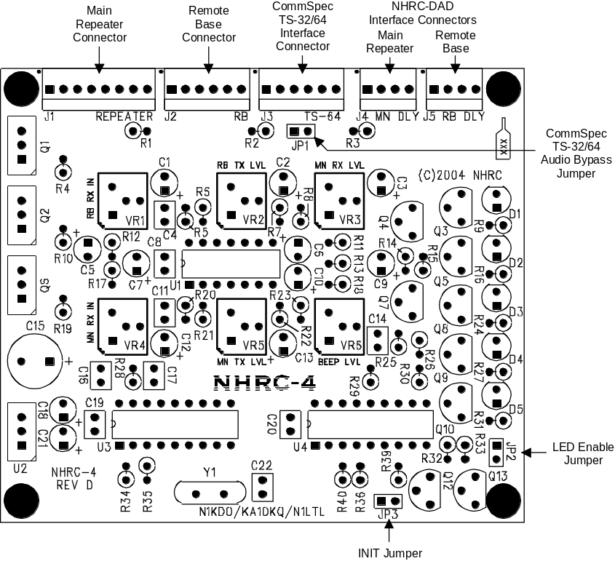

Schematics
The following two pages the schematic diagram for the Revision “D2” Version of the NHRC-4 Repeater Controller.
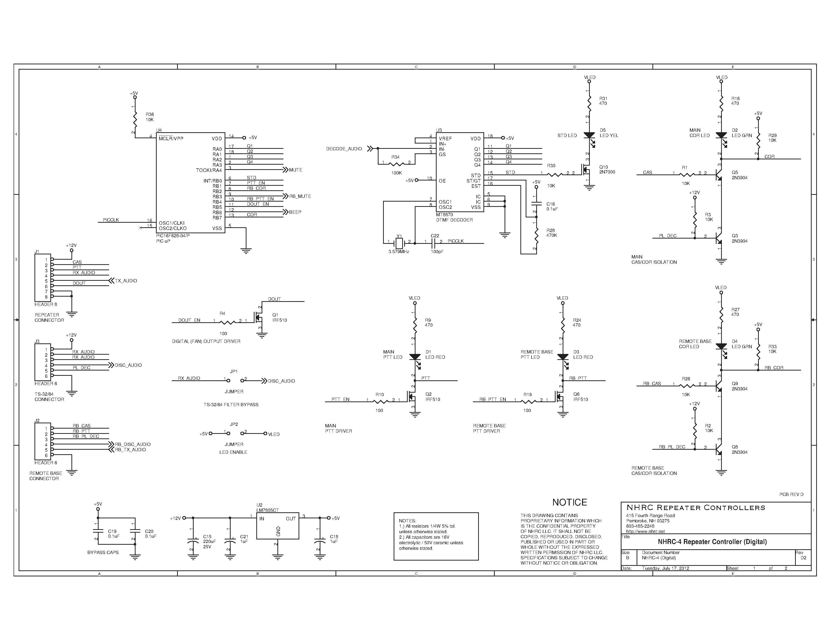

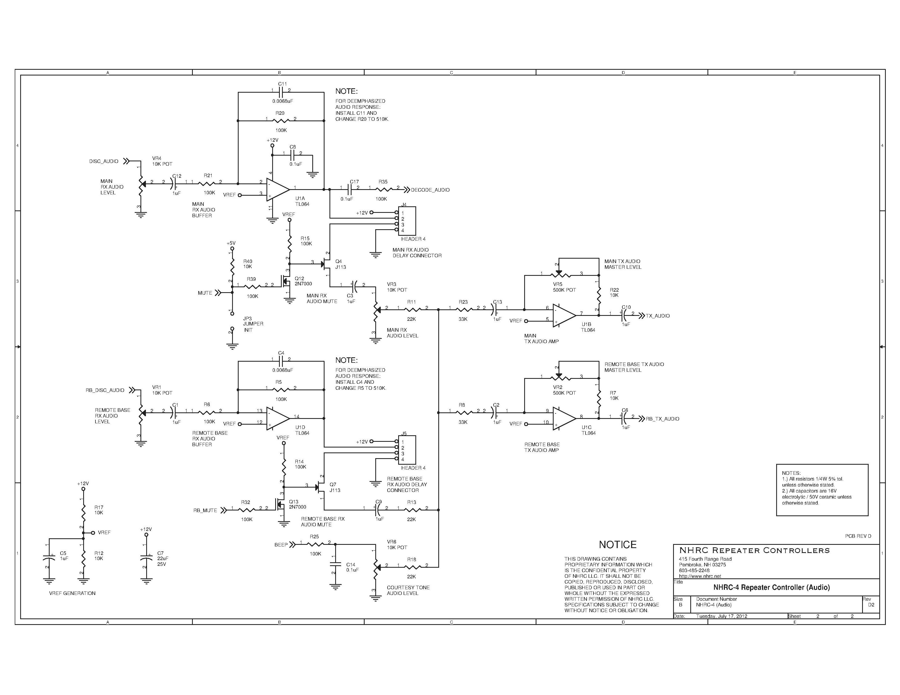

Parts List
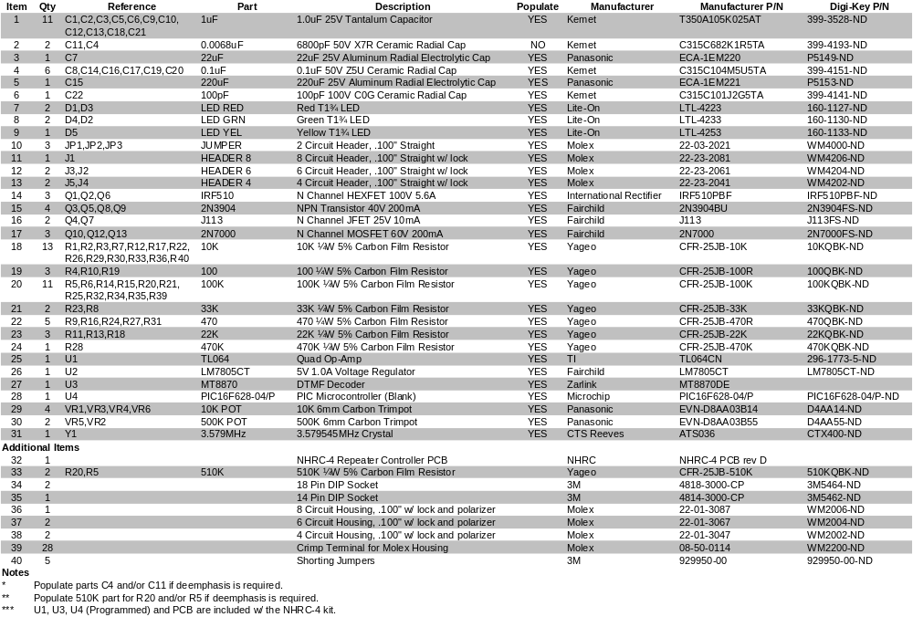The following is the bill of materials for revision “D” of the NHRC-4 Repeater Controller.

NHRC LLC Limited Warranty
NHRC LLC warrants that it’s assembled and tested products will be free from defects in materials and workmanship for a period of NINETY DAYS from the date of shipment. During this period, NHRC LLC will repair or replace, at our option, any of our products that fail as a result of defects in materials or workmanship. NHRC LLC’s liability will be limited to parts, labor, and return shipping for this period.
NHRC LLC warrants that its kit products will contain components that are free from defects in materials and workmanship for a period of THIRTY DAYS from the date of shipment. During this period, NHRC will replace any of the components in a kit ONCE. Subsequent replacement of any component any subsequent times is completely at the discretion of NHRC LLC, and may require the complete return of the kit.
In no case will NHRC LLC be liable for products damaged by improper wiring (including, but not limited to, over-voltage or application of reverse polarity), physical damage resulting from misuse and/or abuse of the product, neglect, or acts of God (lightning, floods, etc.).
Unauthorized modification of a NHRC product will void the warranty on the modified product.
In no case will NHRC LLC be liable for any direct, consequential, or incidental loss or damage resulting from the use or inability to use any of its products.
Some states or countries do not allow the limitation of incidental or consequential damages, so the paragraph above may not apply to you.
This warranty applies only to the original purchaser of the product; proof of purchase must be presented to receive warranty service.

