
NHRC-4/MVP
Installation
And
Setup Guide

Hardware Version: | Rev. C.
Guide Version: | 2006-Jul-05

Copyright Notice

Copyright © 2000, 2001, 2005, 2006, by NHRC LLC
This document contains proprietary information, which is the confidential property of NHRC LLC.
No part of this document may be used or reproduced, by any means, or for any purpose, without the expressed written consent of NHRC LLC.
No part of this document should be considered to be specifications for the proper or correct operation of the NHRC-4/MVP Repeater Controller. In no way will NHRC LLC be liable for direct or indirect damages to the controller or attached equipment.

Printed in the U.S.A.

Thank You!

Thank you for purchasing the NHRC-4/MVP Repeater Controller. This controller has been designed using the very latest state-of-the-art technology. Please review this manual carefully before putting your controller into operation.
This manual represents a very large documentation effort. Your comments are important to us. If you find an error or find any passages that are not clearly understandable we would like to hear about it. Please send your comments to software-support@nhrc.net.
Support for the controller is available by email or telephone. Please direct software-related questions via email to software-support@nhrc.net. Please direct hardware-related questions via email to hardware-support@nhrc.net . Your question(s) will be answered promptly.
Questions of a more urgent nature can be answered by telephone support. Telephone support is available Monday through Friday, from 6 PM until 10 PM, Eastern Time.

1. Introduction 2
2. Installation 3
2.1 J4 Primary Radio Port Connections 3
2.2 J3 Secondary Radio Port Connections 4
2.3 TS-32/TS-64 hookup 5
2.3.1 TS-64 Notes 6
2.3.2 TS-32 Notes 6
2.4 J1 & J2 DAD Connectors 6
2.5 The LED Status Indicators 7
2.6 Using the Digital Output 7
2.7 Adjusting the Audio Levels 7
3. GE Custom MVP Full-Duplex Modification 9
3.1 Before You Begin 9
3.2 Duplex Modifications 9
3.2.1 Multi-Channel Radios 9
3.2.2 Antenna Connections 9
3.2.3 Simultaneous Transmit and Receive Modification 9
4. Controller Installation and Hookup 13
5. Appendices 14
5.1 Terminology and Abbreviations 14
6. Circuit Board 15
6.1 Interconnections 15
7. Schematics 17
8. Parts List 20
NHRC LLC Limited Warranty 22

Introduction
This manual describes how to install and set up the NHRC-4/MVP repeater controller. This manual should be used in conjunction with the NHRC-4 Operating Manual, which describes the programming and operation of the controller.

Installation
This section of the User Guide describes the electrical interfaces used to connect the controller to:
- Power and primary repeater (the GE Custom MVP),
- Link/Remote Base radio
- Communications Specialists TS-32 or TS-64 CTCSS Encoder/Decoder
- Optional NHRC-DAD digital audio delay board(s).
It is intended for the repeater operator to use in the planning and installation of the NHRC-4/MVP Repeater Controller into a repeater system.
The controller uses an 8 pin 0.100” header for all the primary radio's signals and DC power, a 6 pin 0.100” header for the secondary radio's signals, and a 6 pin 0.100” header for an external TS-64 CTCSS encoder/decoder for the primary radio. In addition, it has two 4 pin 0.100” connectors to support optional NHRC-DAD digital audio delays for both radio ports.
Each radio port requires audio and a signal present indication (CAS) from its receiver, and supplies transmit audio and PTT to its transmitter. The controller requires 13.8 volts DC for power, which is provided on the primary radio's connector. Be very careful when wiring DC power to the controller, reverse polarity will severely damage the controller. The connector pinouts are shown in the tables below.
Consult sections 3 and 4 for specific Custom MVP modification and installation instructions.

J4 Primary Radio Port Connections
Receiver audio can typically be taken from the high side of the squelch control. This audio must be de-emphasized with the controller's de-emphasis circuit, which provides a 6dB/octave slope. Optionally, audio can be taken from later in the receiver's audio chain, where it is already de-emphasized. Care must be taken that this source of audio is not subject to adjustment by the radio's volume control. If the receiver audio has not been properly de-emphasized, either in the receiver itself or on the controller board, the repeater will have a very "tinny", unnatural sound to it. The NHRC-4/MVP repeater controller is shipped with the de-emphasis circuit populated on the printed circuit board for main repeater audio and without de-emphasis for remote base audio for "flat" audio response. To install the de-emphasis filter for the remote base audio, two 100K ohm resistors must be removed (R10 and R11), and a replaced with a 10K ohm at R11, a 93.1K ohm at R10, and a 0.0068 microfarad capacitor at C10 must be installed on the board. Consult the NHRC-4/MVP Repeater Controller (Audio) schematic as a reference for the modification.
The receiver must provide a signal present indication (also called CAS, COR, RUS) to the controller. The controller requires an "active-high" signal here. If your radio only has "active-low" signaling available, a simple inverter can be constructed with a 2N3906 and a 4.7K resistor. Connect the emitter of the transistor to a source of positive voltage, the collector to the controller's CAS terminal, and the base to the active-low signal through the 4.7K resistor.
Transmitter audio can be fed directly into the microphone input of the transmitter. VR5 is the master level control for the primary radio, used to set the audio level into the transmitter. VR6 is the master level control for the secondary radio. The transmitter's deviation limiter (sometimes called IDC) should be set such that the transmitter cannot overdeviate, regardless of input signal level. One way to adjust transmitter deviation is to set the transmitter deviation limiter wide open (unlimited), adjust the controller's master output until the transmitter is slightly overdeviating, then set the transmitter's deviation limiter to limit just below 5 KHz deviation. Then reduce the controller's master output until the transmitted audio does not sound compressed or clipped. Transmitter deviation should be adjusted with a service monitor or deviation meter.
Transmitter keying is provided by a power MOSFET (Q1/Q9) configured in an open-drain circuit. This can be used to key many transmitters directly. The MOSFET essentially provides a closure to ground for PTT. For other transmitters, the MOSFET can drive a small relay to key the radio. Although this MOSFET can handle several amps, we recommend that no more than 500 mA of current be drawn through it.
J4 Primary Radio Port
("REPEATER")
Pin | Use
1 | +13.8 Volts
2 | CAS (active high)
3 | PTT (active low)
4 | Receiver Audio
5 | Transmitter Audio
6 | Fan/Digital output (active low)
7 | Ground/Audio Return
8 | Ground/Audio Return

J3 Secondary Radio Port Connections
J3 Secondary Radio Port
("REMOTE BASE")
Pin | Use
1 | CAS (active high)
2 | PTT (active low)
3 | CTCSS detect (active high)
4 | Receiver Audio
5 | Transmitter Audio
6 | Ground/Audio Return

TS-32/TS-64 hookup
Connector JTS64 is a 6-pin header that allows the easy installation of an optional Communications Specialists TS-32 or TS-64 for CTCSS decode, encode and CTCSS audio filtering. Wire JTS64 to the TS-32/TS-64 as follows:
JTS64 Connections for Com-Spec TS-32
JTS64  Pin # | TS-32  Signal | Description
1 | +V POWER | +10 volts to CTCSS board
2 | DECODER INPUT | Receiver audio to CTCSS decoder
3 | AUDIO FILTER INPUT | Receiver audio to audio filter input
4 | AUDIO FILTER OUTPUT | Filtered audio to controller
5 | OUT-2 | Decode signal from CTCSS decoder  See important warning below!
6 | GROUND & HANG-UP | Ground

JTS64 Connections for Com-Spec TS-64
JTS64  Pin # | TS-64  Signal | Description
1 | +VOLTAGE | +10 volts to CTCSS decoder
2 | DISCRIMINATOR INPUT | Receiver audio to CTCSS decoder
3 | N/C | Receiver audio to CTCSS decoder
4 | HIGH PASS FILTER OUTPUT | Filtered audio to controller
5 | CTCSS OUTPUT | Decode signal from CTCSS decoder  See important warning below!
6 | GROUND & HANG-UP & PTT  INPUT | Ground

WARNING:
DO NOT APPLY VOLTAGE TO THE CTCSS DETECT INPUT!
This input is pulled low by the CTCSS decoder when CTCSS is NOT PRESENT. It will float high when CTCSS is detected. Application of voltage to this input will destroy Q12 and render the controller inoperative. Damage of this nature is not covered by the NHRC Limited Warranty.

The TS-32 and the TS-64 both have a high-pass filter to remove the CTCSS tone from the repeated audio. By removing jumper JP2, the controller's audio can be passed through the audio filter on the TS-32/TS-64.
Note: If the audio filter is not used, then jumper JP2 must be installed in order for audio to be passed through the controller.
The Communications Specialists CTCSS boards are not supplied by NHRC. Contact Communications Specialists at 800-854-0547 directly to order these boards.

TS-64 Notes
Consult the NHRC-4/M2 TS-64 Application note for detailed connection instructions.
Adjust the CTCSS deviation with R20 on the TS-64 board. The ideal deviation for the CTCSS tone is 750 Hz.
Consult the TS-64 INSTRUCTION SHEET for details on setting the CTCSS frequency.

TS-32 Notes
The TS-32 must have the JU-2 jumper cut. Use the OUT-2 signal from the TS-32 into the CTCSS detect of the NHRC-4/MVP. If you want to be able to disable the CTCSS requirement, install a switch on the HANGUP lead.
Adjust the CTCSS deviation with the R29 on the TS-32 board. The ideal deviation for the CTCSS tone is 750 Hz.
Consult the TS-32 INSTRUCTION SHEET for details on setting the CTCSS frequency.

J1 & J2 DAD Connectors
The audio delay for the primary radio simply plugs in to J4. The audio delay for the secondary radio plugs in to J5. If the audio delay is not installed, a jumper between pins 2 and 3 of the port's delay connector must be installed, or the controller will not pass audio.

J2 Primary Radio DAD
("DELAY ")
J1 Secondary Radio DAD
("RB DELAY ")
Pin | Use
1 | +13.8 Volts to Delay Board
2 | Audio to Delay Board
3 | Audio from Delay Board
4 | Ground/Audio Return

The LED Status Indicators
The NHRC-4/MVP repeater controller is equipped with five status LED’s that aid in setup and troubleshooting. There are green LED’s for each radio port (D2 and D4) that indicate that the controller has getting a valid CAS (carrier operated switch) and, if a CTCSS decoder is connected, a valid CTCSS decode signal. This LED should light when the repeater's receiver is active, and, if a CTCSS decoder is present, that the correct CTCSS tone is present. The yellow LED (D1) indicates that a DTMF signal is being decoded on the primary receiver. This LED should light for the entire duration that the DTMF signal is present on the primary receiver. The red LED’s (D3 and D5) indicate transmit. These LED’s will light when the each transmitter is transmitting.
The LED’s can be disabled to reduce the power consumption of the controller. Remove jumper JP3 to disable the LED’s.

Using the Digital Output
The NHRC-4/MVP Repeater Controller has a digital output that can be used for various remote control applications or to control a fan on the repeater's transmitter. The digital output is an open-drain into a power MOSFET, which is capable of sinking quite a bit of current, but we recommend a maximum load of about 500 mA. Use a relay to drive larger loads. The open-drain output can be used to gate the HOOKSWITCH signal to a TS-64 or other CTCSS decoder. Software allows the output to be enabled, disabled, or pulsed. In fan control mode, this output will be turned on when the transmitter is turned on, and turned off a programmable amount of time after the transmitter is turned off.

Adjusting the Audio Levels

Audio Level Adjustments
Potentiometer | Use
VR1 | Primary Receiver Level
VR2 | Secondary Receiver Level
VR3 | Primary Receiver Mix Level
VR4 | Beep Tone Mix Level
VR5 | Primary Transmitter Master Level
VR6 | Secondary Transmitter Master Level

Preset all potentiometers to midrange. Key a radio on the primary input frequency, send some touch-tones, and adjust VR1 (the primary receiver level) until DTMF decoding is reliably indicated by yellow LED (D1).
The primary radio's transmit deviation is set with VR5 (the primary transmitter master level) on the controller board and the transmitter's deviation/modulation control. The key to properly adjusting these controls is to remember that the limiter in the transmitter is after VR5 but probably before the transmitter's deviation/modulation control. The transmitter's deviation/modulation control will set the actual peak deviation, and VR5 will set the level into the transmitter. You do not want excessive limiting on normal speech going through the repeater; it sounds bad and tends to "pump-up" background noise. On the other hand, some limiting is desirable. An oscilloscope connected to the audio output of a receiver tuned to the transmitter's frequency will show limiting as the audio gets "flat-topped" or clipped by the limiter. Ideally, a 4.5KHz deviation signal input to the repeater should result in a 4.5 KHz deviation output, and 5.5 KHz of input deviation should result in just under 5.0 KHz of deviation out of the repeater. A service monitor (or two), deviation meter, and/or a signal generator are necessary to do this job right.
The secondary radio's transmit deviation is set with VR6 (the secondary transmitter master level). Enable the secondary transmitter, and adjust VR6 for proper transmit deviation, similarly to VR5.
Enable the secondary receiver, and adjust VR2 for reasonable deviation on the enabled transmitters when a signal is received on the secondary receiver.
Adjust VR4 (the beep level) to set the courtesy tone and CW tone level.
VR3 is used to set the receiver audio mix level, and may not need to be adjusted from midpoint.

GE Custom MVP Full-Duplex Modification

Before You Begin
Before you begin with the duplexing modifications and installation of the NHRC-4/MVP repeater controller, it is imperative that you verify that your Custom MVP operates correctly. This will reduce the amount of time you may have to spend troubleshooting if you do run into problems with the radio modifications or controller installation.
NHRC assumes no liability for any damages to your Custom MVP or you inability to perform these modifications. If you have any doubt about your ability to correctly perform the modifications or to install the repeater controller seek professional assistance. Damage to your Custom MVP and/or NHRC-4/MVP repeater controller caused by improper installation or hookup is not covered by the NHRC limited warranty.
We strongly recommend that you have access to a service manual for your Custom MVP, it is nearly impossible to properly modify, tune, and maintain the radio without one.
This document is the only support available for duplexing the Custom MVP. No other assistance is available from NHRC regarding duplexing this radio.

Duplex Modifications

Multi-Channel Radios
If your MVP is a multi-channel radio, you will probably want to disable the channel selector and select channel 1 (F1) with a jumper installed on the Oscillator/Multiplier board. Consult the Service Manual for this jumper location.

Antenna Connections
In order to use the Custom MVP in duplex operation, a separate antenna lead must be brought out of the radio for the receiver antenna connection. Remove the jumper between the T/R Relay board and the receiver input, which is located inside the RF assembly casting. Drill a ¼” hole adjacent to the SO-239 antenna connection, making sure you leave sufficient room to put the cover back on the radio. Route a piece of double-shielded coax through the hole. We recommend that you use RG-142, RG-223, or RG-400 cable here. Solder a RCA plug onto the end of the cable inside the radio, and plug it into the receiver antenna jack. Install the connector of your choice on the other end of this cable. This will serve as your receiver antenna input.

Simultaneous Transmit and Receive Modification
The rest of the duplexing modifications are performed on the System-Audio-Squelch (SAS) board. The SAS board is located behind the front panel of the radio. Remove the front panel to access the SAS board.
The SAS board is shown below.
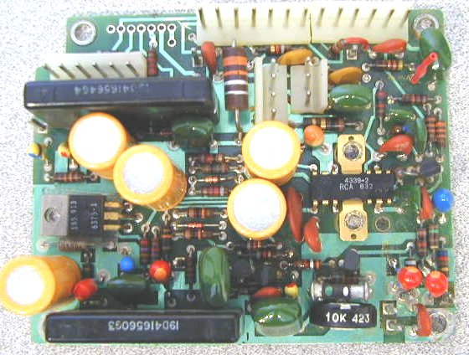
Remove the GE “Channel Guard” (CG) module if it is installed. The CG module is located next to the SAS board, and can be identified by the lack of any connectors on the board. Unplug the CG boards connections to the SAS board. Cut off or completely remove the CG encoder cable that runs from the CG board to the exciter. You may want to keep the cables and plugs from the CG board, they may come in handy when interfacing the needed repeater signals to the radio after all duplexing modifications have been performed.
Remove the SAS board from the radio. These boards vary slightly from revision to revision but are fundamentally the same. Remove the 2 screws on the audio amp IC heat sink. Remove the screw from the voltage regulator TO-220 transistor. Note the insulators over and under this transistor, they must be re-installed later. Make note of the connections you disconnect. The front panel assembly can be removed by unplugging the cabling and setting it aside out of your way.
Defeat the RX oscillator control circuit. Find and cut the PCB trace that connects J904 pin 2 to hybrid IC U902 pin 7. Refer to the service manual PCB layout. It is best to cut this trace on the bottom of the PCB. There is a via and a small segment of trace leading to pin 7 of the hybrid. Cut the trace between the via and hybrid with an X-Acto knife. See picture below:
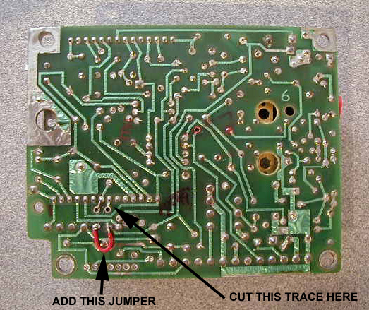
Strap the RX oscillator always on by placing 10V on the RX oscillator control line. You can do this by installing a jumper from J904 pin 1 to J904 pin 2. See the picture for the jumper location.
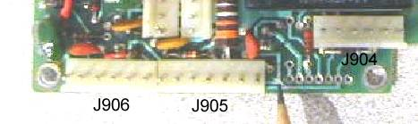
Defeat the RX mute circuit at U902 pin 6. Cut the trace from U902 pin 6 to J906 pin 5. It is best to cut this trace at the point that it makes an “S” pattern near pin 7 of J905 and H-11. This trace runs near a square post J-11. Be certain you are severing the proper connection or CAS circuit could be disabled. See picture below:

If your radio had a CG board installed, you will need to Re install R33, a 1K ohm 1/4w resistor from H1 to H2. H1 and H2 are holes in the PCB just behind J906. Be certain the resistor lead does not contact and short against the square post J10. See picture below:
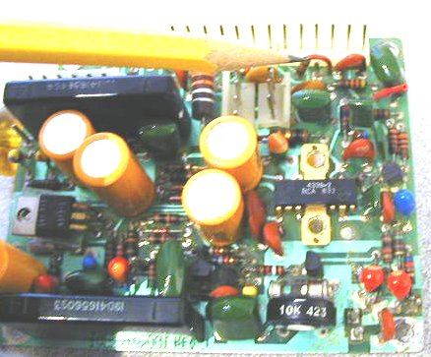

Your systems board duplexing modifications are now complete. Go back and carefully check your work.
Note: A .100-inch center header fits nicely into the row of holes denoted on the PCB as H11 through H17. You can install a header here so you can pickup the PTT line without soldering. Do this now before you install the System-Audio-Squelch PCB.
Re-install your System-Audio-Squelch PCB in the reverse order in which you removed it. Be careful to properly re-install the insulator over and under the TO-220 voltage regulator transistor. Install all other screws previously removed.
Re-test your MVP now. It should receive and transmit simultaneously now. If you have problem at this point do not proceed until you have the radio working correctly.

Controller Installation and Hookup
Install your NHRC-4/MVP controller in place of the Channel Guard Encoder/Decoder you have discarded. Use the 3 screws leftover from the removal to mount your controller. If needed obtain some 6-32 X 1/4 inch pan head screws to mount your controller to the mounting bosses on the MVP.
Care must be taken to avoid shorting the transistors (Q1, Q6 and Q9) which are mounted on the end of the controller next to the inside of radio if your controller was factory assembled with non-insulated tab transistors or if you have replaced an insulated tab transistor with a non-insulated tab part. If so, the use of electrical tape or some other insulating material between the transistors and the radio is highly recommended.
Use connectors to make your connections to the controller and systems board. This will make your installation look professional and be more reliable. Controllers received for repair with solder on the header pins will have the header pins replaced at the customer’s expense.
All connections to the controller are easily available on the System-Audio-Squelch PCB next to the controller.
NHRC-4/MVP  J4 Pin # | Signal Name | Connection to Custom MVP
1 | +10 VDC | +10 volts is available on the SAS board at J906 pin 6.
2 | CAS | CAS is available from J906 pin 5 (was RX MUTE).
3 | PTT | PTT is available at H17.
4 | RX AUDIO  (from Receiver) | The receiver audio is available at J906 pin 4 (VSQ-HI).
5 | TX AUDIO  (to Transmitter) | TX Audio is supplied to the white or yellowish-white wire that is or was connected to J13. If this is still connected to J13 disconnect it. Note that this wire is MIC-HI and J13 is the MIC-BIAS voltage supply. This disconnects the MIC bias and will defeat the external microphone. If a local microphone is desired, seek an alternate way to provide audio to the exciter. There may be audio loading issues with the local microphone.
6 | DIGITAL OUTPUT/  FAN CONTROL | This connection is optional. If you desire to use this feature, the now unused hang up lead from the old channel guard board is an easy way to get this signal out of the radio. The channel guard hang-up lead comes out on the power/speaker jack on pin 8.
7 | GROUND | Ground is available at J906 pin 1.

Connections are now complete for basic repeater operation.
Before powering on your repeater go back and check your work. Apply power with the controller disconnected and check your power supply connections. With a grounded probe touch the PTT pin, your MVP should transmit. Check to see that your CAS signal goes to approx 7 volts when the squelch opens and goes low when it closes.

Appendices

Terminology and Abbreviations
Term | Description
CAS | Carrier Activated Squelch, where receipt of a signal, with or without CTCSS tones will activate the controller.
CW | Continuous Wave signals, commonly using “Morse Code.” The term “CW” refers to the radio emission type, while “Morse Code” refers to the signaling type used. Typically, they are incorrectly used interchangeably.
Digital Audio Delay (DAD) | Digital Audio Delay (DAD) removes squelch crashes and allows DTMF tones to be fully muted.
DTMF | Also known as “Touch Tone®” codes.
ID | Identification
PTT | Push-to-Talk

Circuit Board

Interconnections
Connector | Name | Purpose
J1 | “RB DELAY” | Connects power and audio signals for operation of the Digital Audio Delay (NHRC-DAD) board for the secondary radio port.
J2 | “DELAY” | Connects power and audio signals for operation of the Digital Audio Delay (NHRC-DAD) board for the primary radio port.
J3 | “REMOTE BASE” | Connects the secondary repeater transmit and receive audio, PTT, and CAS signals for the radio to the controller.
J4 | “REPEATER” | Connects the primary repeater transmit and receive audio, PTT, CAS, fan control, and power signals to the controller.
JTS64 | “JTS64” | Interfaces a Communications Specialists TS-64 to the controller for CTCSS detection.

The following page is a detailed top view of the Revision “B” printed wiring board for the NHRC-4/MVP Repeater Controller.
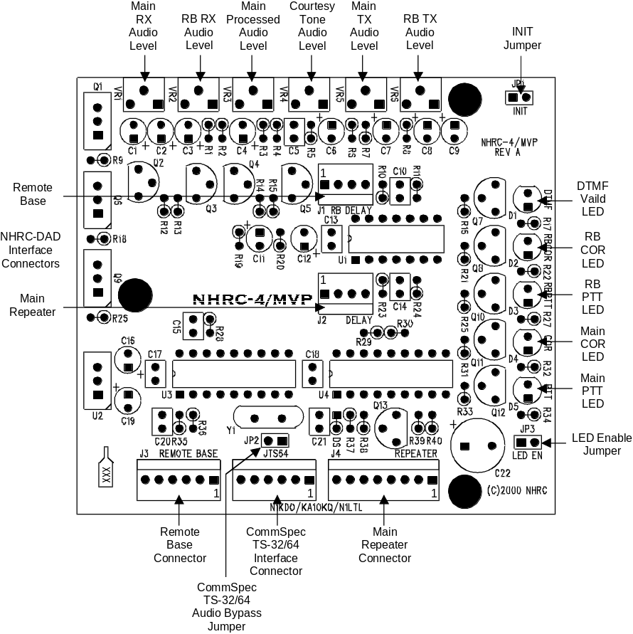

Schematics
The following two pages the schematic diagram for the Revision “C” Version of the NHRC-4/MVP Repeater Controller.

Replace this page with schematic page 1.
Replace this page with Schematic Page 2.

Parts List
The following is the bill of materials for revision “B” of the NHRC-4/MVP Repeater Controller.
Item | Qty. | Ref. | Schematic  Value |  | Description | Mfg. | Mfg. P/N | Notes
1 | 11 | C1 | 1uF |  | 1uF 16V Tantalum Cap | Panasonic | ECS-F1CE105K | or equivalent
 |  | C2 | 1uF |  | 1uF 16V Tantalum Cap | Panasonic | ECS-F1CE105K | or equivalent
 |  | C3 | 1uF |  | 1uF 16V Tantalum Cap | Panasonic | ECS-F1CE105K | or equivalent
 |  | C4 | 1uF |  | 1uF 16V Tantalum Cap | Panasonic | ECS-F1CE105K | or equivalent
 |  | C6 | 1uF |  | 1uF 16V Tantalum Cap | Panasonic | ECS-F1CE105K | or equivalent
 |  | C7 | 1uF |  | 1uF 16V Tantalum Cap | Panasonic | ECS-F1CE105K | or equivalent
 |  | C8 | 1uF |  | 1uF 16V Tantalum Cap | Panasonic | ECS-F1CE105K | or equivalent
 |  | C9 | 1uF |  | 1uF 16V Tantalum Cap | Panasonic | ECS-F1CE105K | or equivalent
 |  | C11 | 1uF |  | 1uF 16V Tantalum Cap | Panasonic | ECS-F1CE105K | or equivalent
 |  | C16 | 1uF |  | 1uF 16V Tantalum Cap | Panasonic | ECS-F1CE105K | or equivalent
 |  | C19 | 1uF |  | 1uF 16V Tantalum Cap | Panasonic | ECS-F1CE105K | or equivalent
2 | 6 | C5 | 0.1uF |  | 0.1uF 50V Z5U Ceramic Radial Cap | Panasonic | ECU-S1H104MEA | or equivalent
 |  | C13 | 0.1uF |  | 0.1uF 50V Z5U Ceramic Radial Cap | Panasonic | ECU-S1H104MEA | or equivalent
 |  | C15 | 0.1uF |  | 0.1uF 50V Z5U Ceramic Radial Cap | Panasonic | ECU-S1H104MEA | or equivalent
 |  | C17 | 0.1uF |  | 0.1uF 50V Z5U Ceramic Radial Cap | Panasonic | ECU-S1H104MEA | or equivalent
 |  | C18 | 0.1uF |  | 0.1uF 50V Z5U Ceramic Radial Cap | Panasonic | ECU-S1H104MEA | or equivalent
 |  | C20 | 0.1uF |  | 0.1uF 50V Z5U Ceramic Radial Cap | Panasonic | ECU-S1H104MEA | or equivalent
3 | 2 | C14 | 0.0068uF |  | 0.0068uF 50V X7R Ceramic Radial Cap | Panasonic | ECU-S1H682KBA | or equivalent
 |  | C10 | 0.0068uF |  | 0.0068uF 50V X7R Ceramic Radial Cap | Panasonic | ECU-S1H682KBA | Do Not Populate
4 | 1 | C12 | 22uF | 25V | 22uF 25V Aluminum Radial Electrolytic Cap | Panasonic | ECA-1EM220 | or equivalent
5 | 1 | C21 | 33pF |  | 33pF 100V C0G Ceramic Radial Cap | Panasonic | ECU-S2A330JCA | or equivalent
6 | 1 | C22 | 220uF | 25V | 220uF 25V Aluminum Radial Electrolytic Cap | Panasonic | ECA-1EM221 | or equivalent
7 | 1 | D1 | LED | YEL | Yellow T1¾ LED | Lite-On | LTL-4253 | or equivalent
8 | 2 | D2 | LED | GRN | Green T1¾ LED | Lite-On | LTL-4233 | or equivalent
 |  | D4 | LED | GRN | Green T1¾ LED | Lite-On | LTL-4233 | or equivalent
9 | 2 | D5 | LED | RED | Red T1¾ LED | Lite-On | LTL-4203 | or equivalent
 |  | D3 | LED | RED | Red T1¾ LED | Lite-On | LTL-4203 | or equivalent
10 | 1 | D6 | 1N5226B | 3.3V | 3.3V 5% 500mW Zener Diode | Diodes Inc. | 1N5226B | or equivalent
11 | 3 | JP1 | JUMPER |  | 2 Circuit Header, .100" Straight | Molex | 22-03-2021 | or equivalent
 |  | JP2 | JUMPER |  | 2 Circuit Header, .100" Straight | Molex | 22-03-2021 | or equivalent
 |  | JP3 | JUMPER |  | 2 Circuit Header, .100" Straight | Molex | 22-03-2021 | or equivalent
12 | 2 | JTS64 | HEADER 6 |  | 6 Circuit Header, .100" Straight w/ lock | Molex | 22-23-2061 | or equivalent
 |  | J3 | HEADER 6 |  | 6 Circuit Header, .100" Straight w/ lock | Molex | 22-23-2061 | or equivalent
13 | 2 | J1 | HEADER 4 |  | 4 Circuit Header, .100" Straight w/ lock | Molex | 22-23-2041 | or equivalent
 |  | J2 | HEADER 4 |  | 4 Circuit Header, .100" Straight w/ lock | Molex | 22-23-2041 | or equivalent
14 | 1 | J4 | HEADER 8 |  | 8 Circuit Header, .100" Straight w/ lock | Molex | 22-23-2081 | or equivalent
15 | 3 | Q1 | IRFI510G |  | N Channel HEXFET | IRF | IRFI510G | or equivalent
 |  | Q6 | IRFI510G |  | N Channel HEXFET | IRF | IRFI510G | or equivalent
 |  | Q9 | IRFI510G |  | N Channel HEXFET | IRF | IRFI510G | or equivalent
16 | 3 | Q2 | 2N7000 |  | N Channel MOSFET | Fairchild | 2N7000 | or equivalent
 |  | Q5 | 2N7000 |  | N Channel MOSFET | Fairchild | 2N7000 | or equivalent
 |  | Q7 | 2N7000 |  | N Channel MOSFET | Fairchild | 2N7000 | or equivalent
17 | 2 | Q4 | MPF102 |  | N Channel JFET | Fairchild | MPF102 | or equivalent
 |  | Q3 | MPF102 |  | N Channel JFET | Fairchild | MPF102 | or equivalent
18 | 4 | Q8 | 2N3904 |  | NPN Transistor | Fairchild | 2N3904 | or equivalent
 |  | Q10 | 2N3904 |  | NPN Transistor | Fairchild | 2N3904 | or equivalent
 |  | Q11 | 2N3904 |  | NPN Transistor | Fairchild | 2N3904 | or equivalent
 |  | Q12 | 2N3904 |  | NPN Transistor | Fairchild | 2N3904 | or equivalent
19 | 1 | Q13 | 2N3906 |  | PNP Transistor | Fairchild | 2N3906 | or equivalent
20 | 3 | R1 | 22K |  | 22K ¼W 5% Carbon Film Resistor | Yaego | CFR-25JB-22K | or equivalent
 |  | R2 | 22K |  | 22K ¼W 5% Carbon Film Resistor | Yaego | CFR-25JB-22K | or equivalent
 |  | R4 | 22K |  | 22K ¼W 5% Carbon Film Resistor | Yaego | CFR-25JB-22K | or equivalent
21 | 3 | R3 | 33K |  | 33K ¼W 5% Carbon Film Resistor | Yaego | CFR-25JB-33K | or equivalent
 |  | R7 | 33K |  | 33K ¼W 5% Carbon Film Resistor | Yaego | CFR-25JB-33K | or equivalent
 |  | R38 | 33K |  | 33K ¼W 5% Carbon Film Resistor | Yaego | CFR-25JB-33K | or equivalent
22 | 9 | R5 | 100K |  | 100K ¼W 5% Carbon Film Resistor | Yaego | CFR-25JB-100K | or equivalent
 |  | R10 | 100K |  | 100K ¼W 5% Carbon Film Resistor | Yaego | CFR-25JB-100K | or equivalent
 |  | R11 | 100K |  | 100K ¼W 5% Carbon Film Resistor | Yaego | CFR-25JB-100K | or equivalent
 |  | R12 | 100K |  | 100K ¼W 5% Carbon Film Resistor | Yaego | CFR-25JB-100K | or equivalent
 |  | R13 | 100K |  | 100K ¼W 5% Carbon Film Resistor | Yaego | CFR-25JB-100K | or equivalent
 |  | R14 | 100K |  | 100K ¼W 5% Carbon Film Resistor | Yaego | CFR-25JB-100K | or equivalent
 |  | R15 | 100K |  | 100K ¼W 5% Carbon Film Resistor | Yaego | CFR-25JB-100K | or equivalent
 |  | R35 | 100K |  | 100K ¼W 5% Carbon Film Resistor | Yaego | CFR-25JB-100K | or equivalent
 |  | R36 | 100K |  | 100K ¼W 5% Carbon Film Resistor | Yaego | CFR-25JB-100K | or equivalent
23 | 14 | R6 | 10K |  | 10K ¼W 5% Carbon Film Resistor | Yaego | CFR-25JB-10K | or equivalent
 |  | R8 | 10K |  | 10K ¼W 5% Carbon Film Resistor | Yaego | CFR-25JB-10K | or equivalent
 |  | R16 | 10K |  | 10K ¼W 5% Carbon Film Resistor | Yaego | CFR-25JB-10K | or equivalent
 |  | R19 | 10K |  | 10K ¼W 5% Carbon Film Resistor | Yaego | CFR-25JB-10K | or equivalent
 |  | R20 | 10K |  | 10K ¼W 5% Carbon Film Resistor | Yaego | CFR-25JB-10K | or equivalent
 |  | R21 | 10K |  | 10K ¼W 5% Carbon Film Resistor | Yaego | CFR-25JB-10K | or equivalent
 |  | R24 | 10K |  | 10K ¼W 5% Carbon Film Resistor | Yaego | CFR-25JB-10K | or equivalent
 |  | R25 | 10K |  | 10K ¼W 5% Carbon Film Resistor | Yaego | CFR-25JB-10K | or equivalent
 |  | R29 | 10K |  | 10K ¼W 5% Carbon Film Resistor | Yaego | CFR-25JB-10K | or equivalent
 |  | R30 | 10K |  | 10K ¼W 5% Carbon Film Resistor | Yaego | CFR-25JB-10K | or equivalent
 |  | R31 | 10K |  | 10K ¼W 5% Carbon Film Resistor | Yaego | CFR-25JB-10K | or equivalent
 |  | R33 | 10K |  | 10K ¼W 5% Carbon Film Resistor | Yaego | CFR-25JB-10K | or equivalent
 |  | R37 | 10K |  | 10K ¼W 5% Carbon Film Resistor | Yaego | CFR-25JB-10K | or equivalent
 |  | R40 | 10K |  | 10K ¼W 5% Carbon Film Resistor | Yaego | CFR-25JB-10K | or equivalent
24 | 3 | R9 | 100 |  | 100 ¼W 5% Carbon Film Resistor | Yaego | CFR-25JB-100R | or equivalent
 |  | R18 | 100 |  | 100 ¼W 5% Carbon Film Resistor | Yaego | CFR-25JB-100R | or equivalent
 |  | R26 | 100 |  | 100 ¼W 5% Carbon Film Resistor | Yaego | CFR-25JB-100R | or equivalent
25 | 1 | R23 | 93.1K |  | 93.1K ¼W 5% Metal Film Resistor | Yaego | MFR-25FBF-93K1 | or equivalent
26 | 5 | R17 | 470 |  | 470 ¼W 5% Carbon Film Resistor | Yaego | CFR-25JB-470R | or equivalent
 |  | R22 | 470 |  | 470 ¼W 5% Carbon Film Resistor | Yaego | CFR-25JB-470R | or equivalent
 |  | R27 | 470 |  | 470 ¼W 5% Carbon Film Resistor | Yaego | CFR-25JB-470R | or equivalent
 |  | R32 | 470 |  | 470 ¼W 5% Carbon Film Resistor | Yaego | CFR-25JB-470R | or equivalent
 |  | R34 | 470 |  | 470 ¼W 5% Carbon Film Resistor | Yaego | CFR-25JB-470R | or equivalent
27 | 1 | R28 | 470K |  | 470K ¼W 5% Carbon Film Resistor | Yaego | CFR-25JB-470K | or equivalent
28 | 1 | R39 | 39K |  | 39K ¼W 5% Carbon Film Resistor | Yaego | CFR-25JB-39K | or equivalent
29 | 1 | U1 | TL064 |  | Quad Op-Amp | TI | TL064CN | see note 1
30 | 1 | U2 | LM7805CT |  | 5V 1.0A Voltage Regulator | Nat'l Semi | LM340T-5.0 | or equivalent
31 | 1 | U3 | M-8870-01 |  | DTMF Decoder | Teltone | M-8870-01 | see note 1
32 | 1 | U4 | PIC16C84-04/P |  | PIC Microcontroller (Blank) | Microchip | PIC16F84-04I/P | see note 1
33 | 4 | VR1 | 10K | POT | 10K 6mm Carbon Trimpot | Panasonic | EVN-D2AA03B14 | or equivalent
 |  | VR2 | 10K | POT | 10K 6mm Carbon Trimpot | Panasonic | EVN-D2AA03B14 | or equivalent
 |  | VR3 | 10K | POT | 10K 6mm Carbon Trimpot | Panasonic | EVN-D2AA03B14 | or equivalent
 |  | VR4 | 10K | POT | 10K 6mm Carbon Trimpot | Panasonic | EVN-D2AA03B14 | or equivalent
34 | 2 | VR5 | 200K | POT | 200K 6mm Carbon Trimpot | Panasonic | EVN-D2AA03B25 | or equivalent
 |  | VR6 | 200K | POT | 200K 6mm Carbon Trimpot | Panasonic | EVN-D2AA03B25 | or equivalent
35 | 1 | Y1 | 3.579MHz |  | 3.579545MHz Crystal | ECS | ECS-35-17-4 | or equivalent
 |  |  |  |  | Additional Items
36 | 1 |  |  |  | NHRC-4/MVP PCB REV B | NHRC | NHRC-4/MVP PCB REV B
37 | 2 |  |  |  | 18 Pin DIP Socket | Mill-Max | 110-99-318-41-001 | use at U3/U4
38 | 1 |  |  |  | 14 Pin DIP Socket | Mill-Max | 110-99-314-41-001 | use at U1

Notes:
1. Use sockets for U1, U3 and U4.

NHRC LLC Limited Warranty
NHRC LLC warrants that it’s assembled and tested products will be free from defects in materials and workmanship for a period of NINETY DAYS from the date of shipment. During this period, NHRC LLC will repair or replace, at our option, any of our products that fail as a result of defects in materials or workmanship. NHRC LLC’s liability will be limited to parts, labor, and return shipping for this period.
NHRC LLC warrants that its kit products will contain components that are free from defects in materials and workmanship for a period of THIRTY DAYS from the date of shipment. During this period, NHRC will replace any of the components in a kit ONCE. Subsequent replacement of any component any subsequent times is completely at the discretion of NHRC LLC, and may require the complete return of the kit.
In no case will NHRC LLC be liable for products damaged by improper wiring (including, but not limited to, over-voltage or application of reverse polarity), physical damage resulting from misuse and/or abuse of the product, neglect, or acts of God (lightning, floods, etc.).
Unauthorized modification of a NHRC product will void the warranty on the modified product.
In no case will NHRC LLC be liable for any direct, consequential, or incidental loss or damage resulting from the use or inability to use any of its products.
Some states or countries do not allow the limitation of incidental or consequential damages, so the paragraph above may not apply to you.
This warranty applies only to the original purchaser of the product; proof of purchase must be presented to receive warranty service.

