Before You Begin
Before you begin with the duplexing modifications and installation of the NHRC-4/MVP repeater controller, it is imperative that you verify that your Custom MVP operates correctly. This will reduce the amount of time you may have to spend troubleshooting if you do run into problems with the radio modifications or controller installation.
NHRC assumes no liability for any damages to your Custom MVP or you inability to perform these modifications. If you have any doubt about your ability to correctly perform the modifications or to install the repeater controller seek professional assistance. Damage to your Custom MVP and/or NHRC-4/MVP repeater controller caused by improper installation or hookup is not covered by the NHRC limited warranty.
We recommend that you have access to a service manual for your Custom MVP, it is nearly impossible to properly modify, tune, and maintain the radio without one.
This document is the only support available for duplexing the Custom MVP. No other assistance is available from NHRC regarding duplexing this radio

Duplex Modifications

Multi-Channel Radios
If your MVP is a multi-channel radio, you will probably want to disable the channel selector and select channel 1 (F1) with a jumper installed on the Oscillator/Multiplier board. Consult the Service Manual for this jumper location.

Antenna Connections
In order to use the Custom MVP in duplex operation, a separate antenna lead must be brought out of the radio for the receiver antenna connection. Remove the jumper between the T/R Relay board and the receiver input, which is located inside the RF assembly casting. Drill a ¼” hole adjacent to the SO-239 antenna connection, making sure you leave sufficient room to put the cover back on the radio. Route a piece of double-shielded coax through the hole. We recommend that you use RG-142, RG-223, or RG-400 cable here. Solder a RCA plug onto the end of the cable inside the radio, and plug it into the receiver antenna jack. Install the connector of your choice on the other end of this cable. This will serve as your receiver antenna input.

Simultaneous Transmit and Receive Modification
The rest of the duplexing modifications are performed on the System-Audio-Squelch (SAS) board. The SAS board is located behind the front panel of the radio. Remove the front panel to access the SAS board.
The SAS board is shown below.
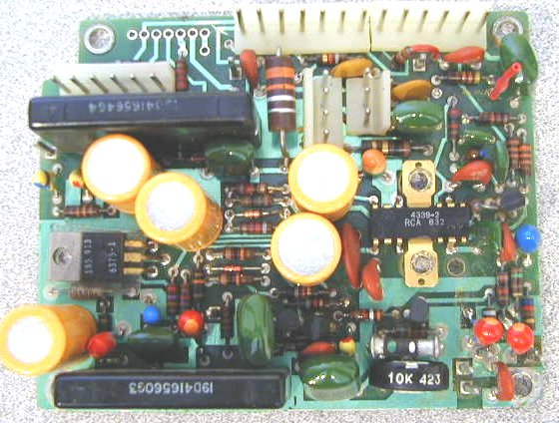
Remove the GE “Channel Guard” (CG) module if it is installed. The CG module is located next to the SAS board, and can be identified by the lack of any connectors on the board. Unplug the CG boards connections to the SAS board. Cut off or completely remove the CG encoder cable that runs from the CG board to the exciter. You may want to keep the cables and plugs from the CG board, they may come in handy when interfacing the needed repeater signals to the radio after all duplexing modifications have been performed.
Remove the SAS board from the radio. These boards vary slightly from revision to revision but are fundamentally the same. Remove the 2 screws on the audio amp IC heat sink. Remove the screw from the voltage regulator TO-220 transistor. Note the insulators over and under this transistor, they must be re-installed later. Make note of the connections you disconnect. The front panel assembly can be removed by unplugging the cabling and setting it aside out of your way.
Defeat the RX oscillator control circuit. Find and cut the PCB trace that connects J904 pin 2 to hybrid IC U902 pin 7. Refer to the service manual PCB layout. It is best to cut this trace on the bottom of the PCB. There is a via and a small segment of trace leading to pin 7 of the hybrid. Cut the trace between the via and hybrid with an X-acto knife. See picture below:
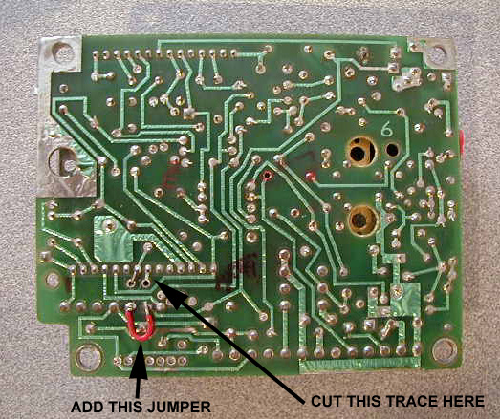
Strap the RX oscillator always on by placing 10V on the RX oscillator control line. This is most easily done by installing a jumper from J904 pin 1 to J904 pin 2. See the picture for the jumper location.
Defeat the RX mute circuit at U902 pin 6. Cut the trace from U902 pin 6 to J902 pin 5. It is best to cut this trace at the point that it makes an “S” pattern near pin7 of J905 and H-11. This trace runs near a square post J-11. Be certain you are severing the proper connection or CAS circuit could be disabled. See picture
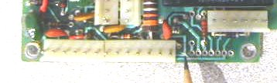
If your radio had a CG board installed, you will need to Re install R33, a 1K ohm 1/4w resistor from H-1 to H-2. H1 and H2 are holes in the PCB just behind J906. Be certain the resistor lead does not contact and short against the square post J10. See Picture below:
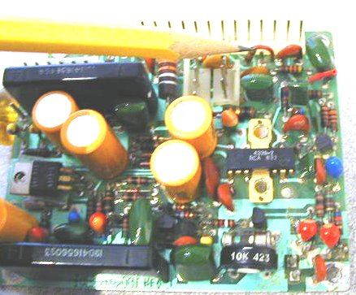

Your systems board duplexing modifications are now complete. Go back and carefully check your work.
Note: A .100-inch center header fits nicely into the row of holes denoted on the PCB as H11 through H17. I install a header here so I can pickup the PTT line without soldering. Do this now before you re-install the System-Audio-Squelch PCB.
Re-install your System-Audio-Squelch PCB in the reverse order in which you removed it. Be careful to properly re-install the insulator over and under the TO-220 voltage regulator transistor. Install all other screws previously removed.
Re-test your MVP now. It should receive and transmit simultaneously now. If you have problem at this point do not proceed until you have the radio working correctly.

Controller installation and hookup
Install your NHRC-4/MVP controller in place of the Channel Guard Encoder/Decoder you have discarded. Use the 3 screws leftover from the removal to mount your controller. If needed obtain some 6-32 X 1/4 inch pan head screws to mount your controller to the mounting bosses on the MVP.
Care must be taken to avoid shorting the transistors which are mounted on the end of the controller next to the inside of radio. The use of electrical tape or some other insulating material between the transistors and the radio is highly recommended.
Use connectors to make your connections to the controller and systems board. This will make your installation look professional and be more reliable. Controllers received for repair with solder on the header pins will have the header pins replaced at the customer’s expense.
All connections to the controller are easily available on the System-Audio-Squelch PCB next to the controller.
Pin  # | Signal Name | Connection Information
1 | +10 VDC | Connect a wire from J906 pin 10 to J4 Pin1 of the NHRC-4/MVP
2 | CAS | Connect a wire from J906 pin 5 (was rx mute) to J4 pin 2 of the NHRC-4/mvp
3 | PTT | Connect a wire from H17 to J4 pin 3 of the NHRC-4/mvp
4 | RX AUDIO  (from Receiver) | Connect a wire from J906 pin 4 ( VSQ-hi) to 5 to J4 pin 4 of the NHRC-4/MVP
5 | TX AUDIO  (to Transmitter) | Connect this to the white or yellowish-white wire that is or was connected to J13. If this is still connected to J13 disconnect it and connect it to J4 pin 5 of the NHRC-4/mvp. Note that this wire is MIC-HI and J13 is the MIC-BIAS voltage supply. This disconnects the MIC bias and will defeat the external microphone. If a local Mic is desired, seek an alternate way to provide audio to the exciter. There may be audio loading issues with the local mic.
6 | DIGITAL OUTPUT/  FAN CONTROL | This connection is optional. If you desire to use this feature, the now unused hang up lead from the old channel guard board is an easy way to get this signal out of the radio. The channel hang-up lead comes out on the power/speaker jack on pin 8.
7 | GROUND | Connect J906 pin 1 to J4 pin 8 of the NHRC-4/MVP.

Connections are now complete for basic repeater operation.
Before powering on your repeater go back and check your work. Apply power with the controller disconnected and check your power supply connections. With a grounded probe touch the PTT pin, your MVP should transmit.. Check to see that your CAS signal goes to aprox 7 volts when the squelch opens and goes low when it closes.
Refer to the NHRC4/MVP operating instructions for setup and operating information

