Introduction
The NHRC-DAD Digital Audio Delay utilizes the latest available technology to provide maximum functionality with the lowest number of parts. This results in very reliable operation.
It is based on the CML Microcircuits MX609/CMX639 CVSD CODEC and offers superior all digital performance over older analog bucket brigade designs. The NHRC-DAD is designed for use with NHRC Repeater Controllers to completely mute all touch tones and eliminate squelch bursts that occur when users un-key their radios.
The key features of the NHRC-DAD are:
- Elimination of squelch tail crashes on your repeated audio
- Elimination of DTMF tones on your repeated audio
- Flexible delay time settings from 8mS to 2048mS
- Plugs directly into all NHRC Repeater Controllers (except the NHRC-2)

Electrical Connections

J1: Controller Interface
A mating interface cable is supplied with the NHRC-DAD. This cable allows for easy installation to any NHRC Repeater Controller. Note: To install the DAD interface cable to the repeater controller, a shorting jumper must be removed between pins 2 and 3 of the delay connector on the controller that you will be installing the NHRC-DAD to.
The interface connector J1 is a 5 position 0.100” pin header. The pinout for connector J1 is listed in the table below. The 5 position end of the interface cable plugs into J1 and the 4 position end plugs into the controllers delay connector.
J1 Pinout:
Pin | Use | Comments
1 | +12V Input
2 | Audio Input | From Controller
3 | Delayed Audio Output AC Coupled
4 | Delayed Audio Output DC Biased | To Controller
5 | Ground

The DC biased output (Pin 4) is used on all NHRC controller models. The AC coupled output (Pin 3) is provided for use with controllers of other manufacturers.
⇒ Caution: Reverse polarity will damage the NHRC-DAD, and will void the warranty.

Input / Output Signal Levels
Audio input impedance is approx. 100K ohms and may be DC biased. Audio output impedance is approx. 70 ohms and is user selectable DC biased or AC coupled output. See the J1 Pinout Table for the location of the output signal connections.

Operation

Setting Delay Time
The NHRC-DAD is capable of producing a maximum input to output delay of 2048mS. Delay time is set by setting DIP switch (JP1) positions D0-D7. The maximum delay time is achieved by setting all of the DIP switches to the ON position. Reducing delay time is done by switching OFF the DIP switches starting at D0 and working to D7.

Delay Time Table
JP1 Setting | Delay Time (mS)
ALL OFF | 8
D0-D6 OFF | 16
D0-D5 OFF | 32
D0-D4 OFF | 64
D0-D3 OFF | 128
D0-D2 OFF | 256
D0-D1 OFF | 512
D0 OFF | 1024
ALL ON | 2048

Switches must be turned off as specified in the above table. Improper switch configurations will result in choppy sounding audio.
NHRC recommends a 128mS delay time. The software in all NHRC controllers is optimized to provide the best muting performance at this setting. Delay times over 512mS are not recommended and may cause squelch tails to appear upon keyup due to the large amount of audio in the delay pipeline at the time of keyup.

Circuit Board
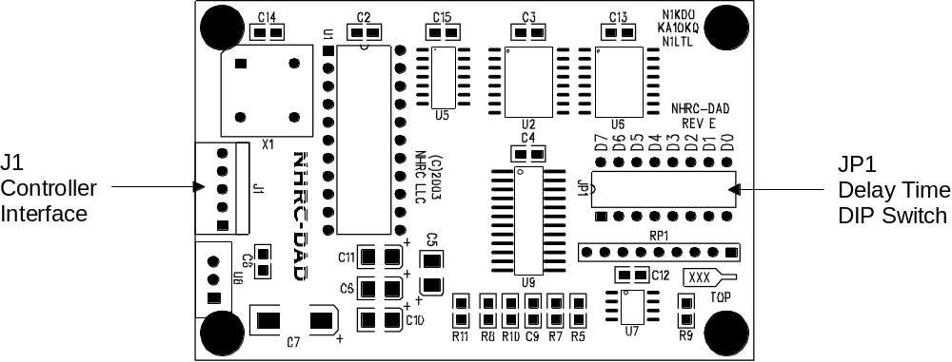

Copyright
Copyright 2003, NHRC LLC
This document contains proprietary information which is the confidential property of NHRC LLC.
No part of this document may be used or reproduced, by any means, for any purpose, without the expressed written consent of NHRC LLC.
No part of this document should be considered to be specifications for the proper or correct operation of the NHRC-DAD Digital Audio Delay. In no way will NHRC LLC be liable for direct or indirect damages to the controller or attached equipment.

NHRC LLC Limited Warranty
NHRC LLC warrants that its assembled and tested products will be free from defects in materials and workmanship for a period of NINETY (90) DAYS from the date of shipment. During this period, NHRC LLC will repair or replace, at our option, any of our products that fail as a result of defects in materials or workmanship. NHRC LLC’s liability will be limited to parts, labor, and return shipping for this period.
NHRC LLC warrants that its kit products will contain components that are free from defects in materials and workmanship for a period of THIRTY (30) DAYS from the date of shipment. During this period, NHRC will replace any of the components in a kit ONCE. Subsequent replacement of any component any subsequent times is completely at the discretion of NHRC LLC, and may require the complete return of the kit.
In no case will NHRC LLC be liable for products damaged by improper wiring (including, but not limited to, over-voltage or application of reverse polarity), physical damage resulting from misuse and/or abuse of the product, neglect, or acts of God (lightning, floods, etc.).
Unauthorized modification of a NHRC product will void the warranty on the modified product.
In no case will NHRC LLC be liable for any direct, consequential, or incidental loss or damage resulting from the use or inability to use any of its products.
Some states or countries do not allow the limitation of incidental or consequential damages, so the paragraph above may not apply to you.
This warranty applies only to the original purchaser of the product; proof of purchase must be presented to receive warranty service.

