
NHRC-μ
User Guide

Software Version: | 1.01
User Guide Version: | 2012-July-16

Copyright Notice

Copyright © 2005, 2012 by NHRC LLC
This document contains proprietary information that is the confidential property of NHRC LLC.
No part of this document may be used or reproduced, by any means, for any purpose, without the express written consent of NHRC LLC.
No part of this document should be considered to be specifications for the proper or correct operation of the NHRC-μ Repeater Controller. In no way will NHRC LLC be liable for direct or indirect damages to the controller or attached equipment.

Printed in the U.S.A.

Thank You!

Thank you for purchasing the NHRC-μ Repeater Controller. This controller has been designed using the very latest state-of-the-art technology. Please review this manual carefully before putting your controller into operation.
This manual represents a very large documentation effort. Your comments are important to us. If you find an error or find any passages that are not clearly understandable, we would like to hear about it. Please send your comments to software-support@nhrc.net.
Support for the controller is available by email or telephone. Please direct software-related questions via email to software-support@nhrc.net. Please direct hardware-related questions via email to hardware-support@nhrc.net . Your question(s) will be answered promptly.
Questions of a more urgent nature can be answered by telephone support. Telephone support is available Monday through Friday, from 6 PM until 10 PM, Eastern time.

1. Introduction 1
1.1 Sending commands 2
1.2 ID Messages 2
1.3 “Unlocked Mode” 3
2. Electrical Connections 4
2.1 Input and Output Signal Levels. 4
2.2 J2: Controller/Repeater Interface 5
2.3 Audio Level Adjustment 6
2.4 The LED Indicators 8
2.5 Computer Programming with the Serial Interface 8
3. Programming the Controller 9
3.1 Quick Setup 9
3.2 Initializing the Controller 11
3.3 *0: Unlocked Mode Control Operator Access 12
3.3.1 Set Control Operator Switches 12
3.4 *1: Save Setup 13
3.4.1 Save configuration setup 13
3.5 *2: Program Command Prefixes 14
3.5.1 Set command prefix 15
3.6 *3: Set timers 16
3.6.1 Program a timer 17
3.7 *4: (Reserved for NHRC) 18
3.8 *5: (Reserved for NHRC) 18
3.9 *6: (Reserved for NHRC) 18
3.10 *7: Program CW and Beep Messages 19
3.10.1 Program a CW ID 19
3.10.2 Program or play courtesy tones 20
3.11 *8: (Reserved for NHRC) 21
3.12 *9: (Reserved for NHRC) 21
3.13 **: Reset Controller 21
4. Control Operator Commands 22
4.1 Group 0 Switches: Repeater Control 23
4.2 Group 1 Switches: Repeater Timer Control 24
4.3 Group 2 Switches: Courtesy Tones and Muting 25
4.4 Group 3 Switches: IDer control 26
4.5 Group 4 Switches: Reserved for NHRC 27
4.6 Group 5 Switches: Reserved for NHRC 28
4.7 Group 6 Switches: Reserved for NHRC 29
4.8 Group 7 Switches: Reserved for NHRC 30
4.9 Group 8 Switches: Programming Write Protect 31
4.10 Group 9 Switches: Control Operator Group Access 32
5. User Commands 33
5.1 DTMF Access 33
5.2 Load Saved Setup 34
6. Appendices 35
6.1 Factory Defaults 35
6.1.1 Default Command Prefixes Table 35
6.1.2 Timer Defaults Table 36
6.1.3 Courtesy Tone Component Tones Table 37
6.1.4 CW (“Morse Code”) Character Table 38
6.2 Control Operator Controls Summary 39
6.2.1 Control Operator Group 0 (Repeater Control) Operations Table 39
6.2.2 Control Operator Group 1 (Repeater Timer Control) Operations Table 39
6.2.3 Control Operator Group 2 (Courtesy Tones and Muting) Operations Table 40
6.2.4 Control Operator Group 3 (IDer control) Operations Table 40
6.2.5 Control Operator Group 4 (Reserved for NHRC) Operations Table 41
6.2.6 Control Operator Group 5 (Reserved for NHRC) Operations Table 41
6.2.7 Control Operator Group 6 (Reserved for NHRC) Operations Table 42
6.2.8 Control Operator Group 7 (Reserved for NHRC) Operations Table 42
6.2.9 Control Operator Group 8 (Programming Write Protect) Operations Table 43
6.2.10 Control Operator Group 7 (Control Operator Group Access) Operations Table 43
6.3 Terminology and Abbreviations 44
7. Circuit Board 45
7.1 Interconnections 45
7.2 Jumpers 45
7.3 NHRC-μ Detailed Top-View Diagram 46
8. Schematics 47
9. Parts List 49
10. NHRC LLC Limited Warranty 50

Introduction
The NHRC-μ (pronounced “micro”, rather than “mu”) Repeater Controller represents the current state-of-the-art in repeater controller designs. It utilizes the latest available technology to provide maximum functionality with the lowest number of parts. This results in very reliable operation.
The key features of the NHRC-μ are:
- Ultra-small package can be installed almost anywhere with double-sided mounting tape.
- Repeater controller, IDer, or beacon controller modes.
- Supports Windows-based programming software for simple configuration.
- DTMF programming over the air.
- DTMF, "Carrier,” “Carrier and CTCSS,” and “Carrier or CTCSS” repeater access modes.
- Granular security features that allow tailored control operator access.

Sending commands
All of the controller’s commands are sent by DTMF (Touch-Tone®) sequences that are received on the main repeater. DTMF tones received will be evaluated, and if correct, executed, when either the DTMF inter-digit timer expires (2.0 seconds) or the CAS (receiver unsquelched) signal drops; whichever comes first. This allows the controller to be commanded even when a weak on-channel signal is holding the receiver’s squelch open.
To send a command over the main repeater:
- Key your transmitter.
- Enter the DTMF command digits.
- Unkey the transmitter.
This will cause the command to be evaluated immediately.
If you pause for more than 2.0 seconds while sending a command, the command you entered prior to the pause will be evaluated, the command buffer will be emptied, and you can immediately enter another command.
When a command is successfully evaluated, the controller will send a response. Each command’s possible responses are detailed with the command description.
In general, if you do not receive a command response, then the controller did not accept your command.

ID Messages
The controller has one CW ID, which can be programmed with either the NHRC-μ Windows based programmer, or with DTMF command sequences sent over the air.
There are several configuration settings that control whether the controller IDs continuously or on an as-needed basis. Consult section 3.10.1 of this manual for more information.
The controller can be configured to play an “initial ID” when the repeater is first activated after a period of inactivity. The ID will also play when ID timer expires. If the ID timer expires during a user’s transmission, the ID will be mixed with the user’s voice, however, the controller tries to be “polite” when identifying, and will identify early at the end of a users transmission if the ID timer is about to expire.

“Unlocked Mode”
All of the controller’s important programming information is protected by a special password, the “unlock code.” The default unlock code is “03”. For security reasons, you should not leave the controllers unlock code programmed to the default.
The unlock code can only be changed while the INIT jumper is installed on the circuit board, which means that the unlock code cannot be programmed without physical access to the controller.
To unlock the controller, send the unlock code DTMF digits over the air. When the controller accepts the unlock code, it will transmit the word “OK” (dah dah dah, dah dit dah) in CW, and the courtesy tone will change to a four-tone high-low-high-low sequence to indicate the controller is unlocked.
The controller can be locked by:
- Sending the “#” command, or
- The controller will lock itself after two minutes of inactivity.
When the controller leaves the unlocked mode:
- The courtesy tone will revert to the normal tone for the controller’s current state.

Electrical Connections
This section of the User Guide describes the electrical interfaces used to connect the controller to:
- Power
- Repeater/Radio
- Computer Serial Port for programming
It is intended for the repeater operator to use in the planning and installation of the NHRC-μ Repeater Controller into a repeater system.

Input and Output Signal Levels.
Control signals into the controller are active-high or active low signals. The active high inputs (CAS and CTCSS Decode) are buffered to allow the connection of popular radios to the controller. Signal levels should be 0.0 to 0.5 volts for low, and 2.0 to 16.0 volts for high. The active-low inputs are pull-to-ground inputs, and work well with open-collector outputs from your repeater or radio. DO NOT USE BOTH ACTIVE HIGH AND ACTIVE LOW INPUTS FOR ONE SIGNAL. It is, however, acceptable to use an active high COR input and an active low CTCSS input, or vice-versa.
The controller’s PTT output is an open-collector and can key most radios PTT line directly. If the radio has a relay connected to the PTT line, NHRC recommends that you use a reverse-biased rectifier diode to snub the relay coil so it does not damage the controller when the relay is de-energized. The PTT output can sink up to 100 mA and tolerate voltages up to 20 VDC. Damage to the PTT output is not covered by the NHRC Limited Warranty.
Audio signals into the controller should be in the range of 0.2 to 2.0 volts peak-to-peak. The controller’s transmit audio outputs are adjustable from about 0.1 volt to about 5 volts peak-to-peak.

J2: Controller/Repeater Interface
The controller uses a 12 pin header for all signals. NHRC supplies a harness assembly that approximately 12” leads to all connections to the header.
The controller requires receiver audio and a signal present indication (CAS) from the receiver, supplies transmit audio and PTT to the transmitter, and requires 13.8 volts DC for power. Be very careful when wiring DC power to the controller, reverse polarity will damage or destroy it. The connector pinouts are shown in the table below.
J1 REPEATER/COMMUNICATIONS Connector Electrical
Pin | Wire Color | Use
1 | Red | +13.8 Volts
2 | Black | Ground
3 | Yellow | CTCSS Active High
4 | Orange | CTCSS Active Low
5 | Blue | COR Active High
6 | Violet | COR Active Low
7 | White | PTT
8 | Tan | RX Audio (from receiver)
9 | Pink | TX Audio (to transmitter)
10 | Brown | Serial Data to Controller
11 | Grey | Serial Data from Controller
12 | Green | Serial Ground

Damage to the controller caused by application of reverse polarity is not covered by the NHRC Limited Warranty.

Audio Level Adjustment
Description of Audio Processing:
The NHRC-μ uses analog switching and audio mixing to route audio from audio sources to the transmitter port.
The controller’s audio path is described in detail below.
The main receiver’s audio is passed into the controller through potentiometer VR1, and then buffered through audio amplifier U4A for impedance isolation and equalization. This amplifier can be set up to provide flat audio response or 6 dB/octave de-emphasis with a roll-off of approximately 250 Hz, allowing the use of discriminator audio. The buffered audio is then passed to touch-tone decoder U2. The main receiver audio is gated through analog switch Q6. The gated audio is supplied to the transmitter mix bus.
Flat or de-emphasized audio on the repeater port is simply selected by moving the shorting jumper JP1 from (N) normal position to (D) de-emphasized position. Note: if the jumper is completely removed, the audio processing circuit will provide approximately a 10X audio gain with flat response.
Courtesy tones are generated directly by the microprocessor U1, filtered, and provided to the transmitter mix bus through potentiometer VR3.
The transmitter mix bus is provided to the main transmitter through buffer amplifier U4B, with the master transmitter level adjusted with potentiometer VR2.
Description of Controls:
VR1 sets the receiver audio input level into the controller, and, more critically, into the DTMF decoder.
VR3 sets the beep level into the transmitter mix bus.
VR2 sets the transmit audio master level.

Audio Level Setup:
Recommended equipment:
- Signal generator or another method of generating a RF signal for the main receiver, modulated with a 1 KHz tone at 3 KHz deviation.
- Deviation meter.
- A Service Monitor is recommended for overall ease of alignment.
Procedure:
The reference level will be a 1 KHz tone at 3 KHz deviation.
- Prepare the controller for audio alignment by setting all potentiometers to the midrange position, and properly configuring the input equalization (normal or de-emphasized) by setting jumper JP1 to the appropriate pins.
- Transmit the reference tone through the repeater, and adjust VR2 for reasonable transmitted deviation, about 3 KHz. The final adjustment of VR2 will occur later. Turn off the reference signal.
- Transmit some DTMF tones into the repeater, and adjust VR1 for reliable DTMF decoding, as indicated by LED D6.
- Use VR3 to set the courtesy tone to a reasonable level.
- If necessary, the output level of the controller can be adjusted with VR2.

The LED Indicators
The NHRC-μ has four LED indicators. These LEDs indicate the state of the COR and CTCSS inputs to the controller, the PTT output of the controller, and a LED to indicate that a DTMF digit is being received. These LEDs are most useful during setup. The LEDs display the following information:
NHRC-μ LED Indicator Functions
Label | Color | Indication
PTT | Red | Transmit Indicator
COR | Green | Unsquelched Indicator
CTCSS | Green | CTCSS Detect Indicator
DTMF | Yellow | DTMF Detect Indicator

Computer Programming with the Serial Interface
The NHRC-μ has a serial interface to allow the controller to be programmed with a Windows-based PC. The programming software is available on the NHRC web site at http://www.nhrc.net/nhrc-micro.php
The computer and controller communicate through a RS-232 serial interface. If your computer does not support a RS-232 serial interface, you can use a USB-to-RS-232 converter cable. The software expects to find the controller on the PC’s COM1 interface.
The NHRC-μ has a 3-pin header attached to the interface cable. NHRC offers a optional programming cable that mates with this connector and your PC’s serial port DB9 connector. If you like, you can build your own programming cable.
NHRC-μ Serial Interface Cable Wiring
Pin | Wire Color | Use | DE9S Female  Serial Port Connector
10 | Brown | Serial Data to Controller | 3
11 | Grey | Serial Data from Controller | 2
12 | Green | Serial Ground | 5

Programming the Controller
This section of the User Guide describes how the repeater operator programs the repeater.
It is intended for repeater operators and users who have an interest in how the controller is customized for specific configurations.
⇒ Note: *n commands are only available when the controller has been unlocked by sending the unlock command.

Quick Setup
This section of the User Guide is intended to get a first-time user “up and running” quickly using a minimum of the customizable features.
NHRC-μ controllers are shipped from the factory enabled, with all command prefixes programmed to the default values. Once your controller is installed and functioning, you should follow the procedure described in this section to begin to customize its operation to suit your needs.
Note that the initialization process described below will completely reset the controller to the factory defaults.
You are not required to use this procedure. It is completely possible to program the NHRC-μ as shipped from the factory without initialization.
DO NOT PERFORM THIS PROCEDURE WITHOUT FIRST READING THE INSTRUCTIONS ABOVE.
Procedure to restore factory defaults:
- Make all the necessary electrical connections. See Section 2.
- Install the initialize jumper (SW1, located near the bottom edge of the board.)
- Apply power to the NHRC-μ. After a short pause, the controller will transmit “NHRC MICRO” in CW. At this time, NHRC recommends that you immediately program the unlock code.
- Leave the initialize jumper installed for this operation.
- Send the default unlock code (03) to the controller. The controller should respond with a CW “OK”
- Use the *2 command to program command prefix 03: the unlock prefix. To program the unlock code to 314159, send the following command: *203314159. The controller will respond with a CW “OK” message.
- Send the “#” command to lock the controller. The controller should respond with a CW “OK” message.
- Remove the initialize jumper (SW1.)
You could program the CW ID at this time, if you so desire. See Sections 3.10.1 for information on programming the CW ID.
You could also program the command prefixes to something other than the supplied defaults. This will make your controller more secure from unauthorized tampering.. (See Section 3.5 for information on programming command prefixes.)
⇒ Note: For increased security, NHRC recommends that you do not leave the initial default command prefixes in the controller.

Initializing the Controller
Initializing the controller will re-program the controller’s non-volatile EEPROM memory with the factory defaults. All customized settings are lost, including command prefixes, timer presets, the CW ID, and the voice messages are reset.
⇒ Note: The controller should never require initialization except for new installations.
Procedure:
- Install the initialize jumper (SW1, located near the bottom edge of the circuit board)
- Apply power to the controller. After a short delay of about 10 seconds, the controller will sent the CW message “NHRC MICRO”.
- Remove the initialize jumper (otherwise the controller will initialize again the next time it is powered up).
⇒ Note: DO NOT LEAVE THE INITIALIZE JUMPER INSTALLED, BECAUSE IF YOU DO, THE CONTROLLER WILL BE INITIALIZED TO THE FACTORY DEFAULTS EACH TIME IT POWERS UP.
See the Appendix of factory defaults for the controller.

*0: Unlocked Mode Control Operator Access

Set Control Operator Switches
The *0 command allows access to all control operator switch groups, including groups 6 and 7 which are not accessible using the control operator prefix. Groups 6 and 7 help to implement controller security by controlling write access to controller data and control operator access to the other eight groups.
The format of this command is
*0<g><i><s> where:
<g> | specifies the group number. Valid range is 0 to 9.
<i> | specifies the switch number. Valid range is 0 to 7.
<s> | is optional. If present, it is the new state of the switch. Valid values are 0 and 1.

Upon receipt of a valid *0 command without the state, the controller will transmit the current state of the selected control operator switch.

Example: Sending the command *000 will inquire of the state of control operator group 0 item 0, and the controller will read back the current state as either ON or OFF with the CW messages “ON” (dah-dah-dah, dah-dit) or “OFF”(dah-dah-dah, dit-dit-dah-dit, dit-dit-dah-dit) in CW.

See Section 4 for more information about control operator switches.

*1: Save Setup
The NHRC-μ Repeater Controller has five “saved configuration setups” that allow the repeater operator to save five presets of all 64 of the control operator switches.
The default setup is #0, which is loaded when the controller is powered up.

Save configuration setup
*1<n> where:
<n> | specifies the setup number to save. Valid range is 0 to 4.

After a valid command is received, the controller will respond with “OK” in CW.
A saved setup can be loaded by using the load saved setup command:
(See Section 5.2 for information about the Load Saved Setup command.)

Example: To save the current controller state (all 10 control operator switch groups) as state #1, send the following command with the controller unlocked: “*11”. The controller will transmit "OK" in CW if the command is accepted.
(Note: the default unlock code is “03”.)

*2: Program Command Prefixes
Every command accepted by the NHRC-μ controller when it is locked consists of a command prefix and optional command arguments.
Each prefix can be programmed to restrict access to certain functions to only those users who know the prefix. This gives the repeater operator the ability to only allow specific users to access certain features.
Command Prefix Rules:
- A command prefix is one to seven digits long.
- A command prefix cannot be left blank.
- No two command prefixes should be programmed the same, or be programmed the same as the beginning of a different prefix. For example, do not program the control operator prefix to 1234 and the DTMF access prefix to 12345, because the controller would not understand whether 123456 was intended to access the controller or change a control operator settings.

Section 6.1.1 describes the Factory Default Command Prefixes.

Set command prefix
*2<pp><prefix> where:
<pp> | specifies the prefix number to set. Valid values are in the range 00 to 15. Two digits must be used. See the Command “Prefixes by Number Table” to determine the prefix number you want to set.
<prefix> | specifies the new prefix to assign. Must be 1 to 7 digits in length.  The valid digits are 0-9, A-D, * and #.

After a valid command is received, the controller will respond “OK.”

Command Prefixes by Number
Prefix  Number | Description
00 | Control Operator
01 | DTMF Access
02 | Load Saved Setup
03 | Unlock the Controller

⇒ Note: For security reasons, command prefixes will never be sent over the air by the controller.

Example: To set the DTMF access prefix to 4321, send the following command with the controller unlocked: "*2014321”. The controller will respond with a CW "OK" if the command is accepted.
⇒ Note: For security reasons, command prefix 03 (the unlock code) cannot be changed unless the initialize jumper (SW1) is installed. This means that the unlock code cannot be changed without physical access to the controller. To change the code, install the jumper, enter the command, and remove the jumper. Do not leave the initialize jumper installed, and do not power up the controller with the initialize jumper installed, unless you want to reset the controller to factory defaults.
⇒ Caution: Do not set any prefix to use the same initial digits as any other prefix, because the controller will not be able to tell the difference between them. For example, if the DTMF access code is set to “123”, and the load saved setup code is set to “1234”, then when a user sends “12340” the controller will try to load saved setup 0 rather than enabling the controller in DTMF access mode.

*3: Set timers
The NHRC-μ has eight “timers.” Two of the timer settings are not actually timers, but are the CW speed and pitch controls.
Each timer has its own resolution which is the amount of time each timer count represents.
For example, the hang timer’s resolution is .1 second. To program a hang time of 5.0 seconds, the hang timer would actually be programmed to 50 because there are 50 .1 second intervals in 5.0 seconds.

Program a timer
The NHRC-μ timers are programmed as follows:
*3<nn><time> where:
<nn> | specifies the timer to set. Valid range is 00 to 12. Both digits must be present. Consult the NHRC-μ Timers by Number Table for the timer number.
<time> | The value to program the timer to. The valid range for <time> is 0 to 255.

After a valid set timer command is received, the controller will respond with the word “OK” in CW.
NHRC- Timers, by Number
Timer  No. | Description | Timer  Resolution
00 | Hang timer long | 0.1
01 | Hang timer short | 0.1
02 | ID timer | 10
03 | DTMF access timer | 10
04 | Time-out timer long | 1
05 | Time-out timer short | 1
06 | CW Pitch | See table
07 | CW Speed | WPM

Examples:
To program the ID timer to six minutes (360 seconds), send the following command with the controller unlocked: "*30236”. If the command is accepted, the controller will respond with “OK” in CW.
To set the long hang timer for 20 seconds, send the following command with the controller unlocked: "*300200”. If the command is accepted, the controller will respond with “OK” in CW.
Note: the default unlock code is “03”.

*4: (Reserved for NHRC)
This command is reserved by NHRC for future expansion.

*5: (Reserved for NHRC)
This command is reserved by NHRC for future expansion.

*6: (Reserved for NHRC)
This command is reserved by NHRC for future expansion.

*7: Program CW and Beep Messages
The *7 command is used to program or play the CW ID and courtesy tones. *70 is used to program or play the CW ID, and *71 to program or play the courtesy tones. See below.

Program a CW ID
The CW ID can be programmed or played with the *70 command, as follows:
*70<dd..dd..dd..> where:
<dd…dd…dd…> | is the CW ID message. If left blank, the current CW ID message will play. When present, the part of the command represented by <dd..dd..dd..> consists of 1 to 12 digit pairs. Each pair of digits represents one CW character.

(See Section 6.1.4, the CW Character Table, to look up the code for each CW character.)

Example: To program “DE N1KDO/R” as the CW ID, the following command would be entered with the controller unlocked: *70 31 32 11 62 01 52 63 12 72.

Program or play courtesy tones
The NHRC-μ supports eight different courtesy tones (0 through 7). Courtesy tones are composed of up to four segments of tones. Each segment has a tone frequency and duration. Courtesy tone 7 is reserved for the unlocked courtesy tone.
The courtesy tones are played and programmed with command *71 as follows:
*71<n><ddtt ddtt ddtt ddtt> where:
<n> | is the courtesy tone number to play or program. The valid range of values is 0 to 7.
<ddtt ddtt ddtt ddtt> | is up to four sets of duration and tone.
Duration is in 10 ms increments; valid range is 01-99. Both digits must be specified. Tone is the number of the tone from Section 6.1.3, the Courtesy Tone Components Table.

Example: The default courtesy tone #0, (four 50MS bursts of notes E5, G5, B5, D6) would be programmed like: *7100517052005240527.

Each courtesy tone can be selected based on control operator switches in Group 2. See section 4.3 for information about selecting a particular courtesy tone. Each saved setup could potentially have its own courtesy tone, to indicate which saved setup is selected.

*8: (Reserved for NHRC)
This command is reserved by NHRC for future expansion.

*9: (Reserved for NHRC)
This command is reserved by NHRC for future expansion.

**: Reset Controller
Command ** is used to reset the controller to the power-up state for any reason.
The controller will send “NHRC MICRO” in CW, then play the initial ID.

Control Operator Commands
The NHRC-μ supports 24 different control operator settings arranged into eight different groups of eight “software switches.” Each software switch represents an item in the controller that can be set to either on or off. Every switch is addressed by naming the group, then the item number. There are eight groups of eight items each.

The format for all control operator commands is:
<ctl-op-prefix><group><item><state>
<ctl-op-prefix> | The control operator prefix assigned by the repeater operator. (See Section 3.5 for information on Programming Command Prefixes.)
<group> | The group code for the switch to set or inquire. The valid range for <group> is 0 to 7. Groups 8 and 9 can only be accessed with the programming *0 command. (See Section 3.3 for information about *0: Unlocked Mode Control Operator Access.)
<item> | The item number to set or inquire. The valid range for <item> is 0 to 7.
<state> | is optional. If present, it is the state (1=on, 0=off) to which the control operator switch is to be set.

When <state> is not present, or after a successful control operator command that sets the switch state, the controller will respond by transmitting either the CW message “ON” or “OFF”, depending on the state of the particular switch.
For example, to set group 0 item 0 to enabled, the following command would be sent: <ctl-op-prefix>001.
The controller will respond by transmitting the word “ON” in CW.
All of the control operator switches are saved when the controller’s state is saved. Saved state 0 is the power-up state, so if you want to make your changes to the control operator switches be restored after a power failure, it is important to save the controller’s state. See section 3.4 for information on the Save State Command.

Group 0 Switches: Repeater Control
Group 0 contains switches that control the repeater and access to the repeater.
Group 0 Switches:
Switch | Name | Description
0 | Repeater Enable | This is the repeater’s master enable/disable control. Set this to 0 to disable the repeater.
1 | CTCSS and COR Required | Allows the repeater to be set into a CTCSS required mode when enabled. When disabled, the repeater is carrier access.
2 | CTCSS or COR required | Setting this switch to 1 enables “Dual Squelch” mode. In “Dual-Squelch” mode, either the CAS or the CTCSS signal will cause the repeater to be accessed. This is sometimes called “OR-Squelch” mode, and can be used to allow the repeater to have a tight squelch for carrier access, but looser access when the CTCSS tone is present.
3 | COR, plus  CTCSS when idle | Setting this switch to 1 will make the controller require valid CTCSS for access, unless the hang timer is running. This mode allows the repeater to be activated by a user with the valid CTCSS tone, but then accessed by users without CTCSS, or to be activated with a 1750 Hz. tone for countries that require tone-burst access.
4 | DTMF Access Mode Select | Allows the control operator to place the repeater into DTMF access mode. In DTMF access mode, the repeater, when idle, can only be activated by sending the DTMF access prefix, followed by a 1 to enable the repeater. The repeater will remain active until either disabled with the DTMF access prefix followed by a 0, or the repeater remains idle for longer than the time specified in the DTMF access timer
5 | Reserved | Reserved for NHRC.
6 | Reserved | Reserved for NHRC.
7 | Reserved | Reserved for NHRC.

Group 1 Switches: Repeater Timer Control
Group 1 contains switches that control the repeater timers.
Group 1 Switches:
Switch | Name | Description
0 | Hang Timer Enabled | Normally enabled, but can be disabled when the repeater runs on battery power, or to discourage “kerchunkers.”
1 | Hang Timer Long Select | Allows the control operator to select which hang timer value is used. Allows the long (1) or short (0) timer to be selected.
2 | Repeater Time-out Timer Enable | Allows the time-out timer on the main repeater to be enabled or disabled. Normally the time-out timer will be enabled. However, certain applications may require that the time-out timer be disabled (nets, shuttle rebroadcast, etc.). Set this switch to 1 to enable the repeater time-out timer.
3 | Time-out Timer Long Select | Allows the long (1) or short (0) timer to be selected.
4 | Reserved | Reserved for NHRC.
5 | Reserved | Reserved for NHRC.
6 | Reserved | Reserved for NHRC.
7 | Key Up Delay (“Kerchunker Filter”) | Allows the “kerchunker filter” to be enabled. The “kerchunker filter” requires a signal for more than ½ second before the repeater will begin to repeat, but only when the transmitter is not on.

Group 2 Switches: Courtesy Tones and Muting
Group 2 controls courtesy tones and DTMF muting.
Group 2 Switches:
Switch | Name | Description
0 | Courtesy Tone Enable | When enabled (1) the controller will play a courtesy tone after each users transmission ends.
1 | DTMF Muting Enable | When enabled (1), the controller will mute the receiver audio to prevent received DTMF command tones from being broadcast over the repeater.
2 | Select Courtesy Tone 1 | Select Courtesy Tone 1
3 | Select Courtesy Tone 2 | Select Courtesy Tone 2. Takes precedence over lower numbered courtesy tones.
4 | Select Courtesy Tone 3 | Select Courtesy Tone 3. Takes precedence over lower numbered courtesy tones.
5 | Select Courtesy Tone 4 | Select Courtesy Tone 4. Takes precedence over lower numbered courtesy tones.
6 | Select Courtesy Tone 5 | Select Courtesy Tone 5. Takes precedence over lower numbered courtesy tones.
7 | Select Courtesy Tone 6 | Select Courtesy Tone 6. Takes precedence over lower numbered courtesy tones.

Group 3 Switches: IDer control
Group 3 contains switches that control the operation of the IDer.
Group 3 Switches:
Switch | Name | Description
0 | Immediate ID Mode | When enabled (1), the controller will cause a CW ID to play at the end of the first user’s transmission after an idle period.
1 | Beacon ID Mode | When enabled (1) this switch causes the controller to continuously ID every ID timer interval, regardless of input activity.
2 | IDer mode | When enabled, the controller will add no hang time, play no courtesy tones, have no timeout timer, but will produce a CW ID to mix with the received audio.
3 | CW waveform on PTT | When enabled, the controller’s CW output will key the PTT lead directly, for keying a CW transmitter. The CW beep tone will also be present for monitoring or MCW applications..
4 | Reserved | Reserved for NHRC.
5 | Reserved | Reserved for NHRC.
6 | Reserved | Reserved for NHRC.
7 | Reserved | Reserved for NHRC.

Group 4 Switches: Reserved for NHRC
Group 4 contains switches that are reserved for future use by NHRC.
Group 4 Switches:
Switch | Name | Description
0 | Reserved. | Reserved for NHRC.
1 | Reserved. | Reserved for NHRC.
2 | Reserved. | Reserved for NHRC.
3 | Reserved. | Reserved for NHRC.
4 | Reserved. | Reserved for NHRC.
5 | Reserved | Reserved for NHRC.
6 | Reserved | Reserved for NHRC.
7 | Reserved | Reserved for NHRC.

Group 5 Switches: Reserved for NHRC
Group 5 contains switches that are reserved for future use by NHRC.
Group 5 Switches:
Switch | Action | Description
0 | Reserved | Reserved for NHRC.
1 | Reserved | Reserved for NHRC.
2 | Reserved | Reserved for NHRC.
3 | Reserved | Reserved for NHRC.
4 | Reserved | Reserved for NHRC.
4 | Reserved | Reserved for NHRC.
5 | Reserved | Reserved for NHRC.
6 | Reserved | Reserved for NHRC.
7 | Reserved | Reserved for NHRC.

Group 6 Switches: Reserved for NHRC
Group 6 contains 5 contains switches that are reserved for future use by NHRC.
Group 6 Switches:
Switch | Name | Description
0 | Reserved | Reserved for NHRC.
1 | Reserved | Reserved for NHRC.
2 | Reserved | Reserved for NHRC.
3 | Reserved | Reserved for NHRC.
4 | Reserved | Reserved for NHRC.
5 | Reserved | Reserved for NHRC.
6 | Reserved | Reserved for NHRC.
7 | Reserved | Reserved for NHRC.

Group 7 Switches: Reserved for NHRC
Group 7 contains 5 contains switches that are reserved for future use by NHRC.
Group 7 Switches:
Switch | Name | Description
0 | Reserved | Reserved for NHRC.
1 | Reserved | Reserved for NHRC.
2 | Reserved | Reserved for NHRC.
3 | Reserved | Reserved for NHRC.
4 | Reserved | Reserved for NHRC.
5 | Reserved | Reserved for NHRC.
6 | Reserved | Reserved for NHRC.
7 | Reserved | Reserved for NHRC.

Group 8 Switches: Programming Write Protect
Group 8 contains 5 contains switches that are used to write-protect the controller setups. This group cannot be accessed by the control operator. Groups 8 and 9 can only be accessed when the controller is unlocked, by using the *0 command.
Group 8 Switches:
Switch | Name | Description
0 | Write Protect Control Group Setups | When enabled (1), causes the *1 command (Save Setup) to fail, effectively disallowing control groups to be saved.
1 | Write Protect Command Prefixes | When enabled (1), causes the *2 Program Command Prefix command to fail, effectively disallowing modification of the command prefixes.
2 | Write Protect Timers | When enabled (1), causes the *3 Set Timers command to fail, effectively disallowing modification of the timer values.
3 | Reserved | Reserved for NHRC.
4 | Reserved | Reserved for NHRC.
5 | Reserved | Reserved for NHRC.
6 | Write Protect CW Messages and Courtesy Tones | When enabled (1), causes the *70 and *71 commands to fail when new messages are specified, effectively disallowing modification of the CW ID and courtesy tones.
7 | NHRC Test Mode | NHRC Test Mode. Reserved for NHRC.

Group 9 Switches: Control Operator Group Access
Group 9 contains switches which enable or disable control operator access to the control operator groups. This group cannot be accessed by the control operator. Groups 8 and 9 can only be accessed using the *0 (unlocked mode control operator access) command. These switches allow the repeater operator to selectively disable control operator functions on a group-by-group basis, allowing more granularity of controller security. (See Section 3.3 for information on the unlocked mode control operator access.)

Group 9 Switches:
Switch | Name | Description
0 | Enable Control Operator Access to Group 0 | When enabled (1), allow the control operator to change the settings in Group 0.
1 | Enable Control Operator Access to Group 1 | When enabled (1), allow the control operator to change the settings in Group 1.
2 | Enable Control Operator Access to Group 2 | When enabled (1), allow the control operator to change the settings in Group 2.
3 | Enable Control Operator Access to Group 3 | When enabled (1), allow the control operator to change the settings in Group 3.
4 | Enable Control Operator Access to Group 4 | When enabled (1), allow the control operator to change the settings in Group 4.
5 | Enable Control Operator Access to Group 5 | When enabled (1), allow the control operator to change the settings in Group 5.
6 | Enable Control Operator Access to Group 6 | When enabled (1), allow the control operator to change the settings in Group 6.
7 | Enable Control Operator Access to Group 7 | When enabled (1), allow the control operator to change the settings in Group 7.

User Commands
This section of the manual describes commands that are available to the repeater users. Every command has a command prefix which is set by the repeater operator. The prefixes can be kept secret, so only certain users have access to certain functions. (See Section 3.5 for more information on programming command prefixes.)
Throughout this section of the manual, the command prefix will be shown as <prefix>, which must be replaced with the actual command prefix as programmed by the repeater operator.

DTMF Access
The NHRC-μ Repeater Controller supports a DTMF access mode which allows the repeater to be left in a secured disabled state, but users who know the DTMF access code can enable the repeater. The repeater reverts to the secured disabled state when either the repeater is idle for longer than the DTMF Access Mode Timer, or a user sends the DTMF access code followed by a zero.
The repeater is put into DTMF Access Mode by setting control operator group 0, item 4 to enabled (1). (See Section 4.1 for information about this control operator switch, and section 3.5 for information on programming the DTMF Access Prefix and section 3.6 for information on setting the DTMF access timer.)

When the repeater is in the DTMF access mode, the DTMF access command is used as follows:
<prefix><state> where:
<prefix> | is the DTMF access mode prefix.
<state> | is 1 to enable the repeater. <state> is 0 to return the repeater to the secure disabled mode.

Example: If the repeater is in DTMF Access Mode, and the DTMF Access Prefix is “567”, the repeater can be activated by sending “5671”. At that time the repeater will remain on until either no activity occurs on the repeater for a period longer than the DTMF Access Mode timer or the repeater is manually deactivated by sending “5670”.

Load Saved Setup
The NHRC-μ supports five saved setups of all 80 control operator switches. (See Section 3.4 for information about saving the controller state.)
This command allows users or control operators to select one of the preset repeater states.

The format for the load saved state command is:
<prefix><state-number> where:
<prefix> | is the load saved state prefix as programmed by the repeater operator.
<state-number> | is the state to load. Valid state numbers are 0 to 4.

Example: Assuming the Load Saved Setup prefix is set to 314159, and you want to select your “net mode”, saved as setup #1, send “3141591”. The controller will respond with “OK” in CW.

Appendices

Factory Defaults

Default Command Prefixes Table

Index | Description | Default  Prefix
00 | Control Operator | 00
01 | DTMF Access | 01
02 | Load Saved Setup | 02
03 | Unlock Controller | 03

Timer Defaults Table

Timer  Number | Description | Multiplier | Timer  Value | Effective  Value
00 | Hang Timer Long | .1 | 100 | 10.0
01 | Hang Timer Short | .1 | 50 | 5.0
02 | ID Timer | 10 | 54 | 540
03 | DTMF Access Timer | 10 | 60 | 600
04 | Time-Out Timer Long | 1 | 180 | 180
05 | Time-Out Timer Short | 1 | 30 | 30
06 | CW Pitch | * | 20 | C6 note
07 | CW Speed | WPM | 20 | 20 WPM

Courtesy Tone Component Tones Table
Tone Code | Tone
00 | No tone
01 | F4
02 | F#4
03 | G4
04 | G#4
05 | A4
06 | A#4
07 | B4
08 | C5
09 | C#5
10 | D5
11 | D#5
12 | E5
13 | F5
14 | F#5
15 | G5
16 | G#5
17 | A5
18 | A#5
19 | B5
20 | C6
21 | C#6
22 | D6
23 | D#6
24 | E6
25 | F6
26 | F#6
27 | G6
28 | G#6
29 | A6
30 | A#6
31 | B6

CW (“Morse Code”) Character Table
Letter | Code
0 | 00
1 | 01
2 | 02
3 | 03
4 | 04
5 | 05
6 | 06
7 | 07
8 | 08
9 | 09
A | 21
B | 22
C | 23
D | 31
E | 32
F | 33
G | 41
H | 42
I | 43
J | 51
K | 52
L | 53
M | 61
N | 62
O | 63
P | 71
Q | 70
R | 72
S | 73
T | 81
U | 82
V | 83
W | 91
X | 92
Y | 93
Z | 90
Space | 11
/ | 12

Control Operator Controls Summary

Control Operator Group 0 (Repeater Control) Operations Table
Group  # | Item  # | Function | Default | Comments
0 | 0 | Repeater Enable | 1
0 | 1 | COR and CTCSS | 0
0 | 2 | COR or CTCSS | 0 | “dual-squelch” mode
0 | 3 | COR during hang time,  COR and CTCSS when idle | 0 | Useful for 1750 hz tone decoder on CTCSS input
0 | 4 | DTMF Access Mode | 0 | see related DTMF access code and timer information
0 | 5 | Reserved | 0
0 | 6 | Reserved | 0
0 | 7 | Reserved | 0

Control Operator Group 1 (Repeater Timer Control) Operations Table
Group  # | Item  # | Function | Default | Comments
1 | 0 | Hang Timer Enable | 1 | 1=enabled
1 | 1 | Hang Timer Long / Short | 0 | 0=short, 1=long, see related timer values
1 | 2 | Timeout Timer Enable” | 0 | 1=enabled
1 | 3 | Timeout Timer Long / Short | 1 | 0=short, 1=long, see related timer values
1 | 4 | Reserved | 0
1 | 5 | Reserved | 0
1 | 6 | Reserved | 0
1 | 7 | Key Up Delay Enable | 1 | 1=enabled. The “kerchunker filter”

Control Operator Group 2 (Courtesy Tones and Muting) Operations Table
Group  # | Item  # | Function | Default | Comments
2 | 0 | Courtesy Tone Enable | 1 | 1=enabled
2 | 1 | DTMF Muting Enable | 1 | 1=enabled
2 | 2 | Select Courtesy Tone 1 | 0 | Courtesy tone 0 is the default when no other tone is selected.
2 | 3 | Select Courtesy Tone 2 | 0
2 | 4 | Select Courtesy Tone 3 | 0
2 | 5 | Select Courtesy Tone 4 | 0
2 | 6 | Select Courtesy Tone 5 | 0
2 | 7 | Select Courtesy Tone 6 | 0 | Reserved for NHRC

Control Operator Group 3 (IDer control) Operations Table
Group  # | Item  # | Function | Default | Comments
3 | 0 | Immediate ID Mode | 1 | 1=enable. Plays the “welcoming” ID when repeater was brought up after a period of inactivity
3 | 1 | Beacon ID Mode | 0 | 1=enable. When enabled, the IDs play every ID cycle, regardless of repeater activity
3 | 2 | IDer mode | 0 | 1=enable. Selects no hang time, no timeout, no courtesy tone for IDer use.
3 | 3 | CW waveform on PTT | 0 | 1=enable. Uses PTT for CW keying waveform for CW transmitters.
3 | 4 | Reserved | 0 | Reserved for NHRC
3 | 5 | Reserved | 0 | Reserved for NHRC
3 | 6 | Reserved | 0 | Reserved for NHRC
3 | 7 | Reserved | 0 | Reserved for NHRC

Control Operator Group 4 (Reserved for NHRC) Operations Table
Group  # | Item  # | Function | Default | Comments
4 | 0 | Reserved. | 0 | Reserved for NHRC
4 | 1 | Reserved | 0 | Reserved for NHRC
4 | 2 | Reserved | 0 | Reserved for NHRC
4 | 3 | Reserved | 0 | Reserved for NHRC
4 | 4 | Reserved | 0 | Reserved for NHRC
4 | 5 | Reserved | 0 | Reserved for NHRC
4 | 6 | Reserved | 0 | Reserved for NHRC
4 | 7 | Reserved | 0 | Reserved for NHRC

Control Operator Group 5 (Reserved for NHRC) Operations Table
Group  # | Item  # | Function | Default | Comments
5 | 0 | Reserved. | 0 | Reserved for NHRC
5 | 1 | Reserved. | 0 | Reserved for NHRC
5 | 2 | Reserved. | 0 | Reserved for NHRC
5 | 3 | Reserved. | 0 | Reserved for NHRC
5 | 4 | Reserved. | 0 | Reserved for NHRC
5 | 5 | Reserved. | 0 | Reserved for NHRC
5 | 6 | Reserved. | 0 | Reserved for NHRC
5 | 7 | Reserved. | 0 | Reserved for NHRC

Control Operator Group 6 (Reserved for NHRC) Operations Table
Group  # | Item  # | Function | Default | Comments
6 | 0 | Reserved. | 0 | Reserved for NHRC
6 | 1 | Reserved | 0 | Reserved for NHRC
6 | 2 | Reserved | 0 | Reserved for NHRC
6 | 3 | Reserved | 0 | Reserved for NHRC
6 | 4 | Reserved | 0 | Reserved for NHRC
6 | 5 | Reserved | 0 | Reserved for NHRC
6 | 6 | Reserved | 0 | Reserved for NHRC
6 | 7 | Reserved | 0 | Reserved for NHRC

Control Operator Group 7 (Reserved for NHRC) Operations Table
Group  # | Item  # | Function | Default | Comments
7 | 0 | Reserved. | 0 | Reserved for NHRC
7 | 1 | Reserved. | 0 | Reserved for NHRC
7 | 2 | Reserved. | 0 | Reserved for NHRC
7 | 3 | Reserved. | 0 | Reserved for NHRC
7 | 4 | Reserved. | 0 | Reserved for NHRC
7 | 5 | Reserved. | 0 | Reserved for NHRC
7 | 6 | Reserved. | 0 | Reserved for NHRC
7 | 7 | Reserved. | 0 | Reserved for NHRC

Control Operator Group 8 (Programming Write Protect) Operations Table
Group  # | Item  # | Function | Default | Comments
8* | 0 | Write Protect Control Group Setups | 0
8* | 1 | Write Protect Prefixes | 0
8* | 2 | Write Protect Timers | 0
8* | 3 | Reserved | 0 | Reserved for NHRC
8* | 4 | Reserved | 0 | Reserved for NHRC
8* | 5 | Reserved | 0 | Reserved for NHRC
8* | 6 | Write Protect CW Messages & Courtesy Tones | 0
8* | 7 | Reserved | 0 | Reserved for NHRC

Control Operator Group 9 (Control Operator Group Access) Operations Table
Group  # | Item  # | Function | Default | Comments
9* | 0 | Enable Access To Group 0 | 1
9* | 1 | Enable Access To Group 1 | 1
9* | 2 | Enable Access To Group 2 | 1
9* | 3 | Enable Access To Group 3 | 1
9* | 4 | Enable Access To Group 4 | 1
9* | 5 | Enable Access To Group 5 | 1
9* | 6 | Enable Access To Group 6 | 0 | Reserved for NHRC
9* | 7 | Enable Access To Group 7 | 0 | Reserved for NHRC

* controller must be unlocked to access groups 6 and 7

Terminology and Abbreviations
Term | Description
CAS | Carrier Activated Squelch, where receipt of a signal, with or without CTCSS tones will activate the controller.
CW | Continuous Wave signals, commonly using “Morse Code.” The term “CW” refers to the radio emission type, while “Morse Code” refers to the signaling type used. Typically, they are incorrectly used interchangeably.
DTMF | Also known as “Touch Tone®” codes.
Dual Squelch | “Dual Squelch,” also known as CAS or CTCSS mode, allows the repeater to be configured with a tight squelch for users without CTCSS, but allows a valid CTCSS to access the repeater even when the signal is not quiet enough to open the carrier squelch.
ID | Identification
PTT | Push-to-Talk
Unlock Code | A special password used to enable programming of the controller.

Circuit Board

Interconnections
Connector | Name | Purpose
J1 | “Repeater/ Communication” | Connects the repeater transmit and receive audio, PTT, CAS, and power signals to the controller. Also provides serial communication for PC-based programming.
J2 | “ICD” | Reserved for NHRC. Do not use. Connecting to any of the J2 pads can damage the controller, and this damage will not be covered by the NHRC limited warranty

Jumpers
Jumper | Purpose
SW1 | Initialize/Change Unlock Code jumper. If this jumper is present at controller power-up, then the controller’s non-volatile settings are reset to the factory defaults. This jumper can be installed after the power is up to change the controller’s unlock code. Do not leave this jumper installed after initialization or changing the unlock code, or the controller will initialize on the next power-up. The microprocessor shares this connection with the audio muting circuit; when the jumper is installed the audio will be unmuted. This is normal.

NHRC-μ Detailed Top-View Diagram
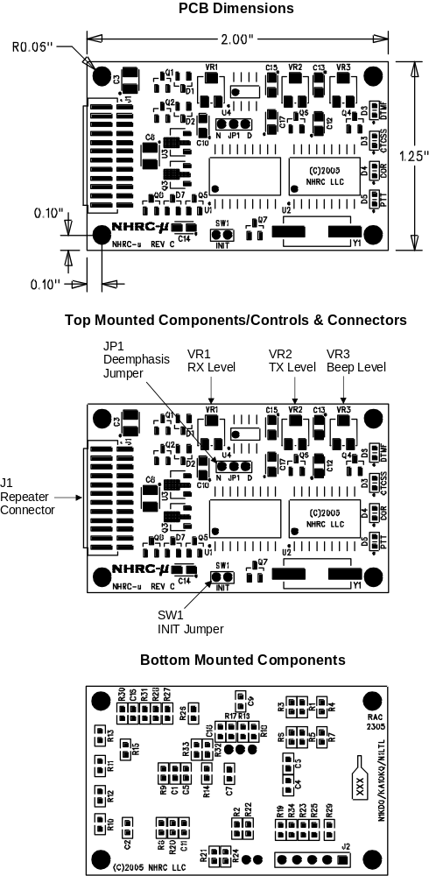The following diagram is a detailed top view of the Revision “C” printed wiring board for the NHRC-μ Repeater Controller.

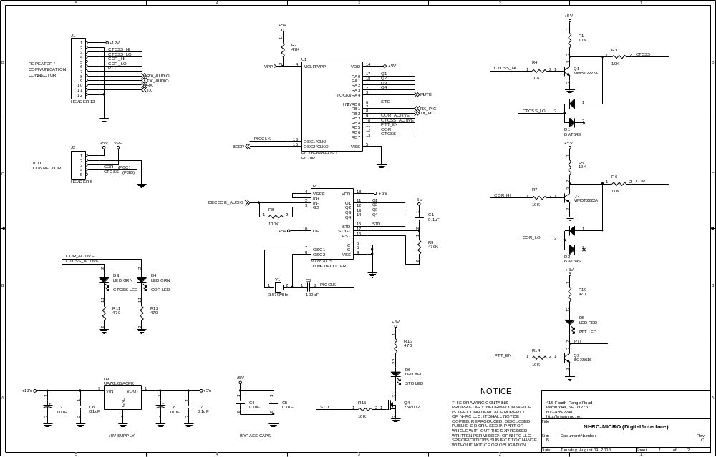Schematics
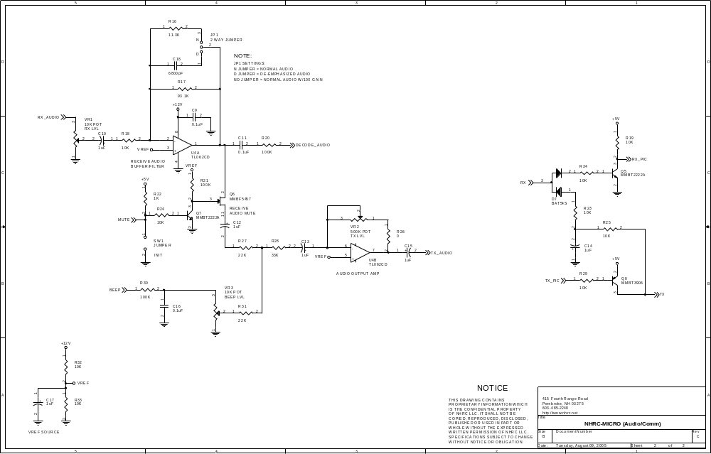

Parts List
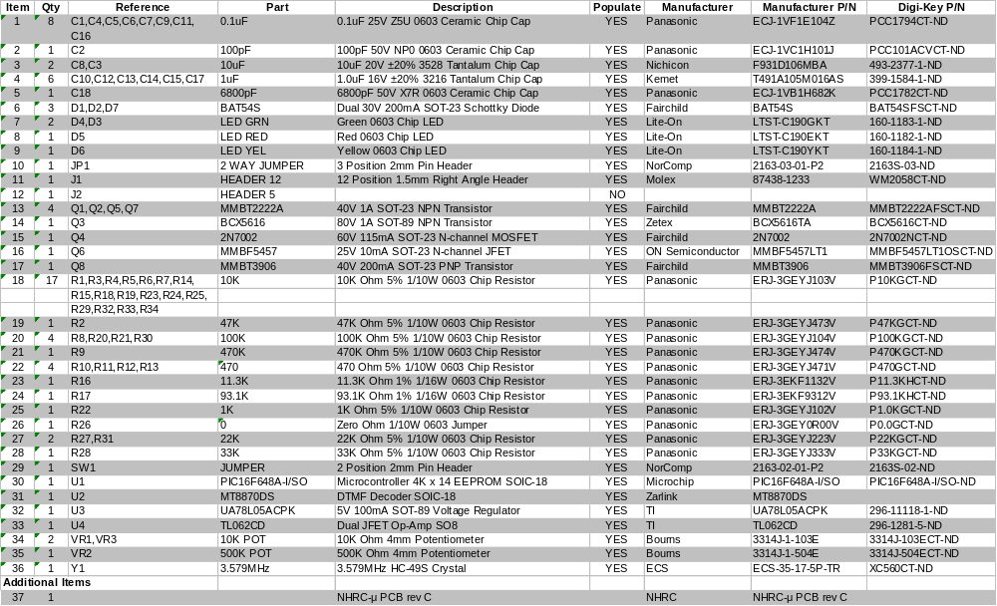NHRC-μ Repeater Controller Bill of Materials, PCB Revision C

NHRC LLC Limited Warranty
NHRC LLC warrants that its assembled and tested products will be free from defects in materials and workmanship for a period of NINETY (90) DAYS from the date of shipment. During this period, NHRC LLC will repair or replace, at our option, any of our products that fail as a result of defects in materials or workmanship. NHRC LLC’s liability will be limited to parts, labor, and return shipping for this period.
NHRC LLC warrants that its kit products will contain components that are free from defects in materials and workmanship for a period of THIRTY (30) DAYS from the date of shipment. During this period, NHRC will replace any of the components in a kit ONCE. Subsequent replacement of any component any subsequent times is completely at the discretion of NHRC LLC, and may require the complete return of the kit.
In no case will NHRC LLC be liable for products damaged by improper wiring (including, but not limited to, over-voltage or application of reverse polarity), physical damage resulting from misuse and/or abuse of the product, neglect, or acts of God (lightning, floods, etc.).
Unauthorized modification of a NHRC product will void the warranty on the modified product.
In no case will NHRC LLC be liable for any direct, consequential, or incidental loss or damage resulting from the use or inability to use any of its products.
Some states or countries do not allow the limitation of incidental or consequential damages, so the paragraph above may not apply to you.
This warranty applies only to the original purchaser of the product; proof of purchase must be presented to receive warranty service.

