The NHRC-Micro is a ultra-compact repeater controller/IDer designed for easy installation in close quarters. The NHRC-Micro can function as a conventional repeater controller, as an IDer for repeaters, or as a beacon controller. It can be easily mounted almost anywhere with double-sided foam adhesive tape, allowing simple installation in just about any equipment.
Features:
- Repeater Controller, IDer, or Beacon modes.
- High- and low-going COR and CTCSS inputs.
- Extremely compact.
- "Intelligent" ID algorithm.
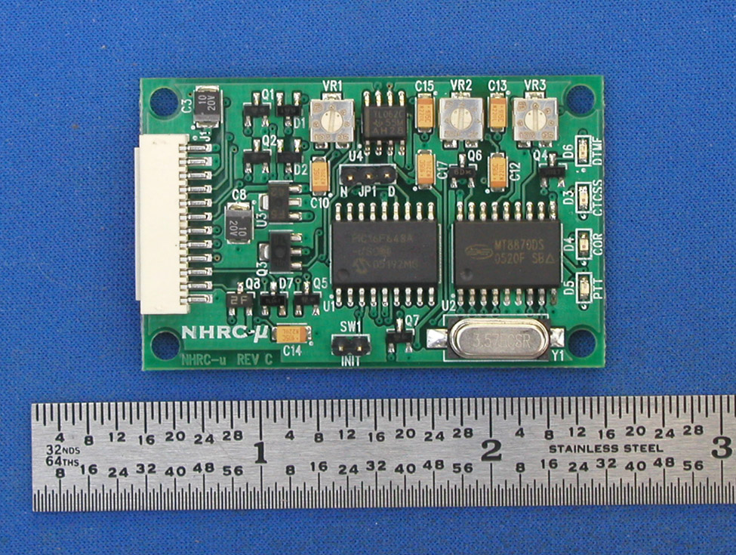
- Programmable Morse Code ID speed and pitch.
- Touch-Tone remote control and programming.
- Windows-based, serial port programming.
- Hang timer, ID timer, Timeout timer, and ID message are stored in non-volatile memory.
- Jumper-selectable receiver de-emphasis.
- LEDs indicate CAS, CTCSS, PTT, and DTMF.
- Extremely low power consumption.

The NHRC-Micro is programmable by sending DTMF sequences over the air, or by computer with a serial port connection and the free NHRC-Micro programming software. The CW ID, hang time, ID timer, timeout timer and courtesy tone beeps can all be programmed by the user. All programming is stored in non-volatile EEPROM memory.
As a repeater controller, the NHRC-Micro provides “hang time” or “repeater tail,” repeater time-out timer, courtesy beep, and Morse code identification. DTMF (“touch-tone”) commands can be used to enable or disable the repeater, or change repeater operating characteristics over the air.
The NHRC-Micro can be configured as a repeater IDer to make existing repeaters compliant with government regulations. It can also be configured as a “beacon” controller, to periodically send a Morse code message over nearly any radio link.
The ultra-compact NHRC-micro can be installed inside the cabinet of most any equipment when mounted with double-sided foam adhesive tape — it measures only 2.0” x 1.25”. It includes a pre-wired connector and wiring harness.
The NHRC-Micro is available immediately for $119.
Please see our website for more information about the NHRC-Micro and our complete line of repeater controllers and accessories.

