
NHRC-PXP
Phoenix SX Programmer
User Guide
Software Version: | 1.00
User Guide Version: | 2004-09-11

Copyright Notice

Copyright © 2004 by NHRC LLC
This document contains proprietary information that is the confidential property of NHRC LLC.
No part of this document may be used or reproduced, by any means, or for any purpose, without the express written consent of NHRC LLC.
No part of this document should be considered to be specifications for the proper or correct operation of the NHRC-PXP Programmer. In no way will NHRC LLC be liable for direct or indirect damages to the controller or attached equipment.

Warranty

This software is supplied at no charge with absolutely no warranty. It may or may not be suitable for the purposes described in this manual. In no case will NHRC LLC be liable for any direct, consequential, or incidental loss or damage resulting from the use or inability to use this software.

Printed in the U.S.A.

Welcome!

Thank you for your purchase of the NHRC-PXP Phoenix SX Programmer.

We are interested in your feedback about the software and documentation. Please email your questions and comments to software-support@nhrc.net. Telephone support requests will be taken on an as-available basis.

1. Introduction 7
1.1 Supported Computer Platforms 7
1.2 Supported Radios 7
2. Using the NHRC-PXP Pod 8
2.1 DC Power Connector 8
2.2 EEPROM Socket 8
2.3 LED Indicators 9
2.4 Pushbuttons 9
3. Using the NHRC-PXP software 10
3.1 Installation 10
3.2 Starting the NHRC-PXP Software 12
3.3 Basic Operation 13
3.3.1 Loading Data 14
3.3.2 Editing Data 15
3.3.3 Saving Data 17
3.4 Printing Radio Program data 18
3.5 Displaying Version Information 19
3.6 Uninstalling the NHRC-PXP Programming Software 19
4. Schematic 20
5. Parts List 22
6. NHRC LLC Limited Warranty 23

Introduction
The NHRC-PXP Phoenix SX Programmer consists of the NHRC-PXP programming pod and the Windows ™ software to support various radios.
The Phoenix and Phoenix Scan software allows you to easily program General Electric Phoenix SX and Phoenix SX Scan radios, in both VHF and UHF. The software, in conjunction with the programming pod, allow you to read and write X2212 Nonvolatile Static RAM that contains the programming data for the radios. The software can save radio programs to your disk, and print out radio programming sheets.
The NHRC-PXP programming pod can be used without a computer to copy radio programs that are stored on X2212 parts.
The NHRC-PXP communicates with the computer through a serial interface. Only COM1 is supported in the current versions of the software.

Supported Computer Platforms
The NHRC-PXP Phoenix Programming Software is developed to run on Windows 2000 or Windows XP. It may work in prior versions of Windows, but is not supported on any platforms other than Windows 2000 and Windows XP.
The software requires about 200 Kbytes of disk space. Each saved radio program requires less than 1 Kbyte.
In order to communicate with the NHRC-PXP programming pod, the computer must have a RS-232 port on COM1: available

Supported Radios
The current release of the NHRC-PXP supports General Electric Phoenix SX radios, with or without scan, on VHF or UHF. Future support for Delta SX is planned.

Using the NHRC-PXP Pod
This section of the manual describes how to use the NHRC-PXP Pod in standalone mode.

DC Power Connector
A mating power connector is supplied with the controller.
DC Power is supplied to the controller at connector “J1,” with a 5.5 mm coaxial power connector.
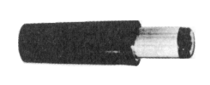
5.5 mm Coaxial Power plug
The inner connector (“Tip”) is positive
The outer barrel (“Sleeve”) is negative.
⇒ Caution: Reverse polarity could damage the NHRC-PXP Pod.

J7 12V Connector Pin-out
Pin # |  | Use
Sleeve | “Outer Barrel” | Ground
Tip | “Inner Connector” | +12 (13.8)

The NHRC-PXP Pod is protected against short circuits with a PolyFuse resetable fuse.

EEPROM Socket
The NHRC-PXP has a Textool zero-insertion-force (ZIF) socket for the X2212 device to be programmed or read. Note that pin 1 of the X2212 device should be located toward the handle of the socket.
To use the ZIF socket, raise the handle to open the socket. Place the part to be programmed or read into the socket, paying attention to proper orientation of the pins. Lower the handle to lock the part into the socket. When your read or write operation is complete, raise the handle to remove the part.

LED Indicators
The NHRC-PXP has three LEDs that indicate the status of the pod.
NHRC-PXP LED Indicators
Label | Color | Description | Indication
D2 | Red | Power | DC Power is present
D3 | Yellow | Status | The Pod is busy
D4 | Green | Active | The X2212 device has power applied.

⇒ Caution: Do not install or remove the X2212 part when the Active LED is lit. Damage the to the NHRC-PXP Pod and/or the X2212 part could occur..

Pushbuttons
The NHRC-PXP Pod has two pushbuttons that allow the pod to be used without a computer.
NHRC-PXP LED Indicators
Label | Description | Use
SW1 | READ | Read the X2212 device into the pod
SW2 | WRITE | Write a program stored in the pod into the X2212 device.

To copy a radio program from one X2212 part into another, perform the following steps:
- Apply power to the pod
- Insert the X2212 you want to copy from.
- Press “READ.” The “STATUS” and “ACTIVE” LEDs will flash.
- Insert the X2212 you want to copy to.
- Press “WRITE.” The “STATUS” and “ACTIVE” LEDs will flash. The new part will now have a copy of the data from the first part.
- Repeat steps 4 and 5 to copy to additional parts
The radio program read from the X2212 in step 3 will be stored in non-volatile memory in the pod. It is possible to read a part, power the pod off, then power up the pod later and write the same program to other parts. The pod can store one radio program in its non-volatile memory. It will keep the last radio program read in standalone mode or the last program written to the pod by the programming software.

Using the NHRC-PXP software

Installation
The NHRC-PXP Programming Software is distributed by electronic download or on 1.44 MB floppy. You can either download the executable programs alone, or download an installer program.
If you choose to download the installer, it will arrive on your computer as a zip archive called “pxp-installer.zip”. Unzip the installer to a new directory, then execute the program called “Disk1\Setup.exe”
When you start the setup program, a informational message will be displayed.
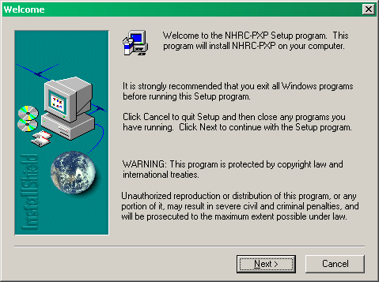
When the installation starts, click the “Next” button to start the installation process. The installer will them prompt you for the location to install the NHRC-PXP software
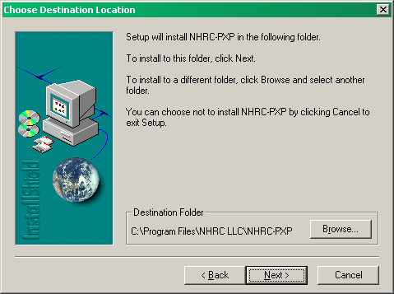
It is quite reasonable to accept the defaults and simply click “Next” on this dialog.
The installer will then install the software. A few more clicks of “Next” and the installation successful message will be shown. Click “Close” to finish the installer.
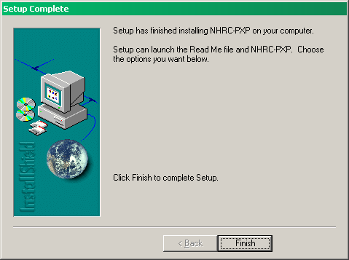

Starting the NHRC-PXP Software
To start the NHRC-PXP Programming Software, press the Windows “Start” button. Select “Programs” and navigate to the menu called “NHRC-PXP”, clicking on either the “Phoenix” or “PhoenixScan” selections.
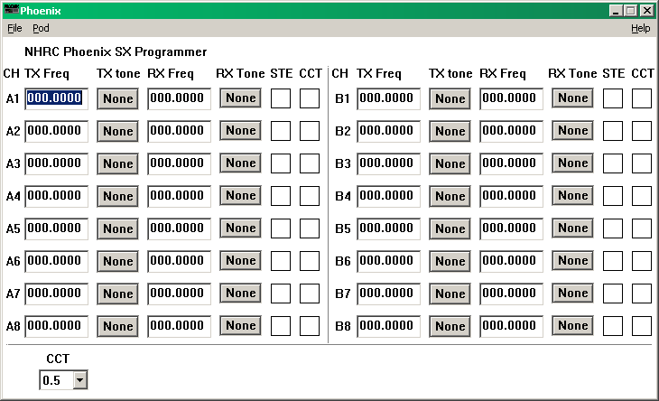
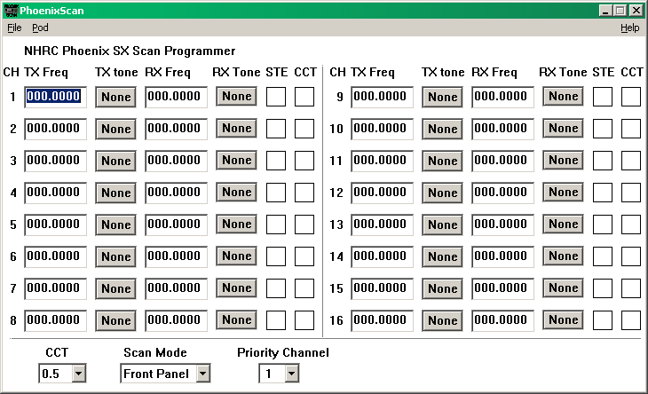
The main window displays all 16 possible channels for the radio, as well as programming information that is common to all channels in the radio, for example the CCT (carrier control timer.)

Basic Operation
The NHRC-PXP Programmer application is used to edit Phoenix SX radio programs. In order to edit radio programs, the software must first load the data from either a X2212 part containing a radio program or a saved radio program data file stored on the computer.
Once the data is loaded, the program can be used to edit it.
Finally, when the configuration data has been edited, it should be saved to computer disk and/or into a X2212 part.

Loading Data
Radio program data can be loaded from disk files stored on the computer, or loaded from a X2212 in the NHRC-PXP pod.

Reading a radio program file from disk
To read radio program files from disk, use the “File” menu “Open…” selection. A Windows file dialog box will appear, and you will be able to navigate to and select the radio program file you want to edit.
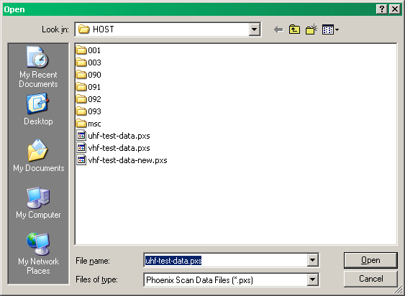
When a file is selected and successfully read by the NHRC-PXP Programmer, the filename will appear in the title bar.

Reading a radio program from the NHRC-PXP Pod
Connect the NHRC-PXP pod to your computer’s COM1 serial port with a straight-through RS-232 cable.
Select the “Pod” menu “Read Device In Pod” option. The “STATUS” and “ACTIVE” LEDs on the pod should flash.
Select the “Pod” menu “Get Program From Pod” option. The “STATUS” LED should flash.
The radio program will be transferred to the programming software, and the radio’s program should appear in the window. The data transferred is very small, and the transfer occurs very quickly.

If the pod is not correctly connected, one or more error messages will appear and the data will not be successfully transferred.
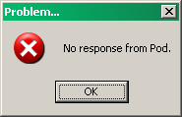

Editing Data
Once a valid radio program into the NHRC-PXP Programming Software, the next step is to edit the data. Each channel can be edited by typing the new frequency into the text field on the screen.
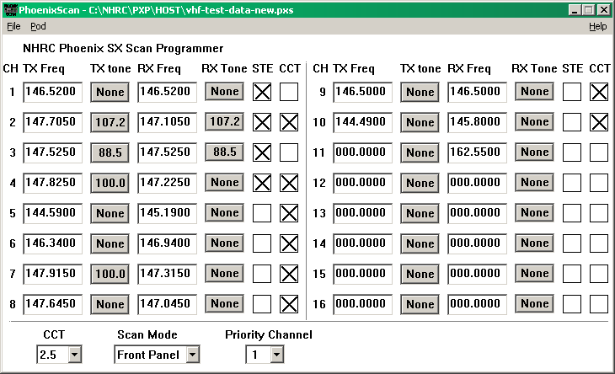
Channel Guard or Digital Channel Guard can be selected for each channel’s receive and transmit settings by pressing either the appropriate “TX Tone” or “RX Tone” button.
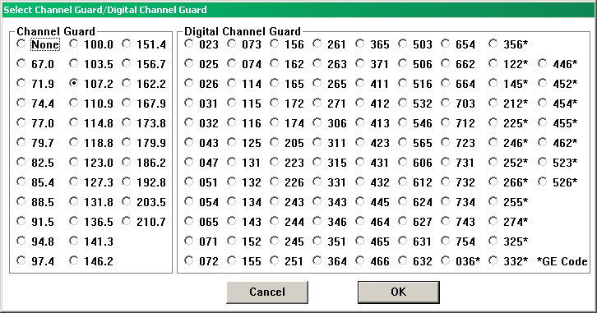
Carrier control timer and Squelch Tail Elimination can be set for each channel by checking the appropriate boxes.

Saving Data
A radio program, once edited, should be saved to a disk file and/or to a X2212 device in the NHRC-PXP pod.

Saving a Radio Program to Disk
To save a radio program to disk, select either the “File” menu “Save” or “Save As…” option. The “Save As” choice will cause the “Save As” dialog box to appear. Choose a directory, specify a file name, and click the “Save” button to save the radio program
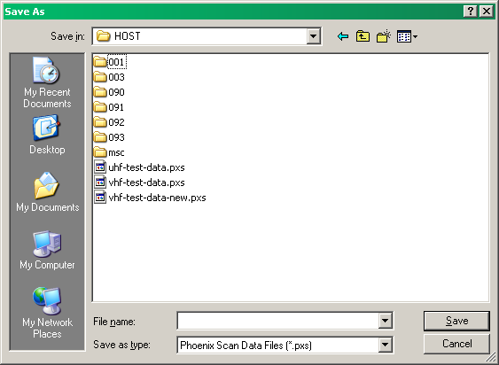
If you select the “Save” option, and you have already specified a file name (either by previously loading a file, or by using the “Save As…” function) the program will quietly save your data to disk.
If “Save” is selected, and a file name has not already been specified the “Save As” dialog will be shown, and you will have to select a location and filename to save the file.

Saving a Radio Program to a X2212 device
To save a radio program to a X2212 device (this is how you program the radio), first connect the NHRC-PXP pod to your computer’s COM1 serial port with a straight-through RS-232 cable.
Select the “Pod” menu “Put Program into Pot” option. The “STATUS” and “ACTIVE” LEDs on the pod should flash. This will transfer the radio program into the pod’s non-volatile memory.
Then, select the “Pod” menu “Write device in pod” option to program the device in the pod. If you want to program multiple devices, you can repeat this step after installing the next part to program.

Printing Radio Program data
The radio program data can be printed by selecting the “File” menu “Print” option.
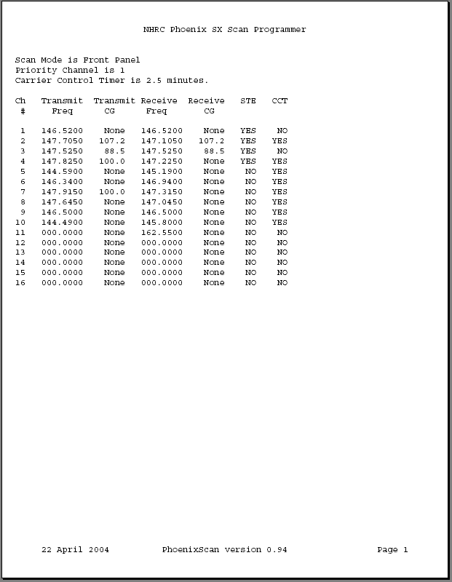

Displaying Version Information
The version number and copyright information can be shown by selecting the “Help” menu “About” option.
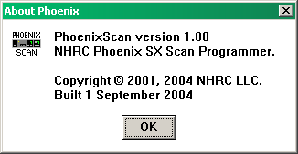

Uninstalling the NHRC-PXP Programming Software
The NHRC-PXP Programming software can be removed from your computer by using the “Add or Remove Programs” icon in the Windows control panel. Select “NHRC-PXP” from the list of programs in the “Add or Remove Programs” window and press the “Remove” button. Press “Yes” to the “Are you sure you want to remove NHRC-PXP Programmer from your computer, and the program will be uninstalled.

Schematic
The next page contains the Schematic for the NHRC-PXP Pod.
Replace this page with the schematic

Parts List
Put the parts list here.

NHRC LLC Limited Warranty
NHRC LLC warrants that it’s assembled and tested products will be free from defects in materials and workmanship for a period of NINETY DAYS from the date of shipment. During this period, NHRC LLC will repair or replace, at our option, any of our products that fail as a result of defects in materials or workmanship. NHRC LLC’s liability will be limited to parts, labor, and return shipping for this period.
NHRC LLC warrants that it’s kit products will contain components that are free from defects in materials and workmanship for a period of THIRTY DAYS from the date of shipment. During this period, NHRC will replace any of the components in a kit ONCE. Subsequent replacement of any component any subsequent times is completely at the discretion of NHRC LLC, and may require the complete return of the kit.
In no case will NHRC LLC be liable for products damaged by improper wiring (including, but not limited to, over-voltage or application of reverse polarity), physical damage resulting from misuse and/or abuse of the product, neglect, or acts of God (lightning, floods, etc.).
Unauthorized modification of a NHRC product will void the warranty on the modified product.
In no case will NHRC LLC be liable for any direct, consequential, or incidental loss or damage resulting from the use or inability to use any of it’s products.
Some states or countries do not allow the limitation of incidental or consequential damages, so the paragraph above may not apply to you.
This warranty applies only to the original purchaser of the product; proof of purchase must be presented to receive warranty service.

