
NHRC-Remote +
Intelligent DTMF Remote Control
Programming and Operations Guide
Introduction:
The NHRC Remote + was born from the requests for a simple way to remotely control things around your shack or at your repeater site. Unlike other "dumb" remote controllers, the NHRC Remote + sends a command response in CW to all valid commands when connected to a transceiver. It is a very cost effective (read: CHEAP) but elegant way to implement control of any device or help you comply with FCC rules to have a control channel for your repeater. The NHRC Remote + can be connected to most any audio source, receiver or transceiver without the need to dig around inside the radio for any signals. All connections are similar to connecting a TNC to your transceiver. Consult you transceivers operating manual for TNC connection instructions.
The NHRC Remote + allows you to control up to 8 loads by sending DTMF commands over any audio circuit. The heart of the NHRC Remote + is a Microchip PIC16F84 microcontroller and the Teltone M8870 DTMF decoder IC.
The NHRC Remote + has the ability to send command confirmation messages via Morse code, which can be sent over any audio circuit. This makes the device useful for radio or wireline applications. For radio applications, the NHRC Remote + can send a Morse code ID message a user defined amount of time after first transmitting.
Theory of operation:
When audio arrives at the DTMF decoder, valid DTMF tones decoded by the M8870 cause the STD data valid signal to go high, at which point the microprocessor starts "listening" to the data from the DTMF decoder. Since it is only listening to the audio it does not know when you have stopped transmitting. The internal program starts a timer (inter-digit timer) that is refreshed with each valid DTMF received from the DTMF decoder. All commands are evaluated and executed after the inter-digit timer expires. (The inter-digit timer is hard coded at 1.5 seconds) If the first four digits match the user defined password stored in the internal EEPROM of the microprocessor then the following four command digits are evaluated and executed if valid. Besides your password, the current output states, port configurations, the CW callsign, and the ID timer value are stored in the microcontrollers internal EEPROM and are retained indefinitely. All of this happens inside the PIC microcontroller at approximately 1 MIP (million instructions per second). The microprocessor clock is driven by the clock output of the M8870 saving the cost of an additional crystal.
The microcontroller processes the received command and sends the appropriate logic signal to the IRF510 power MOSFET’s. A high on the gate of the MOSFET causes the drain of the MOSFET to close to ground. We chose open drain MOSFET outputs instead of relay outputs because relays can bounce making connection to digital circuitry a problem in some cases. The NHRC Remote +’s outputs can drive well in excess of 1 amp allowing control of huge relays if required. Valid commands are acknowledged by asserting the PTT line (pulling it to ground) and sending a CW messages of "1 HI”, “1 LO”, or “1 PU” (“PU” is used to indicate pulsed operation) depending on the channel commanded. Status indicator LED’s show at a glance the state of all channels, valid DTMF digit decode and the PTT line status. The status LED’s can be disabled for lower power consumption. The NHRC Remote+ draws about 14mA @13.8V with the LED’s disabled making it ideal for solar powered applications. Since a 4-digit password is used, up to 10,000 NHRC Remote + boards could be addressed on the same audio channel.
Initial setup and Initialization
The NHRC Remote + uses a user defined four-digit password for access to all commands. This four-digit password can only be set by initializing the processor. The microcontroller stores the password, CW messages and all output configurations and states internally in non-volatile EEPROM. After a power failure the NHRC Remote + will power back up in the exact state it was in before the interruption of power.
To INIT the processor, short the INIT jumper and apply power and release the short. The first four valid DTMF digits received become the password. For the rest of this document, the symbol pppp will indicate the password entered. Note: There will not be a response after the INIT sequence.
The NHRC Remote + has only two adjustments; VR2 controls the audio input level to the touch-tone decoder. Set this pot for reliable touch-tone decode as noted by the DTMF decode LED D7. VR1 sets the audio level of the CW output. Set this level to drive your transmitter to 4KHz deviation.
Port Configuration:
The 8 output ports can be configured for ON/OFF or PULSED (½ second on) operation. The default port configuration is for ON/OFF mode. Each port (1-8) can be individually configured. To configure port “n” for PULSED operation, send the command pppp710n. To configure port “n” for ON/OFF operation, send the command pppp700n. In either case, the NHRC Remote + will respond with “OK” in Morse code.
Pulsed operation is especially useful for toggling the up down keys on a transceiver to change channels remotely, or it could be used to activate your garage door opener, etc.
Port Control:
The 8 output ports can be turned ON or OFF or PULSED. If the port is configured for PULSED operation, then setting the port to ON will result in the port being turned on for ½ second. To set port “n” on, (or pulsed it if so configured) send the command pppp610n. To set port “n” off, send the command pppp600n. If an output is configured for pulsed operation it cannot be latched on by this control method.
The entire output port may also be addressed as a "word" allowing writing to all outputs with one command by programming the port control register directly. (See memory map table) Example 1: To set all outputs OFF enter pppp0000. Example 2: To set all outputs ON enter pppp00FF. Note: Since you are writing directly to the output register that drives the output FET’s, any port configured for pulsed operation will be latched on and will stay on until commanded off.
CW ID AND CW Message Programming:
The ID messages and command response messages are programmed into successive locations in the NHRC Remote +’s EEPROM memory. There are 40 characters reserved for the ID message, from address 12h to address 39h. The address and data bytes must be entered as hexadecimal bytes. These locations are programmed by entering the command ppppxxyy, where “xx” is the address to program and “yy” is the data. The message must be terminated with the “magic” end of message character “FF” in the location immediately following the last letter in your ID. CW characters are mapped to hex numbers per the character map table following below.
Hex numbers (base 16) and your DTMF pad.
There are 16 hex digits in base 16: 0, 1, 2, 3, 4, 5, 6, 7, 8, 9, 0, A, B, C, D, E and F. These map directly to your 16 key DTMF pad on your radio except for E and F. We have mapped E to the * key and F to the # keys on you DTMF pad.
Morse character encoding table

Character | Morse  Code | Hex  Encoding
sk | ...-.- | 68
ar | .-.-. | 2A
bt | -...- | 31
/ | -..-. | 29
0 | ----- | 3F
1 | .---- | 3E
2 | ..--- | 3C
3 | ...-- | 38
4 | ....- | 30
5 | ..... | 20
6 | -.... | 21
7 | --... | 23
8 | ---.. | 27
9 | ----. | 2F
a | .- | 06
b | -... | 11
c | -.-. | 15
d | -.. | 09
e | . | 02
f | ..-. | 14
g | --. | 0B

Character | Morse  Code | Hex  Encoding
h | .... | 10
i | .. | 04
j | .--- | 1E
k | -.- | 0D
l | .-.. | 12
m | -- | 07
n | -. | 05
o | --- | 0F
p | .--. | 16
q | --.- | 1B
r | .-. | 0A
s | ... | 08
t | - | 03
u | ..- | 0C
v | ...- | 18
w | .-- | 0E
x | -..- | 19
y | -.-- | 1D
z | --.. | 13
space |  | 00
EOM |  | FF

ID Timer Programming:
The ID timer can be set by programming a hex value representing tens (10s) of seconds of delay into address 02. Remember: The addresses and data values are in HEX. Example: The default timer value is 32 hex. 32 hex equals 50 in decimal. Since the ID timer is incremented in 10 sec increments 50 X 10 = 500 sec or 8.33 min. The NHRC Remote +s will ID 8.33 min after if sent a confirmation message. Note: The calculator in Windows 95 or 98 (in scientific view) can convert between decimal and hex for you.

Programming Memory Map

Address | Default  Data | Purpose/Use
00 | 00 | Port Control
01 | 00 | Port Mode
02 | 32 | ID Timer
03 | 10 | ‘H’
04 | 04 | ‘I’
05 | FF | EOM
06 | 12 | ‘L’
07 | 0F | ‘O’
08 | FF | EOM
09 | 16 | ‘P’
0A | 0C | ‘U’
0B | FF | EOM
0C | 0F | ‘O’
0D | 0D | ‘K’
0E | FF | EOM
0F | 05 | ‘N’
10 | 0B | ‘G’
11 | FF | EOM
12 | 09 | ‘D’
13 | 02 | ‘E’
14 | 00 | Space
15 | 05 | ‘N’
16 | 10 | ‘H’
17 | 0A | ‘R’
18 | 15 | ‘C’
19 | 29 | ‘/’
1A | 0a | ‘R’
1B | 02 | ‘E’
1C | 07 | ‘M’
1D | 0F | ‘O’

Address | Default  Data | Purpose/Use
1E | 03 | ‘T’
1F | 02 | ‘E’
20 | FF | EOM
21 | FF | EOM
22 | FF | EOM
23 | FF | EOM
24 | FF | EOM
25 | FF | EOM
26 | FF | EOM
27 | FF | EOM
28 | FF | EOM
29 | FF | EOM
2A | FF | EOM
2B | FF | EOM
2C | FF | EOM
2D | FF | EOM
2E | FF | EOM
2F | FF | EOM
30 | FF | EOM
31 | FF | EOM
32 | FF | EOM
33 | FF | EOM
34 | FF | EOM
35 | FF | EOM
36 | FF | EOM
37 | FF | EOM
38 | FF | EOM
39 | FF | EOM
3A | FF | EOM
3B | FF | EOM

Summary
The NHRC Remote + is a simple and inexpensive way to keep things under control around your shack or repeater site. Its compact 3"x 3" size will allow it to be even embedded inside your project or repeater. Its unique ability to respond to your commands eliminates the guesswork in remotely controlling your station. You won't be wondering "Did I make it?" You will always know if the NHRC Remote + controller heard your command. The NHRC Remote + can be built in about an hour and you may already have some of the parts hanging around in your shack.
The NHRC NHRC Remote + is available assembled and tested or as a partial kit. Contact the factory or see our web site for current pricing. All prices are for domestic delivery, please inquire for international orders. The partial kit contains the printed circuit board (PCB is double sided with plated through holes, solder mask and silk screen), programmed microprocessor and DTMF decoder, a printed manual with a parts list for ordering all of the additional components from Digi-Key Corp. and detailed assembly instructions. The additional components needed to complete the kit cost approx. $20 from Digi-Key Corp. Digi-Key can be reached at 1-800-344-4539. Technical support, answers to FAQ and ordering info is also available at our web site at http://www.nhrc.net

Orders can be sent to:
NHRC
415 Fourth Range Rd.
Pembroke, NH 03275.
Phone: 603-485-2248
Fax: 603-210-2248
http://www.nhrc.net

Electrical Connections:

J1 Radio
J1 is a 5-position .100 header. This connector is used to interface the radio or other audio source to the NHRC-Remote+
J1 RADIO Electrical Connections
Pin | Use
1 | No Connection
2 | TX-Beep
3 | Audio In
4 | PTT Out (active low)
5 | Ground

J2 Power
J1 is a 2-position .156 header. This connector is used to supply power to the NHRC-Remote+
J2 +12V Electrical Connections
Pin | Use
1 | +12 (or 13.8) Volts
2 | Ground

J3 Radio Interface
J1 is a 9-position .156 header. This connector is used to provide the open-drain outputs to loads. The output pin is pulled to ground when the output is enabled. These outputs can drive small relays directly, wire one side of the relay coil to +12 and the other side to the NHRC-Remote+.
J2 REPEATER Electrical Connections
Pin | Use
1 | Output 8
2 | Output 7
3 | Output 6
4 | Output 5
5 | Output 4
6 | Output 3
7 | Output 2
8 | Output 1
9 | +12

Assembly of the NHRC-Remote+:
The NHRC-Remote+ is a fairly simple project to build. Minimal electronic experience is required. Assembly time should be around 1 hour.
Organize your parts per the parts list. Use a small soldering iron of approx. 25 watts. (DO NOT USE A SOLDERING GUN). Consider using a water-soluble flux-core solder (such as Alpha Metals Aqualine 6000). A quick rinse under warm water in your sink after assembly and your finished product will look professional. Rosin flux-core solder is OK as well, but be sure to clean your board after assembly with isopropyl alcohol.
As you install a part check it off on your parts list. Socket your chips! Pin 1 of many components are denoted by the square pad on the PCB. Install the IRF510 FET's (Q1-8) so the heatsink surface faces J3, note the silkscreen orientation of the LED’s (D1-8) and small transistors (Q9-10) when installing them. Be careful to install all polarized capacitors (C2, C6, and C7) per the silkscreen (note the "+" sign). Reversing the polarity of the caps will let out the smoke!
Once assembly is complete, power up your board without the chips installed. Refer to the schematic and check voltages to your chips. (Example: +5 volts across bypass caps C1 and C4) When all checks out OK, install the chips in their sockets, power-up the board, INIT the processor and enjoy!
Notes:
A detailed troubleshooting guide is available on our web site at http://www.nhrc.net.
Alpha Metals solder info is available at http://www.alphametals.com

SOCKET YOUR CHIPS
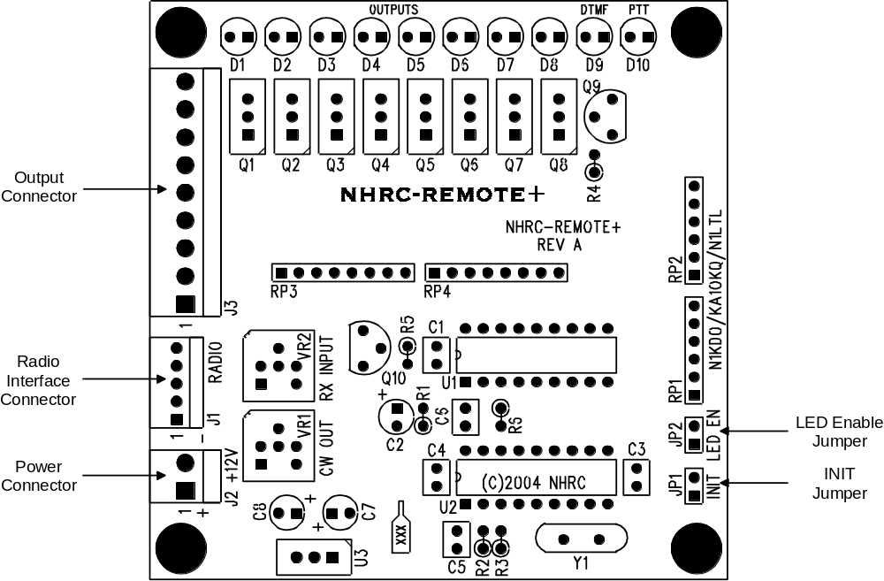

Assembly notes for PCB Rev A:
- Socket your chips
- Square pad denotes pin 1 for ICs, + lead of capacitors, and Anode of LEDs.
- U3 (7805) heat sink faces out
- DO NOT USE A SOLDERING GUN. Use only a 25 watt or temperature controlled soldering iron.
- Use Rosin Core solder or Alpha Metals Aqualine 6000. If you use the Aqualine solder, be sure to wash all the flux off the board with hot water.
Technical support is available on our web site at http://www.nhrc.net

NHRC LLC Limited Warranty

NHRC LLC warrants that its assembled and tested products will be free from defects in materials and workmanship for a period of NINETY (90) DAYS from the date of shipment. During this period, NHRC LLC will repair or replace, at our option, any of our products that fail as a result of defects in materials or workmanship. NHRC LLC’s liability will be limited to parts, labor, and return shipping for this period.
NHRC LLC warrants that its kit products will contain components that are free from defects in materials and workmanship for a period of THIRTY (30) DAYS from the date of shipment. During this period, NHRC will replace any of the components in a kit ONCE. Subsequent replacement of any component any subsequent times is completely at the discretion of NHRC LLC, and may require the complete return of the kit.
In no case will NHRC LLC be liable for products damaged by improper wiring (including, but not limited to, over-voltage or application of reverse polarity), physical damage resulting from misuse and/or abuse of the product, neglect, or acts of God (lightning, floods, etc.).
Unauthorized modification of a NHRC product will void the warranty on the modified product.
In no case will NHRC LLC be liable for any direct, consequential, or incidental loss or damage resulting from the use or inability to use any of its products.
Some states or countries do not allow the limitation of incidental or consequential damages, so the paragraph above may not apply to you.
This warranty applies only to the original purchaser of the product; proof of purchase must be presented to receive warranty service.
BOM Page 1
Schematic Page 1
Schematic Page 2

