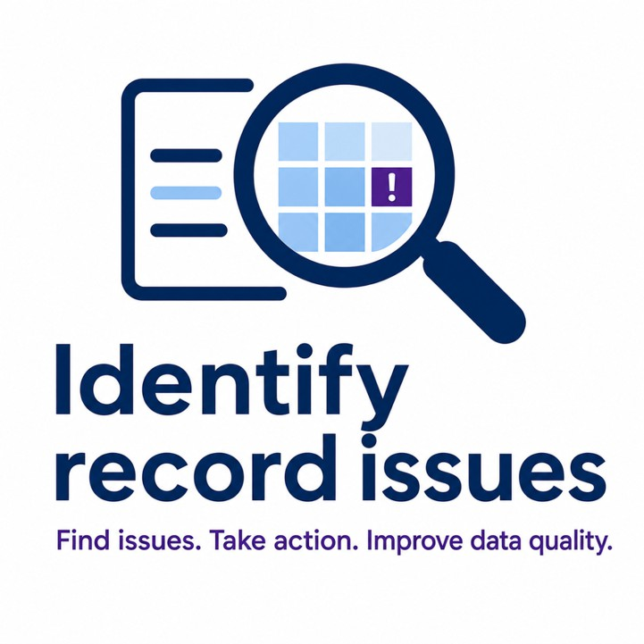

Training guide

Use the Identify Record Issues tool with confidence during routine casework

The data used in this document is fictional and is used for the purposes of illustration only

Table of Contents
Purpose of this guide 2
Quick start (start here if you’re new) 3
What the tool does 4
What the tool does not do 4
How the tool works 4
Using the tool 4
Step 1: Access and sign in 5
Step 2: Find a member 5
Step 3: Member details page overview 5
Step 4: Review the notification banner 5
Step 5: Check the data 5
Step 6: Locate the issue 6
Step 7: Fix in Compendia 6
Identify record issues - the basics 6
Search for a member 7
Member summary (basic data) 7
Validation notification banner 8
Core data sets 9
Identifying where issues exist 10
Row-level highlighting 11
Understanding corruption messages 11
Corruption types 12
Reading corruption messages 12
Key features of the tool 13
Search for a new record 14
Update / refresh data sets 14
Filter data sets 15
Hide correct rows 16
Customise dataset view 17
Pagination 18
Compare data sets (critical feature) 19
How to use the ‘Compare data set’ feature 20
Back to top 21
Common questions (FAQs) 22
I can’t find the issue 23
There’s too much data - my screen is so busy 23
The data doesn’t match 23
The record is very large 23
This record doesn’t make sense 23
I’ve made changes in Compendia 24
I want to start again 24
Pension issues overview 24
Final checks and guidance 26
What ‘good’ looks like 27
Important reminder 27
Additional support 27

For further assistance please review the video tutorials

Purpose of this guide

This guide supports you in confidently using the Identify record issues tool during routine casework to:
- Check member records
- Identify data issues (corruptions)
- Take corrective action
- Leave records in a clean state

Quick start (start here if you’re new)
If you’re using the tool for the first time, follow this journey:
- Search for a member using their unique member number
- Check the notification banner for issues
- Open datasets with flagged issues
- Read the corruption message
- Use Compare datasets if needed
- Identify the corrupted data
- Fix the issue in Compendia
- Refresh the data in the tool


For more information consult the video training guide

What the tool does
  - Detects data corruption (broken or inconsistent data)
  - Flags integrity issues between datasets
  - Highlights where to investigate

What the tool does not do
  - It does not fix data
  - It does not guarantee a record is correct
  - It does not detect all corruption types - refer to the Pensions overview tab

How the tool works
The tool checks a member’s record by comparing data across multiple datasets. Think of it like this:

Before you start your task, you can check to see if the members record is good or if it
has any corruptions that would slow you down before you begin your task.

A lot of corruptions can remain hidden in the data, so the tool is designed to highlight them easily and early for you to action.

Using the tool

This guide is designed to:
  - Show you what to do
  - Help you understand why you’re doing it
  - Teach you how to get the most out of the tool

Step 1: Access and sign in
  - Access the tool via the link on Pensions Hub
  - Use Single Sign-On (SSO) to log in
  - No additional credentials required
  - Reach out to your Team Manager if you face any sign in issues

Step 2: Find a member

How to search
  - Enter a unique member number into the search field
  - Select Continue

Key points:
  - You can search for one member at a time
  - You do not need to re-enter the member ID elsewhere

Step 3: Member details page overview

This is the primary screen that displays the members’ details. Here you can:

  - Review member data
  - Identify issues
  - Navigate data sets

Step 4: Review the notification banner
  - Displays total number of issues
  - Let’s you know if the record is clean or not
  - For more information click here

Step 5: Check the data
  - The data is set out in data sets like Compendia
  - Check these as normal for data issues
  - Datasets are marked with issue counts
  - Focus on datasets with flagged issues
  - Refer to the ‘Identify record issues - the basics’ for how to check data on the tool

Key points:
  - The data is live and mirrors the data you will see in Compendia
  - The layout of the Identify record issues tool is designed to make looking through the data sets faster, easier and less stressful

Step 6: Locate the issue
  - Rows with issues are highlighted
  - Use pagination if needed (issues may not be on page 1)

Step 7: Fix in Compendia
  - Make corrections in the source system
  - Refresh datasets to confirm resolution

Identify record issues - the basics

Search for a member

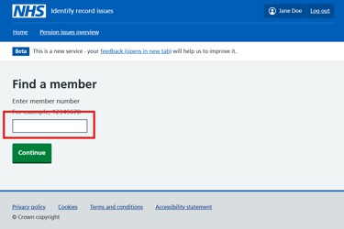
Figure 1 - Search for a member's record

How to search
  - Enter a unique member number into the search field
  - Select Continue

Key points:
  - You can search for one member at a time
  - You do not need to re-enter the member ID elsewhere


For more information consult the video walkthrough here

Member summary (basic data)
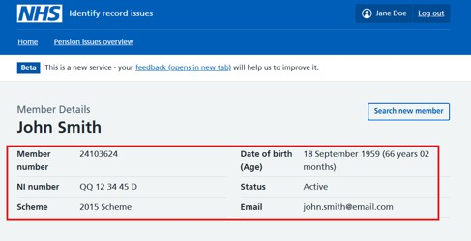
Figure 2 - Basic member information
Displays key identifying information:

  - Member number
  - Name
  - Date of birth
  - NI number
  - Scheme
  - Status

Why it matters:

Confirms you are working on the correct record before making changes.


For more information consult the video walkthrough here

Validation notification banner
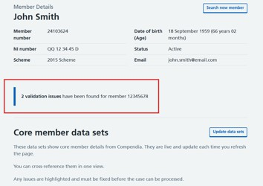
Figure 3 - Record corruption notification banner

What this tells you:
  - Whether issues exist on the record
  - The number of issues


For more information consult the video walkthrough here

Core data sets
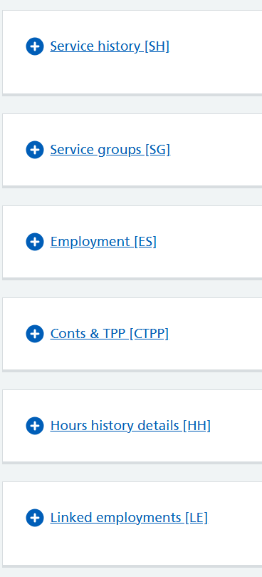
Figure 4 - Data sets on Identify record issues tool

These represent the data domains used in validation:
  - Service history [SH]
  - Service groups [SG]
  - Employment [ES]
  - Conts & TPP [CTPP]
  - Hours history details [HH]
  - Linked employments [LE]

How to use
  - Select a data set to expand
  - You can expand multiple data sets at a time
  - Review rows and highlighted issues within the sets


For more information consult the video walkthrough here

Identifying where issues exist
Each dataset shows:
  - Issue count (such as 1 issue found)
  - Visual emphasis on affected sets

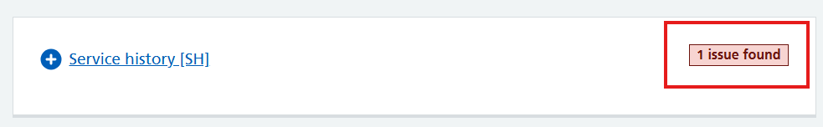
Figure 5 - Data set showing 1 corruption has been found
Key points
  - Identifies if, where, and how many issues exist within a set
  - If a set does not have an issue status - it’s likely the data is not corrupt

Row-level highlighting
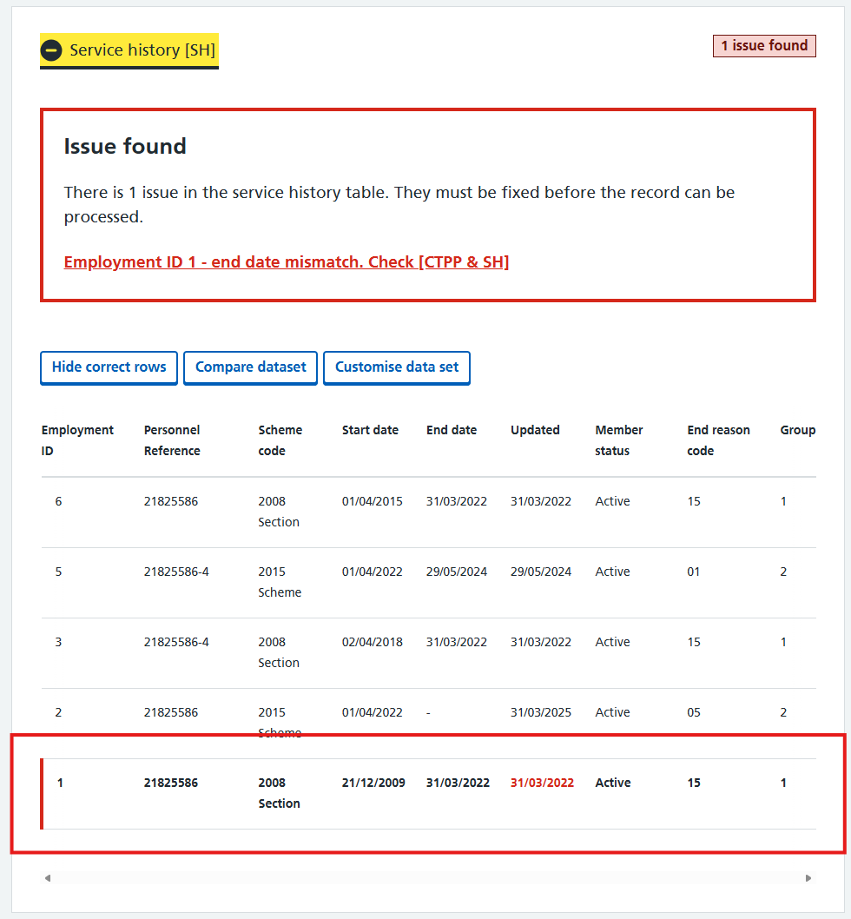
Figure 6 - Highlighted row indicating where the corruption is present in the data set
When a data set is open and where a corruption is present - the tool will highlight the affected row to help identify where the data is corrupted.
  - Specific rows are visually highlighted
  - These correspond directly to validation
failures
This helps you:

  - Pinpoint the exact record causing the issue
  - Spend less time searching for the problem

Understanding corruption messages

Corruption types
  - Mismatch - Comparison across data sets failed
    - Two (or more) related data sets contain values that do not agree with each other, when they should
    - How to resolve:
      - Use compare data sets
      - Align by checking the relevant data sets such as [SH & LE]
      - Identify which dataset is incorrect

  - Duplicate - The same record exists more than once when it should be unique
    - There are multiple entries representing the same thing, which can cause calculation or processing errors
    - How to resolve:
      - Identify duplicate rows (same key fields)
      - Confirm which record is valid
      - Remove or correct the duplicate in Compendia

  - Missing - Required data is absent
    - A record or value that must exist is not present
    - How to resolve:
      - Use the message to identify what’s missing
      - Navigate to the referenced dataset
      - Create or restore the missing data

  - Overlapping - Two records cover the same period when they should not
    - Date ranges or periods conflict with each other, causing ambiguity
    - How to resolve:
      - Compare date ranges within the dataset
      - Identify where overlap occurs
      - Adjust dates so periods are continuous, not conflicting

  - Invalid - Data breaks a rule or contains an incorrect value
    - The data exists, but it is not acceptable according to business rules
    - How to resolve:
      - Check the message and highlighted data
      - Verify correct value from source system (Support team necessary)
      - Update the data to a valid state

Reading corruption messages

Each message tells you:
  - What is wrong
  - Which datasets are involved
  - Where to look

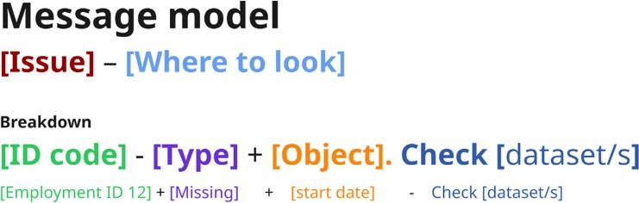
Figure 7 - Corruption message structure

For example:

‘Mismatch scheme code. Check [SH & SG]’

This means:
  - Compare Service History and Service Groups
  - Identify where scheme codes differ
  - Determine which is correct
Key notes:
  - While most messages follow this formula. Due to the complexity and verity of corruptions some messages may look different.


For more information consult the video walkthrough here

Key features of the tool

How to get the most of out the tool!

Search for a new record

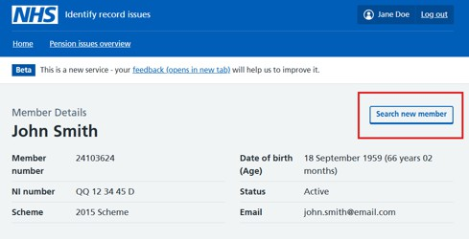
Figure 8 - Search for a new member button
  - Located at top right of page
  - Returns you to search screen
Use when: switching cases

For more information consult the video walkthrough here

Update / refresh data sets

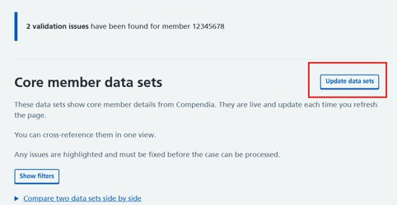
Figure 9 - Update data so it is live and matches compendia

  - Refresh button reloads live data from Compendia
Important:
  - Data is live but not auto refreshed
  - You must refresh after making changes in Compendia


For more information consult the video walkthrough here

Filter data sets

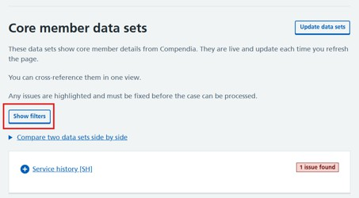
Figure 10 - Filter button – used to filter visible data sets
  - Allows filtering of data sets
  - Step 1: Click ‘Show filters’
  - Step 2: Click on the checkbox to turn on/off filters
    - If a check box does not have a tick it’ll be removed.
    - If a check does have a tick, it’ll remain
    - If a text box is greyed out, it’ll remain
  - Step 3: Click 'Apply filters'
  - Step 4: Visible data sets will change

Key points:
- Just because a data set is not flagged as having a corruption it does not always mean the data there is correct as some corruptions impact multiple data sets.
- Where a set is greyed out (such as service history in the example below) you cannot interact with this set, and it must remain visible. A set will be greyed out because the tool will have flagged a data issue in it which requires your attention.
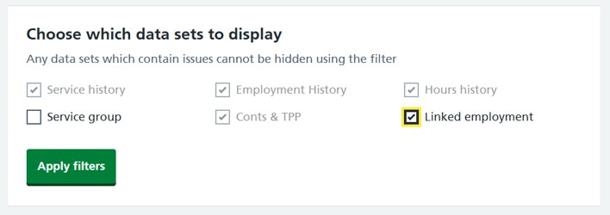
Figure 11 - Example of how to filter data sets
Changed your mind:

If you have clicked ‘Show filters' by mistake and do not want to hide any data sets. Click 'Hide filters’ to close the filter options.

Use when:
  - You want to reduce the amount of data on your screen
  - Focusing on specific records


For more information consult the video walkthrough here

Hide correct rows
  - Displays only rows with issues
  - Removes all rows where data is deemed safe
Use when:
  - Quickly isolating corruption
  - Reducing noise in large records

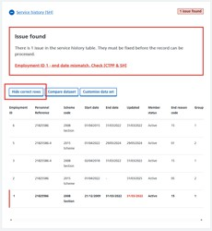
Figure 12 - Before hiding correct rows - click hide correct rows to hide correct data

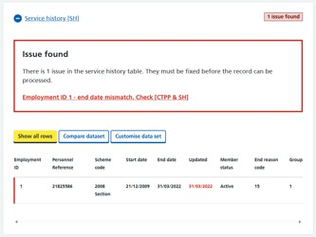
Figure 13 - After hiding correct rows - click show all rows to return the hidden data


For more information consult the video walkthrough here

Customise dataset view
  - Select which fields/columns to display with a data set
  - Some sets on Compendia have a lot of data - choose which data you want to see and what data you want to hide

Use when:
  - Focusing on relevant attributes
  - Simplifying analysis / investigation

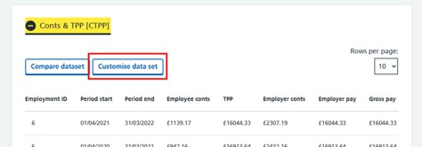 | 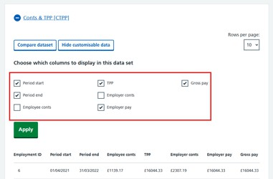 | 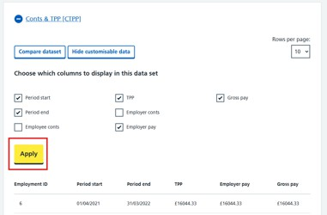
Figure 14 - Step 1 - Click ‘Customise data set’ to bring up the filtering options | Figure 15 - Step 2 - Untick the data sets you wish to hide. If a data set is ticked, it will remain visible. | Figure 16 - Step 3 - Once you are happy with your selection. Click ‘Apply’ to remove or show the data


For more information consult the video walkthrough here

Pagination
  - Large datasets are split across multiple pages
How to use:
  - Navigate using page controls at the bottom of datasets
  - You can also choose how much data you want to see on each page by using the option in the top right of the data set

You can select 5, 10 or All of the rows for that set.
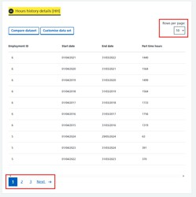
Use when:
  - Reviewing high-volume records
  - Ensuring no issues are missed beyond the first page

Important:
Issues may exist on any page, not just the first. Make sure to check every page/ row.


For more information consult the video walkthrough here

Compare data sets (critical feature)

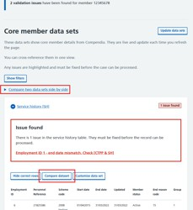
Figure 8 - How to compare data sets
This allows you to view two datasets side by side to trace mismatches.

Use when:

  - Investigating mismatches
  - A message refers to two data sets such as: Check [SH & CTPP]
  - Validating relationships between datasets (such as service history vs service groups)

How to use the ‘Compare data set’ feature

Step 1: Click compare data sets

  - You can decide to compare data sets from two areas on the tool.
- At the top of the data sets click to open the ‘Compare two data sets side by side’ link
- When in a data set - click ‘Compare data set’

Step 2: Choose datasets

  - You can only select 2 data sets
  - If you choose to compare data from within a set using the button - this set will be pre-selected for you
For example:

  - Left: Service history [SH]
  - Right: Service groups [SG]

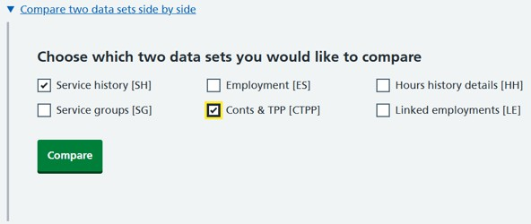
Figure 9 - Selecting the sets you want to compare

Why it’s useful:

This stops the need to screenshot data and allows you to compare live data from 2 sets next to each other to support your investigation.

Step 3: Check data

  - Work as normal to interrogate the data and investigate the issue
  - When you have finished with this view select the back button in the top left of the page

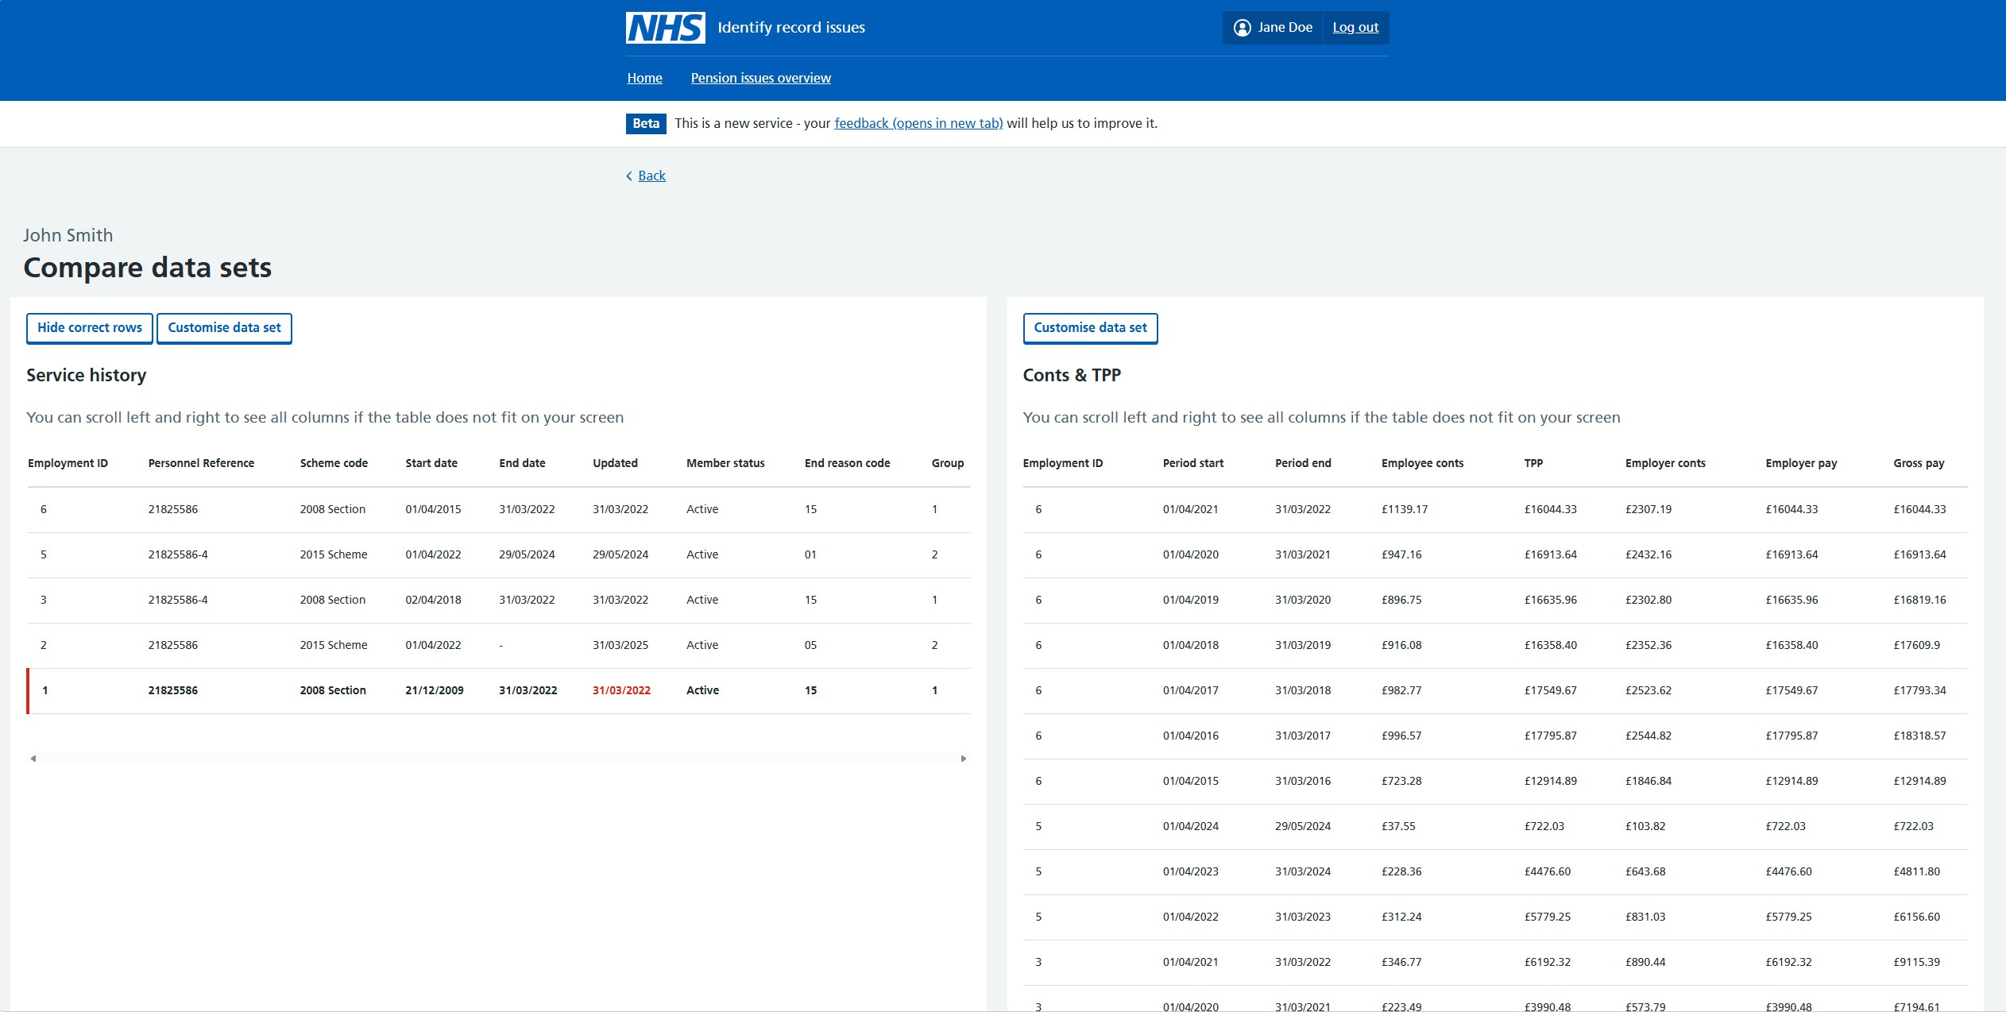

Figure 10 - Comparison view [SH & CTPP]

For more information consult the video walkthrough here

Back to top

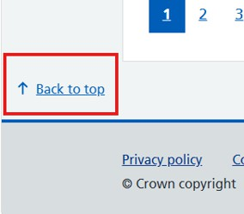
Figure 20 - Back to the top button

- Returns user to top of page
- This moves around with you and remains on your screen

Use when:
  - Navigating large records efficiently

Common questions (FAQs)

I can’t find the issue

Use:
  - Highlighted rows (this shows exactly where the issue exists)
  - Check the issue message (this will sometimes direct you to other data sets that are linked to the problem)
  - Use pagination if needed (issues may not be on page 1)

There’s too much data - my screen is so busy

Use:
  - Hide correct rows (removes correct data and lets you focus on the problem)
  - Filter data sets and columns (Reduces noise and surfaces problem data)

The data doesn’t match

Use:
Compare data sets (See two sets side by side for easy comparison)

The record is very large

Use:
  - Pagination (Allows you to chop and change how much data you see)
  - Always check all pages to make sure there are no hidden corruptions

This record doesn’t make sense

Do:
  - Re-read the corruption message
  - Re-check the related datasets
  - Confirm whether the issue type is supported (via the overview page)

If still unclear:
  - Refer to your SME
  - Raise a ticket where needed

I’ve made changes in Compendia

Use:

Update data (After making changes in Compendia make sure to click ‘Update data sets’ to ensure you are viewing the latest information.)

I want to start again

Use:
Search for a new record (Allows you to enter another unique member ID)

Pension issues overview

The ‘Pensions overview page’ sits at the top in the header alongside the ‘Home’ option.
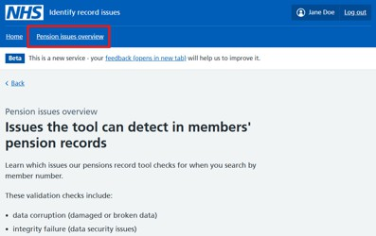
Figure 21 - Pension issues overview

The goal of this page is to help you:

  - Understand what checks exist
  - Confirm whether your issue type is supported
  - Understand limitations of the tool (what it cannot do yet)

The tool currently validates corruptions across these data sets:
  - Service history
  - Service groups
  - Employment
  - Conts & TPP
  - Hours history
  - Linked employment

These map directly to what you’ll see on the member details page.

Most importantly it details what the tool can do and what it can’t do. If your issue is not supported by the tool:

  - Do not rely on the tool
  - Investigate manually

You are responsible for:
  - Investigating
  - Interpreting
  - Fixing


For more information consult the video walkthrough here

Final checks and guidance

Before moving on from a record, take a moment to confirm:
  - You have reviewed all flagged datasets
  - You have checked all pages (not just the first)
  - You have used Compare datasets where mismatches were present
  - You have refreshed the data after making changes

What ‘good’ looks like

A record is in a good state when:
  - No issues are shown in the notification banner
  - The data is consistent across related datasets
  - No obvious gaps or anomalies remain after review

Important reminder

‘0 issues’ in the validation notification banner does not guarantee the record is correct

The tool helps you identify known corruption types, but:
  - Some issues are not yet detectable
  - Some inconsistencies require manual judgement

Additional support

To see the Identify record issues tool in action:
- Refer to the video tutorials linked in this guide
- Use them alongside this guide to reinforce your understanding

This tool is here to help you identify corruptions by supporting your investigation - not replacing it.

It helps you:

- Navigate complex data
- Identify where problems exist
- Understand relationships between datasets

But you must:

- Apply judgement where data looks suspicious and known gaps exist (Pension issues overview)
- Use Compendia to fix
- Understand its limitations (via the overview page)
- Ensure the record is accurate

By combining the tool with your knowledge and these practices, you can confidently identify and resolve data issues.

